Potato Diseases Detection Using Machine Learning

Tejas Dhavale
Dept. of MECHANICAL
VPKBIET Baramati, Pune
tejas.dhavale.mech.2019@vpkbiet.org

Roshan Kature
Dept. of MECHANICAL VPKBIET Baramati, Pune
roshan.kature.mech.2019@vpkbiet.org

Saurabh Kadam
Dept. of MECHANICAL VPKBIET Baramati, Pune
saurabh.kadam.mech.2019@vpkbiet.org

Harsh Rananavare
Dept. of MECHANICAL
VPKBIET Baramati, Pune
harsh.rananavare.mech.2019@vpkbiet.org

Assistant Prof. Avinash Kolekar
Dept. of MECHANICAL
VPKBIET Baramati, Pune
avinash.kolekar@vpkbiet.org

Abstract—Leaf diseases are a significant threat to crop production, causing substantial yield losses and reducing overall plant health. Early and accurate detection of leaf diseases is crucial for effective disease management strategies. Deep learning, a subset of machine learning, has emerged as a promising approach for leaf disease detection due to its ability to automatically learn complex features and patterns from large datasets. In this review, we provide a comprehensive overview of the existing literature on leaf disease detection using deep learning, including various deep learning architectures, datasets, and evaluation metrics. We discuss the advantages and limitations of deep learning-based approaches, including their accuracy, robustness, scalability, and potential for integration with other technologies for smart farming and precision agriculture. We also highlight the challenges and opportunities in leaf disease detection using deep learning, such as the need for large and diverse datasets, interpretability of deep learning models, and deployment in real-world agricultural settings. This review aims to provide valuable insights into the current state-of-the-art in leaf disease detection using deep learning and guide future research directions in the field of plant health monitoring.
Index Terms— Leaf diseases, deep learning, convolutional neural networks, recurrent neural networks, plant health monitoring, precision agriculture

- INTRODUCTION
Plant diseases are a significant threat to global agriculture, causing substantial crop losses and economic impacts. Early and accurate detection of plant diseases is crucial for effective disease management and crop protection. Traditional methods of plant disease detection, such as visual inspection and laboratory-based assays, can be time-consuming, labor intensive, and subjective. With advancements in computer vision and machine learning, there has been growing interest in using automated techniques for plant disease detection. Plant disease detection involves the analysis of various plant parts, such as leaves, stems, fruits, and roots, for the presence of disease symptoms or pathogen infections. Among these, leaf based disease detection is particularly important as leaves are the primary organs that display visible symptoms of diseases. specifically using leaf images. Deep learning, a subset of machine learning, has shown great potential for image-based tasks, including plant disease detection, due to its ability to automatically learn relevant features from large amounts of data. Convolutional neural networks (CNNs), a type of deep learning architecture, have been particularly successful in image processing tasks, making them well-suited for plant disease detection. CNNs can learn to extract meaningful features from leaf images, and then use these features to classify or localize diseased areas in unseen images. Plant diseases can affect leaves in various ways, depending on the type of disease and the specific pathogen involved. Here are some common ways in which diseases can affect leaves: Leaf spots: Many plant diseases cause the formation of spots on leaves.
These spots can be of different colors, shapes, and sizes, depending on the pathogen. Leaf spots may be circular, irregular, or angular, and can range from small specks to large lesions that cover the entire leaf surface. Leaf spots can be caused by bacteria, fungi, or viruses, and can result in defoliation, reduced photosynthesis, and decreased plant vigor. Chlorosis: Chlorosis refers to the yellowing or whitening of leaves, which is caused by a decrease in chlorophyll production or function. Chlorosis can be a symptom of various diseases, including nutrient deficiencies, viral infections, and physiological disorders. Chlorotic leaves are less efficient in photosynthesis and may result in reduced plant growth and yield. Necrosis: Necrosis refers to the death of leaf tissue, which can be caused by various diseases, including fungal, bacterial, and viral infections. Necrotic areas on leaves can appear as brown, black, or dark-colored lesions, and may cause defoliation, reduced photosynthesis, and overall plant decline. These are just a few examples of how diseases can affect leaves. It's important to note that different diseases can have overlapping symptoms, and accurate diagnosis often requires laboratory testing and expert knowledge. Early detection and appropriate management of plant diseases are crucial for minimizing their impact on leaves and overall plant health

II. METHODOLOGY

Deep learning is powerful machine learning approach which have mitigated the traditional machine learning headache of feature engineering. It doesn’t need any domain expertise now and all credit goes to deep learning. The core of deep learning is artificial neural network (ANN). Artificial neural networks are mathematical models that replicate with their neurons and synapses interconnecting them the general principles of brain function to implement neural network one of the most standard libraries is TensorFlow It provides all libraries related to artificial neural network. With the help of TensorFlow one can perform classification tasks on text as well as images.

2.1 Convolutional Neural Networks (CNNs)
Convolutional Neural Networks (CNNs) are a type of deep learning algorithm commonly used for image processing tasks, including leaf disease detection. CNNs are specifically designed to automatically learn patterns and features from images, making them well-suited for tasks that require image analysis and classification. The architecture of a typical CNN consists of multiple layers, including convolutional layers,
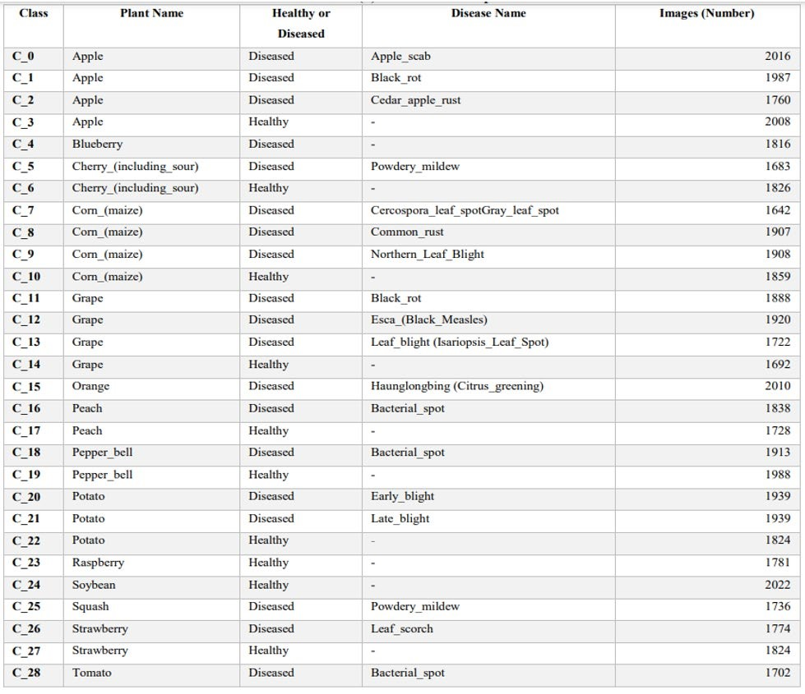
pooling layers, and fully connected layers. Here's a brief overview of each type of layer Convolutional layers: These layers apply convolution operations to input images, which involves sliding small filters or kernels across the image to extract local features. These features may include edges, textures, or other patterns that are relevant for disease detection in leaf images. Convolutional layers help the CNN to learn hierarchical representations of the input images. Pooling layers: These layers down sample the feature maps generated by the convolutional layers, reducing their spatial dimensions. Common pooling techniques include max pooling and average pooling, which help to reduce the computational cost and increase the model's translation invariance, i.e., the ability to recognize features irrespective of their position in the image. Fully connected layers: These layers are traditional neural network layers, where all neurons are connected to every neuron in the previous and subsequent layers. Fully connected layers are typically used in the final layers of a CNN to make predictions and classify the input images into different disease classes based on the learned features. The general workflow of a CNN for leaf disease detection involves feeding the preprocessed leaf images as input to the CNN, passing them through the convolutional, pooling, and fully connected layers to learn relevant features, and finally making predictions about the presence or absence of diseases. The CNN is trained using a labeled dataset of leaf images, and the model parameters are optimized through backpropagation and gradient descent to minimize the prediction error

2.2 Dataset Discussion
Two datasets are used to perform plant disease detection. The first dataset consists of 15 classes and second consists of 38 classes. Both databases have number of images of each plant. First dataset has total 2952 images. Final findings of this work are on Plant Village dataset which contains 38 classes of different plants. It is also openly accessible over internet. Description of these classes and dataset is given in following Dataset is divided into two parts one for training and other for Testing. Splitting of dataset is 80/20 ratio randomly. 80% for the training dataset and rest 20% for testing dataset. Training dataset consists 56,236 image and testing consists 14,059 images. Training of model is done using 56,236 images and 14,056 images were kept unseen by model so that accuracy of model can be checked.

2.3 Model Description
First some preprocessing is applied on dataset in form of augmentation to increase size of dataset in order to achieve better accuracy. Then images size is reduced by 256x256 pixels. After that a convolution neural network-based model will be created with multiple pooling and convolution layers and a dense layer for prediction. Five convolution layers with 3x3 filter are used and five MaxPooling2D layers with 2x2 filter. Batch Normalization is also used in this model. Batch normalization is used to scale data on particular scale but the difference is that it not just does it on input layer but it also does it at other hidden layers. At last model is trained on Plant Village dataset
Epochs 25 | 25
Batch Size | 32
Learning Rate 1e-1 | 1e-1
Activation in middle layers | Relu
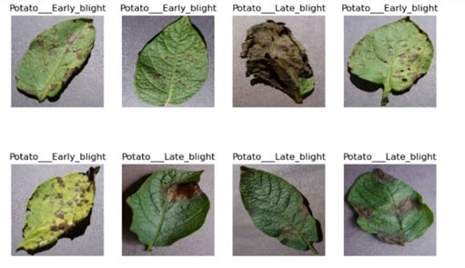
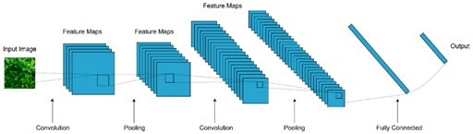

III. RESULTS AND DISCUSSION
This study highlights the importance of plant disease diagnosis today. The model was developed using deep learning in Python. Twenty percent (14,059) of the images in the Plant Village dataset were used to test the accuracy of the model. Images from 38 different categories. 20% of each class is randomly selected for testing. Some live footage is also available. These images are taken from the local environment. They do not belong to any of the existing categories in the database. But the model tells us if it's a healthy leaf, giving these images more than 95% accuracy. A total of 100 images were used, 96 of which were correctly classified. Some of the photos were taken at night with the help of light, and some of them were incorrectly classified because they had dirt on them. Some of the photos we took from our local environment Testing dataset gives accuracy more than 98%. It means 1379 images from 14,059 images were classified correctly by model. Below is the Training and Validation accuracy graph generated by our model on testing dataset
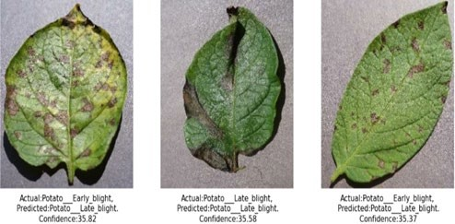

IV. CONCLUSION
This study has employed deep learning abilities to accomplish an automated plant disease detection system. This system is based on a simple classification mechanism which exploits the feature extraction functionalities of CNN. For prediction finally, the model employs the totally connected layers. The analysis was carried out utilizing the publicly accessible collection of 70295 images, and 100 images from experimental prerequisites and the actual environment. The system has gained an overall 98% testing accuracy on publically accessible datasets.
It is concluded from the accuracy that CNN is favourably suitable for the automatic detection and diagnosis of plants. This system can be integrated into mini-drones to live detection of diseases from plants in cultivated areas. Though this system is trained on the Plant Village dataset with only 38 classes it could tell if the plant has a disease or not as somehow symptoms are the same in all kinds of plants. In addition, more actual environment images can be added to the dataset to improve the accuracy of real-condition images of leaves and classify more plant types as well as disease types. In the future, this system can also adopt 3-layer approach where the first layer detects if there’s any plant in an image or not, the second layer tells the plant type and the third layer tells if there is any disease or not and what type of disease is there if any.

REFERENCES
- S. Kumar, R. Kumar and M. Gupta, "Analysis of Apple Plant Leaf Diseases Detection and Classification: A Review," 2022 Seventh International Conference on Parallel, Distributed and Grid Computing (PDGC), Solan, Himachal Pradesh, India, 2022, pp. 361-365.
- D. Anil, M. N. Sindhushree, T. M and T. A. Lone, "Disease Detection and Diagnosis on the Leaves using Image Processing," 2022 IEEE 3rd Global Conference for Advancement in Technology (GCAT), Bangalore, India, 2022, pp. 1-6.
- M. I. Khaleel, P. G. Sai, A. U. R. Kumar, P. Raja and V. T. Hoang, "Rose Plant Leaves: Disease Detection and Pesticide Management using CNN," 2022 6th International
  - Conference Trends in Electronics and Informatics (ICOEI), Tirunelveli, India, 2022, pp. 1067-1072.
- M. D. Nirmal, P. Jadhav, S. Pawar, M. Kharde and Pravara,
  - "Deep Learning-based Disease Detection using Pomegranate Leaf Image," 2022 Smart Technologies, Communication and Robotics (STCR), Sathyamangalam,
  - India, 2022, pp. 1-5.
- S. Omar, R. Jain and V. Bali, "Leaf Disease Detection using Convolutional Neural Network," 2022 International Conference on Machine Learning, Big Data, Cloud and Parallel Computing (COM-IT-CON), Faridabad, India, 2022, pp. 53-56.
- A. Lakshmanarao, M. R. Babu and T. S. R. Kiran, "Plant Disease Prediction and classification using Deep Learning ConvNets," 2021 International Conference on Artificial Intelligence and Machine Vision (AIMV), Gandhinagar, India, 2021, pp. 1-6.
- P. V. Raja, K. Sangeetha, N. B A, S. M and S. S S, "Convolutional Neural Networks based Classification and Detection of Plant Disease," 2022 6th International Conference on Computing Methodologies and Communication (ICCMC), Erode, India, 2022, pp. 14841488.
- V. Menon, V. Ashwin and R. K. Deepa, "Plant Disease Detection using CNN and Transfer Learning," 2021 International Conference on Communication, Control and Information Sciences (ICCISc), Idukki, India, 2021, pp. 1-6

