ELECTRO MAGNETIC ABRASIVE FINISHING MACHINE

Dr. Pawan Kumar Singotia: Professor, Department of Mechanical Engineering, Raghu Engineering College, Visakhapatnam, Andhra Pradesh.
G. Sai Arjun Manikanta, K. Ganesh Kumar, P. Dinesh Pavan Varma, V. Sri Sai Naga Siva, T. Naga Sai Kumar Reddy UG Students, Department of Mechanical Engineering, Raghu Engineering College, Visakhapatnam, Andhra Pradesh.

ABSTRACT: The demand for high finish with accuracy, combined with difficulty to finish components by conventional methods lead to the growth of advanced finishing processes. Magnetic abrasive finishing process is an advanced finishing process capable of finishing, deburring and precision chamfering of components. Magnetic abrasive finishing process can economically achieve nanometre surface finish on flat and cylindrical workpieces both internal and as well as externally. During magnetic abrasive finishing process, very low magnitude of finishing forces is applied on the magnetic abrasive particles to obtain nanometre surface finish. Therefore, it is particularly useful in finishing brittle materials without developing micro cracks and other defects. Various researchers modified the process and developed its hybrid variants. Their prime objective is to make the process more efficient and also capable of finishing micro features. To understand the physics of the process a considerable amount of work has been carried out in the form of experimental study with few attempts in the modeling of the magnetic abrasive finishing process.
KEYWORDS: Magnetic abrasive finishing Surface roughness Modeling Abrasive particle
INTRODUCTION:
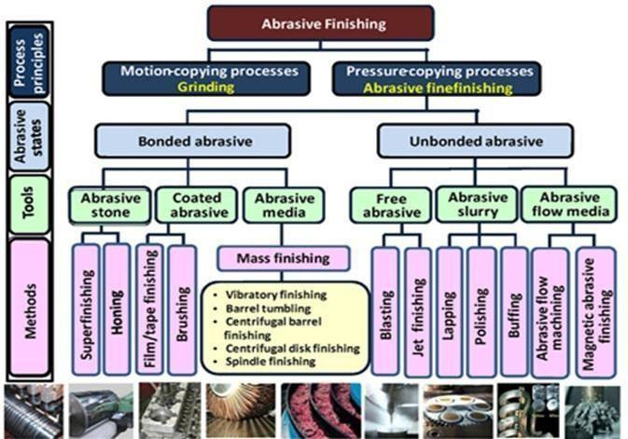
A high-quality surface with a low value of surface roughness and high dimensional accuracy is required for products in different applications such as aerospace equipment, medical instruments, semiconductors, automobiles, tools and dies, among others. The modern manufacturing industries are dependent on advanced materials like alloys of hard materials, glass, ceramics, and composite materials, to produce components with a complex shape for these applications. Final finishing of these materials is difficult due to high hardness and toughness, as well as the shape complexity of the products. The final operation in manufacturing of components is the finishing process and it requires approximately 15% of the total manufacturing cost. One promising precision surface finishing technique is abrasive finishing. It is widely used to finish the complex shapes of hard materials while providing precise tolerances that can be required in advanced engineering applications. Magnetic fields have assisted in a wide spectrum of manufacturing processes such as finishing, cleaning, deburring, and burnishing of difficult to machine materials. They have been used in a number of machining and abrasive finishing techniques to control the effective parameters of these processes, such as finishing force and applied voltage. Magnetic Abrasive Flow Machining (MAFM), Magnetic Float Polishing (MFP), Magnetorheological Abrasive Flow Finishing (MRAFF), and Magnetic Abrasive Finishing (MAF) are some examples of these abrasive machining processes. Additionally, abrasive finishing utilizing magnetic fields have also been used to overcome the limitations of traditional finishing processes, in terms of accuracy, shape complexity, and cost. Traditional finishing processes cannot finish complex shaped workpieces, for example, cooling holes in turbine blades having diameters less than two millimeters. The cutting energy in traditional finishing methods, which use rigid tools, is mainly used to overcome the cohesion forces of the machined material. Also, mechanical properties of the finished part can be affected by surface cracks and internal stresses due to external forces applied by the high- strength rigid tools. Furthermore, the finished material’s properties can also be affected by microstructural changes due to excessive heat which is generated during performing of the finishing processes, especially when most of the cutting energy is transferred into heat and absorbed by the workpiece. These limitations become substantial factors during micromachining processes which are used to fabricate micro- components or to create micro-features on macro/micro-parts.
Classifications of Abrasive Finishing Processes (AFP)
OBJECTIVES:
This study aims to propose a novel magnetic abrasive finishing design using stationary equipment whereby the machining process is carried out by regulation of magnetic fields without using any mechanical moving parts. A rotating magnetic field, which is obtained by energizing the electromagnets sequentially via control of the duty cycle, and on-time interval, for each electromagnet, was used. Thus, regulating the magnetic field allows control of the magnetic force which, in this case, represents the cutting force. This enables automating of the performance of the finishing process. Further, it enhances the accuracy and controllability of the process, and it also improves the quality of the final product. From another perspective, it also minimizes the mechanical power consumption by elimination of any mechanical motion.
The designing process involved several steps including development of a simulation and mathematical model for the metal removal mechanism and magnetic and cutting force calculation of the MAF process. In addition to design and optimization of the electromagnetic actuator and fabrication of the experimental setup. Moreover, studying the effect of the process parameters (such as applied current, frequency of the rotating of the magnetic field, and magnetic abrasive particles), and characterizing of the finished surface with respect to the roughness profile and surface textures is done.
LITERATURE REVIEW:
Henry P. Coats[1] was the first to mention Magnetic Abrasive Finishing (MAF) in his patent in 1938 in the USA. The first attempt to explain the basic principles of MAF process was done by Shinmura T. .[2] where they confirmed experimentally in a model test that the Magnetic Abrasive Particles (MAPs) supply enough pressure to finish the work surface corresponding to the strength of the applied magnetic field. They described the internal finishing process of a stainless-steel tube by MAF. They also studied the effect of process parameters that could affect the final surface roughness and found that the strength controlling of magnetic force is dependent on the material, shape and size of the workpiece, permanent magnet. The experimental results showed that the surface roughness was improved up to 0.1µm Rmax and he is the first to use the electromagnet with Alternating Current (AC) in the MAF process. They applied a rotating magnetic field which was obtained by activating three coils arranged in a circular alignment at intervals of 120̊ with a three-phase AC current. Experiments were conducted for an internal finishing of cylindrical work pieces. It was concluded that as compared with application of a static magnetic field, stock removal was increased by using a rotating magnetic field, but surface finish was reduced and he also proposed a new finishing process by applying a rotating magnetic field with six coils installed on a circular yoke. A new ultra-precision magnetic abrasive finishing process using an alternating magnetic field was described by Yanhua Zou[4]. They investigated the effect of finishing parameters such as rotational speed of magnetic pole, and alternating current frequency, on the metal removal rate and final surface finishing. Furthermore, they studied the effect of cutting fluid and proved that neat cutting oil is more suitable for this processing than water-soluble cutting fluid and silicone fluid.
Early research of using the electromagnet with DC in the MAF process was proposed by Kurobe, T. When DC voltage was supplied, a magnetic field was produced and induced polishing pressure to perform the finishing operation. Another investigation was done by Jain V. K. et al. to study the effect of working gap and circumferential speed on the performance of in the MAF process. For complex internal geometries Jha S. and Jain V.K.[5] applied a new precision finishing technique using a magnetorheological polishing fluid (MR) containing carbonyl iron powder and silicon carbide abrasives with mineral oil.
Yamaguchi H.[3] proposed an internal MAF process using a rotating magnetic pole with a new technique of magnetic field assisted finishing and also used for internal capillary tubes. The relationship between the magnetic field, force on the abrasive, and the abrasive behavior were explained in this study. A mechanism of a planar magnetic abrasive polishing process for a nonmagnetic material, stainless steel was done by Mori T[8]. They examined the formation of a Magnetic Abrasive Flexible Brush (MAFB), and how the normal force pushes the abrasives on the brush end to indent into the material surface of the workpiece. The MAF process was proposed by Wang and Hu to produce high quality finished inner surfaces of tubes. This study concluded that the Material Removal Rate (MRR) increased with the increasing of the rotational speed of the magnetic pole. Lin C.T.[9] used a permanent magnetic finishing mechanism installed in a CNC machining center to conduct free-form surface abrasion of stainless steel. The operations were performed using the Taguchi experimental design to study the effecting factors inclusive of the working gap, feed rate, and MAPs. The study showed that the working gap has the largest impact on the finishing quality. To prove that MAF can be used for non- ferrous materials, Kwak J.S.[6] proposed a method to improve the magnetic flux density in magnetic abrasive polishing process for a magnesium specimen. Early research of using the electromagnet with DC in the MAF process was proposed by Kurobe,T.[7] When DC voltage was supplied, a magnetic field was produced and induced polishing pressure to perform the finishing operation. Another investigation was done by Jain V. K. to study the effect of working gap and circumferential speed on the performance of in the MAF process. For complex internal geometries Jha S. and Jain V.K. applied a new precision finishing technique using a magnetorheological polishing fluid (MR) containing carbonyl iron powder and silicon carbide abrasives with mineral oil.
ABOUT SYSTEM:
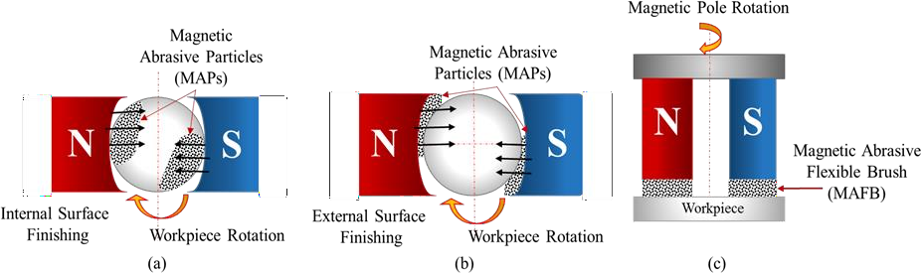
Electro Magnetic Abrasive Finishing (EMAF) is a specialized machining process used to achieve high-quality surface finishes on metallic workpieces. EMAF uses a combination of abrasive particles and an electromagnetic field to remove material from the workpiece surface, resulting in a smoother and more uniform finish.
Figure 1. 7: Examples of existing MAF methods, (a): Fixed magnetic source with rotated work piece internal Surface Finishing. (b): Fixed magnetic source with rotated work piece external Surface Finishing. (c): Rotated magnetic source with fixed work piece.

PROPOSED SYSTEM:
The proposed setup is a stationary system that depends on using a rotating magnetic field to move MAPs on the workpiece surface and control the finishing process. In addition to a flat surface, this setup is examined to ensure it is applicable to finish a component with a complex shape such as: femoral components of knee prosthetics, grooves of ring seals, and surface and initial edges of cutting tools. This system does not require any mechanical moving parts to perform the finishing process. It depends on use of a rotating magnetic field which can be obtained by energizing the electromagnets sequentially via controlling their duty cycle and on-time interval. In most of the previous work in the literature, the electromagnets are activated by using a direct current (DC) power supply. However, using DC power supply causes two essential problems: coil heating, which may damage the electromagnet, and exhaustion of the abrasive particles’ cutting edges due to continuous use of the same particles. Thus, using the proposed technique for energizing the electromagnets can solve these problems and overcome the drawbacks. The main features of the proposed system includes wide range of surface roughness, Cutting force control, Cost saving, Size and mobility.
SYSTEM DESIGN:
The EMAF machine consists of a workpiece holder, an abrasive suspension tank, and an electromagnetic field generator. The workpiece is placed in the holder, which is then submerged in the abrasive suspension. The generator produces a strong magnetic field, which causes the abrasive particles to move across the workpiece surface in a controlled manner, removing material and creating the desired surface finish. The abrasive particles used in EMAF can be either loose or bonded to a carrier material, depending on the specific application. The magnetic field can be adjusted to vary the intensity of the abrasion, allowing for precise control over the surface finish achieved.
EMAF is used in a variety of industries, including aerospace, automotive, and medical device manufacturing, where high-quality surface finishes are critical to product performance and longevity. It is particularly effective for finishing complex or irregularly shaped parts, such as turbine blades or medical implants, where traditional machining techniques may be limited. The below figure shows the experimental setup of the system.
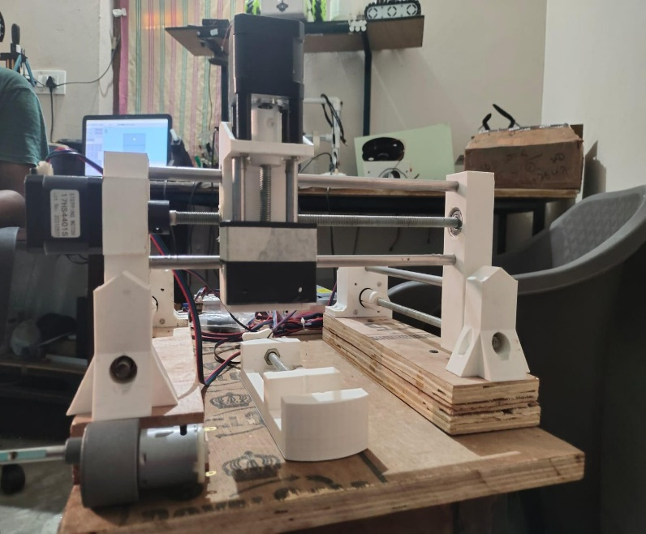
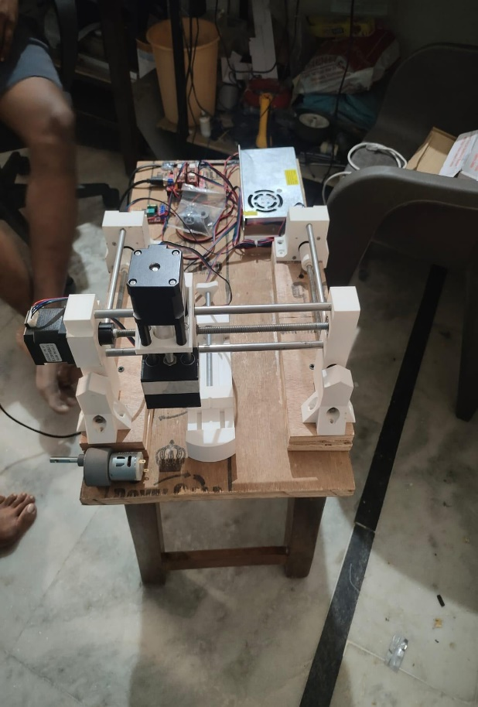
a b

Fig: Four-coil configuration, (a) Coils hang under the workpiece and MAPs,
(b) Coils are located above the workpiece
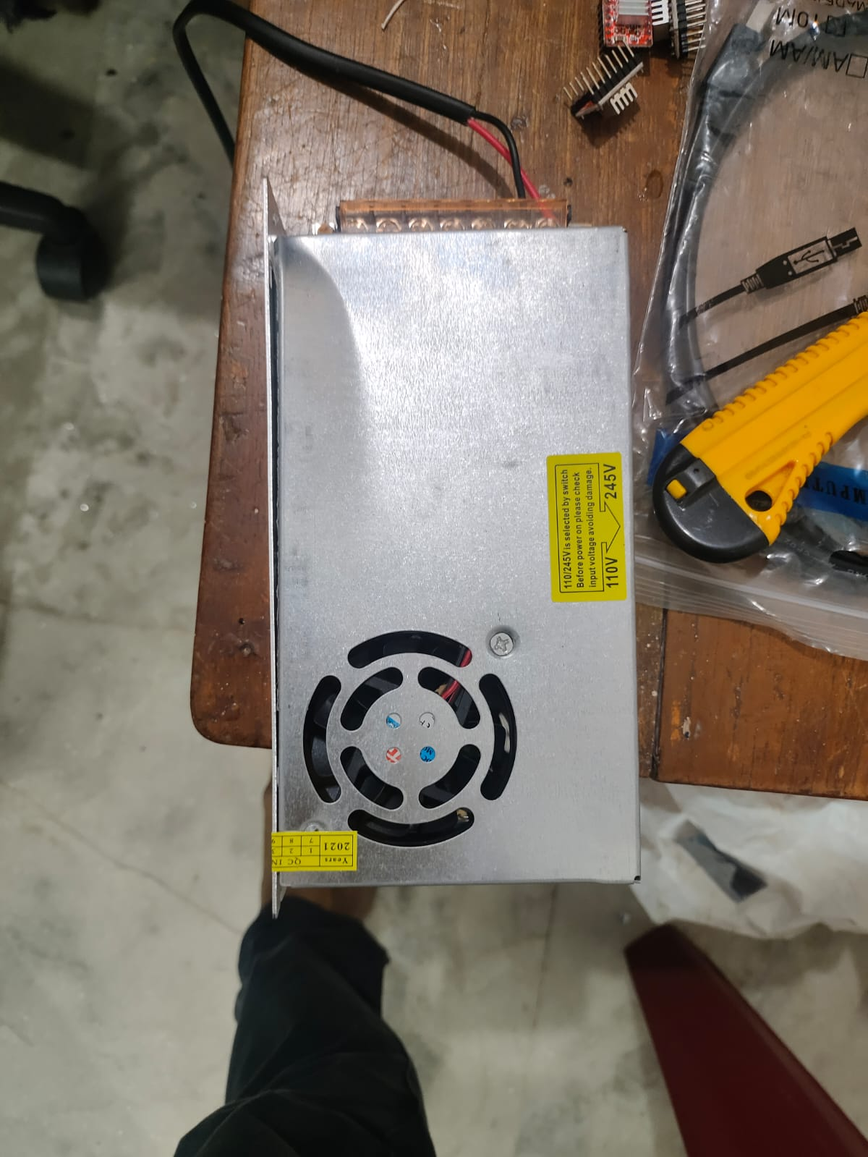
HARDWARE DESIGN:
This includes a switched motor power supply, Stepper motor.
Power supply
Fig: SMPS
A switched-mode power supply (switching-mode power supply, switch-mode power supply, switched power supply, SMPS, or switcher) is an electronic power supply that incorporates a switching regulator to convert electrical power efficiently.
Like other power supplies, an SMPS transfers power from a DC or AC source (often mains power, see AC adapter) to DC loads, such as a personal computer, while converting voltage and current characteristics. Unlike a linear power supply, the pass transistor of a switching-mode supply continually switches between low-dissipation, full-on and full-off states, and spends very little time in the high dissipation transitions, which minimizes wasted energy. A hypothetical ideal switched-mode power supply dissipates no power. Voltage regulation is achieved by varying the ratio of on-to-off time (also known as duty cycles). In contrast, a linear power supply regulates the output voltage by continually dissipating power in the pass transistor. The switched-mode power supply's higher electrical efficiency is an important advantage.
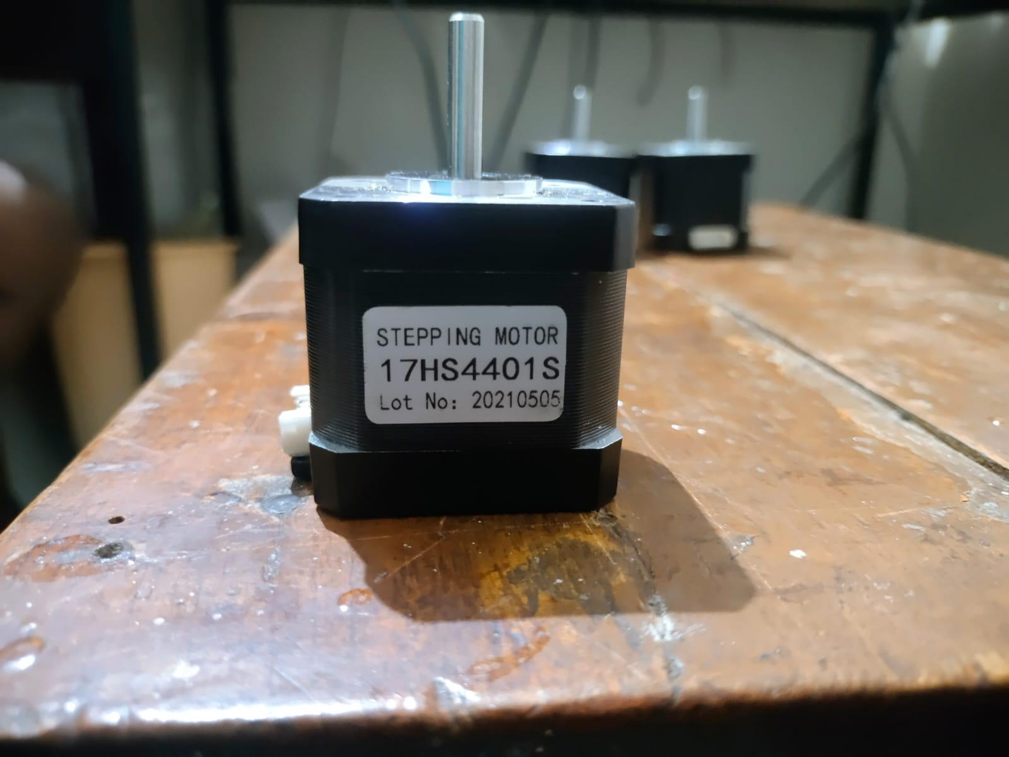
Stepper motor
Fig: stepper motor
A stepper motor is a brushless DC electric motor that divides a full rotation into a number of equal steps. The motor's position can be commanded to move and hold at one of these steps without any position sensor for feedback (an open-loop controller), as long as the motor is correctly sized to the application in respect to torque and speed. Switched reluctance motors are very large stepping motors with a reduced pole count, and generally are closed-loop commutated.

Brushed DC motors rotate continuously when DC voltage is applied to their terminals. The stepper motor is known for its property of converting a train of input pulses (typically square waves) into a precisely defined increment in the shaft’s rotational position. Each pulse rotates the shaft through a fixed angle. Stepper motors effectively have multiple "toothed" electromagnets arranged as a stator around a central rotor, a gear-shaped piece of iron.

3D Printer

A 3D printer is a type of additive manufacturing technology that uses computer-aided design (CAD) software to create three-dimensional objects by adding material layer by layer. The printer reads a digital 3D model and then creates the object by extruding or laying down material in successive layers until the final object is formed.

There are many different types of 3D printers, including Fused Deposition Modeling (FDM), Stereolithography (SLA), and Selective Laser Sintering (SLS). Each type of printer uses different materials and processes to create objects with varying levels of complexity, detail, and strength. 3D printing has a wide range of applications across various industries, including product design and development, architecture, engineering, medicine, and education. It allows for faster prototyping, customization, and the creation of complex shapes and structures that would be difficult or impossible to produce using traditional manufacturing methods.

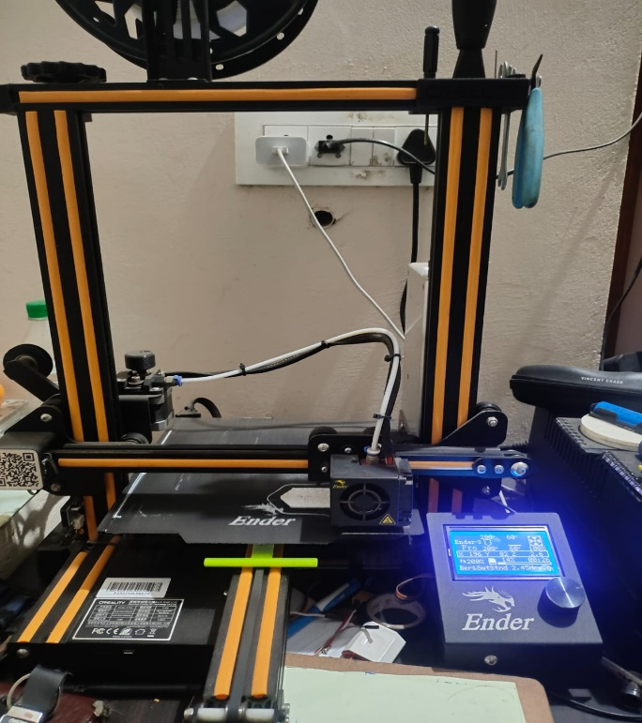
While 3D printing technology has come a long way in recent years, it still has some limitations, such as the time it takes to print large objects, the quality of the finished product, and the cost of materials. However, ongoing research and development in the field are expected to address these limitations and make 3D printing an even more valuable technology in the future.

Fig: 3D Printer

SOFTWARE DESIGN:

This involves designing of the hardware equipment for holding the motor, the workpiece and coils. For that designing process we use Tinkercad and an app is used to control the machine with g code.

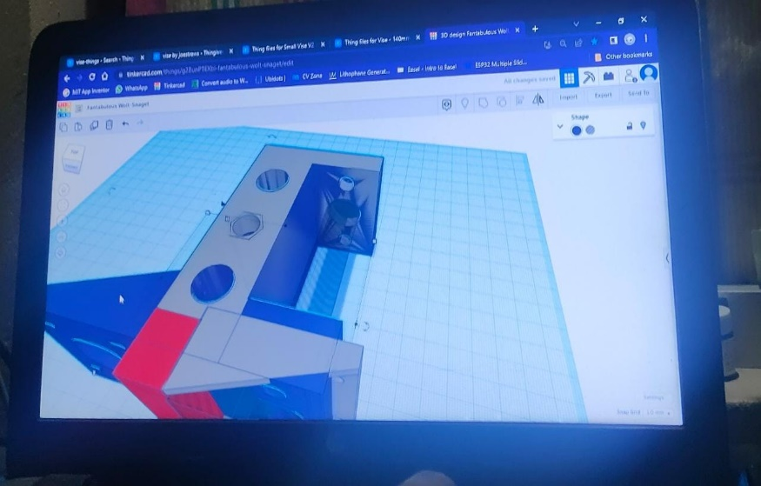
Tinker CAD

Fig: Designing the 3D model of hardware in tinkercad

Tinkercad is a popular web-based 3D design and modeling software used by beginners and professionals alike for various purposes. Some of the uses of Tinkercad are:

Education: Tinkercad is widely used in classrooms and educational institutions to teach students about 3D modeling and design. It is easy to learn, free to use, and provides a simple interface for creating 3D models.

Rapid Prototyping: Tinkercad is often used for rapid prototyping of designs, where quick and simple 3D models are needed to test and validate ideas. Its user-friendly interface allows users to quickly create 3D models and iterate on them, reducing the time and cost required for prototyping.

3D Printing: Tinkercad is compatible with various 3D printing software and services, making it a popular choice for creating 3D models for printing. Users can export their designs in various file formats compatible with different 3D printers.

Product Design: Tinkercad can be used by product designers to create 3D models of products and parts for various industries such as automotive, aerospace, and medical device manufacturing. It provides an easy-to-use interface for designing complex 3D models, making it a popular choice for product designers.

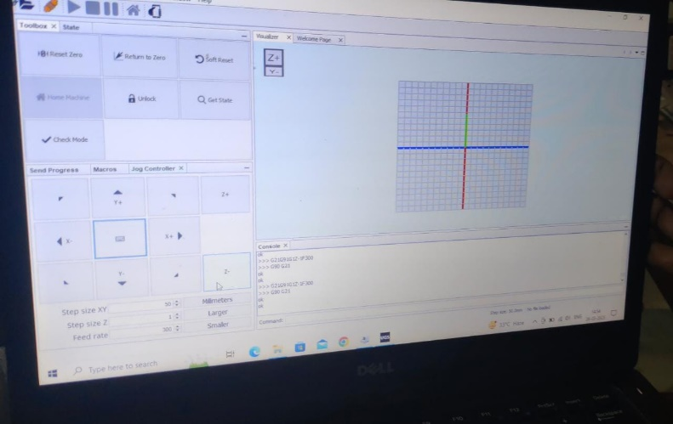
UGS Platform

Fig: An app to control the Machine with g code

UGS Platform is the next generation of Universal Gcode Sender. It is built on top of the Net beans Platform which allows us to leverage its mature modular framework. This platform allows more features to be added without compromising on code quality, or being bogged down by a home grown framework. The Classic GUI is used as a library, so core features benefit both interfaces.

Platform Benefits

This is the current target for new UGS features.

Out of the box dynamic windowing system allows arranging the UI dynamically.

Plugin Framework available for decoupling features.

Huge library of modules to leverage: Code Editors, Auto-updates, Keybindings

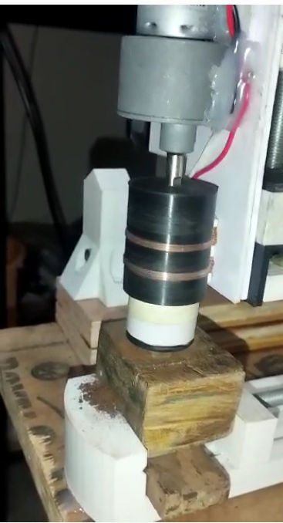
RESULT:

Fig: Abrasive finishing

CONCLUSION:

The project of designing and building an electromagnetic abrasive finishing machine requires careful consideration of various factors, such as the selection of suitable materials, design of the electromagnetic coil system, choice of abrasive particles, and optimization of the operating parameters. The machine's performance can be enhanced through proper calibration and fine-tuning of the operating parameters.

The experimental results of the EMAF machine showed that the surface finish of the workpiece improved significantly as the processing time increased. The analysis of the surface roughness and material removal rate showed that the EMAF machine is an effective method for achieving a high-quality surface finish in a shorter time. In conclusion, the EMAF machine is a highly effective method for precision surface finishing of metallic and non-metallic materials. The machine provides an excellent surface finish, high material removal rate, and reduced processing time. With further research and development, the EMAF machine has the potential to become an essential tool in various industries that require high-quality surface finishing.

REFERENCES:

[1] A Review on magnetic abrasive machining Henry P. Coats

http://revtn.ro/_legacy/pdf2-2017/2%20Slatineanu_ReviewMagnAbrasMachining_22Aug2917.pdf

[2] Shinmura T, Takazawa K, Hatano E, Matsunaga M, Matsuo T. Study on magnetic abrasive finishing. CIRP Ann 1990;39(1):325–328. https://doi.org/10.1016/s0007-8506(07)61064-6, Google ScholarCrossref

[3] Yamaguchi H, Shinmura T. Study of an internal magnetic abrasive finishing using a pole rotation system: Discussion of the characteristic abrasive behavior. Precis Eng 2000;24:237–244. https://doi.org/10.1016/s0141-6359(00)00037-4, Google ScholarCrossref

[4] Study on an Ultra-Precision Plane Magnetic Abrasive Finishing Process by Use of Alternating Magnetic Field by Yanhua Zou.

[5] Effect of working gap and circumferential speed on the performance of magnetic abrasive finishing process by Vijay Kumar Jain.

[6] Kwak J.S., (2009), Enhanced Magnetic Abrasive Polishing of Non-Ferrous Metals Utilizing A Permanent Magnet, International Journal of Machine Tools & Manufacture.

[7] Kurobe T., (1983), "Magnetic Field Assisted Fine Finishing, Bulletin Japan Society for Precision Engineering.

[8]Mori T., Hirota K., and Kawashima Y.,(2003), Clarification of Magnetic Abrasive Finishing Mechanism, Journal of Materials Processing Technology

[9] Lin C.T., Yang L.D., and Chow H.M.,(2007), Study of Magnetic Abrasive Finishing In Free- Form Surface Operations Using The Taguchi Method, International Journal of Advance Manufacturing Technology.

