TOUR AND TRAVEL MAMAGEMENT SYSTEM
By
Nidhi Thakare

ABSTRACT

Tour and Travel is very important part of our daily life. The purpose is to design a system using which one can perform all operations related to traveling. Tour and Travel is fast developing industry worldwide and very famous now day. It is use to booking a travel package and managing all travel information. The project is designed in HTML, CSS, JAVASCRIPT and REACTJS. The Tour and Travel system is a web based application and maintains a detail of all related information of tours. Users can decide about places they want to visit and bookings online for travel. Tour and Travel website is handling by admin. Users can decide about destination they want to visit and make bookings online for travel. With the help of single website we can book our ticket and travel all around the world. Tour and travel is very important for booking holiday trip, family trip, work etc. Tour and Travel website contain all the information of tour and travels agency. User can plan a trip and have it executed properly.

INTRODUCTION

Tour and Travel management system is use to book a travel package and all the information related to journey. Tour and Travel management system provide offer tour and travel services including ticket bookings, rental car services, holiday tour packages, other tour packages, etc. with the help of Tour and Travel we can easily travel all over the world. It is very helpful for travelling. This has been tried to achieve thought making the whole system computerized of all storage network. Tour and Travel contain additional feature like making new user to use this software better, user interaction etc. All the information related to tour and travel is store in one place user can easily access the all information from the Tour and Travel Website. Tour and Travel website provide the feature of booking travel package. In the system a customer has to see various agencies to find details of places and to book tickets. Tour and Travel is very easy to use and user-friendly. Tour and Travels arranges holidays for customers. It offer tour and travel services including ticket bookings, rental car services, holiday tour packages, domestic tour packages. Bookings are made online directly by customers. With the help of Tour and Travel management system you can explore the world. The main goel of the system is to learn about Tour and Travel managemet system success story.

LITERATURE REVIEW

A large body of literature on Tour and Travel marketing, Brand promotion was referred to frame the conceptual background on the subject. Tour and Travel is a temporary movement of people to book, stay, in various destination.
Promotion and the employment of promotional instruments rather than marketing activities are an effective mean of competitive retribution according to joncos(1990). One of four up’s in the marketing mix portions aids in the achievements of marketing objectives(Rowley 1998).
Promotion is the dissemination of information by a company to various groups of people with the
goal of advertising, persuading, or encouraging them to acquire the company's
products/services by influencing their state of mind (Khan & Ghorpode, 2016).
To influence destination image ,tourist destinations use promotional tools and marketing communication methods (fridge, 1984; gartner, 1993; beerli, and martn, 2004) “ The destination image also puts up factors for unfavourable judgement ,”fair-weather discovered. The promotional picture is heavily weighted in favor of a series of positive experiences. Visitors ‘reactions might be harsh when they see setting or experience that fall well short of their expectations.”
Promotion is the dissemination of information by a company to various groups of people with the goal of advertising, persuading, or encouraging them to acquire the company‘s products /services by influencing their state of mind (khan & ghorpode, 2016).
Promotional technique such as print, television and radio advertisements, among others, have a different impact on the tour and travel industry. People carefully examine and evaluate the messages presented in commercials before deciding on the most ideal tourist destination as advertised (Ketabchi and mohammad, 2004).
Slogans are the growing trend in advertising. Slogans are gaining more traction in people’s minds.

METHODS

Frontend Development
In Tour and Travel project frontend is developed using HTML, CSS, JAVASCRIPT, REACT language. It is a website for booking Tour and Travel agency worldwide. The designing is done in HTML, CSS, REACT. We want to make our website user-friendly and easy to use. In this project we have made two domains one is Admin another one is for User. User can book package online. The major feature of project is booking tours.
Backend Development
In Tour and Travel project backend is developed using PHP language. This website is mostly using for Tour and Travel booking system. The database is done using MYSQL. The main advantage of the system is proving security. Tour and travel is very famous in this time. All the information stored in database. The system is secure and easy to use. The table is made is mysql.

FLOWCHART
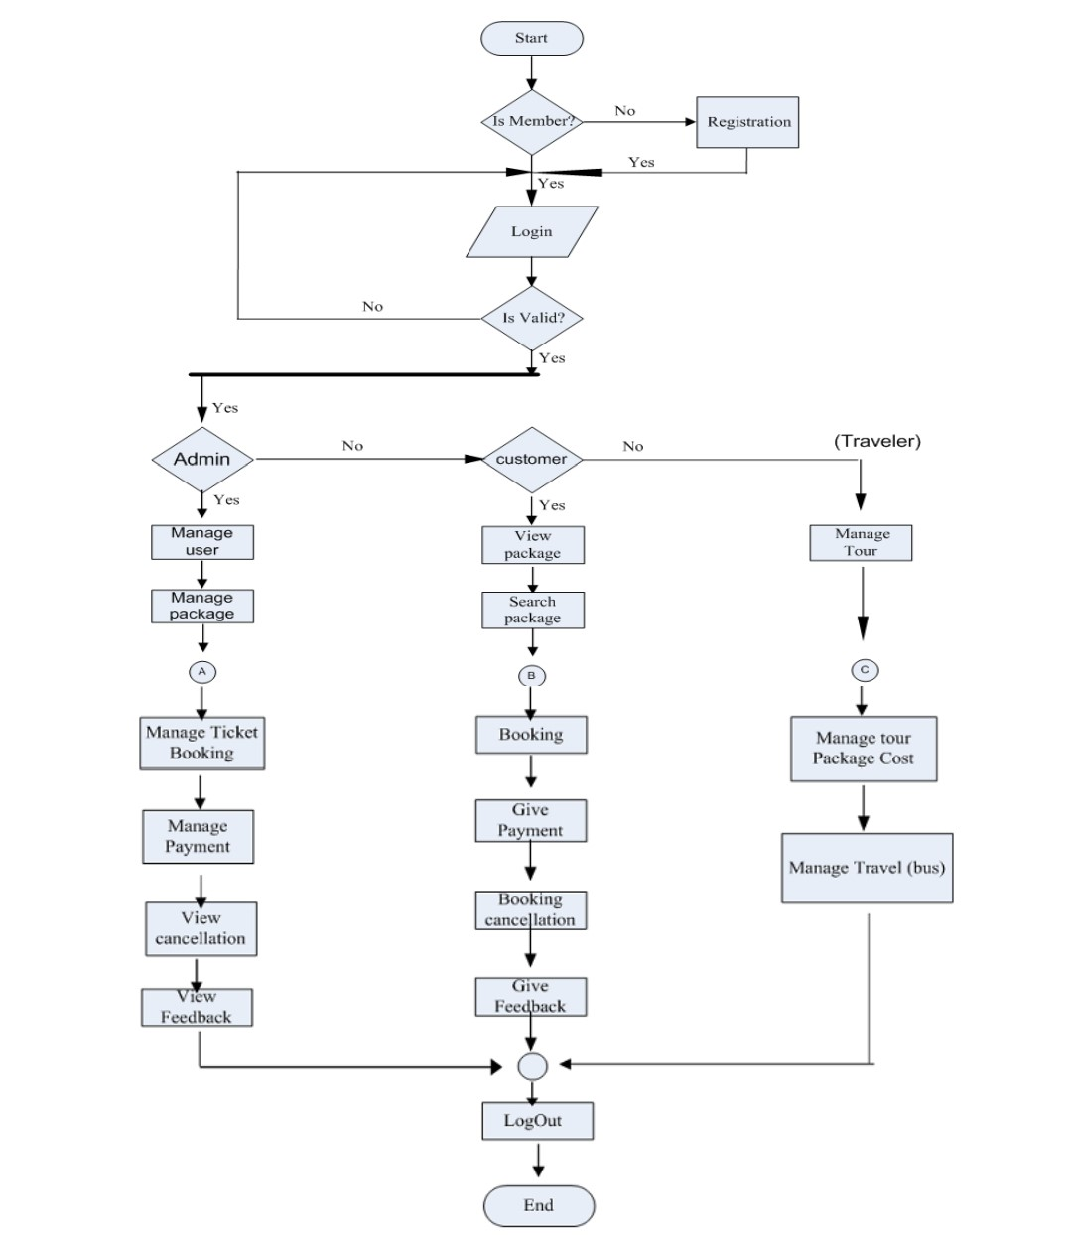

CONCLUSION
Tour and travel project focuses on implanting platform for user on booking a tour. It is helpful for choosing a tour and booking for travel. We provide security to enhance the performance of the tour and travel management system. With the help of traveling we can meet a new people and discover new things. It involves the management of multitude of activities such as studying tope destination planning the tour destination, planning the tour , making travel arrangements and providing accommodation.

REFERENCE

1. https://www.studocu.com/in/document/the-maharaja-sayajirao-university-of-baroda/computer-networks-ii/literature-review-of-tourism/24473536

2. https://www.slideshare.net

3. I. Sommerville, Software Engineering, Addison-Wesley (2001).

4. Abdullah, M.,S., Evans, A., Benest,,I. Paige, R., Kimble C. , 2004, “Modelling Knowledge Based Systems Using the executable Modelling Framework(XMF)”, Proceedings of the IEEE, Conference on Cybernetics and Intelligent Systems, Singapore(2004).

5. Booch, G., "Object-Oriented Analysis and Design with Applications", second Edition. Addison-Wesley (1994).

6. Schreiber, A. Th., Akkermans, J., Anjewierden, A., De Hoog, R., Shadbolt, N. Van De Velde W., Wielinga, B. ,“KnowledgeEngineering and Management: The Common KADS Methodology”, MIT Press,(2000).

