AI-BASED SELF-PROCTORING QUIZ MANAGEMENT SYSTEM
Rajat Choudhary¹, Rishika Agarwal²
Choudharyrajat037@gmail.com¹, Rishika.agarwal.cs.2019@miet.ac.in²
¹Department of Computer Science & Engineering, Meerut Institute of Engineering & Technology, Meerut
²Department of Computer Science & Engineering, Meerut Institute of Engineering & Technology, Meerut

---------------------------------------------------------------------***---------------------------------------------------------------------
Abstract: This article presents a system for monitoring and detecting fraudulent behavior during online tests to maintain academic integrity. It analyzes multimedia data in real-time to identify suspicious actions by test takers. The captured audio-visual data must be suitable for fraud detection. The shift towards online education has increased due to the COVID-19 pandemic, leading to a higher demand for online proctoring services, including AI-powered systems. However, concerns exist regarding the privacy of sensitive information collected by these systems.The article explores AI-based and non-AI-based supervision systems, discussing their advantages and limitations. Universities and IT institutions worldwide offer online courses, exams, and tools, providing flexibility and cost savings. The article introduces a new approach to test proctoring using webcams, highlighting the importance of exam security and reducing test taker stress. By comparing webcam-based monitoring with traditional methods, the article examines the effectiveness and potential benefits of this alternative approach. Ensuring the security and credibility of online exams remains a significant concern, and the article discusses the operation and implications of webcam-based proctoring in addressing these challenges.
Keywords: AIPS, Exam, Online supervision, Online Education, Artificial Intelligence, Online Proctoring System

1. INTRODUCTION
The growth of online education has been rapid in recent years. More students are taking advantage of the Massive Open Online Courses (MOOCS) and other online certification courses. The university is also moving online to provide students with more than resources. The number of people distributing courses has also increased. All of this provides students with opportunities to learn and improve.(Li et al., 2015). Last year, nearly all educational institutions were forced to switch to online education during the pandemic (Moreno-Guerrero et al., 2020). Universities have started offering online courses and tests for courses in all disciplines. The COVID-19 pandemic has also impacted the recruitment process, which filters students through the entrance and written tests. We recognize that it is our duty to uphold the academic discipline and integrity of the exam. This sudden shift to online learning has different impacts on students at each level. You cannot expect the same level of seriousness and focus for graduate students and high school students. Each of our students will have a unique ability to learn, understand and retain information. Under these circumstances, negligence in academic performance, such as plagiarism or cheating during exams, will increase. We believe in the implementation of the Artificial Intelligence Proctoring System (AIPS) is urgent. We also believe that the use of these systems to continuously monitor digital exams, from MOOCs to employment exams, will soon become the norm. The quality of the online certificate is directly related to the quality of the testing process that goes through to obtain the certificate. In the same way that the exam is administered in schools and colleges, they should be administered online. AIPS should test all students as they have more ways and opportunities for students to cheat when taking online exams. The exact teacher-to-student ratio used to control for health screenings is not practical in this scenario.
This software helps human supervisors track student activity. This will move the student to the foreground of the human supervisor's screen whenever it is suspected, and any suspicious activity will be flagged for future viewing. It also provides an extra layer for monitoring systems. This will reduce the number of false positives and reduce the manpower required to monitor the test. System selection will depend on university preferences and the majority of student resources. If a student is taking the exam in a location with poor network connectivity or no electricity, the human proctor system may not work as any problems with the student's live stream can delay the exam. Browser-based digital security systems work better. You can administer tests while monitoring students while the computer is running.
What is Remote Online Proctoring?
1) The process used to supervise or observe candidates during online exams. In this process, candidates are supervised remotely by supervisors in different remote locations with the help of technology.
2) This process is used to prevent fraud or abuse of any kind by candidates during the online exam.
3) Remote proctoring is the only mechanism available to stop fraud or abuse of any kind during the online exam, It is designed with the best technology and therefore helps you to take your online exam without cheating.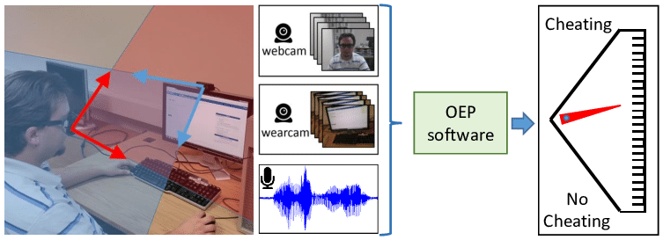
Fig -1: Student using OPS
Online Proctoring System (OPS): An Overview Online proctoring in education is not a new area of ​​study. Even before the pandemic, many universities/institutions were using supervision systems for online courses. Competitive and adaptive exams such as the GRE, GMAT, and CAT are purely proctor-based exams. Online proctors use virtual tools to monitor activity (e.g. 6424 Education and Information Technologies (2021) 26:6421–6445 1 3 tab changes, timestamps, background noise, etc.) to assess students coming to the test. These tests are typically administered online and at remote locations, allowing any student, anywhere to take the test to ensure integrity (Caveon et al., 2013). The Online Proctoring System focuses on two main components. A webcam that records a video of the student appearing in exam for later viewing by the examiner/proctor. Examiners/proctors can potentially see all pranks and cheating, whether or not they occur during the test. The second component is a lock that prevents students from opening other tabs in their web browser. This is also known as a computer or browser lock (Alessio et al., 2017). According to (Hussein et al., 2020), the online proctoring system has the following functions, summarized in the table below (Table 1):
(Hussein et al., 2020) distinguish three types of proctoring systems. Figure 1 shows the types of online proctoring systems.
Table 1: Online Proctoring System features
Features | Description | New Technologies
Authentication | The process of authentication involves verifying the identity of both the candidate and the proctors who are part of the proctoring software. | The proctoring system uses various authentication methods such as two-factor authentication, one-time password, and facial recognition to verify the identity of the user.
Browsing tolerance | The proctoring system software imposes limitations on the usage of other resources, such as other tabs of browsers or other face detection tools during live proctoring. | It is accomplished through various methods such as logging and analysis, facial detection, and object detection.
Remote authorizing  and control | It grants the proctor the power to remotely manage the proctoring system, such as initiating, pausing, or stopping the examination of a specific student. | It is accomplished by granting administrative privileges and employing security models with multiple levels.
Report generation | This involves generating a report and activity log of the student's actions during the examination. | This is achieved using various technologies such as JS, Python, ASP.net, or other programming languages that are open source.

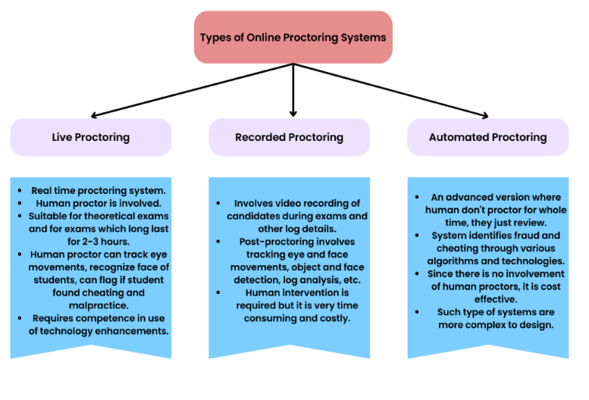
Fig -2: Types of Online Proctoring Systems
2. LITERATURE REVIEW
This systematic literature review aimed to evaluate the current state of research on online exams and their equivalents. Many scholars have found online learning environments to be more conducive to their well-being, personal lives, and academic performance. Faculty members preferred online exams for workload management and ease of administration, and an initial evaluation of paper-based exam logistics indicated some significant ongoing cost savings. While not all faculty members and students preferred online testing environments, studies that examined age and gender found only minimal differences. (Reference: Rios & Liu, 2017)
While the literature on online examinations is growing, there's still a dearth of discussion at the pedagogical and governance situations. Our review of the documents and our new familiarity have led us to point out two main directions for experimenters Authentication and Authenticity. We know that there are numerous avenues to consider regarding the thickness of operation cessions, the validity and trustability of online testing and whether online testing is a better measure and enables better pupil success. It's also possible to synthesize other innovative digital tutoring bias and online test literature. For illustration, Immersive literacy surroundings( Herrington etal., 2007), Mobile Technology( Jahnke & Liebscher, 2020); Social Networks( Yannikas, 2020) and the Internet2.0 technologies( Bennett etal., 2012). The literature examined acknowledges crucial rudiments of the underpinning need for online examinations from scholars, academic, and specialized perspectives. This has included the need for online examinations need to be accessible, need to be suitable to distinguish a true pass from a true fail, secure, minimize openings for cheating, directly authenticates the pupil, reduce marking time, and designed to be nimble in software or technological failure.
We turn attention now to areas of need in unborn exploration, concentrate on delegation and authenticity over these alternates given there's a real need for further exploration previous to the conflation of knowledge on the ultimate pathways. Trust in online classrooms has been blamed because of the distance between scholars and preceptors, which can contribute to breaches of integrity( Moten, Fitterer, Brazier, Leonard, & Brown, 2013). Experimenters argue that online programs must ensure student integrity. Using proctoring software is one way to assure fair and effective exam assessments. Moten and associates explained that in online courses, scholars work fairly autonomously and anonymously, and proctors may not know who's taking the test.
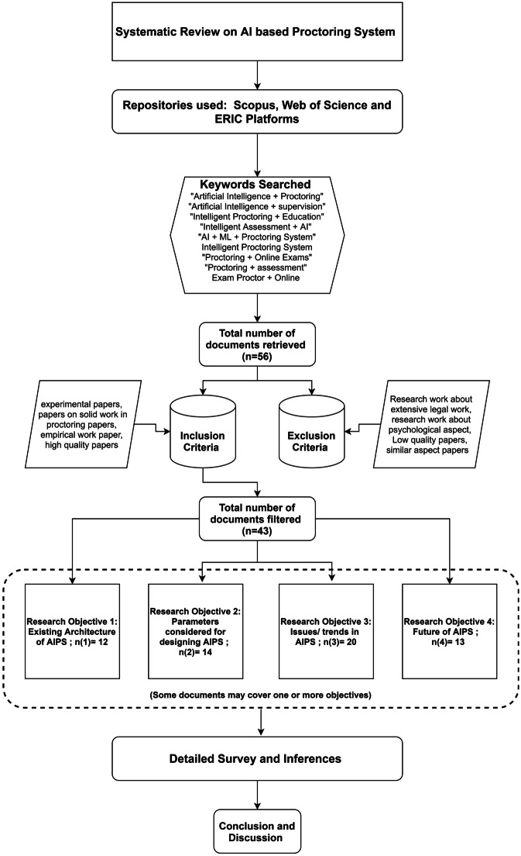
Fig -3: Criteria of Search, Inclusion/Exclusion of the systematic work
Artificial Intelligence-based Proctoring System: Current Scenario
The current design of AIPS, such as ProctorU and Kryterion, involves live proctoring through the use of webcams and microphones to monitor students during online exams. Prior to starting the examination, proctors check for any unauthorized material and verify the student's identity by requesting identification. Continuous audio-visual communication is maintained between the supervisor and student throughout the session (Milone et al., 2017; Pratish et al., 2016). However, the ProctorU AI module is not highly secure and may be vulnerable to spoofing. Therefore, a hybrid approach is recommended, which combines automated supervision with expert proctors who can intervene if needed (Slusky, 2020). Other examples of supervisory systems include Xprocor, which uses facial recognition, streaming video behavior, audio, and picture methods to authenticate students and continuously monitor them, and the Tesla project, which utilizes biometrics such as face recognition, voice recognition, keystroke analysis, and fingerprint analysis to prevent impersonation and ensure the authenticity of test responses (Slusky, 2020).
Issues
One of the key considerations to keep in mind when developing software is problems that may arise at any stage of execution. In the case of supervisory software, you must first consider two factors that can cause users to experience problems: technology and human response. A key security element easily abused is user privacy (Beust et al., 2018). Because user must be authenticated before allowing students to take the test; You must confirm your personal information with your supervisor.This can be done by scanning user IDs such as university IDs, Aadhar cards, etc. (Butler-Henderson & Crawford, 2020; Caveon et al., 2013; Slusky, 2020). These documents are often linked to sensitive user data and can be easily misused. linked mobile numbers can also lead to phishing calls and serious crimes such as extortion, harassment and more.Inspector may engage in immoral conduct with available information (Coghlan et al., 2020). Therefore, special care must be taken to ensure that any supervision software is reliable, secure, and respects the privacy of subjects. Impersonation by candidates is another security issue to avoid (Hylton et al., 2016).Since Proctoring software gives you the freedom to do all your exams at home, users can abuse this feature by forcing others to take the exam using their credentials (Ghizlane et al., 2019 ). Therefore, user authentication is required before anyone can start the exam. Supervisory software uses a number of security measures to ensure fair evaluation. Some applications involve controlling a candidate's device.This also includes access to the webcam, microphone and desktop/laptop/mobile screen sharing.
Future/Scope
Educational institutions and commercial associations across the world had gradually begun the process of using online proctoring software over the old decade to conduct remote examinations in a fair manner and making sure that the students gave the test in a given atmosphere. Due to the COVID-19 Epidemic, it has come the need of the hour to use remote proctoring platforms to conduct flawless tests while also making sure that the students don't indulge in malpractices during these online examinations.( Remote Proctoring, 2020). There are multiple benefits to any institution when they conduct any assessment via remote proctoring rather of the traditional pen- and- paper based system. The scheduling of examinations becomes easier as there is no need to set up a special test center for the exam.. Communication between the examiner and testee has come more streamlined, smoother and quick. Findings can be generated more snappily, in some cases nearly immediately. Online testing also allows institutions to run tests at scale without having to worry about running out of test centers.( Arora, 2021). Still, must make a sincere trouble to develop proctoring practices so that the quality of the online test is original to the offline test in all aspects; be it integrity of a given grade, making sure that students aren't involved in using unfair means, and more. The social perception of the public about online exams must also change, and the benefits resulting from it must also be recognized. The challenges of developing an Artificial Intelligence-based proctoring system discussed above must be addressed using existing technology offerings. A conscious effort must be made to allow existing technologies to mitigate existing problems. (Pimp, 2021). Any proctoring software must accurately identify all the candidates performing the test. Impersonating someone else poses a serious threat to the integrity of online exams, so various methods are used to verify that a designated person is the one administering the exam. The supervisory software asks each candidate to provide some personal information or identification, which is then checked before allowing the candidate to continue. phone or laptop.
PROPOSED SYSTEM
Proctoring software or web app comprises two main components. Firstly, it activates the computer's camera and records the student taking the exam, allowing faculty to monitor their behavior and detect cheating activities, such as talking to others or using books to look up information. The automatic proctoring software doesn’t need faculty to proctor the exam, An Artificial Intelligence model library WebGazer.JS (A JavaScript-based eye tracking library) can be used along with the Tensorflow.JS (An open-source library created to use and train machine learning models in the web browser.) can be used to automate the proctoring of exams and quizzes. Secondly, it can either restrict students' access to other computer tasks, such as copying and pasting, printing, or searching the internet, or it can record all activities on their computers, or both. This is known as "locking down" the computer or browser. Professors or teaching assistants can review exam recordings or alternatively,
Recommended Hardware Requirements:
RAM: 4 GB
Disk Storage: 4 GB of free disk space
CPU: 2.8 GHz or faster processor
Peripherals: Web Cam, Mic, Speaker
Recommended Software Requirements:
OS: Microsoft Windows 10 or Newer, MacOS 10.12 and newer
Application Software: Google Chrome (latest stable version), Firefox (latest stable version)
Drivers: Audio driver, Camera Driver

3. CONCLUSION AND DISCUSSIONS
The impact of video proctoring suggests a significant effect on test scores, indicating that non-proctored tests can lead to academic dishonesty. This is because students may use resources that are prohibited during the test. The use of video proctoring also affects the percentage of time taken to complete the test, with proctored tests taking less time than non-proctored tests. Although lockdown software without video monitoring is available, it does not have the same impact as video proctoring software. The use of video proctoring can negatively affect online test grades as it deters cheating. Therefore, it is important to ensure academic integrity by using similar test-taking conditions in similar courses when taking online tests.
Due to the challenges posed by the ongoing COVID-19 pandemic, online testing has seen a significant increase in demand after online learning. Online Proctoring Software (OPS) is not completely foolproof, but it is changing the way online testing from home is adopted. However, security concerns associated with OPS are increasing, especially since highly sensitive biometric data can be collected and stored for verification purposes. Therefore, personal data collected during OPS operations must be classified, identified, and labeled based on its sensitivity level to maintain confidentiality, integrity, and availability. Although there are drawbacks to remote proctoring technologies, the debate and disagreement surrounding their appropriateness are likely to continue. Despite these challenges, there are certain considerations that favor the use of such technologies. While AI proctoring is not ethically perfect, as it may also miss instances of cheating, it is crucial to maintain academic integrity to protect both students and institutions.

REFERENCES
- Anderson, H. M., Cain, J., & Bird, E. (2005). Online Student Course Evaluations: Review of Literature and a Pilot Study. The American Journal of Pharmaceutical Education, 69(1), 5. https://doi.org/10.5688/aj690105
- Ardid, M., Gómez-Tejedor, J. A., Meseguer-Dueñas, J., Riera, J., & Vidaurre, A. (2015). Online exams for blended assessment. Study of different application methodologies. Computers & Education, 81, 296–303. https://doi.org/10.1016/j.compedu.2014.10.010
- Li, X. (2007). Intelligent Agent-Supported Online Education. Decision Sciences Journal of Innovative Education, 5(2), 311–331. https://doi.org/10.1111/j.1540-4609.2007.00143.x
- Crowell, C. R., Quintanar, L. R., & Grant, K. J. (1981). PROCTOR: An on-line student evaluation and monitoring system for use with PSI format courses. Behavior Research Methods. https://doi.org/10.3758/bf03207920
- Wellman, G. S. (2005). Comparing Learning Style to Performance in On-Line Teaching: Impact of Proctored v. Un-Proctored Testing. Journal of Interactive Online Learning, 4(1), 20–39. http://www.ncolr.org/jiol/issues/pdf/4.1.2.pdf

