Noida.

FAKE PRODUCT IDENTIFICATION USING BLOCKCHAIN

Rakshit Tyagi1, Pragati Kumari2, Nisha Kumari3, Abhishek Rajput4 , Mr. Aditya Dayal Tyagi5
Students, Department of Computer Science and Engineering1,2,3,4,
Assistant Professor, Department of Computer Science and Engineering5
ITS Engineering College, Greater Noida, UP, India

U.G. Student, Department of Computer Science & Engineering College, Greater

ABSTRACT
The usage of blockchain for fraudulent product detection will assist the customer in determining whether the product is genuine or not and will help the retailer gain their trust. Over the past few years, there has been a sharp growth in the creation of counterfeit items, which has reduced revenue and profit and hurt the company's reputation. The buyer of a knockoff or identical product will also be unsatisfied and run the risk of losing their safety. The decentralized, distributed ledger maintained by blockchain technology is made up of unchangeable, extremely secure blocks connected by chains. With the aid of this technology, a customer can independently confirm the legitimacy of a product.
Keywords: Client, QR code, fake product, smart contracts, blockchain.
I. INTRODUCTION
In a system that is decentralized, like the blockchain, records can only be added and cannot be changed. Countering the issue of fake goods is made easier by blockchain technology. It is more trustworthy. It is known as fraudulent product detection via Bitcoin to store the product's information. After the product is put on the internet and assigned a hash number, it will be possible to maintain all of the transaction records. Since there won't be a third party engaged, no one will be able to get into the systems that hold data. A chain containing the details of the current owner will be created for such product transactions. All transaction histories will be stored as blocks in the blockchain. Each product in the proposed system receives a generated QR code, which the customer can scan to find out everything there is to know about that product. By scanning the QR code, we can determine whether a product is authentic or not. Slowly, several blockchain-based applications are being developed. Payment verification is the main focus of some programs, including those for virtual currency, stock trading, and . Some people focus on integrating the Internet of Things (IoT) and blockchain technology, for instance, by collecting data from IoT devices. Gaming, betting, online voting, car rentals, and more decentralized blockchain applications are available. Here, we'll emphasize an inventory management app that will allow consumers to scan quick response codes on goods to gather relevant data, such as the history of transactions and the present owner, so as to assess if the good is real or fake. The Blockchain 2

code-based QR Genuine Item Identification Solution is being developed by us. using Ethereum smart contracts to increase its dependability and security. With the help of Node JS, Ethereum, MySQL, and Contracts built. product starting at the point of production. Customers who scan QR codes are alerted as to whether the goods are genuine or fake. Some of the elements of the blockchain system are shown in Figure 1.
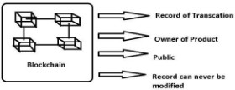

Fig. 1: Block diagram of the Blockchain system

II. RELATED WORK
[1Using Open CV and inventory management using QR codes, A Global Meeting on Computer Communication and IT (ICCCI-2021), Coimbatore, India, January 27–29, 2021 G. Vidhya for Krishna; Subbarao was Gogulamudi; Bodapati Nagaeswari; and Shaik Reehana.

this, QR codes are created using Python and blockchain technology. They then developed a website that will enable users to manage their inventories using this technology. They are building a trustworthy and open inventory management system by integrating the benefits of blockchain and QR codes. They may make QR codes that are tailored for various products by using Python. The P2P network is then used to distribute information about the sold goods [1].

By obtaining product information from the blockchain database (EVM), a manufacturer may quickly calculate the inventory.

The Ethereum protocol has been implemented using Python. Chain is included, along with compatibility for the upcoming Ethereum 2.0 protocol. For storing knowledge regarding sold-out goods, they built the Ethereum blockchain using -EVM [1].

This is the foundational paper on which we built our system. In this case, they are creating QR codes with Python and the Ethereum blockchain technology, which can be improved by using its algorithm. They employed this technology to control the inventory in this case, and we improvised by building a website and utilizing the information for the purpose of manufacturing bogus goods.

They are granted access to the required information, A product's authenticity can be established through information like past transactions and the current owner. It is possible to keep all of a product's transaction records once it is added to the system's network and provided with a hash number. [1].

[2]By obtaining product information from the blockchain database, a company can swiftly calculate its inventory. EVM is a Python-based programme that implements the Ethereum protocol. It supports the upcoming Ethereum 2.0 specification and provides a small number of

primitives for the current Ethereum 1.0 chain. They built the Ethereum blockchain using Py-EVM to store information about sold-out goods [1].

This is the foundational paper that we used to create this system. Here, they are creating QR codes with Python and Ethereum blockchain technology, which can be improved upon by using blockchain technology algorithms. Here, they used technology for inventory management, and we took advantage of it to make fake goods by creating a website using the information they provided. [1].

[3The International Encyclopaedia of Recent Science and Education (IJRTE), 10, Issue 1, May 2021, "Identifying Fake Drugs With Blockchain," Abhinav is sanghi, Aayush Singh Ashutosh Katakwar, Anshul Arora, and Aditya Kaushik

This study aids in following the flow of medications from the manufacturer to the patient. The entire concept is implemented mostly using the Hyperledger fabric. In this system, the manufacturer must submit a drug's specifications on a website before the information is forwarded to the government for approval. Once a medicine has received government approval, pharmacies can request it via blockchain technology. Additionally, a request is submitted to the blockchain network if a patient needs to receive certain medications.

- the 23rd International Conference on Information Technology, which was held in 2018. Intelligent Labels for Trademark Security and Anti-Counterfeiting in the Grape Market by Steve Sandi, Sanja Radonjic, Elena Drobnjak, Otto Simeunovic, Biljana Stamatovic, and Tommy Popovic"

In this work, they provide a smart tag-based and cloud-enabled anti-counterfeiting and brand protection approach for the wine business. The use of quick response codes and functional inks, which integrate cloud systems and permit interaction between the final user and the vintner, is one of the primary concepts underlying intelligent tags. [13].

  - Believed that the suggested forgery was challenging. Mobile applications and cloud storage, used by wine manufacturers, distributors, and clients, offer two-way communication between users. Advanced Near-Field Communication (NFC) sensors are included in the proposed system and can be utilized in addition to the photochromic inks used in QR codes to boost
security. Photochromic writing returns to its initial condition and becomes invisible after the source of light has been eliminated. When a second coat of photochromic paint is applied, a regular QR code is transformed into a dual-state QR image [13]. In order to explain how secure the goods are, counterfeiters use various technologies, such as open-sensing tags and photochromic ink, as examples.

In this instance, they produce QR codes with Python and blockchain technology. Then, utilizing this technology, they created a website that lets users manage their inventory. They are working on a reliable and transparent inventory management system by integrating coding and blockchain capabilities. They are able to produce QR codes that are unique for various products by using Python. The P2P network is then used to share the particulars of the sold goods [1].

  - By obtaining product information from the blockchain database, a company can swiftly calculate its inventory. Ethereum is a Python-based program that implements the Ethereum protocol. It supports the upcoming Ethereum 2.0 specification and provides low-level basics for the current Ethereum 1.0 chain. They built the Ethereum blockchain using Py-EVM to store information about sold-out goods [1].

This is the foundational paper that we used to create this system. Here, they are creating QR codes with Python and Ethereum blockchain technology, which can be improved upon by using blockchain technology algorithms. Here, they used technology for inventory management, and we improvised by building a website and exploiting the information for the purpose of manufacturing bogus goods [1]

In this article, they describe an anti-counterfeiting and brand protection strategy based on smart tags and cloud-enabled systems for the wine sector. Smart tags, a component of a cloud-based system that enables communication in both directions between the final user and the winery, use active inks and rapid response codes. [13].

[7]It is expected that the suggested approach will make wine forgery challenging and unprofitable. Smartphones and cloud storage, used by wine producers, retailers, and buyers, offer two-way communication between users. Advanced Near-Field Communication (NFC) sensors are included in the suggested system and can be utilized alongside the photochromic inks
used in QR codes to boost security. Once the source of the light has been removed, photochromic ink returns to its original state and turns invisible. A regular[13] when a second layer of photochromic ink is put over it. For the purpose of explaining how secure the goods are, counterfeiters make use of different technologies, such as QR codes.
III. Proposed Distributed Network

The following paragraphs introduce a blockchain-based decentralized system, describe the tools used and the approach that was taken, and clarify the platform's layout.

- Methodology

We employ a virtual money wallet called Meta Mask to connect with the Ethereum blockchain. The smart contract program is performed through the IDE Remix tool. The XAMPP server offers a SQL interface (phpMyAdmin), making handling records simple. Last but not least, PHP is used to implement blockchain proof- of-work.
- Copy the private key of any account which is listed beneath the accounts tab in Ganache.
- The account's import area, then paste the copied private key here. This secret key is going to be used to sign and approve transactions as we create a node.

- Here, in the source code of the Remix IDE, we write the Smart contract code. This code needs to be stored and compiled. We then deploy it by choosing Injected Web3 as the environment.
  - The contract's address and ABI must be copied into the app.js file.

•
- The next step is to enable Apache and MySQL on the XAMP server.
- We have to make certain that our work folder is positioned in the root directory's htdocs folder.
- The SQL queries are then written in PhpMyAdmin and run. A database has been set up.
- Finally, in order to use our newly established Decentralised Shopping platform, we must open the localhost URL.
•
- Instruments necessary
Ganache is a fully loaded blockchain simulator, which allows us to run the blockchain on our machine. We are not required to buy. The Ganache interface contains a variety of addresses and a fake ether balance. We may generate, set up, and test our smart contract using this phony ether. We also receive additional information regarding blocks, transactions, contracts, events, and logs. Fig. 2 illustrates this, A piece of software called Meta mask makes working with any blockchain a lot easier. In basic terms, a Meta mask automates all the coding that we had to do. Either a security layer or an accessibility layer is offered by Meta Mask. Nothing can leave our Meta mask wallet and get to that website unless we have permission to do so. Fig. 3 displays the account created in Meta mask Using the Remix IDE, Solidity enables the deployment of smart contracts. The online tool Remix IDE is where we must create your solidity-based contract for smart contracts. Our ability to swiftly deploy the smart contracts we developed to test nets or main nets allows us to verify and test the smart contracts in these settings. The source code for an intelligent contract created for a decentralised e-commerce site is presented.
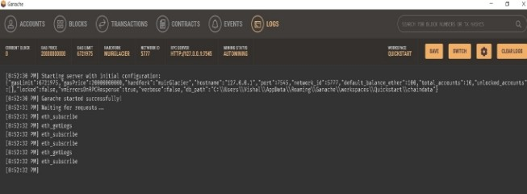
Fig. 2: Ganache Interface

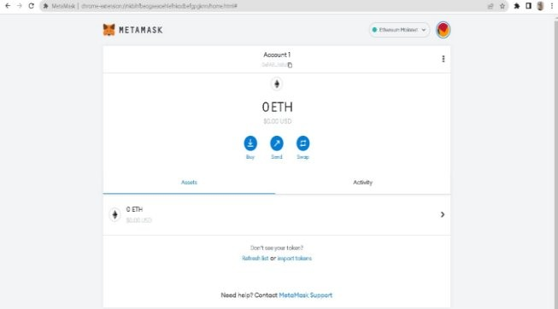
Fig. 3: Meta mask
The web3.js pack is employed when creating sites or other kinds of clients that can communicate with blockchains. JSON RPC is a Web3 protocol that enables websites to communicate with blockchains. We may communicate with the Ethereum blockchain using a method of communication known as RPC, or remote procedure call. the block
Fig. 5 depicts a diagram of how web3js functions.

If we wish to install XAMPP as part of our PHP environment. Make sure MySQL is running, please. The database may then be set up, and the MySQL queries can be executed. In Fig. 6, the database setup for the distributed website is shown.
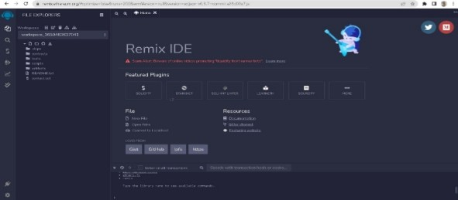

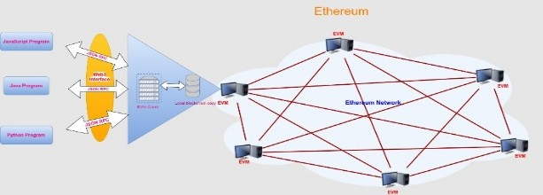

Fig. 5: Web3.js Library

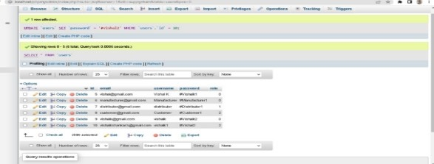
Fig. 6: PhpMyAdmin

- In this project, QR codes (quick response) offer a powerful way to tackle the practice of product counterfeiting due to advances in mobile and wireless technology. A QR code scanner is used for recognizing counterfeit goods since the product's QR code links to a blockchain.
- Therefore, this approach may be utilized for saving product information as well as the distinctive codes of the item in question as database blocks.
This website will include information on the product and the producer. To obtain the product he intends to sell, a shopkeeper can log in.
The maker can be shown the product's details. Product requests are approved or rejected by manufacturers.
The manufacturer generates the product's special QR code after accepting the order. False Item Identification System Utilising Bitcoin 4 Once an order for a product has been saved on the network, a code known as a hash has been generated for that product. In order to store product information and produce unique codes as blocks in the purchase of the product, this approach may be utilized.
A QR code is developed for a specific product in the proposed system. Customers can use a QR code scanner application on their smartphone or the shortcode reader application that comes with the product or package to scan the QR code.
We can determine whether a product is authentic or fraudulent after scanning. To monitor the goods along the

supply chain, the blockchain system ultimately stores these product specifics along with a record of transactions. A hash value, block name, and all the product information are recorded in the database.

VI SYSTEM ARCHITECTURE
Three actors are playing roles in our described application. The first is the product vendor, who uses our service to create QR codes for their products and uploads them to the blockchain on Ethereum together with information about the original owner. To verify the legitimacy of the documents, the potential purchaser must upload his own documents. Additionally, the retailer must upload what kind of goods they intend to use our service for. Once their approval is accepted, they can check the status and wait for it. If a general merchant wants to join our service, they must submit an application on a page titled "Get a Trader" End users, can easily assess whether an item is genuine or not by reading the QR code that comes along with it, making up our platform's second user demographic. The visitor is directed to a website that features the exact product details once the bar code is scanned. as well as additional details about the original producer. The person who certifies the merchant's trustworthiness will be the application's third user. A MySQL database will be used to keep metadata about the merchants and other minor data, whereas the Ethereum blockchain will be used to store information about the products and the merchants that sell them.
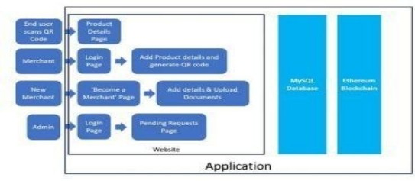

Fig 1: Architecture Diagram
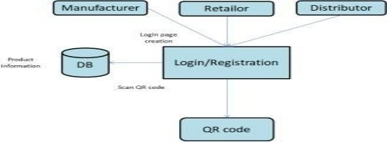
Data Flow System
The recommended strategy's main objective is to assist the client in keeping track of the item's past in order to preserve the originality of the product. Customers have the capacity to use the system to trace a given item's provenance from source to customer via blockchain. There are three main functions operating in this information flow system, in that order: producer, shopper, and distributor. Manufacturers and retailers sign in or create accounts together. Using the Ethereum wallet, the maker creates a bar code for the good and adds any further information required. The product data will be saved to the database. By reading the shortcode that keeps track of transactions, customers may judge the value of an item and confirm its validity.

Fig 2: Data Flow Diagram

Sequence Diagram
Manufacturer, distributor, seller, and customer constitute its four roles. The product will be added by the manufacturer first before it undergoes shipment to the customer. The manufacturer will include the item and send it to the distributor. The retailer will receive that from the distributor, and the blockchain will be updated with every piece of data. The customer will be able

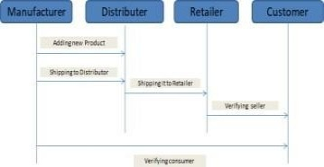
to

Fig 3: Order Chart

VII CONCLUSIN AND Data

The suggested approach makes sure that websites are used to detect phony goods in real life. The
three key components of the proposed system are the cloud or database, the manufacturer's or firm's Android application, and the customer's or user's Android application. Fig. 7 shows a block diagram of the blockchain network. We must first register in the website's first area, the Manufacturers and Corporate Side Application. After logging in and completing the registration procedure, we can choose from an array of options. Creating a product and letting its maker fill in the details is one option. Another option is to display the order so they may view the particulars of the orders placed by consumers before figuring out if they want to accept them. Additionally, the manufacturer has access to data on the status of deliveries. On this website, a QR code scanner may be used to scan a product's QR code to determine if it is genuine or fake. A blockchain is a unique option; it shows the name of the formed block, the quantity of the product, the generated hash value, and if the product is corrupted or not. The customer logs in and enters all the necessary information in our proposed system in order to order and reserve the product. The product's order could be displayed for the maker. The product request's acceptance is determined by the manufacturer. The manufacturer generates the specific QR code for the product after the order is accepted.
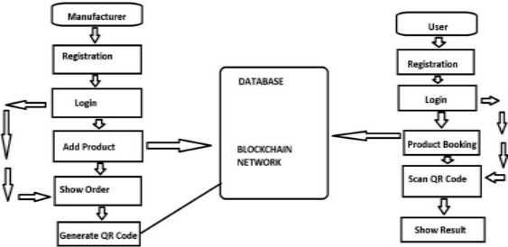

Fig. 7: Block diagram of the Blockchain network

We saw blockchain technology, which remains in development, as an answer to our present predicament. We use this sort of technology to facilitate interaction among the client and all departments. used to build the script. The suggested solution generates a QR code for a particular product. Customers can use a QR code reader app on their smartphone or a QR code scanner included in their customer app to scan the QR code found on products or packaging. After scanning, we can tell whether the product is genuine or not. The blockchain system also keeps a transaction history and these product facts, ensuring the tracking of products across the supply chain. The UI was developed with React. For interaction with the Ethereum blockchain, operations including ether

transfers, transaction confirmations, and reading and writing data from smart contracts are carried out using the Web3.js module. Installing Meta mask, a wallet that communicates with the Ethereum blockchain, on the browser enables access to an Ethereum wallet using that browser. Before the transactions can be included, they must be verified using their account and the Web3.js-integrated meta mask wallet. After then, the ultimate user can check the reliability
of 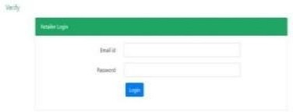 Products can be verified in the supply chain by scanning the QR code.

Fig 4:
.Figure 4 illustrates how a retailer logs into their account using their login data, such as their email address and password.

Fig 5: Retailer Registration Page Fig 6: Generation of QR Code
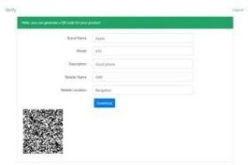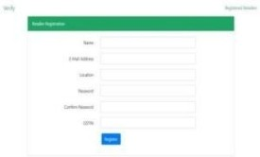

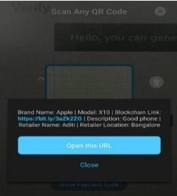

Once the retailer has registered, he will add the product's details and a bar code will be produced for that specific product.

An authorization box regarding the metaphysical mask displays and asks for confirmation, as shown in Figure 7.

Fig 8: using the digital masking purse to complete the transaction
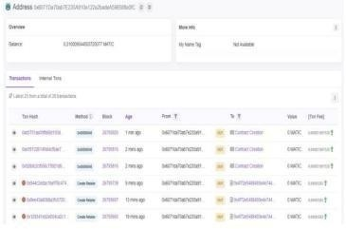
Fig 9: Product transaction history

VIII CONCLUSION

Customers and online retailers may both benefit from using blockchain technology to avoid product counterfeiting. From the time a product is manufactured until the supplier, distributor, and client will all be granted insight into the information once it reaches the customer. The information about the product cannot, therefore, be changed via any of the blockchain's linkages by an outsider or hacker. Smart contract codes govern blockchain technology. soon as a customer receives goods and the QR code is read, the product's QR code is confirmed. Because
of the code's simplicity, customers goal of the next project could be to. Customers are unlikely to be accustomed to Therefore, in order to persuade customers to purchase something from this blog, they must be aware of how it differs from other e-commerce websites and the advantages it provides. It will be difficult to market this website.

IX REFERENCE

- [1] [1] "Fake Goods Identification Using Bitcoin Software," Vol. 7, Issue 4, 2021, Tejaswini Tambe, Sonali Chitalkar, Manali Khurud, Madhavi Varpe, and S.
Y. Raut
- [2] [2] Ajay Funde, Pranjal Nahar, Ashwini Khilari, Nikhil Marne, and Ms. Nikhita Nerkar, "Blockchain-Based Fake Item Identification in the Supplier Chain," 2019 June Issue 06, Issue 05
[2] [2] [3] Blockchain Technology: An Overview, by Dylan Yaga, Peter Mell, Nik Roby, and Karen Scarfone, was released on October 3, 2018.

"Blockchain problems and possibilities: a survey" by Zibin Zheng, Shaoan Xie, Hong-
Ning Dai, Xiangping Chen, and Huaimin Wang was published in October 2018.

"A Survey of Blockchain from the Views of Apps, Challenges, and Opportunity," IEEE Access (Volume: 7), August 19, 2019. Ahmed Afif Monrat, Olov Schelén, and Karl Andersson

- [6] [6] Toqeer Ali Syed, Ali Alzahrani, Salman Jan, Muhammad Shoaib Siddiqui, Adnan Nadeem and Turki Alghamdi, “A Comparative Analysis of Blockchain Architecture and its Applications: Problems and Recommendations” IEEE Access (Volume: 7) 04 December 2019.
- [7] [7] Qiheng Zhou, Huawei Huang, Zibin Zheng and Jing Bian, ”Solutions to Scalability of Blockchain: A Survey” IEEE Access (Volume: 8) 17 January 2020.
- [8] [8] Umesh Bodkhe, Sudeep Tanwar, Karan Parekh, Pimal Khanpara, Sudhanshu Tyagi, Neeraj Kumar and Mamoun Alazab, “Blockchain for Industry 4.0: A Comprehensive Review” IEEE Access (Volume: 8) 17 April 2020.
- [9] [9] Weilin Zheng; Zibin Zheng; Xiangping Chen; Kemian Dai; Peishan Li; Renfei Chen, ”NutBaaS: A Blockchain-as-a-Service Platform” IEEE Access ( Volume: 7) 17 September 2019.

[10]. Sanjay K. S, Dr. Ajit Danti “Detection of fake opinions on online products using Decision Tree and Information Gain” Third International Conference on Computing Methodologies and Communication (ICCMC 2019),2019.
[11]. Mario Tomisa, Marin Milkovic, Marko Cacic, “Performance Evaluation of Dynamic and Static WordPress- based Websites”, IEEE Access 2019.
[12]. Sidra Malik, Volkan Dedeoglu, Salil S. Kanhere, and Raja Jurdak, “TrustChain: Trust Management in Blockchain and IoT supported Supply Chains”, 9 IEEE International Conference on Blockchain (Blockchain),2019.
[13]. Steven Sandi, Sanja Radonjic, Jovana Drobnjak, Marko Simeunovic, Biljana Stamatovic and Tomo Popovic “Smart Tags for Brand Protection and Anti-counterfeiting in wine Industry” 23rd International Scientific- Professional Conference on Information Technology (IT), 2018.
[14]. Abhijeet Mendh, Mr. Deepak Kumar Gupta, Dr. Krishna Pal Sharma, The piece, "Secure QR-Code- Inspired Information Exchange System Using Crypto and Steganography", First International Conference on Secure Cyber Computing and Communication (ICSCCC),2018.
[15]. Mayur M Patil “A qualitative analysis of the performance of MongoDB vs MySQL Database based on insertion andretrieval operations using a web/android application to explore Load Balancing – Sharding in MongoDB and its advantages” International conference on I-SMAC (IoT in Social, Mobile, Analytics and Cloud) (I-SMAC 2017),2017.
[16]. Ningning Yi, Xin Feng, Chunfang Li, “The Design and Implementation of the Front End of the Art Play Library System”, 7th International Conference on Communication Systems and Network Technologies,2017.
[17]. G. Sri Harsha Vardhan, Naveen Sivadasan, Ashudeb Dutta, “QR-Code based Chipless RFID System for Unique Identification”, IEEE International Conference on RFID Technology and Applications, 2016.
[18]. Bo Ya, Guangwen Huang, “Application of RFID and Internet of Things in Monitoring and Anti- counterfeiting for Products”, International Seminar on Business and Information Management,2016.
[19]. Mark A. Holliday and Andrew S. Scott “A Software Development Course Based on Server-Side JavaScript” Dept.of Mathematics and Computer Science Western Carolina University,2016.
[20]. Leeladevi B, Pinku Hazarika and Hemadri Pavan Kumar Nanyam “Transforming a website from desktop to mobile:A cross platform viewpoint” Siemens Technology and Services Bangalore, India,2015[21] Saksham Aggarwal “A Blocks-Based Editor for HTML Code” International Institute of Information Technology Hyderabad, India,2015.
[21]. Saksham Aggarwal “A Blocks-Based Editor for HTML Code” International Institute of Information Technology Hyderabad, India,2015.

