Ainul Hasan¹
Department of Electronics and Communication Engineering
I.T.S. Engineering College
Greater Noida, Uttar Pradesh, India
ainulhasanva_ece19@its.edu.in
Md. Mudassir²
Department of Electronics and Communication Engineering
I.T.S. Engineering College
Greater Noida, Uttar Pradesh, India
mohdmudassirms_ece19@its.edu.in
Kshitij Upmanyu³
Department of Electronics and Communication Engineering
I.T.S. Engineering College
Greater Noida, Uttar Pradesh, India
kshitijupmanyuas_ece19@its.edu.in
Setu Garg⁴
Department of Electronics and Communication Engineering
I.T.S. Engineering College
Greater Noida, Uttar Pradesh, India
setu.ece19@its.edu.in
Monika Jain⁵
Department of Electronics and Communication Engineering
I.T.S. Engineering College
Greater Noida, Uttar Pradesh, India
hod.ece@its.edu.in

A Comprehensive Study on Near-Infrared (NIR) Sensor , ECG Sensor and Electromyography (EMG) Sensor for Biomedical Applications: A Review

Abstract:

The main focus of the method is to implement a prototype model for the real time patient monitoring system. The proposed method is used to measure Electromyography (EMG) and near-infrared spectroscopy (NIRS) sensors are two types of sensors that are commonly used in a variety of applications, including clinical diagnosis, sports performance monitoring, and rehabilitation. EMG sensors detect and record the electrical activity of muscles, while NIR sensors measure changes in the concentration of oxygenated and deoxygenated hemoglobin in the blood.The amplitude and frequency of the waveform can provide information about the strength and timing of the muscle contraction. In contrast, NIR sensors are non-invasive and can provide information about changes in blood flow and oxygenation in the tissue. However, NIRS sensors are limited by the depth of tissue penetration and can only measure changes in oxygenation in the superficial tissue.
In recent years, there has been growing interest in combining EMG and NIR sensors to provide more comprehensive information about muscle function. EMG and NIR sensors can provide complementary information about muscle activity, with EMG sensors providing information about the electrical activity of the muscle fibers and NIRS sensors providing information about the metabolic demands of the muscle.

Traditionally, wired communication technology has been used for ICU patient health monitoring systems. However, the novel system continuously monitors patient health and transmits acquired data through a Wi-Fi wireless sensor network. An embedded processor analyzes the patient's input, and the results of all parameters are stored in a database. If the patient experiences any abnormality, indications are sent to medical officials or caretakers. The advanced ARDUINO microcontroller is used to implement the system, and simulation results are obtained.
Health monitoring has become essential for all individuals in recent years, and several techniques have been used for this purpose. The Atmega328 microcontroller is used for continuous monitoring, and several sensor units are considered, including temperature and heart rate sensors.

Introduction:

Recent advancements in remote health monitoring have led to the development of innovative architectures, including smartphone-based applications. However, using traditional continuous data transmission methods in remote healthcare monitoring can lead to problems such as reduced node lifespan, data failures due to delays and buffer overloading. These issues are unacceptable, particularly in healthcare applications. Therefore, a proposed architecture involves a central gateway that collects data from users and periodically transmits it to a central server. Clinicians can then assess the users' health status based on this data. Continuous monitoring techniques are of particular interest as they provide long-term information, record emergency situations, and enable real-time responses to significant changes in a person's health condition. Healthcare is crucial for everyone, and regular monitoring of vital parameters and appropriate treatments based on this data are essential. As individuals age, their need for monitoring and medical assistance increases, as they may be unable to manage their health conditions without specialized medical support or advanced equipment. The older a person gets, the wider the range of potential diseases and unexpected emergencies that may occur. To address this, they need to maintain a connection with a hospital, be monitored by medical professionals, and receive immediate assistance if any abnormal parameters are detected.

LITERATURE REVIEW :
[1] S. M. Riazul islam et al proposes an intelligent collaborative security model to minimize security risk; discusses how different innovations such as big data, ambient intelligence, and wearable’s can be leveraged in a health care context; addresses various IoT and health policies and regulations across the world to determine how they can facilitate economies and societies in terms of sustainable development; and provides some avenues for future research on IoT-based health care based on a set of open issues and challenges
[2] Junaid Mohammed et al monitor ECG wave remotely using IOIO-OTG Microcontroller and Android app. Data collected and stored in the app.
[3] Mohammed S. Jasses et al body temperature monitoring with Raspberry Pi in a cloud-based system. Raspberry Pi monitors temperature, transfers via WSN, and adds data to cloud websites for monitoring.
[4] Hasmah Mansor et al monitor body temperature using LM35 sensor connected to Arduino Uno. Data sent to SQL database website via Arduino Uno for login-based temperature monitoring.
[5] Afef Mdhaffar et al new IoT-based health monitoring approach: Medical sensor data sent to analysis module via low-cost, low-power, secure LoraWAN network.
[6] Mathan Kumar et al monitors ECG, respiration rate, heart rate, and body temperature. Sensors connected to PIC16F887A microcontroller. Data manually uploaded to a website for monitoring. Android app and web page created for health status monitoring.
[7] Soumya Roy et al monitor ECG waves using AT Mega 16L microcontroller. Transfer data using the Zigbee module to the nearest connected system.
PROPOSED METHODOLOGY :

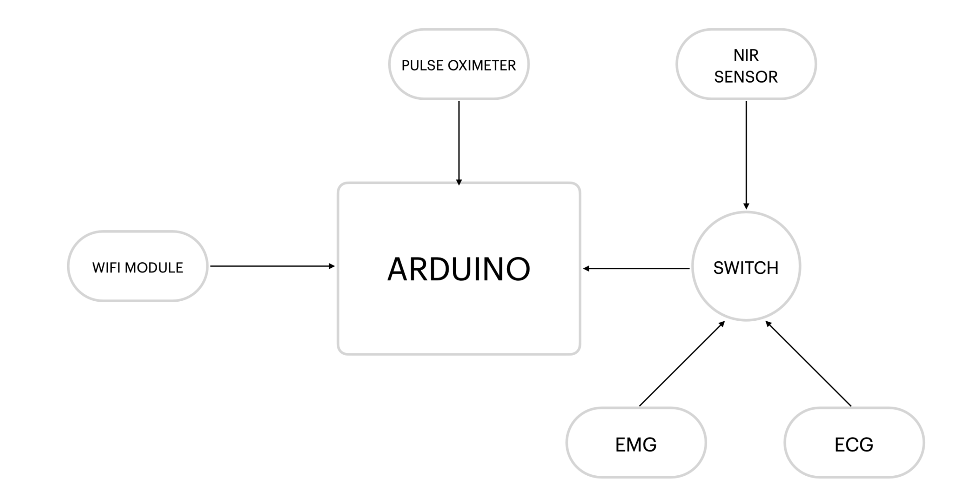

EMG Sensor:

EMG sensors are used to monitor muscle activity and provide valuable information about muscle function. The electrical activity generated by muscle fibers when they contract is detected and recorded by EMG sensors. The amplitude and frequency of the waveform can provide information about the strength and timing of the muscle contraction. In clinical applications, EMG sensors are used to diagnose neuromuscular disorders such as muscular dystrophy, multiple sclerosis, and spinal cord injuries. EMG sensors can also be used to monitor muscle function during surgery, helping surgeons to avoid damaging nerves and muscles.

The accuracy and precision of the ECG measurements depend on the type of material used in the sensor. In this essay, we will discuss the types of materials used in ECG sensors, their properties, and their significance.
The materials used in ECG sensors can be broadly classified into two categories: conductive materials and non-conductive materials. The material used in ECG depends on several factors, such as the required sensitivity, biocompatibility, durability, and cost.

Conductive Materials:

Conductive materials have high electrical conductivity and can provide accurate and precise measurements of the electrical activity of the heart. The most common conductive materials used in ECG sensors are silver, gold, platinum, and carbon.

Silver :

Silver is the most commonly used material in ECG sensors due to its high electrical conductivity and biocompatibility. Silver electrodes are highly sensitive and can detect even small electrical signals from the heart. Silver is also highly biocompatible, with Electrocardiogram (ECG) sensors are medical devices that are used to detect and record the electrical activity of the heart. The ECG sensors play an essential role in monitoring the heart's health and detecting abnormalities. The accuracy and precision of the ECG measurements depend on the type of material used in the sensor.

Gold :

Gold is another conductive material used in ECG sensors due to its high electrical conductivity and stability. Gold electrodes are highly stable and do not corrode easily, which makes them suitable for long-term use. Gold is also highly biocompatible and does not cause any adverse reactions in the body.
Platinum is also highly biocompatible and does not cause any adverse reactions in the body. However, platinum electrodes are more expensive than silver and gold electrodes, which can make them less cost-effective for some applications.

Carbon:

Carbon is a conductive material used in ECG sensors due to its high electrical conductivity and low cost. Carbon electrodes are highly sensitive and can detect even small electrical signals from the heart. Carbon is also highly biocompatible and does not cause any adverse reactions in the body. However, carbon electrodes are less stable than silver, gold, and platinum electrodes and can deteriorate over time.

Non-conductive Materials:

Non-conductive materials are used in ECG sensors as insulation to prevent electrical interference from other sources. These materials do not conduct electricity and can help to improve the accuracy and precision of the ECG measurements. The most common non-conductive materials used in ECG sensors are polyester, polyurethane, and silicone.
Polyester :

Polyester is highly resistant to abrasion, which makes it suitable for long-term use. Polyester is also flexible, which allows it to conform to the shape of the skin and improve the contact between the electrode and the skin. However, polyester is not biocompatible and can cause skin irritation in some people.
Polyurethane :

Polyurethane is highly resistant to abrasion and can withstand repeated use without losing its properties. Polyurethane is also biocompatible and does not cause any adverse reactions in the body.

NIR Sensor:

Near-Infrared (NIR) sensors are devices that detect and measure the amount of NIR radiation that is reflected or absorbed by an object. NIR radiation has wavelengths that range from 700 to 2500 nanometers, and is beyond the visible spectrum of light.
The working principle of an NIR sensor is based on the fact that different materials reflect and absorb NIR radiation differently. When NIR radiation is directed at an object, some of the radiation is reflected back to the sensor, while some of it is absorbed by the object. The amount of NIR radiation that is reflected or absorbed by the object can be used to determine its chemical composition, moisture content, or other physical properties.
NIR sensors typically consist of a light source that emits NIR radiation, a sample holder where the object to be analyzed is placed, and a detector that measures the amount of NIR radiation that is reflected or absorbed by the object. The detector produces an output signal that is proportional to the amount of NIR radiation detected, and this signal can be processed to obtain information about the properties of the object being analyzed.
NIR sensors are typically made of one of two types of materials: silicon and indium gallium arsenide (InGaAs). Silicon-based sensors are used for wavelengths between 400 and 1100 nanometers (nm), while InGaAs-based sensors are used for wavelengths between 900 and 2500 nm. Both materials have their unique properties, Silicon-based NIR sensors:
Silicon-based NIR sensors are the most commonly used sensors in NIR spectroscopy instruments. They are made from silicon semiconductor materials, which are easy to fabricate and can be mass-produced at a low cost. Silicon sensors have a high quantum efficiency, which means they can convert a high percentage of the incident photons into electrical signals. This results in high sensitivity, which is essential for accurate and precise measurements.
Silicon sensors have a wide spectral range, covering the visible and near-infrared regions. They are also sensitive to temperature changes, which can affect their performance. To mitigate this, silicon sensors are often operated at a constant temperature to maintain their sensitivity and accuracy. Another disadvantage of silicon sensors is that they are not suitable for measuring wavelengths beyond 1100 nm, which limits their applications in some industries.

InGaAs-based NIR sensors:

InGaAs-based NIR sensors are used for wavelengths beyond 1100 nm, where silicon sensors are not sensitive. InGaAs is a semiconductor material composed of indium, gallium, and arsenic. It has a high electron mobility, which means it can transport electrical charge quickly and efficiently. InGaAs sensors have a high quantum efficiency, similar to silicon sensors, which makes them suitable for high sensitivity measurements.
InGaAs sensors have a narrower spectral range than silicon sensors, covering only the near-infrared region. They are also more expensive to manufacture than silicon sensors due to their complex fabrication process. InGaAs sensors are less sensitive to temperature changes than silicon sensors, which makes them more suitable for applications in harsh environments. However, they are more susceptible to noise and dark current, which can affect the accuracy and precision of the measurements.

ECG:
Electrocardiogram (ECG) sensors are medical devices that are used to detect and record the electrical activity of the heart. The ECG sensors play an essential role in monitoring the heart's health and detecting abnormalities. The accuracy and precision of the ECG measurements depend on the type of material used in the sensor.
ECG (electrocardiogram) sensors are typically made using electrodes that come in contact with the skin to detect and measure the electrical activity of the heart. These electrodes are responsible for picking up the tiny electrical signals generated by the heart muscles during each heartbeat.
The most common type of material used for ECG sensors is silver/silver chloride (Ag/AgCl). Ag/AgCl electrodes are widely used in medical applications due to their excellent electrical conductivity, stability, and compatibility with the human body.
Ag/AgCl electrodes are commonly used in various medical settings due to their reliability, ease of use, and ability to provide high-quality ECG signals. They are designed to be disposable or reusable, depending on the specific application and intended usage.

BLYNK APP AND SERVER :

Blynk is a mobile application and cloud-based platform that allows developers and hobbyists to build custom Internet of Things (IoT) projects without having to write complex code. The platform provides a simple drag-and-drop interface to create custom user interfaces for controlling and monitoring IoT devices. In addition, Blynk provides a cloud-based server that allows users to remotely access and control their devices from anywhere with an internet connection.

Blynk App:

The Blynk app is a mobile application available for iOS and Android devices that provides a user-friendly interface for controlling and monitoring IoT devices. The app allows users to create custom interfaces using widgets such as buttons, sliders, and gauges to control and monitor their devices. The widgets can be easily added to the interface by dragging and dropping them onto the screen.

Blynk Server:
The Blynk server is a cloud-based platform that provides a central location for managing and controlling IoT devices. The server allows users to remotely access and control their devices from anywhere with an internet connection, making it an ideal platform for building IoT projects that require remote access.The Blynk server provides a number of features for managing IoT devices, including the ability to create and manage user accounts, create and manage projects, and monitor device activity. In addition, the server provides a set of APIs that can be used to integrate Blynk with other platforms and services.Blynk server is its support for a wide range of IoT hardware platforms, including popular platforms such as Arduino, Raspberry Pi, and ESP8266. This makes it easy for developers and hobbyists to integrate Blynk into their existing IoT projects or to start building new projects from scratch.

Blynk Architecture:
The Blynk platform is built around a client-server architecture, with the Blynk app acting as the client and the Blynk server acting as the server. When a user creates a custom interface using the Blynk app, the interface is uploaded to the Blynk server. The user's IoT device then connects to the Blynk server using a unique authentication token, which is generated when the project is created.Once the IoT device is connected to the Blynk server, it can send and receive data using a variety of communication protocols, including Wi-Fi, Ethernet, and Bluetooth.

Security:
Security is a critical aspect of any IoT platform, and the Blynk platform provides a number of features to help ensure the security of user data and devices. The Blynk server uses industry-standard SSL encryption to protect user data during transmission, and user authentication tokens are stored securely on the server.

