Smart Classroom with Energy Saving System
Swami M. V.¹, Gawali S. M.², Karpe A. R.³
¹ Electronics & Telecommunication Engineering & Vishweshwarayya Abhiyantriki Padvika Mahavidyalaya
² Electronics & Telecommunication Engineering & Vishweshwarayya Abhiyantriki Padvika Mahavidyalaya
³ Electronics & Telecommunication Engineering & Vishweshwarayya Abhiyantriki Padvika Mahavidyalaya

---------------------------------------------------------------------***---------------------------------------------------------------------
Abstract - These document expressions the mandatory format and appearance of an essay prepared for SPIE e-journals. The abstract should consist of a solo paragraph containing no more than 200 words. It should be a summary of the paper and not a starter. Because the immaterial may be used in abstracting and indexing databases, it should be self-sufficient (i.e., no numerical references) and essential in nature, presenting concisely the intentions, organization used, results found, and their connotation. A list of up to six keywords ought to immediately follow, with the keywords disconnected by commas and culmination with a period.

Key Words: LCD, Arduino, Relay, LDR, Temperature Sensor (LM35).

- INTRODUCTION

Modern day study halls are furnished with electronic gadgets that have supporting programming to improve and encourage educating strategies. Be that as it may, it is frequently observed that huge class time is squandered on gauging participation, or the class may confront interference because generally sections of understudies and aggravations, for example, the manual control of fan and light. Subsequently, to conquer those issues a plausible framework is made right now that will have no physical mediation from instructors, understudies or floor participation. Information from every one of these sensors is ceaselessly gotten and handled by Arduino Nano board which goes about as a microcontroller unit. This project manages controlling the different electrical equipment present in the classroom. In this way, the framework will encourage the smooth running of the booked classes at our study class and limit time misfortune...
The framework is created with the assistance of ARDUINO UNO board which can be utilized to control the electric fan dependent on the adjustments in temperature of its encompassing utilizing Sensor. The brilliant study class framework controls programmed start or stop fan and light framework dependent on the darkness and nonappearance of the human inside the room through IR Sensor and dependent on the temperatures of the room.

PROPOSED SYSTEM
The power supply can be defined as it is an electrical device used to give electrical supply to electrical loads. The main function of this device is to change the electrical current from a source to the accurate voltage, frequency and current to supply the load.
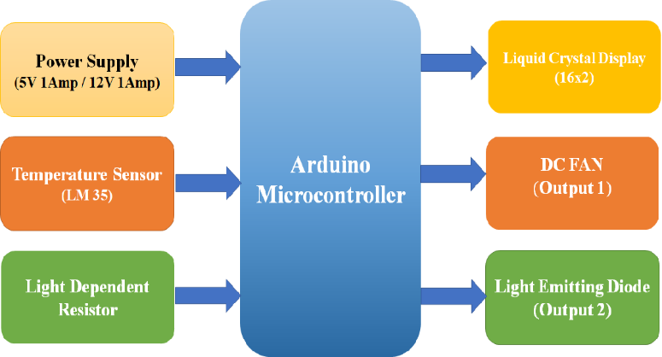Fig 1: Block Diagram of Smart Classroom with Energy Saving System
The input transformer is used to convert the incoming line voltage down to the required level of the power supply. It also isolates the output circuit from the line supply. Here we are using a step-down transformer. The rectifier used to convert the incoming signal from an AC format into raw DC is providing the full-wave rectifier these output goes to filter. The pulsated DC from the rectifier is fed to the smoothing capacitor. It will remove the unwanted ripples in the pulsated DC. These output of filter is pure dc but not fixed is variable so can be used regulator IC 7805 and 7812 is pure dc output of regulator and all power supply is applied to Arduino Uno, relay and other peripheral. Arduino Uno is concocted to FAN, LDR, LM 35, LCD and LED to handle and to use Smart Classroom with Energy Saving System.
- MODEL DESIGN AND IMPLENTATION
- WORKING

Arduino UNO is a microcontroller board based on the ATmega328P. It has 14 digital input/output pins (of which 6 can be used as PWM outputs), 6 analog inputs, a 16 MHz ceramic resonator, a USB connection, a power jack, an ICSP header and a reset button. It contains everything needed to support the microcontroller; simply connect it to a computer with a Universal Serial Bus cable or power it with an AC-to-DC adapter or battery to get started.
Class room temperature is low fan will be off and class room temperature is high fan will be on these process to goes to Arduino Uno through LM35. LM 35 are to sensing room temperature for LOW that conduction DC Fan will be OFF and room temperature is higher that time fan will be ON in next room temperature not goes to LOW

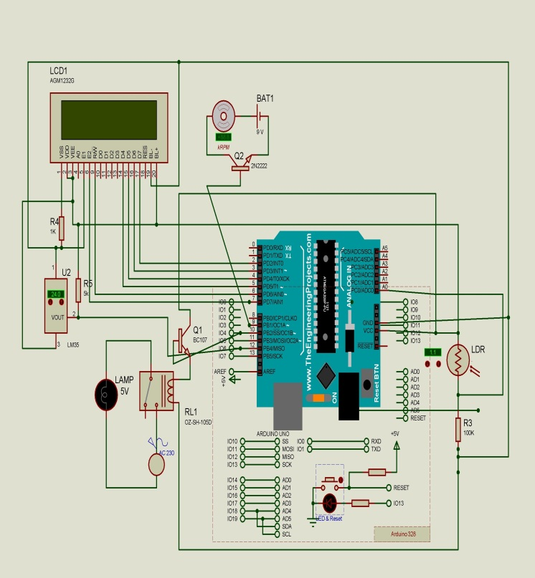
Fig 2: Circuit Diagram of Smart Classroom with Energy Saving System.
In other way class room night mode of you conducting class automatically turn ON your bulb, so use Arduino Uno and Light Dependent Resistor technology. Light Dependent Resistor in darkness so that time flow current through Light Dependent Resistor and pass through Arduino Uno these single to apply bulb and bulb is turn ON. But no any darkness of Light Dependent Resistor that time no any current pass through Light Dependent Resistor and no any single pass Arduino Uno that time not pass to any single in bulb so bulb is turn OFF All process are going that will be display in Liquid Crystal Display
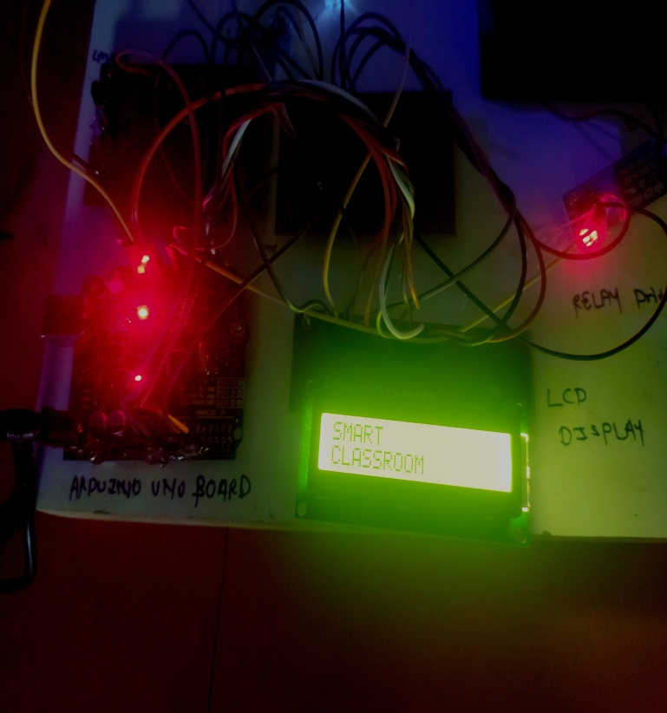 Fig 3: Modal of Smart Classroom with Energy Saving System.

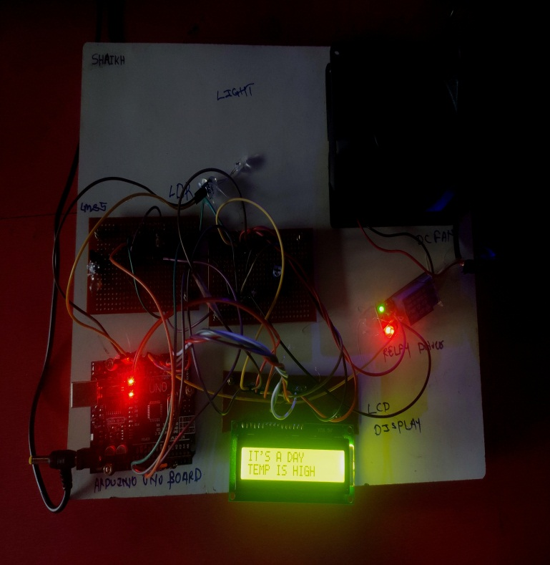
Fig 4: Modal of Temperature high, Fan ON in day mode.

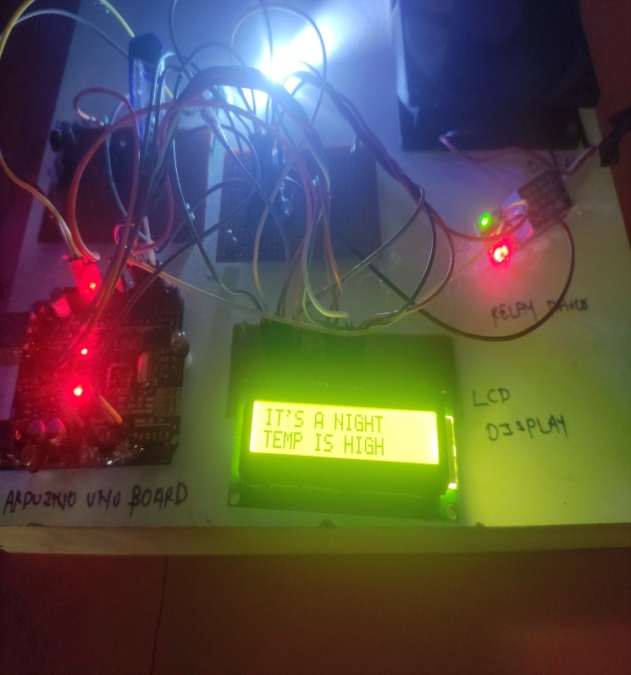
Fig 5: Modal of Temperature high, Fan ON in Night mode Bulb ON

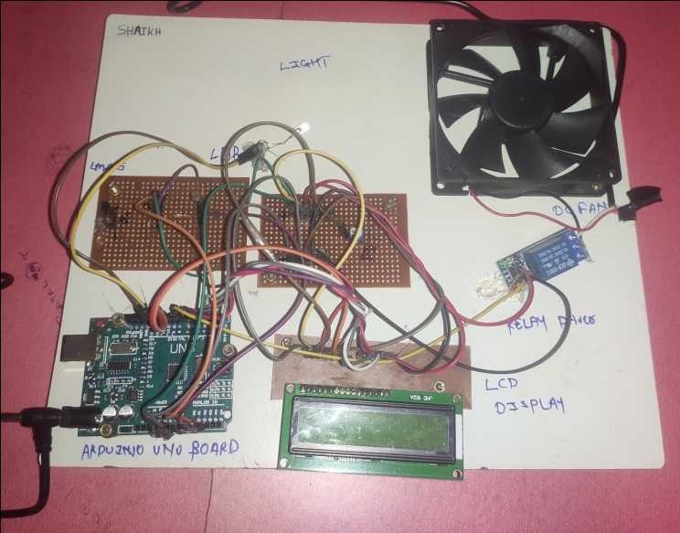
Fig 6: Hardware of Smart Classroom with Energy Saving System.

- CONCLUSIONS AND FUTURE SCOPE
Thus, we have designed a smart classroom system to avoid human efforts and to save power which is the main application of our system. The system is very smart due to use of microcontroller. It responds very fast to the sensor output.
We can further interface GPS module to our project with advance tracking mechanism like IOT. The intimation through cloud can be implemented.

- REFERENCES

1. Vinayak T. Shelar, Mahadev S. Patil “Implementation of automated smart classroom using sensors” International Journal of Intellectual Advancements and Research in Engineering Computation, Volume 6pp. 468-478, June 2015.
2. Mrs. Tanuja Sali, Shelar, Mr. Chetan Pardeshi, Mr. Vikas Malshette,“Classroom Automation System” International Journal of Innovations in Engineering and Technology (IJIET), Volume, Mar 2014.
3. Ms. Ruchashinde, ms. Poojagosavi, ms. Ishashirsat, ms. Srushtishivade, ms. Divya dhagate "IOT BASED CLASSROOM AUTOMATION WORKING ON SOLAR "international journal of scientific research and review, volume 07, issue 02, february 2019.
4. Yasodharan r, karthick s, prince roy, harikrishnan v,"iot based classroom automation using arduino" international journal of trend in scientific research and development (ijtsrd), volume – 2 | issue – 2 | jan-feb 2018
5. Nathan david, abafor chima, aronu ugochukwu, “design of a home automation system using arduino”, c 2015.
6. “Vicent Ricquebourg, David Menga, David Durand, Bruno Marhic, Laurent Delahoche, Christophe Loge”- The Smart Home Concept: our immediate future, http://protege.stanford.edu/

