Optimization of 3D printing of SLM Process with aluminum 6364 alloy and zirconium
Prajeeth. p, prajeethceasar9@gmail.com, Manikandan. j, mk7722582@gmail.com, Sabarish. T, sabarish20me@kct.ac.in

Abstract

By examining the effects of ageing temperature and ageing time on the microstructure, mechanical properties, and corrosion resistance of the alloy, Al-Zr alloys, an advanced metal matrix composite material, have several unique applications in selective laser melting. Aluminium: 97.9 to 99.4% is what makes up aluminium 6364. Copper: maximum 0.2%, Iron: maximum 0.15%, Magnesium: maximum 0.45 to 0.9%, Manganese: maximum 0.05%, Silicon: maximum 0.2 to 0.6%, Zinc: maximum 0.05%, Residuals: maximum 0.15%.The alloys that are printed and directly aged develop a distinctive grain structure that is made up of fine equiaxed grains at the molten pool boundary and coarse columnar grains inside the molten pool. Direct ageing treatment can increase the alloy's mechanical characteristics, and the highest tensile strength was 465. MPa. To assess the examined alloy's corrosion resistance, it is critical to consider the precipitates and percentage of high-angle grain boundaries. The ideal ageing process for the alloy under study in this research is 150 °C for 4 hours, considering its mechanical characteristics and corrosion resistance.
Keywords
Al–Zr alloy; Zirconium; Advanced technology; Selective laser melting; Heat treatment; Mechanical property; Corrosion resistance

Introduction
Metal matrix composites (MMC) are in higher demand, particularly alloys based on aluminium. The aluminium is a reasonably cheap, lightweight, and easily produced metal that can be heat treated to a reasonable level of strength, which makes it highly alluring. Aluminium is one of the most adaptable, affordable, and appealing metallic materials for a wide range of applications, including aerospace, automotive, electronics, or other cutting-edge technologies. This is due to the special qualities of aluminium and its alloys.

One of the modifiers for aluminium and its alloys is zirconium. The maximal solubility of zirconium in aluminium is around 0.234 weight percent at the peritectic temperature of 660 °C, according to the binary Al-Zr phase diagram. Zr is more soluble in molten aluminium as the temperature rises. Zr is added to Al-Zr alloys in proportions ranging from 0.02-0.20 weight percent, which nearly triples the alloy's strength while also guaranteeing the stability of its properties at temperatures up to 300 °C. Zirconium addition to alloys based on aluminium also increases resistance to fatigue cracking, corrosion, and ageing.

By utilizing zirconia (ZrO2), Al-Zr alloy costs can be decreased. High fracture toughness, wear resistance, thermal shock resistance, mechanical strength, and superior surface finish characteristics are all provided by zirconium dioxide in the aluminium matrix. Some studies have investigated how zirconia and/or alumina affect aluminium MMC. There are several ways to make Al-Zr alloys utilizing ZrO2, which is a less expensive and more readily available source of zirconium.

Literature review
Al-Zr alloys synthesis

According to Chen et al. (2020) [1], the production of Al-Zr alloys from cryolite melts seems to be extremely promising. With various ZrO2 and Al2O3 additions, it was possible to characterize low temperature sodium and potassium-based systems as an electrochemically active molecule. AlF3 was added in varying amounts depending on the cryolite system (42mol% for sodium, 45.5mol% for potassium). Up to 2mol% for the sodium system and 3mol% for the potassium system of Al or Zr were added. The synthesis's outcome shows that the electric conductivity was true over a wide range of temperatures and concentrations.

Tensile properties of Al-Zr alloys

Wang et al. (2023) [4] Al alloys with high strength are utilized instead of conventional steels and titanium alloys. A selective laser melting process is used to create high strength Al-Zr-Mg-Si-Sc. Al-Mg-Si-Sc-Zr shows bi-modal microstructures, as evidenced by the results of the tensile test, which showed that strength and stiffness are equal in all directions within the plane (intrinsically quasi-isotropic) characteristics. Large ultrafine grains are produced because of poor fiber texture and randomly aligned cracking-prone grains, resulting in Al-Mg-Si-Sc-Zr with inherent quasi-isotropic tensile characteristics.

Microstructure and strengthening mechanism
Yanfang wang and others, 2023 [5] has shown that Zr produced by selective laser melting can easily modify the strengthening mechanism of heat-treatable Al alloys. The study shows how direct ageing affects microstructure and how strengthening Zr alteration by selective laser melting. The typical aluminium grain size is 1.1 m. The precipitates have a radius of 1.1 nm and are Al2CuMg and Al3Zr-L12. Up to 30 Mpa more strength was obtained after the DA treatment, and an additional 5 Mpa of grain boundary strengthening was added. After the DA treatment, a lot of Cu and Mg rich particles were discovered. As a result, the work offers insightful information for the creation of 2000 series Al alloys modified with Zr.

Selective laser melting with high-strength Er- and Zr-modified Al-Mn-Mg alloy

Geng et al. (2022) According to this article, recent studies on selective laser melting have concentrated on Sc- and Zr-modified Al-Mg and Al-Mn alloys. A minor number of equiaxed grains were found at the edges of the melt pools, but columnar grains dominated the microstructure of the alloys that were created following the SLM. As a result, with an elongation of 12.2%, the tensile yield strength and ultimate tensile strength can reach up to 327 MPa and 502 MPa. This study presents a novel technique for producing high-performance aluminum through SLM that enables the use of inexpensive raw materials.
FEA of temperature and stress fields during SLM process of Al−Mg−Sc−Zr alloy
Peng and others (2021) The temperature and stress fields during the Al, Mg, Sc, and Zr alloy's selective laser melting process have been examined using 3D finite elements. Numerous factors, including thermal characteristics, molten pool dimension, molten pool convection, temperature distribution, and residual stress were examined in accordance with the experiments carried out. The results show that when laser power rises, point distance and hatch spacing fall, and the size of the molten pool gradually grows. The end of each scanning track and the center of the first scanning track are where the residual stress is most concentrated. Additionally, it has been observed that the density changes depending on the laser's strength and point distance. The best process parameters are therefore laser power of 325–375 W, point distance of 80−100 μm and hatch spacing of 80 μm.

Materials and method
Chemicals
Based on the research done by (Kubiáková et al, 2020). All the chemicals were of analytical grade and were dried for 4 hours at 450 °C with 99.5% Al2O3, 99% ZrO2, and NaCl. Potassium fluoride (KF) was dried in a vacuum dryer with phosphorus pentoxide for 4 days and without P2O5 at 200 °C for 3 days. AlF3 was purified by sublimation at 1250 °C. Sigma Aldrich provided the following compounds.

Sample preparation and powder
In accordance with the research by Nie et al. (2018) Al-4.24 and Cu-1.97 are added with 2.5% Zr added to Mg to customize the alloy for a 1.5% zirconium considerable crack is eliminated. According to (K.E. Knipling et al. 2008), the Zr-modified Al-4.24, Cu-1.97, Mg alloy has demonstrated a high ultimate tensile strength of approximately 451 MPa with an elongation of only 2.7%. Excellent tensile strength and a wide processes window were obtained in this investigation.

Fabricated microstructure
As per the result by (Wang et al. 2023). The bimodal grain structure with a mixture of fine and coarse grains in the fabricated sample with the building direction (BD). The fine grain region is mainly located at the fusion boundary, whereas the coarse grain region is within the solidified molten pool. Similar microstructural features have been observed in the Zr-modified Al alloys by (G.C. Li et al. 2022) and (N. Zhao et al. 2012). the average grain size in fine grain region was 0.96 μm

Production of powder and casting
As per the experiment conducted by (Qbau et al, 2020) The chemical composition of Al-5.5, Mg-0.2Sc in weight percentage was prepared through casting from raw brick shaped aluminum, Al-2% with Sc as master alloy and magnesium. The initial prosses was to load the raw materials into a 2-L graphite crucible which was placed inside a box furnace. The furnace was then heated up to 700 °C with a ramp rate of 10 °C/min and 10 ml (about 0.34 oz)/min of argon protections flow rate. The temperature was held at 700 °C for 20 min before applying the mechanical stirring for 15 min, which was followed by the ultrasonic for another 5 min to achieve the best chemical homogeneity. A cast ingot with diameter and height 10 and 20 cm (about 7.87 in) was produced by the bottom pouring method. The billet was prepared and subsequently heated to 400 °C and held for 1 hour prior to the horizontal extrusion process to obtain a wire of 4 mm (about 0.16 in) diameter as the material input for the powder atomization. The powder atomization process was carried out using small-scale plasma atomization equipment. The atomized powder was reduced to the size below 63 μm for printing using the selective melting machine. The powder characteristics were characterized using the Freeman Technology.

Processing parameters
The SLM experiments which was conducted by (D. Gu et al, 2012) whose details reveal that when the laser contacts the metal powder, a series of complex physical and chemical phenomena occur during the rapid melting and solidification processes, such as the absorption and scattering of laser energy, heat transfer, phase transition and melt flow in the molten pool. According to morphology report by (H. Zhang et al. 2017) average particle size and the chemical composition of Al-4.24 Cu-1.97, Mg-0.56Mn powders have been described. The Zr powder particles had irregular shapes with particles distribution of 2–18 μm. Six different levels of Zr content, namely, 0, 0.6, 1, 1.5, 2 and 2.5 wt% were selected in the Zr/Al-Cu-Mg-Mn system.

Result and Discussion
Conventional Al alloys have been used nearly entirely in SLM applications. There is a critical requirement for novel alloys that make greater use of the SLM processing conditions in terms of the microstructure and associated anisotropic mechanical properties. The presence of a very small melt-pool positioned over very cool solidified material is one of these SLM-specific circumstances.

Powder behaviour
As per the test conducted by (Qbau et al, 2020) Fig. 1 displayed the properties of Al-5.5Mg-0.2Sc powder. It demonstrates that the powder has a spherical shape and several satellites. The laser particle sizer Horiba-650 was used to analyze the particle size distribution, which ranges from a few microns to 63 microns, with an average powder size of 27 microns.

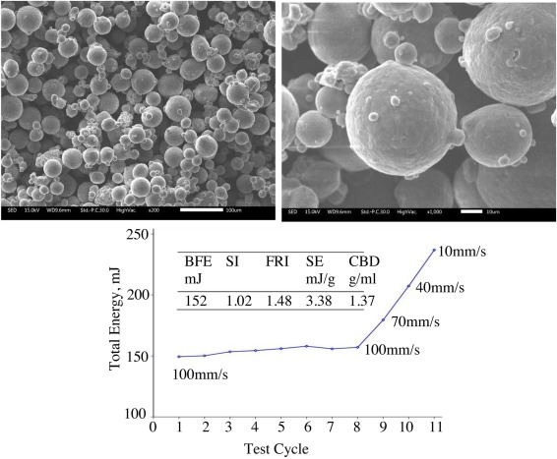

Fig. 1. Characteristics and rheological behaviors of Al-5.5Mg-0.2Sc powder.

The outcomes validate the powder's excellent behavior in the powder bed fusion process and are consistent with earlier findings. Additionally, it is advised that the powder rheometer be used as the testing method of choice for the lighter powders.

Mechanical properties
This sample's micro hardness value was only slightly greater than that of pure aluminum (90 HV) and aluminum alloy 6061 (95 HV), which were both made using the same selective laser melting method by (Uddin et al, 2018)
This sample's micro hardness value was only slightly greater than that of pure aluminum (90 HV) and aluminum alloy 6061 (95 HV), which were both made using the same selective laser melting method shown in Fig. 2

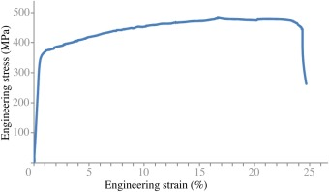

Fig. 2. Engineering tensile stress-strain curve of Al-5.5Mg-0.2Sc

The fracture mechanism of the damaged tensile samples was then revealed by scanning electron microscopy, as illustrated in Fig. 3. The photos exhibit typical ductile features with plastic deformation bands along the coarsened round pores, even though the samples were primarily fractured at a 40- to 45-degree angle. Higher magnification exposes very small honeybee features with sizes ranging from microns to plastically deformed pores leading to a crack at a high stress concentration location. Bundles of micron-sized tubes and the presence of fracture along the interface of the bundles were visible when the samples were tilted at a 10-degree angle, as per the test conducted by (K. Schmidtke et al, 2011)

Al-Cu-Mg alloy and Al-Cu-Mg alloy treated with zirconium were utilized to produce the components by (Zhang et al, 2017). The inclusion of Zr had the effect of purifying the grain, which considerably lessened the hot-cracking phenomenon that occurs during the SLM process. The Zr-modified Al-Cu-Mg part with the ultrafine grain has higher yield strength (446 4.3 MPa) and ultimate tensile strength (451 3.6 MPa) than the Al-Cu-Mg part. These results offered a foundation for creative alloy design for SLM.

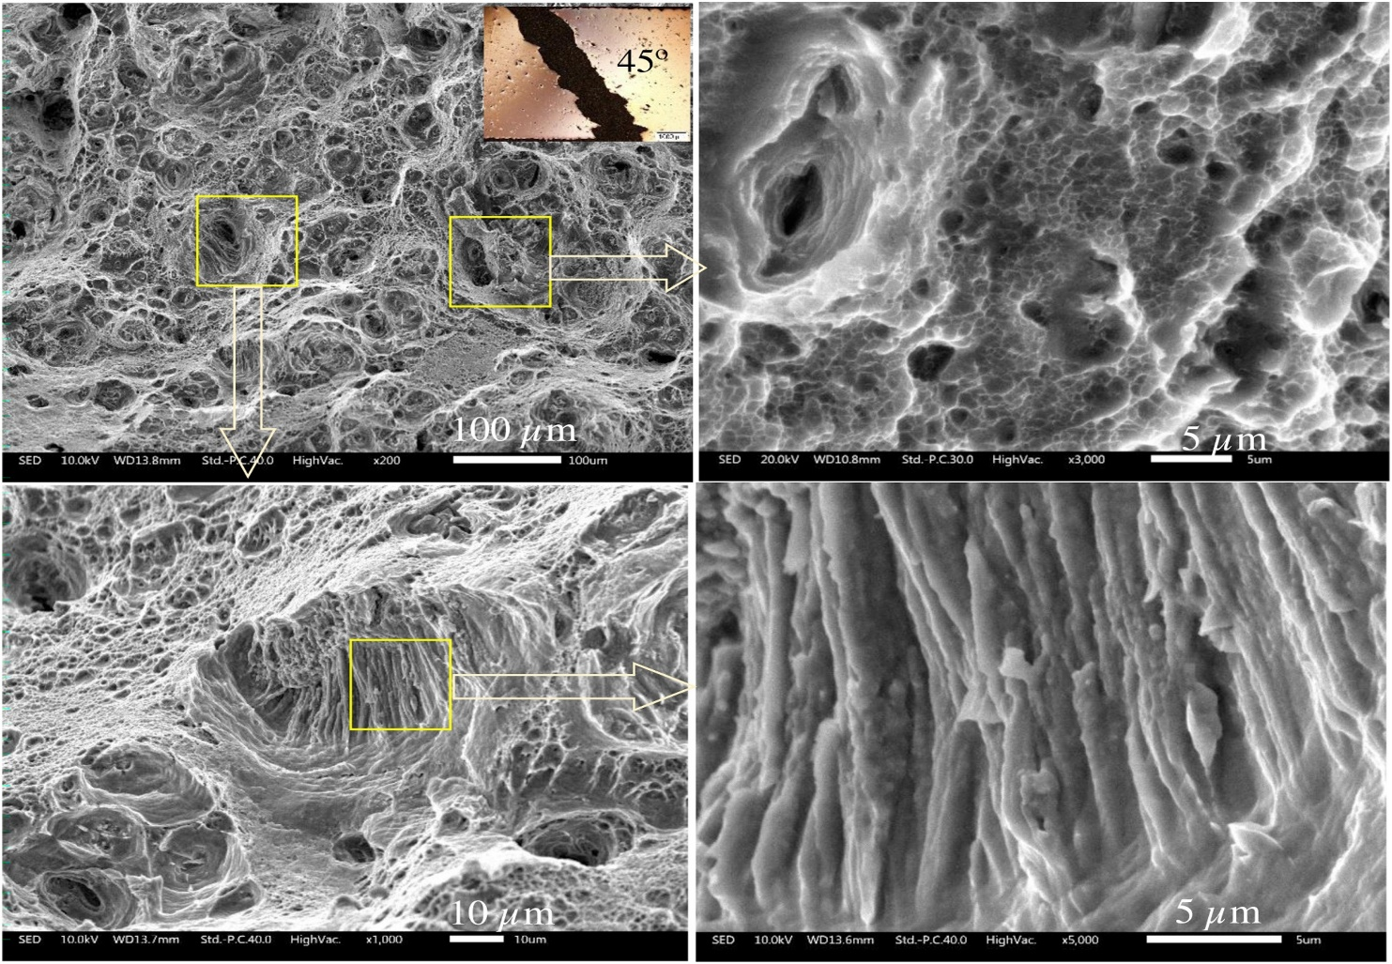
Fig. 3. Fractography of Al-5.5Mg-0.2Sc sample showing plastic deformation band, void coarsening, and bundles of tubes.

Conclusion
In this study, SLM was used to create a crack-free Al-Mg-Si-Sc-Zr alloy. Its tensile characteristics and solidification microstructures were thoroughly investigated. Discussions were held regarding the fundamental mechanics of tensile directionality. a bimodal grain structure that is fine-coarse. The Direct Ageing-treated sample's measured average total grain size (about 1.07 m) and the as-fabricated sample's measured average total grain size (around 1.15 m) were comparable.

The Al and Zr composite modified A357 alloy has enhanced overall tensile qualities, with the greatest yield strength being 333 2 MPa, the tensile strength being 454 1 MPa, and the elongation reaching 12.5 1%. It is primarily related to the fact that grain refining slows the spread of cracks and prevents the movement of dislocations.

References
Chen et al.
Synthesis of Al–Zr master alloy in KF–AlF₃–ZrO₂ melts by aluminothermy reduction–molten salt electrolysis
" Journal of Cleaner Production 378 (2022)

Qbau et al.

Development of light weight high strength aluminum alloy for selective laser melting
" Journal of Materials Research and Technology 9.6 “
(2020)

Yanwu, et al.

Approaching an ultrafine microstructure and excellent tensile properties of a novel Er/Zr modified Al–7Si-0.6 Mg alloy fabricated by selective laser melting
" Journal of Materials Research and Technology 22 “
(2023)
Wang gang et al.

The intrinsically quasi-isotropic tensile properties of as-fabricated Al-Mg-Si-Sc-Zr alloy produced by selective laser melting
" Journal of Alloys and Compounds 947 “
(2023)

Wang Yanfang, et al

Microstructure and strengthening mechanisms of Zr-modified Al–Cu–Mg alloy processed by selective laser melting
" Materials Science and Engineering: A 870”
(2023)

Zhang, Zhiqiang, et al.

Effect of direct aging treatment on microstructure, mechanical and corrosion properties of a Si-Zr-Er modified Al-Zn-Mg-Cu alloy prepared by selective laser melting technology
" Materials Characterization 194”
(2022)

Spierings, Adriaan B, et al.

Microstructural features of Sc- and Zr-modified Al-Mg alloys processed by selective laser melting
"Microstructural features of Sc-and Zr-modified Al-Mg alloys processed by selective laser melting." Materials & Design 115 “
(2017)

D.M. Neto et al.

Effect of load blocks on fatigue crack growth

Int J Fatigue
(2022)

H. Zhang et al.

Selective laser melting of rare earth element Sc modified aluminum alloy: thermodynamics of precipitation behavior and its influence on mechanical properties

Addit Manuf
(2018)

L.B. Li et al.

Microstructures and tensile properties of a selective laser melted Al–Zn–Mg–Cu (Al7075) alloy by Si and Zr microalloying

Mater Sci Eng A
(2020)

Q. Jia

Selective laser melting of a high strength Al-Mn-Sc alloy: Alloy design and strengthening mechanisms

Acta Mater.
(2019)

Z.X. Zhou et al.

Optimization of heat treatment for an Al–Mg–Sc–Mn–Zr alloy with ultrafine grains manufactured by laser powder bed fusion

Mater Charact
(2022)

D.H. Liu et al.

Formation mechanism of Al–Zn–Mg–Cu alloy fabricated by laser–arc hybrid additive manufacturing: microstructure evaluation and mechanical properties

Addit Manuf
(2022)
L.B. Li et al.

Microstructures and mechanical properties of Si and Zr modified Al–Zn–Mg–Cu alloy–A comparison between selective laser melting and spark plasma sintering

J Alloy Compd
(2020)

Z. Liao et al.

Fatigue crack growth behaviour of an Al-Mg4.5Mn alloy fabricated by hybrid in situ rolled wire + arc additive manufacturing

Int J Fract
(2021)

M.Y. Ma et al.

Investigation of fatigue crack propagation behavior of 5083 aluminum alloy under various stress ratios: Role of grain boundary and Schmid factor

Mater Sci Eng A
(2020)

C. Cauthen et al.

Fatigue crack nucleation and microstructurally small crack growth mechanisms in high strength aluminum alloys

Int J Fatigue
(2020)

Y. Otani et al.

Effects of the addition of silicon to 7075 aluminum alloy on microstructure, mechanical properties, and selective laser melting processability

Mater Sci Eng A
(2020)

L. Thijs

Fine-structured aluminium products with controllable texture by selective laser melting of pre-alloyed AlSi10Mg powder

Acta Mater.
(2013)

C. Qiu

Selective laser melting of Invar 36: microstructure and properties

Acta Mater.
(2016)

S. Cheng

Optimizing the strength and ductility of fine structured 2024 Al alloy by nano-precipitation

Acta Mater.
(2007)

J. Bi

Effect of Al3(Sc, Zr) and Mg2Si precipitates on microstructure and tensile properties of selective laser melted Al-14.1Mg-0.47Si-0.31Sc-0.17Zr alloy

Intermetallic
(2020)

A.M. Samuel

On the castability of Al-Si/SiC particle-reinforced metal-matrix composities. Factors affecting fluidity and soundness

Compos. Sci. Technol.
(1993)

H. Zhang

Effect of Zirconium addition on crack, microstructure and mechanical behavior of selective laser melted Al-Cu-Mg alloy

Scr. Mater.
(2017)

M.J. Paul

Fracture resistance of AlSi10Mg fabricated by laser powder bed fusion

Acta Mater.
(2021)

N. Read

Selective laser melting of AlSi10Mg alloy: process optimisation and mechanical properties development

Mater. Des.
(2015)

A. Heinz

Recent development in aluminium alloys for aerospace applications

Mater. Sci. Eng.: A
(2000)

M. Ni

Anisotropic tensile behavior of in situ precipitation strengthened Inconel 718 fabricated by additive manufacturing

Mater. Sci. Eng. A-Struct. Mater. Prop. Microstructure. Process.
(2017)

Z. Chen

Anisotropy of nickel-based superalloy K418 fabricated by selective laser melting

Prog. Nat. Sci. -Mater. Int.
(2018)

L.B. Zhou

Anisotropic mechanical behavior of biomedical Ti-13Nb-13Zr alloy manufactured by selective laser melting

J. Alloy. Compd.
(2018)

S. Zhou et al.

Effect of Sc on microstructure and mechanical properties of as-cast Al-Mg alloys

Mater. Des.
(2016)

L. Thijs et al.

Fine-structured aluminium products with controllable texture by selective laser melting of pre-alloyed AlSi10Mg powder

Acta Mater.
(2013)

B. AlMangour et al.

Selective laser melting of TiB2/316L stainless steel composites: the roles of powder preparation and hot isostatic pressing post-treatment

Powder Technol.
(2017)

