SMART AUTO BAHN DRIVE WITH SHARP-WITTED AND DIVERSION
Abstract – There maximal growth in Vehicles and that leads high traffic congestion. The main cause of wastage of fuels and air pollution. Same as now if the number of vehicles keep on increasing on the road, then besides heavy traffic problems also increase. The Heavy vehicles continue to enter into city roads during no entry hours and it leads to traffic snarls. These vehicles cause lot of inconvenience to residents and occupies main city roads these situation makes people to find their way more difficult. Every day the delivery products need to reach the destination on time without delay, the ambulance need reach the hospital without any delay and refer vehicle to reach with good and fresh to the costumers. This project's primary goal is to reduce the traffic congestion and monitoring the heavy vehicles if they entered into the restricted zone. In this work primitively Zeb crystal clear camera detect the vehicles density and node mcu which is in transmitter end is used to sends vehicles density data to another nodemcu which is a receiver end. LCD display is used to convey information whether there is a traffic occurred or not. RFID is used to detect the trespass vehicles and immediately sends fine amount. The trespass vehicles with their ID and fine amount send to the control room.
Keywords: Traffic Congestion, Heavy vehicles monitoring, Image Processing, Automatic fine.

- INTRODUCTION
For traffic congestion it is very much important to provide an indication to the people who are all in driving on the road and it makes the vehicle drivers to understand easily thus the road has traffic so we need to go on alternative way. This indication makes people clear, the heavy vehicles they have a certain time for enter into the city area. In traffic peak time when heavy vehicle enter it will be detected and automatically fine will be generated. In the control room they will monitor then they will easily identify that heavy vehicle entered in uncertain time. Every day by millions of people across the globe are directly affected by the traffic congestion. Traffic congestion originates significant air pollution and noise pollution consequently aggravate the whole atmosphere surrounding [1]. Currently, there are two popular methods to detect traffic congestion from traffic images. The first method consists of identifying objects from traffic images, counting the number of vehicles, and applying traffic congestion labels when the number of vehicles reaches a threshold. The second method consists of manually labeling images collected from traffic cameras as congested or not congested, followed by the use of a layered machine learning model.[5]. The semi-passive RFID tag is placed inside the vehicle. The complete data of a vehicle are stored in the traffic information database collected by the Department of Transportation [DOT]. The RFID readers will be placed with an embedded controller in traffic signals, tollgates, parking areas and important junctions. So, whenever a vehicle is crossing that signal area, the RFID system will automatically read the entire database about a particular vehicle.[2]. Involvement of heavy vehicles often results in higher levels of injury severities due to the large mass involved in such crashes since heavy trucks take considerably more time to slow down and stop than regular vehicles do [8]. The transportation system is important in everyone’s life. Traffic congestion is a major issue in our daily life. There are several reasons for the sudden surge in the traffic, in many regions. The main reason can be defined as, to increase in the population which in turn has caused a rise in the number of vehicles on the road. Also, there are several other issues for traffic congestion like insufficient infrastructure, ineffective management of capacity (i.e., poor traffic timing), work zone, special events, emergencies, unconstraint demands etc. [3].
Traffic jams, congestion, and accidents on city roads is a common problem in most major cities across the world. Traffic monitoring systems have the capability to capture and transmit number of vehicles that pass through an intersection as a function of time intervals.[7]

SYSTEM METHODOLOGY

Transmitter
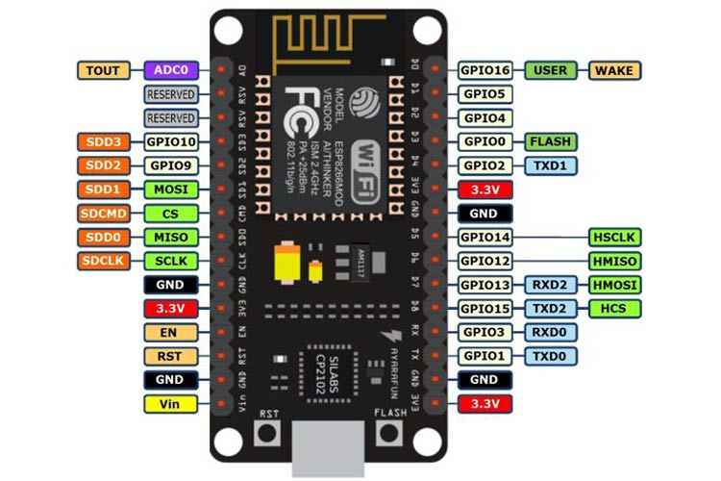
Receiver

Figure 1 Block Diagram
ML algorithm
Adaptive thresholding is an advanced method of global thresholding. This is a form of image thresholding technique in which the threshold value is adjusted and selected automatically according to the image pixels and layout without manually specifying the threshold value or using any restrictions, for converting the image pixels to grayscale or a binary image without Essentially, this method supports the automatic selection of the threshold value for segregating the main object from its background in various lighting conditions, colours or shape of the object. While providing manual threshold value, the foreground object may not be identified from tha background accurately because of inaccurate threshold value. The object may be identified partially because of variable exposure of the object surface. By using the adaptive thresholding technique, we can differentiate the foreground object form the background with more accurate threshold value.

NodeMCU
The NodeMCU (Node Microcontroller Unit) is an open-source software and hardware development environment built around an inexpensive System-on-a-Chip (SoC) called the ESP8266. Can connect objects and let data transfer using the Wi-Fi protocol. In addition, by providing some of the most important features of microcontrollers such as GPIO, PWM, ADC, and etc., NodeMCU comes with an 80MHz of clock speed and 4MB of flash memory. Support for the 32-bit ESP32 Microcontroller was eventually implemented. Contains a WI-FI connection and can connect to the internet through Wi-Fi. It is best suited for IoT applications. NodeMCU” is actually
Figure 2 nodemcu pin diagram
referring to the firmware, not the development kits. Plus, you can get both the firmware and prototype board designs for free.
RFID Reader
Radio Frequency Identification (RFID) refers to a wireless system comprised of two components: tags and readers. The reader is a device that has one or more antennas that emit radio waves and receive signals back from the RFID tag. Tags, which use radio waves to communicate their identity and other information to nearby readers, can be passive or active. Passive RFID tags are powered by the reader and do not have a battery. Active RFID tags are powered by batteries.

RFID EM-18 Reader
It is used to read unique ID from RFID tags. Whenever RFID tags comes in range, RFID reader reads its unique ID and transmits it serially to the microcontroller or PC. RFID reader has transceiver and an antenna mounted on it. It is mostly fixed in
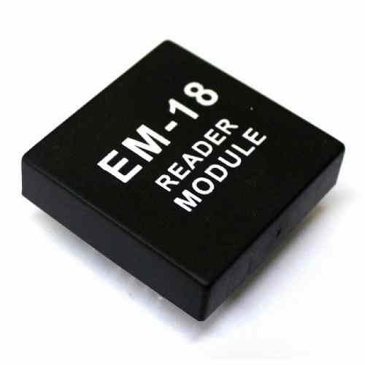
Figure 3 RFID reader

stationary position.
RFID Tag
Includes microchip with radio antenna mounted on substrate which carries 12 Byte unique Identification number.
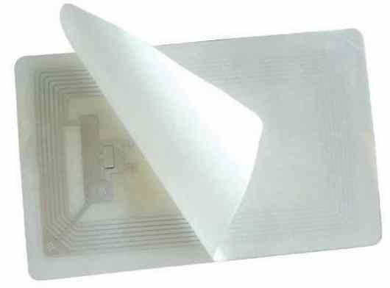
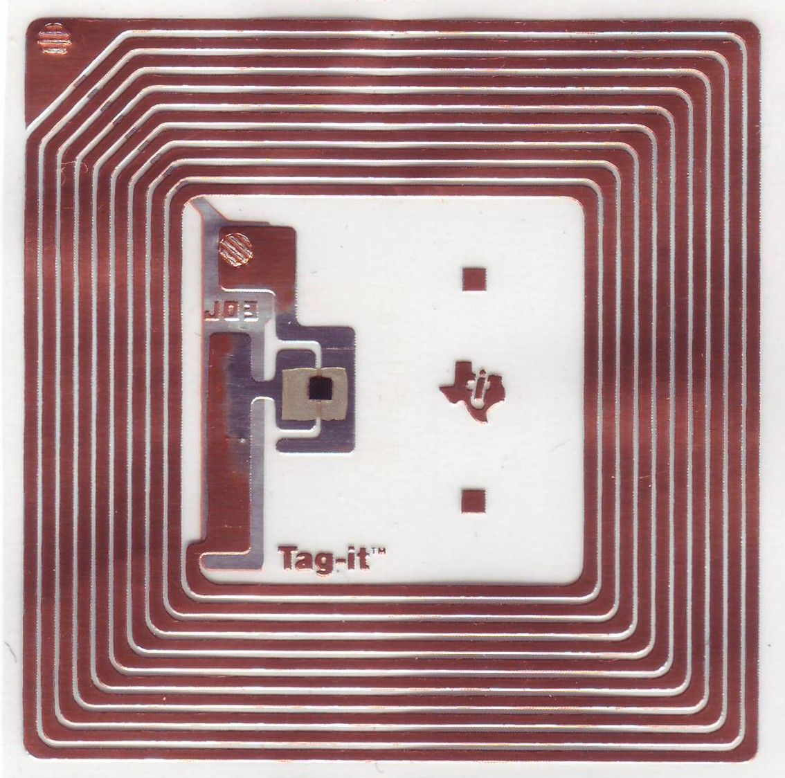
Figure 4 RFID tag

Crystal clear camera
The High-resolution camera comes with a built-in microphone, and auto white balance, night vision feature, and a manual switch for LED. It has 3P high quality lens that produces high-resolution & clear videos.
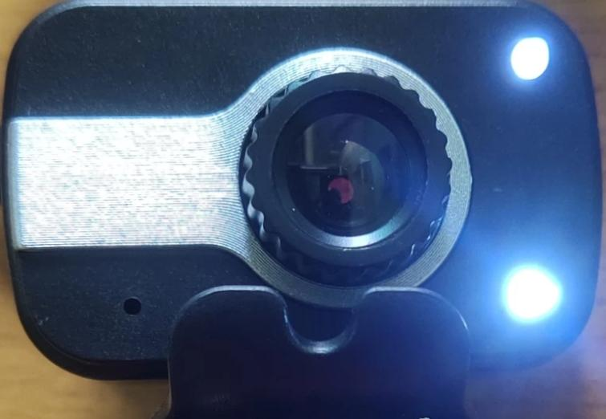
Figure 5 Camera

Power Supply
These days, 12V (or 12VDC) supplies are some of the most widely used power sources. It is common to use a transformer, diode, and transistor combination to change a 120VAC or 240VAC input into a 12VDC output. Regulated power supplies and unregulated power supplies are the two different types of 12V power supply. In addition, significant EMI filtering and shielding are used in acopian switching regulated power supply to reduce noise that is passed to the line and load in both common and differential modes.
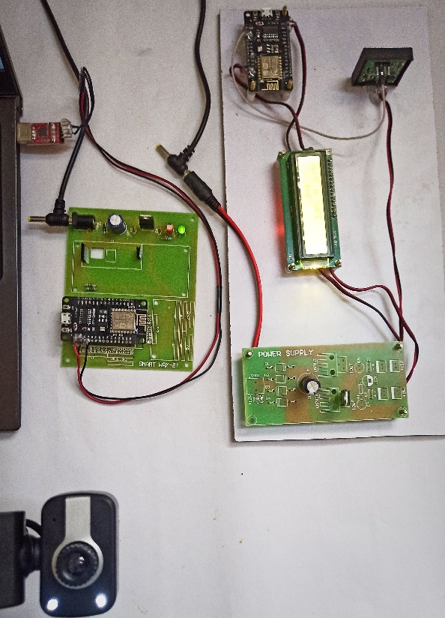
Figure 6 Power supply
LCD Display
LCD module at a temperature and relative humidity of 40% and 40%, respectively. Lower temperatures can slow the display's blinking pace, while higher temperatures can cause the display's overall color to change. The display will return to normal when the temperature falls within the established range. Heat and humidity can cause polarization degradation, bubble production, or polarizer peel-off.
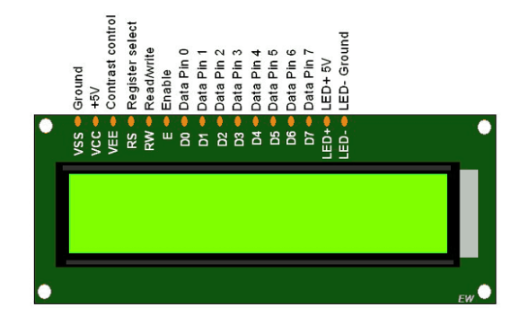
Figure 7 LCD Display
RESULT AND DISCUSSION
In this work initially camera module identifies vehicles density, and LCD display the traffic occurred in this region so don’t take this way. If any heavy vehicles enter into the traffic occurred area the RFid em-18 detect the vehicle Id and automatically fine generated, it will be monitored through an application in the control room. Then density of vehicles was high the transmitter nodemcu send traffic data to receiver nodemcu, then it will show traffic occurred region here. If any vehicle did not notice the display and enter in the traffic area the vehicle id was detected and send to control room here cloud storage plays a major role to monitor the vehicles who are all violated against the traffic rules.
Figure 8 Hardware Setup

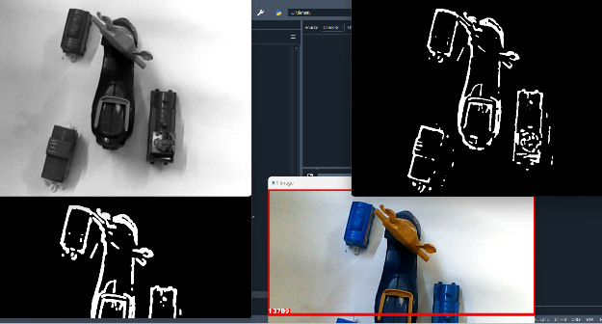
Figure 9 Density detection from camera image
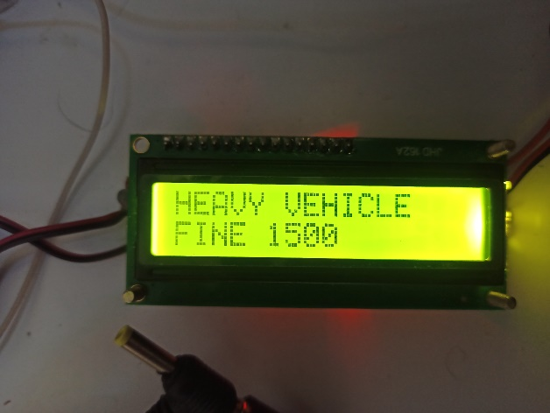
Figure 9 Experimental Results
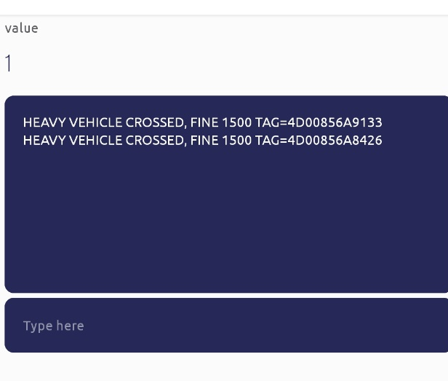
Figure 10 blink results

5. CONCLUSION
It is evident that there is a prerequisite for technology furtherance so that it can reduce the traffic congestion, makes people easy to reach and go on . We can expect significant benefits like Saving fuel, stress free , and easy to reach. The ambulance can easy to reach the hospitals ,in morning the milk can reach to shop on time without any delays it makes business better not only this but also the cold storage it is used. The density of the vehicles was detected by already trained data. It can be utilize in urban and semi urban areas, sometimes the heavy vehicles travel through rural areas and sometimes distribution occurs in rural areas also , so this we can expect and error -free is used rural areas also . It will reduce the Patrol stress and work pressure.
References
- Analysis of Traffic Congestion Impacts of Urban
Road Network under Indian Condition To cite this article: S R Samal et al 2020 IOP Conf. Ser.: Mater. Sci. Eng. 1006 012002
- Controlling & calibrating vehicle-related issues using rfid technology by srivelravi, arokiaraj David & Mohammed Imad Uddin
- Intelligent Road Traffic Control System for Traffic Congestion by A Perspective Pallavi A. Mandhare , Vilas Kharat , C.Y. Patil
- Traffic Controller Using Image Processing by Mrs. Sangeetha, Ms. Kavibharathi, Gnanasoundari & Mr. Kishorekumar T
- Research on traffic congestion detection from camera images in a location of da lat by Nguyen Thi Luong
- Iot based smart highways by dr. R. Shankar, t. Aishwarya, v. Rahul, 4g. Jagadish, p. Srikanth Reddy
- Vehicle Detection in Traffic Monitoring with Machine Learning Based on Big Data and Cloud Patel Parin, Gayatry Pandi (Jain), Research Scholar
- Injury severities from heavy vehicle accidents: An exploratory empirical analysis by panel Hamsa Zubaidi , Ali Alnedawi , Ihsan Obaid , Masoud Ghodrat Abadi
- WSNet: A local–global consistent traffic density estimation method based on weakly supervised learning by panel Ying-Xiang Hu, Rui-Sheng Jia, Yan-Bo Liu, Yong-Chao Li, Hong-Mei Sun
- High-performance optimal incentive-seeking in transactive control for traffic congestion panel Daniel E. Ochoa, Jorge I. Poveda
- Mobile phone penalties and road crashes: Are changes in sanctions effective panel Jane M. Fry
- Influence of road and environmental factors towards heavy-goods vehicle fatal crashes panel Nor Izzah Zainuddin, Ahmad Kamil Arshad, Rizati Hamidun, Suria Haron, Wardati Hashim

