SONAR ROCK VS MINE PREDICTION

USING LOGISTIC REGRESSION & K -
NEAREST NEIGHBOR

MR. M.KRISHNA RAJ. ASSOCIATE PROFESSOR¹ , ROHITH B², ROSHAN S.B^{3,} YUGENDRAN M⁴

1.Department of Information Technology, Panimalar Institute Of Technology, Tamil Nadu - 600123, India, Monykrishnaraj@gmail.com.
2.Department of Information Technology, Panimalar Institute Of Technology, Tamil Nadu - 600123, India, rohithrohithbalaji2002@gmail.com
3.Department of Information Technology, Panimalar Institute Of Technology, Tamil Nadu - 600123, India, roshan24001@gmail.com
4.Department of Information Technology, Panimalar Institute Of Technology, Tamil Nadu - 600123, India,yugeyou@gmail.com

ABSTRACT: Caval defense systems rely on the use of underwater mines as a critical layer of security, but these mines pose a risk to marine life and submarines due to their resemblance to rocks. To counter this threat, Mine Countermeasure (MCM) units utilize mine hunting, which involves the detection and classification of all mines within a suspicious area. This process typically involves using a sonar mounted on a ship or underwater vehicle to capture data, which is then analyzed by military personnel to identify mine-like objects (MLOs) and benign objects. To improve the accuracy of this system, it is necessary to develop a more precise prediction model. Such a model could significantly enhance the safety and reliability of underwater mine detection. However, the accuracy of the prediction model is directly linked to the quality of the data used to train it. To address this issue, we used a dataset obtained from sources such as Kaggle to train a machine learning model for underwater mine and rock classification. The dataset comprises 208 sonar signals recorded at 60 different angles, which capture the unique frequency characteristics of underwater objects. We compared the performance of three binary classifier models using Python and supervised machine learning algorithms, and selected the most accurate model for predictions

KEYWORDS: mine detection; mine classification; sonar imagery; mine countermeasure; mine-like object

I. INTRODUCTION

Underwater Mines:

To prevent enemy surface ships and submarines, self-contained explosive devices known as underwater or naval mines have been utilized since the mid-19th century. During the American Civil War, David Buchner introduced sea mines in 1977, and today, an estimated 5,000 naval mines from both world wars remain in the Adriatic Sea. While previous mines were only triggered by physical contact, modern mines can be activated through acoustic, pressure, and magnetic changes in the water, referred to as influence mines. These underwater mines are classified as either offensive or defensive warfare, with the former being strewn across hostile shipping lanes to damage merchant ships and military boats, while the latter are placed along coastlines to divert enemy submarines and ships away from critical locations and into more heavily guarded areas. Due to their resemblance to rocks in terms of shape, length, and width, mines are often misidentified. To avoid such confusion, a more precise input is needed to achieve an accurate output. One effective method of detecting mines is through the use of SONAR technology.

Sonar:

The SONAR system uses sound waves to locate and detect objects underwater. SONAR has numerous applications, including acoustic mine detection for military purposes, finding fish, mapping the ocean floor, and locating divers for non-military purposes. The range and frequency of SONAR are limited due to the rapid increase in sound wave attenuation with frequency. SONAR frequencies typically range from 0.1 to 1 MHz for mine hunting, with a range of 1 to 0.1 km. Ultrasonic waves are preferred over infrasonic waves in SONAR, as they cannot propagate underwater. SONAR is divided into two types: active and passive. Passive SONAR only detects sounds and is therefore called listening SONAR. Active SONAR uses a sound transmitter and receiver. When a sound wave from the transmitter hits an object, it reflects back and creates an echo. The receiver records the frequencies of the object's echo to determine its nature. In this case, we use the frequencies obtained by active SONAR at 60 different angles as input to determine whether the target is a mine or a rock. The frequency range of active SONAR is typically 20KHz.

The process of mine countermeasures is typically broken down into four stages:

- detection, which involves locating targets through various signals such as acoustic or magnetic;

- classification, which distinguishes between potential mines and harmless objects;

- identification, which confirms the classification with the aid of additional information from tools like underwater cameras;

- disposal, which involves safely removing or destroying the mine.

II. LITERATURE SURVEY

- Lu Feng, et al “Application of Logistic

Regression in Predicting the Occurrence of Coal

and Gas Outburst" (2019) .This paper discusses the use of logistic regression to predict the occurrence of coal and gas outburst in underground coal mines. The authors found that the logistic regression model had a high accuracy rate and could effectively predict coal and gas outburst.

- Yanping Wei and Wenqiang Sun “K-Nearest

Neighbor Method for Predicting Coal and Gas Outburst" (2019) Explores the use of KNN to predict coal and gas outburst in coal mines. The authors found that KNN had a higher prediction accuracy than traditional methods and could effectively predict coal and gas outburst

- Bakytbek Jumabekov, et al “Logistic

Regression and K-Nearest Neighbor Techniques in Predicting the Occurrence of Gold Mineralization in the Kyrgyz Republic" (2019).

This paper discusses the use of logistic regression and KNN to predict the occurrence of gold mineralization in the Kyrgyz Republic. The authors found that both techniques had high prediction accuracy, with KNN outperforming logistic regression.

.

- A. Akande, et al. “A Comparative Study of

Logistic Regression and K-Nearest Neighbor for Prediction of Mine Accidents” (2016). This paper compares the performance of logistic regression and

KNN in predicting mine accidents. The authors found that both techniques had high accuracy rates, but KNN outperformed logistic regression.

- Lingling Zhang, et al "Application of Logistic

Regression and K-Nearest Neighbor to

Predicting Rockburst in Deep Metal

Mines”(2020).This paper discusses the use of logistic regression and KNN to predict rockburst in deep metal mines. The authors found that both techniques had high prediction accuracy, with KNN outperforming logistic regression.

- S. K. Das and S. K. Pal . “Prediction of roof fall risk in underground coal mines using logistic regression and decision tree analysis"(2015). This paper presents a comparative study of logistic regression and decision tree analysis for predicting the risk of roof fall in underground coal mines. The authors found that logistic regression had a higher accuracy than decision tree analysis.

  - EXISTING SYSTEM

The existing system for Sonar Rock vs Mine prediction using machine learning algorithms using traditional methods had several disadvantages. The detection of mines was done by explosive ordnance disposal divers, marine mammals, video cameras on mine neutralization vehicles, and laser systems, which can be time-consuming and costly. Additionally, these methods had a limited range and were not highly accurate, leading to the risk of undetected mines.

Moreover, the use of such equipment can cause a risk to marine life, and the loss of life cannot be ruled out. These traditional methods had limitations and risks associated with them, such as harm to marine life, insufficient accuracy, and the potential loss of human life.

As technology improved, SONAR became a primary tool for detecting mines in the underwater environment. SONAR uses sound waves to detect objects in water and has proved to be an effective tool for detecting mines in real-time. However, even the SONAR-based system has some limitations, such as the possibility of generating false positives, difficulty in detecting small-sized mines, and the need for constant calibration.

IV. PROPOSED SYSTEM

We developed a predictive system using a dataset from "Analysis of Hidden Units in a Layered Network Trained to Classify Sonar Targets." The dataset was obtained by striking metal cylinders

with sonar signals from 60 angles. The output frequencies were used as input to predict if the object is a rock or a mine using classification machine learning techniques.

To accurately classify objects as either rocks or mines, we used classification techniques in our machine learning models. These models were trained on the dataset to ensure they could accurately distinguish between rocks and mines based on their unique frequency characteristics. By utilizing these machine learning techniques, we aim to improve the accuracy and reliability of underwater mine detection and reduce the risk of harm to marine life and submarines. Our predictive system has the potential to enhance the safety and effectiveness of Mine Countermeasure (MCM) units in identifying mines and protecting naval vessels.

In order to decrease the workload of technical operators and reduce post-mission analysis time, computer-aided detection (CAD), computer-aided classification (CAC), and automated target recognition (ATR) algorithms have been implemented.

These algorithms analyze various types of image characteristics, which can be classified into three categories:

- texture-based features, such as patterns and local variations of image intensity,
- geometrical features like length and area

- spectral features including color and energy.

Mine detection and classification (a) based on segmentation, and (b) on texture feature extraction.

Various detection and classification methods for detecting mines in sonar images have been developed, including classical image processing, machine learning (ML), and deep learning (DL) techniques. While ML has limitations in terms of time, reliability, and background information, DL overcomes these limitations with its ability to work with unstructured and structured data and perform automatic feature extraction. DL also works efficiently with vast amounts of data and is more reliable.

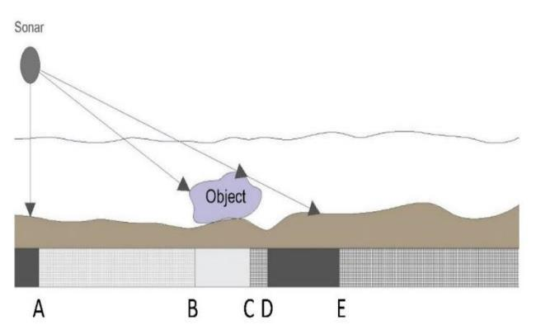

Figure 1. Background, shadow and highlight combination.

Machine learning automatically detects or predicts patterns in data, but it requires high-quality imaging data and has limitations. Deep learning, which uses artificial neural networks, overcomes these limitations and is more reliable.
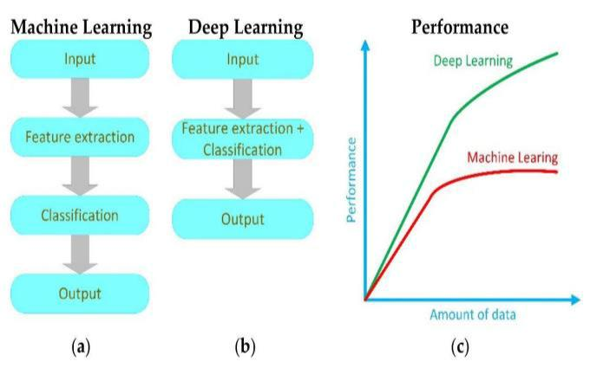

Figure 2.
- Working process of ML;

- working process of DL; (c) performance of ML and DP

Deep learning algorithms require large amounts of data for training, but obtaining high-quality data for mine detection remains a challenge due to confidentiality and lack of publicly available datasets. To address this, techniques such as sonar data simulation and data augmentation are used.

Transfer learning and algorithm fusion are also employed to improve reliability in mine detection and classification methods. Combining classical image processing with deep learning can further enhance performance and mitigate the negative impact of unbalanced data. A review of recent and past methods in mine detection and classification is presented.

Underwater Sonar:

Sonar is an acronym for SOund Navigation And Ranging, which is a technique used to locate objects underwater by transmitting and receiving acoustic waves. The basic principle of sonar is to send out an acoustic wave that travels through water and bounces back when it hits an object. By measuring the time it takes for the sound wave to travel to the object and back, the distance to the object can be calculated. The speed of sound in water is faster than in air and is affected by factors such as depth, temperature, pH, and salinity. The frequency of acoustic waves used in sonar ranges from 10 Hz to 1 MHz, depending on the application. The sonar equation is used to calculate the energy required to detect a target, taking into account factors such as detection threshold, source level, transmission loss, target strength, noise level, and directivity index. Sonar systems use hydrophones to transmit and receive acoustic waves, and the accuracy of range estimation depends on the pulse length and bandwidth of the acoustic signal.
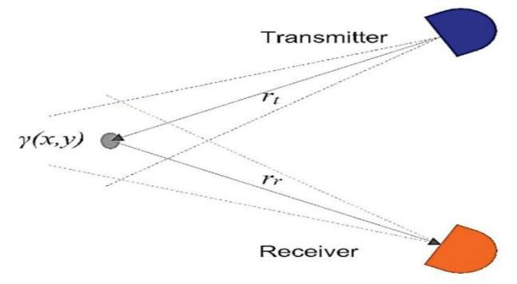

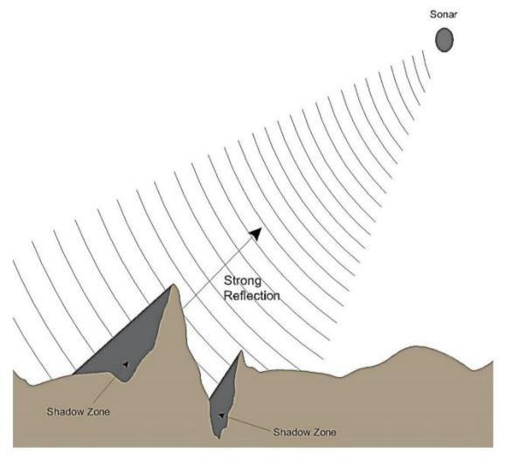
Figure 3. Basic imaging geometry
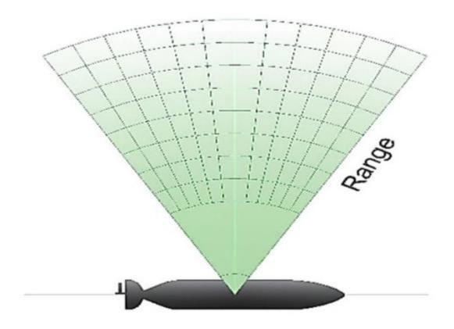

Figure 6. Acoustic reflection.

Figure 4. Sectorscan sonar.
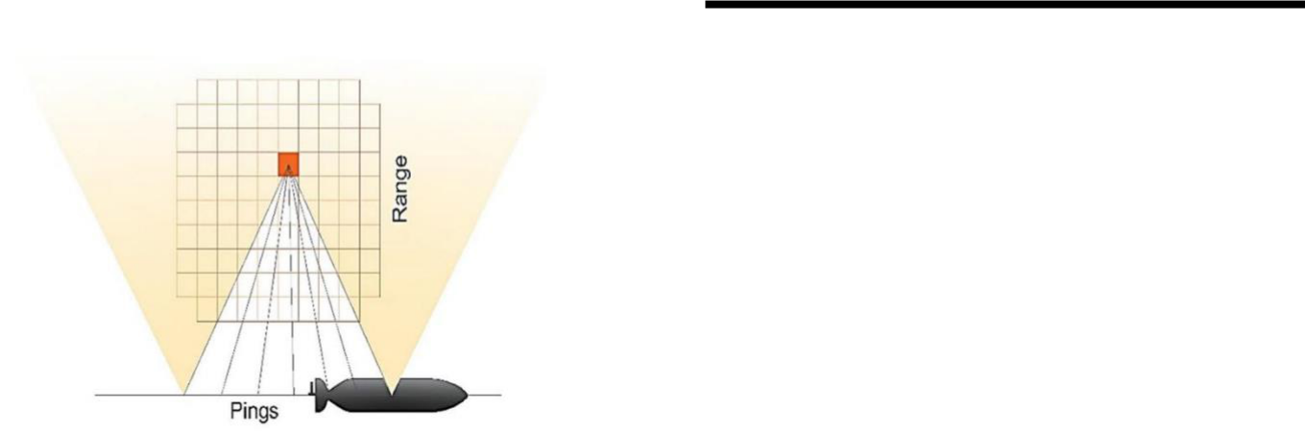

Figure 5. Synthetic-aperture sonar

Highlights and Shadows:

In sonar imaging, a target's reflectivity determines the size of the highlight and shadow regions produced. The target's structure, thickness, size, and shape affect its reflectivity, while the shadow is caused by wave obstruction. Shadows provide information on target characteristics and can also represent bottom depressions, but they must be combined with highlights to locate targets of interest.

- METHODOLOGIES:

- Data collection: The first step in any data-driven prediction task is to collect relevant data. In the case of mine prediction, this can involve collecting data on factors such as geology, mining techniques, equipment, environmental conditions, and safety records. This data can be collected manually, through surveys or observations, or automatically, using sensors and other monitoring technologies.

- Data preprocessing: Once the data is collected, it needs to be preprocessed to make it suitable for analysis. This can involve tasks such as cleaning the data, removing missing values, scaling and normalizing the data, and splitting the data into training and testing sets.

- Feature selection: The next step is to select the most relevant features to be used in the prediction model. This can involve using domain knowledge to identify relevant features, or using feature selection techniques such as correlation analysis or principal component analysis (PCA).

- Model training: Once the data is

preprocessed and the features are selected, the logistic regression and K-nearest neighbor models can be trained using the training data. The models are trained by adjusting their parameters to minimize a loss function, such as mean squared error or cross-entropy loss.
- Model evaluation: After the models

are trained, they need to be evaluated to assess their performance. This can involve testing the models on the testing data and calculating metrics such as accuracy, precision, recall, and F1 score.

- Model tuning: If the model

performance is not satisfactory, model parameters can be adjusted to improve performance. For example, in the case of K-nearest neighbor, the value of k can be adjusted to optimize prediction accuracy.

- Model deployment: Once the models

are trained and their parameters are optimized, they can be deployed for prediction in real-world scenarios. This can involve integrating the models with existing monitoring and control systems in mining operations.

classification, efficient convolutional networks, and statistically-based algorithms have also been proposed for target classification, achieving robustness against noise, occlusion, and clutter.
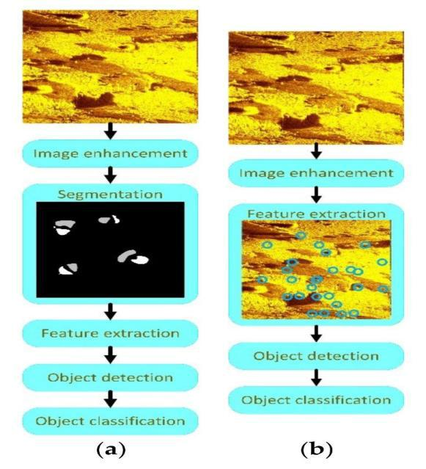

Object Detection:

Object detection in sonar is challenging due to environmental obstacles, but mines can be detected due to their highlight and shadow segments.

Image enhancement:

Image enhancement techniques such as histogram equalization, filters, and wavelet-based denoising reduce noise and normalize images to prepare for object detection and classification. The choice of technique should align with detection and classification schemes.

Image segmentation:

Image segmentation is widely used in sonar imagery for identifying homogeneous regions such as highlight and shadow areas related to mines. Various techniques such as thresholding, MRF, fuzzy functions, and deep learning-based methods have been employed for segmentation, providing improved accuracy and reduced computational

resources. Sparse reconstruction-based

Figure 7. Image segmentation

MLO Detection:

Various techniques, such as thresholding, MRF, fuzzy functions, and deep learning-based methods, have been used for image segmentation in sonar imagery to identify regions like highlight and shadow areas related to mines. A Gabor-based deep neural network architecture was developed to detect MLOs. It merges strong and weak features to accurately detect MLOs at multiple scales, providing an effective method for AUVs in terms of accuracy and model size.

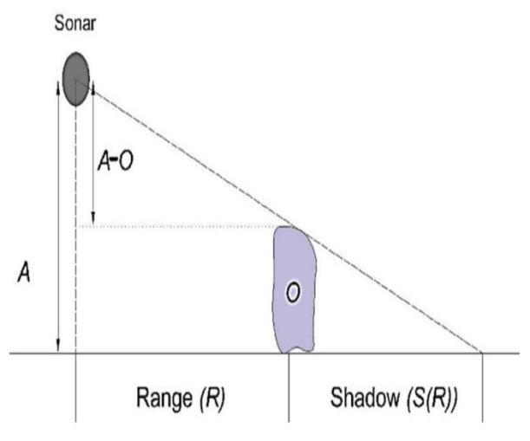

Figure 8. Template’s geometry.
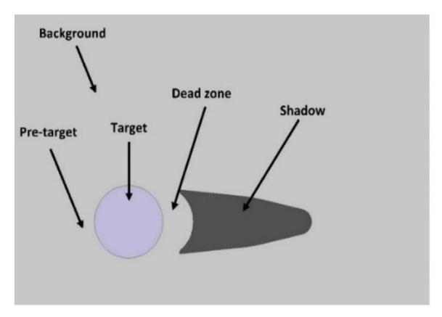

Figure 9. Template of an MLO.

Evaluation of classification models:

When choosing an ML model, factors like performance, complexity, dataset size, and understandability must be considered. Evaluating the model beforehand is crucial to improve its performance. Classification metrics are used to assess various techniques and determine their potential. The simplest way to evaluate a model is to measure its accuracy.

Accuracy =(TP + TN)/( TP + TN + FP + FN)

Figure 10. Architecture diagram
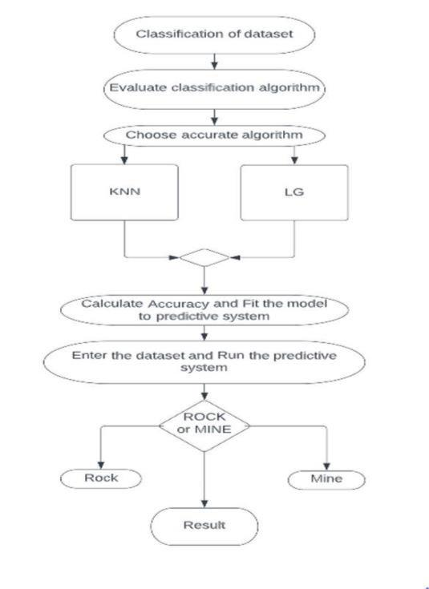

WORKING PROCEDURE:

Step 1: Firstly, we collect the dataset and prepare it by cleaning it through exploratory data analysis.

Step 2: Then, we divide the dataset into training and testing sets and evaluate various classification models.

Step 3: After evaluating the models, we select the top three performers, namely KNN, SVM, and Logistic Regression.

Step 4: We assess the accuracy of these models and generate a classification report.

Step 5: Next, we train the models to create an efficient and accurate prediction system.

Step 6: Finally, we use the predictive systems to determine whether the object is a Mine or a Rock.

VI. RESULTS

KNN:

KNN is a basic classification algorithm for pattern recognition based on feature categorization. The data is split into dependent and independent variables, with categorical values in the dataset. The KNN model is fit to the train and test data with the optimal k value (in this case, k=3).

Logistic Regression:

Logistic Regression predicts binary outcomes by analyzing the relationship between dependent and independent variables. After partitioning the dataset, we fit the model using a binary encoder and liblinear solver, evaluate its performance, and use it to create a prediction system.

VII FUTURE

ENHANCEMENT:

- Feature engineering: The performance of logistic regression and K-nearest neighbor models can be improved by identifying and engineering more relevant features. This can involve using domain knowledge to select or create new features, or using techniques such as principal component analysis (PCA) to extract useful information from the data.

- Ensemble methods: Ensemble methods, such as bagging, boosting, and random forests, can be used to combine multiple logistic regression and K-nearest neighbor models to improve prediction accuracy. This can be particularly effective when there is a large amount of data and multiple models can be trained on different subsets of the data.

- Deep learning: Deep learning techniques, such as convolutional neural networks (CNNs) and

recurrent neural networks (RNNs), can be used to automatically learn useful features from the data and improve prediction accuracy. These techniques have been successful in a variety of applications and may be particularly useful when dealing with complex data or when the relationship between features and outcomes is nonlinear.

4. Model interpretability: While logistic regression and K-nearest neighbor are relatively interpretable models, there is still room for improvement in understanding how they arrive at their predictions. Future research can focus on developing methods to explain the decisions made by these models, which can increase trust and confidence in their predictions.

- Real-time prediction: Mining operations require real-time decision making, and therefore there is a need for mine prediction models that can make predictions quickly and accurately. Future research can focus on developing models that can make predictions in real-time and can be integrated with existing monitoring and control systems.

- Improved data collection: The accuracy of mine prediction models relies on the quality of the data used to train them. Future research can focus on improving data collection methods, such as using sensors and other monitoring technologies, to collect more accurate and comprehensive data. This can help to improve the accuracy and usefulness of mine prediction models.

VIII. CONCLUSION

Our project aims to detect rocks and mines in the ocean bed to prevent negative economic and environmental impacts caused by naval mines. The traditional methods of detection involve sonar signals and manpower, with the former being the safer option. The collected data is stored in a CSV file and analyzed using various machine learning techniques to build an accurate prediction model. Python, being open-source and fast, is used to create

a cost-effective solution. The objective of this project is to simplify the process of mine detection and improve its efficiency.

IX. REFERENCES

- Sri Ramya Yaramasu , Uppada Sai Gayatri, Vadlamani Manjusha, Vaishna C Bhanu, Koda Indu.

“A Review of Underwater Mine Detection and Classification in Sonar Imagery”

- B. Zhu, L. Wang, and Y. Zhao "A study on mine safety early warning model based on logistic regression and KNN algorithm," (2016).

- H. Jia, J. Wu, Y. Sun, and J. Zhang "A mine ventilation network model based on KNN algorithm and logistic regression," (2017)

- Wang, J. Yang, and Y. Li, "Research on prediction of mine water inrush based on K-nearest neighbor algorithm and logistic regression," (2016)

- S. Du, G. Zhang, and F. Chen, "Research on mine roof monitoring and prediction model based on K-nearest neighbor algorithm and logistic regression,"(2016)

- Y. Guo, S. Hu, and X. Zhang, "Research on the prediction model of mine water inrush based on logistic regression and KNN algorithm,"(2020).

