DISSECTION

INTRODUCTION:-
Splenules are small lymphoid tissues seen as a separate mass from the actual spleen. The site of occurrence of it may vary but it is mostly on the hilum part of spleen. Embryologically it is considered as ananomaly of incomplete fusion of mesenchymal buds ordran external injury to the area can also be a reason. Interesting fact is that it is functionally a mini-spleen and receives supply from the branches of splenic artery . The only identification points other than these is the sharp regular outer margin and the location. Here presence of splenic artery makes us sure that the structure is neither any pathology or a lymphadenopathy.

CASE REPORT:-

■During routine dissection classes for students in the anatomy department of KAMC Vadodara, we came across a small splenule embedded in an embalmed female cadaver of the age of 50 years.

■On measuring the length it was 15mm with breadth and depth equal to 15mm.

■There was a small branch of splenic artery and splenule also has Splenic tissue which is more darker in colour as like that of spleen proper.

DIAGRAM:-
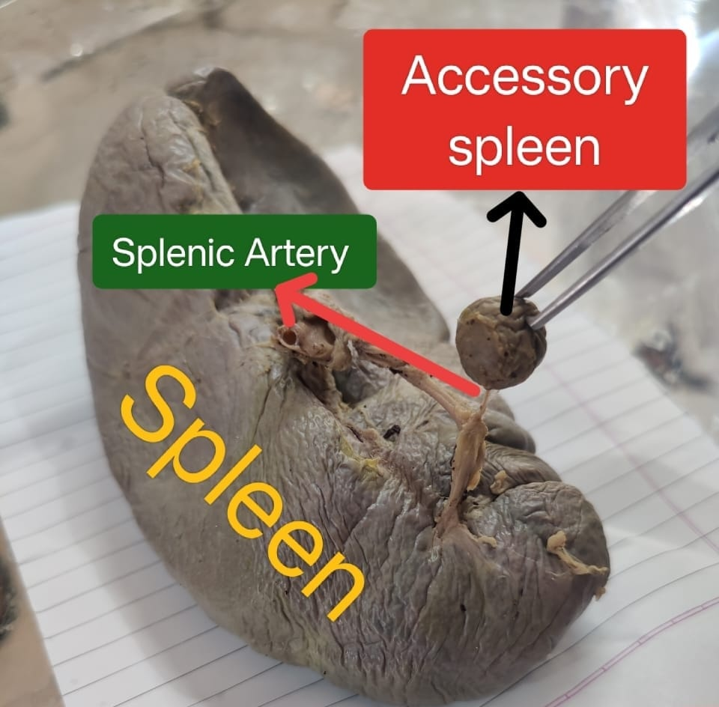

DISCUSSION:-

■It should resemble the normal spleen macroscopically and microscopically.

■On identifying the spleen just below the left rib cage one can search for the presence of only splenules identical to spleen.

■They can be ovoid or very rarely triangular, usually contained within a capsule.

FINDINGS:-
■Here the mass instead of the common shape of occurrence, i.e. The ovoid shape, it slightly resembles a globular round mass.

■The confirmation of it as a splenule or accessory spleen is done with the presence of splenic artery, its location Is in the area near the hilum and it colour is identical to the colour of spleen.

IMPORTANCE OF SPLENULES:-

1.It is commonly misunderstood as a lymphadenopathy. Helps to differentiate from this one.

2.Mistaken as a malignant tumor. Only by identifying the features of colour and splenic artery connected near the hilum makes us differentiate it from cancerous masses.

For confirmation, it is better to evaluate for any growth of tissue, if any biopsy may be recommended for further evaluation.

3.In case of surgeries and splenectomy, it is recommended for removal of splenules also to avoid any further complications and growth of splenule.

CONCLUSION:-

Knowledge of variational anatomy of spleen is of fundamental importance to surgeons while they perform surgical operations not to mistaken it as some other structures which are related to the spleen, to prevent interpretation errors in diagnostic imaging for radiologists and is very important for anatomists during routine cadaveric dissections.

CONFLICTS OF INTEREST:- None

REFERENCES:-

[1]. Pushpalatha M, Sujana M, Sharmada K L. Accessory
Spleen –a case report. Int J Cur ResRev.2012
Nov;4(1):121-2.
[2]. B Calin, BN Sebastin, B Vasile, O Andrea. Lost and
found: the accessoryspleen. Med Con.2012
June;2(26):63-6.
[3]. Batista et al. Accessory spleen detection at
laparoscopic splenectomy is adequate for immune
thrombocytopenic purpura- a prospective study.
Bras J Video- Surg. 2008;1(4):156-162.
[4]. Impellizzeri et al. Accessory spleen torsion: a rare
cause of acute abdomen in children: a

review.2009
Sep;44(9):e15-18.
[5]. Gayer G, Zissin R, Apter S, Atar E, Portnoy O, Itzchak
Y.CT findings in congenital anomalies of the spleen.
Br J Radiol.2001 Aug;74(884):767-2.
[6]. H Amanjit, Bhardwaj S, Handa U. Splenunculi-report
of three cases. J Anat Soc India. 2002; 51(1):70-71
[7]. Barawi M, Bekal P, Gress F. Accessory spleen:a
potential cause of misdiagnosis at EUS Gastrointest
Endosc.2000 Dec;52(6):769-72.
[8]. Standring SM (ed.) 2005.Gray’s Anatomy. 39th
ed.New York: Churchill Livinstone. P1239,1267.
9]. Moore KL.Clinically Oriented Anatomy.3rd
ed.Baltimore: Williams & Wilkins 1992; 185-7.

[10]. Richard D, Rice WT, Fremont, MD. Splenosis: a
review. South Med J.2007;100(6): 589 -93.
[11]. Dodds WJ, Taylor AJ, Erickson SJ, Stewart ET, Lawson
TL. Radiologic imaging of splenic anomalies. Am
J Roentgenol.1990;155:805–10.
[12]. Unver Dogan N, Uysal II, Demirci S, Dogan KH, Kolcu
G. Accessory spleens at autopsy. Clini Anat.2011
Sep;24(6):757-62

