SMART FARMING WITH IOT

Shwetha S V, G P Hegde, Shreyas S S, Akshay Bhandarkar H, Sujay V Mutalik Desai, Rakesh V R
Department of Information Science and Engineering
Sri Dharmasthala Manjunatheshwara Institute of Technology, Ujire-574240, Karnataka, India

Abstract: This research paper explores the implementation of IoT-based smart farming systems using Arduino, soil moisture sensors, and PIR sensors. The proposed system addresses two critical aspects of farming - automated irrigation and animal intrusion detection. By detecting low soil moisture levels, the system activates motors to irrigate crops, improving crop yield and reducing water usage. Similarly, the PIR sensor triggers a buzzer to alert farmers of animal intrusions, helping protect crops from damage. The paper analyzes the benefits of using IoT-based smart farming systems and its potential to transform the agriculture sector.

Keywords –: Smart Farming, Intrusion detection, Automatic irrigation system, Internet of Things, Arduino, Smart Agriculture

INTRODUCTION

India is one of the countries having one of the greatest populations in the world. India depends mostly on agriculture for its income in order to maintain a robust economy. In India, the agricultural sector employs around 70% of the workforce and generates 25% of the GDP. As the nation's agricultural sector grows, the government is providing farmers with a variety of online tools and service providers to maintain healthy agricultural profitability.

With the world population projected to reach 9.7 billion by 2050, there is a growing demand for sustainable and efficient agricultural practices. Smart farming, an emerging field that leverages the power of Internet of Things (IoT) technologies to revolutionize traditional agriculture, has the potential to address these challenges. By integrating sensors, actuators, and other IoT devices, smart farming systems can monitor and control various aspects of crop growth, including irrigation, fertilization, and pest control, in real-time.

In this research paper, we present a smart farming system that uses Arduino, soil moisture sensors, and PIR sensors to automate irrigation and detect animal intrusions in farmland. The system is designed to address two critical challenges faced by farmers - efficient water usage and protection of crops from animal damage. When the soil moisture level is low, the system activates motors to irrigate crops, reducing water wastage and improving crop yield. Additionally, the PIR sensor triggers a buzzer to alert farmers of animal intrusions, allowing them to take immediate action and protect crops from damage.

The paper analyzes the benefits of implementing IoT-based smart farming systems and their potential to transform the agriculture sector. We discuss the advantages of using real-time data and automation to optimize crop growth, reduce costs, and increase productivity. The research paper also explores the challenges and limitations of implementing smart farming systems and highlights areas for future research. Overall, this paper aims to provide insights into the potential of smart farming and its role in shaping the future of sustainable agriculture.

LITERATURE SURVEY

Several studies have shown the potential benefits of smart farming with IoT, including increased crop yields, reduced water consumption, improved animal health, and better resource management. One study by Zhang et al. (2020) [1] demonstrated the use of IoT sensors to monitor soil moisture and temperature in a greenhouse, resulting in a 15% increase in tomato yield.
Bhattacharya and Haque (2021) [2] conducted a comprehensive review of IoT-based smart agriculture, where they analyzed the various components of smart farming, such as sensors, devices, networks, and data analytics. They also discussed the benefits and challenges of IoT-based smart agriculture, including improved crop yields, reduced water consumption, and increased efficiency. The authors highlighted the need for standardization and interoperability in IoT-based smart agriculture to ensure seamless integration of different devices and systems.
Another study by Mawson et al. (2019) [3] explored the use of IoT-based systems for precision agriculture. The authors discussed the different types of sensors used in precision agriculture, such as soil moisture sensors, temperature sensors, and GPS. They also highlighted the importance of data analytics in precision agriculture, which can help farmers make data-driven decisions and optimize their crop yields. The authors concluded that IoT-based systems have the potential to revolutionize the way farming is done, and can lead to more sustainable and efficient agriculture practices.
In a study by Mehta et al. (2021), [4] the authors proposed a smart irrigation system using IoT-based technologies. The system involved the use of soil moisture sensors and a microcontroller to automatically water crops when the soil moisture levels were low. The authors tested the system in a greenhouse environment and found that it reduced water consumption by up to 60% while maintaining optimal soil moisture levels. The authors concluded that IoT-based smart irrigation systems have the potential to revolutionize agriculture and make it more sustainable.

STUDY CARRIED OUT ON RELATED WORK

The study of the existing systems with respect to the proposed system is carried out. We have studied multiple existing systems that facilitate smart agriculture.
Farmbot, Seeed Studio, CropX, John Deere Precision and Edyn are some of the systems that are available to the farmers on the market. They provide multiple features such as automated irrigation of water to crops, animal intrusion detection and alarming, high level of precision in irrigation and fertilization, automated soil mapping, soil nutrient sensing and the ability to control using mobile app.
However, there are some limitations in all of these systems such as high cost, limited functionality, requiring technical expertise for setup and maintenance among others.
The proposed system aims to be easy to deploy, inexpensive and can scale relatively well depending upon requirements. It is also easy and simple to setup and maintain and does not require extensive technical expertise and can be effectively used. The proposed system is also more versatile and since it is not limited to a specific use case scenario, it can be utilized in a wide variety of different scenarios and environments.

METHODOLOGY
- Step 1: The system will collect data from soil moisture sensor. This includes how much water content is present in the farmland.
System | Pros | Cons
Farmbot | Low cost, Automated irrigation and animal intrusion detection. | Requires technical expertise for setup and maintenance.
Seeed Studio | Low cost, Variety of sensors available, Easy to use with drag-and-drop interface. | Limited functionality compared to other systems.
CropX | High level of precision in irrigation and fertilization. Automated soil mapping. | High cost, Limited to soil moisture sensing and irrigation.
John Deere Precision | Automated mapping and data analysis. | Can be expensive for smaller organizations. Limited functionality compared to other systems.
Edyn | Easy to use with mobile app, Soil nutrient sensing. | Limited scalability.
- Step 2: By analyzing the collected data, the Arduino decides whether to deliver water to the farmland or not depending on the values obtained from the sensor and comparing it to a certain predefined threshold.
- Step 3: The system also makes use of PIR sensor in order to detect motion by any invasive animals.
- Step 4: In case of detection of any intrusive animals, the system will enable the alarm system by turning the buzzer on.
- Step 5: By the combination of multiple sensors, the system will deliver optimal amount of water to the farmland and facilitates an alarm system in case of any invasive animals.

PROPOSED SYSTEM
The architecture of the proposed system is depicted in figure
below
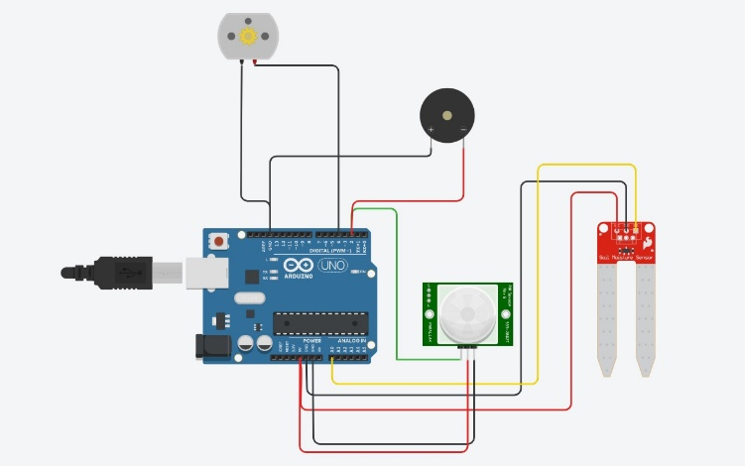
Figure: Architecture of the proposed system

LOW LEVEL SYSTEM DESIGN

The below figure shows the flowchart of Smart Farming with IoT

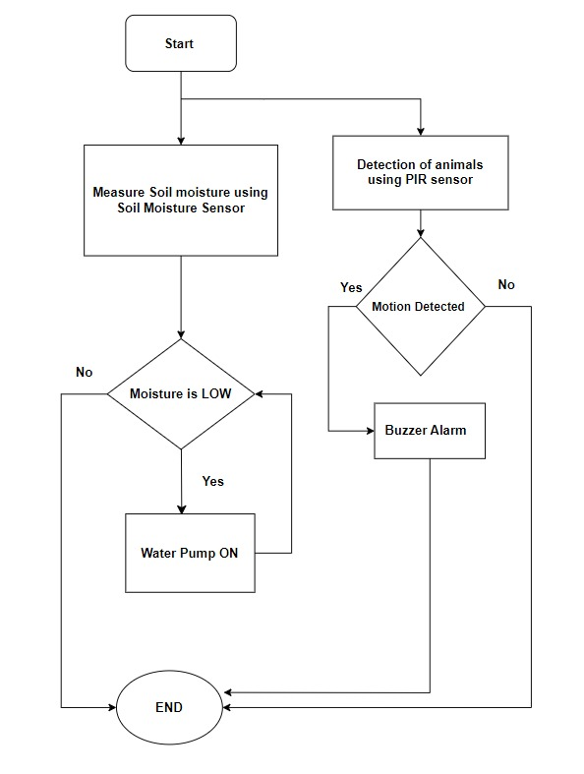
Figure: Flowchart of the proposed system

CONCLUSION
In conclusion, the smart farming system developed in this project demonstrates the potential of IoT technologies to improve efficiency, reduce costs, and increase productivity in traditional agriculture. The system's ability to automate irrigation and detect animal intrusions has significant benefits for farmers, resulting in improved crop yield and reduced crop damage. While there are challenges and limitations to implementing IoT-based smart farming systems, they have the potential to transform the agriculture sector and promote sustainable agricultural practices.

REFERENCES

[1] Zhang, X., Yang, F., Wang, Y., & Huang, S. (2020). Smart agriculture based on IoT: A review. Computers and Electronics in Agriculture, 175, 105595.
[2] Bhattacharya, S., & Haque, M. E. (2021). A comprehensive review on internet of things (IoT) based smart agriculture. Computers and Electronics in Agriculture, 183, 106033.
[3] Mawson, S., de la Hera, A., Storer, A., & Poblete, T. (2019). The Internet of Things in agriculture for sustainable rural living: A review. Sustainability, 11(24), 7064.
[4] Mehta, S., Kaur, P., & Kumar, A. (2021). An IoT based smart irrigation system for precision agriculture. International Journal of Computer Applications, 183(5), 22-27.
[5] Al-Fuqaha, A., Guizani, M., Mohammadi, M., Aledhari, M., & Ayyash, M. (2015). Internet of things: A survey on enabling technologies, protocols, and applications. IEEE Communications Surveys & Tutorials, 17(4), 2347-2376.
[6] Bregt, A. K., & Braun, A. R. (2018). Smart farming: Synergy between sustainable agriculture and digital technology. Springer.
[7] Garg, H., & Sharma, S. K. (2021). IoT-Based Smart Agriculture System: A Review of Applications and Future Perspective. In Advanced Data Analytics for Agriculture (pp. 121-134). Springer.
[8] Khan, M. A., Han, J., & Ahn, S. (2019). IoT-based smart farming: A review. Sensors, 19(22), 4949.
[9] Meena, R., & Rathore, M. (2020). Smart agriculture using IoT: A comprehensive review. Journal of Ambient Intelligence and Humanized Computing, 11(1), 269-292.
[10] Yan, J., Yan, H., & Zhang, Y. (2018). A smart agriculture monitoring system based on IoT. IEEE Access, 6, 14331-14338.

