Source Current Ripple Reduction with Input Voltage Controlled LED Driver
U. Vijaya Lakshmi  Electrical and Electronics Engineering  Gokaraju Rangaraju Institute of  Engineering and Technology  Hyderabad, India  lakswhite29@gmail.com  T. Lahari  Electrical and Electronics Engineering  Gokaraju Rangaraju Institute of  Engineering and Technology  Hyderabad, India  tlahari2002@gmail.com |  | N. Sowmya  Electrical and Electronics Engineering  Gokaraju Rangaraju Institute of  Engineering and Technology  Hyderabad, India nimmanagotisowmya10@gmail.com  Vaishnavi Gorantla  Electrical and Electronics Engineering  Gokaraju Rangaraju Institute of  Engineering and Technology  Hyderabad, India  vaishnavi.gorantla@gmail.com | S. Srikari  Electrical and Electronics Engineering  Gokaraju Rangaraju Institute of  Engineering and Technology  Hyderabad, India srikarisaraswathi@gmail.com  B. Saritha  Electrical and Electronics Engineering  Gokaraju Rangaraju Institute of Engineering and Technology  Hyderabad, India  saritha.banoth2000@gmail.com

Abstract- Nowadays the world is becoming more and more globalized and digitalized. It is now thriving to become more and more self sufficient in each and every field like science, technology, medicine, economy, warfare etc. And in the field of science there are more developments. Let’s say today’s world is directly or indirectly more dependent on LED applications. Lighting applications are becoming more and more LED based. The industries are turning their way to LED’s. It is because they have the potency to change the world. The PV systems are more advantageous if it has a current with reduced ripples. So, for this we are using an LED configuration in PV-based systems will reduce source current ripple. To get the DC voltage output, we used a 3-phase resonant converter. The inverter's input voltage is used to control the output voltage. This regulated voltage is calculated and sent into the PV source. The input to the inverter must remain consistent regardless of changes in the PV source. The low frequency PWM method is used to lower the light.
Keywords— LED configuration, PV systems, ripples, 3-phase resonant converter, PWM technique.

1. INTRODUCTION

Nowadays life has become more and more comfortable due to globalization and technology is developing at a rapid speed. All the countries are striving to improve their resources to become a developed nation. Considering this situation, in the field of science energy usage has become a major challenge globally. So, the solution that we are using is the implementation of LEDs. Even they are replacing the fluorescent lamps. We all are familiar with LEDs in our daily life. They are more advantageous because they have high efficiency, long duration. They also have a speedy response and consume lesser energy and also show right color index.

LEDs are linked in strings that are either series or parallel depending on the application. LEDs are fixed DC devices which supply a steady current to the device. As a result, we must ensure that it's always fed by an efficient device. A circuit with steady power is necessary for the LEDs to function.
The driver's source current may have excessive ripples. In the driving circuit, we use a 3-phase full bridge inverter to reduce this. In addition, we are employing a buck-boost converter to eliminate current ripples. In this case, we may utilize a battery and PV panels as the circuit's input sources. We can achieve low current ripples by using PV panels. We can use a resonant converter for this.
By doing this research, we propose a three-phase resonant converter with voltage control for regulating current in an LED load.
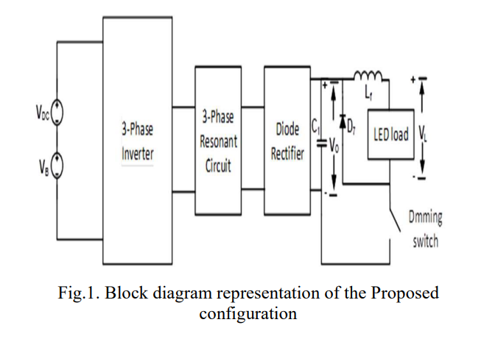

This recommended arrangement is more advantageous since it lowers source current ripples.

1.1 Problem Statement

Many configurations have already been proposed, however they are unsatisfactory. Conventional approaches often entail performing these comparisons one at a time, which may be time consuming. To address this, we created a setup that is far more beneficial and will assist us in developing an LED driver with lower ripple current.

1.2 Objective

The goal of this study is to give a comprehensive examination of the literature and industrial processes related to constraint analysis, as well as a conceptual framework.

2. PROPOSED CONFIGURATION

2.1 Approach

We may conclude from Fig.1 that it is a typical block diagram for our LED setup. We have connected a voltage VDC and a buck-boost voltage VB to the three-phase full bridge inverter, it states. Because we are employing a PV panel as an input source, the source voltage VDC is not continuous. The buck-boost voltage VB either adds to or subtracts from the source voltage. As a result, it aids in keeping a steady input voltage to the inverter. The direct current voltage is transformed to alternating current voltage and then fed via a resonant circuit that includes an inductor and a capacitor. This resonant circuit functions as a filter, removing undesirable voltage and current disturbances. The voltage is then changed from alternating current to direct current by passing through a diode rectifier. This voltage is then transmitted through a capacitor, resulting in a regulated voltage. This regulated voltage is sent into the LED load as an input.
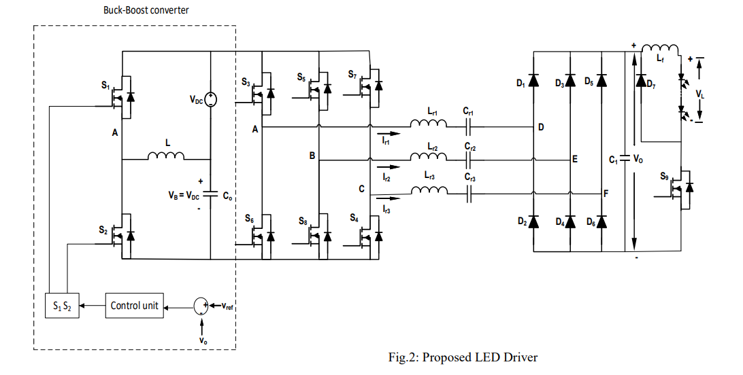
Fig.2 LED configuration

The LED driver is a setup with 1.76 ohms of resistance and 0.4 amps of current for each LED.

2.2 Methodology

- We utilised a photovoltaic panel as an input in this case. It collects solar energy and stores it as a direct current input.
- The trapped energy inside the panel is stored in the battery.
- As a result, the battery stores the energy absorbed by the PV panel.
- We also know that a PV panel does not provide a steady dc voltage.
- As a result, we are employing a buck-boost converter.
- This either increases or reduces the voltage and adds it to the input dc voltage.
- The inverter is now being fed with a consistent voltage.
- For the purposes of our research, the input given to the inverter, which converts input dc voltage and current to output ac voltage, must be kept constant.
- Next, we have a resonant circuit that serves as a filter and contains capacitors and inductors, which eliminates unwanted disturbances.
- Next, the ac voltage is passed through the rectifier circuit, where the ac voltage and current are converted into dc voltage.
- Finally, the dc output voltage is passed through the LED.
- The LED strings are connected in series and in each string the LED are connected in parallel.
- When the voltage is given to it gives output voltage and current.

- The output current that we get here has a reduced ripple.

2.3 Parameters

PARAMETER | VALUE
Solar panel voltage | 6.3V
Battery voltage | 8V
Inverter input voltage | 7V
Inverter output voltage | 12V
Capacitor voltage | 50mF
Inductor voltage | 8.4mH
LED voltage | 2.32V
LED current | 0.4A
Output voltage | 7.09V
Output current | 2A
Inverter resonant frequency | 90KHz
Inverter switching frequency | 100KHz

2.4 Circuit diagram

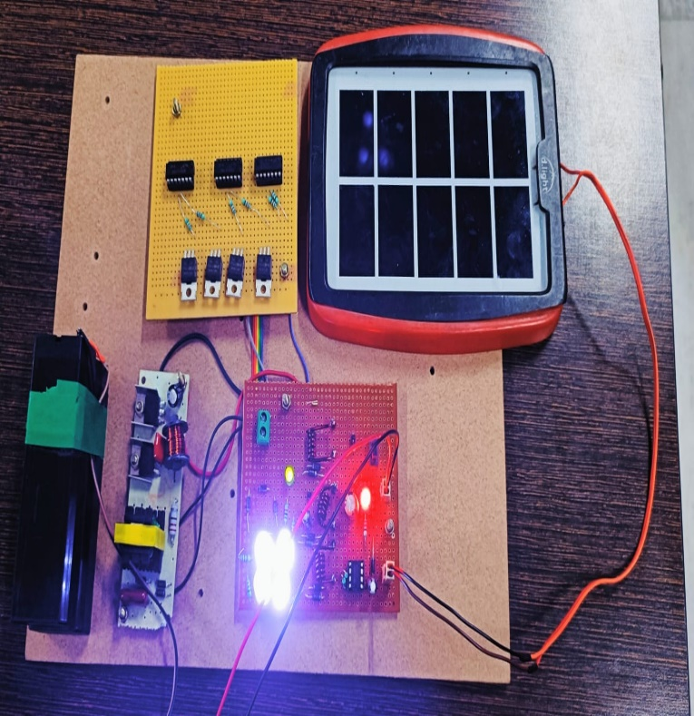

3. RESULTS

Now we are looking the results of the hardware that we have done.

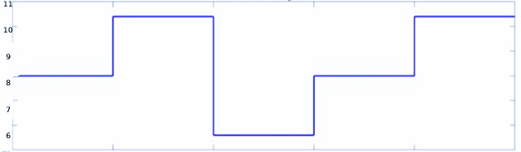

Fig.3 DC source voltage

In the above figure the source voltage is 8V. And to make it constant we use a buck-boost voltage.
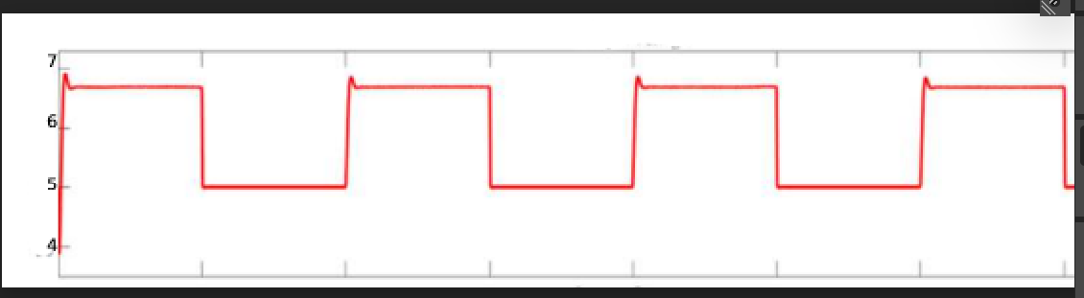

Fig.4 Output voltage

In the above figure we got the output voltage at 7.09V.

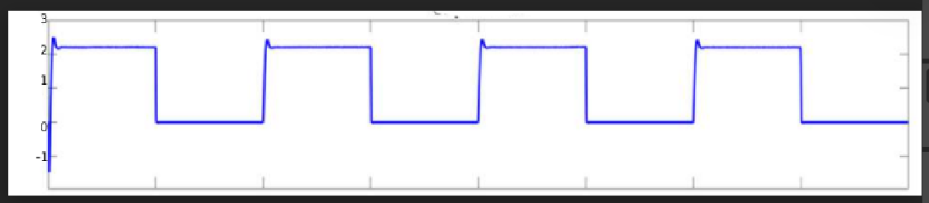

Fig.5 Output current

In the above figure the output current that we got is 2A. Here the current that we got has reduced ripples.

4. CONCLUSION

The suggested LED driver arrangement is intended to fulfil the goal of supporting huge loads while minimizing current ripple. And there are additional benefits because it is particularly helpful in industrial applications. 1.5A is the input current. The switching action is gentle, which reduces losses and improves efficiency. As a result, we conclude that this structure is advantageous and the best approach to manage big loads.

5. REFERENCES

[1] S. Mukherjee, A. Sepahvand, V. Yousefzadeh, M. Doshi and D. Maksimović, "Automotive LED Driver based on Resonant DC-DC Converter with Wide Input and Output Voltage Ranges," 2019 20th Workshop on Control and Modeling for Power Electronics (COMPEL), 2019, pp. 1-6, doi: 10.1109/COMPEL.2019.8769716.

[2] Y. Wang, J. M. Alonso and X. Ruan, "A Review of LED Drivers and Related Technologies," in IEEE Transactions on Industrial Electronics, vol. 64, no. 7, pp. 5754-5765, July 2017, doi: 10.1109/TIE.2017.2677335.

[3] Li, S., Tan, S.C., Lee, C.K., et al.: ‘A survey, classification, and critical review of light-emitting diode drivers’, IEEE Trans. Power Electron., 016,31, (2), pp. 1503–1516.

[4] K. Eguchi, A. Shibata, F. Asadi, T. Ishibashi, Y. Harada and I. Oota, "Design of an LED Sink Driver Using a Switched-Inductor and Switched-Capacitor Buck-Boost Converter with High Voltage Gains," 2020 2nd International Conference on Smart Power & Internet Energy Systems (SPIES), 2020, pp. 33-38, doi: 10.1109/SPIES48661.2020.9243052.

[5] S. Devabhaktuni, N. Vishwanathan and S. Porpandiselvi, "LED Driver with Three-Phase Series Resonant Converter with Reduced Source Ripple Current," 2020 21st National Power Systems Conference (NPSC), 2020, pp. 1-5, doi: 10.1109/NPSC49263.2020.9331864.

[6] A. Jha and B. Singh, "Bridgeless buck-boost PFC converter for multistring LED driver," 2017 IEEE Industry Applications Society Annual Meeting, 2017, pp. 1-8, doi: 10.1109/IAS.2017.8101800.

