THREAD SPECIFIC SECURITY RISK EVALUATION IN THE CLOUD

Ms.S.Thangamani¹, J.Mohamod suhail², S.Nandhakumaran³, B.Dhiyanesh⁴,S.Senthilkumar⁵

1Assistant Professor, Department of Information Technology, Nandha Engineering College-Erode- 638052, Tamilnadu, India.

^{2,3,4,5}UG Scholar, Information Technology, Nandha Engineering College-Erode- 638052, Tamilnadu, India.

E-mail : mohamodsuhail@gmail.com

Abstract. We offer a threat-specific risk evaluation technique that makes use of multiple cloud security aspects (e.g., vulnerability information, attack likelihood, and the effect of each assault associated with the detected threat(s)) as well as client-specific cloud security needs.

Our solution enables a cloud provider's security administrator to make fine-grained judgments for selecting mitigation measures in order to safeguard particular customers' outsourced computing assets against specific attacks depending on their specific security demands. This differs from conventional asset-based systems, which lack the functionality to give a security review of the cloud in relation to specific risks.

The suggested technique, on the other hand, enables security managers to calculate a range of more effective client-specific countermeasures based on the relevance of security needs and threats. Frothy Disturbance Intrusion Detection Systems (FIDSs) can be useful in identifying and preventing security threats. The internet is being integrated with entities from several fields of human civilization (such as smart homes, health care, smart grids, industrial processes, product supply networks, and environmental monitoring).

INTRODUCTION

Software called an interruption detection system checks a single PC or a network of PCs for harmful behaviors like capturing or blue-penciling data or violating system norms. The majority of current interruption detection methods are unable to handle the complex and dynamic nature of digital attacks on PC systems. Despite the fact that adaptable strategies that work, like various machine learning systems, can increase detection rates, decrease false alarm rates, and reduce computation and correspondence costs to a reasonable level. Continuous example mining, order, grouping, and a smaller-than-usual information stream are all possible outcomes of information mining. A literary analysis of machine learning and information mining techniques for digital investigation and interruption detection is Cyber Security.

An intrusion detection system (IDS) is a piece of software that looks for suspicious activity in a system or network. The fast extension and utilization of the web brings up doubts about how to defend and share computerized data in a solid manner. Programmers these days use a few types of assaults to get valuable data. These attacks can be detected with the help of a variety of approaches, strategies, and algorithms for intrusion detection. The primary objective of this intrusion detection research is the internet.

LITERATURE SURVEY

- Chaima Boudagdigue and others , has proposed in his paper that in order to keep up with the Industrial Revolution 4.0, automobile manufacturers all over the world are increasingly installing Industrial Internet of Things (IoT) devices in their factories. The main obstacles to incorporating the Internet of Things (IoT) into industrial processes are security and privacy concerns. As a result, industrial data stored in IoT devices must be safeguarded and kept confidential. In this paper, we propose a dynamic trust management model that is appropriate for industrial settings as a first step in this direction. In addition, we propose transforming the conventionally centralized architecture of IoT networks in automotive factories into a hybrid architecture based on brand-new industrial relationship rules. There are two parts to this work's performance evaluation. In the first section, we contrast the proposed architecture with the conventional IoT network architecture of the plant.
- Luigi Atzori and others, has proposed in this paper This paper tends to the Web of Things. The integration of multiple technologies and communication solutions is the primary factor that makes this promising paradigm possible. The most important technologies include distributed intelligence for smart objects, wired and wireless sensor and actuator networks, enhanced communication protocols (shared with the Next Generation Internet), and technologies for identification and tracking. Any significant advancement of the Internet of Things must, as can be easily imagined, be the result of coordinated efforts in a variety of scientific disciplines, including telecommunications, informatics, electronics, and social science. This survey is meant for people who want to approach this complicated field and help it grow in such a complicated situation. The enabling technologies and various visions of this Internet of Things paradigm are discussed. What arises is that actually significant issues will be looked by the examination local area.
- Chunsheng Zhu and others, has proposed in this paper that in recent years, as digital devices and social network
applications have become more common, the explosive growth of multimedia big data makes it difficult for users to securely obtain it in a variety of application scenarios. The most recent research on multimedia big data and SC is reviewed first in this article, which investigates secure multimedia big data application in trust-assisted sensor cloud (TASC), one type of SC for smart city. In addition, the most pressing issues that have an impact on the achievement of secure multimedia big data in TASC are identified. This article therefore proposes two types of TASC, motivated by addressing the identified critical issues: TASC-M and TASC-S, both of which have multiple trust value thresholds, respectively. At long last, with broad reproduction results about TASC-S and TASC- M as well as SC without trust help (SCWTA), the accompanying bits of knowledge into secure mixed media enormous information in TASC are accomplished: Generally, TASC-S and TASC-M have a throughput that is higher than SCWTA's; TASC-S's throughput can follow a tuned trust value threshold; TASC-M's throughput can fluctuate despite maintaining the same trust value thresholds.
- Bandyopadhyay Debasis et al. In this paper, the term "Internet of Things" (IoT) is used to describe a future Internet in which physical objects, such as bicycles and banknotes, can participate actively in the Internet by exchanging information about themselves and their surroundings. Innovative services, as well as an increase in productivity and efficiency, will result from having instant access to information about the physical world and its objects thanks to this. This paper compares and contrasts IoT definitions from a variety of academic and industry perspectives, as well as the most important technological drivers, potential applications, challenges, and future research directions in the field. Finally, we identify and briefly discuss a few major IoT research questions. We can get a clear idea of how the Internet of Things will be implemented globally over the next few years by looking at the most cutting-edge technologies currently available.

- Charith Perera et.al. , has proposed in this paper the total populace is developing at a quick speed. Half of the world's population is living in towns and cities, putting enormous pressure on every aspect of urban living. It is common knowledge that facilities and resources are concentrated in cities. Such conditions draw in individuals from rustic regions. However, unprecedented attraction is now a major concern for city politics and governance. The huge tension towards productive city the executives has
set off different Shrewd City drives by both government and confidential area organizations to put resources into ICT to track down maintainable answers for the developing issues.

Over the past ten years, the Internet of Things (IoT) has also received a lot of attention. In Smart Cities, the Internet of Things (IoT) envisions connecting billions of sensors to the Internet for effective and efficient resource management. Utilizing cloud technologies, infrastructure, platforms, and software applications are currently offered as services. In this paper, we investigate the connection between sensing as a service and the Internet of Things. Our goal is to examine the idea of sensing as a service model from a social, economic, and technological point of view and identify the major unresolved problems.

MODULE DESCRIPTION

  - NETWORK FORMATION

In this Module, our organization has an organization regulator. All sensor Virtual Machines are associated with network regulator. There is a free examiner Promotion in the organization. Promotion is free as in it isn't related with any Virtual Machine in PSD and has no information on the mysteries (e.g., cryptographic keys) held by different Virtual Machines. The evaluator is answerable
for recognizing vindictive Virtual Machines on request. In particular, we accept S gets criticism from D when D suspects that the connection is enduring an onslaught.

DATA TRANSMISSION

The source Virtual Machine S persistently sends information to the objective Virtual Machine D through between intervene Virtual Machines n 1 ; ... ;nK , where ni is the upstream Virtual Machine of n I-1 , for 1 <= I <= K
- 1. We expect that S knows about the connection PSD , as in Powerful Source Directing (DSR).

On the off chance that DSR isn't utilized, S can distinguish the Virtual Machines in PSD by playing out a trace link activity. Here we basically center on static or semi static Distributed computing organizations, i.e., we expect that the organization geography and connection qualities stay unaltered for a generally significant stretch of time.

AUDITION
This stage is set off when the public inspector Promotion gets an ADR message from S. The ADR message remembers the id of the Virtual Machines for PSD, requested in the downstream bearing, i.e., n1; ... ;n K , 's HLA public key data pk =(v, g, u), the arrangement quantities of the latest M information sent by S, and the succession quantities of the subset of these M information that were gotten by D.

Review that we accept the data sent by S and D is honest, on the grounds that identifying assaults is to their greatest advantage.

Firewall
Server’s manager port
Servers
Outlet maintainer
Human service ports
Internet
For request human service
Self service outlets
Self service outlets
Monitor
Monitor
For request human service
Sensors
For request human service
Sensors

DETECTION
The public inspector Promotion enters the identification stage in the wake of getting and examining the answer to its test from all Virtual Machines on PSD. The Principal errands of Promotion in this stage incorporate the accompanying: distinguishing any exaggeration of information misfortune at each Virtual Machine, developing an information misfortune bitmap for each jump, working out the autocorrelation capability for the information misfortune on each bounce, and concluding whether pernicious way of behaving is available. At last it recognizes all information droppings.

PACKET VERIFICATION PHASE

In the bundle confirmation stage, a hub checks each got parcel. Assuming the outcome is positive, it refreshes the information as per the got bundle. At the point when a sensor hub, say Sj , gets a parcel either from an approved client or from its one-jump neighbors, it first really takes a look at the bundle's key field.

- Assuming that this is a notice bundle ( P0 {Certj; h (P1); SIGSK j f h (P1)}} for the information hash chain technique while P0 =fCertj; root; SIGSK j f root}} for the Merkle hash tree strategy), hub S j first focuses on the lawfulness of the dispersal honor Pri j. For instance, hub S j requirements to check whether the personality of itself is remembered for the hub character set of Pri j.

- In any case, it is an information parcel Pi, where I = 1; 2; ...; n. Hub S j executes the accompanying technique: For the information hash chain strategy, hub Sj checks the

validness and uprightness of Pi by contrasting the hash worth of Pi and H I which has been gotten in a similar round and confirmed. Assuming the outcome is positive and the rendition number is new, hub S j then, at that point, refreshes the information recognized by the critical put away in Pi and replaces its put away < round, H I > by < round, H i+ 1 > (here Hey + 1 is remembered for bundle Pi );

RESULT ANALYSIS

While the proposed Homomorphic Straight Authenticator (HLA)- based public inspecting design for finding lost data is a promising methodology, leading an intensive investigation of its presentation and effectiveness is fundamental. The investigation ought to incorporate different measurements, for example, location precision, calculation time, capacity above, and correspondence above. One significant measurement to assess is the identification exactness of the engineering. This measurement estimates the capacity of the engineering to identify lost data precisely. The precision not set in stone by looking at the announced lost data from Virtual Machines to the real lost data. Assuming the precision is high; it demonstrates that the design is compelling in finding lost data.

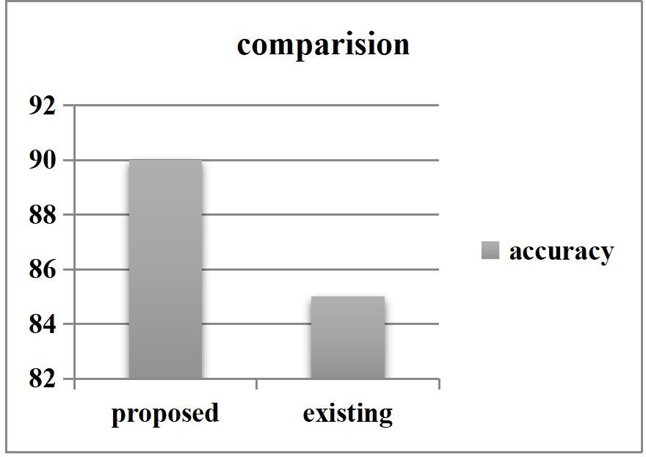

algorithm accuracy
proposed | 90
existing | 85

CONCLUSION

We demonstrated that the existing asset-based risk assessment approaches may result in ineffective risk mitigation strategies because the selected countermeasures are likely to be coarse-grained (i.e., not specific to a threat posed to the security requirements of a specific client of the cloud computing). nIn contrast, the proposed threat- specific risk assessment can evaluate and identify more effective, fine-grained countermeasures taking into account user-specified threats. We demonstrated the applicability, feasibility and usability of our proposed approach through experimental evaluation via simulations. A simulation experiment was performed to validate the performance of the proposed algorithm.

REFERENCES

- C. Zhu, J. J. P. C. Rodrigues, V. C. M. Leung, L. Shu, and L. T. Yang, ''Trust-based correspondence for modern Web of Things,'' IEEE Commun. Mag., to be distributed.
- L. Atzori, A. Iera, and G. Morabito, ''The Web of Things: A review,'' Comput. Netw., vol. 54, no. 15, pp. 2787-2805, Oct. 2020
- C. Zhu, L. Shu, V. C. M. Leung, S. Guo, Y. Zhang, and L. T. Yang, ''Secure media huge information in trust- helped sensor-cloud for shrewd city,'' IEEE Commun.
Mag., vol. 55, no. 12, pp. 24-30, Dec. 2021

- D. Bandyopadhyay and J. Sen, ''Web of Things: Applications and difficulties in innovation and normalization,'' Remote Pers. Commun., vol. 58, no. 1, pp. 49-69, 2020.

