Customized Tourism and Travel Recommendation System based on User-location

Karansingh pratapsingh raghuwanshi¹, Nikhil jitendra manik², Vedant mukund unawane³,
Shaikh Shahzeb Ejaz^{4,} Shaikh Ayaan Hussain⁵ ^{1,2,3,4,5}
Diploma student, Dept. of Computer Engineering,
Chhatrapati Shivaji Maharaj College of Engineering

ABSTRACT

Location-based public networks provide community with an interface to share their location and write reviews about interesting places of attraction. Social networking websites allows us to understand the user‟s attention and behavior pattern on various Travel and Tourism services, especially travel attraction and point of interest, which can be exploited to recommend personalized list of places to users. The major challenge faced by Travel and Tourism advice system is to understand the indirect relations that exist between the user and the point of interest. In this paper, user- location vector approach to represent and recognize the implicit relationship between customer and point of interest using a vector has been used.

General Terms
- RS-Recommendation System
- TRS- Tourist Recommendation System
- ULV- User Location Vector

Keywords
Social media mining, Tourism, Recommendation System, User- Location vector

INTRODUCTION

Nowadays, tourism plays a vital role in nation's economic growth. Of which e-Tourism is a major part. e-Tourism is a tourist advice and planning application to assist users on the organization of a leisure and tourist agenda. e- Tourism makes recommendations based on the user‟s choice, his demographic classification, the places visited by the user in former trips and, finally, his current visit preferences.
A great figure of services now exist that can offer support or help the traveler before, through and following the travel. There is a vast information related to travel end and their associated resources such as housing, restaurant, Museums, Transports or events available on the Internet. When the amount of online information and services increases, it become very complex and time devastating for tourist to discover the relevant information.
Modern tourists are advanced not only by the desire to reduce costs, but also use of contextual information society in which the necessary information is available. today tourist trusts less in advertising brochures of travel agents, does not want to pay for expensive travel guides. At the planning stage of their journey tourist usually tends to make his own analysis for information with the help of large information portal, online feedback,photos,videos and commentary submitted by those

who have visited this trip. Nowadays the actual problem is not the traditional multi filtering search of relevant information, but search into be person oriented, personalized, adapted to the individual needs of particular “sophisticated” users need information. User‟s searches request for urgent information resources in extended web environment occasionally is faced with the problem of selection of useful data in this field. This Problem can be solved with the help of the Recommendation Engine. User generated data from the social media can be processed, and used by the recommendation systems. Recommender system is a field of Information Retrieval that are widely used in our day to day applications and e- commerce sites to filter product and services according to user interest and preferences. A recommendation system is a subclass of iinformation filtering system that helps to predict the "rating" or "preference" a user would give to an item.

The Common Types of Recommendation Systems Available Today are

Content Based Recommendation System
It is content based suggestion system, when the data considered for the reference is user profile and their past history.

Collaborative-Filtering Based Recommendation System
Collaborative filtering based recommendation system recommends using both history of the user under consideration and also the history of the users who are similar to considered user.

1.1.2 Hybrid Recommendation System
A hybrid advice system is the combination of the content based and collaborative filtering based recommendation system.

LITERATURE SURVEY

The major issue with the previous recommender is that it is not personalized for a particular user. Another major problem faced by the Travel and Tourism recommendation system is to find out the relationship between the places and the users [4]. To overcome the above difficulty, here the approach called user-location vector has been used which has a weighted value intended for places of interest that corresponds to the relationship that the user and the place of interest shares.

This Recommender system analyses the user’s profile, builds the user-location vector and recommend a rank list of places totally based on the user’s interest and preference [1].

ARCHITECTURE

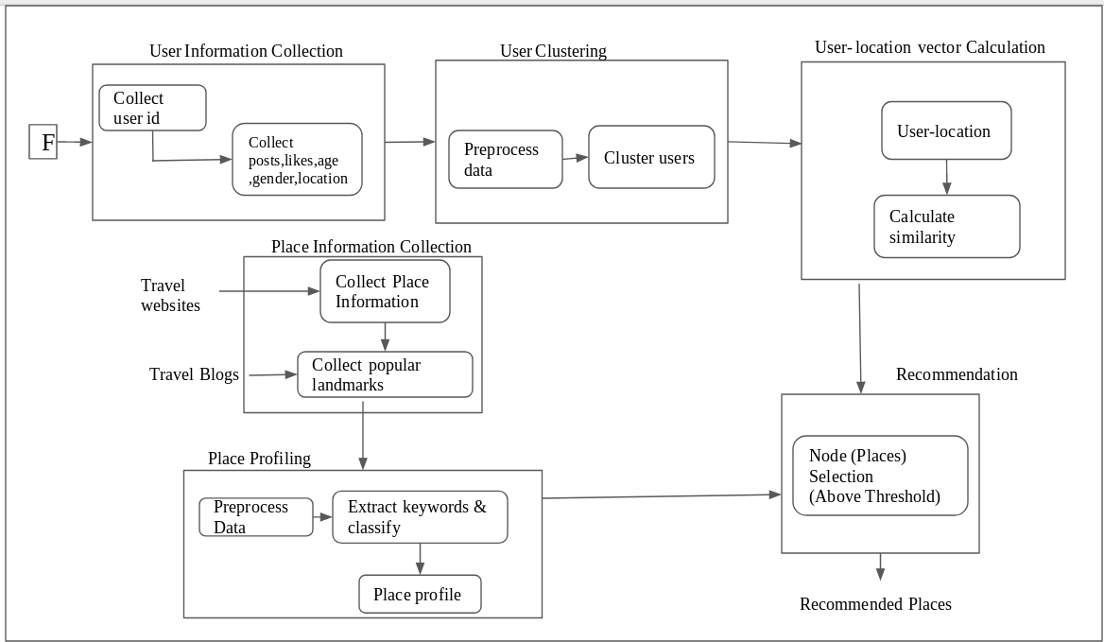

- ALGORITHMS

Algorithm1
User Information Collection (UserId) Input:User Id
Fig 1: System Architecture

4.3 Algorithm3
K-Means Clustering(n,I,k,d,c)
Input: n-no. of users, i-information of users, k- no. of clusters,d-distance between centroids and users in clusters, c-cluster of users (assume k-centroids)

Output: Characteristics and properties of
user: age, tagged-locations, likes, posts, emotions ,gender
Begin If(UserId) then
return (age, tagged-locations, likes, posts,emotions, gender)
else
return NULL End

Algorithm2
Data Preprocessing (Data)
Input:Data- tagged-locations, posts, emotions, likes, age, gender
Begin if(Data) then return data End
Else if(!tagged-location or !posts or ! emotions or
!likes) then
return -1 (discard data) End
End
return ULV; End
Begin while(d greater than 0.1) do for j=1 to n do
d is calculated with all centroids i is assigned to a cluster
end
Recompute centroid // mean of its user points End
Return c End

Algorithm4
User location vector calculation algorithm
Input:N- number of users, v-number of tagged locations for each user, l-likes on locations, m- number of point of interest, j-number of tagged location for a user, k-number of likes on a location for a user k. Output : ULV(User Location Vector).
Begin
for j 1 to N do for p 1 to m do
ULV [j][p] Normalize((2*j[p]+k[p])/(v + l)); end
end

Algorithm5
Node Selection(s,i,t)
Input: s similar users, i user-place vector,t threshold
Output: p place of interest of the user Begin
for j=1 to s do if(i[j] greater than t) then P places retrieved from ontology
return p End else
return null end
end End

Algorithm6
User similarity computation (g,n)
Input: g- user to be compared, n is the number of users
Output: User Similarity calculated based on Euclidean distance measure
Begin s=0 ;
for j=1 to n do for k=1 to m do
s=s+pow((g[k]-i[k]),2);
End dis=1/sqrt(s); end
End

Algorithm7
Ranking(p,i)
Input: p-no. osf selected places, i- user- place vector Output: r -sort places based on the vector
Begin for j=1 to p do
r=sort places based on the user-location vector ranked based on
True Bayesian Estimator end
return r End

MERITS

- A hybrid approach combines the two types of information, while it is also possible to use the recommendation of the two filtering techniques independently.
- Using the user-location vector, the counsel system predicts the user‟s interest more perfect that other existing system.

DEMERITS

[1] The limitations include going through the list of places in the place profile while advise which is ineffective use of time.

CONCLUSION AND FUTURE WORK

Nowadays, Recommendation system is base for providing needful and accurate data to the users, in the world of internet. The use of mix reference system gives the better result than by either using content based recommendation system or collaborative filtering suggestion system. Hybrid recommendation system has several advantages like its more personalized, dynamic and efficient. It can be used in several domains like e-commerce, e-tourism, medical, media,etc. E-tourism RSs are getting popular day by day. Thus TRSs which uses user site vector, predict the users interest more accurate than that of other RSs. In order to overcome the limitations, ontology of places can be constructed. Another potential augmentation can be to counsel a travel plan using the recommended places.

REFERENCES

- Hsiu-Sen Chiang, Tien-Chi Huang,‟ User-adapted travel planning system for personalized schedule recommendation‟, Journal of Information Fusion,Vol.21,pp.3-17, January 2015

- IEEE paper-"A user-location vector based approach for personalised tourism and travel recommendation " by Ajantha D,Jobi Vijay and Raji Sridhar,2017.
- Paper-"Personalized Dynamic Recommendation System for Tourism Using Hybrid Approach in Web Mining" by Priyanka B. Tiwari, 2Krunal J. Panchal published in International Journal of Engineering Development and Research.
- IEEE paper-"A Survey on Recommender Systems" by Motlatsi Liphoto,Chunling Du, Seleman Ngwira,2014.
- Zhiwen Yu, Huang Xu, Zhe Yang, and Bin Guo
,Personalized Travel Package With Multi-Point-of Interest Recommendation Based on Crowdsourced User Footprints, IEEE Transactions On Human-machine Systems, Vol. 46, No. 1,pp. 151 - 158, February 2016.

