UAPA in the name of National Security: Boon or Bane

A country as big as India suffers from the constant threat of external extremists as well as internal conflicts. In the current scenario, India, has only one anti-terror law i.e. The Unlawful Activities(Prevention) Amendment Act, 2019, an Act which deals with terrorist and terrorism. The main motive of this Act is to allow the authorities to arrest an individual as a terrorist for the violence created and propagated by him and to introduce the fourth schedule to add or remove the name of individual terrorists.
The necessity of UAPA
From the very first day of Independence, India remains an easy target in the eyes of Organisations and Countries. India being a peace preaching country, never invaded or attacked any territory in the first place. But this does not go same for others, time to time, India suffered from extremist attacks taken out by several international terrorist organisation as well as some citizens of this country too.
When it comes to tackle international terrorist organisation India has a very capable armed force and diplomats but what happens when the violence is committed by the people residing in the country?
The nature of crime depends not just on actions or criminal mindset but it also depends on the scale of the crime. Even though the term Unlawful Activities has a very broad and vague meaning, the Unlawful Activities(Prevention) Amendment Act, 2019 deals with terrorists and terrorist organisations only.
UAPA not just prosecute the criminals but it also creates a sense of fear among the prospective criminals.
The loopholes in UAPA
There is no description of the term ‘terrorist’ in the law nor it has been stated on what grounds or proof one can be arrested. Section 35 of the Act, does not require a proper reason for the arrest of an individual nor it has any clarity of when a person can be termed as a “terrorist”. The actions taken under the Act can be termed as arbitrary and could result in giving away immense power in the hands of government leading to despotism.
To mitigate terrorism, government can violate a person’s fundamental rights to any extent. In the pursuit of peace government can run its own personal agenda. If putting people behind the bars and giving them tags of a terrorist becomes a norm, the dignity of an individual will remain on a constant stake and will be a subject of public humiliation even before any judicial mind is applied in the matter.

THE REALITY OF UAPA
Prior to UAPA there were two more anti-terror laws in India, Terrorist and Disruptive Activities(Prevention)Act, 1987(TADA) and Prevention of Terrorism Act, 2002(POTA) but these two laws got repealed because of the constant misuse of the power it provides to the government. Before the recent amendments of the Act, the government was able to take actions on terrorist organisations only but after the amendments of 2019, government can take necessary actions against individuals also. The new powers given to the agencies can be seen as a threat to fundamental rights but we need to understand that in order to provide safety to every citizen of the country some extreme steps needs to be taken.
Like privacy is a myth, the rights are myth too. It is a subjective view of how we see things.
We think we have rights because we are an independent country and our constitution gifted these rights to us but the matter of fact is that we can enjoy the rights only if we fulfil our duties. The actions we take not only affect our life but it causes a great deal of affect in others life too. The ripple effect started by our actions can cause drastic changes to many people hence, it is our duty to ensure that no one should be in any bad position because of our deeds.
There are many laws to rectify/punish disturbing actions and one of them is UAPA, even though it deals with crimes whose scale and affect can cause national and international turmoil, in its core this law is just like any other Criminal law but with special powers.
India is a peace preaching country but this doesn’t mean that every citizen of this country is a peace loving person. A very notable name of a citizen going rouge is Syed Mohammed Ahmed Zarar Siddibappa also known as Yasin Bhatkal, is a convicted Indian islamist terrorist, who was the co-founder and leader of banned terrorist organisation Indian Mujahideen. This terrorist organisation has carried out several attacks against civilian targets in India and Yasin was notably personally involved in the 2010 Pune bombing, 2010
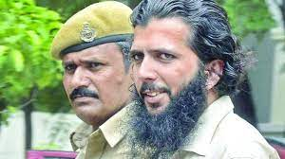YASIN BHATKAL
Bangalore stadium bombing, 2011 Mumbai bombings, 2012 Pune bombings and the 2013 Hyderabad blasts. He was convicted under Indian Penal Code sections 120-B(criminal conspiracy), 121(waging war against country) and 121-A(conspiracy to wage war), as well as the Arms Act and various sections of the Unlawful Activities(Prevention) Act and was given a death-sentence.

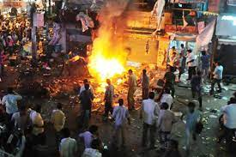 HYDERABAD BOMB BLAST

Yasin bhatkal is just one of many other people who have committed such heinous crimes. This is not a simple criminal case where a crime has been committed because of sudden rage or simple enmity but these crimes are done by people whose intentions are to kill every people who don’t belong to their ideology. A mindset which is going to destroy not just some people but the whole humanity in existence and in order to prevent these people from doing anything which goes against the safety of civilians, UAPA is a very important tool for democracy and government.
Even though laws are enacted and amended without having any biases for caste, creed, race or religion, the ruling government can use these laws which are not properly framed for their own personal agendas and UAPA is such a law which was used and is still being used by the government as a means to suppress civilians and their freedom of expression if they are not aligned with the government’s motto.
Well it is very important to understand that laws are made to give citizens a better and safe life while providing justice to the victims and punishments to the criminals, the constant misuse of power is a reality and we as civilians are becoming so much accustomed with the norm that if someone is in power he/she must be having their personal agendas and biases that we are forgetting the fact that getting rid of crimes and punishing criminals are the two of the most important aspects of criminal law.
As the world is growing and we are connecting and interacting with more people we are constantly developing our knowledge and shaping our existing ideology, in this “always learning, always growing” stage we find ourselves in a grey area, where our ideology is not wholly true and other’s ideologies are not totally wrong, we are in the middle of everything and we think that if someone is committing something morally or legally wrong he/she must be in some need/or problem and then we voluntarily support the person(not the actions) that he/she should be sent to some counselling or rehab then we expect from our government and judiciary that they should also evaluate their actions on an emotional level but fortunately this is not how things work in reality.
No one wants to hear the fact that terrorists or people who wants to kill other people just because of different colour, caste, creed or religion are not mentally ill people, they have a very sound mental health and they carry out their heinous crimes with proper planning and execution. They are just full of hatred and anger for no reason, the superiority complex might sound like a psychological condition but it is just a term used for people who are less in knowledge and full of disgust.
Now, eliminating these flawed thoughts from one’s mind is a tough job and when we take into account the amount of people having the same discriminatory thoughts, it is next to impossible to correct everyone, so for convenience and to create a large impact laws like UAPA is a very vital tool. Not just to punish but to give a message that there is only one thing which is superior than humans and that is Law.

CONFIRMATION BIAS
A psychological term, which briefly means that our mind first choose a side or story and then put all the related things or events in accordance to them.
But why am I putting a psychological term in a research paper which is majorly talking on the subjects of flaws in a law and hidden political agendas?
The answer to this question is that I am not referring about the biasness in our system but I am talking about the preconceived notions that general people have. When authorities arrests someone, based on the religion or caste of the arrested person, the first thought that comes in our mind is either he is the culprit or government has a hidden agenda.
But why?
Because of the generations long appeasement strategies of political parties. These appeasement strategies created a rift among the various sections of people. Resulting the day to rifts among them. This is the breeding ground of hate mongering people, these people then lure others like minded persons to join them and cause mass riots and anti-national acts. They also have the audacity to justify their actions too. To maintain peace and punishing people who are constantly causing havocs and hampering integrity of this nation, UAPA is a necessity for our country.
TERRORISTS ATTACKS : INDIAN STATISTICS
Around 3400 communal riots and around 12 terrorist attacks took place in India from 2016-2020.
December 5, 2014: terrorists carried out an attack on the mohra army camp in Uri Tehsil, in which 10 army personnel and six terrorists were killed.
December 28, 2014: Bengaluru’s Church Street was bombed, killing one and injuring two.
June 4, 2015: A group of militants ambushed a military convoy in Manipur, killing 18 Indian Armed forces personnel and injuring 11. This was one of the worst attacks suffered by the Indian Army in a decade.
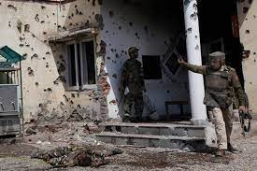PATHANKOT ATTACK

January 2, 2016: The Pathankot Air force base was attacked by terrorists killing one civilian and eight security personnel.
September 18, 2016: Four heavily armed terrorists attacked the administrative base of one of the army units in Uri, J&K, killing 19 security personnel.
October 3, 2016: A terror attack was carried out in J&K’s Baramulla, in which one Border Security Force(BSF) personnel was killed.
November 29, 2016: Seven Army personnel were killed when militants dressed as policemen stormed into Nagrota military camping J&K, triggering a gun battle which lasted for more than 12 hours.
March 7, 2017: A bomb blast was reported in a Bhopal-Ujjain passenger train, in which 11 persons were injured.
April 24, 2017: A Maoist attack was carried out in Sukma, Chhattisgarh, in which 25 Central Reserve Police Force(CRPF) were killed and seven were injured. In retaliatory fire, 10-12 Maoist were also killed.
March 13, 2018: An improvised explosive device(IED) blast in sukma, Chhattisgarh killed nine CRPF personnel.
February 14, 2019: A car bomb attack was carried out near Pulwama in J&K by a suicide bomber, killing 40 paramilitary personnel.
November 20, 2020: An assistant commandant of the Commando Battalion for Resolute Action(CoBRA) died while undergoing treatment for injuries he sustained in an IED blast in Sukma District.

With the above mentioned attacks it is well established that extremist attacks are becoming a norm in the current scenario, in order to minimise and retaliate we need not just external dominance but we also need to have surveillance on the citizens of this country too, and when once found their involvement in such things UAPA have appropriate means to take actions against them. Thus UAPA should remain in existence.

LESS CONVICTION RATE
With less than 2% of those arrested under UAPA are convicted makes people to evaluate the authenticity of the charges pressed against the accused persons. According to NCRB(National Crimes Record Bureau), alone in the year 2020, 1,763 people were arrested.
Even though many of the arrests were made by giving reason that they had links with terrorist organisations, most of the time they fail to provide any substantial evidence to prove their claim.
But the opposition of several states accuses that in the name of investigation the government is taking out its own personal agendas. Many journalists who have been doing nothing were arrested just to showcase government’s power and how they misuse them .

Romila Thapar & Ors. v. Union of India & Ors.¹

In the dissenting opinion, D Y Chandrachud stated that in this particular case the investigation by the Special Investigating Team (SIT) is needed and the SIT should be
constituted for the independent and fair investigation. He also stated that investigation should be monitored by the court in this case.
He further held that there were sufficient doubts regarding the impartiality of the Maharashtra Police. He observed that the remedies for which the petitioner stands before the court do not related to remedies which belongs to the criminal procedure.
He is of view that the petition file before court is not political affected. In relation with the court’s intervention to the police inquiry he stated that the Court can interrupt the inquiry of police when the police commits any serious procedural lapse.

VISUAL GRAPHS OF ACTIVE UAPA CASES

INTERNATIONAL PERSPECTIVE
On one hand where India’s anti-terror law restricts itself to Indians and criminals committing crimes on Indian soil whereas countries like United States of America have anti-terror laws which deter and punish terrorist acts in their land as well as around the world. This is also a form of superiority complex where a country thinks that sovereignty is for them only. They are not going to allow any other country to even think of having a law which would have an impact on any other country. The USA PATRIOT ACT, 2001² is such a law which was drafted after the attacks of 9/11. The emotional and diplomatic support USA received at that time made it possible for the United States to draft such an outrageous law. It completely violates the integrity and sovereignty of a country.
The anti – terror laws of USA are very strict and rigid and even though gives the culprit a chance to defend themselves but their fates are already decided.
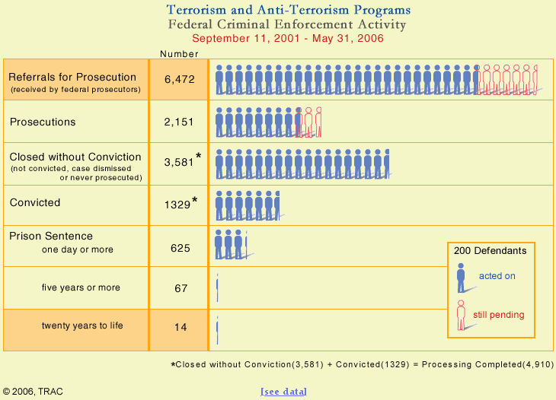

United Kingdom has a very organised and well planned strategies to handle terrorists and terror attacks, they focuses on their own territory and execute plan in accordance to it.
Due to the well planned and organised system of the country, they are able to stop attacks but due to the constant riots and violence the outcome on paper fails to leave an impression even after having a conviction rate of 86%

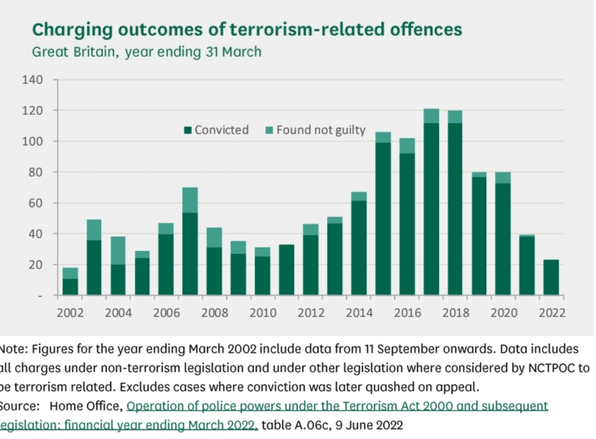3

CONCLUSION
This is now well established fact that UAPA is a law which we need in the current scenario, it is the only anti-terror law in existence in our country. A country like India, with this much of diversity and the feeling of inclusivity, we remain in the constant threat of people enticing hatred and eventually extremist attacks, so to maintain peace and creating a sense of fear among potential offenders UAPA should remain in existence.
Now the question arises of wrongful arrests and low conviction rates, and the answer to that is keeping a constant check on the actions taken by the authorities. This is a reality that every government has their own hidden agendas and ideologies and to make people align with their mindset, they use every type of tactics, now it is the duty of citizens to keep a check on the government.
I know this is a lot to ask but remember to enjoy your unrestricted rights, you must need to fulfil some duties. The most important and biggest opposition of a government is the citizens of the country only. One needs to understand that diplomatic power might be in the hands of the government but the citizens of a country has a soft power which might not sound like something important but when you unite everyone’s will to oppose the actions of government, no one can go against their will.
References:-
UAPA- AMENDMENT, A BOON OR BANE?, available at https://thejuscommune.wordpress.com/2020/06/25/uapa-amendment-a-boon-or-bane/ (last visited on December 16, 2022)

