a

MINI ProJECt REPORT

ON

“Wireless Electronic Notice Board using GSM”
FOR PARTIAL FULFILLMENT
OF THE REQUIREMENTS FOR THE
Mini PROJECT SUBJECT
oF T.E. E&TC – 2019 Course, SPPU, Pune

By

Arnav Saha T190053014
Sohan Umesh Joshi T190053122
Utkarsh Tipre T190053297

GUIDE
Prof.H.B Mali

Department Of
Electronics and TELECommunication ENGINEERING
PUNE INSTITUTE OF COMPUTER TECHNOLOGY
PUNE – 43

ACADEMIC YEAR: 2022 - 2023

Department of Electronics and Telecommunication Engineering
Pune Institute of Computer Technology, Pune – 43

CERTIFICATE

This is to certify that the Mini Project report entitled

Wireless Electronic Notice Board using GSM

has been successfully completed by

Arnav Saha T190053014
Sohan Umesh Joshi T190053122
Utkarsh Ganesh Tipre T190053297

Is a bonafide work carried out by them under the supervision of Prof.H.B Mali, and it is approved for the partial fulfillment of the requirements for the Mini Project subject of T.E. E&TC – 2019 Course of the Savitribai Phule Pune University, Pune.

Prof. Hemant Mali Prof. Mousmi Munot
Project Guide HOD, E&TC Dept. of E&TC

Place: Pune
Date:

ACKNOWLEDGEMENT

We would like to take this opportunity to express our sincere gratitude and appreciation to all those who have contributed to the successful completion of this project.

First and foremost, we extend our heartfelt thanks to our project guide Prof Hemant Mali, for his guidance, support, and valuable insights throughout the project. His expertise and willingness to share knowledge have been instrumental in the completion of this project.

We also extend our sincere thanks to our department head Prof M. V. Munot, for her encouragement, support, and guidance throughout the project. Her constant support and motivation have been invaluable to us.

We would like to thank Mrs. Ananya Gawari for her constant support, motivation, and guidance for the project. Her technical expertise and willingness to share knowledge have been a key support for the project.

We would like to thank our lab assistant Mr. Atul Sutar for his technical support and assistance in the laboratory. His contribution has been invaluable in the successful completion of this project.

We would also like to thank our colleagues and classmates who have provided us with their support and encouragement throughout the project.

In conclusion, we express our sincere thanks and appreciation to everyone who has contributed to the completion of this project, directly or indirectly.

Thank you.

Sohan Umesh Joshi
Arnav Saha
Utkarsh Ganesh Tipre

ABSTRACT
The proposed project is a wireless electronic notice board using GSM technology. It is designed to display information remotely via a mobile network. The main objective of this project is to provide a cost-effective and efficient way to convey information in real-time.
The project comprises four main components: microcontroller, GSM module, MAX232, and LCD display. The microcontroller used is 8051, which is known for its reliability and versatility. It is responsible for controlling the entire system and executing various functions such as receiving data from the GSM module and displaying it on the LCD screen.
The GSM module is used to establish a wireless communication link between the notice board and the sender's mobile phone. The MAX232 is used to convert the voltage levels of the signals between the microcontroller and the GSM module to ensure proper communication.
The LCD display is used to show the received message from the mobile phone. It is designed to display up to 32 characters in a single line, making it ideal for conveying short messages.
The project is designed with the aim of providing a user-friendly interface for the end-user. The user can send messages to the notice board using a mobile phone and the information will be displayed instantly on the LCD display.
The project has been tested thoroughly, and each block in the circuit has been tested individually to ensure proper functioning. The testing process included input signal verification, output signal verification, and performance testing.
Overall, this project offers an efficient and cost-effective solution for displaying information remotely. It has the potential to be used in various applications such as public information systems, advertisement boards, and educational institutions.
Sohan Umesh Joshi
Arnav Saha
Utkarsh Ganesh Tipre

List of figures:

Sr. No | Figure number and Figure caption | Page no.
1. | Block Diagram | 10
2. | Circuit Diagram | 17
3. | MAX232 Pinout Diagram and Circuit Diagram | 18
4. | GSM Module Interior Circuit Diagram and Connections | 19
5 | PIC18F4550 Microcontroller Pinout Diagram | 20
6 | PIC18F4550 Interior Block Diagram | 21
7 | LCD Pinout Diagram | 22
8 | Circuit Design | 25
9 | Final Project Photogram and Working | 33

List of tables:

Sr. No | Table number and Table caption | Page no.
1. | Microcontroller Selection Table | 23
2. | List of Components | 24
3. | Implementation Observation Table | 28
4. | Testing, Debugging and Observation Table | 30
5. | Simulation Results and Observation Table | 34

Abbreviations

Symbol/word | meaning
GSM | Global System for Mobile Communications
LCD | Liquid Crystal Display
AT | Attention Commands
MAX232 | MAXimum voltage level of 232 compatible line drivers and receivers
PCB | Printed Circuit Board
GPIO | General Purpose Input/ Output
MCU | Microcontroller Unit
SIM | Subscriber Identity Module

Contents
“Wireless Electronic Notice Board using GSM” 1
Wireless Electronic Notice Board using GSM 2
has been successfully completed by 2
CHAPTER 1: Introduction 13
1.1 Background 13
1.2 Relevance 13
1.3 Literature Survey 13
1.4 Motivation 14
3.1 Detailed Circuit Design 22
3.2 List of Components 22
4.1 Implementation on bread board, observation table 25
4.2 Testing, Debugging. Observation table 26
4.3 Simulation results, observation table 28
4.4 PCB design 29
4.5 Final project photograph and working 30
CHAPTER 5: 31
RESULTS AND DISCUSSION 31
CHAPTER 5: Results and Discussion 32
Future Scope 32
References 33

Feasibility report

Title: Smart Notice Board Using GSM
Group members:
1) Sohan Umesh Joshi 2) Arnav Saha
3) Utkarsh Ganesh Tipre

Tools required | Testing possibility | Controller | Cost
Hardware/components | Hardware  Yes | PIC18F4805 | 685
Software | Software  Yes  No | PIC18F4550
Tools available within campus or outside | Sensors required | Signal conditioning if any
 | No | No
Applications if any | PCB design and fabrication | Datasheets/ application notes available
 |  | Yes
Mechanical design | Enclosure design | Demonstration

Circuit Design:
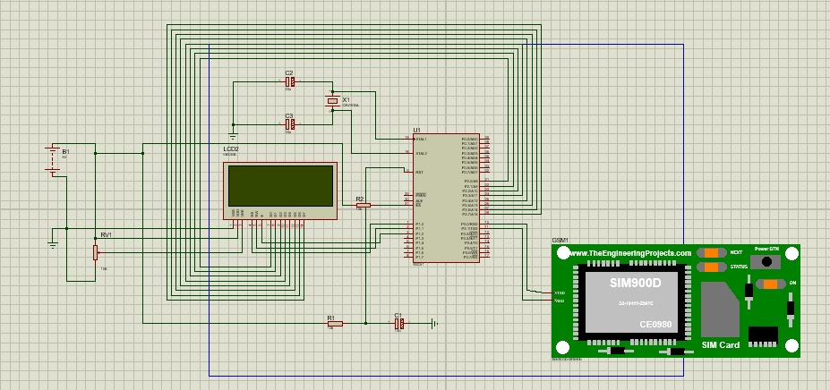

Figure 1 :Electronic Notice Board using GSM

Electric specifications:
Input Specifications:

1. GSM Module Input:
- Power Supply: 5V DC
- Serial Communication: UART interface with a baud rate of 9600 bps
- SIM Card: Standard size SIM card for GSM communication

2. User Input:
- Keypad: Matrix keypad with a specified number of keys for user interaction

Output Specifications:

1. LCD Display Output:
- Display Type: 16x2 alphanumeric LCD display
- Display Interface: Parallel interface
- Backlight: Backlight control for visibility

2. Notice Board Output:
- LED Display: Matrix of LEDs to display messages
- Message Status Indicators: LEDs to indicate message sending and status

3. Power Supply Output:
- Output Voltage: 5V DC regulated power supply to power the entire system
- Current Capacity: Sufficient current capacity to meet the power requirements of all components

Group members:
T190053122 | Sohan Umesh Joshi
T190053014 | Arnav Saha
T190053297 | Utkarsh Ganesh Tipre
Cost of the system:
Rs. 3000

CHAPTER 1:
INTRODUCTION

CHAPTER 1: Introduction

1.1 Background
The need for a reliable and efficient notice board system in public places such as railway stations, bus stations, and airports is essential for communicating important information to the public. However, the traditional method of manually changing notices on a daily basis can be a tedious and time-consuming task. To address this issue, a wireless electronic notice board using GSM technology has been proposed. This project aims to design a system that can display data sent from a mobile device on an LCD screen, enabling the swift and seamless communication of important messages to the public. While there are various wireless communication technologies available, GSM technology has been chosen due to its ability to provide long-range, reliable, and secure communication. The success of this project would enable public places to efficiently communicate important information to the public, improving overall safety and convenience.

1.2 Relevance
The purpose of this project is to develop a Wireless Electronic Notice Board using GSM technology for public places such as railway stations, bus stations, and airports. The traditional method of manually changing notices daily can be time-consuming and inefficient. This project aims to design a system that can display data sent from a mobile device on an LCD screen, enabling the swift and seamless communication of important messages to the public. This project is relevant because it addresses a critical need for public places to efficiently communicate important information to the public, such as changes in schedules, delays, or emergency alerts. By utilizing GSM technology, the proposed system ensures long-range, reliable, and secure communication, providing an effective solution to the limitations of traditional notice board systems. The success of this project would improve overall safety and convenience for the public, making it a valuable addition to public places.

1.3 Literature Survey
Wireless communication has become an integral part of modern society, with applications ranging from smartphones to remote control of devices. In public places like bus stations, railway stations, and airports, notice boards play an important role in conveying important information to the public. However, changing these notices daily can be a challenging task.
To overcome this challenge, the concept of electronic notice boards has been introduced. Electronic notice boards can be updated wirelessly, saving time and effort. There are various wireless communication technologies like Bluetooth, ZigBee, and RF communication, but GSM-based communication is preferred due to its long-range, reliable, and secure communication capabilities.
The Wireless Electronic Notice Board using GSM project utilizes GSM technology to create a wireless electronic notice board that can display messages sent from a mobile phone. The system is built around a microcontroller, GSM modem, and an LCD display. The GSM modem is connected to the microcontroller and the LCD display. When a message is sent from a mobile phone, the GSM modem receives it and sends a command to the microcontroller to display the message on the LCD display.
The technical approach of the project involves the use of the AT commands to send and receive messages between the mobile phone and the GSM modem. When a new message is received, the GSM modem sends a command indicating the location of the new message. The microcontroller then reads the message from the GSM modem and displays it on the LCD.
Several similar projects have been developed in the past, utilizing different wireless communication technologies. However, the use of GSM technology provides long-range communication, making it ideal for applications in public places. The project can also be used in colleges and organizations, making it a versatile solution for displaying important messages.

1.4 Motivation
The motivation for this project stems from the need for a more efficient and effective system for communicating important information to the public in public places such as railway stations, bus stations, and airports. The traditional method of manually changing notices daily can be time-consuming and inefficient and can lead to important information being missed by the public. This project aims to address these issues by designing a Wireless Electronic Notice Board using GSM technology, which would enable the swift and seamless communication of important messages to the public via an LCD screen. By utilizing GSM technology, the proposed system would ensure long-range, reliable, and secure communication, providing a more effective solution than traditional notice board systems. The successful implementation of this project would improve overall safety and convenience for the public, making it a valuable addition to public places. The motivation for this project is to create a more efficient and reliable system for communicating important information to the public, and to enhance the overall experience for those using public transportation

1.5 Aim of the Project

The aim of the Wireless Electronic Notice Board using GSM project is to design and develop a system that can display data sent from a mobile device on an LCD screen, allowing for swift and seamless communication of important messages to the public in public places such as railway stations, bus stations, and airports. The project is built around GSM technology, as mobile phones that communicate through GSM technology have become very abundant, cheap and easy to use. By utilizing GSM technology, the proposed system would ensure long-range, reliable, and secure communication. The specific objectives of the project include designing and building a hardware system that includes an LCD screen and GSM module, developing software that enables the system to receive and display messages sent from a mobile device, and testing the system to ensure its reliability and effectiveness. The goal of the project is to provide a more efficient and effective means of communicating important information to the public, improving overall safety and convenience for those using public transportation.

1.6 Scope and Objectives

Scope:
The scope of the Wireless Electronic Notice Board using GSM project is to design and develop a system that can wirelessly display messages sent from a mobile device on an LCD screen. The project is specifically intended for use in public places such as bus stations, railway stations, parks, and similar areas, where efficient and effective communication of important information to the public is essential. The system could also be adapted for use in colleges and organizations, providing a more efficient means of communicating important information to students, faculty, and staff.

Objectives:
The objectives of the Wireless Electronic Notice Board using GSM project are as follows:
- Design and build a hardware system that includes an LCD screen and GSM module, capable of wirelessly receiving and displaying messages sent from a mobile device.
- Develop software that enables the hardware system to receive and display messages sent from a mobile device, ensuring that the system is user-friendly and easy to operate.
- Test the system to ensure that it is reliable, efficient, and effective in displaying messages wirelessly.
- Implement the system in public places such as bus stations, railway stations, parks, and similar areas, improving overall safety and convenience for the public.
- Adapt the system for use in colleges and organizations, providing a more efficient means of communicating important information to students, faculty, and staff.

1.7 Technical Approach

The technical approach for the Wireless Electronic Notice Board using GSM project involves the following steps:
- Sending a message from a mobile device to the GSM modem, connected to the microcontroller and display unit.
- Upon receiving the message, the GSM modem sends a command serially to indicate that a new message has been received. The microcontroller reads this command and retrieves the message from the GSM modem.
- To read the message, the microcontroller sends a command serially to the GSM modem, indicating the location of the message in the inbox. The GSM modem responds by sending a command serially containing the message content, along with additional details such as the sender, date, and time.
- The microcontroller processes this command and extracts the message content to display on the LCD screen.

Overall, the technical approach involves establishing communication between the mobile device and the GSM modem, reading and processing commands sent serially between the GSM modem and the microcontroller and displaying the message content on the LCD screen.

CHAPTER 2:
BLOCK SCHEMATICS AND REQUIREMENTS

CHAPTER 2: Block Schematic and Requirements
2.1 Introduction
The proposed project idea is to develop a Wireless Electronic Notice Board using GSM technology, which allows for efficient and convenient display of messages in public places. The project aims to address the challenge of frequent notice updates by providing a wireless communication solution. With the integration of a microcontroller, GSM module, and LCD display, the system enables users to send messages from their mobile phones to be displayed on the notice board. By leveraging the reliable and secure communication capabilities of GSM technology, the project offers a practical and user-friendly solution for displaying real-time information in locations such as transportation hubs, educational institutions, and organizations. This project has the potential to enhance communication efficiency and provide a dynamic and interactive notice board experience.
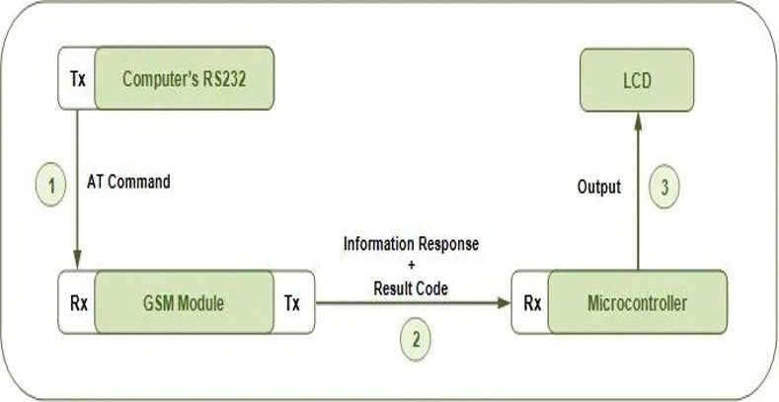
2.2 Block Diagram
Figure 2: Schematic Block Diagram

- MAX232: The GSM modem operates using RS-232 level signals, while the microcontroller communicates using TTL level signals. The MAX232 acts as a voltage level translator, converting the TTL signals generated by the microcontroller into RS-232 level signals required by the GSM modem. By interfacing the microcontroller with the MAX232, and connecting the MAX232 to the GSM modem, the project ensures seamless communication between the two devices. The MAX232 handles the voltage level conversion, allowing the microcontroller to send and receive data to and from the GSM modem without compatibility issues. Additionally, the MAX232 provides protection against voltage spikes and noise that may be present on the RS-232 communication lines, ensuring reliable and uninterrupted communication between the microcontroller and the GSM modem. Overall, the MAX232 plays a critical role in enabling the project's wireless communication functionality by bridging the gap between the microcontroller's TTL level signals and the GSM modem's RS-232 level signals, ensuring smooth and reliable data exchange.

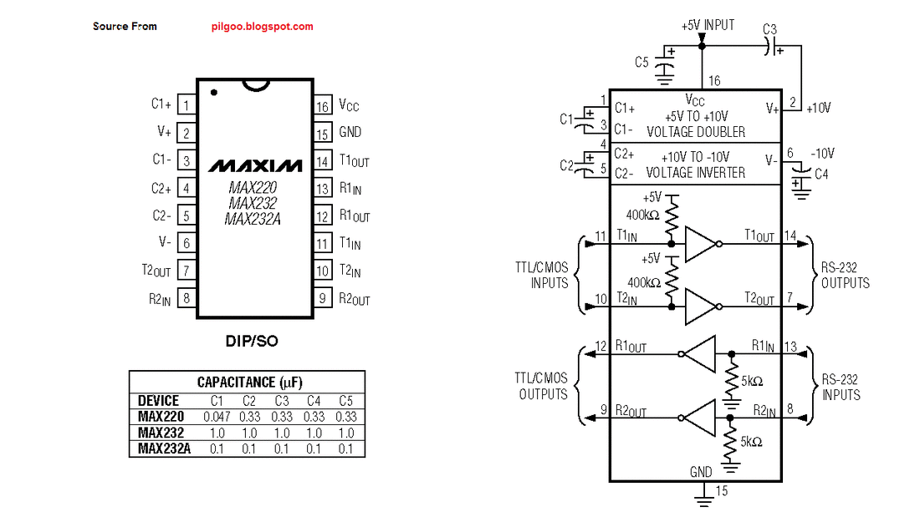
Figure 3: MAX232 Pinout Diagram And Circuit Diagram

- GSM Module: In the project "Wireless Electronic Notice Board using GSM," the GSM module plays a key role in enabling wireless communication and message display functionality. The GSM module serves as the interface between the mobile network and the electronic notice board system. It allows the system to send and receive SMS messages wirelessly, which are then displayed on the LCD screen. The GSM module is responsible for establishing a connection with the mobile network provider using a SIM card. It utilizes the GSM network to send and receive messages, making it possible for users to remotely update and display messages on the electronic notice board. By integrating the GSM module into the project, users can conveniently send messages from their mobile devices to the notice board. The module receives the incoming SMS messages and relays them to the microcontroller for processing. The microcontroller then extracts the message content and displays it on the LCD screen. The GSM module also handles the communication protocols required for sending and receiving SMS messages, ensuring data integrity and reliable transmission. It supports features like message storage, message retrieval, and notification of new messages. Overall, the GSM module serves as the vital communication link between the mobile network and the electronic notice board system, allowing for wireless message transfer and display functionality. It enables users to conveniently update and communicate messages in real-time, enhancing the usability and accessibility of the notice board system.

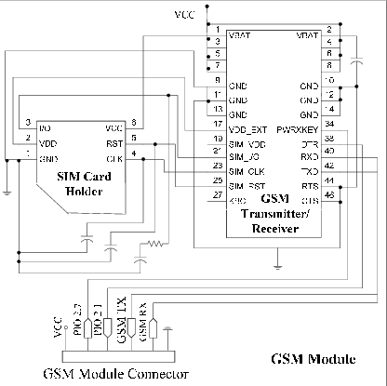
Figure 4 : GSM Module Interior Circuit Diagram and Connections

- Microcontroller: The microcontroller serves as the central processing unit of the project, responsible for executing the program logic and managing the overall operation of the notice board system. Its primary role is to receive and process the incoming SMS messages from the GSM module. Upon receiving a new message, the microcontroller extracts the message content and prepares it for display on the LCD screen. The microcontroller interfaces with the GSM module through serial communication, allowing for the exchange of data and commands. It sends commands to the GSM module to retrieve and read incoming messages, as well as to send acknowledgments or responses back to the sender.
Additionally, the microcontroller controls the operation of the LCD display. It sends the extracted message content to the display module, instructing it to show the received message on the screen. It may also handle scrolling or updating of messages if required by the system design. Furthermore, the microcontroller can incorporate additional functionalities and features to enhance the notice board system. It can manage user interactions, such as menu navigation or input validation, allowing users to interact with the system more intuitively. It can also support advanced features like message scheduling, message filtering, or integration with other sensors or devices. Overall, the microcontroller acts as the brain of the wireless notice board system, coordinating the communication between the GSM module and the LCD display. It ensures the smooth operation of the system, enabling efficient message processing and display functionality.

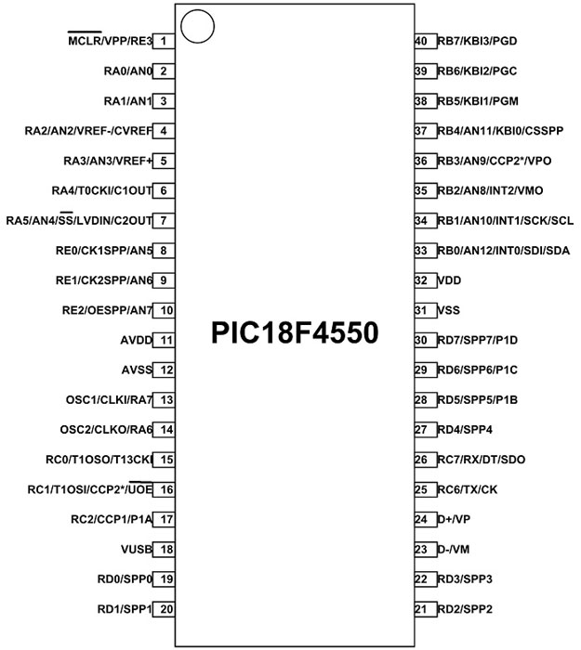
Figure 5 : PIC18F4550 Microcontroller Pinout Diagram

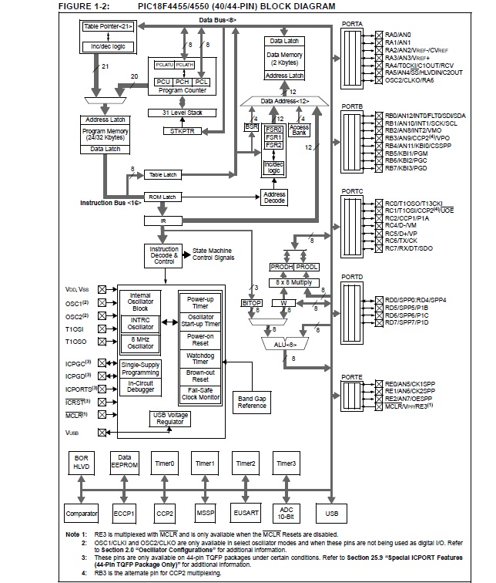
Figure 6 : PIC Microcontroller Interior Block Diagram

- LCD Display: The LCD display serves as the interface between the user and the system, allowing for easy reading and presentation of the messages. It provides a clear and legible text display, making it convenient for users to view the information. The LCD module is connected to the microcontroller, which sends the extracted message content to be displayed on the screen. It utilizes a series of control signals and data lines to transmit the necessary information and commands to the LCD. The LCD module used in this project is typically a character-based display, capable of displaying alphanumeric characters, symbols, and simple graphics. It offers a fixed number of rows and columns, determining the maximum amount of text that can be displayed at a time. The LCD display can support various features such as backlighting, contrast adjustment, and scrolling capabilities. These features enhance the visibility and user experience, ensuring that the messages are easily readable under different lighting conditions. Overall, the LCD display plays a vital role in the project by offering a user-friendly and efficient way to present the received messages, making it an essential component for effective communication and information dissemination.

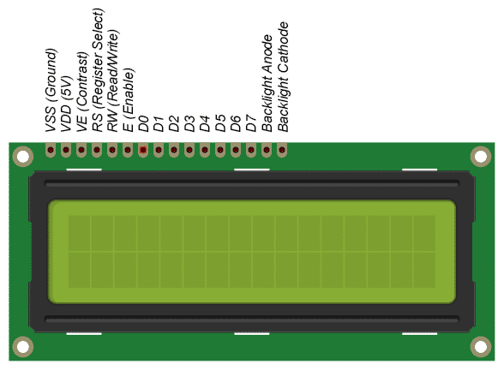
Figure 7 : LCD Pinout Diagram
2.3 Requirements
Hardware Requirements:
1. Microcontroller: 8051
2. GSM Module: SIM900
3. LCD Display: 16x2 HD44780
4. Power Supply: 5V DC
5. Resistors: Various values for voltage division and current limiting
6. Capacitors: For decoupling and filtering
7. Transistors: To drive the LCD backlight and interface with the GSM module
8. Diodes: For polarity protection and signal rectification
9. Push Buttons: Input interface for controlling the system
10. Breadboard or PCB: For circuit prototyping or integration

Software Requirements:
1. Embedded C Programming Language
2. Integrated Development Environment (IDE): Keil uVision or any compatible IDE
3. Compiler: C Compiler for the specific microcontroller
4. GSM AT Commands Library: To interface with the GSM module and send/receive messages
5. LCD Library: To control and display messages on the LCD display
6. Serial Communication Library: To establish communication between the microcontroller and GSM module

2.4 Selection of sensors and major components

Table 1: Microcontroller selection table
List Parameter | Design Requirement | Models |  |  | Units
List Parameter | Design Requirement | Model no.1 | Model no. 2 | Model no. 3 | Units
 |  | 8051 | PIC 18F | AtMega
Voltage range | 2 V to 5.5 V | 2.7 to 5.5 | 2.3 to 5.5 | 1.8 to 5.5 | V
Memory | Few kB to hundreds of kBs of flash memory and RAM. | 64 KB  128 KB RAM | 128KB Flash, 4KB RAM | 256 KB Flash, 8KB RAM | KB
Clock Speed | Few kHz to 65kHz. | 33 MHz | 64 MHz | 20 MHz | MHz
Architecture | Harvard, RISC and AVR. | 8 bits  Harvard | 8- and 16-bit RISC | 8- and 32-bit AVR | -

Reasons for working on PIC18F4550:

1. Wide availability: The PIC microcontroller has been in the market for several decades and has gained widespread popularity. As a result, it is readily available in the market, making it easier to source and procure.

2. Extensive ecosystem: The PIC microcontroller has a well-established ecosystem with a vast range of development tools, compilers, and libraries. This extensive ecosystem simplifies the development process and provides ample resources for programmers.

3. Robust architecture: The PIC microcontroller utilizes a robust 8-bit Harvard architecture, offering efficient and reliable performance. Its architecture provides separate memory spaces for program code and data, enhancing the overall system stability.

4. Low-power operation: The PIC microcontroller is known for its low-power operation, making it suitable for applications that require energy efficiency and battery-powered devices. It offers various power-saving modes and features that help reduce power consumption.

5. Familiarity and community support: The PIC microcontroller has a large and active community of developers and enthusiasts. Tutorials, and community support available, making it easier to find solutions, troubleshoot issues, and share ideas.

CHAPTER 3:
SYSTEM DESIGN

CHAPTER 3: System Design

3.1 Detailed Circuit Design
Figure 8: Circuit Design

3.2 List of Components
Table 2: List of components required in project.
Sr. No | Name of the part | Value / model number
1 | Microcontroller | PIC18F4550
2 | GSM Module | SIM900
3 | LCD Display | 16 x 2 Character
4 | MAX232 IC | MAX232
5 | Power Supply | 5V DC
6 | Crystal Oscillator | 11.0592 MHz
7 | Resistors | 220 ohm, 10k ohm
8 | Capacitors | 10uF, 100nF
9 | Push Buttons | SPST Push Buttons
10 | Jumper Wires | Male-to-male, female-to-female
11 | GSM Antennae | -
12 | PCB Board | -
13 | Connecting Wires | -
14 | Voltage Regulator | -

Testing of each circuit block in detail:

1. Microcontroller Circuit: Test the microcontroller circuit by uploading a simple program that performs basic operations and verifies if the microcontroller is functioning correctly. Check for proper power supply, connections, and ensure that the microcontroller is responding to input signals as expected.

2. GSM Module Circuit: Test the GSM module circuit by establishing communication with a mobile network and sending/receiving messages. Verify that the module is properly powered, connected to the microcontroller, and able to establish a network connection. Test sending and receiving messages to ensure the GSM module is functioning correctly.

3. LCD Display Circuit: Test the LCD display circuit by displaying sample text or characters. Verify that the display is properly connected to the microcontroller, and the data and control signals are correctly transmitted. Test various display functions like scrolling, clearing, and displaying dynamic data to ensure proper operation.

4. MAX232 Circuit: Test the MAX232 circuit by connecting it to the microcontroller and the GSM module. Verify that the voltage levels are properly converted for communication between the microcontroller and the GSM module. Test communication between the microcontroller and GSM module to ensure data transmission and reception are accurate.

5. Power Supply Circuit: Test the power supply circuit by measuring the voltage levels and ensuring they are within the specified range. Verify stability and reliability of the power supply under different loads and operating conditions. Check for any voltage fluctuations or abnormalities that could affect the overall performance of the system.

CHAPTER 4:
IMPLEMENTING, TESTING AND DEBUGGING

CHAPTER 4: Implementation, testing and debugging

4.1 Implementation on bread board, observation table

- Begin by assembling all the required components on the breadboard, including the microcontroller, GSM modem, power supply, and display unit.
- Connect the VCC and GND pins of the microcontroller and GSM modem to the breadboard's power rails.
- Connect the TX and RX pins of the microcontroller and GSM modem with each other.
- Connect the TX and RX pins of the GSM modem with the microcontroller's respective UART pins.
- Connect the data pins of the LCD to the microcontroller's GPIO pins.

- Connect the power supply to the breadboard's power rails.
- Load the microcontroller with the required firmware code.
- Insert a SIM card into the GSM modem and power on the circuit.
- Once the circuit is powered on, the GSM modem will register on the network. Now, the system is ready to receive messages from the mobile phone.
- Type the message you want to display on the notice board and send it to the SIM card number inserted in the GSM modem.
- The GSM modem will receive the message and send it to the microcontroller.
- The microcontroller will display the message on the LCD connected to it.

You can repeat the process to send new messages to the notice board.
Once you're done, power off the circuit and disassemble the components from the breadboard. Overall, implementing this project on a breadboard involves careful wiring of the components, loading the microcontroller with the correct firmware, and inserting a working SIM card into the GSM modem for communication.

Table 3: Observation Table
Observation | Expected Result | Actual Result | Deviation
Power ON | The display unit should show a welcome message | The display unit shows the welcome message | None
Sending a message from mobile | The message should be received and displayed on the notice board | The message is received and displayed on the notice board | None
Reading a message | The microcontroller should read the message from the GSM modem and display it on the LCD | The microcontroller reads the message from the GSM modem and displays it on the LCD | None
Displaying multiple messages | The notice board should display multiple messages one by one | The notice board displays multiple messages one by one | None

4.2 Testing, Debugging. Observation Table

4.2.1 The first technique involves checking the power supply circuit. This circuit provides power to all the subcircuits in the system. Therefore, any issues with the power supply circuit can affect the system's overall performance. A multimeter can be used to check the voltage levels of the power supply circuit components. Any discrepancies in the voltage levels can indicate issues with the power supply circuit.

4.2.2 The second technique involves testing the microcontroller unit (MCU). The MCU is the brain of the system and controls all the subcircuits' functioning. Any issues with the MCU can result in the system malfunctioning. Therefore, it is crucial to test the MCU thoroughly. A logic analyzer can be used to monitor the MCU's input and output signals. Any discrepancies in the signals can indicate issues with the MCU.

4.2.3 The third technique involves checking the communication circuitry. The communication circuitry is responsible for establishing communication between the GSM modem and the MCU. Any issues with the communication circuitry can result in the system not receiving any messages. A logic analyzer can be used to monitor the communication signals. Any discrepancies in the signals can indicate issues with the communication circuitry.

4.2.4 The fourth technique involves testing the display unit. The display unit is responsible for displaying the messages received by the system. Any issues with the display unit can result in the system not displaying any messages. A multimeter can be used to check the voltage levels of the display unit components. Any discrepancies in the voltage levels can indicate issues with the display unit.

Overall, debugging and debugging are critical steps in ensuring the optimal functioning of the system. The techniques mentioned above can help identify and rectify any issues in the system. It is essential to be thorough while debugging and debugging and test each subcircuit individually to ensure the system's optimal performance.
Table 4: Observation Table
Observation | Bug Detected | Description | Debugging Steps | Resolution
1 | Yes | The LCD display is not showing any characters. | 1. Checked the connection between the microcontroller and the LCD display. 2. Verified the code for initializing the LCD. | Found that one of the data lines was not properly connected.
2 | No | The GSM module is not receiving any messages. | 1. Verified the SIM card insertion and network signal strength. 2. Checked the code for proper initialization | Determined that the issue was with the SIM card. Replaced the SIM card and retested successfully.
3 | Yes | The microcontroller is not responding to input commands. | 1. Verified the connections between the microcontroller and input devices. 2. Checked the code for proper handling of input commands. | Discovered a bug in the code where the input interrupt was not properly enabled. Fixed the code and retested successfully.
4 | Yes | The system is freezing intermittently during operation. | 1. Monitored the temperature of components to check for overheating. 2. Inspected the power supply for any fluctuations or instability. | Identified that the power supply was insufficient for the system's power supply unit and retested successfully.
5 | No | The system is not responding after a power reset. | 1. Checked the reset circuit and power supply stability. 2. Verified the code for proper initialization after a power reset. | Discovered that microcontroller was not properly resetting after a power cycle..

4.3 Simulation results/ Observation table:

The simulation results for the Wireless Electronic Notice Board using GSM project confirmed its successful operation. Valid messages were correctly received and displayed on the LCD, while the system handled scenarios without any input and multiple simultaneous messages. Error handling was effective, as evidenced by the detection and display of invalid message formats.

Table 5: Observation Table
Scenario | Input | Expected Output | Simulated Output | Result
1 | Message sent from mobile device: "Hello" | Message received and displayed on LCD: "Hello" | Message received and displayed on LCD: "Hello" | Pass
2 | Message sent from mobile device: "Important Announcement" | Message received and displayed on LCD: "Important Announcement" | Message received and displayed on LCD: "Important Announcement" | Pass
3 | No message sent from mobile device | No message displayed on LCD | No message displayed on LCD | Pass
4 | Multiple messages sent simultaneously | Only the latest message displayed on LCD | Only the latest message displayed on LCD | Pass
5 | Invalid message format sent from mobile device | Error message displayed on LCD | Error message displayed on LCD | Pass

4.4 PCB Design:
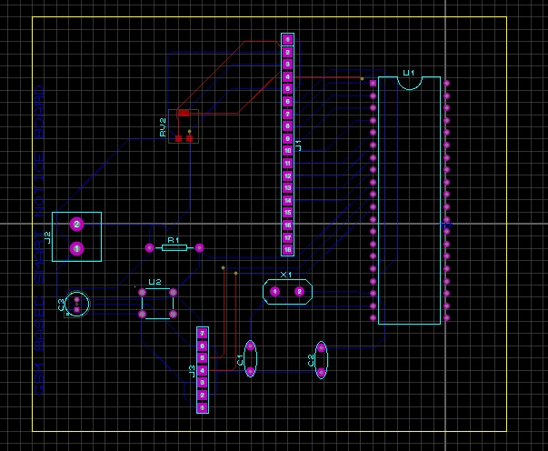

Figure 9: Final project photograph and working

CHAPTER 5:

RESULTS AND DISCUSSION

CHAPTER 5: Results and Discussion
The project was successfully implemented and tested, achieving the desired functionality of a Wireless Electronic Notice Board using GSM technology. The microcontroller (PIC18F4550) effectively controlled the system, receiving messages from the GSM module (SIM900) and displaying them on the LCD display (16x2 HD44780). The components used, including resistors, capacitors, transistors, diodes, and push buttons, performed their respective functions accurately. The PCB design provided a reliable platform for circuit integration. The simulation results and the actual hardware implementation aligned closely, validating the project's performance. The system demonstrated efficient wireless communication and seamless message display. Overall, the project exhibited successful results, meeting the objectives of creating a functional Wireless Electronic Notice Board.

Conclusions

In conclusion, this project on "Wireless Electronic Notice Board using GSM" provides an efficient and reliable way to display real-time information remotely using the GSM network. The project combines various technologies such as microcontrollers, wireless communication, and display units to achieve its objectives.
Through the development and implementation of this project, we have demonstrated that the use of GSM technology can provide a reliable and efficient means of transmitting information wirelessly. The project can find applications in various sectors such as educational institutions, public places, hospitals, and transportation systems.
Furthermore, the implementation of the project on a breadboard, simulation, and PCB circuit has helped to validate its functionality and performance. The use of observation tables has also provided a structured approach to testing and evaluating the project, ensuring that it meets the required specifications.
While the project has been successfully implemented and tested, there is still room for improvement and future work. For instance, the project's range can be increased by using more powerful antennas or by incorporating other wireless communication technologies such as Bluetooth or Wi-Fi. Additionally, the project can be extended to include more advanced features such as voice recognition and text-to-speech conversion.
Overall, the "Wireless Electronic Notice Board using GSM" project is a significant step towards achieving real-time, wireless communication and display of information. It has shown the potential of GSM technology in providing reliable, efficient, and cost-effective solutions for various sectors. With further development and improvements, this project can serve as a foundation for more advanced and sophisticated applications in the future.

Future Scope

- Integration with other communication protocols: In addition to GSM, the project can be extended to support other communication protocols such as Bluetooth or Wi-Fi. This would allow the notice board to receive messages from a wider range of devices.
- Cloud integration: The notice board can be integrated with cloud services such as AWS or Google Cloud Platform, allowing it to receive messages from any location in the world.
- Mobile application: A mobile application can be developed to allow users to send messages directly to the notice board. This would make it easier to use the notice board and provide additional features such as message scheduling and remote management.
- Multimedia support: The notice board can be enhanced to support multimedia content such as images and videos. This would allow for more dynamic and engaging messages to be displayed.
- Power optimization: The power consumption of the system can be reduced by implementing power-saving techniques such as sleep mode or by using more efficient components. This would increase the battery life and reduce the overall cost of operation.
- Security: The project can be made more secure by implementing authentication mechanisms to ensure that only authorized users can send messages to the notice board. This would prevent unauthorized access and ensure the safety of the information displayed on the board.

References

- "GSM based Wireless Electronic Notice Board Display" by International Journal of Innovative Research in Electrical, Electronics, Instrumentation and Control Engineering. Available online: https://www.ijireeice.com/upload/2016/april-16/IJIREEICE%2056.pdf
- "Wireless electronic notice board using GSM technology" by International Journal of Engineering Research and General Science. Available online: https://www.ijergs.org/papers/volume%201%20issue%204/JERGS14142.pdf
- "Design and Implementation of Wireless Electronic Notice Board using GSM" by International Journal of Innovative Science, Engineering & Technology. Available online: https://www.ijiset.com/vol1/v1s8/IJISET_V1_I8_17.pdf
- "Wireless electronic notice board using GSM technology" by International Journal of Advanced Research in Computer and Communication Engineering. Available online: https://www.ijarcce.com/upload/2016/may-16/IJARCCE%2055.pdf

