Enhancing Security in Cloud-Enabled Industrial Smart Vehicles through Attribute-Based Access Management

Vansh Gupta Tarun Kumar Rohit Aggarwal

Vansh.gupta.csit.2019@miet.ac.in Tarun.kumar.csit.2019@miet.ac.in rohit.aggarwal@miet.ac.in

Meerut Institute of Engineering and Meerut Institute of Engineering and Meerut Institute of Engineering

Technology, Meerut Technology, Meerut and Technology, Meerut

Abstract-
Smart cities' vision will encompass connected industrial vehicles, which will offer data-driven and intelligent services to the user. Exploring the Interconnectedness of Dispersed Objects: Enhancing Driver Safety and User Experience: The Key Motivation behind Intelligent Transportation Systems (ITS). Nevertheless, the intricate nature of these infrastructures exposes extensive vulnerabilities, providing adversaries with opportunities to remotely exploit and manipulate vital components of smart vehicles, such as engine and brake assemblies. Addressing Information Security and Privacy Considerations: Essential Pre-Requisites for the Full-scale Implementation of ITS. This article serves as a foundational contribution to addressing access control challenges within the ecosystem. This research introduces an advanced attribute-based access control system, named ITS-ABAC\mahram{_G}, which establishes a robust foundation for efficient access control. Associating them with diverse intelligent entities based on various attributes. Furthermore, it facilitates the enforcement of detailed security policies while considering individual privacy preferences in conjunction with system-wide regulations. To demonstrate its practicality and potential for widespread adoption, a prototype implementation of the proposed model is showcased on the Amazon Web Services IoT platform, accompanied by comprehensive performance evaluations.

Introduction:
Cloud-enabled industrial smart vehicles are becoming increasingly prevalent in the modern world, where they are used for a wide range of applications, including transportation, logistics, and manufacturing. These vehicles are equipped with various sensors and devices that allow them to collect and process large amounts of data, making them an essential component of the Industrial Internet of Things (IIOT). However, as with any internet-connected device.
Access control is the famous fundamental part of security , which is the process of determining who is allowed to access a resource and under what circumstances. Conventional access control mechanisms, like role-based access control, prove inadequate for managing access in the dynamic and heterogeneous environment of cloud-enabled industrial smart vehicles, as they lack the necessary flexibility and granularity.
ABAC is a popular access control mechanism in the cloud computing domain and has been applied to various other domains such as healthcare, finance, and e-commerce.
The proposed model is designed to provide secure and efficient access control in a dynamic and heterogeneous environment. The model is evaluated using a simulation-based approach, and the results demonstrate that it is effective in controlling access to resources in a cloud-enabled industrial smart vehicle environment. This paper highlights the importance of ABAC for cloud-enabled industrial.
Attribute-Based Access Control (ABAC) is a security model that grants or denies access to resources based on attributes associated with a user, such as their role, location, time of day, and more. ABAC is particularly useful in cloud-enabled industrial smart vehicles because it allows for fine-grained access control to data and resources, which is critical in maintaining the confidentiality, integrity, and availability of the system.
ABAC provides several benefits for cloud-enabled industrial smart vehicles, including:
1: Fine-grained access control: ABAC allows for precise control over who can access what resources, based on a wide range of attributes. This helps ensure that sensitive data and resources are only accessible to authorized users.
2: Dynamic access control: ABAC policies can be updated in real-time to reflect changes in the environment, such as user roles or resource availability. This allows for flexible and responsive access control.
3: Centralized policy management: ABAC policies can be centrally managed, making enforcing consistent access control across the system easier. This reduces the risk of unauthorized access due to inconsistent policies.
Overall, ABAC is a powerful security model that can help enhance the security and privacy of cloud-enabled industrial smart vehicles. By providing fine-grained, dynamic, and centralized access control, ABAC can help prevent unauthorized access and protect sensitive data and resources.
Relevant Background and Technologies
An Attribute-Based Access Control (ABAC) for Cloud-Enabled Industrial Smart Vehicles is a security mechanism designed to protect and regulate access to resources in cloud-enabled industrial smart vehicle systems. It ensures that only authorized entities can access specific resources based on their attributes and associated policies.
Here are some relevant backgrounds and technologies related to this topic:
Cloud Computing: Cloud computing refers to the delivery of computing resources and services over the Internet. It provides on-demand access to a shared pool of configurable computing resources, including networks, servers, storage, applications, and services. Cloud computing enables industrial smart vehicle systems to leverage the scalability, flexibility, and cost-efficiency of cloud infrastructure.
1: Industrial Smart Vehicles: Industrial smart vehicles are autonomous or semi-autonomous vehicles used in industrial settings such as warehouses, factories, and logistics centers. These vehicles are equipped with various sensors, communication modules, and intelligent control systems to perform tasks such as material handling, transportation, and surveillance.
2: Attribute-Based Access Control (ABAC): ABAC is a flexible access control model that relies on attributes to define access policies and make access control decisions. Attributes can include user attributes (e.g., role, department), object attributes (e.g., sensitivity, type), and environmental attributes (e.g., time, location). ABAC policies specify the conditions under which access is granted or denied based on attribute values.
3: Policy-Based Access Control: Policy-based access control is an access control approach that relies on the definition and enforcement of policies to govern access decisions. Policies specify rules, conditions, and constraints that determine whether access should be granted or denied. ABAC for cloud-enabled industrial smart vehicles employs policy-based access control to define and enforce access control rules based on attributes.
4: Security and Privacy: Ensuring security and privacy is crucial in cloud-enabled industrial smart vehicle systems. These systems handle sensitive data, perform critical tasks, and may be susceptible to various cyber threats. ABAC helps in enforcing access control policies and preventing unauthorized access, thereby enhancing security and protecting privacy in these systems.
5: Emerging Technologies: Various emerging technologies are relevant to the topic of ABAC for cloud-enabled industrial smart vehicles. These include the Internet of Things (IoT) for connectivity and data exchange between vehicles and sensors, edge computing for real-time data processing and decision-making, artificial intelligence (AI) for intelligent control and analytics, and blockchain for secure and tamper-proof record-keeping.
By considering these backgrounds and technologies, an attribute-based access control mechanism can be developed to secure cloud-enabled industrial smart vehicle systems, providing controlled access.

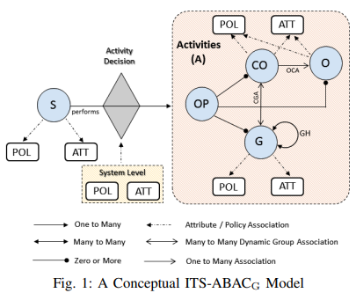

ABAC Model for Cloud ITS

An Attribute-Based Access Control (ABAC) model for Cloud Intelligent Transportation Systems (ITS) is a security framework designed to regulate access to resources and data in cloud-based ITS environments. It leverages attributes associated with users, objects, and environmental conditions to make access control decisions. Here are the key components and aspects of an ABAC model for Cloud ITS:

1: Policy Enforcement Point (PEP): The PEP is responsible for intercepting access requests and enforcing access control policies. It evaluates the attributes associated with the requesting entity, the target resource, and the environment to determine whether access should be granted or denied.

2: Policy Decision Point (PDP): The PDP is the central component of the ABAC model. It receives attribute-based access control policies and makes access control decisions based on these policies. The PDP evaluates the attributes associated with the requesting entity, resource, and environment against the policy rules to determine the appropriate action.

3: Policy Administration Point (PAP): The PAP is responsible for managing and administering the access control policies in the ABAC model. It allows administrators to define, modify, and delete policies based on the organization's security requirements and regulatory compliance.

4: Policy Language: The ABAC model for Cloud ITS employs a policy language that allows administrators to express access control policies in a structured and understandable format. Common policy languages used in ABAC include XACML (extensible Access Control Markup Language) and ALFA (Abbreviated Language for Authorization).

5: Access Control Policies: Access control policies in an ABAC model for Cloud ITS are defined based on attributes. Policies specify the conditions under which access should be granted or denied. For example, a policy might state that only users with the "Administrator" role can access the vehicle diagnostics data during business hours.

Model Implementation in AWS

Implementing the ITS-ABACG (Intelligent Transportation Systems - model in the AWS (Amazon Web Services) environment involves leveraging AWS services and resources to build and deploy the access control system. Here's an outline of the implementation steps:

1: Design the Architecture: Define the architecture of the ITS-ABACG system, considering the components mentioned in the model. This includes the cloud infrastructure, smart vehicles, Attribute Authority (AA),
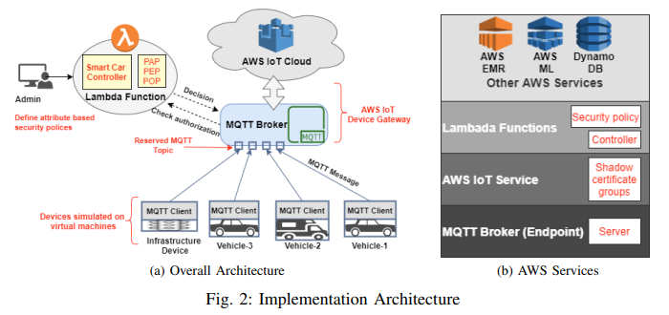

3: Cloud Infrastructure: Set up the required cloud infrastructure components using AWS services such as Amazon EC2 (Elastic Compute Cloud) for hosting servers, Amazon S3 (Simple Storage Service) for storage needs, and Amazon VPC (Virtual Private Cloud) for network isolation.

4: Attribute Authority (AA) Layer: Utilize AWS services like Amazon DynamoDB or Amazon RDS (Relational Database Service) to create attribute repositories for storing and retrieving attribute values associated with users, objects, and environmental conditions.

5: Policy Decision Point (PDP) Layer: Implement the PDP using AWS Lambda, a serverless compute service, to evaluate access requests based on predefined policies and attributes. Lambda functions can be written in a programming language of choice and can interact with the AA layer to retrieve attribute values.

6: Policy Enforcement Point (PEP) Layer: Implement the PEP component using AWS API Gateway, which acts as an intermediary between the smart vehicles and the PDP. The API Gateway receives access requests, invokes the Lambda functions of the PDP, and enforces the access control decisions returned by the PDP.

7: Policy Repository Layer: Store the access control policies in a centralized or distributed repository using AWS services such as Amazon DynamoDB, Amazon S3, or Amazon Aurora.

8: Audit and Logging Layer: Configure AWS CloudTrail to capture and log access control events, policy evaluations, and attribute values. This provides an audit trail and enables compliance and forensic analysis.

9: User Interface Layer: Develop a user interface using AWS services such as AWS AppSync, Amazon API Gateway, or AWS Amplify. This interface allows administrators or authorized users to manage policies, configure attributes, and monitor access control activities.

10: Secure Communications: Ensure secure communications between the smart vehicles and the cloud infrastructure by utilizing appropriate encryption mechanisms such as Transport Layer Security (TLS) or Virtual Private Network (VPN) connections.

11: Testing and Deployment: Thoroughly test the implemented system to validate its functionality and security. Once tested, deploy the system in the AWS environment, ensuring scalability and high availability as required.

12: Monitoring and Maintenance: Set up monitoring and alerting using AWS CloudWatch to monitor the performance, availability, and security of the ITS-ABACG system. Perform regular maintenance tasks, such as patching and updating components, to ensure system integrity and security.

By following these steps and leveraging AWS services, you can implement the ITS-ABACG model in the AWS environment for secure and controlled access to resources in Cloud-enabled Industrial Smart Vehicles.

In the implementation of the ITS-ABACG model, there are two distinct phases: the administrative phase and the operational phase. Here's a breakdown of each phase:

1: Administrative Phase:

Hierarchical Groups: Develop a hierarchical group structure in the system, organizing smart cars into various defined groups based on geography or other criteria. This allows for easier management and organization of entities.

Assignment of Smart Cars: Assign smart cars to the appropriate groups within the hierarchy, considering factors such as location, function, or other relevant attributes.

Attribute Inheritance: Define attribute inheritance rules, ensuring that smart cars inherit attributes and alerts from the groups to which they are assigned. This simplifies attribute management and ensures consistency within the system.

Attribute Changes: Enable administrators to modify attributes associated with different entities in the system. Some attribute changes may be initiated by administrators, while others may be automatically triggered based on environmental conditions.

Multi-Layer Authorization Security Policies: Develop multi-layer authorization security policies that govern the administrative phase, ensuring that only authorized administrators can perform administrative tasks and make attribute changes.

In the implementation of the ITS-ABACG model in AWS IoT services, a group hierarchy is created to organize the smart cars. The group hierarchy consists of three levels. At the highest level of the hierarchy, County-XYZ serves as the overarching entity. County-XYZ is further partitioned into four distinct and non-overlapping location clusters: Cluster-A, Cluster-B, Cluster-C, and Cluster-D. Each location cluster is then subdivided into two subclusters, one designated for cars and the other for buses, aligning with the specific vehicle types associated with each subcluster. This hierarchical arrangement facilitates efficient organization and management of the vehicles based on their precise location and vehicle category. In order to replicate the movement of intelligent vehicles, a Python script can be used to dispatch MQTT (Message Queuing Telemetry Transport) messages to virtual vehicle counterparts, also known as shadows. By updating the GPS coordinates in the MQTT messages, the system can track the movement and location of the smart cars within the group hierarchy. This hierarchical grouping and simulation setup enables effective management and tracking of the smart cars in the IIOV environment. The AWS IoT services, along with the Python script and Google API, provide the necessary tools and functionality to implement this group hierarchy and simulate the movement of smart cars.

2: Operational Phase:

ABAC Policy Decision Point (PDP): Implement a policy decision point component responsible for evaluating access requests based on the defined ABAC policies. The PDP considers attributes of the requester, requested resources, and environmental conditions to make access control decisions.

ABAC Policy Enforcement Point (PEP): Implement a policy enforcement point component that enforces the access control decisions made by the PDP. This component intercepts access requests, communicates with the PDP for decision-making, and enforces the decisions by allowing or denying access to resources. External Policy Evaluation Engine: Utilize the group structure established during the administrative phase to ensure that notifications and alerts are relevant to authorized entities. This may involve delivering notifications and alerts based on the group memberships of the smart cars. In the phase mentioned, the evaluation involves enforcing policies that restrict alerts, notifications, and services in response to regulation signals within environment.

This approach ensures that alerts, notifications, and services are targeted to the vehicles that are relevant to the specific requests or activities, improving the efficiency and effectiveness of the IIOV system.

By leveraging AWS services, such as the MQTT-based messaging system and AWS shadow topics, the system can dynamically determine the subgroup and deliver the appropriate alerts and notifications to the relevant vehicles in the IIOV environment.

Performance Evaluation Metrics and Analysis

Performance evaluation of (ABAC) system can involve several metrics and analysis techniques. Here are some key performance evaluation metrics and analysis approaches:

1: Throughput: ABAC system can handle per unit of time. Higher throughput indicates the system's ability to efficiently process a large volume of requests. It is particularly important in scenarios with high concurrency and frequent access requests.

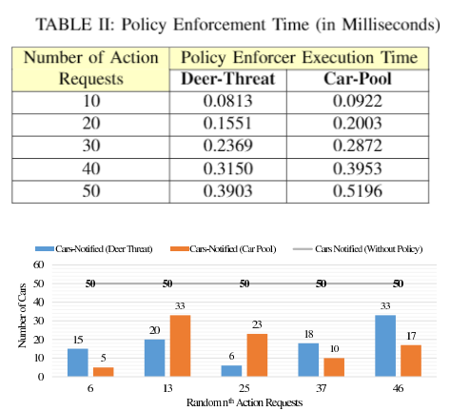

2: Scalability: Evaluate how the ABAC system performs as the number of users, objects, and attributes increases. Measure the system's ability to handle a growing workload without significant degradation in performance. Scalability is crucial to ensure the system can accommodate the requirements of an industrial environment.

3: Resource Utilization: Monitor the utilization of system resources, such as CPU, memory, and network bandwidth. Ensure that the ABAC system operates efficiently and optimally utilizes available resources. Identify any resource bottlenecks that may affect system performance.

4: Policy Evaluation Time: Measure the time taken by the ABAC system to evaluate complex policies involving multiple attributes and conditions. Analyse the impact of policy complexity on the overall system performance and identify potential optimization opportunities.

5: Audit Log Analysis: Analyse the audit logs generated by the ABAC system to identify access patterns, detect anomalies, and assess the effectiveness of access control policies. This analysis helps in understanding the system's behaviour, identifying potential security risks, and ensuring compliance with regulatory requirements.

6: Security Analysis: Assess the security aspects of the ABAC system, including vulnerability assessments and penetration testing. Identify any security weaknesses or potential threats that could compromise the access control mechanism. Evaluate the system's ability to mitigate attacks and protect sensitive resources.

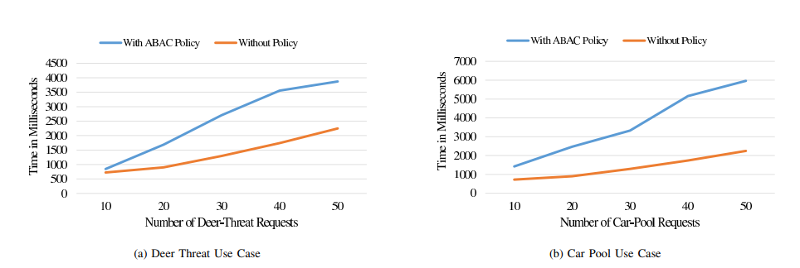

7: User Experience: Evaluate the user experience of authorized users interacting with the ABAC system. Assess factors such as authentication and authorization time, user interface responsiveness, and ease of use. User feedback and satisfaction surveys can provide valuable insights into the system's performance from a user perspective.

The scope and relevance of alerts received by smart cars in the proposed ITS-ABACG model depend on the execution of policies within the system. It is important to ensure that only relevant notifications are sent to drivers to maintain their attention and avoid distractions. The effectiveness of the ABAC policies is crucial in achieving this objective. Without the implementation of any policy, all 50 vehicles receive notifications regardless of their location or driver preferences. This scenario may result in irrelevant notifications reaching the drivers. However, when cloud-based policies are enforced, notifications become relevant to the vehicles. In the example shown in Figure 6, on the 25th request, only 23 vehicles receive the car-pool request notification. Improving their relevance and avoiding unnecessary distractions for drivers. By implementing effective ABAC policies, the ITS-ABACG model can ensure that notifications and alerts are targeted to the appropriate vehicles based on location, preferences, and relevant factors. This enhances the overall efficiency, safety, and convenience of the smart-vehicle ecosystem.

Performance graphs depict the execution time for the ITS-ABACG model with the implemented ABAC policy (blue line) compared to the scenario without any policy (orange line) for two specific use cases: deer-threat alerts (Figure 7a) and pooling notifications (Figure 7b). The x-axis represents the total number of execution requests, indicating the frequency of generating deer-threat alerts or pool notifications. The vertical axis of the graphs illustrates the total duration (measured in milliseconds) starting from the moment the AWS Lambda function receives the notification or access request within the central cloud until the system logs the number of vehicles that have been notified. The objective of these graphical representations is to evaluate the influence of ABAC policy execution on the overall time taken for the assessment process. As the volume of access requests escalates, the frequency of policy evaluations also rises, subsequently impacting the overall duration of the evaluation process. The blue line on the graph depicts the execution time when the ABAC policy is implemented, whereas the orange line portrays the execution time in the absence of any policy.

Graphs provide insights into how the implementation of the ABAC policy affects the system's performance in terms of evaluation time. By comparing the blue and orange lines, it is possible to observe the performance improvement achieved by the ABAC policy in managing and controlling notifications and alerts. This evaluation helps in understanding the trade-off between the additional evaluation time introduced by the policy and the enhanced security and relevance of notifications for the vehicles in the system. Analysing the performance graphs can assist in optimizing the ABAC policy implementation, fine-tuning the system parameters, and ensuring an efficient balance between security and performance in the ITS-ABACG model.

Conclusion

In future research, the aim is to enhance the attribute-based access control (ABAC) model for cloud-enabled industrial smart vehicles by expanding its capabilities in several specific areas:
1. In-vehicle Access Control Security Solutions: The model will be extended to encompass security solutions that specifically address access control within the vehicles themselves. This will provide a holistic approach to securing the entire system.
2. Trust-based Risk-aware Adaptive Models: The research will explore the integration of trust-based mechanisms and risk-aware adaptive models into the ABAC framework. This will enable the system to dynamically adjust access permissions based on the trustworthiness of entities and the level of risk associated with specific actions.
3. Privacy-preserving Mechanisms: To address concerns related to location privacy, privacy-preserving techniques such as homomorphic encryption will be investigated. These mechanisms will ensure that sensitive location information is protected while still allowing for the necessary access control and notifications.
4. V2X Edge-assisted Solutions: Exploring V2X (Vehicle-to-Everything) edge-assisted solutions will be a key area of focus. This involves leveraging communication between vehicles and roadside infrastructure to establish trusted and secure channels for data exchange, contributing to the overall security and efficiency of the system.
Overall, these future enhancements aim to further strengthen the ABAC model, making it more robust and adaptable to the evolving needs of cloud-enabled industrial smart vehicles. By incorporating these advancements, the research will contribute to the advancement of intelligent transportation systems, ensuring secure and efficient operations while addressing privacy concerns and user preferences.
References

[1] Z. Zhou et al., “Social big-data-based content dissemination in the Internet of vehicles,” IEEE Transactions on Industrial Informatics, vol. 14, no. 2, pp. 768–777, 2018.

[2] M. Azam et al, “Cloud of things: Integrating internet of things and cloud computing and the issues involved,” in Proc. of IBCAST, Jan 2014, pp. 414–419.

[3] R. Lea and M. Blackstock, “City hub: A cloud-based IOTY platform for smart cities,” in Proc. of IEEE Cloud Com, Dec 2014, pp. 799–804.

[4] M. Gupta and R. Sandhu, “Authorization framework for secure cloud-assisted connected cars and vehicular internet of things,” in Proc. of ACM SACMAT, 2018, pp. 193–204.

[5] M. Gupta, J. Benson, F. Patwa, and R. Sandhu, “Secure V2V and V2I communication in intelligent transportation using cloudlets,” ARXIV preprint arXiv:2001.04041, 2020.

[6] R. S. Sandhu and P. Samrati, “Access control: principle and practice,” IEEE communications magazine, vol. 32, no. 9, pp. 40–48, 1994.

[7] D. F. Ferraiolo et al., “Proposed NIST standard for role-based access control,” ACM Transactions on Information and System Security (TISSEC), vol. 4, no. 3, pp. 224–274, 2001.

[8] V. C. Hu, D. R. Kuhn, and D. F. Ferraiolo, “Attribute-based access control,” IEEE Computer, no. 2, pp. 85–88, 2015. 9https://azure.microsoft.com/en-us/services/iot-hub/ 10https://cloud.google.com/iot-core/ 11https://www.openstack.org/

[9] X. Jin et al., “A unified attribute-based access control model covering DAC, MAC, and RBAC,” in Proc. of DBSec. Springer, 2012, pp. 41–55.

[10] S. S. L. Chukkapalli et al., “A smart-farming ontology for attribute-based access control,” in 6th IEEE International Conference on Big Data Security on Cloud (BigDataSecurity 2020), 2020.

[11] Z. Lu, G. Qu, and Z. Liu, “A survey on recent advances in vehicular network security, trust, and privacy,” IEEE Transactions on Intelligent Transportation Systems, vol. 20, no. 2, pp. 760–776, 2018.

[12] I. Ali et al., “Authentication and privacy schemes for vehicular ad hoc networks (VANETs): A survey,” Vehicular Communications, 2019.

[13] M. N. Mejri, J. Ben-Othman, and M. Hamdi, “Survey on vanet security challenges and possible cryptographic solutions,” Vehicular Communications, vol. 1, no. 2, pp. 53–66, 2014.

[14] Y. F. Payalan and M. A. Guvensan, “Towards next-generation vehicles featuring the vehicle intelligence,” IEEE Transactions on Intelligent Transportation Systems, 2019.

[15] U. Ahmad, H. Song, A. Bilal, M. Alazab, and A. Jolfaei, “Securing smart vehicles from relay attacks using machine learning,” The Journal of Supercomputing, pp. 1–18, 2019.

[16] F. M. Awaysheh, J. C. Cabaleiro, T. F. Pena, and M. Alazab, “Poster: A pluggable authentication module for big data federation architecture,” in Proc. of the ACM SACMAT, 2019, pp. 223–225.

[17] M. Shojafar, N. Cordeschi, and E. Baccarelli, “Energy-efficient adaptive resource management for real-time vehicular cloud services,” IEEE Transactions on Cloud computing, vol. 7, no. 1, pp. 196–209, 2016.

[18] N. Cordeschi, D. Amendola, M. Shojafar, and E. Baccarelli, “Distributed and adaptive resource management in cloud-assisted cognitive radio vehicular networks with hard reliability guarantees,” Vehicular Communications, vol. 2, no. 1, pp. 1–12, 2015.

[19] S. Ghane, A. Jolfaei, L. Kulik, K. Ramamohanarao, and D. Puthal, “Preserving privacy in the internet of connected vehicles,” IEEE Transactions on Intelligent Transportation Systems, 2020.

[20] S. Darbha, S. Konduri, and P. R. Pagilla, “Benefits of V2V communication for autonomous and connected vehicles,” IEEE Transactions on Intelligent Transportation Systems, vol. 20, no. 5, pp. 1954–1963, 2018.

[21] A. Kayes et al., “Achieving security scalability and flexibility using fog-based context-aware access control,” Future Generation Computer Systems, vol. 107, pp. 307–323, 2020.

[22] W. Liu and Y. Shoji, “DeepVM: RNN-based vehicle mobility prediction to support intelligent vehicle applications,” IEEE Transactions on Industrial Informatics, 2019.

[23] M. Gupta, J. Benson, F. Patwa, and R. Sandhu, “Dynamic Groups and Attribute-Based Access Control for Next-Generation Smart Cars,” in Proc. of the ACM CODASPY, 2019, pp. 61–72.

[24] J. Li et al., “An efficient attribute-based encryption scheme with policy update and file update in cloud computing,” IEEE Transactions on Industrial Informatics, vol. 15, no. 12, pp. 6500–6509, 2019.

[25] M. Aladwan et al., “TrustE-VC: Trustworthy Evaluation Framework for Industrial Connected Vehicles in the Cloud,” IEEE Transactions on Industrial Informatics, 2020.

[26] L. Zhu, F. R. Yu, Y. Wang, B. Ning, and T. Tang, “Big data analytics in intelligent transportation systems: A survey,” IEEE Transactions on Intelligent Transportation Systems, vol. 20, no. 1, pp. 383–398, 2018.

[27] F. Awaysheh, J. C. Cabaleiro, et al., “Big data security frameworks meet the intelligent transportation systems trust challenges,” in Proc. of IEEE TrustCom/BigDataSE, 2019, pp. 807–813.

[28] F. Awaysheh et al., “Next-generation big data federation access control: A reference model,” Future Generation Computer Systems, 2020.

[29] M. Aladwan et al., “Common security criteria for vehicular clouds and internet of vehicles evaluation and selection,” in Proc. of IEEE TrustCom/BigDataSE, 2019, pp. 814–820.

[30] E. Union, Certificate Policy for Deployment and Operation of European Cooperative Intelligent Transport Systems (C-ITS), 2017. [Online]. Available: https://ec.europa.eu/transport/sites/transport/files/cits certificate policy release 1.pdf

