VEHICLE ACCIDENT ALEART SYSTEM USING GSM & GPS WITH SENSORS
Mr.Gawali S.M¹, Mr.Swami M.V.², Miss.Kulkarni R.R.³
M.Tech ECE¹, ME VLSI&ESY², Diploma E&TC³
Lecturer Electronics & telecommunication Department
Vishweshwaryya Polytechnic Dilip Nagar Almala, Maharashtra, India

Abstract:
Arduino Based Vehicle Accident Alert System using GPS, GSM and Accelerometer. Accelerometer detects the sudden change in the axes
of vehicle and GSM module send the alert message on your Mobile Phone with the location of the accident. The advancing technology
has made our day to day lives easier.

Keywords: GPS, GSM, Sensors, Arduino, Acclerometer

INDRODUCTION

A vehicle tracking system combines the installation of an electronic device in a vehicle, or fleet of vehicles, with purpose-designed computer software to enable the owner or a third party to track the vehicle's location, collecting data in the process. Modern vehicle tracking systems commonly use Global Positioning System (GPS) technology for locating the vehicle, but other types of automatic vehicle location technology can also be used. Vehicle information can be viewed on electronic maps via the Internet or specialized software. In the main they are easy to steal, and the average motorist has very little knowledge of what it is all about. To avoid this kind of steal we are going to implement a system it provides faster first-aid to the accidental person. Older System only provides security like: security lock and alarm is implemented in a car, If a burglar can break /open the lock, then it becomes easy for the burglar to steal the car, And in old security system if the car is stolen then it is out of the owner control. User doesn’t have any awareness about the current location of the vehicle.
Here circuit, senses the dash, acceleration in the vehicle by various sensors placed in our project and then GPS will be locate the position of vehicle and transmit that data to the microcontroller. Microcontroller takes action to send SMS through GSM modem for saved mobile number in the system. This will be a much simpler and low cost technique compared to others.

BLOCK DIAGRAM:

- POWER SUPPLY:-
Circuit requires 5V DC for LCD module, arduino uno
Board, GSM modem and GPS required 12V. This power supply can be provided 12V transformer to charge 12V battery with rectifier, filter, with regulator of 5V.
ARDUINO UNO BOARD here we using arduino board for only programming purpose, we have implemented this project using atmega328 microcontroller

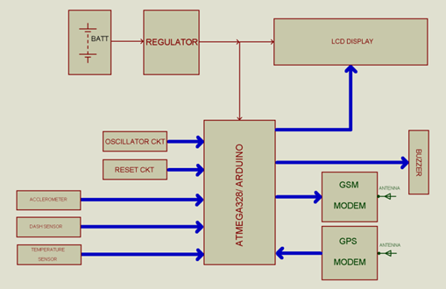

FIGURE.1. BLOCK DIAGRAM

POWER (USB / BARREL JACK)
Every Arduino board needs a way to be connected to a power source. The Arduino UNO can be powered from a USB cable coming from your computer or a wall power supply that is terminated in a barrel jack. In the picture above the USB connection is labeled (1) and the barrel jack is labeled (2).The USB connection is also load code onto your Arduino board.
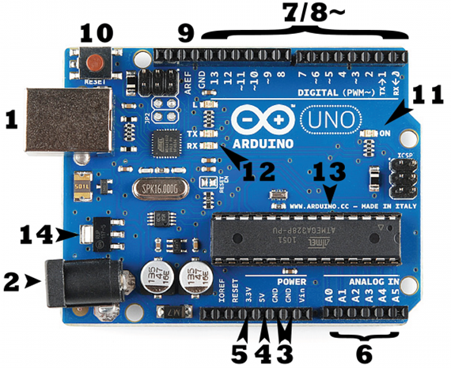

- PINS (5V, 3.3V, GND, ANALOG, DIGITAL, PWM, AREF)
The pins on your Arduino are the places where you connect wires to construct a circuit (probably in conjunction with a breadboard / PCBs and some wire. They usually have black plastic ‘headers’ that allow you to just plug a wire right into the board. The Arduino has several different kinds of pins, each of which is labeled on the board and used for different functions.
GND (3): Short for ‘Ground’. There are several GND pins on the Arduino, any of which can be used to ground your circuit.
5V (4) & 3.3V (5): As you might guess, the 5V pin supplies 5 volts of power, and the 3.3V pin supplies 3.3 volts of power. Most of the simple components used with the Arduino run happily off of 5 or 3.3 volts.
Analog (6): The area of pins under the ‘Analog In’ label (A0 through A5 on the UNO) are Analog In pins. These pins can read the signal from an analog sensor (like a light sensor) and convert it into a digital value that we can read.
Digital (7): Across from the analog pins are the digital pins (0 through 13 on the UNO). These pins can be used for both digital input (like telling if a button is pushed) and digital output (like powering an LED).
PWM (8): You may have noticed the tilde (~) next to some of the digital pins (3, 5, 6, 9, 10, and 11 on the UNO). These pins act as normal digital pins, but can also be used for something called Pulse-Width Modulation (PWM).
AREF (9): Stands for Analog Reference. Most of the time you can leave this pin alone. It is sometimes used to set an external reference voltage (between 0 and 5 Volts) as the upper limit for the analog input pins.

RESET BUTTON
The Arduino has a reset button (10). Pushing it will temporarily connect the reset pin to ground and restart any code that is loaded on the Arduino. This can be very useful if your code doesn’t repeat, but you want to test it multiple times.

POWER LED INDICATOR

Just beneath and to the right of the word “UNO” on your circuit board, there’s a tiny LED next to the word ‘ON’ (11). This

LED should light up whenever you plug your Arduino into a power source. If this light doesn’t turn on, there’s a good chance something is wrong. Time to re-check your circuit.

TX RX LEDs

TX is short for transmit, RX is short for receive. These markings appear quite a bit in electronics to indicate the pins responsible for serial communication. In our case, there are two places on the Arduino UNO where TX and RX appear – once by digital pins 0 and 1, and a second time next to the TX and RX indicator LEDs (12). These LEDs will give us some nice visual indications whenever our Arduino is receiving or transmitting data (like when we’re loading a new program onto the board).

- LM35 temperature sensor

The LM35 series are precision integrated-circuit temperature sensors, whose output voltage is linearly proportional to the Celsius (Centigrade) temperature. ... The LM35 is rated to operate over a −55˚ to +150˚C temperature range, while the LM35C is rated for a −40˚ to +110˚C range (−10˚ with improved accuracy).

- ACCLEROMETER

Accelerometer is acceleration sensor used to sense acceleration in X and Y directions, its output changes with accelerometer angle from 0 to 1800 degree. Accelerometer output is low required to amplify to detect in digital format. So opamp is used in investing and non-inverting configurations. And flex sensor is used to sense and control grip movement.

- DASH SENSOR

Here Dash sensor detect, dash. Dash detected output is given to microcontroller to detect and takes further action.

- GSM MODEM

A GSM modem is a specialized type of modem which accepts a SIM card, and operates over a subscription to a mobile operator, just like a mobile phone. From the mobile operator perspective, a GSM modem looks just like a mobile phone.
GSM Modem comes in interfaces like USB, and Serial. GSM

Modem is however the main difference is that GSM Modem
is wireless, while dial-up modem is wired (telephone previously).
GSM is used here to interface with microcontroller and
Microcontroller command to the GSM modem with AT (abbreviation of Attention) command set implemented in our program. If
Voltage difference in microcontroller and GSM modem voltage level shifter IC required to use.
LED indicators connected to the which operation is working now, as like LED RED for vehicle stop, LED green for vehicle on.

- GPS MODEM

A GPS modem is a specialized type of modem which detects location from satellite directly with longitude and latitude coded format.
GPS Modem comes in interfaces like USB, and Serial. GPS Modem is However global positioning system.
GPS is used here to interface with microcontroller and microcontroller command to the GPS modem with AT (abbreviation of Attention) command set implemented in our program. If voltage difference in microcontroller and GPS modem voltage level shifter IC required using.
As switch is pressed, location along longitude and latitude find out
and SMS sending done over GSM to the stored mobile numbers.

- LCD DISPLAY
LCD (Liquid Crystal Display) screen is an electronic display module and find a wide range of applications. A 16x2 LCD display is very basic module and is very commonly used in various devices and circuits. These modules are preferred over seven segments and other multi segment LEDs. The reasons being: LCDs are economical; easily programmable; have no limitation of displaying special & even custom characters (unlike in seven segments), animations and so on.
A 16x2 LCD means it can display 16 characters per line and there are 2 such lines. In this LCD each character is displayed in 5x7 pixel matrix. This LCD has two registers, namely, Command and Data.

WORKING:
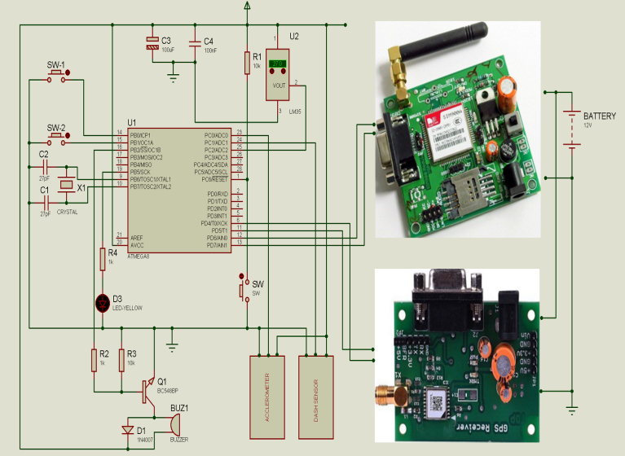

FIGURE.2. CIRCUIT DIAGRAM

Here circuit requires 5V and 12V regulated DC supply. We used here 230V to 12V-0-12V step down transformer. The output AC of transformer 12V is rectified by center tap rectifier. Rectified output is pulsating it is pure by the capacitor filter of 1000uf 25V. Now the out of capacitor is DC 12V-15V to charge the battery according to transformer ratings given to the arduino board, which is required to convert in 5V regulated for microcontroller and other devices, here we have used LM7805 regulator for getting 5V regulated DC. For LCD display.
In this arduino board (microcontroller) works with 16MHz frequency used for (timer configuration), the unwanted frequency produced is bypassed by the capacitor of 27pf capacitor. Reset pin is connected to resistor of 10K whenever reset requires the reset switch (2 lead push to ON switch/ micro push to switch) required to press.
LCD data pins (AD4 to AD7) is connected to the pin 10, pin 11, pin12, pin 13 to send the data for the LCD display. The control pins of LCD display is connected to pin 8, pin 9, respectively take action as RS, E. Variable resistor of 10K (or fixed 2.2K) is connected to the adjust contrast of 16X2 LCD display. 10uf capacitor is used to cancel loading effect and 0.1uf is used to bypass the unwanted spikes produced in the circuit.

According to programming conditions in arduino board, when sensors sense the physical condition microcontroller takes action to get location from GSM and send location to stored mobile number from GSM.

Pin 0 RXD (0) and 1 TXD (1) are serial communication pins used to interface with GPS and GSM modem. These modem has TXD and RXD pins for transmit and receive data or commands serially. Microcontroller (arduino board) works with 5V DC and GPS/ GSM works with same supply so level shifter IC not required to

Communicate each other. In GSM module fast LED blinking notify searching for network connectivity. Slowly blink notify connected with network, now we can transmit SMS with location in longitude and latitude format.
All capacitors of 0.1uf near analog/ digital/ microcontroller ICs are connected to reduce spikes in the circuit, spikes produced by inductive load/ sparking contacts of loads and capacitor of 1000uf/25V at regulator output is connected for the cancel loading effect in the circuit while driving the high current source.

- ADVANTAGES :

- The circuit required power supply is very less, (12V, 750mAh) provides more backup to the circuit.
- Can be found accuracy less than 10 meter area. In open space and 100meter in closed area.
- The circuit is compact in size, so small space is required.
- If the network is not available, then it sends previous location from where that system comes.

- APPLICTIONS

- It can be used in protect violence against women, like in panic switch.
- It can be used in security or protection unit in vehicles.
- It can be used in military purpose to tress location of soldiers
- It can be used in border alert system for fishermen.

- CONCLUSION:

It works satisfy with live location send to mobile for saved number, when sensor sense physical condition. If network is not available then it sends previous location, wherever last location detected. System can store one or more mobile numbers to send messages.

REFERENCES:

- International Journal of Creative Research Thoughts (IJCRT) www.ijcrt.org, Accident Alert System using GPS and GSM.

- International Journal of Engineering Research and Technology (IJERT) Volume 9, issue 5, GSM based Vehicle Accident Alert System.

- Social Science Research Network Vol-5, issue 2, Accident Alert and Vehicle Tracking System using GPS and GSM.

- International Research Journal of Engineering and Technology (IRJET) Volume 6, Vehicle Accident Detection System by using GSM and GPS.

- Asian Journal of Applied Science and Technology (AJAST) Volume 5, Accident Alert and Vehicle Tracking System using GPS and GSM.

