Research Paper

Comparative analysis of Mess Management System
Department of Computer Application
By
Ms.Namrata Mandloi & Ms. Nandani Namdev
Medi-caps University Indore (M.P.)

Abstract
The mess management system provides all types of facilities. Firstly, users have to sign up for using mess facilities they have to fulfill their all details through the sign-up form these help to check the status of a user or customer related through the mess. It is also helpful to get daily updates and a messy timetable. Use gets more benefits with this proposed system. A mess management system is mainly designed for those students who have to take mess facilities from college offices and particular universities. This system is designed for users who enjoy their meals on mess and check their daily details only sign-up users.

Introduction
These systems provide healthy and fresh food for many people’s like student employee and those users who use mess facility. These is our new facility in which we have provided a special Jain thali and fresh fruits for our users who asked for that through our system.This system helpful for those user who know about the details for our menu related to our mess and reserve their food if they are getting late . We are mainly focus on timing issues related to our mess in a system .We provide a facility in which if user did’nt reach mess at time then, they can inform before time and reserve their food. This facility helps for those who didn't reach mess at time.Mainly many messes have do not get the facility just like for an example if a student did’nt reach mess at time then they don’t get their food but if they are using our system then they informed previously through our website and get their food. Mess management system also provides facility of checking menu because it is helpful for those who follow their rituals just like in festive time many people brings their fast at that time these time they do not eat some kind of food so if they know about the menu previously then it will be helpful for all.

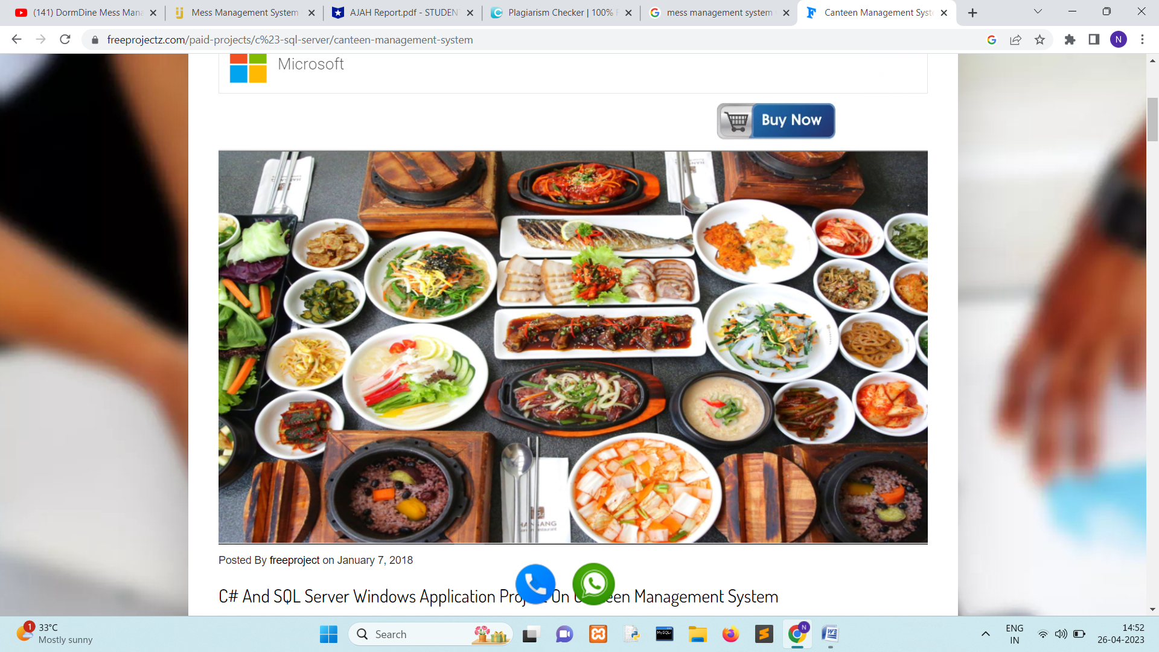

Literature Review
1. In this system we have provided a special Jain thali booking facility for a particular area food like Jain caste people. The other facility of our site is to provide online mess menu in which users can easily check the day by day items in the mess food court.
This website is made with React Js, HTML, and CSS for frontend work, and for backend work, we have used node js.
2. In this mess management system firstly users have to sign-up for using the mess facility they have to fulfill their all details through sign up for this helps to check the status of a user or customer related to the mess.
3. An mess management system that provides the special Jain thali and fruits. This is very useful for Jain people because many Jain people do not eat food with ginger, onion, or garlic.

Proposed System
Firstly student can register yourself and then he request for admin to get their details now admin have accept their request and provide id password for login because these is a particular system for colleges , universities and organistions users.Now user have to enter their id and password for login after login they have sent request to admin to get the menu chart of our mess related to their needs now admin accept it and show all the mess facilities provided for our mess.After these process a user have to be satisfied of our services now they have to give a feedback and should logout. Once the user logout then they can login through their I’d and password again But if they sign out so they do not login again because his session will be dismissed and they don’t be able to use our website.They created their id again and admin will be reset their id and password.So these is best for their security purpose.
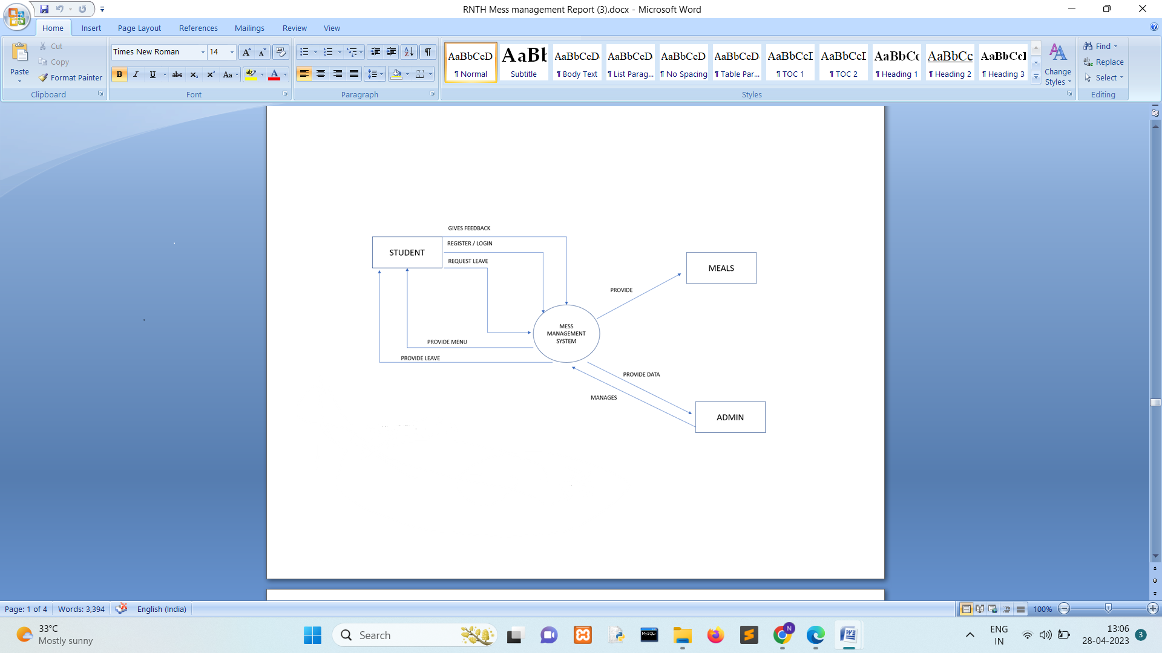
Conclusion
After implementing the system in the market, its advantages were in comparable to the present contemporary system available in the market. The most admirable features found was its simplicity city in terms of application to the user but its highly beneficial outputs can cannot be ignored .The users will be highly benefited after using the system .There is always room for you to win any software, however efficient the system may be. These system is very flexible and in future any changes should be done easily. These research pepar helpful to providing more facility like special Jain Thali.
References
(1) R.Groff and P. N Weinberg. Complete Reference SQL Second Edition.
(2) Vineetha Rohra, Anurag Sukhija, +1 author Ajay Karare
Published 24 April 2018
Computer Science
International journal of engineering research and technology
(3) Mess Management Software by Initio (2010).

