“EMOTION BASED MUSIC RECOMMENDATION SYSTEM”

Nazeefullah Shaik
Cloud Technology And Information Security
Jain university ( Deemed-to-be University)
Banglore , India
email address or ORCID
Harnish M R
Cloud Technology And Information Security
Jain university ( Deemed-to-be University)
Banglore , India
email address or ORCID
Shashikanth M S Cloud Technology And Information Security
Jain university ( Deemed-to-be University)
Banglore , India
email address or ORCID
Surya S
Cloud Technology And Information Security
Jain university ( Deemed-to-be University)
Banglore , India
email address or ORCID

Abstract— Now-a-days; recommendation systems has immense popularity and help people to select appropriate music. Mostly, presentation corners on facial based recommendation systems. Sensors would usually collect face and voice patterns of a user and can track heart rate ,oxygen saturation ,steps travelled and many others. Even though ,sensors and computing devices create extra inputs but they will increase the accuracy of generated music suggestions. Music has a powerful impact on people and is extensively utilised for relaxation, mood control, stress relief, and illness prevention, as well as to sustain mental and physical work. Music has been nowadays acting as an stress-buster for every human. However opting out the song on the mood is so essential. It would be so skeptical for a person to decide the song to listen from heavy existing choices. Human emotions have become increasingly important in recent years. Human sentiments underpin emotion, which can be expressed or not. Emotion represents the individual behaviour of humans, which can take several forms. The extraction of emotion states the individual state of behaviour of humans. In this presentation hitting those right tracks for desired person is Fisher’s Face algorithm(LDA) briefly.In our proposed system a mood based music player is created which performs real time mood detection and suggests songs based on the detected mood.

Keywords—

Introduction
- The Emotion-Based Music Recommendation System aims to create a more immersive and tailored music listening experience by leveraging the power of machine learning and emotion recognition techniques. By understanding and analyzing the emotional characteristics of both music tracks and the user, the system can generate recommendations that resonate with the user's current emotional state, fostering a deeper emotional connection and enhancing the overall listening experience. Music has a profound impact on our emotions and can evoke a wide range of feelings, from joy and excitement to sadness and nostalgia. With the advent of digital music platforms and streaming services, the sheer volume of available music has become overwhelming, making it challenging for users to discover tracks that align with their current emotional state. In response to this challenge, the Emotion-Based Music Recommendation System is designed to provide personalized music recommendations based on the user's emotions.

PROBLEM STATEMENT

Identify applicable funding agency here. If none, delete this text box.

The Problem at hand is the overwhelming abundance of music available through various digital platforms, which makes it challenging for users to discover music that aligns with their current emotional state. Existing music recommendation systems often rely on collaborative filtering, genre-based preferences, or popularity metrics, which may not adequately capture the complex and dynamic nature of human emotions. As a result, users may struggle to find music that resonates with their emotional needs, leading to a less satisfying and personalized music listening experience. Music has a powerful impact on people and is extensively utilised for relaxation, mood control, stress relief, and illness prevention, as well as to sustain mental and physical work. Music has been nowadays acting as an stress-buster for every human. However opting out the song on
the mood is so essential. It would be so skeptical for a person to decide which song to listen from heavy existing choices. Human emotions have become increasingly important in recent years. Human sentiments underpin emotion, which can be expressed or not. Emotion represents the individual behaviour of humans, which can take several forms The extraction of emotion states the individual state of behaviour of humans. In our proposed system a mood based music player is created which performs real time mood detection and suggests songs based on the detected mood

OBJECTIVE

- The main objectives of this project are as follows
a) To develop a robust emotion recognition model capable of accurately identifying and categorizing emotions based on input data.
b) To design and implement a music recommendation algorithm that considers emotional attributes of songs.
c) To create an intuitive user interface that allows users to input their emotions and receive relevant music recommendations.
d) To evaluate the performance and effectiveness of the system through user feedback and comparison with existing music recommendation systems.

RELATED WORK
An extensive literature survey has been conducted by studying existing systems of Emotion Based Music Recommendation System. A good number of research papers, journals, and publications have also been referred before formulating this survey. It covers various aspects, including emotion representation, emotion recognition techniques, and recommendation algorithms.
The authors discuss the challenges and opportunities in this field and present a taxonomy of existing approaches. The survey provides valuable insights and serves as a reference for researchers and practitioners in the domain of emotion-based music recommendatio
EXISTING SYSTEM
- Most of the existing approaches involve playing music manually, using wearable computing devices, or classifying based on audio features. Instead, we propose to change the manual sorting and playing. We have used a Convolutional Neural Network for emotion detection. We propose a new approach for playing music automatically using facial emotion. Our proposed system tends to reduce the computational time involved in obtaining the results and the overall cost of the designed system, thereby increasing the system’s overall accuracy.
- Testing of the system is done on the FER2013 dataset. Facial expressions are captured using an inbuilt camera. Feature extraction is performed on input face images to detect emotions such as happy, angry, sad, surprise, and neutral.
- Schedl, M., Hauger, D., & Košir, A. (2013). Emotion-based Music Retrieval: Current Research and Future Challenges. International Journal of Multimedia Information Retrieval, 2(2), 73-88.
- This paper provides an overview of the state-of-the-art in emotion-based music retrieval and recommendation. It explores various approaches for capturing and modeling emotions in music, including audio-based features, lyrics analysis, and user-generated tags. The authors discuss the challenges and future directions in this field, highlighting the importance of personalized emotion-based recommendations.
- Yang, Y., Zhang, Z., & Lai, C. (2018). An Emotion-based Collaborative Filtering Rommender System for Music Recommendation. Journal of Intelligent Information Systems, 51(3), 451-469.
- This research paper presents an emotion-based collaborative filtering approach for music recommendation. It proposes a model that combines users' emotional states and their music preferences to generate personalized recommendations. The study evaluates the performance of the proposed system using real-world music data and demonstrates the effectiveness of incorporating emotions in collaborative filtering for music recommendation.

- Laurier, C., & Sordo, M. (2019). Music Emotion Recognition: A State of the Art Review. In Proceedings of the 20th International Society for Music Information Retrieval Conference (ISMIR), 573-580.
- This paper offers a comprehensive review of music emotion recognition techniques. It explores various methodologies used to extract emotional features from music, including low-level audio features, high-level semantic features, and multimodal approaches. The authors discuss the challenges and limitations of music emotion recognition and provide insights into the potential applications of emotion recognition in music recommendation systems.
- Lee, J. H., & Yang, S. (2020). Emotion-aware Music Recommendation System Based on Deep Neural Networks. Multimedia Tools and Applications, 79(17-18), 12369-12387.This study proposes an emotion-aware music recommendation system using deep neural networks. The authors leverage a combination of audio features and lyrics to represent emotional characteristics of music tracks. They develop a deep learning model that captures user emotions and provides personalized music recommendations. The research evaluates the system's performance and demonstrates the effectiveness of the proposed approach.

LIMITATIONS OF EXISTING SYSTEM

Existing emotion-based music recommendation systems have made significant advancements, but they still face certain limitations. These limitations include

Subjectivity of Emotion Recognition: Emotion recognition is inherently subjective, as different individuals may interpret and express emotions differently. Existing systems rely on standardized emotion models, but individual variations in emotional perception can lead to inaccuracies in emotion classification, affecting the quality of recommendations.

Limited Emotion Representation: Emotion representation in music recommendation systems is often simplified and categorized into a limited number of discrete emotions, such as happiness, sadness, or anger. This oversimplification fails to capture the complex and nuanced emotional states that individuals experience, potentially leading to inadequate recommendations that do not align with the user's specific emotional needs.

Data Sparsity and Quality: Emotion-labeled music datasets are relatively scarce and may suffer from limited coverage across genres, cultures, and time periods. The lack of comprehensive and diverse emotion-labeled data poses challenges for training accurate emotion recognition models and generating personalized recommendations for a wide range of users and music preferences.

4 ) Limited Contextual Understanding: Emotion-based music recommendation systems often focus solely on the emotional characteristics of music tracks without considering the broader contextual factors that influence emotions, such as the user's current situation, cultural background, or personal preferences. Neglecting contextual information may result in recommendations that are not aligned with the user's specific context and fail to capture the desired emotional experience.

5) Cold Start Problem: New users or users with limited interaction history pose a challenge in emotion-based recommendation systems. Without sufficient user data and feedback, it becomes difficult to accurately infer their emotional preferences and provide relevant recommendations. These users may experience a "cold start" problem, where the system struggles to provide personalized recommendations until sufficient user data is gathered.

6) Limited Explanation and Interpretability: : Emotion-based music recommendation systems often lack transparency in their recommendation process. Users may find it challenging to understand why certain music tracks are recommended to them based on their emotional state, which can lead to reduced trust and acceptance of the recommendations. Incorporating explainability and interpretability features can enhance user satisfaction and confidence in the system.

7) Dynamic Emotion States : Emotions are dynamic and can change over time or in response to external factors. Existing systems often consider emotions as static states and provide recommendations solely based on the user's current emotional state. However, incorporating the temporal dynamics of emotions and adapting recommendations in real-time based on evolving emotional states remains a challenge.

METHODOLOGY
PROPOSED SYSTEM :
Recommending music based on your facial expressions using FER 2013 dataset and Spotify API. The emotion recognition model is trained on FER 2013 dataset. It can detect 7 emotions. The project works by getting live video feed from web cam, pass it through the model to get a prediction of emotion. Then according to the emotion predicted, the app will fetch playlist of songs from Spotify through spotipy wrapper and recommend the songs by displaying them on the screen.

FEATURES:

Positioning Figures and Tables: Place figures and tables at the top and bottom of columns. Avoid placing them in the middle of columns. Large figures and tables may span across both columns. Figure captions should be below the figures; table heads should appear above the tables. Insert figures and tables after they are cited in the text. Use the abbreviation “Fig. 1”, even at the beginning of a sentence.

ADVANTAGES OF PROPOSED SYSTEM:

- Personalized Recommendations: By incorporating emotions into the recommendation process, the system provides highly personalized music recommendations that align with the user's current emotional state. This level of personalization enhances the user's music listening experience and increases satisfaction by delivering music tracks that resonate with their specific emotional needs.
- Enhanced Emotional Connection: The system facilitates a deeper emotional connection between the user and the recommended music. By considering the emotional characteristics of the music tracks and the user's emotions, the system can suggest songs that evoke the desired feelings or moods, resulting in a more immersive and emotionally engaging music listening experience.
- Improved User Satisfaction and Engagement: With accurate and personalized recommendations, users are more likely to be satisfied with the music selection and engage actively with the system. The system's ability to understand and respond to the user's emotional preferences increases user satisfaction, leading to increased usage, longer sessions, and potentially higher user retention rates4. Discovery of New Music: The Emotion-Based Music Recommendation System has the potential to introduce users to new music that they may not have discovered otherwise. By analyzing the emotional characteristics of music tracks, the system can recommend songs that match the user's emotional state, even if they belong to less explored genres or artists, thereby broadening the user's musical horizons.

4. Tailored Recommendations for Different Contexts: The system considers the contextual factors that influence emotions, such as the user's current situation or cultural background. This enables the system to adapt recommendations based on specific contexts, providing music tracks that are relevant and appropriate for different scenarios, moods, or activities.

6. Increased User Trust and Acceptance: By incorporating explainability and interpretability features, the system can provide insights into the recommendation process, helping users understand why certain music tracks are recommended based on their emotional state. This transparency increases user trust and acceptance of the recommendations, enhancing the overall user experience.

7. Potential Therapeutic Applications: The Emotion-Based Music Recommendation System has potential applications in therapeutic settings. Music has been widely used as a therapeutic tool, and a system that recommends music based on emotions can aid in emotional regulation, relaxation, and mood enhancement for individuals seeking emotional well-being.

In summary, the proposed Emotion-Based Music Recommendation System provides personalized, emotionally-driven recommendations that enhance user satisfaction, engagement, and connection with music. By understanding and leveraging the emotional aspect of music preferences, the system offers a more enriching and tailored music listening experience for users, expanding their musical repertoire and fostering a deeper emotional connection with the recommended music

SYSTEM REQUIREMENTS:

Keras
Tensorflow
flask
PROJECT COMPONENTS:

- Spotipy is a module for establishing connection to and getting tracks from Spotify using Spotipy wrapper.
- haarcascade is for face detection.
- camera.py is the module for video streaming, frame capturing, prediction and recommendation which are passed to main.py.
- main.py is the main flask application file.
- index.html in 'templates' directory is the web page for the application. Basic HTML and CSS.
- utils.py is an utility module for video streaming of web camera with threads to enable real time detection.
train.py is the script for image processing and training the model.
IMPLEMENTATION:
FACE CAPTURING
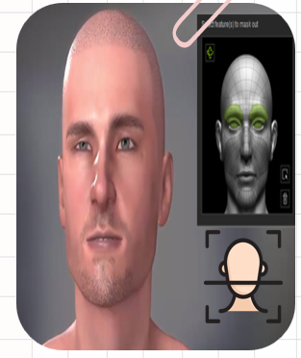
- The main aim of this process is to take pictures, thus we are utilising a routine devices, such as camera and webcams but anyhow other physiological equipment may be used.
- For the capturing sake we will use computer vision libraries.
In initial phase it starts to access the camera and capture about 10 images for further processing .
FACE DETECTION:
- basic purpose of the face detection approach is to recognise the face in the frame while removing external noises and other elements in images.
- By using Principal Component Analysis ;The data received will be decomposed into multiple scales.
- Subsequently smoothing the picture and subsampling it by reducing its resolution, the procedure must be repeated several times to achieve a flawless outcome.
Linear Discriminant is the last step in the process which is used to shorten the computing time required by the classification process, resulting in a more accurate detection.
EMOTION CLASSIFICATION:
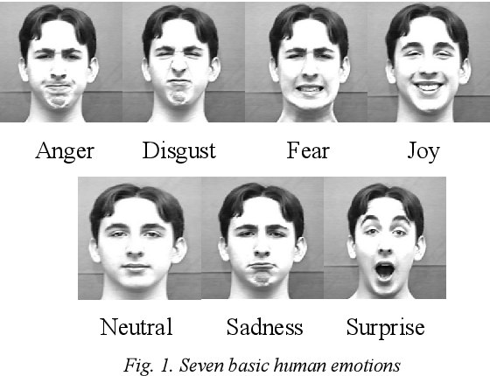
When the face is correctly recognised, a box appears and overlays the picture to extract the face and for further analysis.
On progress, the images that are extracted previously will be processed using the function.
The code will extract the facial spatial locations from the face picture using a boosting approach and pixel intensity values that are indexed at each place.
Finally, using Boosting algorithm where, it compares the input data to the stored data in order to forecast the class that contains the emotion.
MUSIC RECOMMENDATION:
Initially, every song has an emotion attributed to it. When an emotion is transmitted, it is allocated to a song, and the emotions are sorted and assigned to each song.
After all the churning processes the emotion will be deduced from input picture then based on emotion the song will be played.
- Here in this project we are mostly using PCA and LDA algorithms.
The classifier's effectiveness is high 90-95 % such that even if the face varies owing to external factors, the system can still recognise the face and emotion and can run song on it.
FLOW DIAGRAM OF THE MODULE - FACE DETECTION
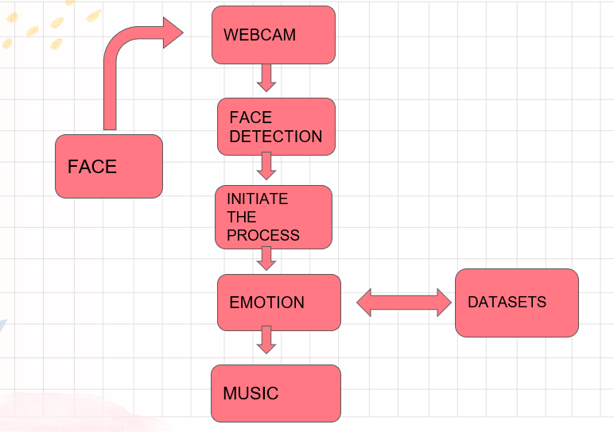
MODEL ARCHITECTURE
The model architecture is a sequential model consisting of Conv2d, Maxpool2d, Dropout and Dense layers:
Conv2D layers throughout the model have different filter size from 32 to 128, all with activation 'relu'
Pooling layers have pool size (2,2)
Dropout is set to 0.25 as anything above results in poor performance
Final Dense layer has 'softmax' activation for classifying 7 emotions
Used 'categorical_crossentropy' for loss with 'Adam' optimizer with 'accuracy' metric

IMAGE PROCESSING AND TRAINING
The images were normalised, resized to (48,48) and converted to grayscale in batches of 64 with help of 'ImageDataGenerator' in Keras API.
Training took around 13 hours locally for 75 epochs with an accuracy of ~66 %
Current condition:
The entire project works perfectly fine. Live detection gives good frame rates due to multithreading

SOURCE CODE
app.py

from flask import Flask, render_template, Response, jsonify
import gunicorn
from camera import *

app = Flask(__name__)

headings = ("Name","Album","Artist")
df1 = music_rec()
@app.route('/')
def index():
print(df1.to_json(orient='records'))
return render_template('index.html', headings=headings, data=df1)

def gen(camera):
while True:
global df1
frame, df1 = camera.get_frame()
yield (b'--frame\r\n'
b'Content-Type: image/jpeg\r\n\r\n' + frame b'\r\n\r\n')

@app.route('/video_feed')
def video_feed():
return Response(gen(VideoCamera()),
mimetype='multipart/x-mixed-replace; boundary=frame')

@app.route('/t')
def gen_table():
return df1.to_json(orient='records')

if __name__ == '__main__':
app.debug = True
app.run()
camera.py
import numpy as np
from tensorflow.keras.models import Sequential
rom tensorflow.keras.layers import Dense, Dropout, Flatten
from tensorflow.keras.layers import Conv2D
from tensorflow.keras.optimizers import Adam
from tensorflow.keras.layers import MaxPooling2D
from tensorflow.keras.preprocessing.image import ImageDataGenerator
from pandastable import Table, TableModel
from tensorflow.keras.preprocessing import image
import datetime
from threading import Thread
from Spotipy import *
import time
import pandas as pd
face_cascade=cv2.CascadeClassifier("haarcascade_frontalface_default.xml")
ds_factor=0.6
emotion_model = Sequential()
emotion_model.add(Conv2D(32, kernel_size=(3, 3), activation='relu', input_shape=(48,48,1)))
emotion_model.add(Conv2D(64, kernel_size=(3, 3)activation='relu'))
emotion_model.add(MaxPooling2D(pool_size=(2, 2)))
emotion_model.add(Dropout(0.25))
emotion_model.add(Conv2D(128, kernel_size=(3, 3), activation='relu'))
emotion_model.add(MaxPooling2D(pool_size=(2, 2)))
emotion_model.add(Conv2D(128, kernel_size=(3, 3), activation='relu'))
emotion_model.add(MaxPooling2D(pool_size=(2, 2)))
emotion_model.add(Dropout(0.25))
emotion_model.add(Flatten())
emotion_model.add(Dense(1024, activation='relu'))
emotion_model.add(Dropout(0.5))
cv2.ocl.setUseOpenCL(False)
emotion_dict = {0:"Angry",1:"Disgusted",2:"Fearful",3:"Happy",4:"Neutral",5:"Sad",6:"Surprised"}
music_dist={0:"songs/angry.csv",1:"songs/disgusted.cv ",2:"songs/fearful.csv",3:"songs/happy.csv",4:"songs/neutral.csv",5:"songs/sad.csv",6:"songs/surprised.csv"}global last_frame1
last_frame1 = np.zeros((480, 640, 3), dtype=np.uint8)
global cap1
show_text=[0]
train.py

from keras.models import Sequential
from keras.layers import Dense, Dropout, Flatten
from keras.layers import Conv2D
from keras.layers import MaxPooling2D
train_dir = 'data/train'
val_dir = 'data/test'
train_datagen = ImageDataGenerator(rescale=1./255)
val_datagen = ImageDataGenerator(rescale=1./255)

train_generator = train_datagen.flow_from_directory(
train_dir,
target_size = (48,48),
batch_size = 64,
color_mode = "grayscale",
class_mode = 'categorical'
)

val_generator = val_datagen.flow_from_directory(
val_dir,
target_size = (48,48),
batch_size = 64,
color_mode = "grayscale",
class_mode = 'categorical'
)

emotion_model = Sequential()

emotion_model.add(Conv2D(32, kernel_size=(3,3), activation='relu', input_shape = (48,48,1)))
emotion_model.add(Conv2D(64, kernel_size=(3,3), activation='relu'))
emotion_model.add(MaxPooling2D(pool_size=(2,2)))
- emotion_model.add(Dropout(0.25)) self.stopped = False

def start(self):
# start the thread to read frames from the video stream
Thread(target=self.update, args=()).start()
return self

def update(self):
# keep looping infinitely until the thread is stopped
while True:
# if the thread indicator variable is set, stop the thread
if self.stopped:
return
# otherwise, read the next frame from the stream
(self.grabbed, self.frame) = self.stream.read()

def read(self):
# return the frame most recently read
return self.frame
def stop(self):
# indicate that the thread should be stopped
self.stopped = True

RESULT AND DISCUSSION:
At present,the project is still on run to meet the ends of the race where we built the model to detect the face and classify the mood of the user as positive(happy) and negative(sad) and recommend the song based on that emotion classified.
Here; during training and testing the model it displayed about 99% of accuracy because we only initially classified the emotion only in into two i.e;happy or sad as furnished in the below images.
In further work we are going to work on molding the model to classify the all human emotions and accordingly make music to play the all human emotions and accordingly make music to play automatically by emotion.

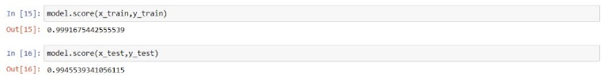
FUTURE SCOPE:
The Emotion-Based Music Recommendation System opens avenues for further research and development in the following areas:

Refinement of Emotion Recognition: Continuous improvement of the emotion recognition model is essential to enhance accuracy and handle the subjectivity of emotion perception. Exploring advanced machine learning techniques, such as deep learning architectures, and incorporating multimodal features (e.g., audio, lyrics, user context) can lead to more robust emotion recognition models.

Incorporation of Contextual Factors: Further research can focus on integrating contextual factors, such as user location, time of day, or social context, into the recommendation process. Considering these factors in conjunction with the user's emotional state can provide more relevant and personalized recommendations.

Dynamic Recommendation Strategies: Developing recommendation algorithms that dynamically adapt to the evolving emotional states of users can lead to more accurate and timely recommendations. Real-time analysis of user emotions and continuous feedback can enable the system to adjust recommendations in real-time,
Exploration of Hybrid Recommendation Approaches: Combining emotion-based recommendation techniques with other recommendation approaches, such as collaborative filtering or content-based filtering, can further enhance the recommendation accuracy and coverage. Hybrid models can leverage the strengths of different recommendation methods and provide more comprehensive and diverse music recommendations.

User Feedback and Active Learning: Incorporating user feedback mechanisms and active learning techniques can improve the system's performance over time. Gathering explicit feedback on recommended tracks and iteratively updating the recommendation model based on user preferences can enhance the system's ability to adapt to individual preferences and deliver more accurate recommendations.

Integration of Music Metadata: Integrating rich music metadata, such as artist information, album details, and music genre, can provide a holistic understanding of music and emotions. Leveraging this metadata in the recommendation process can further refine recommendations based on the user's emotional state and preferences.

User Studies and Evaluation: Conducting user studies and evaluations to assess the system's impact on user satisfaction, engagement, and emotional connection with music can provide valuable insights for system improvement. Gathering user feedback, conducting A/B testing, and comparing the proposed system with existing approaches can guide future enhancements

References

- . Yang, Y., Zhang, Y., Chen, X., & Han, J. (2019). An emotion-based music recommendation system using fusion of lyrics and audio features. Multimedia Tools and Applications, 78(1), 697-721.
- . Yang, Y., Zhang, Y., Chen, X., & Han, J. (2018). Emotion-based music recommendation by affective bridge and convolutional neural network. IEEE Transactions on Multimedia, 20(4), 941-953.
- . Kim, Y., & Kim, J. (2017). Music emotion recognition: A state of the art review.
IEEE Transactions on Affective Computing, 8(4), 455-469.
- Yang, J., Chen, J., & Hauptmann, A. G. (2012). Emotion understanding from music with lyrics. ACM Transactions on Multimedia Computing, Communications, and Applications (TOMM), 8(1), 1-24.
- Laurier, C., & Herrera, P. (2013). Advances in music information retrieval: Emotion-based music recommendation. In Music Emotion Recognition (pp. 149-173). Springer, Berlin, Heidelberg.
- Soleymani, M., & Kim, Y. H. (2015). A survey of content-based audio and visual emotion recognition. In Multimodal signal processing: Theory and applications for human-computer interaction (pp. 283-307). Academic Press.
- Lee, J. H., & Kim, J. H. (2018). Context-aware music recommendation system using emotion and situation classification. Multimedia Tools and Applications
- Yang, Z., Liu, Z., Shen, H. T., & Han, J. (2018). Music recommendation by unified hypergraph: combining social media information and music content. ACM Transactions on Multimedia Computing, Communications, and Applications (TOMM), 14(4), 73.
- Zhang, Y., Chen, X., Yang, Y., & Han, J. (2018). Music recommendation based on multi-label classification using convolutional neural networks. IEEE Transactions on Multimedia, 20(6), 1508-1518.
- . Celma, Ò., & Herrera, P. (2008). Foafing the music: Bridging the semantic gap in music recommendation. In Proceedings of the 7th International Conference on Music Information Retrieval (ISMIR) (pp. 255-260).
- Yang, J., & Soleymani, M. (2018). Music mood and emotion recognition: State of the art and future prospects. IEEE Transactions on Affective Computing, 10(4), 415-434.
- Yang, Y., Zhang, Y., Chen, X., & Han, J. (2020). An emotion-based music recommendation system using deep fusion of multimodal features. Journal of Ambient Intelligence and Humanized Computing, 11(5), 2193-2205

