DESIGN AND ANALYSIS OF ELECTRIC GO KART
AATIF KHAN ¹, SAHIL POONIWALA² , SHIVRAJ SHINDE³
¹,²,³DEPARTMENT OF ELECTRICAL ENGINEERING , THAKUR SHIV KUMAR SINGH MEMORIAL ENGINEERING , JHIRI,DIST BURHANPUR, INDIA

Abstract –
Go- Kart is a racing vehicle having veritably low ground concurrence and can be work on only flat racing circuits. This paper concentrates on explaining the engineering behind designing of a safe, rigid and torsional free frame, well- mounted power train along with retardation and steering system. We approached our design by considering all possible druthers
For a system and modelling them in SOLIDWORKS & CREO3.0. The design process of the vehicle is iterative and is grounded on colourful engineering and rear engineering processes depending upon the vacuity, cost and other similar factors. The design objects, set out to be achieved were four simple pretensions applied to every element of the vehicle durable, Safety & ergonomics, light- weight and high performance.
The design of the go-kart took into account various parameters such as trustworthiness, safety, cost, performance, aesthetics, ergonomics, standard requirements, and materials. Finite element analysis (FEA) was conducted on the corridor under regular loading conditions, and modifications were made accordingly to prevent any design failures. Furthermore, DFMEA and DVP were performed for each individual part during the design process to enhance our quality standards, factor of safety, and other safety parameters. The resulting go-kart is well-equipped to withstand adverse road conditions, as each element was designed with all types of failures and safety issues in mind. The power train was specifically designed to achieve maximum speed and performance, surpassing that of any other geared vehicle
KEYWORDS:- Safety , Durability, ergonomics , FEA , aesthetics, DFMEA , DVP

INTRODUCTION-
Karts are specialized vehicles designed for flat track racing, without any suspension system. They have been in use since the mid-20th century, with a wide range of karts available for racing. The current trend in automotive design emphasizes eco-friendliness to minimize emissions. In this regard, electric motors are gaining popularity as they offer comparable power to traditional engines, and can be implemented in karting as well. An electric kart requires a frame that is both sturdy and rigid to withstand heavy loads, while also being lightweight and flexible. The design process emphasizes safety as the top priority, with every subsystem integrated into the final design. To achieve this, 3D modeling and assembly are completed using software like SOLIDWORKS 13 and PTC CREO3.0, and Finite Element Analysis is performed using ANSYS14.5 to test for front, side, and rear impacts. Based on the test results, the design is modified to ensure optimal stability. The center of gravity is kept low to maximize stability, and the length of the vehicle is reduced to minimize weight. The wheelbase and track range are selected accordingly, with the frontal track range kept to a minimum to increase the project and reduce the turning radius.

FRAME DESIGN-
• Objective-
The ideal of the lattice is to synopsize all factors of the kart, including a motorist, efficiently and safely. Star aspects of the lattice concentrated on during the design and perpetration included motorist safety, drive train integration, and structural weight, and driver ergonomic. The number one precedence in the lattice design was motorist safety. By using Finite Element Analysis( FEA), the design assured
- To insure safety of the motorist
- To maintain low centre of graveness.
- To insure that all the systems fit onto the lattice
- To design a lattice with high strength and low weight.
• Design-
A go-kart’s chassis is essentially a framework constructed using pipes and various materials with different cross sections. It is critical for the chassis to have sufficient stability, torsional rigidity, and a certain degree of flexibility since there is no suspension. Additionally, the chassis must possess adequate strength to support the weight of the operator and any accessories. Safety and convenience are key considerations when designing the chassis for a go-kart, ensuring that it can support the load without compromising its structural integrity, providing a safe ride for the operator.
• Material used-
AISI-1018 material was utilized in the frame design owing to its excellent weld ability, relatively soft nature, and good manufacturability. A sturdy material is crucial for a roll cage since it needs to absorb as much energy as possible to prevent the roll cage material from fracturing during high impact. The selection of AISI-1018 for the chassis was based on its structural properties, which provide a low weight-to-strength ratio.
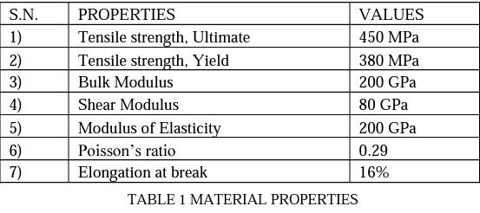

❖ SAFETY
The implementation of roll cage features was initially driven by safety requirements. The primary safety standard that was prioritized during the design process was ensuring the driver’s body had sufficient clearance from other rigid parts such as the engine compartment and firewall structure. Once these crucial requirements were met, additional safety designs were integrated. The chassis was designed to offer occupants more space to maneuverer the vehicle easily. The fire extinguisher was placed in an easily accessible location, and foam padding was installed over the pipes next to the driver for added protection.

❖ STEERING SYSTEM DESIGN
The steering mechanism for this Electric Vehicle was designed using a simple mechanical arrangement with a 1:1 steering ratio, which was chosen for its straightforward operation. To achieve this, a mechanical type linkage was employed. The Ackermann steering geometry was utilized for this vehicle.
•REASON: Ackerman gives 60 degree lock to lock turn of steering wheel which is extremely suitable for the track because it allows quick turns with small input and being more precise at an equivalent time
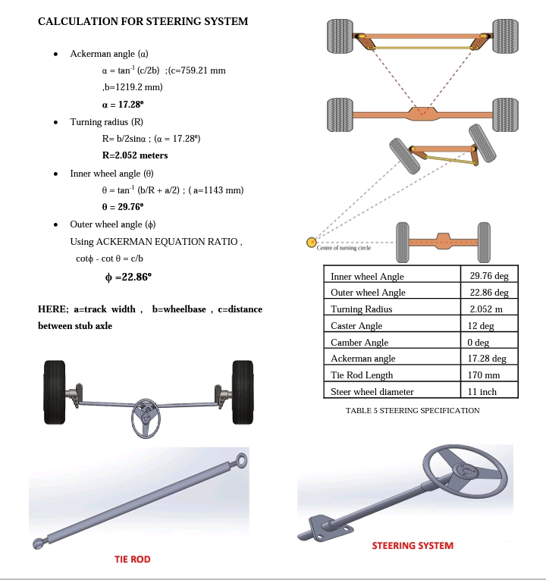

❖ BRAKING SYSTEM DESIGN
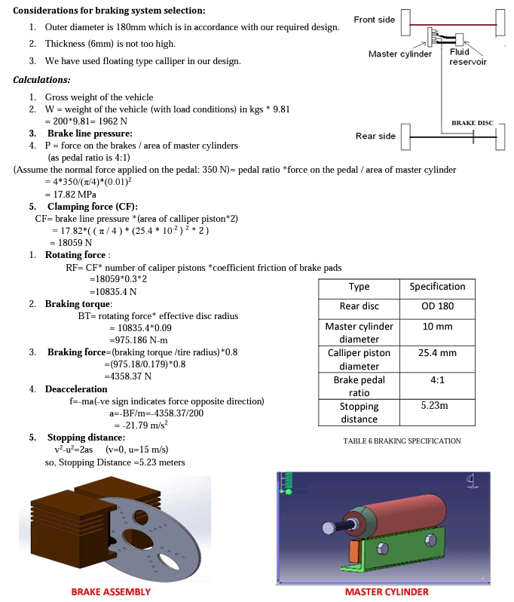
The braking system utilized in our Electric Vehicle is the Hydraulic Disc Braking System. This system was chosen for its ability to provide sufficient braking force to fully lock the wheels at the end of a specified acceleration run while remaining cost-effective. Through market research, suitable components such as the disc, calliper’s, and master cylinders were identified and selected for use in the braking system.
❖ TRANSMISSION SYSTEM
• Power developed by the motor is transferred to the wheels by transmission system .We use CHAIN AND SPROCKET mechanism in our kart and it consist of reverse gear mechanism for moving vehicle in reverse direction.
• We are using BLDC motor which is better than the PMDC & AC motor.
➢ CALCULATION-
• Gear ratio = No. of teeth on the driven /No. of teeth on driver = 40 / 14 = 2.85
• Kart speed = wheel speed * π * Dw /60 (Diameter of Rear wheel (Dw) = 0.2794 m)
= 15.58 m/ssec
• Rolling resistance on rear tire = μ*m*g*wt. transfer ratio (rear) = 0.04*200*9.81*0.4 = 47N
• Rolling resistance on front tire = μ*m*g*wt. transfer ratio (front) = 0.04*200*9.81*0.6 = 31N
• Efficiency = 90%
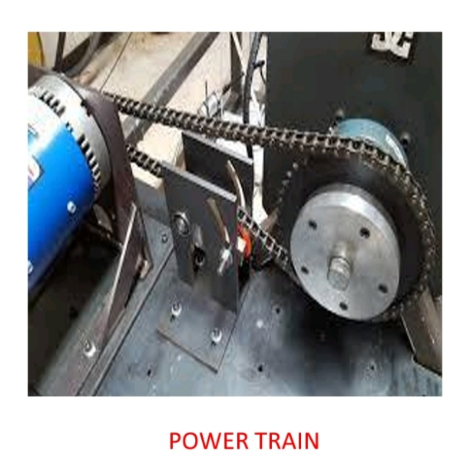
❖ ELECTRICAL SYSTEM
Motor :- We are using BLDC motor which is 2.5kw 48v, run at 3500rpm because as our calculation shows that the mechanical output torque that need to move vehicle is 67.36 N-m and the motor provide torque to the wheel is approx. 150.88 N-m so it fulfilling our requirement and it also provide max torque at starting.

Controller:- On the basis of motor we are choosing controller, we are using KELLY 7218 controller.
Voltage:- 48/60v Rated current :- 65ampere Rated torque:- 9.2Nm Max output torque:- 400% of rated value= 46Nm.

Battery:- Li-ion battery of 48v, 60AH, BMS of passive balancing without communication of rating and specs are 13 series lithium-ion 40/80A continuous current has packing of (FRP + metallic) and capacity of 2.40kwh.
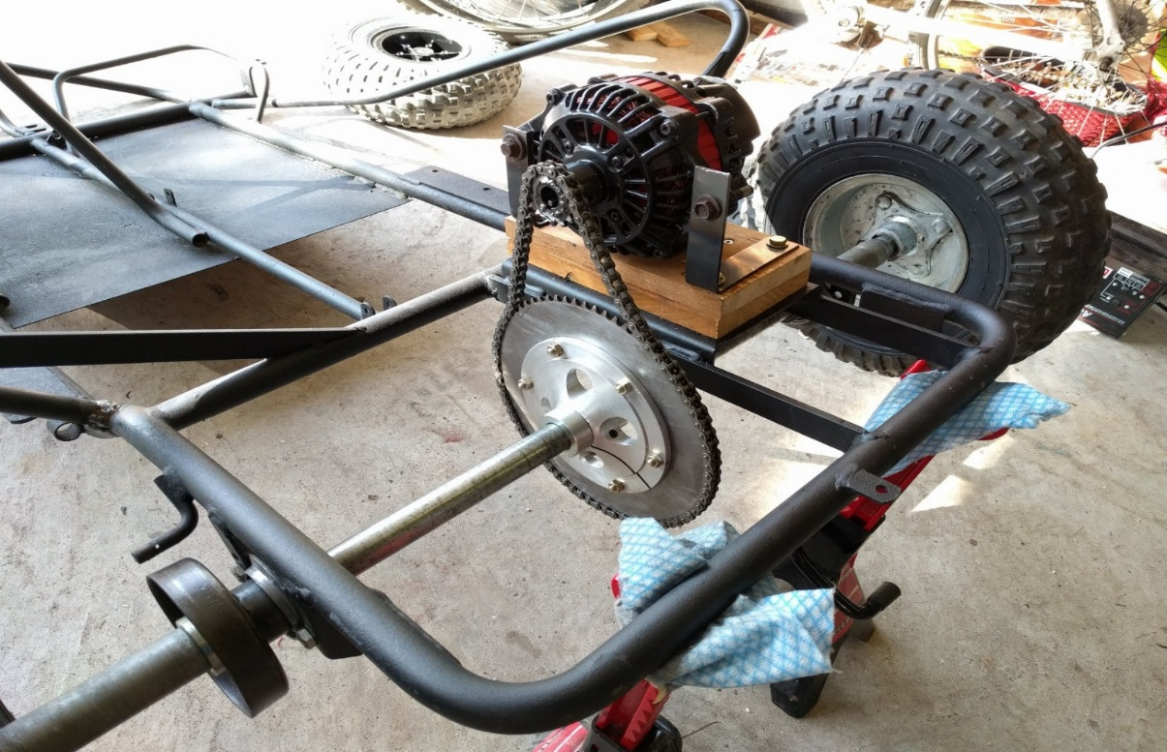
- Electrical system

- Circuit diagram
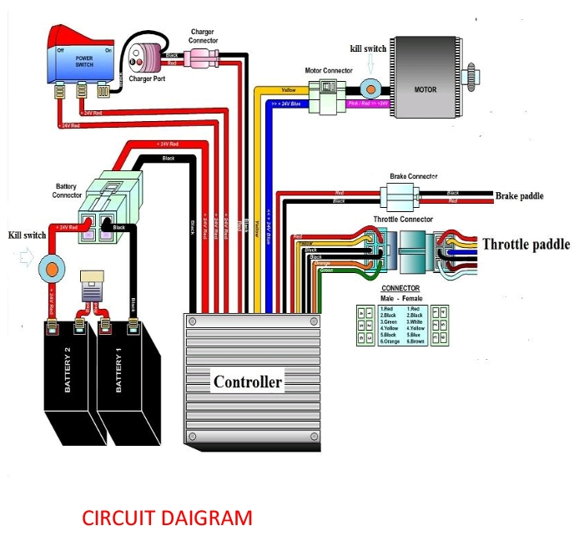

- CONCLUSION-
When engineering vehicles, several factors must be considered to create the most effective and safe product for society. The design we have chosen for our racing vehicle is both the safest and most reliable. All aspects, including reliability, safety, cost, performance, aesthetics, ergonomics, standard dimensions, and material, were carefully considered during the design process. To avoid any potential design failure, finite element analysis was conducted on regularly loaded parts, and necessary modifications were made. The design of the go-kart provides ample opportunities for skill development, including training in 3-D modelling software such as SolidWorks. Analysis of the design determines the stresses that develop within the chassis, which plays a critical role in factor safety. Through analysis, we can predict whether the chassis is safe or not, and by observing the deformation and stress modifications within the kart chassis, further modifications can be made

Result –
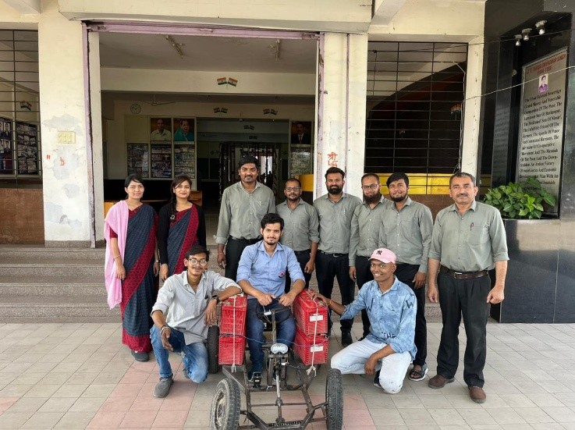
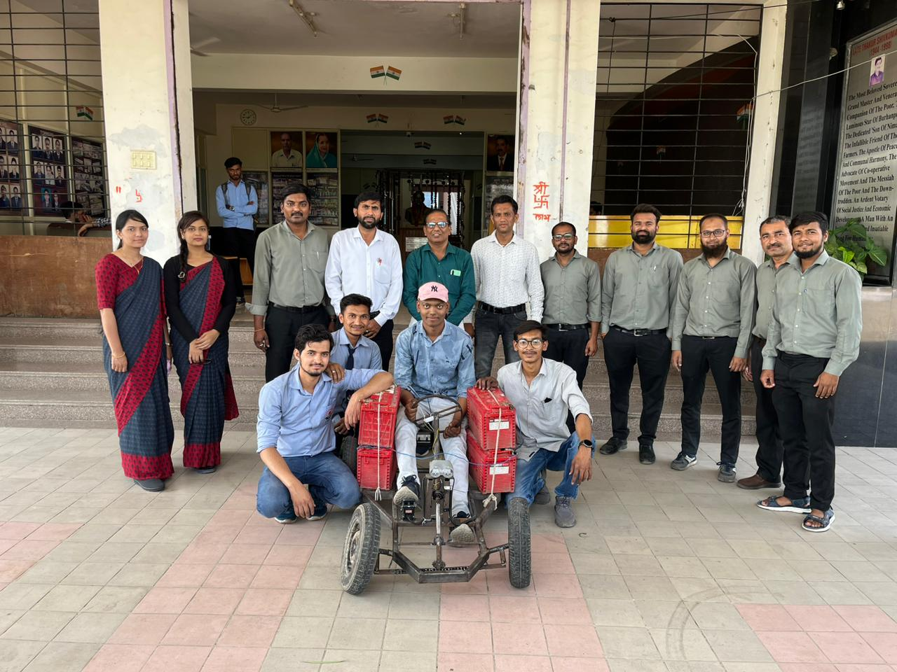
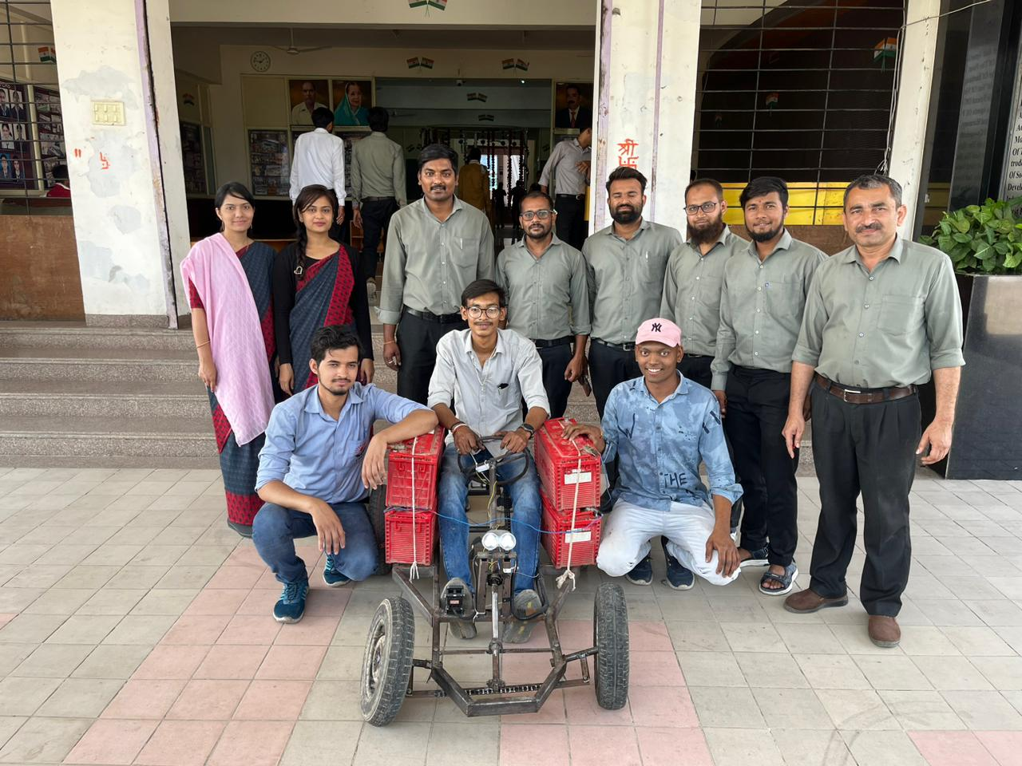
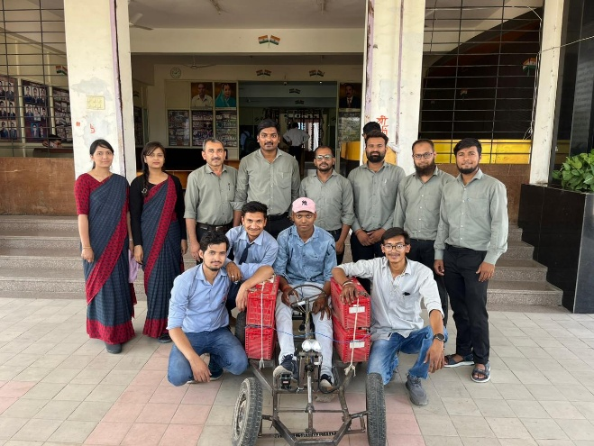
REFERENCES –
[1] Abhinay Nilawar, Harmeet Singh Nannade, Amey Pohankar, Nikhil Selokar, “DESIGN OF GO-KART”, Maharashtra,India, IJFEAT, ISSN: 2321-8134
[2] Baja 09 design report: Paper Number-TTTITM2 Uploaded by Midhun Davis
[3] Kanaad Bhardwaj , Mahesh Kumawat, Abhinav Pamecha , Aryan Sharma, Hemant Choudhary , Dhruv Rana , Ajit Singh Gour, Atul Katara “ Design and Performance Evaluation of an Electric Go-Kart “ IJARIIE-ISSN(O)-2395-4396 Vol-6 Issue-3 2020
[4]”Design and Fabrication of an Electric Go-Kart” by K. Vinoth Kumar, S. Gowtham, K. Gokulnath, and K. Vinoth Kumar. This paper discusses the design and fabrication of an electric go-kart using a DC motor and lithium-ion batteries. It includes details on the selection of components, design considerations, and performance testing.
[5] Electric Race Technologies - https://electricracetech.com/

[6] Bintelli Karts - https://bintellikarts.com/electric-go-karts/

[7]Karting Distributors – https://www.kartingdistributors.com/electric-go-karts/

