

Research Paper
On


Carbon Nanotubes


Made

by:

Asvin
Kant Sharma

Guided

By:

Mrs

Deepali

Sonawane

Atharva

Shivade

Yashovardhan

Poddar

Abstract

Carbon nanotubes are unique tubular structures of nanometer diameter and large length/diameter ratio. The nanotubes may consist of one up to tens and hundreds of concentric shells of carbons with adjacent shells separation of 0.34 nm. The carbon network of the shells is closely related to the honeycomb arrangement of the carbon atoms in the graphite sheets. The amazing mechanical and electronic properties of the nanotubes stem in their quasi-one-dimensional (1D) structure and the graphite-like arrangement of the carbon atoms in the shells. Thus, the nanotubes have high Young’s modulus and tensile strength, which makes them preferable for composite materials with improved mechanical properties. The nanotubes can be metallic or semiconducting depending on their structural parameters. This opens the ways for application of the nanotubes as central elements in electronic devices including field-effect transistors (FET), single-electron transistors and rectifying diodes. Possibilities for using of the nanotubes as high-capacity hydrogen storage media were also considered. This report is intended to summarize some of the major achievements in the field of the carbon nanotube research both experimental and theoretical in connection with the possible industrial applications of the nanotubes.

Introduction
Elemental carbon in the sp2 hybridization can form a variety of amazing structures. Apart from the well-known graphite, carbon can build closed and open cages with honeycomb atomic arrangement. First such structure to be discovered was the C60 molecule by Kroto et al. Although various carbon cages were studied, it was only in 1991, when Iijima observed for the first time tubular carbon structures. The nanotubes consisted of up to several tens of graphitic shells (socalled multi-walled carbon nanotubes (MWNTs)) with adjacent shell
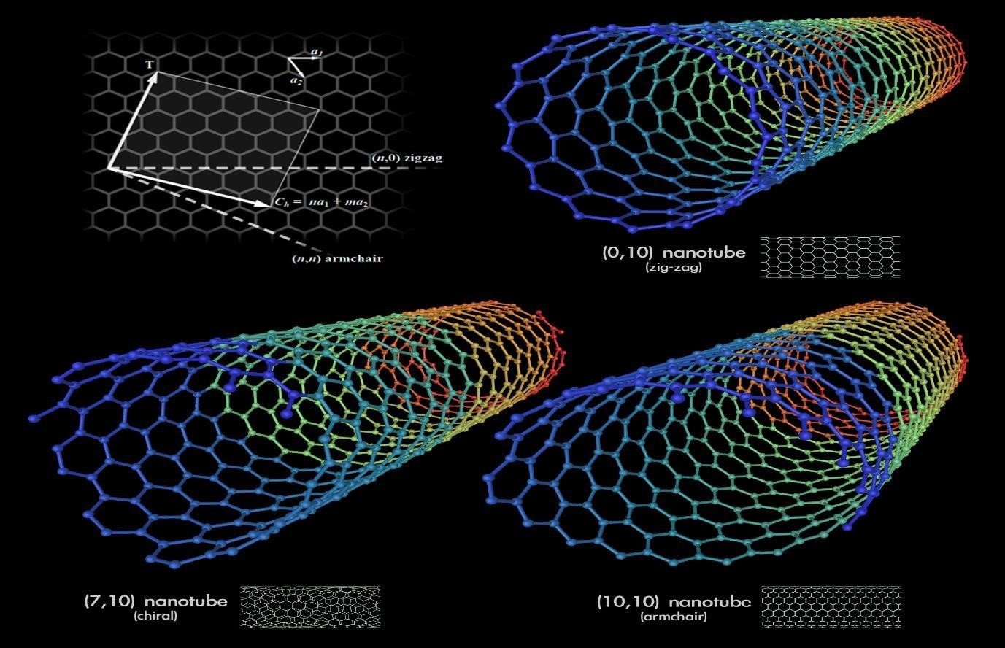
separation of 0.34 nm, diameters of 1 nm and large length/diameter ratio. Two years later, Iijima and Ichihashi [3] and Bethune et al. [4] synthesized single-walled carbon nanotubes (SWNTs). Nowadays, MWNTs and SWNTs are produced mainly by three techniques: arc- discharge, laser-ablation, and catalytic growth. The synthesized nanotube samples are characterized by means of Raman, electronic, and optical spectroscopies. Important information is derived by mechanical, electrical and thermal measurements. The experimental data is discussed in comparison with the results of theoretical models and computer simulations .

Along with the improvement of the production and characterization techniques for nanotubes, progress is being made in their application. The estimated high Young’s modulus and tensile strength of the nanotubes has lead to speculations for their possible use in composite materials with improved mechanical properties [10]. Nanotubes are suitable as electron field emitters because of their nanosize, structural perfection, high electrical conductivity, and chemical stability with an application in flat panel displays [11]. Multiwall nanotubes have been used to electro-catalize an oxygen reduction reaction, which is important for fuel cells. Electrochemically Li-intercalated SWNT materials showed large irreversible capacities and voltage hysteresis which is an advantage for using them as battery electrodes . The extraordinary high and reversible hydrogen adsorption in SWNT materials has attracted much attention because of the possibility of using nanotubes as high-capacity hydrogen storage media. It was proposed to use nanotubes as central elements of electronic devices including field-effect transistors, single-electron transistors and rectifying diodes and for logic circuits .

This paper is intended to summarize the major achievements in the field of the nanotube research both experimental and theoretical in connection with the possible industrial applications of the nanotubes. The paper is organized as follows.
Section 1 focuses on the synthesis of carbon nanotubes.

Section 2 considers possible growth mechanisms of nanotubes.

Section 3deals with the electronic band structure of the nanotubes and their optical properties.
Section 4 reviews transport through ideal nanotubes

Section 5 considers transport through nanotube junctions.

Section 6 presents the theory of the phonon dispersion in nanotubes and Raman
spectroscopy.
Section 7 surveys the mechanical properties of nanotubes.

Finally the thermal properties of nanotubes. The report ends with a summary.

Section snippets

Synthesis of CNTs

The MWNTs were first discovered in the soot of the arc-discharge method by Iijima [2]. This method has been used long before that in the production of carbon fibers and fullerenes. It took 2 years to Iijima and Ichihashi , and Bethune et al. to synthesize SWNTs by use of metal catalysts in the arc-discharge method in 1993. A significant progress was achieved by laser- ablation synthesis of bundles of aligned SWNTs with small diameter distribution by Smalley and co-workers Catalytic.
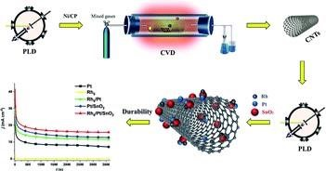

Growth mechanisms

It has been established experimentally that transition metal catalysts are necessary for the growth of SWNTs but are not required for MWNTs. This fact suggests different growth mechanisms in both cases. The role of the growth conditions on the structural characteristics of the obtained samples were studied both on experimental and theoretical levels. In this Section, the growth mechanisms for individual and bundled, single-walled and multi-walled nanotubes, studied within semi-empirical .

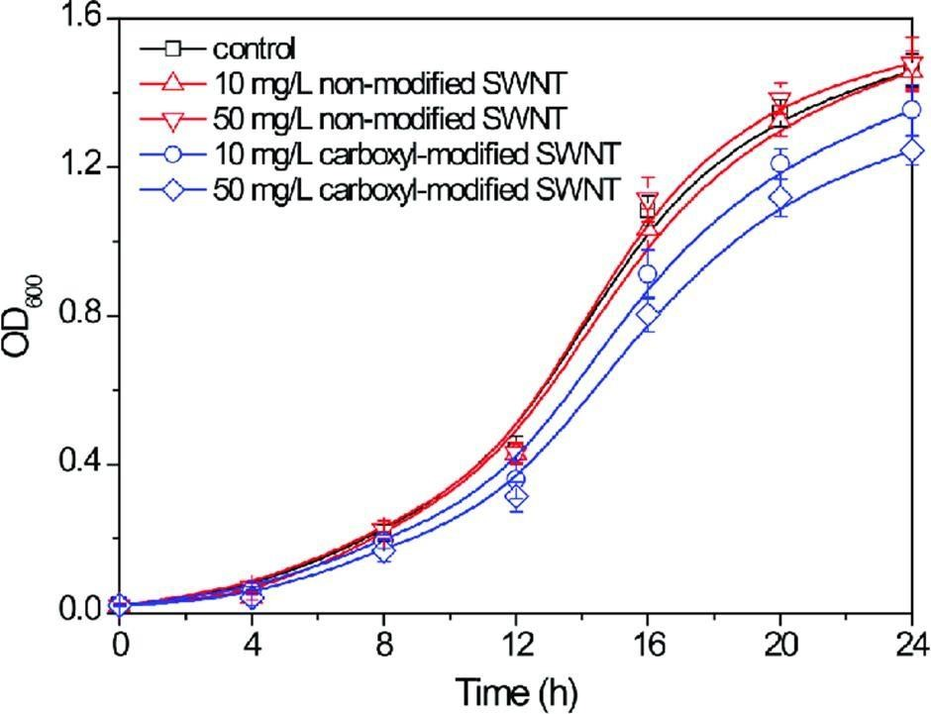

Optical properties

The early theoretical studies of the electronic properties of SWNTs predicted that SWNTs could be either metallic or semiconducting depending on their structural parameters. In the π-tight-binding model within the zone-folding scheme, one third of the nanotubes are metallic and two thirds are semiconducting depending on their indices (n, m). The tight- binding calculations based on the use of σ and π bands, due to the curvature-induced mixing of these bands.

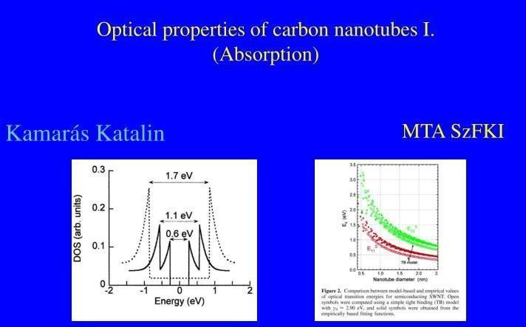

Electrical transport in perfect nanotubes

Electrical transport through carbon nanotubes has attracted considerable interest due to the many possible applications of the nanotubes in nanoscale electronic devices. The nanotubes are nearly perfect 1D conductors in which at low temperatures a number of interesting mesoscopic phenomena has been observed such as single-electron charging, resonant tunneling through discrete energy levels and proximity-induced superconductivity.
At relatively high temperatures, tunneling conductance
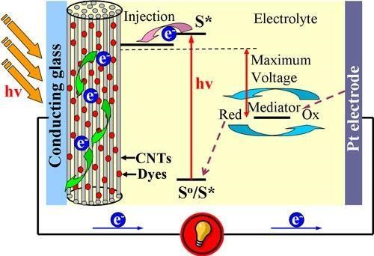

Electrical transport through junctions

Due to the sensitivity of the electronic properties of carbon nanotubes on their structure, they are suitable for preparation of metal–semiconductor, semiconductor–semiconductor and metal–metal junctions. They can be realized as on-tube junctions by joining together seamlessly two tubes of different chirality [71]. It has been demonstrated that the introduction of pentagon–heptagon pair of defects into the hexagonal network of a carbon nanotube can change the chirality of the tube and change

Vibrational properties

The atomic vibrations in carbon nanotube were studied theoretically within force-constant models in the zone-folding approximation or for the concrete nanotube structure within tightbinding models and ab initio models. The experimental measurement of the vibrational eigenfrequencies is performed mainly by resonant Raman scattering of light when the laser light energy is close to the energy of allowed electronic transitions.

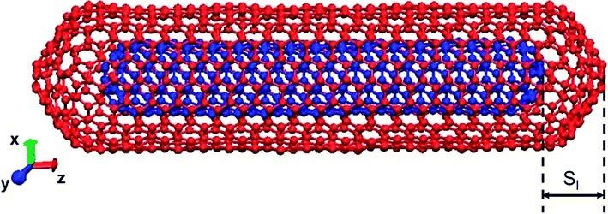

Mechanical properties

The carbon nanotubes are expected to have high stiffness and axial strength as a result of the carbon–carbon sp2 bonding . The practical application of the nanotubes requires the study of the elastic response, the inelastic behaviour and buckling, yield strength and fracture. Efforts have been applied to the experimental and theoretical investigation of these properties.

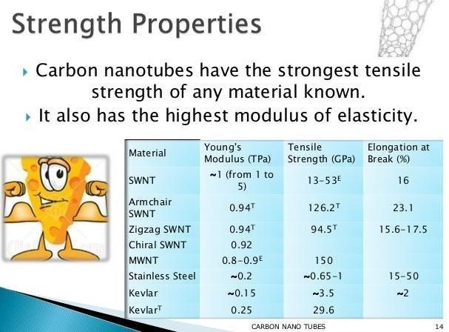

Thermal properties

The specific heat and thermal conductivity of carbon nanotube systems are determined primarily by phonons. At low temperatures, the phonon contribution to these quantities dominates and is due primarily to acoustic phonons. The measurements yield linear specific heat and thermal conductivity above 1 K and below room temperature while a T0.62 behaviour of the specific heat was observed below 1 K .
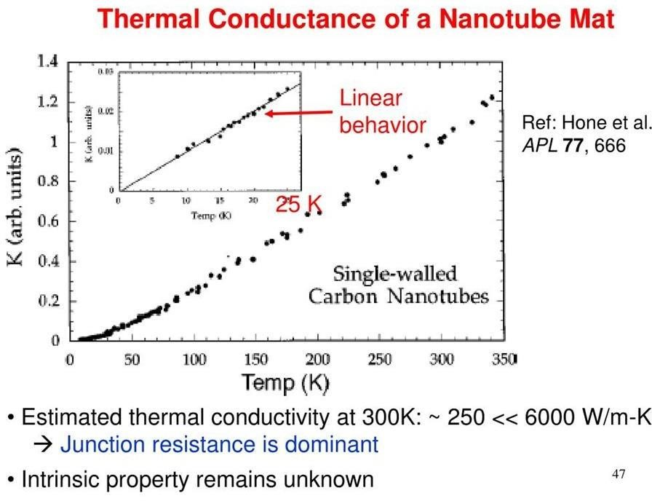

Summary
In this report, the major developments in both the basic research and the industrial application of the carbon nanotubes are reviewed. The theoretical efforts are directed to the understanding the amazing mechanical, electronic, transport, vibrational, thermal, etc., properties most of them owing their uniqueness to the quasi-one-dimensional sp2-bonded structure of the carbon nanotubes.

Acknowledgements
We would like to thank Deepali Sonawane Maam for the encouragement during the preparation of the manuscript.

References
1.A Jorio et al.

Resonance Raman spectra of carbon nanotubes by cross-polarized light
Phys. Rev. Lett. (2003)
2.A Charlier et al.

Lattice dynamics study of zigzag and armchair carbon nanotubes
Phys. Rev. B (1998)
3.H Kataura et al.

Optical properties of single-wall carbon nanotubes
Synth. Metals (1999)
4.H Ajiki et al.

Aharonov–Bohm effect in carbon nanotubes
Physica B (1994)
5.V Ivanov et al.

The study of carbon nanotubules produced by catalytic method
Chem. Phys. Lett. (1994)
6.G.G Tibbetts

Vapor-grown carbon fibers: status and prospectus Carbon (1989)
7.R.T.K Baker Catalytic growth of carbon filaments
Carbon (1989)
8.B Gao et al.

Electrochemical intercalation of single-walled carbon nanotubes with lithium
Chem. Phys. Lett. (1999)
9.M.S Dresselhaus et al.

Physics of carbon nanotubes Carbon (1995)

10.H.W Kroto et al.

C60: buckminsterfullerene Nature (1985)

