PLANT LEAF DISEASE DETECTION AND CLASSIFICATION USING ANN

S. Radhika, E. Nandini, S. Shanmuke, G. Anusha
Professor, ¹Computer Science and Engineering, Sridevi Women's Engineering College
¹Computer Science and Engineering, Sridevi Women’s Engineering College, B.Tech IVYear Hyderabad, India
²Computer Science and Engineering, Sridevi Women’s Engineering College, , B.Tech IVYear Hyderabad, India
3Computer Science and Engineering, Sridevi Women’s Engineering College, B.Tech IVYear, Hyderabad, India

E-mail address: nandinireddy81@gmail.com, shanmuke123@gmail.com, golemgarianusha@gmail.com

Abstract: Automatic detection of plant diseases makes it possible to parade enormous pitches of crops with agility in accumulation distinguish disease indications as shortly by way of they change on plant leaves. By employing advanced technologies and automated detection methods ,farmers can rapidly identify sickness symptoms as they appear on plant leaves, enabling proactive measures to mitigate the spread and minimize crop losses.The Agility to display enormous arenas of crops and mechanically identify disease indications by way of rapidly as they develop on plant leaves makes reflex detection of plant leaf bugs. Software is used in the proposed system to automatically detect and calculate plant leaf diseases. The developed processing method comprises two primary steps: firstly, a colour restructuring is generated for the input true color image, and secondly noise or extraneous components are removed using a specific threshold value; third, the contour extraction using connected component labelling, then the suitable parts stay mined; and fourth, the ANN classification is figured by providing various features, such as size, color, proximity, and average centroid distance. Experimental findings on a database of different diseases support the visibility of the suggested strategy.
Keywords: ARTIFICAL NEURAL NETWORKS(ANN),RGB IMAGE,CLASSIFICATION,SEGMENTATION.

- INTRODUCTION
The primary strategy traditionally employed for noticing and recognizing plant diseases relies on skillful observation deprived of the assistance of technological aids. However, huge farms may not be able to afford the excessively expensive expert monitoring that is required on a constant basis. Furthermore, in certain developing nations, the necessity for framers to travel long distances to consult with experts results in significant expenses and consumes valuable time resources. Furthermore, farmers may not be aware of non-native diseases, further emphazing the need for advancements in automatic plant disease detection.The ability to monitor extensive crop fields and automatically identify illness by analyzing symptoms exhibited on plant leaves has emerged as a crucial research concern in the field plant pathology. This makes visualization possible, which will agree for duplicate-founded method switch, robot The Agility to display massive arenas of harvests and mechanically classify disease indications by way of rapidly as they develop on plant leaves makes automatic detection of herbal leaf diseases. navigation, and autonomous inspection. Visual identification, in contrast, requires more work and is less reliable.

- EXISTING SYSTEM
The k-nn models that were utilized for yield prediction classification suffered from reduced performance due to the presence of nonlinear and highly adaptable issues inherent in the knn algorithm.The k-nn models were operated using a locality-based approach that led to an increase in the dimensionality of the input vector, resulting in confusion during the classification process. The decision making process pertaining to the classification was inadequate due to the limited availability of data that could be used to estimate crop yield. Plant pathologist predominantly rely on visual inspection and disease scoring scales to grade plant disease. However, for large-scale farms, it may not be feasible to constantly invest in prohibitively expensive professional monitoring to ensure timely disease detection and management. Large farms, however, might not be able to afford the prohibitively expensive professional monitoring that is necessary constantly. Additionally, it may be costly and time-consuming for farmers in some developing countries to travel vast distances to consult experts. Farmers could also be ignorant about diseases that aren't common in their region. To over come the challenges of time consuming and infeasible manual disease grading on plant leaves, a solution based on image processing has been proposed. This approach utilizes convolutional neural networks to automatically grade the spread of disease on plant leaves.
2.1 DISADVANTAGES OF EXISTINGSYSTEM
- It is Time Taking Process to detect plant diseases.
- Previous attempts to use k-nn models for yield protection through classification have faced challenges due to the non linearlity and adaptability issues inherent in the inn approach, resulting in lowered performance.
- Farmers may also be unaware of illnesses that are not local to their area.
- Visual identification is labor intensive, less accurate.
- PROBLEM STATEMENT
It will be exceedingly challenging to recognize the characteristics of diseased crops if the symptoms are subtle or complicated, which will substantially impede the efficient treatment of agricultural diseases. By leveraging computer image processing technology, it is possible to analyse images of diseased leaves and extract disease spot features such as color, texture, and other traits in a quantitative manner. When paired with the unique crop conditions, the source and extent of a disease can be accurately and quickly recognized, allowing for comprehensive prevention and control. With the use of image feature extraction technology for agricultural disease research, the utilization of image processing technology for automatic disease detection and grading has a significant impact on the intelligent management of various aspects related to crop growth and health.
- PROPOSED SYSTEM
Internal and external exams make up the two primary components of the quality inspection of leaves. While human vision is mostly used for the external quality inspection, human senses, a smoking test, or chemical analysis are typically used for the internal quality inspection. As leaves contain too many elements to touch, the evaluation of internal quality is a costly and time-consuming process. As a viable alternative, external quality inspection is often employed since external features are strongly correlated with the internal quality of leaves. frequently employed as an alternative for evaluating the interior quality of leaves. The evaluation of a leaf's exterior quality includes measurements of its colour, maturity, surface texture, size, and shape. The primary method of inspection has been through human eyesight, which is inherently constrained by psychological, physiological, and environmental factors. Consequently, it is suggested that leaves be externally checked for quality utilizing image
processing.
4.1 ADVANTAGES OF PROPOSED SYSTEM
- The robustness of the suggested approach has been confirmed by experimental findings on a database of different diseases.
- The extracted features from the diseased leaves were used as inputs to a neural network, enabling accurate classification of different leaf disease.
- Less time consuming for detecting the leaf disease
- SYSTEM DESIGN ARCHITECTURE
Disease of the leaf can be detected based on the twin of the greenery. First the admin will upload the dataset to the scheme and then copy processing is done by removing the unwanted data or noise data, after that the image is segmented into the different parts. From these segmented images choose only the disease effected segment images and extract the features from it. This propose system is trained by the artificial neural networks, so then after the completion of feature extraction then the disease is classified based upon its features that extracted from the uploaded image of the leaf.
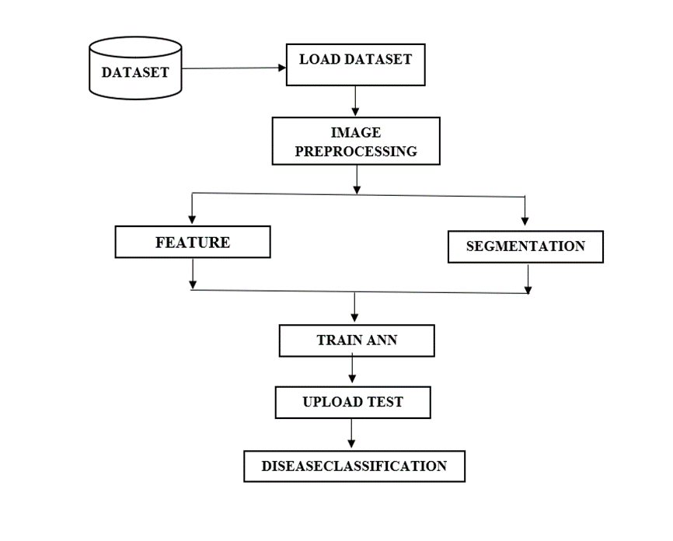

Figure 1: Architecture of the plant leaf disease detection

- ALGORITHMS
- CNN: Convolutional Neural Networks are a type of neural network planned explicitly to analyze and process data that is arranged in a grid-like structure, such as images, with the ability to extract features and patterns from the data.
- Resnet: Residual neural network is a type of Artificial neural network(ANN) that is a variant of the Highway Net. It is gateless or open gated and has the ability to function as a very deep feedforward neural network with hundreds of layers, making it significantly deeper than its predecessors.
- InceptionV2: Inception-ResNet-V2 is a convolutional neural network(CNN) that has been trained on a data set consisting of over a million images sourced from the ImageNet data base.
- Mobile Net and MobileNetv2: Mobile Net and Mobilenetv2 are convolutional neural networks that have been designed for efficient processing on mobile and embedded devices. Mobilenetv2, in particular, uses upturned remaining pieces by bottlenecking features, resulting in a pointedly inferior limitation count. compared to the original mobile net. Further more, Mobile nets can support input sizes bigger than 32*32 , with greater copy dimensions contribution improved concert.
- MODULES
- Data Processing
- Data exploration
- Splitting data into train & test
- Model generation
- Data Prediction
7.1 MODULE DESCRIPTION
- Data Processing: Once can utilize a module to read data processing procedure. It is necessary to ensure that the data is in an appropriate format for the desired processing tasks.
- Data Exploration: By employing this particular module ,one can import data into the system, there by initiating a data exploration process. It is significant to ensure that the information remains properly loaded and organized to facilitate efficient analysis and exploration.
- Splitting data into train & test: This ensures that the typical is proficient on a serving of the data and tested on a independent subset, allowing for an unbiased assessment of its predictive capabilities.
- Model generation: The ability to handle large data sets, and their superior performance on image recognition tasks. CNNs are commonly used in a extensive choice of requests including object recognition, facial recognition, natural linguistic dispensation, and more.
- Data Prediction: After performing the necessary analysis and processing, the final predicted output can be displayed, providing valuable insights and information to the user. It is crucial to confirm that the prediction is exact and consistent, as it container have important suggestions for decision-making and other downstream tasks.
- IMPLEMENTATION
To run we need python 3.7 and TensorFlow package. After installation click on the run file in the folder and you get the below screen.

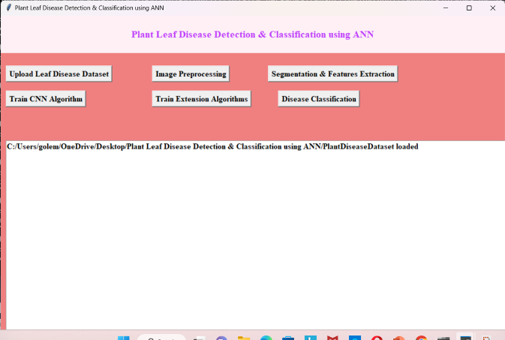

Figure 2: Dataset Loaded

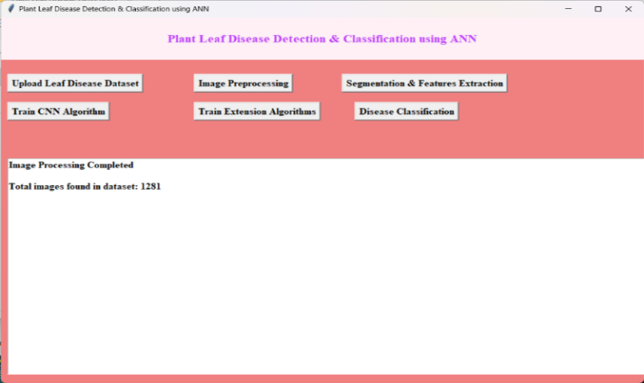

Figure 3: Image Processing

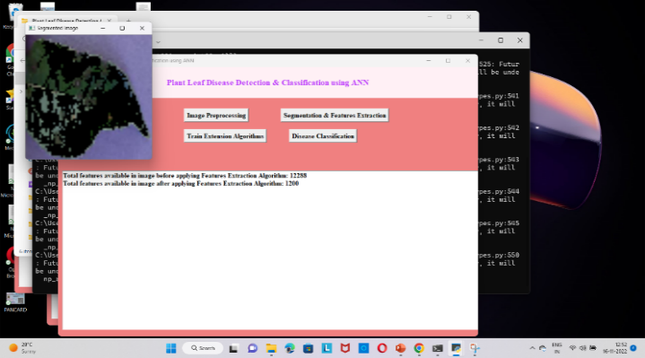

Figure 4: Segmentation and Features extraction

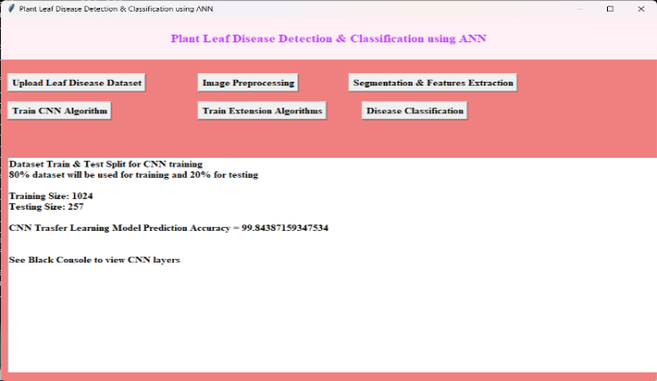

Figure 5: CNN accuracy
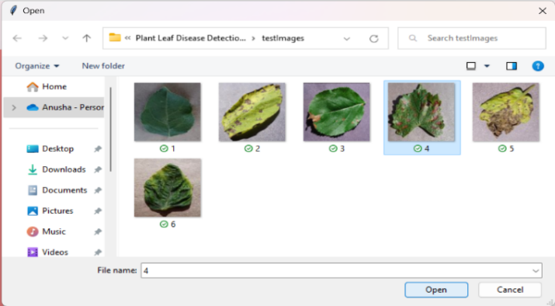
Figure 6: Upload test image

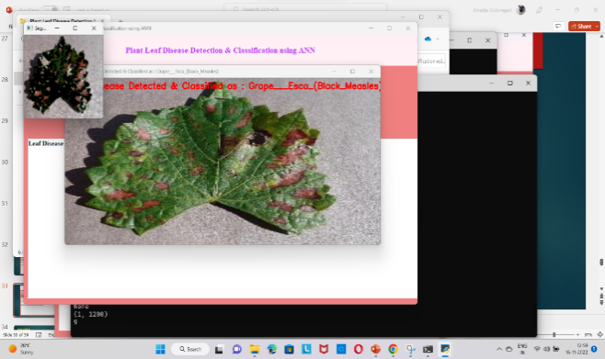

Figure 7: Disease classification

- TESTING
Testing is a crucial phase in software development, where a predetermined set of test data is used to assess the functionality and performance of modules collectively. Testing is an important quality assurance process that ensures that the software is reliable and effective and is essential for delivering a high quality product to the end user. System testing is a critical stage of software development, where the entire system is tested as a whole to ensure that all components and functionalities are working together as intended. By using a comprehensive set of test data, the system can be thoroughly evaluated and any issues or defects can be identified and addressed before the software is released to the end user.
Different testing strategies exist ,each of which is designed to address specific testing requirements.
- SYSTEM TESTING:
It is integrated software product as a whole to validate its functionality and performance. This type of testing verifies that the software happens the specified necessities and is capable of performing as intended in a real world environment. System trying remains a life-threatening stage in the software system advance life cycle and is critical for confirming the worth and dependability of the final product.
- UNIT TESTING:
Unit testing is a testing method used to evaluate individual modules in order to identify any potential issues or defects .This type of testing is typically performed by the developer, and is focused on ensuring the functional correctness of each standalone module. The primary p objective of unit testing is to isolate each unit of the system and thoroughly analyze and fix any defects that may be present. By conducting unit testing, developers can ensure that each ,modules is functioning as intended and can identify and address any issues early on in the software development process.
- DATA FLOW TESTING:
Data flow testing is a type of testing approach that involves the selection of program control flow paths to systematically examine the sequence of events that are related to the state of variable or data objects. This testing method specifically targets the points where variables receive their values and where these values are subsequently utilized.
- INTEGRATION TESTING:
Integration testing is conducted once unit testing has been finalized, and involves the integration of individual units or modules. The goal of integration testing is to assess the functional, performance, and reliability aspects between the integrated modules.
- FUTURE SCOPE
Future work will involve training the model with a larger dataset manually clicking the pictures of the leaves and detecting the disease. An IOT based system which experiments the soil and suggests suitable cultivation measures. Targeting the severity estimation of the detected disease since it is an important problem so the farmers can be helped in deciding how to intervene to stop the disease. The fact that all farmers may not have a smartphone has been acknowledged.
11.CONCLUSION
The suggested technology extracts feature from a segmented diseased area and uses leaf features to detect disease. It is easier to extract size, colour, closeness, and centroids from the hue image from the HSI since it clearly distinguishes between diseased and healthy areas. Four different leaf diseases were classified using these features as inputs to a neural network, demonstrating appropriate classification.
12. REFERENCES
[1] S. S. Sanako and V. S. Raj purohit,” Classification of Pomegranate Diseases Based on Back Propagation Neural Network,” International Research Journal of Engineering and Technology (IRJET), Vol2 Issue: 02 | May-2015
[2] P. R. Rothes and R. V. Kshirsagar,” Cotton Leaf Disease Identification using Pattern Recognition Techniques”, International Conference on Pervasive Computing (ICPC),2015.
3. Aakanksha Rastogi, Ritika Arora and Shanu Sharma,” Leaf Disease Detection and Grading using Computer Vision Technology &Fuzzy Logic” 2nd International Conference on Signal Processing and Integrated Networks
(SPIN)2015.
4. J. G. A. Barbedo, “Digital image processing techniques for detecting, quantifying and classifying plant diseases,” Springer Plus, vol. 2, no.660, 2013.
5. Caglayan, A., Guclu, O., & Can, A. B. (2013, September). “A plant recognition approach using shape and color features in leaf images.” In International Conference on Image Analysis and Processing (pp. 161-170). Springer, Berlin, Heidelberg.

