Road Safety Accident Prediction

Mukul Prasad Ray Arbas Rahaman Harsh Ranjan
mukulray83@gmail.com rahamanarbas@gmail.com harshranjan9966@gmail.com
Lovely Professional University Lovely Professional University Lovely Professional University

Pardeep Kumar
Assistant Professor pardeep.25237@lpu.co.in
Lovely Professional University

ABSTRACT
The continuously increasing number of vehicles on the road has resulted in a concerning rise in the frequency of daily incidents. To address this issue and prevent traffic fatalities and incidents, the transportation department requires the ability to predict the number of accidents that may occur over a specified period. Analysing the frequency of accidents can provide valuable information to develop strategies to minimize their occurrence. While accidents may seem ambiguous, patterns can be observed in various areas of India. These patterns can aid in accurate accident forecasts and the creation of prediction models. This essay explores the correlation between road conditions, environmental factors, and the likelihood of accidents. Using the AdaBoost Algorithm and Classifier, a data mining approach was utilized to develop an accident prediction model with recent datasets of road accidents occurred in different parts of India. The findings of this study can be used by the government's public works departments, contractors, and car sectors to improve road and vehicle designs.

Keywords— Accident prediction, Data mining, AdaBoost Algorithm, Rule mining,

Classifiers.

I. INTRODUCTION

India's worrisome rate of accident growth is now a major source of worry. In light of some recent statistics India owns just 1% of all vehicles worldwide, but it is responsible for around 6% of all traffic incidents worldwide.
Two-wheeler’s irresponsibility is a major cause of recorded accidents, and rush driving is a significant factor. Accidents resulting from drunk driving or other types of traffic offences are also frequent. The disregard shown by individuals towards factors such as vehicle speed, vehicle condition, and failure to wear helmets has led to many accidents despite the existence of strict measures and roadway laws. Although the growing number of vehicles is the primary contributor to traffic accidents, the importance of the state of the roads and other environmental elements cannot be understated.

In India, the amount of fatalities from traffic accidents is undoubtedly concerning. With more than 137,000 persons suffering injuries from traffic accidents, the situation is exceedingly grim. This number is more than four times the number of people killed by terrorism each year. Accidents involving large trucks and even those involving buses, which are utilized for public transit, are among the deadliest kinds of accidents that can happen and cost the lives of innocent people. Rain, fog, and other weather conditions can greatly increase the likelihood of accidents. So, it would be easier to take action to reduce accidents if you have an appropriate guesstimate of incidents, accident hotspots and factors. This calls for careful research on accident and development of safety predication models. It is frequently necessary to construct a well-structured, architectural road management system for in order to deal in the concerns of security of the road. The model is intended to create an improved accident forecast system that could examine most likely problems brought on by infrastructure failures and estimate the contribution of current models to minimizing the likelihood of accidents. The appraisal of the relative importance of each variable's contribution to the accident and the question of how the model should be best constructed to take the effects of all such factors into account are two of the primary issues involved in developing such a model. Previously, various fields such as Finance threat management, Theft observation, Medical informatics, recommendation systems, among others, have been considered and other areas, have found data mining techniques and models to be helpful for the goal of data interpretation. These investigations have also been enhanced by methods integrating machine learning and artificial intelligence. To compose this research, we examined the correlation between traffic accidents and the influence of underlying road conditions and environmental factors in their occurrence. In order to capture all the factors impacting accidents in such a study, we can employ these large quantity of data would normally be unintelligible without the proper explication being applied to them, therefore data mining techniques are being used to analyse them and extract pertinent information from them.

III. METHODOLOGY
We created an application that utilizes road accident data to forecast the probability of accidents occurring. The data was cleaned, normalized, and selected for features through a pre-processing step. Various data mining techniques were employed on the processed data, such as clustering and the AdaBoost Classification Algorithm. The algorithm was used to anticipate the possibility of accidents, while AdaBoost was applied to extract rapid sets of item based on provided values. Different factors that have caused various types and severities of accidents in different weather conditions and roads were considered in establishing rules. AdaBoost classification was utilized to classify accident into a higher or lower-risk group. The system architecture is depicted in Figure 1. Our analysis revealed various factors contributing to road accidents and provided possible solutions to reduce accident rates and fatalities. The use of diverse data mining and visualization approaches helped in comprehending the results.

IV. IMPLMENTATION

A. Dataset
The study utilized the free data available on the web, specifically accident related datasets that occurred in different parts of India between 2016 and 2019. The dataset contains various details, such as the date, time, and place, the reason of the accident (such as racing or skidding), the kind of road (linear or curved), the quantity of lanes, and whether it occurred at a junction. Additionally, it includes information on the number of fatalities. To analyse this dataset, a stochastic model is required as opposed to a simple deterministic model. Therefore, machine learning algorithms are necessary to supplement the data mining techniques used in the study.

B. Architectural Design of the System

Initially, the collected raw data on traffic accidents undergoes processing to produce the dataset, which will subsequently serve as the input for the model. By employing the training set of data, the model receives further training to predict the likelihood of accidents in an area where the user provides the input. The user is provided with a pictorial visualization on the basis of the collected statistics.
The AdaBoost algorithm is used for rule mining, and a frequent element set is created based on the user’s dataset. The AdaBoost, which is usually used for classification, is employed for risk prediction. This model forecasts the likelihood of accidents in a particular location. Using information from the weather, previous accidental reports, and factors accountable for accidents. The upload module let the user provide recent dataset if the previous data is updated.
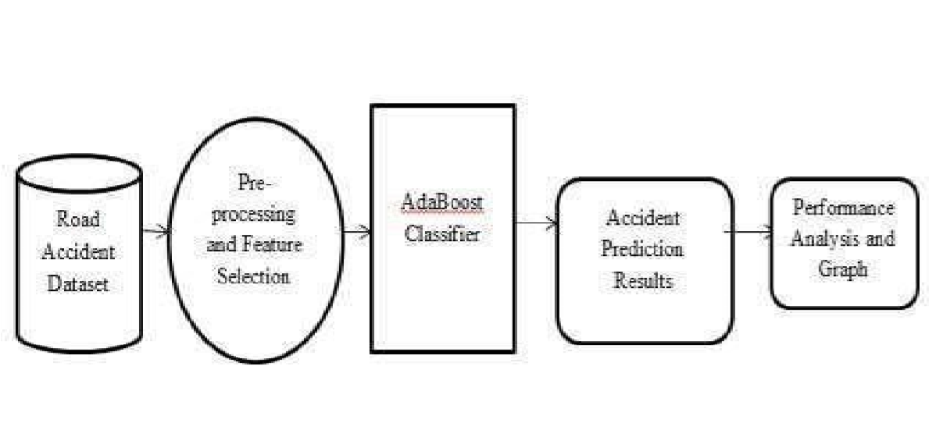
Fig 1. System Architecture of the Application

C. Language and Program Used
The whole application was coded in Python and the application program was implemented using Anaconda Spyder.

D. Simulation
The accident dataset is analysed by utilizing R tools to conduct a simulation, utilizing an array of data mining and exploratory visualization methods. Consequently, an interactive GUI is generated, allowing the analysis of multiple strands contributing to accidents by generating different statistical representation.

E. Findings of Dataset Analysis

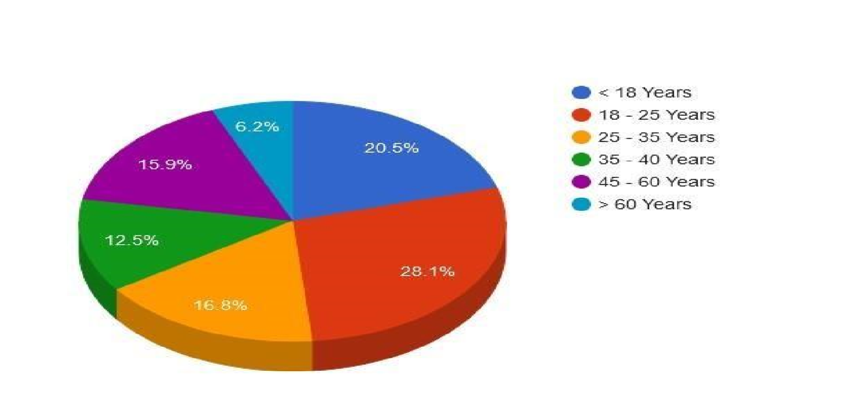
Fig 2. Chart of the Dataset Analysis (Accidents with respect to age)

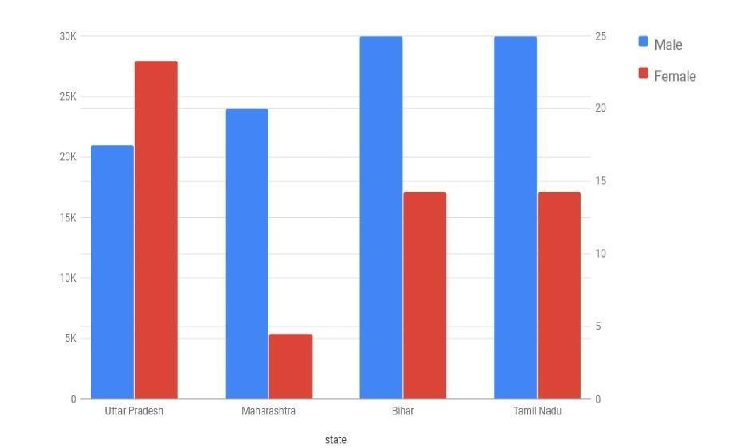
Fig 3. Bar Diagram of Total Accidents in Residential Area (Male and Female)

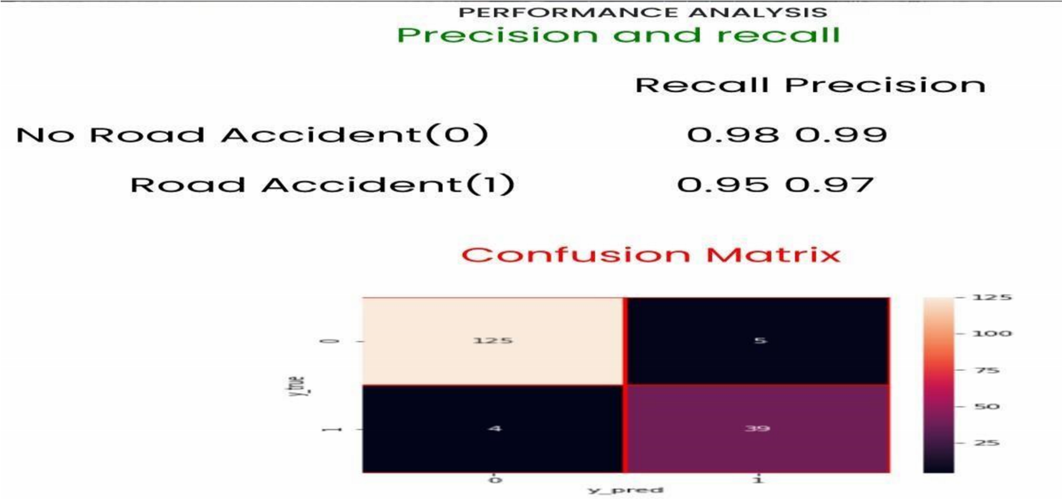
Fig 4. Performance analysis Matrix of the Dataset

V. DISCUSSION
This paper presents a new model for predicting road accidents, which considers various factors such as state of the road, weather, and other accident’s characteristics. In contrast to prior research, this study does not include the sentimental state or experiential influence of the driver. The dataset used for this research includes a growing number of accident cases involving heavy vehicles. This system has been integrated into an application that forecasts the probable risk of accidents in a user-defined area. The application's GUI provides a graphical depiction of the factors that led to accidents in the past, and a categorized forecast of higher degree or lower degree of risk is generated for the selected area. The model enables us to comprehend multiple factors responsible in lethal accidents. Additionally, the application allows users to enter details of new accident cases, upgrading the dataset for further utilization.

VI. CONCLUSION
The number of lives affected by accidents can be significantly reduced if we take responsibility and adopt safe driving practices. While accidents can occur due to various reasons, road development authorities and automobile industries can also take necessary measures to prevent them. Road design can be improved, and better safety features can be incorporated into vehicles. A successful example of such a model is an application that can efficiently predict the likelihood of an accident based on various factors such as vehicle type, driver age, vehicle age, weather conditions, road structure, etc. Utilizing the datasets from different places of India, the application was created and has shown exceptional precision in forecasting the likelihood of accidents occurring in various regions.
There is potential for the current model to be optimized in the future by incorporating several constraints that were not considered in this model. The upgraded model in future, can then be used by concerned governmental authorities to develop more targeted road safety policies that focus on the specific causes of accidents. Additionally, a mobile application could be developed to assist drivers in selecting safer routes for their journeys. The maps service could also incorporate a feature that alerts drivers to the risk probability of their chosen route and provides directions. This technology could be adopted by transport based service companies and transport authority in the future, leading to improved monitoring of higher accident occurrence areas and more timely during any hazard in terms of road accidents. Moreover, the risk information obtained from this model could also be used to install better road safety instructions along highways.

VII. REFERENCES

- https://www.statista.com/topics/5982/road-accidents-in-india/

- Srivastava AN, Zane-Ulman B. (2005). Discovering recurring anomalies in text reports regarding complex space systems. In Aerospace Conference, IEEE. IEEE 3853-3862.

- Ghazizadeh M, McDonald AD, Lee JD. (2014). Text mining to decipher free-response consumer complaints: Insights from the nhtsa vehicle owner’s complaint database. Human Factors 56(6): 11891203. http://dx.doi.org/10.1504/IJFCM.2017.089439.

- Chen ZY, Chen CC. (2015). Identifying the stances of topic persons using a model-based expectation maximization method. J. Inf. Sci. Eng 31(2): 573-595. http://dx.doi.org/10.1504/IJASM.2015.068609.

- Williams T, Betak J, Findley B. (2016). Text mining analysis of railroad accident investigation reports. In 2016 Joint Rail Conference. American Society of Mechanical Engineers V001T06A009V001T06A009. http://dx.doi.org/10.14299/ijser.2013.01.

- Suganya, E. and S. Vijayarani. “Analysis of road accidents in India using data mining classification algorithms.” 2017 International Conference on Inventive Computing and Informatics (ICICI) (2017): 1122-1126.

- Sarkar S, Pateshwari V, Maiti J. (2017). Predictive model for incident occurrences in steel plant in India. In ICCCNT 2017, IEEE, pp. 1-5. http://dx.doi.org/10.14299/ijser.2013.01.

- Stewart M, Liu W, Cardell-Oliver R, Griffin M. (2017). An interactive web-based toolset for knowledge discovery from short text log data. In International Conference on Advanced Data Mining and Applications. Springer, pp. 853-858. http://dx.doi.org/10.1007/978-3- 319-69179-4_61.

- Zheng CT, Liu C, Wong HS. (2018). Corpus based topic diffusion for short text clustering. Neurocomputing 275: 2444-2458. http://dx.doi.org/10.1504/IJIT.2018.090859.

- ArunPrasath, N and Muthusamy Punithavalli. “A review on road accident detection using data mining
techniques.” International Journal of Advanced Research in Computer Science 9 (2018): 881-885.

- George Yannis, Anastasios Dragomanovits, Alexandra Laiou, Thomas Richter, Stephan Ruhl, Francesca La Torre, Lorenzo Domenichini, Daniel Graham, Niovi Karathodorou, Haojie Li (2016). "Use of accident prediction models in road safety management – an international inquiry". Transportation Research Procedia 14, pp. 4257 – 4266.

- Anand, J. V. "A Methodology of Atmospheric Deterioration Forecasting and Evaluation through Data Mining and Business Intelligence." Journal of Ubiquitous Computing and Communication Technologies (UCCT) 2, no. 02 (2020): 79-87.

- Prayag Tiwari, Sachin Kumar, Denis Kalitin (2017). “Road-User Specific Analysis of Traffic Accident Using Data Mining Techniques”. International Conference on Computational Intelligence, Communications, and Business Analytics. 10.1007/978-981-10-6430-2_31.

- Kaur, G. and Er. Harpreet Kaur. “Prediction of the cause of accident and accident prone location on roads using data mining techniques.” 2017 8th International Conference on Computing, Communication and Networking Technologies (ICCCNT) (2017): 1-7.

- Irina Makarova, Ksenia Shubenkova, Eduard Mukhametdinov, and Anton Pashkevich, “Modeling as a
Method to Improve Road Safety During Mass Events”, Transportation Research Procedia 20 (2017) 43.

- https://data.gov.in/resource/stateut-wise-total-number-road-accidents-india-2016-2019

