Online Car Rental System
Gautam Pardeshi ^{[1]} Assistant Professor- Kuber Datt Gautam^{[2]}
Department of computer Application, Medi-caps University, Indore
Abstract - The main aim of this publication is to present the growing demand for online cab service bookings through a web-based application and develop an information management system for car rental industries. The procedure of booking a vehicle for the rental reason is manual. It requires physical undertakings in booking a vehicle and is monotonous and over the top. Likewise, as far as the benefit is concerned, it has fewer recipients and in the long run, decreases the normal results. The vehicle rental framework has a PHP outlook for the organization, an online entryway, and created utilizing PHP and MySQL individually. This entrance is a client well disposed of, practical, and lessens endeavours and time to look through a vehicle. The client needs to make its record by means of enrolment procedure and book the necessary vehicle on the web. This assists with sparing work and increments the accessibility of vehicles to the proper organizations. The additional component of our endeavour report is self-drive vehicle renting and having pickup-drop concentrates so the association can work remotely.
Index Terms - Transportation, software, industry, institute, management, environment, network, adaptive.
I.INTRODUCTION
We certainly consider online shopping, e-banking, etc. Correspondingly, The Car Rental System is the online office to book vehicles online inside hardly any snaps in a manner of speaking. A couple of individuals can't remain to have a vehicle, for those people this system ends up being outstandingly helpful. This framework incorporates different vehicles, according to the client request and solace it put in the request and got according to the pickup-sloping edge area inside the zone. Booking should be possible by means of network access as it were. This undertaking navigates plenty of territories going from business idea to registering field and required to play out a few explore to have the option to accomplish the venture goals The prior investigations demonstrated that management data system could be used to oversee vehicle rental, expected to quicken just as chronicling administrations to clients better and more secure, making it simpler when required whenever. The online execution of the executive’s data framework gave and bolstered the clients to reservations, help the executives in realizing rental vehicle stock at a predetermined time, to process exchanges between branches vehicle rental, transportation exchange handling, which underpins good assistance to clients and bolster the organization's operational procedures. Online vehicle rental data framework expands the clients and helps advancement. The point of this examination is to take care of the issues that happen in Avis Indonesia; propose advancement of the electronic vehicle rental administration data framework.
II. LITERATURE SURVEY
As our structure relies upon the useful Car Renting System which is an authentic application, we inspected the present working circumstance of the renting technique. At present renting, organizations are dependent on manual work which consolidates packages of work area work similarly as a human resource. To date we find Cab Services incredibly easy to book, pay, or drop as they have formed their structures into helpful applications similarly as locales. So there is a need to change the arrangement of the Car Renting Service. But, Car rentbusinessnotwithstandineverything, uses the central methodology for Renting a vehicle to a customer as the customer ought to go genuinely at centre, the owner will similarly be accessible there and the owner will permit the vehicle with his/her own supported driver (which costs more). Our structure and spotlights on renting Self Drive Cars, where the customer with significant License will have the alternative to book similarly as will have the choice to drive his/her own rented vehicle. The customer selection and endorsement are outstandingly straightforward and made with the goal that it makes the structure almost 0% paper vocations. The customer will have the alternative to select and enter his nuances and move remotely from his home, and the association will have the choice to favour every one of his information without even truly meeting the customer.
III. PROBLEM STATEMENT
A vehicle rental is a vehicle that can be utilized for a period with a charge. Leasing a vehicle solace individual to get impacted in any event, when they don’t have key to their very own vehicles or don’t possess a vehicle ever. The individual who needs to lease a vehicle, first contact the vehicle rental organization for the decision of vehicle. This can be finished on the web. At this stop, this individual needs to pass some data, for example, dates of rental, and depiction of vehicle. At the point when these subtleties are worked out, the individual who leases the vehicle must show a substantial Identity Card. The majority of the organizations around the business set a benefit in view of the brand of vehicles that will be leased. The rental vehicles are classified into economy, strong, strong premium, premium, and extravagance. What’s more, clients are permitted to choose any vehicle of their solace that relies upon their wallets and show off such a vehicle at the hour of reservation. Vehicle Rental systems offer types of assistance for outside and nearby clients both. This association settles its customary work by administering; their support of the clients utilizing a hand worked framework. The administration utilizes a hand worked framework for stock, leasing, records, and to lead a report document of all the rental effort and client information.
IV. METHODOLOGY
The web-based car rental system integrated with SMS technology has a very user-friendly interface. By using this system, employees can manage bookings, payment, vehicle issues and SMS notification to the customers within a few clicks only. The new data can be added or existing data can be edited or deleted too by administrators. Thus, there is no delay in the availability of any information, whether needed, can be captured very quickly and easily. For security purposes, all customers need to create a new account before logging in or he/she can log into the system with his/her created account before they can make a reservation for a car. Then, the customer will be notified of the availability of the car reserved through SMS. This system becomes very helpful for employees, administrators and customers.
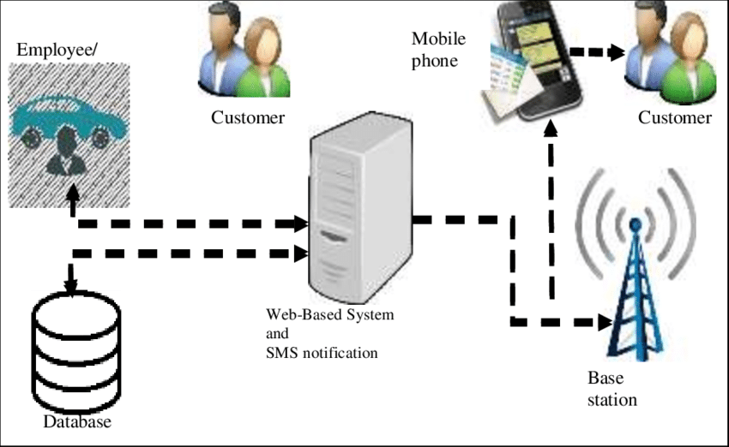
The tools needed to develop the system are MySQL Server, Apache Server, PHP Parser, Linux O.S
V. CONCLUSION
This investigation paper proposes a Self-Drive Online Car Renting System which is proposed after significantly inspecting the present structure and understanding the imperfections in it. The depicted system vanquishes all the imperfections of the present structure and brings a period of dynamic structure which is brisk, profitable and particularly adaptable. The majority of the organizations around the business set a benefit in view of the brand of vehicles that will be leased. The customer will have the alternative to select and enter his nuances and move remotely from his home, and the association will have the choice to favour every one of his information without even truly meeting the customer. It will be verifiably useful for the PC customers. Our structure will make the User experience smoother and specifically, enchanting. We encourage our customers to come and make use of our system and moreover share significant information which will help with improving our structure.

REFERENCES
[1] Busse, M., Busse, M., Swinkels, J., Swinkels, J., Merkley, G., & Merkley, G. (2017). Enterprise rent-a-car. Kellogg School of Management Cases, 1– 15. https://doi.org/10.1108/case.kellogg.2016.00011
[2] Ghoreishi, N., &Shajari, M. (2010). Web-Based SMS Passenger Application: New Approach to Inform Passengers via SMS in Airlines.In Proceedings of the International Conference on eEducation, eBusiness, e-Management, and eLearning 2010.
[3] Gurol-Urganci, I., de Jongh, T., VodopivecJamsek, V., Atun, R., & Car, J. (2013). Mobile phone messaging reminders for attendance at healthcare appointments. The Cochrane Database of Systematic Reviews, (12), CD007458. https://doi.org/10.1002/14651858.CD007458.pu b3 Li, Z. (2013).
[4] Design and realization of a car rental management system based on AJAX+ SSH. Information Technology Journal, 12(14), 2756–2761. Onashoga, A., Ogunjobi, A., Ibharalu, T., & Lawal, O. (2016). A Secure Framework for SMSBased Service Delivery in M-Government Using a Multicast Encryption Scheme. African Journal of Science, Technology, Innovation and Development, 8(3), 247–255. https://doi.org/10.1080/20421338.2016.1156837
[5] Qurratul, A. (2012). Development Of Car Rental Management Information System (Case Study: Avis Indonesia). In proceedings information system business.

