WanderHub-Travel Recommendation App
¹Anish Suvarna, ²Anush Kumar, ³Arpitha Salian, ⁴Sherene Rahel Maben,
¹Student, ²Student, ³Student, ⁴Student
¹Information Science and Engineering
¹A.J. Institute of Engineering and Technology, Mangalore, India

---------------------------------------------------------------------***---------------------------------------------------------------------
Abstract - Tourism is one of the fastest growing industries today. It has been an irreplaceable part of economy growth of every country. By that factor, we were encouraged to build an application to serve detail information of tour destinations to provide easy preparation for travelling. This Application focuses on building recommender system in the tourism field. The application, Wander Hub, recommends to a tourist the best attractions in a particular place according to his preferences, his profile and his appreciation to previous visited places. The recommendation consists of user’s preferences such as user attributes like male/female, cuisine type, and destination interests to create a user profile. It can provide a more appropriate recommendation result matching user’s profile. Both aspects are to support route planning before the journey. It was developed to learn user’s behaviour based on empiric data, which used to offer relevant destinations to certain user by using a hybrid recommendation system that uses K-means for eateries, and Mean-shift clustering for places. Wander Hub is a web-based application which suggests detail information of destinations, eateries.

Key Words: Travel, Restaurants, Recommendation

1.INTRODUCTION
Sometimes we take decisions unaware of the existence of other alternatives. This may be the reason why many people nowadays trust in third parties rather than in themselves to take decisions. This lack of awareness, and also the increasing amount of information that new technologies, such as the Internet, supply are having a positive effect on the importance of having filtering and selection methods that facilitate the decision-making process. Users are given such a large quantity of information that they eventually get overwhelmed. The recent appearance of new and practical tools is lending a hand to tackle this matter in a more effective way. These tools provide users some directions that can help them understand the information needed to make a more advantageous use of it for individuals who are consumed by wanderlust, the Android app Wander Hub offers travel advice. Users of this app may receive recommendations for tourism attractions after being questioned about their interests and having the trip destinations suggested based on those interests. In the proposed system of Wander Hub, the initial step is to scrape the data from the relevant website for the recommendations, followed by cleaning and analyzing using ELT and Pandas. By entering a location, the data set is also used to propose nearby restaurants to consumers. This system has used two different types of algorithms: K-means for a recommendation for eateries, and Mean-shift for the recommendation of places. Moreover, users can rate and comment on the locations they've visited, which might assist other users make decisions about the location based on the reviews. reaching the goal, and without any intermediaries

2.PROBLEM STATEMENT
Traveling has become a common pastime in recent years, and because so many people go to various cities, regions, and nations, it can be challenging to plan an effective tour of any particular site and to become knowledgeable about that country Today, a lot of individuals use internet travel planning services. However, they frequently struggle with the issue of being overloaded with information. As a result, people have to spend a lot of time choosing where to go and when. This huge number of possibilities available on the net makes it difficult for users to discern the more interesting offers from the rest Therefore, the more alluring offerings may pass by undetected. In order to improve the tourist experience, recommender systems offer personalized information to users. In other words, the algorithm finds the most acceptable and adequate places and suggests activities based on their profile.

3.OBJECTIVE
To create an application that performs the following functionalities:
- To explore the dataset for the recommendation of eateries and places.
- Performing ELT for the cleaning of the data, Analysis and storing it in a CSV file
- To explore relevant Algorithms for recommendations of places and eateries and implement them.
- To recommend users placed and Restaurants based on their unique user profiling
4.OUTCOMES
This application-
- recommends travel destinations to the user.
- provides routes to the destination.
- suggests local restaurants.
- enables people to add ratings and reviews for the places they have visited
V. LITERATURE SURVEY

Paromita Nitu, Joseph Coelo, Praveen Madiraju in “Improvising Personalized Travel Recommendation System with Recency Effects” [1] Proposed a system that uses a tweet to get the interest from the user and recommend place according to that, but if a person doesn’t use twitter or most of the user posts and tweets about the restaurants and entertainment rather than the destination places so it would be a drawback. In this project, a prototype solution was implemented that provides users with travel recommendations based on their social media, in particular to twitter profile, contents that were measured temporally. The primary assumption of this study is that every user or the user’s followers/friends have tweets related to travel. Any participant with no travel tweet is a subject to a cold start. The project involves a service that recommends places of interest to a user based on historical data mined from their twitter account. The service takes the user’s twitter handle, extracts the feed (of the user and their friends and followers), identifies travel tweets, segments them into time blocks from latest to oldest, analyses for sentiment, and classifies based on the category of the places identified. The preferences are periodically updated with the user’s latest tweets to reflect alteration in user’s tastes and priorities. Also, existing system contains no features for Solo travellers who are out there to get along with new people, aren’t given enough exposure to it. They are not given the option to chat and get in touch with other travellers. Adding a feature to make this possible, would make the user’s trip a happy one.towards

Akanksha Kumari, Ashish Kumar Singh, Nagamma Patil titled “Travel Recommendation System Using Geotagged Photos.” [2] proposed a system in which the preferences are obtained according to the prior travel history of user(s) and recommendations are suggested. Geo-tagged photos have crucial information imbibed within them, like location, time, tags and weather. Travel Recommendation methods that exist do not take into consideration user preferences and weather all at once. In this paper, a travel recommendation system is proposed for tourists in Mumbai according to their preferences, weather and live events. The preferences are obtained according to the prior travel history of user(s) and recommendations are suggested. Dataset is collected from the Flickr API and the technique is examined for Mumbai, an Indian metropolitan city. The effectiveness of the proposed method can be seen from the experimental results, which shows an average of 15% improvement in the accuracy with respect to the existing methods. Dataset is collected from the Flickr API and the technique is examined for Mumbai, an Indian metropolitan city. These do not suggest the nearby local dining restaurants which could be a drawback for the middle-class users and also if users don’t upload geo tagged photos, then we cannot predict the places of interest.

Tamer Uçar, Adem Karahoca, D. Karahoca titled "NTRS- A new travel recommendation system framework by hybrid data mining."[3] proposed a system that employs hybrid data mining methods on NTRS by combining classification and clustering algorithms. NTRS can be used for different travel data resources to find the best prediction model to generate accurate recommendations. The first step of the proposed approach is the clustering phase. In this step, five different versions of the same data set are created by clustering into four to eight groups. When the first part ends, the second step is finding the best classification algorithm / clustered data pair which will be used for recommendations. To perform this task, system creates a list of possible destination locations by finding previously preferred destinations of instances which are from the same cluster. Then it computes frequencies of each location and picks three locations from this list by finding top three frequency values. For each selected location, system finds the most preferred airline company and average travel duration values Before applying data mining algorithms, data set was cleansed, grouped and pre-processed. Then classification techniques; ANFIS, RBFN and Naïve Bayes were combined with X-means and Fuzzy C-means clustering algorithms to find the best prediction model for proposing alternative trips via NTRS. To identify the most suitable prediction model; recall, specificity, precision, correctness, and RMSE scores were benchmarked and the best one was dynamically selected. However, while recommending places this system does not consider the rating of the places

"Android Tour Recommendation Online App using Data Mining"[4] In this system, the user can make a day plan by selecting his list of places based on his preferences of Food & place type. There can be any number of plans made and all the places are fetched using Google place API and based on Highest rating. In this system, the user can make a day plan by selecting his list of places based on his preferences of Food & place type. There can be any number of plans made and all the places are fetched using Google place API and based on Highest rating. The Plan considered your total number of hours added, so that it can calculate your travelling time + time spend on a particular location. The final places can be manually sorted by the user or can use auto sort to get the proper route. The system will give suggestions of places where and when required based on other users plans. The Plan considered your total number of hours added, so that it can calculate your travelling time + time spend on a particular location. The final places can be manually sorted by the user or can use auto sort to get the proper route. The system will give suggestions of places where and when required based on other users plans, in this system places are searched via Google and this is very difficult to access since Google APIs are difficult to access.

"A Travel Route Recommendation System Based on Smart Phones and Iot Environment" [5] Based on smart phone and IoT technologies, this system automatically gathers visitor travel behaviour data for a particular POI. In order to turn raw behaviour sequences into tourist-behaviour pattern sequences, this system pre-processes the behaviour data. use smart phone and IoT technology to automatically gather visitor travel behaviour data for a particular POI. After pre-processing the behaviour data, the proposed system converts the raw behaviour sequences into Tourist-Behaviour pattern sequences. The system then extracts frequent travel routes from the obtained pattern sequences using the Tourist-Behaviour Prefix Span route mining technique. Last but not least, a technique for proposing tangible travel routes is created to search and rank them based on the constraints and profile of the querying tourist. The system then uses the produced pattern to identify common travel routes. sequences by using an original route mining algorithm, named Tourist-Behaviour Prefix Span. Finally, a route-recommending method is designed to search and rank tangible travel routes according to the querying tourist’s profile and constraint

Mohamed Elyes Ben Haj Kbaier , Hela Masri, Saoussen Krichen titled "A Personalized Hybrid Tourism Recommender System" [6] Proposed a system that focuses on developing a customised recommender system. The programme suggests to a visitor the top attractions in a specific location based on his tastes, profile, and enjoyment of previously visited locations. This system suggests a hybrid recommender system that integrates the three most popular recommender techniques, namely collaborative filtering (CF), content-based filtering (CB), and demographic filtering (DF). This system has used a variety of machine learning algorithms to construct various recommender methods, including switching and weighted hybridization for the decision tree and K-nearest neighbours (K-NN) for the CB and CF. To find the ideal solution for the weighted method, a unique linear programming model is used. values of the weights with the aid of TripAdvisor data that has been retrieved, a thorough experimental investigation based on several assessment criteria has been carried out. Our findings demonstrate that the hybrid strategy outperforms the other recommender systems when used independently. However, this approach does not take into account a location's rating when making recommendations.

Merlinda Sumardi, Jufery, Frenky, Rini Wongso, Ferdinand Ariandy Luwinda titled "TripBuddy Travel Planner with Recommendation based on User’s Browsing Behaviour" [7] Proposed a system that suggests the best route by taking into account the user's schedule, budget, and duration. It also makes recommendations based on the user's browsing of destination information. The application was created to learn the user's behaviour based on empiric data, which is then used to present relevant destinations to specific users by using K-means Clustering. An adaptive web application enables users to use the programme without being constrained by a certain operating system or device. They advise adding a register through email verification option and a get directions tool to the app in order to prevent fraudulent users from using it and provide information on the necessary travel routes. Information about locations, timing, price, and length to make users' trip plans easier it also gives recommendation based on user’s browsing behaviour. However, there is no recommendation for the local eateries and there is no feature for solo travellers to connect with the nearby users. also, while recommending places this system does not consider the rating of the places and restaurants.

Artem Umanetsa, Artur Ferreiraa,1, Nuno Leitea titled "GuideMe-ATourist Guide with a Recommender System and Social Interaction" [8] Proposed a system that offer consultation, publishing, and recommendations for tourism attractions. Each user has the option to examine tourist attractions, obtain recommendations for previously unexplored tourist locations based on the advice of other users, and act on their own recommendations. The renowned Mahout library is used to generate the suggestions. The main innovations of GuideMe, as opposed to other recommender- based travel guides, are its interaction with social networks and the distinctive range of options provided in the application. The usability and load tests conducted to assess the service, including its recommendation engine, have demonstrated the suitability of the interface designs as well as the quick response times that these mobile and Web applications offer for consultation, publication, and recommendation of tourist destinationsEach user has the option to examine tourist attractions, obtain recommendations for previously unexplored tourist locations based on the advice of other users, and act on their own recommendations. The renowned Mahout library is used to generate the suggestions. The main innovations of GuideMe, as opposed to other recommender-based travel guides, are its interaction with social networks and the distinctive range of options provided in the application. The service's recommendation engine was evaluated for usability and load, and the results indicated that the planned interfaces were adequate and had fast response times. However, there isn't a suggestion for a restaurant in the area, and there isn't a way for lone travellers to interact with other people.

Subramaniyaswamy, Vijayakumar, Logesh and Indragandhi titled "Intelligent travel recommendation system by mining attributes from community contributed photos" [9] Proposed a system that Uses user-submitted images of a region that are available on photo-sharing networks, this approach aids users in locating tourist attractions they may like to visit. This study outlines techniques for mining demographic data and recommending trip destinations to consumers. This study also discusses the AdaBoost algorithm for data classification and the Bayesian Learning model for predicting a user's intended location based on preferences. By using user-submitted photos of a place that are available on photo-sharing platforms,this project attempts to create a system that helps people choose tourist attractions they might like visiting. This paper describes methods for proposing travel locations to customers by mining demographic data. In addition, this paper describes a data categorization technique and a Bayesian learning model for predicting a user's preferred location based on individual preferences. This system proposes a probabilistic travel recommendation model which exploits automatically mined knowledge from user contributed photo tags as well as the detected people attributes, travel group types and travel group season in photo contents. AdaBoost is a gradually learning boosting algorithm, therefore good quality images are required. However, this system does not mine the user's interests or propose destinations.

K. Kesorn, W. Juraphanthong, and A. Salaiwarakul titled "Personalized Attraction Recommendation System for Tourists Through Check-In Data"[10] tProposed a system that system provides tourism RS that is based on its recommendations on data dynamically aggregated and extrapolated from the Facebook check-in data. Online social networks increasingly significantly influence our everyday decisions and actions in many different domains. Here, the utilisation of social network data to provide users with access to travel information is of special importance. In order to respond to user inquiries in this area, there is an increasing demand for information about tourism and tourist activities. Large amounts of check-in data are stored by social networks like Facebook, Twitter, and Foursquare, among others, and are a useful resource for promoting tourist destinations. Consequently, the proposed system can dynamically learn user behaviour and appropriately adapt recommendations. This system demonstrates the usefulness of the data available on Facebook through the example studies involving attraction recommendations, resolving the cold-start problem, and adapting the user model to improve recommendation quality in the tourism domain The recommendation process aims at suggesting attractions to users. Various approaches have been deployed in an RS, including: 1) Content-based, 2) Collaborative, and 3) Hybrid methods The main drawback of this method is that the selected neighbours may be controversial, which may result in diverse recommendations and a lack of suggestions
However, the existing system does not have a system that has feature for recommendation for the local eateries. While recommending places, these system does not consider the rating of the places and restaurants. Moreover, if a user is not active in social medias, then recommendation based on that will be difficult. The system we proposed Wander Hub, overcomes all these missing features and gives a better user interaction interface. So, this application would be convenient for the users since all the features and recommendations required for their travel, are all comprised in Wander Hub

6. REQUIREMENT SPECIFICATION
Functional Requirements
- User profile creation: The system should allow users to create a profile that includes their personal information, travel preferences, and past travel experiences.
- functionality: The system should allow users to search for travel options such as flights, hotels, and activities based on their preferences and budget.
- Recommendation engine: The system should have a recommendation engine that uses data analytics and machine learning algorithms to provide personalized recommendations to users based on their search history, preferences, and behaviour.
- Reviews and ratings: The system should allow users to read and post reviews and ratings for hotels, activities, and other travel options to help other users make informed decisions.
- Itinerary planning: The system should allow users to create and save travel itineraries that include flights, hotels, activities, and other travel options.
- Customization: The system should allow users to customize their search and recommendation settings based on their preferences and needs.
Hardware Requirements
Following are the different hardware requirements with respect to installation:
- Processor: Intel and above
- RAM: 4GB and Above
- Hard Disk: 10 GB of free space
Following are the different hardware requirements with respect to executing the system:
- Processor: Intel and above
- RAM: 4GB and Above
- Input Device: Standard keyboard and Mouse
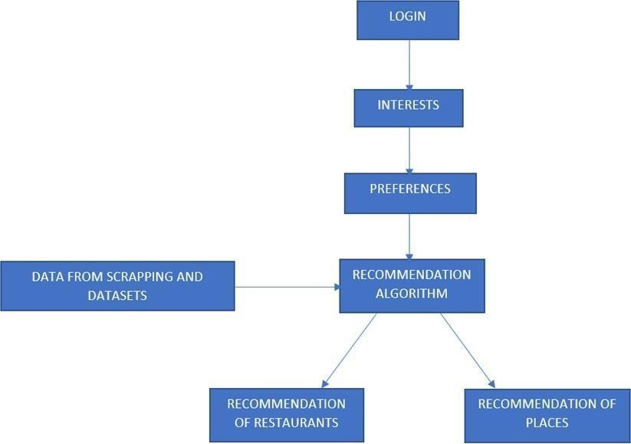
- Output Device: Monitor
- Internet: Required
Software Requirements
Client/ Node Machine:
- Operating System: Windows 7 and above
- Framework: Java JDK
- Cloud: Amazon Web Services CLI
Server Machine:
- Operating System: Windows Desktop OS or Windows Server Edition
- Framework: Java JDK
- Cloud: Amazon Web Services CLI
- Database: SQLit

7.SYSTEM DESIGN
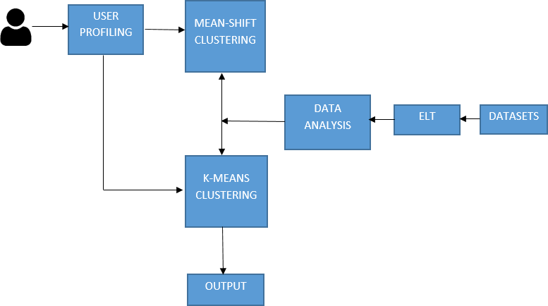
Architectural Design

Above Figure shows the proposed system of Wander Hub, the initial step is to scrape the data from the relevant website for the recommendations, followed by cleaning and analyzing using ELT and Pandas. By entering a location, the data set is also used to propose nearby restaurants to consumers. This system has used two different types of algorithms: K- means for recommendation for eateries, and Mean-shift for recommendation of places. Moreover, users can rate and comment on the locations they've visited, which might assist other users make decisions about the location based on the reviews.

Data Flow Diagram

Below Figure shows us the data flow between different process. The users of the Application will sign in, if they are new to this application they have to create an account and login if the user is already having an account and this data is stored in the database and will be used for the future activities. Once the user logs in to the Application, users will be asked to enter places and restaurants and then using relevant algorithms and the datasets the recommendation is given to the user. For recommendation of places we use Mean-shift and for eateries we use Mean-shift.

8.CONCLUSIONS
The project's goal was to give consumers restaurant and travel recommendations based on their trip information and interests. Utilizing a variety of Data Science tools and methodologies will allow the project's goal to be completed effectively, and the user will be given advice. Because the project's scope is so broad, there is plenty of space for improvement and future development. There are several different websites that may offer more pertinent details about the things and can thus be utilised. By considering the quantity (individually or in a group), kind, and category, the suggestions may also be enhanced (professionals, friends, family with or without kids). If we are travelling with children, for instance, we may focus on recommending family-friendly locations like theme parks and omit suggestions for under-18 travellers. Three recommendation algorithms were applied in this study. The accuracy of the recommendations given can be increased by utilising and fine-tuning a variety of various recommendation algorithms.
9. REFERENCES
- Paromita Nitu, Joseph Coelo, Praveen Madiraju “Improvising Personalized Travel Recommendation System with Recency Effects” (September 2021)
- Akanksha Kumari, Ashish Kumar Singh, Nagamma Patil “Travel Recommendation System Using Geotagged Photos” (November 2017)
- Tamer Uçar, Adem Karahoca, D. Karahoca “NTRS- A new travel recommendation system framework by hybrid data mining” (January 2019)
- “Android Tour Recommendation Online App using Data Mining”
- “A Travel Route Recommendation System Based on Smart Phones and Iot Environment” (2019)
- Mohamed Elyes Ben Haj Kbaier, Hela Masri, Saoussen Krichen “A Personalized Hybrid Tourism Recommender System” (October 2017)
- Merlinda Sumardi, Jufery, Frenky, Rini Wongso, Ferdinand Ariandy Luwinda “TripBuddy- Travel Planner with Recommendation based on User’s Browsing Behaviour” (14 October 2017)
- Artem Umanetsa, Artur Ferreiraa,1, Nuno Leitea “GuideMe-ATourist Guide with a Recommender System and Social Interaction” (2014)
- Subramaniyaswamy, Vijayakumar, Logesh and Indragandhi “Intelligent travel recommendation system by mining attributes from community contributed photos” (2015)
- K. Kesorn, W. Juraphanthong, and A. Salaiwarakul “Personalized Attraction Recommendation System for Tourists Through Check-In Data”

