Design and Development of Human Identification and Obstacle Detection System for blind using Deep learning
Dineshkumar M, Jaisankar G, Mohanraj R, Sethuraman S, Mrs.S.Meenakshi (AP/CSE)
CSE & Selvam College of Technology
---------------------------------------------------------------------***---------------------------------------------------------------------
ABSTRACT

There are millions of visually impaired people in the world, either completely or partially, and they face numerous challenges in detecting obstacles and identifying persons around them. Not only has information technology evolved rapidly, but the spatial cognition theory for blind and visually impaired (BVI) people has also made great strides, which has opened up a new opportunity. As a result, this prototype develops the concept of supplying them with a simple and cost-effective solution via artificial vision. This project has proposed a novel framework by utilizing AI, which makes the framework more straightforward to use specifically for the individuals with visual impedances and to help the society. We developed an intelligent system for visually impaired people using a Deep learning (DL) algorithm.i.e. convolutional neural network (CNN).

Keywords: Blind, Visual, Intelligent. Visually impaired persons, CNN, deep learning.

1. INTRODUCTION
“Visual impairment” is a broad term that is used to refer to any degree of vision loss that affects a person’s ability to perform the usual activities of daily life the way in which vision impairments are classified differs across countries. The World Health Organization (the WHO) classifies visual impairment based on two factors: the visual acuity, or the clarity of vision, and the visual fields, which is the area from which you are able to perceive visual information, while your eyes are in a stationary position and you are looking straight at an object. Your visual acuity is calculated using two numbers. The first number is the distance between the person reading the chart and the chart. The second number is the distance that a person with normal vision would have to stand from an object to see what you did at 20 feet.

1.1. OBJECT DETECTION
The key problem in computer vision is object detection. Those methods are mainly divided into two categories the first one present all methods that can estimate the position as well as the class in one stage like YOLO [3] and SSD [4]. The second category gathers all those methods like Region based convolutional neural network (RCNN) [5] and its enhanced versions. This category requires a primary stage for the object region proposal in the image and a CNN based classifier in the second stage. According to the evaluation of different methods which been described in [6], the YOLO approach has been selected as the main object detector within the proposed system, seeing that fits their configurations.

1.2. DISTANCE ESTIMATION
The distance estimation is an important step under the pretense of identifying the obstacle risk during the user trip. As known, there are numerous sensors for that mission as Laser, Infrared ray, LIDAR, etc. Considering the fact that the authors are planning to come up with a low cost system for the visually impaired community, it seems reasonable to use the camera itself as the distance estimator sensor instead of adding any of the mentioned sensors, there is no doubt that it gives more accurate results, but at the same time it will make the system more complex and sure expensive. This paper use in this regard neural network-based object distance estimation from camera method called DisNet. This method was originally proposed by M. A. Haseb and al. in [2]. DisNet is a supervised learning technique was trained on 2000 different objects extracted from a video camera record using YOLO detector.

2. LITERATURE REVIEW
The researchers have several proposed techniques to develop assistive devices for VIPs. The following technologies have been used in the existing devices: vision-based sensors (camera), non-vision-based sensors (e.g., IR, ultrasonic, inertial and magnetic sensing, etc.), and other technologies such as low-energy Bluetooth beacons, GPS, GPRS, etc. In this section, the main focus is put on vision-based sensing devices due to their relevance to our proposed system.

The researchers have several proposed techniques to develop assistive devices for VIPs. The following technologies have been used in the existing devices: vision-based sensors (camera), non-vision-based sensors (e.g., IR, ultrasonic, inertial and magnetic sensing, etc.), and other technologies such as low-energy Bluetooth beacons, GPS, GPRS, etc. In this section, the main focus is put on vision-based sensing devices due to their relevance to our proposed system. The device is tested on ten blind people aged 20-40 years to evaluate the system’s performance.

The result of the proposed system is promising as it detects the obstacle without any collision from any direction. Yi and Dong [7] have presented a blind-guide crutch using multiple sensors. It detects objects which are 2- 4 meters away. The proposed device is tested on ten people (ages 20-26 years). The volunteers effectively detected the hurdles within the proposed range. Petal et al. [9] developed a multi-sensor system that helps the user detect an object in the indoor surroundings.
The system uses statistical parameters and the SVM (Support Vector Machine) algorithm for detecting the object. The RGB-D is used for obtaining the range and the color information. The individual wears the device to evaluate the performance. The results show that the algorithm is robust and gives approximately 95% accuracy. Yamashita et al. [20] have introduced a wearable device that helps VIPs navigate using RFID, Quasi-Zenith system, and Hololens of Microsoft. The Hololens contain multiple cameras and sensors which help in positioning. Four experiments have been conducted against each individual to assess the system’s performance.
presented a wearable device that VOLUME 10, 2022 14821 F. Ashiq et al.: CNN-Based Object Recognition and Tracking System to Assist Visually Impaired People helps detect the traversable area through RGD-Camera based on the random sample consensus (RANSAC) and surface normal vector estimation. The device gives the interface of non-semantic for transmitting the results to VIPs. It works in both indoor and outdoor surroundings. However, due to heavy computation, it’s difficult for a device to work in a real-time environment and it detects only a short range of attainable areas. For assessing the performance of the system, it is tested on eight individuals and three of them are blind. The results display that the system is useful in an unknown environment.

3. PROPOSED METHODOLOGY
Admittedly, the human brain has a remarkable ability to perceive and understand a real-world scene, going through a very complex process at the level of neurons. This makes simulation a very difficult and complicated. Although, computers exceed most of the big data, human visual system emulation is still primitive and can only capture basic information from visual images such existing objects. Mainly the object detection is the key step in this system. As known, there are numerous sensors for that mission as Laser, radar, etc. [18], [19]. But using a camera it will serve the author’s idea of having a low cost system for the visually impaired community. The main goal is to take this emulation to a next level and pursuing a whole learning process, which groups together the object detection and tracking as well as the risk classification related to all objects around the user, in order to give this assisting system the ability.
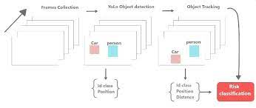

The system only begins to generate warnings of vulnerable objects in the proximities when the distance between the user and the obstacle is less than the thresholding value equal to 0.5 (thresholding-risk). If the distance between the object and the person is less than thresholding-risk, then the object is considered as a high risk obstacle, otherwise is classified as a negligible. Meanwhile the user would be informed just by the surrounding obstacle with high risks and their types, consequently the focus on the global environment where the user navigates would be reduced.
The use of YOLO based object detection in the proposed system is reliable in spite of the fact that YOLO classifier was used in its original form trained with COCO dataset [17], without retraining with the images from the test field. The result of object detection and distance estimation in a dynamic environment (moving car and moving object-obstacle) show that achieving distance estimation is not satisfactory in spite of the fact that objects not fully bounded with the bounding box and also changed within the stream video due to the tracking method, however this part needed an improvement as well as the risk estimation in the case of colliding boxes.

4. OBSTACLE RECOGNITION MODEL
To recognize various obstacles, we used a Google Object Detection application program interface (API) [12] based on Tensor Flow [13]. The API had various pre-trained object detection models, including single shot multibox detector (SSD) Mobile Net and Faster R-CNN. These models could recognize 90 classes (e.g., cat, dog, car, bus). If we used the original pre-trained models, which were not specialized in obstacle data, we could not recognize any bollards or crosswalk lights. For this reason, the models needed to be customized using retraining. We collected obstacle data for bollards and crosswalk lights and retrained the models. The models were applied to the obstacle recognition module and recognized obstacles were learned in real time. According to the recognized results, the obstacles were input into the crosswalk discrimination module and the location calculation module, and a customized algorithm was applied. Each result of the algorithm was passed on to the client, and then, the client could monitor the location of a bollard and the state of the crosswalk light. The guidance was remarkably close to real time and was effective at keeping the client safe.

5.1 SMART GLASS
In this module we design a AI powered smart glass with an integrated camera which helps the user capture images. These images are sent for processing to proprietary FRCNN machine learning models which are deployed on smart glasses. Once the images are processed, the speech response is sent to the Smart glass, which the user hears via the built-in speaker on the glass. Smart Glass is designed as AI glasses for the blind and visually-impaired. It is integrated with AI/ML models and features such as facial recognition Tensor Flow model, Object detection image captioning using FRCNN model.
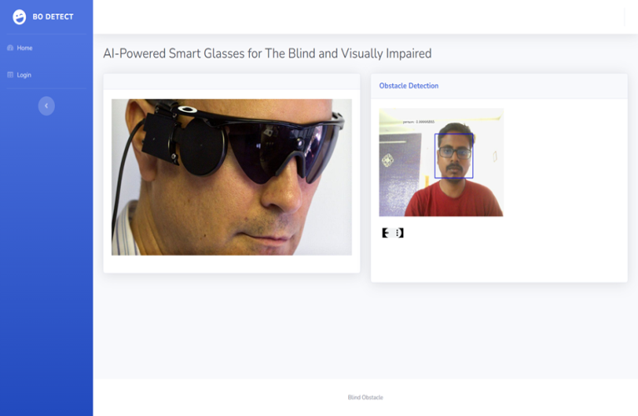

5.2 FACE DETECTION
Therefore, in this module, Region Proposal Network (RPN) generates RoIs by sliding windows on the feature map through anchors with different scales and different aspect ratios. Face detection and segmentation method based on improved RPN. RPN is used to generate RoIs, and RoIAlign faithfully preserves the exact spatial locations. These are responsible for providing a predefined set of bounding boxes of different sizes and ratios that are going to be used for reference when first predicting object locations for the RPN.

5.3 OBJECT DETECTION
Object detection is an important computer vision task used to detect instances of visual objects of certain classes (for example, humans, animals, cars, or buildings) in digital images such as photos or video frames. The goal of object detection is to develop computational models that provide the most fundamental information needed by computer vision applications.

5.4 FEATURE EXTRACTION
After the face detection, face image is given as input to the feature extraction module to find the key features that will be used for classification. With each pose, the facial information including eyes, nose and mouth is automatically extracted and is then used to calculate the effects of the variation using its relation to the frontal face templates.

5.5 OBJECT AND FACE CLASSIFICATION
Region-based convolutional neural networks or regions with CNN features (R-CNNs) are pioneering approaches that apply deep models to object detection. R-CNN models first select several proposed regions from an image (for example, anchor boxes are one type of selection method) and then label their categories and bounding boxes (e.g., offsets). These labels are created based on predefined classes given to the program.
Fast R-CNN was developed with the intention to cut down significantly on train time. While the original R-CNN independently computed the neural network features on each of as many as two thousand regions of interest, Fast R-CNN runs the neural network once on the whole image. At the end of the network is a novel method known as Region of Interest (ROI) Pooling, which slices out each Region of Interest from the network’s output tensor, reshapes, and classifies it. This makes Fast R-CNN more accurate than the original R-CNN. However, because of this recognition technique, fewer data inputs are required to train Fast R-CNN and R-CNN detectors.

6. CONCLUSION
The device presented here is a smart glass that incorporate the functionality of a machine vision and obstacle detection and recognition sensor. It can be conveniently advertised and made accessible to the visually disabled population. It would also help to deter future injuries. Smart devices can be transported comfortably and the system camera can be used to track objects and face from the surrounding environment and display in audio format. Each model represents a specific task or mode. The user can have the desired task run independently from the other tasks. The system design, working mechanism and principles were discussed along with some experiment results. Let the visually impaired people can interact more closely with the people around them, without fear of being blurred and uncertain.

7. REFERENCES
- F. Catherine, Shiri Azenkot, Maya Cakmak, “Designing a Robot Guide for Blind People in Indoor Environments,” ACM/IEEE International Conference on Human-Robot Interaction Extended Abstracts, 2015.
- H. E. Chen, Y. Y. Lin, C. H. Chen, I. F. Wang, “Blindnavi: a mobile navigation app specially designed for the visually impaired,” ACM Conference Extended Abstracts on Human Factors in Computing Systems, 2015.
- K. W. Chen, C. H. Wang, X. Wei, Q. Liang, C. S. Chen, M. H. Yang, and Y. P. Hung, “Vision-based positioning for Internet-of-Vehicles,” IEEE Transactions on Intelligent Transportation Systems, vol. 18, no.2, pp. 364–376, 2016.
- M. Cordts, M. Omran, S. Ramos, T. Rehfeld, M. Enzweiler, R. Benenson, U. Franke, S. Roth, and B. Schiele, “The Cityscapes Dataset for Semantic Urban Scene Understanding,” IEEE Conference on Computer Vision and Pattern Recognition, 2016.
- J. Ducasse, M. Macé, M. Serrano, and C. Jouffrais, “Tangible Reels: Construction and Exploration of Tangible Maps by Visually Impaired Users,” ACM CHI Conference on Human Factors in Computing Systems, 2016.
- J. Engel, T. Schops, and D. Cremers, “LSD-SLAM: Large-scale direct monocular SLAM,” European Conference on Computer Vision, 2014.
- S. Gilson, S. Gohil, F. Khan, V. Nagaonkar, “A Wireless Navigation System for the Visually Impaired,” Capstone Spring, 2015.
- J. Guerreiro, D. Ahmetovic, K. M. Kitani, and C. Asakawa, “Virtual Navigation for Blind People: Building Sequential Representations of the Real-World,” International ACM SIGACCESS Conference on Computers and Accessibility, 2017.
- Kendall, M. Grimes, and R. Cipolla, “PoseNet: a convolutional network for real-time 6-DOF camera relocalization,” International Conference on Computer Vision, 2015.
- Kendall, and R. Cipolla, “Geometric loss function for camera pose regression with deep learning,” International Conference on Computer Vision, 2017.

