ORPHANHUB: Orphanage Learn Earn and Donation Based Application
Nirmala Halakurki, Sharan S Shetty, Sinchana B R, Sukanya N. Shet
Under the Guidance of Prof. Sahaya Shamini
Information Science and Engineering Department, AJ Institute of Engineering and Technology

Abstract— The literature indicates that orphans experience emotional and psychological distress following the death of their parents and etc. Which leads to their poverty, their exploitations in the home of their relatives, their relatives and their loss of education opportunities and many more. This system is basically undertaken for the benefits of the people who are in the orphans who are economically backward, intelligent and meritorious but cannot afford for their needy and financially hard depressed. To overcome this, we have created the system in which orphans can learn several activities by which they can overcome their loneliness or depression and by the same time they can also earn money through their own creative things. Our main motivation for choosing this topic as our project is that we've seen many orphanage kids, people depending on their orphanage for their daily earning which may not be provided always which may lead the people to take some bad decisions in their life.Here they can earn new skills as per their interest and after learning they can create something of their own and sell it in the same app in the market by which 2 needs will be fulfilled that is one way, they will learn new skills other way they will earn on their own. Furthermore, enhancement can be done by collaboration with different companies which sells handcrafts by which there will be a greater number of customers and the user’s requirement will be known by the PPL and to work on the skills required accordingly.

I. INTRODUCTION

An orphanage is a place where children without parents are cared for and housed. If a child has no parents — because the parents died or lost custody — the child is considered an orphan. Orphans are parentless. An orphanage is an institution that takes care of orphans. An orphanage is a residential institution devoted to the care of orphan-children whose parents are unwilling or unable to take care of them. The problem of orphan is acute due to urbanization and industrialization. Need for each of the orphanages varies in different categories such as food, money, clothes, medicine. Most of the people would like to help the orphanages but the major problem is that they have any idea on how to approach these orphanages. The main objective of

this application is to develop a centralized site for orphanages. In our proposed system we try to create
an interface between Orphanages\Old age Homes which are in need of charity and people/Volunteers who are willing to help these people. Volunteers can also approach the Orphanage managers regarding the help that they can afford. People can donate through Internet Banking or Online Money Payment applications. In addition to providing support and training for orphans, this system also serves as an interface between orphanages and old age homes that are in need of charity and people and volunteers who are willing to help. Through this system, people can donate money and other resources to help support orphanages and old age homes, while volunteers can help to provide care and support to those in need.
Overall, this system represents a new approach to addressing the challenges faced by orphans and other vulnerable groups, and it has the potential to make a significant impact on the lives of those who are most in need of support and assistance. By providing a range of resources and opportunities for growth and development, this system can help to build stronger, more resilient communities and empower those who have been most affected by poverty and other forms of social disadvantage.

II.LITERATURREVIEW

Santhosh Kumar, P. Ashish Kumar, V.K.G. Kalaiselvi [1] “Orphanage Helping System” Santhosh Kumar, P. Ashish Kumar, V.K.G. Kalaiselvi, India. In this paper an orphanage is a residential institution devoted to the care of orphan-children whose parents are unwilling or unable to take care of them. The problem of orphan is acute due to urbanization and industrialization. Need for each of the orphanages varies in different categories such as food, money, clothes, medicine. Most of the people would like to help the orphanages but the major problem is that they have any idea on how to approach these orphanages. The main objective of this application is to develop a centralized site for orphanages. In our proposed system we try to create an interface between Orphanages Old age Homes which are in need of charity and people/Volunteers who are willing to help these people.
Jon Dron “Preserving The E-Learning Cottage Industry” [2] Eighth IEEE International Conference on Advanced Learning Technologies E-learning in higher education is usually either a small-scale cottage industry or the product of a production line. Neither approach is perfect: production-line models of distance education suit relatively few learners while the craft approach, though more tailored, is expensive and hard to reuse. However, this picture of the e- learning craftsperson is more complex than it seems: often, learning management systems and their administrators play a subtle role in structuring and scaffolding the process, reducing the artistry required and acting as a silent teaching partner. A closer analogy than a craftsperson’s cottage might be an e-learning sweatshop, in which educators assemble courses within a centrally provided mold or pattern. The solution is a post-industrial model in which the tools informate rather than automate. Rather than creating more industrial machines for learning, we must provide more adaptable, aggregable and interoperable tools for the craftsperson.
Anggy Pradiftha Junfithrana, Euis Liani, Miraz Z.Suwono, Dika Meldiana, Ade Suryana [3] “Rice Donation System in Orphanage Based on Internet of Things, Raspberry-Pi, and Blockchain” . In this system we learn about IOT utilization in daily lives is very potential and can be applied in various fields, unfortunately the implementation in the social field still lacking. The large number of orphanages in Indonesia caused information distribution not easily available, however donors find it difficult to get the right information about food reserves, especially rice stock in orphanages. This paper proposes an IoT-based system where rice stocks in orphanages can be detected by Raspberry pi which is connected to sensors, data information from raspberry-pi connected to the network that can be accessed and monitored by mobile applications. This application designed for service. providers, donors and rice suppliers. Donors send rice through financial transactions with service providers, and rice suppliers will ship items to the orphanage. Blockchain technology is applied to all parties in order to be transparent and reduce transaction manipulation.
Ming-Hua Cheng, Wen-Shyang Hwang, Yan-Jing Wu, Cheng-Han Lin, Wen-Ming [4] “Optimize the Tree Routing efficiency in Wireless Sensor Network by Using Orphan Nodes. Nowadays, wireless sensor networks (WSN) have been widely developed. The feature of WSN is that it supports the short-range and low-speed transmission as well as low-power consumption. ZigBee is a standard for WSN based on IEEE 802.15.4. Through connection, it will produce a tree topology and orphan nodes isolated from the network. During the transmission, tree routing is used to compare the location of nodes for relaying the data. As the network enlarge, the depth of the nodes increases. So does the frequency of the relay during transmission. Even though the distance between source and destination nodes is close, tree routing is still used because they are not located on the same branch. Too many times of relay waste the cost of route, which will influence the overall life cycle of nodes over a long period of time. In order to modify the problem of the relay caused by Zigbee, this paper proposed the using Orphan nodes to Improves the Tree Routing (OITR) mechanism. By the way of rejoining, the orphan node is joined in the connection with the allocation address proposed by this thesis. After the orphan node joining the network, the information of neighbor table is built by the periodically synchronous characteristics of Zigbee network.
K. N. Mishra [5] "Tracing the parents of orphanage children in cloud computing environment by integrating DNA databank with Aadhar and FIR databases," An Aadhar card is a unique and authentic identity card in India which is being used as a valid identity proof for all types of day-to-day transactions including sale, purchase, opening bank account, air tickets, train tickets, bus tickets, and for getting benefits of government of India and state government’s schemes. An Aadhar card of a person includes finger prints, thumbprints, iris images (left eye & right eye), and face image for a normal. But, for differently abled persons like blind, deaf, and physically handicapped persons it includes face, fingerprints, and thumbprints. In this research work the author has proposed a novel technique in which the Aadhar database is integrated with short tandem Repeat (STR) part of DNA database & first information report (FIR) lodged online in different police stations to trace the parents of orphanage children and unclaimed decomposed dead bodies using cloud computing, Internet of Things (IoT), spiral search and block chain technologies. The proposed technique is giving promising results in searching the parents of orphanage children in India and its worldwide implementation will help millions of orphanage children in tracing their parents.
B. Kamala1 B. Rakshana2 B. Reshma B. Deiva [6] “Patronization for Orphans and Adoption Using Android Application” All around the world, every 30 seconds two children become orphans. There are more than 100 million orphans worldwide. In Asia alone there may be 65 million orphans. They are hungry, afraid and lonely. Their main issues are lack of food and clothes for their daily usage and lack of education and money. Here, we are introducing an android application which will defeat these issues in an easy manner as well as quickly without spending more time. The notion of this paper is to support orphans of different orphanages by the people who wish to contribute to the children and adopting children online by using our android application. They can help orphans in the orphanages by contributing foods and clothes to the particular orphanage they wish, through online. The people who wish to adopt children can use this application to see the children’s details with their photos in different orphanages and they can choose the child they like and other formalities are done by visiting that particular orphanage where the chosen orphan is. Fund transactions are also made by our application. This paper will be beneficial for the orphans. The weary persons can make use of this application for contributing orphans and adopting children. This android application not only indulges in the process of adopting the orphans and providing shelter but also impulses their life by donating food, clothes and money.
Diogo Schaffer, Conrado Boeira, Gabriel Rockenbach, Guilherme Maurer, Andre Antonitsch and Soraia Raupp Musse [7] “Simulating Virtual Humans Crowds in Facilities” In this paper we learn about The area of crowd simulation has been widely explored in several contexts from entertainment to safety purposes. In this paper we present an approach to simulate the evacuation of crowds in facilities such as hospitals, geriatric clinics, orphanages and etc, where agents adopt different profiles, e.g. workers, patients and families. We use Snook tables to parametrize the effort of people to push patients impacting the people speed when evacuating in this specific context. This model can be applied in games, although our main goal is to contribute with safety systems by computing evacuation times and finding out the number of trained people needed in different scenarios. To control the motion of people in crowds and to avoid collisions we use Bio Crowds, but any other crowd simulator could be used as well. Results indicate that the total evacuation time is reduced by having more trained workers, smaller hospital floors and an approximately similar number of rescuers and dependents number of patients and rescuers. In addition, we compare our method with another simulation in a hospital and obtained results were coherent. . This model uses an energy-based model that takes into account the expected future state of agents as well as their current state to reach an integration scheme for simulations.
Allan Carlo Lagang Torio, John Paul Antenor Revoltar [8] “CHARIT-E: A Home Fundraising System And Solutions For Philippine Orphanages” In this paper study was conducted to design and develop a web-based donation, fundraising, and volunteer management system. Specifically, the Project Study was developed to help orphanage organizations in overseeing their front operations and in increasing their engagement with potential donors and volunteers through the creation of custom events, fundraising events, newsletters, and in managing volunteers through an in-built scheduling and attendance modules. Moreover, the study was conducted using the Scrum Methodology. In this model, we list down processes and tasks that are needed throughout the software development.
Raffaele Sommese, Mattijs Jonker, Roland van Rijswijk-Deij, Alberto Dainotti [9] “The Forgotten Side of DNS: Orphan and Abandoned Records” The Domain Name System (DNS)is part of the core Internet infrastructure and also one of the most complex parts. The DNS is organized as a hierarchical, distributed database with built-in redundancy. The responsibility for domains is arranged through a process of delegation, in which an entity at a higher level in the hierarchy diverts responsibility for a subset of the name space to another party. The hierarchy starts at the root of the DNS, which delegates top-level domains (TLDs) such as, .net, .nl, etc. These TLDs in turn delegate to second-level domains, which in turn may further delegate parts of the name space. Administration of these delegations, especially at the TLD level, can be a complex task involving many entities. As a matter of fact, within the context of the DNS, we typically identify three types of stakeholders: registries, registrars and registrants. The registry is the entity responsible for the administration of a TLD. The registrar provides an interface between registrant and registry.
Kamta Nath Mishra CSE Department, B.I.T. Mesra, Jharkhand, INDIA Email [10] “Tracing the parents of orphanage children in cloud computing environment by integrating DNA databank with Aadhar and FIR databases”The paper titled "Tracing the parents of orphanage children in cloud computing environment by integrating DNA databank with Aadhar and FIR databases" proposes a system that uses cloud computing to integrate DNA databank, Aadhar database, and FIR database to help trace the parents of orphanage children. The system aims to address the problem of children being separated from their parents due to various reasons, such as natural disasters, accidents, or kidnapping.
Mwaniki EW, Mokoka AN Nutrition Status of Children in Orphanages in Selected Primary Schools within Dagoretti Division Nairobi, Kenya. Journal of Nutrition and Food Science[11] The study by Mwaniki and Mokoka investigated the nutritional status of children living in orphanages in selected primary schools in Dagoretti Division, Nairobi, Kenya. The researchers found that the orphans had a higher prevalence of malnutrition compared to non-orphans, with stunting being the most common form of malnutrition. The study suggested that the nutritional needs of children in orphanages need to be addressed to improve their health outcomes and overall well-being. The research highlights the importance of addressing the nutrition and dietary needs of children living in orphanages. The researchers collected data from 120 orphaned children aged 5-12 years from four different orphanages.

III.METHODOLOGY

The proposed system provides a platform for Orphanages where the orphans can learn to do new creative things by that they can overcome their loneliness and also through this platform they can sell their creative things and earn money. The orphanage manager will have separate login where he has to upload details of the orphanage, details of product which is to be sold and he has to mention what kind of donation is needed. User can search and select the product/crafts which he/she likes, he can also go through the details of the particular orphanage and can know about what kind of donation are required.
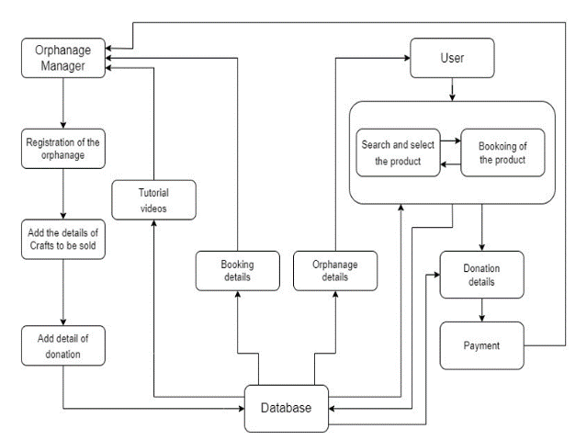
The Application will be mainly used by the people who need to purchase the product and also by orphanage manager who sell products. So, keeping this in mind the platform is designed to be simple as possible without any complex actions so that the users can use the application without any formal training.
Orphanage manager has to register his orphanage details in the application. Later the tutorial videos will be provided so that the orphans can select videos of their interest and start to learn through that. Then comes the sales page where the videos and photos of the creative thing made by orphans will be uploaded in the by the orphanage Manager which are ready to sell. Then the donation page where the manger puts the list of donations that the people can give to orphanage and many more information will be provided there. All the information created by the manager will be stored in database and normal user can see through the information in which area their interested to. Then come the user section. Here the user can will all the details of orphanage like the orphanage photos and videos, the way how orphans create their creativity and also the donation section. In donation section the user can view the details provided by orphanage and he/she can choose what kind of donation they want to do. The information given by the user is stored in database. This is seen by the orphanage Manager and help the user to get the product they want and also on donation matter.

IV.IMPLEMENATION

To implement the proposed system for Orphanages, there are several components that need to be considered. Firstly, a web-based platform needs to be developed that will allow the orphans to learn new creative skills and showcase their crafts. The platform should also have an e-commerce functionality where the orphans can sell their crafts and earn money. To ensure the security and privacy of the users, the platform should have proper authentication and authorization mechanisms in place.
The orphanage manager should have a separate login where he/she can upload details of the orphanage, products/crafts that are available for sale, and the kind of donations that are needed. This will help potential customers to have a better understanding of the orphanage and its needs. The platform should also have an administrative dashboard that will allow the orphanage manager to manage the products, track the sales, and monitor the donations.The platform should have a search functionality that will allow users to easily find the products/crafts they are interested in. Users should be able to filter the products based on their preferences such as price, category, and location. Additionally, the platform should also have a recommendation system that will suggest relevant products to the users based on their previous search history and preferences.

IV. RESULT AND DISCUSSION

The proposed system provides a platform for orphanages to enable orphans to learn new creative skills, sell their crafts, and earn money, thus reducing their sense of loneliness. The system design includes separate logins for both orphanage managers and users, allowing them to access the features relevant to their needs. The orphanage managers can upload details of their orphanage, products available for sale, and mention the kind of donation required.
The users can search for products and crafts based on their preferences and go through the orphanage details to learn more about the donation requirements. This feature provides transparency to the users, and they can contribute to the cause they are interested in. The tutorial videos for hand-made crafts can be an additional feature that can help the orphans to learn new skills and improve their creativity.

Login page
The login page has 2 options called Sign in and Sign Up. Both the orphanage manager and the user will have this page.

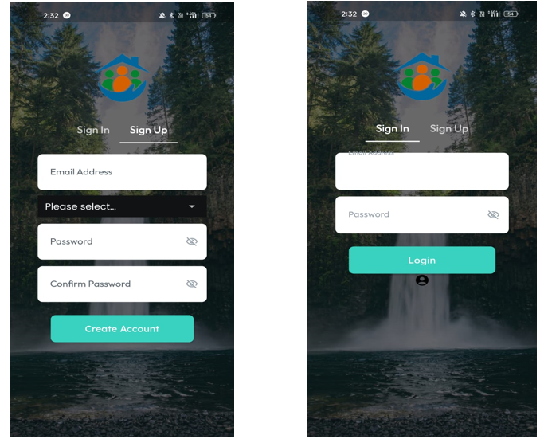

Figure: Sign In and Sign Up Page

Tutorial videos for Orphanage Manager
Tutorial videos can be especially helpful for orphanage managers who want to learn how to create and upload details of handmade crafts that are available for sale on the platform.
• Choosing a craft: The video can help orphanage managers select a craft that they are comfortable making and that has a good demand in the market.
• Gathering materials: The video can show how to gather all the necessary materials required to make the craft, including where to purchase them from.
• Preparing the workspace: The video can explain how to prepare the workspace, including cleaning the area, laying out the materials, and ensuring that there is enough lighting.
• Making the craft: The video can provide step-by-step instructions on how to make the craft, including any tips or tricks that will make the process easier.

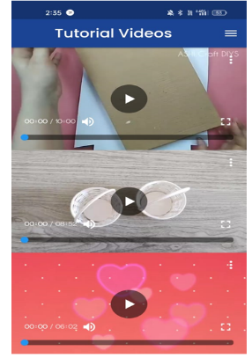
By following the steps outlined in the tutorial video, orphanage managers can create and upload high-quality handmade crafts that will be attractive to buyers on the platform.

Figure: Tutorial videos

Product Post for Orphanage Manager
When orphanage managers log in to the platform, they will have the ability to create product posts that showcase the details of the products/crafts that are available for sale. The product post will typically contain the following information:
• Product title: This is a brief description of the product, which can be used to grab the attention of potential buyers.
• Product description: This is a detailed description of the product, including its features, benefits, and any other relevant information that the buyer should know.
• Product images: Clear and attractive images of the product are essential for attracting potential buyers. The images should show the product from different angles, and should be of high quality.
• Price: The price of the product should be clearly indicated, and should be based on the cost of materials used to create the product, as well as any labor costs.
• Quantity: The number of products available for sale should be indicated, to avoid overselling.
• Shipping details: Shipping details, including the shipping method, delivery time, and cost, should be clearly indicated.
• Payment options: The payment options available to buyers should be indicated, including online payment methods, bank transfer, or cash on delivery.
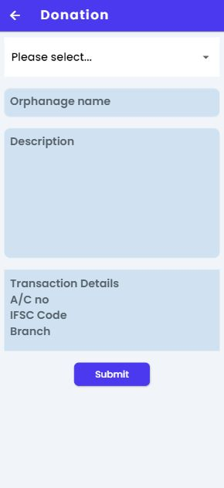
By creating detailed and attractive product posts, orphanage managers can attract potential buyers to their products/crafts, increasing the chances of making sales and earning revenue for their orphanage.
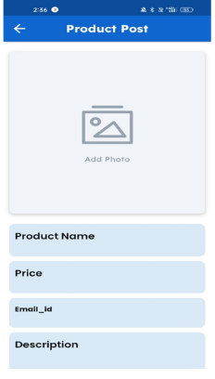
Figure: Product Post Page

Product Page for User
For users, the product section of the platform can provide an opportunity to purchase unique and handmade items while also supporting orphanages. Users can browse through a variety of products that are available for sale and filter them by category, price range, or other relevant criteria.
Each product listing can include information such as the name of the product, a description of the item, the price, and any relevant details about the orphanage that created the product. Additionally, product listings can include photos of the item, which can help users better understand what they are purchasing and make informed decisions.
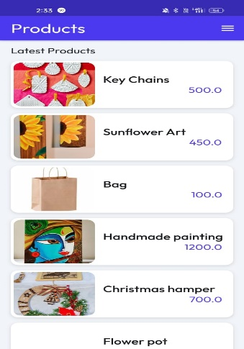
Users can select the products they are interested in and add them to their cart for checkout. Once the purchase is complete, the funds will be directed towards the respective orphanage as a donation to support their mission.
Figure : Products Page

Figure: Donation Page
Donation page for User
For users, the donation page of the platform can provide an opportunity to contribute towards the cause of supporting orphanages. The page can list various orphanages that are registered on
the platform and provide information about their mission and the types of donations they require.
Users can select an orphanage they would like to support and make a donation of their choice. The platform can accept donations through various payment methods such as credit cards, debit cards, PayPal, or other popular payment gateways.
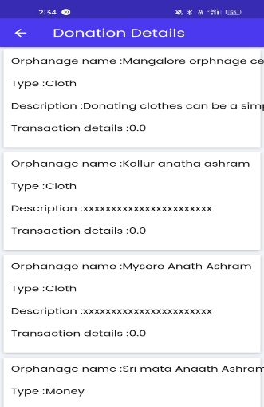
Figure: Donation Details

Logout page for Orphanage Manager
The logout page is an essential part of the platform, as it allows orphanage managers to securely end their session and log out of the platform. When the orphanage manager clicks on the logout button, they will be directed to a page that confirms that they have successfully logged out of the system. This page may also contain additional information, such as tips on how to keep their login credentials secure, or how to access support if they have any issues logging in or using the platform.
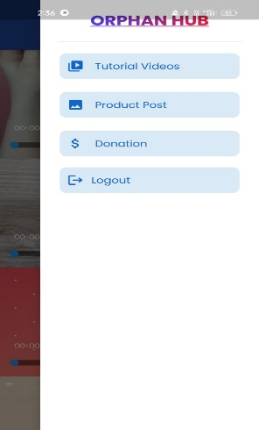
The logout page should also ensure that any sensitive information, such as login credentials or user data, is properly cleared from the system, to ensure that the next user who logs in does not have access to any sensitive information from the previous session. By providing a secure and easy-to-use logout page, the platform can ensure that orphanage managers can safely and securely access and manage their account, and can help to prevent unauthorized access or breaches of sensitive information.

Figure: Logout page 1

Logout page for User
The logout page for users is a crucial component of any application, including the proposed platform for orphanages. When a user clicks on the logout button, the platform should ensure that they are logged out of their account and all their session data is cleared to prevent unauthorized access.
Upon successful logout, the platform can display a confirmation message thanking the user for using the platform and inviting them to log back in whenever they want to support an orphanage or purchase a product.
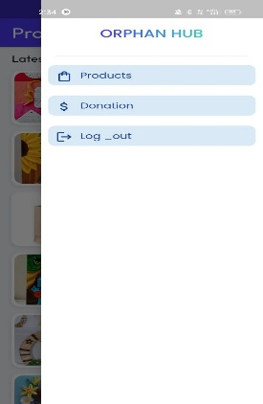
The logout page can also include links to relevant information such as the platform's privacy policy, terms of service, and frequently asked questions (FAQs). This can help users understand the rules and guidelines of the platform and ensure that their personal information is handled responsibly.

Figure: Logout page 2

V.CONCLUSION

The Project ‘ORPHANHUB - Orphanage Learn Earn and Donation Based Application’ is been designed, for helping the orphans who are economically backward, intelligent, but cannot afford on their needy. This app will help them to get them creative knowledge and also brings the mentality that no work is bigger or smaller. Also, this app helps the orphans, the manager of the orphan and the user. The platform even has features which are different and unique too when compared to related studies on this field, enhancing the overall security and accuracy by standing out among all the related studies and proposed systems in this field.

VI. REFERENCES
- Santhosh Kumar K, Ashish Kumar P, Kalaiselvi V.K.G “Orphanage Helping System”, pp 15-19, September 2020
- Jon Dron “PRESERVING THE E-LEARNING COTTAGE INDUSTRY” Eighth IEEE International Conference on Advanced Learning Technologies E-learning in higher education
- A.P. Junfithrana, E. Liani, M. Z. Suwono, D. Meldiana, A. Suryana, (2018) Rice Donation System in Orphanage Based on Internet of Things, Raspberry-Pi, and Blockchain,
- A.P. Junfithrana, E. Liani, M. Z. Suwono, D. Meldiana, A. Suryana, (2018) Rice Donation System in Orphanage Based on Internet of Things, Raspberry-Pi, and Blockchain,
- Ming-Hua Cheng, Wen-Shyang Hwang, Yan-Jing Wu, Cheng-Han Lin, Wen-Ming “Optimize the Tree Routing efficiency in Wireless Sensor Network by Using Orphan Nodes
- K. N. Mishra, “Tracing the parents of orphanage children in cloud computing environment by integrating DNA databank with Aadhar and FIR databases”
- B. Kamala1 B. Rakshana2 B. Reshma B. Deiva “Patronization For Orphans And Adoption Using Android Application”
- Diogo Schaffer, Conrado Boeira, Gabriel Rockenbach, Guilherme Maurer, Andre dr1e2e/wz4Antonitsch and Soraia Raupp Musse “Simulating Virtual Humans Crowds in Facilities”
- John J Lowell, Kirstin Lu, Allan Carlo Lagang, John Paul “CHARIT-E : A Home System and Solution for Philippine Orhanages ,May 2022
- Raffaele Sommese, Mattijs Jonker, Roland van Rijswijk-Deij, Alberto Dainotti “The Forgotten Side of DNS: Orphan and Abandoned Records”
- Chibuzo Onyyemaobi, Maria Adigun “Automated Orphanage System” PP 13-21,January 2020
- Mwaniki EW, Mokoka AN (2013) Nutrition Status of Children in Orphanages in Selected Primary Schools within Dagoretti Division Nairobi, Kenya. Journal of Nutrition and Food Science 4: 248.
- Kamta Nath Mishra CSE Department, B.I.T. Mesra, Jharkhand, INDIA Email:“Tracing the parents of orphanage children in cloud computing environment by integrating DNA databank with Aadhar and FIR databases”

