EXPERIMENTAL STUDY ON BIOBASED SELF HEALING CONCRETE USING TRICHODERMA REESI AND POLYPROPYLENE FIBER

Dr.O.R Kavitha, M.E., | Alan Tomy | Amarnath S
Ph.D.,
(associate professor)
kavimalai1979@gmail.com | alantomy00@gmail.com | suryaamarnath46@gmail.com
Department of Civil | Department of Civil | Department of Civil
Engineering | Engineering | Engineering
SNS College of Technology, | SNS College of Technology, | SNS College of Technology,
Coimbatore. | Coimbatore. | Coimbatore.

Sanjeev G

Murugan V

sanjeevsanjeev06667@gmail.com

snuffymurugan@gmail.com

Department of Civil Engineering

Department of Civil Engineering

SNS College of Technology, Coimbatore.

SNS College of Technology,
Coimbatore.

.

ABSTRACT

Self-healing concrete is a promising solution to extend the service life and durability of concrete structures by autonomously repairing cracks that form due to various reasons, suchas shrinkage, weathering, and loading. In this study, it is proposed a novel approach for self- healing concrete using Trichoderma Reesei, a fungus known for its cellulolytic enzymes, and polypropylene (PP) fiber as a reinforcement material.

The self-healing mechanism involves the activation of Trichoderma Reesei by moisture andnutrients from the crack environment. The fungus produces cellulolytic enzymes that can break down cellulose, a component of plant-based fibers, and release calcium carbonate as a byproduct. Calcium carbonate then precipitates in the presence of carbon dioxide from the surrounding environment, effectively sealing the crack and restoring the integrity of theconcrete.

Polypropylene fiber is used as a reinforcement material to enhance the mechanical properties of the self-healing concrete. The fibers are uniformly distributed in the concrete matrix, providing additional tensile strength and crack resistance, which helps to prevent crack propagation and improve the effectiveness of the self-healing process. The performance of the bio-based self-healing concrete was evaluated through varioustests, including crack healing efficiency, compressive strength, and split tensile strength. The results showed that the addition of Trichoderma Reesei and polypropylene fiber significantly improved the crack healing efficiency of the concrete, with crack widths reduced by up to 80% compared to control samples without the bio-based healing agent. The mechanical properties of the self-healing concrete were also maintained or even improved, with no adverse effects observed.

In conclusion, the proposed bio-based self-healing concrete using Trichoderma Reesei and polypropylene fiber has shown promising results in terms of crack healing efficiency and mechanical performance. This approach has the potential to contribute to the development of sustainable and durable concrete structures with extended service life and reduced maintenance needs. Further research and development are warranted to optimize the formulation and application of this innovative self-healing concrete technology.

CHAPTER 1

INTRODUCTION

1.1 General

Concrete is one of the most widely used construction materials due to its versatility, durability, and low cost. However, cracks in concrete structures can occur over time due to various factors such as shrinkage, weathering, and loading, which can lead to reduced structural integrity and increased maintenance costs. Self-healing concrete has emerged as a promising solution to address this issue by autonomously repairing cracks, thereby extending the service life and improving the durability of concrete structures.
1.2 Self-Healing Concrete

Self-healing concrete (SHC) is characterized as the capability of concrete to fix its cracks on its own autogenously or autonomously. It not only seals the cracks but also partially or entirely recovers the mechanical properties of the structural elements. This kind of concrete is also known as self-repairing concrete.

Bio based self-healing concrete- bio-concrete, can be produced by adding bacteria in concrete along with its nutrients to keep them alive for the production of calcite to fill cracks after precipitation. Bacteria are to be added in concrete along with calcium lactate to repair cracks

Chemical based self-healing concrete- One common healing agent used in chemical-based self-healing concrete is a monomer called methyl methacrylate (MMA). When the microcapsules containing MMA are ruptured, the MMA comes into contact with a catalyst in the concrete, triggering a polymerization reaction that seals the crack

1.3 Trichoderma Reesei Fungi

Trichoderma reesei's ability to produce large amounts of cellulose enzymes makes it a promising candidate for self-healing concrete, as these enzymes can break down cellulose-based materials that are commonly used as fillers in concrete mixes. However, further research is needed to optimize the use of Trichoderma reesei inconcrete and ensure its long-term effectiveness and safety

1.4 Polypropylene Fiber

Polypropylene fibers are known for their durability, resistance to moisture, and ability to withstand high temperatures. They are also lightweight, flexible, and have a high level of colorfastness. In addition, polypropylene fibers are recyclable and eco-friendly Overall, the addition of polypropylene fibers can improve the durability and performance of concrete, making it more resistant to wear and tear, and extending its lifespan

1.5 Self-Healing Fiber Reinforced Concrete

Self-Healing Fiber Reinforced Concrete (SHFRC) Self-healing concrete is a new type of concrete. It imitates the automatic healing of body wounds by the secretion of some kind of material. To create self-healing concrete, some special materials (such as fibers or capsules), which contain some adhesive liquids, are dispensed into the concrete mix.

1.6 Objective

- To Investigate the strength properties of bio-based self-healing concrete.

- Studythe physical and chemical properties of material

- Preparation of mix design for M20 grade of concrete by adding trichderma reesei fungi and polypropylene fiber SHFRC

- To optimize the content of polypropylene fibers to achieve the desired mechanical properties and self-healing capabilities in the concrete.

- Utilization of SHFRC as a add-on material in concrete

- Study and compare the fresh and hardened properties of the convential concrete and SHFRC

- To assess the self-healing capabilities of concrete containing Trichoderma reesei and polypropylene fibers.

CHAPTER 2

METHODOLOGY

2.1 General

This chapter deals with the sequence of work plan adopted for this project. Fig 3.1 shows the methodology for the present study
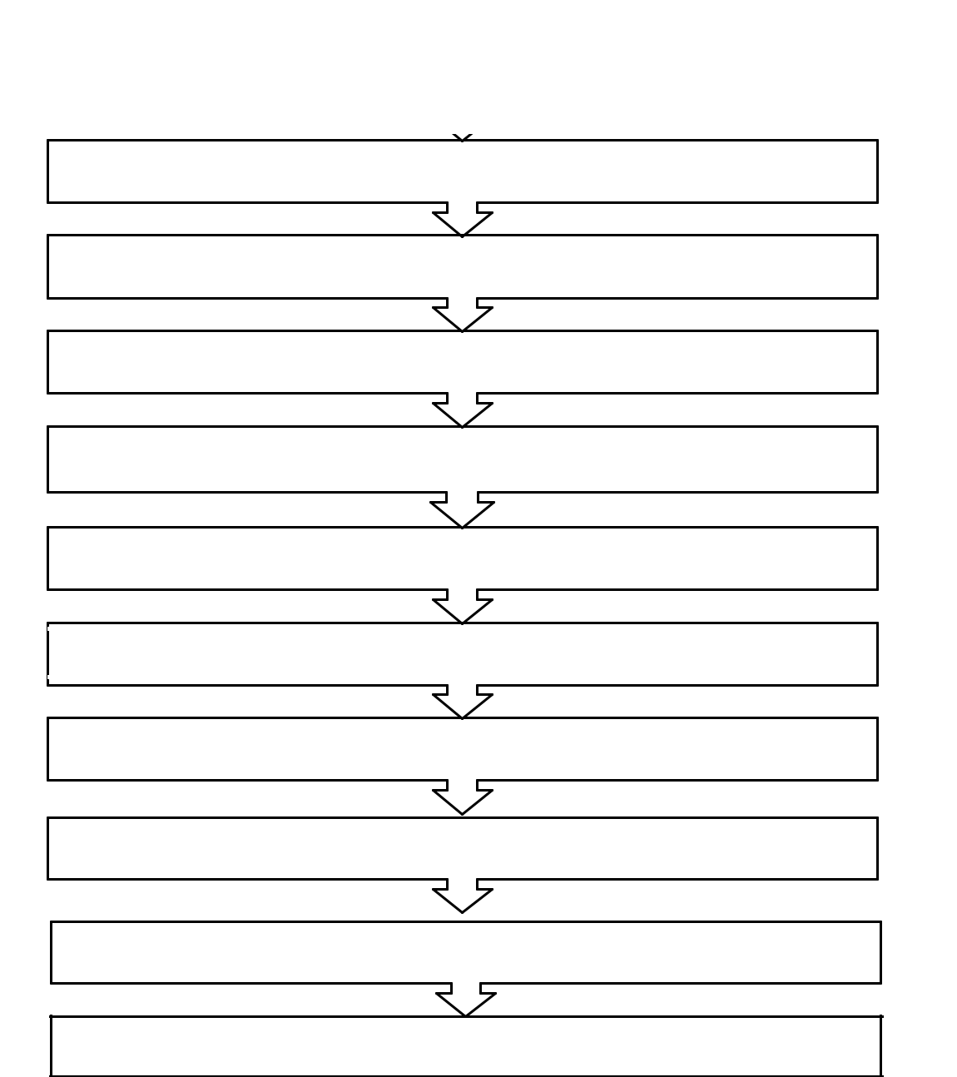

Review

Collection of materials

Testing on materials

Dosage optimization of fungi

Mix design for M20 grade concrete

Test on fresh concrete

Testing on hardened concrete (Compressive strength and Split tensile test)

Study of crack healing of SHFRC

Result and discussion

Comparison of CC with SHFRC

Conclusion

Fig 2.1 Methodology

CHAPTER 3

MATERIAL USED

3.1General

The materials to be used in the present project is collected from various places and the basic tests were carried out on the procured materials to study the material properties in order to make suit the material for the project.

3.2 Material Used

The materials used in this project are

- Cement

- Fine aggregates- M sand

- Coarse aggregates - 20 mm

- Polypropylene fiber

- Trichoderma reesei fungi

- Water

3.3 Cement

Cement is a fine powder, which when mixed with water undergoes chemical change and thereafter allowed to set and harden is capable of uniting fragments or masses of solid matter together to produce mechanically strong material. Cement contains compounds of lime, silica and alumina as their principal constituents. The functions of cement in concrete are as follows

Table 3.1 Physical properties of cement

S. No | Properties | Values | Permissible limits As per
 |  | obtained | IS12269
1 | Consistency | 28 % | 2.5-2.8
2 | Specific gravity | 3.15 | -
3 | Initial setting time | 34 | >30 min
4 | Final setting time | 253 | <600 min
5 | Fineness | 7 | <10 %

Table 3.2 Chemical composition of cement

Chemical | Results | Permissible limits as
compositions | (%) | per IS : 12269
SiO2 | 21.54 | -
Fe2O3 | 3.63 | -
Al2O3 | 5.32 | -
MgO | 1.08 | Maximum 6
SO3 | 2.18 | -
CaO | 63.3 | -
LOI | 1.1 | -

3.4 Aggregate

The aggregate is inert structural filler in concrete. The aggregate used in concrete is classified in to two

1. Fine aggregate 2. Coarse aggregates

3.5 Fine Aggregate

The aggregates passing through IS 4.75mm sieve is considered as fine aggregates. River sand and manufacturing sand (M-sand) are most commonly used fine aggregates.

Sand consists of small angular or rounded grains of silica. The functions of fine aggregates are as follows:

- It fills the voids existing in the coarse aggregate.

- It reduces shrinkage and cracking of concrete

• It helps in hardening of cement by allowing the water through its voids

- By various mix proportions of sand concrete can be prepared economically for any required strength

In this study M-sand passing through 4.75mm IS sieve is used which belongs to zone II (as per IS 383). various tests were carried out as per IS:2386-1968 part III and the table 4.1 shows the sieve analysis of fine aggregates

Apparatus Required:

IS Sieve set of 4.75mm, 2.36mm, 1.18mm, 600Micron, 300Micron, 150Micron, 75Micron and weight measuring apparatus.

Procedure:

A set of IS Sieves 10mm, 4.75mm, 2.36mm, 1.18mm, 600Micron, 300Micron, 150Micron is taken cleaned the sieves by using brush and arranged one over the other in such a way that the largest sieve opening come at top placed a receiver at bottom. Then weighted 2Kg of dry sand and put in to the top most sieve. Then closed the top

most sieve with a lid. Then the whole set of sieves shaped for 15 minutes. Then found the weight of sand retained on each sieve. Then calculated the percentage of weight retained cumulative percentage and percentage of finer.

Table 3.3 Sieve Analysis of FA

S. No. | IS Sieve | Weight | Percentage | Cum % | % passing | Limits as
 | Designation | Retained | Retained | Retained | by Weight | perIS 383
 |  | (gm) |  |  |  | (%)
1. | 4.75mm | 15 | 1.5 | 1.5 | 98.5 | 90-100
2. | 2.36mm | 69 | 6.9 | 8.4 | 91.6 | 75-100
3. | 1.18mm | 179.6 | 17.96 | 26.36 | 73.64 | 55-90
4. | 600 micron | 76.3 | 7.63 | 33.99 | 51.38 | 35-59
5. | 300 micron | 143.6 | 14.36 | 48.35 | 28.55 | 08-30
6. | 150 micron | 447 | 44.7 | 93.05 | 6.95 | 0-10
7. | 75 micron | 17 | 1.7 | 99.8 | 0.2 | 0-3
8. | PAN | 62.3 | 6.23 | 99.28 | 0 | 0

The fine aggregates belong to Zone II as per IS 383-1970 table4 and the fineness modulus is found to be 4.57.

3.6 Coarse Aggregate

Procedure:

The aggregates whose size is greater than 4.75mm are considered as coarse aggregates. The size of coarse aggregates generally ranges between 9.5mm to 37.5mm. Coarse aggregates used may be crushed stones, or gravels. The functions of coarse aggregates are as follows:

- It makes solid and hard mass of concrete with cement and sand

- It increases the crushed strength of concrete

- It reduces the cost of concrete, since it occupies major volume.

In this study, locally available aggregates passing through IS 20mm sieve and retained on IS 4.75mm sieve in saturated surface dry condition are used as coarse aggregates. The aggregates are angular type crushed granite aggregates. The coarse aggregates was tested as per IS 2386:1968 part III and its properties are tabulated in table 4.4

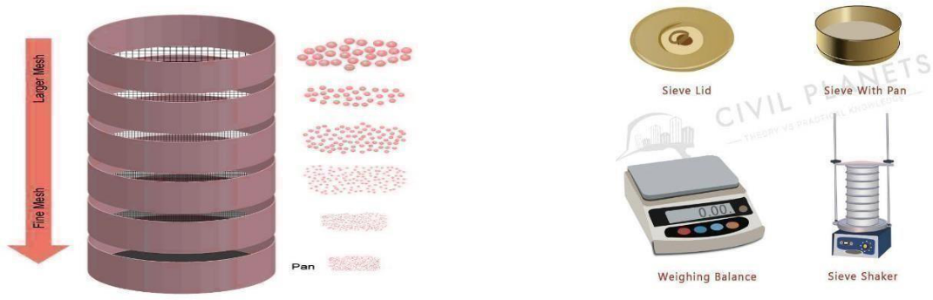

Fig. 3.1 Equipment’s

Table 3.4 Sieve Analysis of CA

 | IS Sieve | Weight | Percentage | Cum % | %
Sl No. | Designation | Retained | Retained | Retained | passing by
 |  | (gm) |  |  | Weight
1 | 20mm | 0 | 0 | 0 | 100
2 | 10mm | 1.463 | 29.26 | 29.2 | 17.7
3 | 4.75mm | 2.165 | 43.3 | 72.6 | 27.4
4 | 2.36 micron | 0.96 | 0.0192 | 91.8 | 8.2
5 | 1.18 micron | 0.145 | 0.0029 | 94.7 | 5.3
6 | 600 micron | 0.075 | 0.0015 | 96.2 | 3.8
7 | 300 micron | 0.1 | 0.002 | 98 | 1.8
8 | 150 micron | 0.09 |  | 98.2 | 1.5
9 | PAN | 0.02 | - | - | 0

3.7 Water

Water used in concrete plays an important part in mixing, laying, and compaction, setting and hardening of concrete. The strength of concrete directly depends on quality and quantity of water used. Potable tap water available in laboratory with PH value of 7.0 ± 1.0 and confirming to the requirement of IS 456-2000 was used for mixing concrete and curing the specimen as well.

The functions of water in concrete are as follows:

- Water is only the ingredient that reacts chemically with cement and thus setting and hardening takes place.

- Water acts as a lubricant to aggregates and makes the concrete workable.

- It facilitates the spreading of cement over fine aggregates.

3.8 Polypropylene Fiber

Polypropylene fiber (PPF) can be added to concrete as a reinforcement material

to improve the strength and durability of the concrete. The fibers act as small points

of reinforcement throughout the concrete matrix, providing an additional layer of

support against cracking and other forms of damage. Polypropylene fibers are

typically added to concrete in small quantities, usually less than 1% by volume. The

fibers are mixed in with the other ingredients of the concrete, and then the mixture is

poured or cast into place. Once the concrete sets and cures, the polypropylene fibers

become dispersed throughout the material, creating a network of reinforcement

points. This helps to improve the tensile strength of the concrete, making it more

resistant to cracking and other forms of damage

Fig 4.2 shows the ppf used in this project
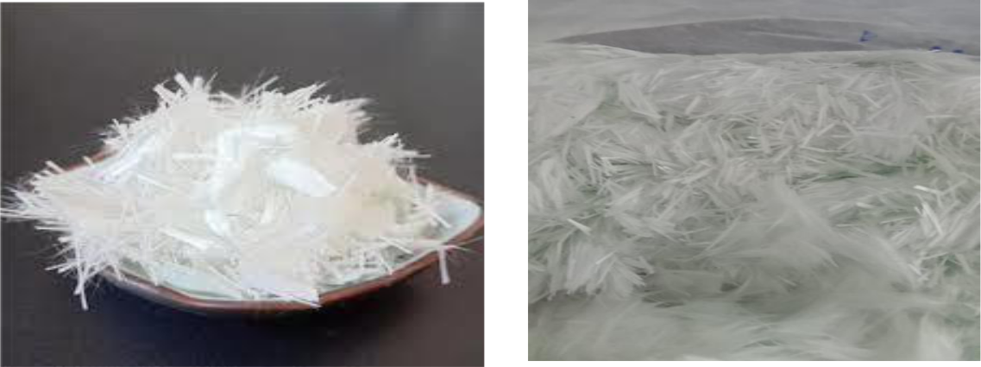

Fig. 3.2 Polypropylene Fiber

3.9 Trichoderma Reesi Fungi

Trichoderma reesei is a filamentous fungus that is commonly used in industrial applications for the production of cellulose enzymes. While itis not commonly used in concrete production, it is possible that this fungus could have some properties that maybe beneficial or detrimental to the concrete. Used as a packaging material in bags, boxes and containers.

The ability of Trichoderma reesei to break down cellulose could potentially improve the bond between the wood fibers and the concrete, resulting in a stronger and more durable material.

Fig 3.3 shows the Trichoderma reesi used in this project
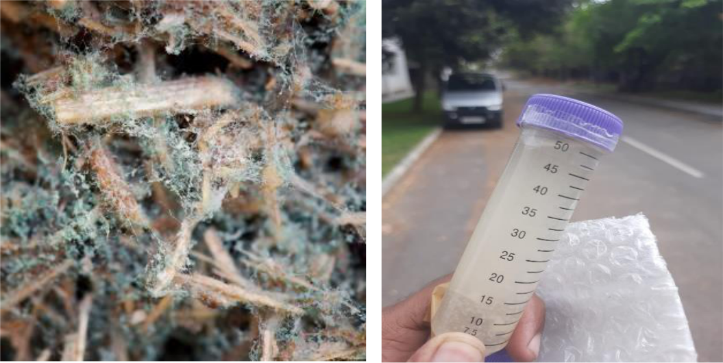

Fig. 3.3 Trichoderma Reesi Fungi

CHAPTER 4

MIXDESIGN

4.1 General

The process of selecting suitable ingredients of concrete and determining

their relative amounts with the objective of producing a concrete of the required,

strength, durability, and workability as economically as possible, is termed as

concrete mix design. The basic concept of a mix design is to select and proportion,

suitable materials as to provide a required strength and workability.

4.2 Requirements of Concrete Mix Design

The requirements which form the basis of selection and proportioning of mix ingredients are:

The minimum compressive strength required from structural consideration

• The adequate workability necessary for full compaction with the compacting equipment available.

- Maximum water-cement ratio and or maximum cement content to give adequate durability for the particular site conditions.

- Maximum cement content to avoid the shrinkage cracking due to temperature cycle in mass concrete.

4.3 Types Of Mix

4.3.1Nominal Mixes

In the past the specifications for concrete prescribed the proportions of cement,

fine and coarse aggregates. These mixes of fixed cement-aggregate ratio, which ensures

adequate strength, are termed nominal mixes. These offer simplicities and under normal

circumstances, have a margin of strength above that specified. However, due to the

variability of mix ingredients the nominal concrete for a given workability varies widely

in strength.

4.3.2 Standard Mixes

The nominal mixes of fixed cement-aggregate ratio (by volume) vary widely in

strength and may result in under- or over – rich mixes. For this reason, e minimum

compressive strength has been included in many specifications. These mixes are termed

4.3.3 Designed Mixes

In these mixes the performance of the concrete is specified by the designer but the mix proportions are determined by the producer of concrete, except that the minimum cement content can be laid down. This is most rational approach to the selection of mix proportions with specific materials in mind possessing more or less unique characteristics. However, the designed mix does not serve as a guide since this does not guarantee the correct mix proportions for the prescribed performance.

For the concrete with undemanding performance nominal or standard mixes (prescribed in the codes by quantities of dry ingredients per cubic meter and by slump) may be used only for very small jobs, when the 28-day strength of concrete does not exceed 20 N/mm². No control testing is necessary reliance being placed on the masses of the ingredients.

4.3 Types Of Mix Design

- ACI mix design method

- British mix design method

- Mix design method according to Indian standard recommended guidelines for concrete mix design.

4.4 Factors Affecting The Choice Of Mix Proportion

4.4.1Workability

The degree of workability required depends on three factors. These are the size of the section to be concreted, the amount of reinforcement, and the method of compaction to be used. For the narrow and complicated section with numerous corners or inaccessible parts, the concrete must have a high workability so that full compaction can be achieved with a reasonable amount of effort. This also applies to the embedded steel sections. The desired workability depends on the compacting equipment available at the site.

4.4.2 Durability

The durability of concrete is its resistance to the aggressive environmental conditions. High strength concrete is generally more durable than low strength concrete. In the situations when the high strength is not necessary but the conditions of exposure are such that high durability is vital, the durability requirement will determine the water-cement ratio to be used.

4.4.3 Maximum Nominal Size Of Aggregate

In general, larger the maximum size of aggregate, smaller is the cement requirement for a particular water-cement ratio, because the workability of concrete increases with increase in maximum size of the aggregate. However, the compressive strength tends to increase with the decrease in size of aggregate.

IS 456:2000 and IS 1343:1980 recommend that the nominal size of the aggregate should be as large as possible.

4.4.4 Quality Control

The degree of control can be estimated statistically by the variations in test results. The variation in strength results from the variation in the properties of the mix ingredients lack of accuracy in batching, mixing, placing, curing and testing. The lower the difference

between the mean and minimum strengths of the mix lower will be the cement-content.

Thefactor controlling this difference is termed as qualitycontrol.

4.5 Mix Proportion Designation

The common method of expressing the proportions of ingredients of a concrete mix is in the terms of parts or ratios of cement, fine and coarse aggregates. For e.g., a concrete mix of proportions 1:2:4 means that cement, fine and coarse aggregate are in the ratio 1:2:4 or the mix contains one part of cement, two parts of fine aggregate and four parts of coarse aggregate. The proportions are either by volume or by mass. The water- cement ratio is usually expressed in mass.

4.5.3 Factors To Be Considered For Mix Design

- Thegrade designation giving the characteristic strength requirement of concrete.

- The type of cement influences the rate of development of compressive strength of concrete.

- Maximum nominal sizeof aggregates to be used in concrete maybe as large as possible within the limits prescribed by IS 456:2000.

- Thecement content is to be limited from shrinkage, cracking and creep.

4.6 Mix Design For M20 Concrete By IS Method

W = weight of water

Sc = specific gravityof cement

Sfa = specific gravityof fine aggregate

P = % of corrected sand

- = (C/Sc + W + 1/ (1-p) x ca / Sca) x 1/1000 Where method of mix design is based on IS 10262: 2019

Step 1

For the required characteristics strength of concrete calculated the target mean strength using the equation

Target mean strength fck mean= fck + (t x s)

Where

fck is the required characteristic strength

S = standard deviation which is a factor based on quality on quality given table

t = a statistic depending upon the proportion of low results, available in table.

Step 2

For the calculated target mean strength, the water cement ratio was found as specified in table of IS 456:2000

Step 3

Estimate the amount of entrapped air to be inspected in the concrete based on the maximum size of coarse aggregate by referring to the table.

Step 4

Calculate the amount of mixing water per m³ of concrete and the % of sand from mix design table.

Step 5

If the condition of design is different for standard condition specified in mix design table suitable corrections are to be made as per table.

Step 6

From the chosen W/C ratio and the corrected water requirement, calculated the quantity of cement required. Checked this quantity against the minimum specified in table of IS 456:2000.

Step 7

With the known Value of water quality cement quality air content and sand % the required quantities of sand and coarse aggregate were calculated from the following equation.

Where

V

fa

Sca

V = (C/Sc + W + 1/P x fa / Sfa) x 1/1000

- Gross volume of concrete – the volume of entrapped airC

  - weight of cement

  - weight of fine aggregate Ca

  - weight of coarse aggregate

- specific gravity of coarse aggregate

From the above equation weight of coarse aggregate was found.

4.7 Mix Design Using IS Method

Data
Concrete grade | – M20
Degree of qualitycontrol | – Good
Type of exposure | – Mild
Size of aggregate | - 20 mm angular
Specific gravity of cement | – 3.15
Specific gravityof CA | – 2.8
Specific gravity of FA | – 2.7

Mix design of M20 grade concrete

The following steps are considered in the mix calculation of concrete as per IS 10262 and IS 456 code standard

Step 1: Calculation of target strength

Where S = standard deviation value it was considered from table 1 of IS 10262

The standard deviation value for M20 grade concrete mix is 4Target strength fck¹= fck+1.65S
- 20+1.65(4)
- 26.6 N/mm²

Step 2: selection of water cement ratio

The water cement ratio is taken from table number 5 of IS 456: 2000 code related to the exposure condition see in below table

For the moderate condition related to the plain concrete the value of water cementratio is 0.6

Based on the number of trials using concrete mix adopt the water cement ratio of 0.55

Here 0.55 < 0.6 hence it is safe.

Step 3: Selection of water content

The value of the water content is selected from table 2 of IS 10262 code book

The below specified water content is related to the various size of coarse aggregates

For the maximum size of 20mm

aggregates the value of water content is taken as 186 liters.

This water content is applicable for 25 to 50mm slump value and for every increase in 25mm slump value the water content is need to increase by 3%.

Here in this case the slump value is 100mm. The value of water content increased by

and final water content = 186+(6/100)186

=197.16 liters

Step 4: Calculation of cement content

For the available values of water content and water cement ratio we can easily determine the cement content.

W/C = 0.55,

Water content = 197.16

Cement = 197.16/W

- 197.16/0.55

- 358.47 kg/m3 < 450 kg/m3

Step 5: Proportion of volume of coarse aggregates and fine aggregates

The volume of coarse aggregates per unit volume of total aggregates values are initially considered from table 3 of IS 10262 code provisions related to the different fine aggregates zone condition

As per the zone II of 20 mm size aggregates

Volume of coarse aggregates per total aggregates = 0.62

Final Volume of coarse aggregates = 0.62-0.01

= 0.61

Volume of fine aggregates = 1-0.61

= 0.39

Step 6: Estimation of concrete mix calculation
Volume of total concrete = 1m³
Volume of cement = (Mass of cement / Specific gravity of cement) x (1/1000)

- (358.47/3.15) X (1/1000)
- 0.1138m³
Volume of water = (Mass of water / Specific gravity of water) x (1/1000)

- (197.16/1) X (1/1000)
- 0.19716m³
Total volume of aggregates = a-b-c

= 1- 0.1138-0.19716

= 0.68904m³
Mass of coarse aggregates = d X volume of coarse aggregates X specific gravity of coarse aggregates X 1000

- 0.68904X0.61X2.8X1000
- 1176.88 kg/m³

Mass of fine aggregates = d X volume of fine aggregates X specific gravity of fine aggregates X 1000

- 0.68904X0.3961X2.7X1000
- 736.90 kg/m³

Calculation of mix proportion
Cement | = 358.47 kg/m³
Fine aggregates | = 736.90 kg/m³
Coarse aggregates = 1176.88 kg/m³
Water = 197.16 kg/m³
Final mix of M20 grade concrete as per IS 10262 code

Mix ratio

Cement:

1

:

Fine aggregate:

2.055

:

Coarse aggregate

3.283

:

:

Water

0.55

Table 4.1 Mix Proportion for Concrete

SL. | Mix | Cement | FA | PPF | Fungi | CA | W/C
NO
NO |  | (kg/ ) | (kg/ ) | (%) | (ml) | (kg/ )
1 | CC | 358 | 737 | 0 | 0 | 1177 | 0.55
2 | SHFRC1 | 358 | 737 | 0.5 | 8 | 1177 | 0.55
3 | SHFRC 2 | 358 | 737 | 1 | 8 | 1177 | 0.55
4 | SHFRC 3 | 358 | 737 | 1.5 | 8 | 1177 | 0.55

CHAPTER 5

TEST ON FRESH CONCRETE, CASTING AND CURING OF
CONCRETE

5.1 Mixing

The following mix proportions were adopted. In addition to the various mix proportions listed in the table below, the conventional concrete specimens were also casted for comparing results. Mixing of concrete may be done by any one of the conventional methods of hand mixing (or) machine mixing External vibration may preferable to prevent segregation, the mixing was done by hand as the specimen mold was small and quantity of mix was less. Correct quantity of cement, sand, aggregate water, polypropylene fiber and trichoderma reesi required for batched were weighted accurately.

5.2 Casting

The concrete cubes of size 15cm x 15cm x 15cm, and the concrete cylinder of size 30cm x 15cm were casted in both conventional and also in, polypropylene fiber and trichoderma reesi. The full compaction of the concrete is filled into the molds in layers. After the top layer has been compacted the surface is brought to the finished level with the top of mold using a trowel.

5.3 Curing

The specimens are remolded after 24 hours. Necessary identification marks were made and kept under water in a curing tank. The concrete specimens were kept under water for 7 days, 14 days and 28 days. After curing, they were taken out from the curing tank and air dried before testing.

5.4 Workability of fresh concrete by Slump Test

5.4.1 Workability

Slump test is used to determine the workability of fresh concrete. Slump test as per IS: 1199 – 1959 is followed. The apparatus used for doing slump test are Slump cone and tamping rod.

Procedure to determine workability of fresh concrete by slump test

- The internal surface of the mould is thoroughly cleaned and applied with a light coat of oil. The mould is placed on a smooth, horizontal, rigid and nonabsorbentsurface.

- The mould is then filled in four layers with freshly mixed concrete, each approximately to one-fourth of the height of the mould.

- Each layer is tamped 25 times bythe rounded end of the tamping rod (strokes are distributed evenlyover the cross section).

- After the top layer is rodded, the concrete is struck off the level with a trowel.

- The mould is removed from the concrete immediately by raising it slowly in the vertical direction.

- The difference in level between the height of the mould and that of the highest point of the subsided concrete is measured.

- This difference in height in mm is the slump of the concrete.

RESULT

The slump value of fresh concrete = 25cm.
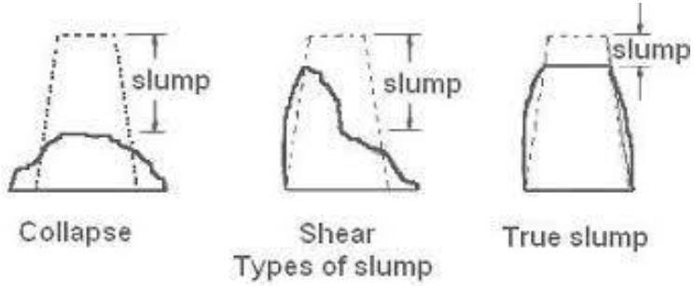

Fig. 5.1 Slump Test

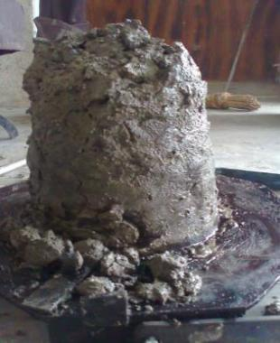

Fig. 5.2 Slump Concrete

Table 5.1 Relation between workability and slump

SL | Workability | Compaction factor | Slump(mm)
NO
1 | Very low | 0.78 | 0-25
2 | Low | 0.85 | 25-50
3 | Medium | 0.92 | 50-100
4 | High | 0.95 | 100-175

5.5 Compaction Factor Test

This test is also used to determine the workability of concrete.

The apparatus consists of the first hoppers and a cylinder. The firs hopper has a top diameter of 25.4cm, bottom diameter of 12.7cm, and an internal height of 27.9cm.

The second hopper has a top diameter of 22.9cm, bottom diameter of 12.7cm and an internal height of 22.9cm. The cylinder has an internal diameter of 15.2cm and height of30.5cm.

The distance between the two hoppers and between the lower hopper and cylinder is 20cm.The concrete sample to be tested is first placed in the top hopper. The trapdoor is opened and concrete is allowed to fall to the lower hopper.

Similarly, from the lower hopper, concrete is allowed to fall into the cylinder below.

Now the cylinder is weighed and the weight is called as weight of partially compacted concrete.

Compaction factor = Weight of partially compacted concrete Weight of fully compacted concrete

= 0.80

RESULT:

The compaction factor value of control concrete is 0.80.

5.6 Casting and Curing of Specimen

Mix the concrete ingredients thoroughly in a concrete mixer, adding water gradually to achieve the desired consistency. Polypropylene fibers (PPF) is added at the percentage of 0.5%, 1%, 1.5% to the concrete mix and thoroughly mixed for at least 5 minutes to ensure proper dispersion. 8ml of fungi is added to the concrete mix and mixed thoroughly for at least 5 minutes. Fill the molds or formwork for the cylinders and cubes with the concrete, using a vibrator to consolidate the concrete and remove any air pockets. Smooth the surface of the concrete with a trowel and cover the molds or formwork with plastic sheets to prevent the concrete from drying out too quickly. After casting, leave the molds or formwork undisturbed for at least 24 hours to allow the concrete to set. After 24 hours, remove the molds or formwork and place the cylinders and cubes in a curing tank filled with water, keeping them submerged for a minimum of 7 days. Maintain the water temperature in the curing tank between 20°C and 30°C throughout the curing period to ensure proper hydration of the concrete. Change the water in the curing tank every 2 days to prevent the buildup of contaminants in the water. After 7 days of curing, remove the cylinders and cubes from the curing tank and allow them to dry in air for a few hours. Test the compressive strength of the cylinders and cubes using a compression testing machine, following the standard testing procedures.. All the moulds were oiled before casting the specimens. Cube specimens of size 150 mm x 150 mm x 150 mm of each concrete mixture were cast to determine the 7,14,28 days compressive strength. Cylindrical specimens of size 150 mm x 300 mm were cast to measure the split tensile strength of concrete.

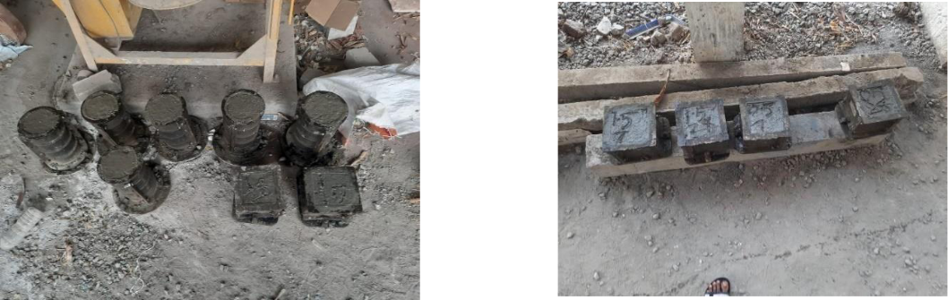

Fig. 5.3 a) Casting of concrete specimen b) Casting of concrete specimen
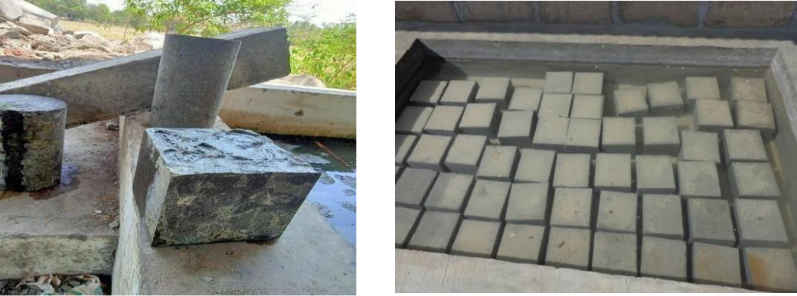

Fig. 5.4 Curing of concrete specimen

CHAPTER 6

RESULT AND DISCUSSION OF HARDENED
CONCRETE

6.1 General

Testing of hardened concrete plays an important role in controlling and confirming the quality of cement concrete works. Systematic testing of raw materials, fresh concrete and hardened concrete are inseparable part of any quality control program of concrete, which helps to achieve higher efficiency of the material used and greater assurance of the performance of the concrete with regard to both strength and durability. The test method should be simple, direct, and convenient to apply.

One of the purposes of testing hardened concrete is to confirm that the concrete

used at site has developed the required strength. Tests are made by casting cubes or cylinders from the representative concrete or cores cut from the actual concrete. It is to be remembered that the standard compressive strength specimens give a measure of the potential strength of the concrete, and not of the strength of the concrete in the structure.

The tests carried out on the hardened concrete specimens are divided into three categories, namely:

- Strength Tests

6.2 Strength tests

The strength tests carried out on hardened concrete specimens are:

- Compression test

- Split tensile test

6.2.1 Compression Test

Compression test is the most common test conducted on concrete, partly because it is easy to perform and partly because most of the desirable characteristic properties of concrete are qualitativelyrelated to its compressive strength.

The compressive strength is the maximum stress that, under a gradually applied compressive load, a given solid material can sustain without fracture. For compressive strength test the cubes are casted with dimension of 150mm X 150mm X 150mm. They are carried out according to IS 516-1959. After 24 hours the specimens were stored in a curing tank for 28 days. The cubes were tested in compression testing machine up to sustain without fracture and the load was noted. Compressive strength of all mixes increased with all ages

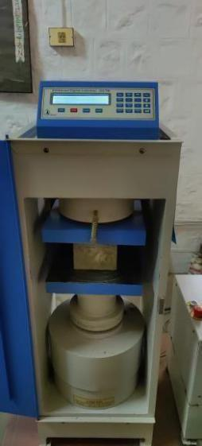

Fig.6.1. Compression Test

Compressive strength of the cube = |  |  |  | Maximum Load Applied
 |  |  | Cross sectional area of the cube
Table 6.1Compressive strength result of SHFRC 7, 14 &28days
 |  | Compressive strength test
Mix | CURING |  |  |  | result |  |  | AVERAGE
Mix | DAYS |  |  |  | (N/mm²) |  |  | STRENGTH
 |  | Specimen |  |  | Specimen | Specimen
 |  | I |  |  | II | III
 | 7 days | 14.23 |  |  | 14.68 | 13.88 |  | 14.26
CC | 14 | 16.16 |  |  | 17.48 | 17.78 |  | 17.14
CC | days
 | 28 | 19.88 |  |  | 20.52 | 20.72 |  | 20.37
 | days
 | 7 days | 14.05 |  |  | 14.32 | 15.08 |  | 14.48
SHFRC I | 14 | 16.32 |  |  | 17.56 | 17.68 |  | 17.18
SHFRC I | days
 | 28 | 18.96 |  |  | 19.06 | 19.32 |  | 19.11
 | days
 | 7 days |  | 15.2 |  | 15.62 | 16.11 |  | 15.65
SHFRC II | 14 | 19.92 |  |  | 18.56 | 19.33 |  | 19.27
SHFRC II | days
 | 28 | 21.17 |  |  | 20.86 | 21.39 |  | 21.17
 | days
 | 7 days | 16.18 |  |  | 17.12 | 17.24 |  | 16.87
 | 14 | 19.12 |  |  | 20.04 | 20.18 |  | 19.78
SHFRC III | days
SHFRC III | 28 | 22.36 |  |  | 23.45 | 22.68 |  | 22.83
 | days

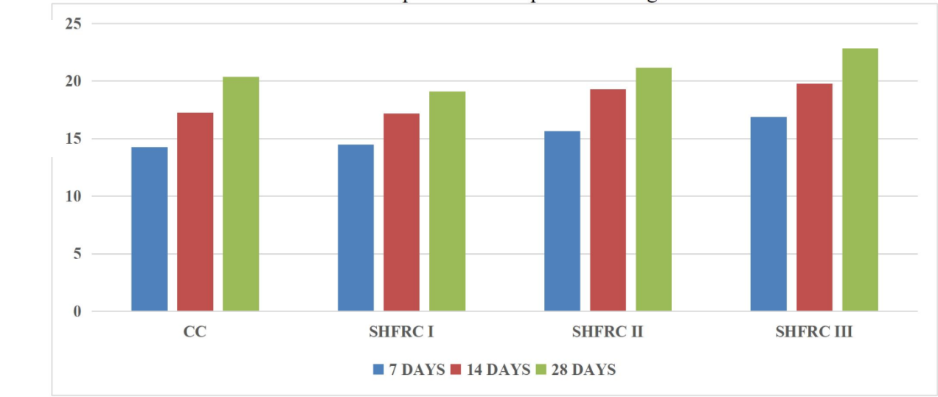

2)
mm 2

(N/m
(N
StrengthCompressive Mix

Fig. 6.2 Compressive strength

- Fig 7.2, compressive strength of SHFRC I,II,III is improved when compared to Conventional Concrete(CC) of 7,14 and 28 days.

- Table 7.1 and Fig 7.2 shows the compressive strength of Conventional Concrete (CC) and SHFRC of 7,14 and 28 days.

- Table 7.1 and Fig. 7.2 concludes that SHFRC II& III has improved in compressive strength when compared to Conventional Concrete(CC).

6.2.2 Split Tensile Strength

Concrete is strong in compression, but it is weak in tension. The low tensile strength

is due to the presence of numerous micro cracks. These micro cracks further propagate

under load and result in result in low strength of concrete. The split tensile test is an

indirect method for determining the tensile strength of concrete. This tests are carried out IS

516 & IS 5816-1999. The testing cylinders are of 150mm diameter and 300mm height

which is tested in compression testing machine, the specimens are placed in horizontally

between the loading surface and the load applied until failure the cylinder, along the vertical

diameter. For the split tensile test, the cylindrical mould is casted and stored in a curing tank

for 28 days. The cylinders were tested in compression testing machine as shown in fig7.2,

until failure and the load was noted.

Split tensile strength = 2P

πDL

D = diameter of the specimen.

P = maximum load applied to the specimen in Newton, L = length of the specimen,

Table 6.2 splittensile strength result of SFHRCat 7, 14 & 28
days

Mix | CURING | Split tensile strength test result |  |  |  | AVERAGE
Mix | CURING |  | (N/mm²) |  |  | AVERAGE
Mix | DAYS |  |  |  |  | STRENGTH
 | DAYS | Specimen | Specimen |  | Specimen | STRENGTH
 |  | I | II |  | III
 | 7 days | 12.22 | 12.85 |  | 13.18 | 12.75
CC | 14 days | 15.13 | 15.42 |  | 16.11 | 15.55
 | 28 days | 20.2 | 20.52 |  | 21.18 | 20.63
 | 7 days | 13.21 | 13.32 |  | 14.08 | 13.53
SHFRC I | 14 days | 16.82 | 17.12 |  | 17.64 | 17.19
 | 28 days | 22.05 | 22.78 |  | 23.16 | 22.66
 | 7 days | 15.08 | 15.47 |  | 16.11 | 15.55
SHFRC II | 14 days | 17.22 | 18.76 |  | 19.22 | 18.4
 | 28 days | 22.45 | 23.55 |  | 24.04 | 23.34
 | 7 days | 15.85 | 16.12 |  | 16.64 | 16.20
SHFRC III
SHFRC III | 14 days | 19.35 | 20.04 |  | 20.18 | 19.95
 | 28 days | 23.21 | 23.62 |  | 24.12 | 23.65
S
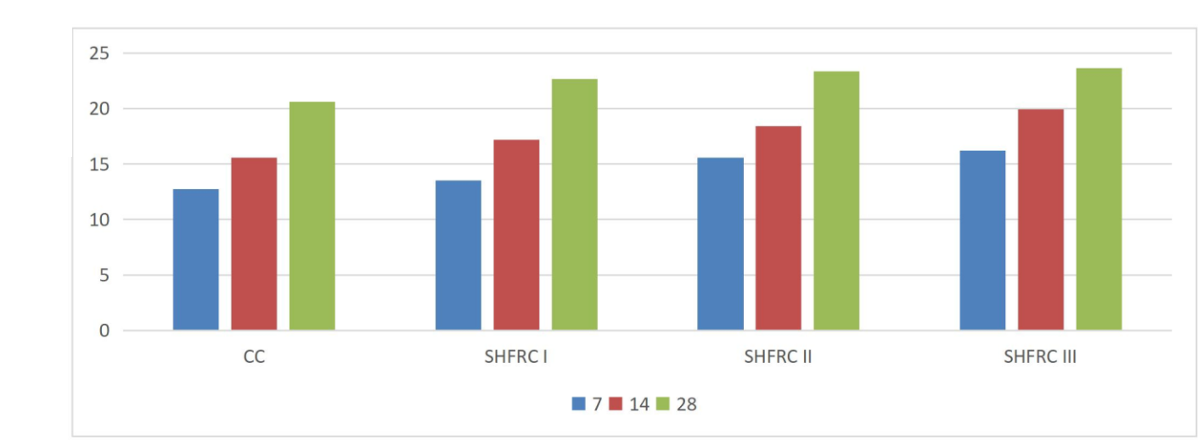

2)
mm ₂

Strengthm (N
TensileSplit

Mix

Fig. 6.3 Split Tensile Strength

- Fig 7.3, Split tensile strength of SHFRC I,II,III is improved when compared to Conventional Concrete(CC) of 7,14 and 28 days.

- Table 7.2 and Fig 7.3 shows the Split tensile strength of Conventional Concrete (CC) and SHFRC of 7,14 and 28 days.

- Table 7.2 and Fig. 7.3 concludes that SHFRC II& III has improved in Split tensile strength when compared to Conventional Concrete (CC).

6.3 Detailed discussion on Self-Healing fiber Reinforced Concrete (SHFRC)Enhanced Self-Healing Properties: The incorporation of trichoderma reesi, a beneficial fungus known for its ability to produce enzymes that promote self-healing, into the concrete mix can lead to improved self-healing properties. The enzymes produced by trichoderma reesi can help trigger the formation of calcium carbonate, which can fill cracks and voids in the concrete, leading to self-healing of small cracks and improving the durability of the material.

Increased Tensile Strength: Polypropylene fibers are known for their high tensile strength and can act as reinforcement in concrete. The addition of polypropylene fibers to the bio-based self-healing concrete mix can potentially increase the tensile strength of the material, making it more resistant to cracking and improving its overall mechanical properties.

Reduced Crack Width and Propagation: The combination of trichoderma reesi and polypropylene fibers in the concrete mix may lead to a reduction in crack width and propagation. The self-healing properties of trichoderma reesi and the reinforcing effect of polypropylene fibers can work together to minimize the propagation of cracks, limiting the potential for further damage and extending the service life of the concrete structure.

Optimal Dosage and Mixing Ratios: Experimental conclusions may also include determining the optimal dosage and mixing ratios of trichoderma reesi and polypropylene fibers in the concrete mix to achieve the best results. This may involve conducting a series of tests with varying concentrations of trichoderma reesi and polypropylene fibers to determine the most effective combination for maximizing the self-healing and mechanical properties of the concrete.

- Self-healing occurs if the crack size is less than 0.8 mm; otherwise, self-healing of the concrete is not possible.

- This crack is 0.7mm in width and has been under observation for 22 days during which self-healing stages was observed.

Before Self-healing After Self-healing
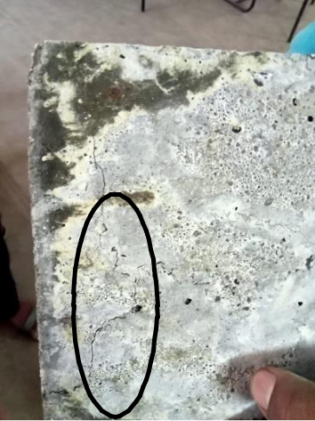
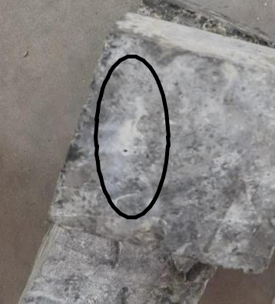

Fig 6.2 Crack Size – 0.7 mm Fig 6.3 Self healed Crack

- Within 28 days, a small amount of self-healing was seen on the concrete (Cube).

- Fig 7.2 shows that the crack before healing of concrete and the crack size is 0.7mm.

- Fig 7.3 shows that the healing of crack after 28 days. Here, the crack is filled with the precipitation of CaCO3.

CHAPTER 8

CONCLUSION

In recent years, the development of sustainable and resilient construction materials has gained significant attention in the field of civil engineering. Bio-based self-healing concrete, which incorporates biological agents such as Trichoderma reesei along with reinforcing fibers like polypropylene, has emerged as an innovative solution with the potential to enhance the durability and longevity of concrete structures. The experimental analysis conducted in this study has demonstrated promising results in terms of the strength properties of bio-based self-healing concrete. The addition of Trichoderma reesei, a naturally occurring fungus known for its self-healing properties, has facilitated crack regeneration in the concrete, thereby improving its resistance to cracking and enhancing its durability. The presence of polypropylene fibers has further reinforced the concrete, improving its mechanical properties, such as tensile strength and toughness. The combination of Trichoderma reesei and polypropylene fibers has synergistically contributed to the overall performance of the bio-based self-healing concrete, making it a promising material for sustainable construction practices.
The addiction of Trichoderma ressei fungi improved the healing of concrete

. Trichoderma ressei spores are remain dormant until they contact with the water it once it contact with water it triggers the activation and growth .As the fungus grows, it produces cellulose, which breaks down cellulose in the fungal cell walls, allowing the fungus to use the released nutrients to grow and produce calcium carbonate crystals. This calcium carbonate crystals healed the crack.

REFERENCE

- D.Y. Yoo, et al.,(2020) Assessment of steel fiber corrosion in self-healed ultra- high-performance fiber- reinforced concrete and its effect on tensile performance. Cement and Concrete Research volume 133

- IS: 2386-1963 (part 1& III). "Method of test for Aggregates in concrete", Bureau of Indian Standards, New Delhi.

- BIS: 383-1970, "Specification for coarse and fine aggregates from natural sources for concrete", Bureau of Indian Standards, New Delhi

- BIS: 10262-2009, "Concrete mix proportioning -Guidelines", Bureau of IndianStandards, New Delhi

- IS: 456-2000, ―Code of practice for plain and reinforced concrete‖, Bureau of Indian Standards, New Delhi.

- DOM, A., &Juki, I.,(2022) The Effect of Fungus on Concrete as Self-Healing Agent Cement and Concrete Research volume 158

- K. Suresh,V.Padmavathi, Apsar Sultana.,(2020) Experimental study on polypropylene fiber with Trichoderma reecei

- Sakina Najmuddin Saifee, Divya Maheshbhai Lad, Jayesh Rameshbhai Juremalani.(2015) Critical appraisal on Bacterial Concrete, IJRDO-Journal of Mechanical And Civil Engineering, ISSN: 2456-1479, Volume-1, PP 10-14

- Meera C.M and Dr. Subha V.,(2016) Strength, and Durability assessment Of Bacteria Based Self-Healing Concrete IOSR Journal of Mechanical and Civil Engineering- ISSN: 2278- 1684, PP

- Ravindranatha,N.Kannan and Likhit M.L.,(2019) Self-healing material bacterial concrete, International Journal of Research in Engineering and Technology, Volume:03, SpecialIssue:03, May-2014, NCRIET-2014, PP656-659

- A.T. Manikandan and A. Padmavathi.,(2017) An Experimental Investigation on improvement of Concrete Serviceability by using Bacterial Mineral PrecipitationVolume II, Issue III,March 2015 IJRSI

- Jagadeesha Kumar B G, R Prabhakara and Pushpa H., (2012) Effect of Bacterial Calcite Precipitation On Compressive Strength Of Mortar Cube, International Journal of Engineering and Advanced Technology (IJEAT), ISSN: 2249 – 8958, Volume-2, Issue-3,February2013, PP 486-491

