EXPERIMENTAL INVESTIGATION ON STRENGTH PROPERTIES OF HYBRID CONCRETE USING JUTE FIBRE AND COIR FIBRE.
Ms. S.KARTHIKA¹, V.BRAGADESHWARAN², P.PRAVEEN³, R.SABARINATHAN⁴,R.VISHNU⁵
Assistant Professor, Department of Civil Engineering¹
UG Students, Department of Civil Engineering^{2,3,4,5}
Anjalai Ammal Mahalingam Engineering College, Kovilvenni, Tiruvarur, Tamil Nadu, India
Affiliated to Anna University
ABSTRACT: The main objective of the Project is to determine the Compressive Strength, Split Tensile Strength and Flexural Strength by adding the fibers to the concrete. Fiber Reinforced concrete is a concrete containing fibrous material which increases the structural integrity. It contains short discrete fibers that are uniformly distributed and randomly oriented. Fibers include coir fibers & jute fibers. The main purpose of adding fibers in concrete is to resist from cracking. Due to the adding of fibers in concrete the freezing and thawing resistance is improved. In this project coir fibers and jute fibers are mixed in various proportions of concrete. coir fibers percentage is 0.1, 0.2% &0.3% and jute fiber percentage is 0.1%, 0.2% & 0.3% using M20 Grade of concrete. The test reveals that the workability and strength of the concrete are slightly better than the Conventional Concrete.
Key words: Fibre reinforced concrete ,Hybrid,coir fibre ,Jute fibre.

I.INTRODUCTION
Concrete is widely recognized as a cost-effective, versatile construction material. But it is also covered with a number of drawbacks that are inherent to its composition. By generally accepted engineering standards, concrete is relatively brittle and lacks flexural strength. Intertwined with these problems is concrete's propensity to crack in both its plastic (early-age) and hardened (long- term) state. Early-age cracks are microscopic fissures caused by the intrinsic stresses created when the concrete settles and shrinks over the first 24 hours after being placed. Long-term cracking is in part caused by the shrinkage that transpires over the months or years, of drying that follow. The demand for high strength, crack resistant and lighter concrete resulted in development of liber reinforced concrete.
Literature Review
A. Zuraid et al., (2011) [1] evaluates the effect of fibre length on mechanical and physical properties of coconut fibre-enhanced albumin cement compounds. The albumin protein was added as a binder, and 2.5, 5, 10 and 20mm long coconut fibres (control cement composite) were used as a partial replacement for the cement mixture. Resistance to bending, compression, apparent density, moisture content and water absorption were tested. Experimental studies have shown that increasing the fibre length increases the bending strength. However, the inclusion of long fibres in the cement slurry reduces processability and thus introduces low density pores. In fact, this in turn increases the water absorption capacity and moisture content.
Sahaya Ruben et al., (2014) [2] they studied the behaviour of natural fibres in concrete structures. Recently Coconut fibre received an attention as a durable fibre-based composite based on the comparison of certain unique mechanical properties of rayon. Coconut fibre is treated with natural latex before it is used in concrete, so the moisture content of the concrete does not affect it. In this 28-day experimental study, compressive strength and tensile strength were achieved with different percentages (e.g., 0.5%) using coconut fibres of different lengths (20 mm, 25 mm, and 30 mm, respectively). 0.75% and 1%. They also depicted that natural fibres should be encouraged in civil engineering as it is locally available materials.
Abdul Nazeer et al., (2014) [3] they studied the mechanical behavior of the coconut fibre of different lengths (5 mm, 10 mm, 15 mm) reinforced with epoxy resin during 5% NaOH fibre treatment. All samples were made by hand placement and samples were prepared in accordance with ASTM D3039. Samples were analysed according to ASTM D3039 using a Universal Test Machine (UTM). Important research results indicate that NaOH treatment improves the tensile properties, ductility and hardness of the compound. It has been found that an increase in fibre length increases tensile strength. Coconut fibres of 15 mm in length were found to have maximum tensile strength.
Rajan Shikha et al., (2015) [4] they studied the behavioural research on coconut fibre in concrete structures. The addition of coconut fibre to concrete improves several technical properties of concrete. Because it has good adhesion properties in concrete. Before using the coconut fibre in concrete it is treated using natural latex. Therefore, the moisture of the concrete does not affect it. Adding coconut fibre can increase the compression, bending and tensile strength of concrete. The study showed an optimum fibre content of 1% to 2% to 3% by weight of cement. For M25 and M30 grade concrete cubes, the compressive strength was evaluated for 7 days, 14 days and 28 days. These results indicate that coconut and coconut concerts can be used for construction as it provides better Western fibre management as coconut fibre, and it is also organic.
III. MATERIAL USED
The various materials used in the preparation of concrete are as follows.
1. Cement.
2. Coarse Aggregate.
3. Fine Aggregate.
4. Coir fibre
5. jute fibre
6. Water.
IV. EXPERIMENTAL PROGRAMME
♦ Mix Design
To investigate the strength and durability of coir fibre jute fibre on the properties of conventional concrete the mix design is done according to 10262-2019. Strength properties of M25 grade concrete were studied.
♦ Casting of test specimen
In present study the specimen of standard cubes of size 150 X 150 X 150mm and 150mm x 300mm, 100mm x 50mm cylinders were used casted. The specimens were tested after 28 days of curing.
1) Mixing
Measured quantities of coarse aggregate and fine aggregate were spread over an impervious concrete floor. The dry PPC were spread out on the aggregate and mixed thoroughly in dry state turning the mixture over and over until the uniformity of color was achieved. Water was measured exactly and it was thoroughly mixed to obtain homogenous concrete. The mixing shall be done for 10 to 15 minutes.
2) Placing and Compacting
The cube moulds are cleaned and all care is taken to avoid irregular dimensions. The mix was placed in 3 layers and the layer was contacted using table vibrator to obtain dense concrete.
3) Curing
The test specimens were stored in a place free from vibration in moist air at 90% relative humidity and at temperature of 27+/ for 24 ½ hours from the time of addition of water to dry ingredients. After 24 hours the specimens are demolded and immediately immersed in clean, fresh water tank for 28 days.
4) Testing
All the tests performed are as per IS specification. After 28 days the specimens are taken for the test. Sorpivity of the modified concrete for the Durability of the concrete. compressive Strength of the modified concrete for the strength of the concrete.
V. PROCEDURE FOR PREPARATION OF CONCRETE
1. Samples are to be prepare by adopting 0.2%, 0.4% and 0.6% adding of coir fibre and jute fibre.
2. Cube samples of size 150mm x 150mm x 150mm are to be prepare for testing of Compressive strength of concrete for 28 days.
3. Durability of cement is measured by finding the % weight losses on each testing days and noted.
4. All the materials used to be prepared the samples are as per IS specifications.
5. All the tests performed are as per IS specification.
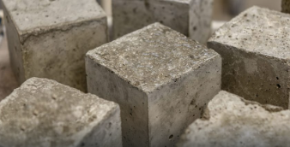
CONCRETE CUBE
VI. EXPERIMENTAL ANALYSIS
1. Compressive Strength Test: Compressive strength of concrete is important property of concrete. The other properties of concrete have definite relationship with the compressive strength. If the compressive strength of concrete is improved there is an improvement in other properties of concrete also, therefore compressive strength is an essential test.Compressive strength of concrete also depends on size of specimen, the height of test specimen is releated to its lateral dimensions has great influence on strength test. The slenderer the specimen lower will be the crushing strength value. Therefore, two types of standard test specimens that is cubes and cylinders are used in this study.
Compressive strength=load/area N/mm²
Apparatus: Compression testing machine,
Preparation of cubes of dimensions: 15cm x 15cm x 15cm.
Procedure:
❖ Concrete mix is design for M25 grade as per IS standards and the proportions are indicated in the observation.
❖ Calculate the material required for cubes using the concrete of proportion 1.1:1.6:2.57 by mass and water to cement ratio 0.5
❖ Take Coarse Aggregate, Fine aggregate, cement, water, coir fibre and jute fibrein required quantity and mix it thoroughly.
❖ Apply oil uniformly to the inside of the moulds on all the surfaces.
❖ If mixing is by hand the cement and the fine aggregate shall be mixed dry to the uniform colour and then the coarse aggregate is to be added, mix until the coarse aggregate is uniformly distributed. Now water shall be added and whole mix is mixed until the resulting concrete is uniform.
❖ Fill concrete in cube moulds in 3 layers each of approximately 75mm and ramming each layer with 25 blows evenly distributed over the surface.
❖ Stike off the excess concrete with a straight metal edge flash with top of the moulds.
Curing:
After 24hrs of casting specimens are capped by neat cement paste of 35% water content on the capping apparatus. After another 24hrs specimens are immersed in water for final curing. Specimens are removed from the mould after 24hrs and cured in water for 28 days. Temperature of curing must be maintained 27’C and water should be periodically changed.
Testing:
• Compressive strength of cube specimens is made as soon as practicable after removing from the curing pit.
• Size of the test specimen is determined by averaging perpendicular dimensions at least at two places.
• Determine the mass of each specimen.
• Place the specimen centrally on the compressive testing machine and load is applied continuously and uniformly.
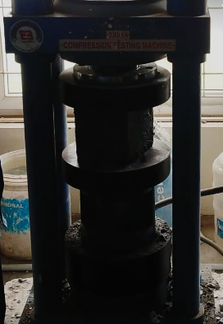
Fig 1.Compressive strength test of concrete cube specimen
• The rate of loading is controlled through central value by hand two 14 N/mm² /min.
• The load is increased until the specimen fails and record the maximum load.
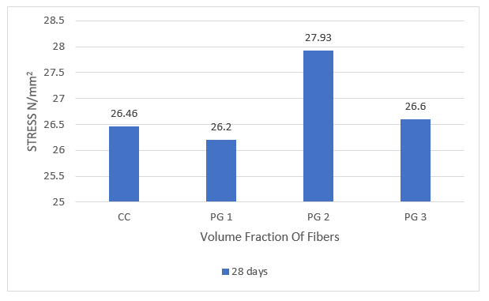
Compressive strength

2. Tensile Strength Test: The tensile strength is one of the basic and important property of concrete. The concrete is not usually expected to resist the direct tension because of its low tensile strength and brittle nature. In the design of structure concrete is exploited so as not to relay on its tensile strength which is low. Split tensile strength for split tensile strength of concrete, 150mm x 300mm cylinders were used. The split tensile strength on cylinder were conducted on a computerized 22 compressive testing machine of capacity 3000KN.The method covers the determination of the splitting tensile strength of cylindrical concrete specimens. This method consists of applying a diametral compressive force along the length of a cylindrical specimen. This loading induces tensile stresses on the plane containing the applied load. Tensile failure occurs rather than compressive failure. Plywood strips are used so that the load is applied uniformly along the length of the cylinder. The maximum load is divided by appropriate geometrical factors to obtain the splitting tensile strength.
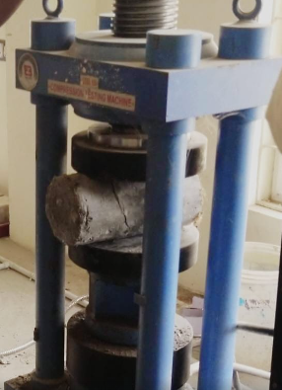
Fig 2.Testing of cylinder specimen for split tensile strength

Procedure:
❖ Concrete mix is design for M25 grade as per IS standards and the proportions are indicated in the observation.
❖ Calculate the material required for cylinders using the concrete of proportion 1.1:1.6:2.57 by mass and water to cement ratio 0.5.
❖ Take Coarse Aggregate, Fine aggregate, cement, water, crimped steel fibre and Nano silica in required quantity and mix it thoroughly.
❖ Caste minimum three cylindrical specimen for each age (28days).
❖ Place the cylindrical concrete specimen for curing.
Curing:
After 24hrs of casting specimens are capped by neat cement paste of 35% water content on the capping apparatus. After another 24hrs specimens are immersed in water for final curing. Specimens are removed from the mould after 24hrs and cured in water for 28 days. Temperature of curing must be maintained 27’C and water should be periodically changed. After that the concrete cubes were immersed in containers containing acidic solutions for 28 days.
Testing:
❖ After 28 days of curing place the cylinders platens on testing machine
❖ Apply the load gradually at the rate of 1.4 N/mm2 per minute until the failure.
❖ Note down the maximum load applied as tensile strength.Split Tensile Strength of Cylinder = 2p/¶DL N/mm²
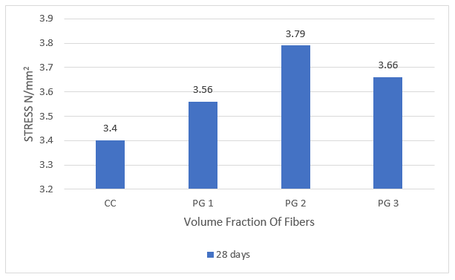 Split tensile test
3. Flexural Strength Test: The prisms were cast with the above mix proportion and tested for 28days strength. Also specimens were cast with coarse aggregate replacement by e-waste in various percentages and tested. The test results are shown in bar chat.
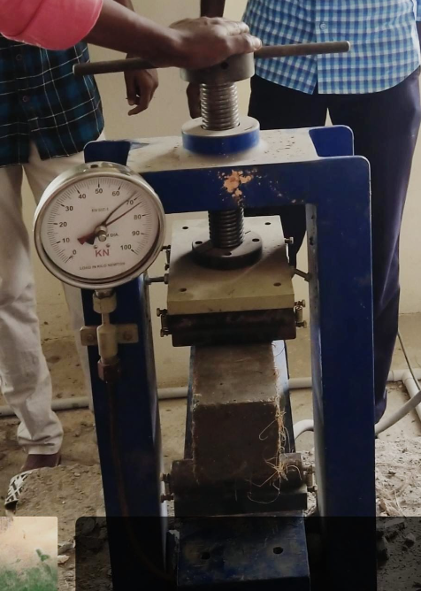
Fig 3.Flexural strength test of prism specimen
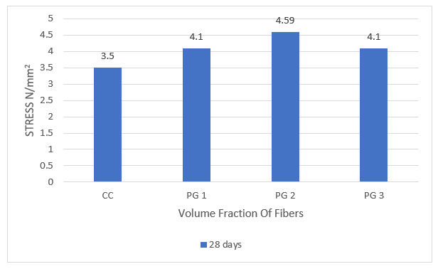 Flexural strength test
VIII.CONCLUSION
The compressive strength of concrete primarily improved up to 0.2% of coir fibre and jute fibre 0.2% with additional increase in coir fibre and jute fibre content the compressive strength of concrete decreases. Concrete containing inferior percentages (0.6%) of coir fibre and jute fibre possess higher values of compressive strength than that of controlled concrete. A considerable increase split tensile strength of of coir fibre and jute fibre concrete was observed associated to precise concrete. Based on the experimental grades, usage of coir fibre and jute fibre in small measures is beneficial on the presentation of concrete. of coir fibre and jute fibre added in small amounts can expand the strength. It can also be decided that the permeability of concrete decreases with the increase in the percentage of coir fibre up to 0.6% due to the effect of coir fibre filling and jute fibre the vacuums in concrete. Strong and rigid is jute fibre improving concrete, have the ability to enhance the brittle cementitious material, improved in the crack part after while more flexible continuing the heat, deformability for an extended period of time through to toughness and has a property to postponement the early cracking. Oxidizing radiation resistance, fracture energy, high wear resistance. It can hold increased compressive strength, splitting tensile strength, with the toughness properties of the three since the concrete exhibit excellent mechanical properties including the flexural strength initial the cracks in the bridge stage, it can improve the resonant capacity of the structure and structural stiffness, impact, can improve the fatigue strength and wear. The high-volume fraction in order to improve the mechanical properties of the composite fibres, that is proportional to, but larger than 0.6%, suggests that may affect the workability of the concrete.
REFERENCES:
1)M.S.SHETTY,,-"CONCRETE TECHNOLOGY".
2) M.L.V. Prasad and P.Rathish Kumar, "Comparative Study of Glass andPolypropylene Fiber Reinforced Self Compacting Concrete(FRSCC)", National Conference on Emerging Trends in Civil Engineering for Infrastructure Development (ETC-ID 2008), Raipur, February-2008.
3) Upendra Varma and A.D. Kumar (2013), "Glass Fiber Reinforced Concrete", International Journal of Engineering Research and Applications, Vol. 3, Issue 5, pp.1914-1918.
4) Manav Mittal, Deependra Singh and Aditya Dhagat, "Effect of Polypropylene Fiber, Steel Fiber & Glass Fiber on Properties of Concrete", International Journal of Civil Engineering & Technology (UCIET), Volume 4, Issue 4, 2013, pp. 163 169, ISSN Print: 0976 - 6308, ISSN Online: 0976-6316.
5) Zheng Z, Feldman D, Synthetic fiber-reinforced concrete, Progr Polymer Sci, vol 20, No3,pp185-210,1995.
6) IS 456:2000, "Code of Practice for Plain and Reinforced Concrete",Bureau of Indian Standards, New Delhi, India.
7) IS 10262:2009, "Recommended Guidelines for Concrete Mix Design",Bureau of Indian Standards, New Delhi, India
8) IS:383-1970 "Specification for Coarse & Fine aggregates from natural resources"
9) IS: 516-1959 "Methods of tests for strength of concrete". 10) IS: 5816 "Method of test for splitting tensile strength".

