A RESEARCH ON
L.A.S.E.R TECHNOLOGY

CONTENTS

Sr.no | Topic/Title | Pg.no
1 | Introduction to LASER
2 | Invention of LASER
3 | Characteristics of LASER
4 | Types of LASER
5 | Application of LASER
6 | Disadvantages of LASER

INTRODUCTION TO LASER
The letters in the word laser stand for Light Amplification by Stimulated Emission of Radiation. A laser is an unusual light source. It is quite different from a light bulb or a flash light. Lasers produce a very narrow beam of light. This type of light is useful for lots of technologies and instruments—even some that you might use at home.

How does LASER work
Light travels in waves, and the distance between the peaks of a wave is called the wavelength.
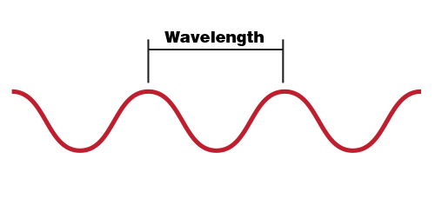
Each colour of light has a different wavelength. For example, blue light has a shorter wavelength than red light. Sunlight—and the typical light from a lightbulb—is made up of light with many different wavelengths. Our eyes see this mixture of wavelengths as white light.

A laser is different. Lasers do not occur in nature. However, we have figured ways to artificially create this special type of light. Lasers produce a narrow beam of light in which all of the light waves have very similar wavelengths. The laser’s light waves travel together with their peaks all lined up, or in phase. This is why laser beams are very narrow, very bright, and can be focused into a very tiny spot.

Because laser light stays focused and does not spread out much (like a flashlight would), laser beams can travel very long distances. They can also concentrate a lot of energy on a very small area.

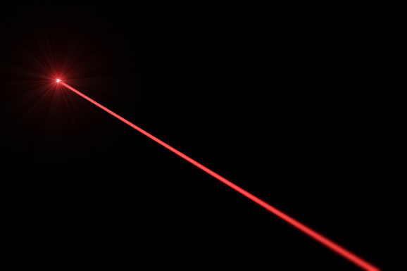

WHO INVENTED LASER AND WHY
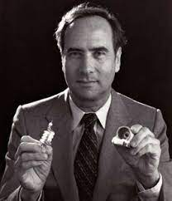
Theodore H. Maiman is credited with creating the laser (Light Amplification by Stimulated Emission of Radiation). In 1960, while employed at Hughes Research Laboratories in California, he created the first functional laser.

It's crucial to remember that prior to Maiman's discovery, other scientists and researchers had already laid the foundation for the laser. For instance, in his 1917 publication, Albert Einstein set the groundwork for the theory of stimulated emission, which is a crucial idea behind how lasers work. Later, the laser was developed with the help of other scientists and engineers, including Gordon Gould, Arthur L. Schawlow, and Charles H. Townes.

The ambition to produce a new, potent source of coherent light and scientific curiosity were the driving forces behind the laser's creation. Once its capabilities were established, the laser's potential for a wide range of applications became clear. Lasers are being used in a wide range of industries, including telecommunications, medical, industry, research, and entertainment. They are crucial in many sectors and fields of science because of their accuracy, great intensity, and capacity to produce a focused beam of light.

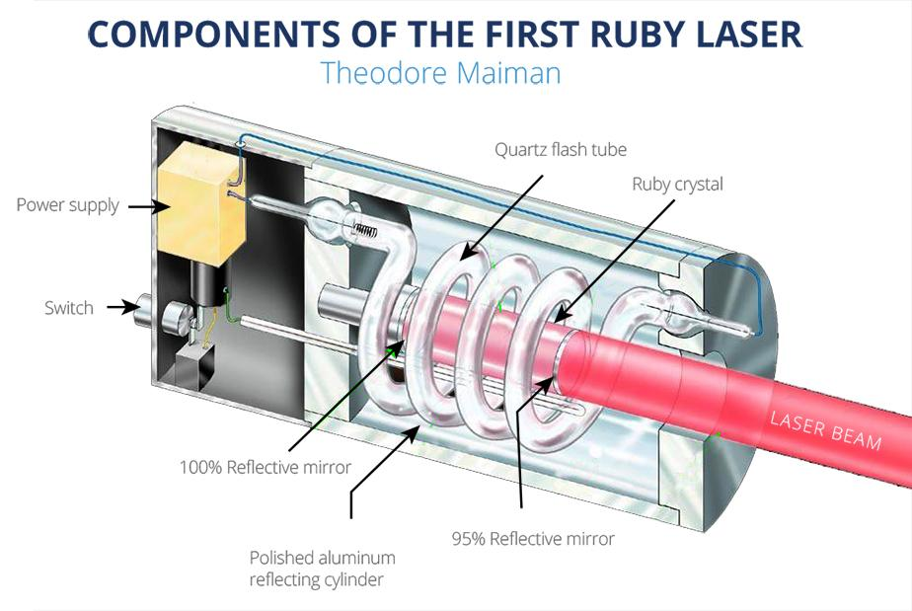

CHARACTERISTICS OF LASER
The following are some features of lasers:

Laser light has a high degree of coherence, which means that the electromagnetic waves it emits are in phase and always in relation to one another. Due to this coherence, the laser beam may maintain focus across long distances, producing a focused and clearly defined beam.

Laser light is monochromatic if it only has one wavelength or colour. Contrary to regular light sources, which generate a variety of wavelengths, lasers emit light that is almost colourless. Due to their monochromatic nature, lasers can be employed for a variety of tasks that call for a certain wavelength.

Collimation: Laser light can be tightly focused into a narrow beam with very little divergence. The emitted beam remains highly concentrated and parallel over long distances, making it suitable for applications such as cutting, welding, and long-range communication.

Intensity: Lasers produce a high-intensity beam of light. The energy in the laser beam is concentrated within a small area, resulting in a high power density. This high intensity enables lasers to perform precise and controlled operations, such as laser surgery or material processing.

Laser light propagates in a clearly defined direction and is therefore extremely directed. Lasers produce a small cone-shaped beam of light instead of the various directions that conventional light sources emit light. Laser light can be accurately focused on a particular target thanks to its directionality.

Laser light has a long coherence length, or the distance over which the phase connection between various beam components remains largely constant. This characteristic enables the coherence and focus of laser light to remain unaltered at extended distances.

The speed of laser light is the same as the speed of light, which in a vacuum is roughly 299,792 kilometres per second. Lasers can be employed in applications requiring quick responses or high data transfer rates, including optical communications or laser-based scanning systems, thanks to their fast operating speeds.

These features of lasers make them valuable in a variety of industries, including manufacturing, research, entertainment, and many other sectors, in addition to medicine and telecommunications.

TYPES OF LASER
Based on numerous factors, including the medium used, emission wavelength, and application, lasers can be divided into various categories. Here are a few typical laser configurations:

Gas Lasers: The active medium in these lasers is a gas mixture. Helium-neon (HeNe), carbon dioxide (CO2), argon-ion, and excimer lasers are a few examples.

Solid-State Lasers: The active medium in solid-state lasers is a solid substance. Neodymium-doped yttrium orthovanadate (Nd:YVO4), ruby lasers, and neodymium-doped yttrium aluminium garnet (Nd:YAG) lasers are typical examples.

Semiconductor Lasers: These devices, also referred to as diode lasers, utilise a semiconductor material as its active medium. They are frequently discovered in laser pointers, optical drive laser diodes, and telecommunications laser diode arrays.

Dye Lasers: An organic dye is used as the gain medium in dye lasers. They are frequently tunable and have a wide variety of laser light emission wavelengths. Spectroscopy and scientific research both use dye lasers.

Fibre Lasers: The gain medium for fibre lasers is an optical fibre. They provide exceptional beam quality while maintaining high power and efficiency. Numerous industries, including telecommunications, material processing, and medical applications, use fibre lasers.

Excimer Lasers: The gain medium for excimer lasers is commonly a mixture of a noble gas and a halogen. They are used in LASIK eye surgery, the production of semiconductors, and scientific research because they emit ultraviolet (UV) light.

Free Electron Lasers: Using a magnetic field to accelerate electrons, free electron lasers (FELs) produce laser light. Ultrashort pulses, great power, and a broad spectrum of tunable wavelengths are all features of FELs. Their main application is in scientific research.

These are but a few examples of the various kinds of lasers that are readily available. Each type of laser has distinct characteristics and uses, making them useful instruments in many different fields, such as medical, telecommunications, manufacturing, research, and others.

APPLICATIONS OF LASERS
Because of these unique properties, lasers are used in various applications.
The most significant applications of lasers include:
- Lasers in medicine
- Lasers in communications
- Lasers in industries
- Lasers in science and technology
- Lasers in military

Lasers for Medical Use
Bloodless surgery is performed with lasers.
Kidney stones are removed with the aid of lasers.
Lasers are employed in the detection and treatment of cancer.
Lasers are used to straighten the curvature of eye lenses.
In order to find intestinal ulcers, fiber-optic endoscopes use lasers.
Laser therapy could be used to treat disorders of the liver and lungs.
Lasers are used to examine the internal organisation of cells and microorganisms.
Chemical reactions are created using lasers.
Plasma is produced using lasers.
Tumours can be successfully removed with laser technology.
The decaying or carious area of the teeth is removed using lasers.
Lasers are utilised in aesthetic procedures like cellulite reduction, acne therapy, and hair removal.

Communications Using Lasers
In optical fibre communications, laser light is utilised to transmit information across long distances with little loss.
Underwater communication networks employ laser light.
Satellites, radars, and space communication all employ lasers.

Industries Using Lasers
Glass and quartz can be sliced by lasers.
In the electronic sector, lasers are used to trim Integrated Circuit (IC) components.
The automotive sector uses lasers for heat treatment.
From the bar code that is written on the object, laser light is utilised to gather data about the fixed prices of various products in stores and commercial settings.
Photolithography in the semiconductor industry uses ultraviolet lasers. UV light is utilised in photolithography, a process for making printed circuit boards (PCBs) and microprocessors.
Aerosol nozzles and control orifices are drilled with the necessary precision using lasers.

Science and technology use of lasers
The study of Brownian particle motion benefits from the use of a laser.
It has been demonstrated that the speed of light is constant in all directions using a helium-neon laser.

The number of atoms in a substance can be counted with the aid of a laser.
Computers use lasers to access data that has been stored on a Compact Disc (CD).
Large amounts of data or information are stored in CD-ROMs using lasers.
The atmosphere's polluting gases and other impurities are measured using lasers.
Accurately calculating the earth's rotational speed is made possible by lasers.
Computer printers employ lasers.
Nuclear explosions and earthquakes can both be detected using lasers.

Military Use of Lasers
Laser range finders are used to calculate a target's distance.
For sensing and measuring very small rotational angles of moving objects, ring laser gyroscopes are used.

Lasers are very precise, covert illuminators that can be utilised for nighttime reconnaissance.
By destroying the missile, lasers are employed to destroy the energy of a warhead.
Lasers offer a lot of benefits and uses, but they also have certain drawbacks. The following are some typical drawbacks of lasers:
Risks to the skin and eyes: Improper laser use might be harmful. Burns to the skin or damage to the eyes can result from direct laser exposure. To reduce these dangers, special safety measures are required, such as the use of protective eyewear and adherence to safety regulations.
Cost: The development, production, and maintenance of lasers can be expensive. When compared to other traditional technologies, laser systems frequently cost more due to the sophisticated technology and specialised components needed.

Power requirements: Some laser systems need a lot of electricity to run, which reduces their portability and raises their energy usage. In some situations where power supply or efficiency are issues, this could be a drawback.

Size and complexity: Some laser types can be big and complex, requiring complex cooling systems and challenging optical configurations. Because of this, they are less useful in applications where simplicity and compactness are important considerations.

Environmental sensitivity: Environmental elements like temperature, humidity, and vibrations can affect how sensitive a laser is. The performance and stability of laser systems can be impacted by variations in these parameters, making them less dependable in some circumstances.

Limited range: While laser beams can travel long distances without significant divergence, they are still subject to atmospheric attenuation and scattering effects. This limits the effective range of laser-based communication or sensing systems, especially in adverse weather conditions or over large distances.

Interaction with certain materials: Laser beams can interact differently with different materials. Some materials may absorb or scatter laser light, limiting the effectiveness of laser processing or cutting. Additionally, some materials may emit hazardous fumes or particles when subjected to laser irradiation, requiring additional safety precautions.

It's worth noting that many of these disadvantages can be mitigated or overcome through proper design, engineering, and safety protocols. Lasers remain a valuable technology despite these limitations, and ongoing research continues to address and improve upon these challenges.

