Weather Enabled Computer Vision for Estimation of Moving Vehicle’s Weight
Theertha A¹, Aparna Anilkumar², Anandu Sasikumar³, Rahul R Krishnan⁴ ,Gargi N R⁵
¹Theertha A Computer Science Engineering & Kottayam Institute of Technology and Science
²Aparna Anilkumar Computer Science Engineering & Kottayam Institute of Technology and Science
³Anandu Sasikumar Computer Science Engineering & Kottayam Institute of Technology and Science
⁴Rahul R Krishnan Computer Science Engineering & Kottayam Institute of Technology and Science
⁵Gargi N R Computer Science Engineering & Kottayam Institute of Technology and Science
---------------------------------------------------------------------***---------------------------------------------------------------------

Abstract - The state of the tires and the importance of the pressure that is now in them are frequently ignored by drivers. The comfort, fuel economy, and safety of driving are all significantly impacted by variations in tire air pressure. Heavy cars, especially those that exceed the permitted weight limit, not only put other drivers in danger but also put a lot of strain on the roads, which can hasten the depreciation and damage of the transportation infrastructure, such as bridges and pavements. In this research, a vehicle weight estimate based on the IFTD algorithm and CNN classification is developed. Effective weighing techniques and systems are employed. In a roadside car, the approach was used. To determine vehicle weight, a convolutional neural network is created and trained, and in the pre-processing stage, a CLAHE filer is applied based on dividing the target image into a number of equal-sized non-overlapping areas.
Keywords: Convolutional Neural Network (CNN), Contrast Limited Adaptive Histogram Equalization (CLAHE), Fully Connected (FC), If Then Decision (IFTD), Optical Character Recognition (OCR), Weigh in motion (WIM).

1. INTRODUCTION
Heavy vehicles, especially those that exceed the permitted weight limit, not only present a risk to general traffic but also put the transportation infrastructure—such as bridges and pavement—under undue strain and risk rapid degradation and damage. Because there aren't many reliable and accurate weighing techniques and systems, enforcing vehicle weight regulations has proven complicated. Heavy vehicles must take a diversion to a weigh station when using the traditional static weighing method, or contemporary practice, which causes severe traffic disruption and delay. When the maximum weights that they are intended to carry are surpassed, vehicles respond differently. The inadequacies of the existing static weighing approach emphasize the significance of creating a Weigh-in-Motion (WIM) system that can weigh a vehicle while enabling it to go along normally without being impeded. The development of WIM systems has received a lot of attention. One method is to softly measure passing axle load with sensors and equipment installed in the pavement, namely pavement-based WIM systems when the weights that they are intended to bear are surpassed. These devices, which enable weight measurement of a moving vehicle, include wheel or axle scale plates, capacitive strips, piezoelectric cables, bending plates, and loadcells with strip sensors. Such systems, however, need expensive hardware, installation, and upkeep.
Devices known as "weighing-in-motion" (WIM) scales are made to measure axle weights and gross vehicle weights while moving vehicles pass over a measuring location. Unlike static scales, which require the vehicle to halt, WIM systems can measure vehicles moving at reduced or standard traffic speeds. It is possible to recognize the sidewall marks on your tires and take pictures of the tires of moving vehicles using a computer vision system that consists of a camera and software. The program also analyses the features of tire deformation. The control room is alerted when the vehicle is overloaded by IoT devices and CNN, which is built and taught to determine the vehicle’s weight precisely.

2. LITERATURE SURVEY
Nirbhay Kashyap, Tanu Priya Choudary [1] In this study, the system is implementing OCR technology to park the vehicles in a smart way and keep track of the vehicle which are entering and leaving. The vehicle is recognized by taking a picture of the license plate and processing it till it can be identified. The mechanisms that make up the OCR system include character segmentation, character localization, image processing, and character recognition. The final output is likewise retained there together with the vehicle's data for storage in the database.
Timothy Pederson, and Torbjorn Haugen [2] In this study, It examined how accurate the weight data from a TEC with a piezoelectric sensor is and examine the accuracy changes over time. it was determined if weight information acquired from a TEC fitted with piezoelectric sensors was accurate. It examined if the accuracy varied over time and explored how utilizing calibration factors may improve it. The dynamic and static weights are consistently inaccurate in both classic piezo-based WIM systems and piezo-based TEC. More research is required to determine how accurate the weight statistics provided by TEC, which are promising, can be. Xuan Kong, Tengyi Wang Jie Zhang, Lu Deng,[3] The methodology for identifying the tire-road contact force by combining the derived equations and computer vision techniques was verified with field experiments on passenger cars and trucks. Two passenger vehicles and two trucks with tires of varied specifications were used to determine the vehicle weight, the relationship between the contact force and the tire inflation pressure, tire vertical deflection, and other physical data, as well as to assess the effectiveness of the recommended technique.
Deepshikha Yadav, Puneet Azad [4], Generation of voltage pulses due to contact between two materials. A graphical user interface has been developed for showing the accuracy of speed. Alarming the overloading of vehicles by observing the magnitude of voltage pulses. A database with six different weights has been generated following a series of on-road testing for weight estimates. The suggested approach makes it easier for researchers and law enforcement to acquire trustworthy information for traffic control and surveillance.

3. METHODOLOGY
The system consists of Arduino uno and IoT modules. The Arduino modules were to create simple, low-cost tools for creating digital projects by non-engineers. The board is equipped with sets of digital and analog I/O pins that may be interfaced with various shields) and other circuits. The board has 14 digital I/O pins (six capable of output), and 6 analog I/O pins, and is programmable with the Integrated Development Environment.
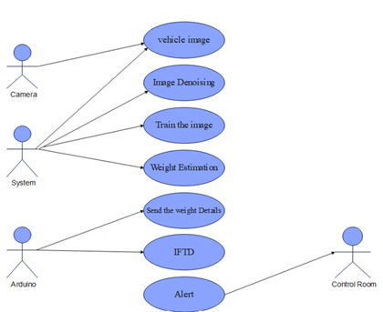
The system begins by taking into account numerous trained datasets. These datasets are pre-processed using a CLAHE filter
This CLAHE is constructed based on dividing the target image into a number of equal-sized, non-overlapping areas, after that. the features are retrieved using CNN layers like the convolution and pooling layers. A convolutional neural network is a kind of feedforward neural network that is able to extract features from data with convolution structures. The categorization process then employs the extracted data.
1. Architecture of the Proposed System
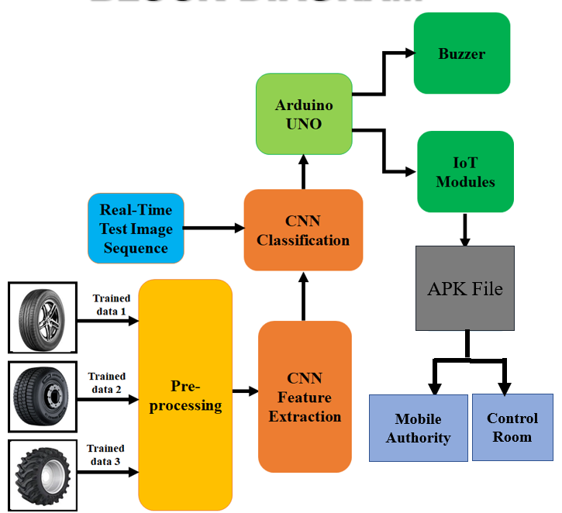Fig -1: Architecture of the proposed system

The data can be categorized into the proper classifications using a real-time image sequence and fully linked layer. Then, the encrypted data is sent to an Arduino microcontroller, which sends the information to either a buzzer or an Internet of Things module. The IoT module can send information by an APK file to the traffic control room or any access that concerns a vehicle that is overloaded.

1.1 Use Case Diagram of the Proposed System
The scope and high-level functions of a system are described in use case diagrams. The interactions between the system and its actors are also depicted in these diagrams. Utilize-case diagrams show what the system does and how the actors utilize it, but they do not show how the system works within. It has four actors: an Arduino, a camera, a system, and a control room. The technology pre-processes the image by removing noise from the image once the camera captures the image of the vehicle. The Arduino UNO utilizes the IFTD method to store all of the training data, and the convolutional neural network is created and trained to recognize vehicle weight. Finally, when a vehicle is overloaded, the IoT devices alert the control room.

Fig -2: Use Case Diagram of the Proposed System

1.2 Activity diagram of the proposed System

Similar to a flowchart or data flow diagram, an activity diagram visually displays a series of actions or the flow of control in a system. In business process modeling, activity diagrams are frequently employed. Additionally, they can outline the procedures in a use-case diagram. In this diagram, Firstly, record the tire image. Once the image is recorded, it is transferred to the system. The transferred image is then used for feature extraction using CNN. Then the image is classified according to the previously taken data. Then the vehicle weight is estimated. It should be the combined result of both extracted image and the Arduino. If the weight estimated is abnormal then the Arduino sends an alert through IOT to the officials.
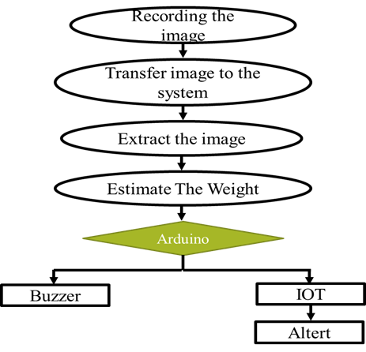

Fig -3: Activity Diagram of the Proposed System

4. IMPLEMENTATION

Our project is divided into Three modules: The pre-processor module, The CNN classification, and The IOT module. Overloaded vehicles are increasingly being blamed for mishaps. Overload impairs the driver's ability to brake and steer, which might lead to an accident. Increased engine stress increases the likelihood of tire failure. It makes the vehicle less stable. Roads and streets are the most essential mode of transportation and communication in the country. Overloading vehicle is a traffic danger, especially for heavier vehicles. A braking system and extra breaking distance are involved. Vehicle overloading should be avoided. It is also our social responsibility. All road users now face a serious problem with overloaded vehicles, and that problem is getting worse every day. The time has arrived to find a solution to this issue. We can at least partially eradicate, if not altogether, this issue. The proposed system may be a helpful one in this.
Every vehicle has a cap on the number of passengers or the amount of cargo it can transport. Most of the time, individuals neglect this and end up packing their cars to capacity with people and goods. This may appear to be a simple solution to your immediate load-carrying difficulty, but in the long run, it could hurt your finances as your vehicle would deteriorate over time, our approach describes a weather-enabled computer vision for the estimation of moving vehicle weight. A dataset of tire images is used to train the model. The dataset needs to be varied and inclusive of a variety of vehicle wheels. Python may be used to build this model together with well-liked tools like Jupyter Notebook or Google Collab.
The pre-processing technique is used to remove unwanted noise artifacts and improve image quality. Pre-processing techniques used are scaling, transforming, zooming, resizing, and converting images to greyscale images. The image boundary is removed with the CLAHE. The target image is divided into a number of equal-sized, non-overlapping regions to create this CLAHE. First, the histograms for each region are calculated utilizing restrictions for contrast expansion and clipping in order to optimize image improvement. After that, the predicted histogram is redistributed in order to keep the height inside the clip limit.
𝐹_(𝑎,𝑏) (𝑞)=((𝑄−1))/𝑃 ∑1_(𝑠=0)^𝑞▒〖𝑟_(𝑎,𝑏) (𝑠)〗 𝑞=1,2…𝑄−1 (1)
The dimensionality reduction method, which divides and condenses a starting set of raw data into smaller, easier-to-manage groupings, includes feature extraction. As a result, processing will be simpler. The fact that these enormous data sets contain a lot of different variables is their most crucial feature. Convolutional Neural Network is utilized for feature extraction and classification of images. A convolutional neural network is a kind of feedforward neural network that is able to extract features from data with convolution structures. Three types of layers in CNN are:
- Convolution Layer
- Pooling Layer
- Fully-connected Layer

The convolution layers are the fundamental building blocks of CNN, and they are in charge of executing convolution operations. The element in this layer that performs the convolution operation is known as the Kernel/Filter (matrix). The kernel shifts horizontally and vertically based on the stride rate until the entire image has been scanned. Dimensionality reduction is the responsibility of the pooling layer. It contributes to lowering the computational power required to process the data. Pooling is classified into two types: maximum pooling and average pooling. Max pooling returns the maximum value from the area of the image covered by the kernel. Average pooling returns the average of all the values in the kernel's portion of the image. The Fully Connected (FC) layer functions on a flattened input, with each input connecting to all neurons. FC layers, if present, are commonly found near the conclusion of CNN architectures.
Convolution is the technique of traveling a picture with a constant-size "window" and multiplying the image pixel with a convolution window to create an output image. Convolutional Neural Networks (CNNs) are the most widely used neural network model for image classification. The essential assumption behind CNNs is that a local comprehension of an image is sufficient. The practical benefit is that having fewer parameters improves learning time and minimizes the amount of data required to train the model. A CNN, as opposed to a fully connected network of weights from each pixel, contains only enough weights to examine a tiny portion of the image. It's like reading a book with a magnifying glass; you eventually read the entire page, but you only see a small portion of it at a time. Our proposed system uses CNN classification for identifying the category of the image. It is a feed-forward neural network. It is able to extract features from data with convolution structures Using three types of layers.
The IoT module is comprised of three major blocks: Node, Gateway, and Services. Protocols employ some controllers and operators to receive information and specific data from sensors; after that, this data is sent to services. These sensors continuously emit data about the working state of the devices. They share a huge amount of data to provide a common platform for all the devices to communicate with each other. Information is transferred from various sensors and sent to the gateway IoT data store which receives the data from the internet. IFTD algorithm fixed in Arduino uno board. Arduino uno sends the data in IOT.

5. RESULT

Using the Convolutional Neural Network (CNN) technique, our project was trained. The model learned from the input data during the training process and was able to generate precise predictions using the data.
In the first step, we interpret the input image as a tire. After capturing the input image, we pre-processed it to improve its quality using the CLAHE filter. Contrast Limited AHE (CLAHE) is a type of adaptive histogram equalization that limits contrast amplification to minimize noise amplification. CLAHE, in a nutshell, does histogram equalization in small patches or small tiles with excellent accuracy and contrast limiting. CLAHE operates on small sections of an image known as tiles rather than the entire image. To remove the artificial boundaries, the adjacent tiles are blended using bilinear interpolation.
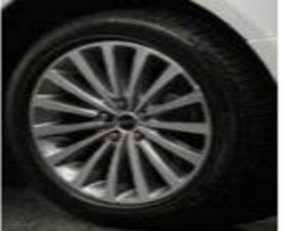

Fig -4: input image
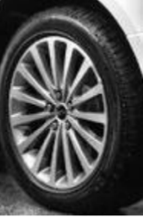
Fig -5: pre-processed image
During the testing phase, the trained model was assessed using a test dataset, and it was discovered that the model used the CNN technique to obtain high accuracy.
The dataset is gathered from Kaggle. The dataset contains Flat tire images, Full tire images, and No tire images. Based on CNN, the dataset is classified into training data and testing data. In this project, 80% of images are considered training data and 20% of data are collected in real-time for testing data.
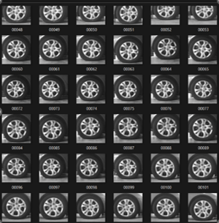

Fig -6: Sample images from the dataset
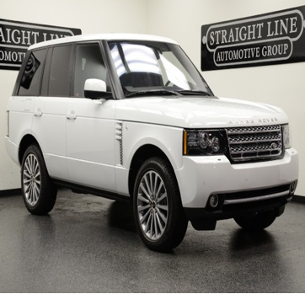
Fig -7: input image
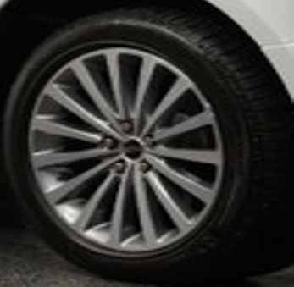
Fig -8: Scaled image
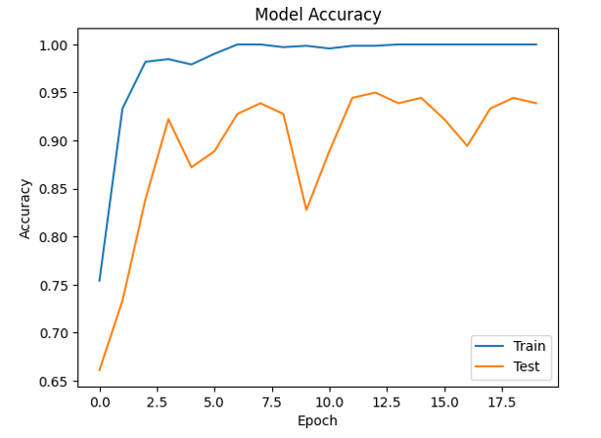
Fig -9: Model accuracy

6. CONCLUSION

The task of estimating the weight of a vehicle while it is in motion is known as moving vehicle weight estimation. Because of the complex vehicle dynamics and vehicle-pavement interaction, it is a difficult challenge. Using an Arduino controller, this project provided computer vision of moving vehicle weight calculation based on the CNN technique. Field trials on passenger vehicles validated the methodology for determining vehicle weight by combining computer vision techniques. To acquire an accurate measurement of the tire deformation characteristics, edge detection techniques were used. CNN classification determines the weight and then sends the information to the Arduino controller, which determines the car tire weight and stores all data in a database. In inclement weather, the computer vision task can be pre-processed with a CLAHE filter to remove issues with illumination and fog. The IFTD (IF Then Decision) method is utilized in the Arduino UNO to make the final crucial weight decision. Finally, IoT gadgets warn the users.

ACKNOWLEDGEMENT

We would like to use this occasion to extend our heartfelt gratitude and appreciation to everyone who assisted us in successfully completing this task. We sincerely appreciate Dr. P Arun Bose, Department Head of Computer Science Engineering, for providing us with all the facilities and assistance we need. For the assistance and cooperation, we would like to sincerely thank Ms. Akhija Lakshmi R, Assistant Professor Project Coordinator Department of Computer Science Engineering.

We would like to officially express our thanks to Ms. Gargi N R, Assistant Professor, Computer Science Engineering, for serving as our project advisor and providing mentorship during this endeavor.

Finally, we would like to express our gratitude to our family, friends, and all those who helped make this project work a success.

REFERENCES
- Jain, Kartikeya, Tanupriya Choudhury, and Nirbhay Kashyap. "Smart vehicle identification system using OCR." In 2017 3rd international conference on computational intelligence & communication technology (CICT), pp. 1-6. IEEE, 2017
- Timothy, and Torbjorn Haugen. "Vehicle weight estimation based on piezoelectric sensors used at traffic enforcement cameras experiences from the Norwegian system." In 2017 IEEE 20th International Conference on Intelligent Transportation Systems (ITSC), pp. 1-5. IEEE, 2017.
- Kong, Xuan, Tengyi Wang, Jie Zhang, Lu Deng, Jiwei Zhong, Yuping Cui, and Shudong Xia. "Tire Contact Force Equations for Vision-Based Vehicle Weight Identification." Applied Sciences 12, no. 9 (2022): 4487.
- Yadav, Deepshikha, and Puneet Azad. "Low‐cost triboelectric sensor for speed measurement and weight estimation of vehicles." IET Intelligent Transport Systems 12, no. 8 (2018): 958-964.
- Feng, Maria Q., Ryan Y. Leung, and Casey M. Eckersley. "Non-contact vehicle weigh-in-motion using computer vision." Measurement 153 (2020): 107415.

