
Research paper
On
Application of Integration

Made by: Asvin Sharma Guided By: Mrs Deepali Sonawane
Atharva Shivade
Yashovardhan Poddar

Title: The Application of Integration: A Comprehensive Review

Abstract:
Integration, a fundamental concept in calculus, plays a crucial role in various scientific and engineering fields. This research paper aims to provide a comprehensive review of the diverse applications of integration across different domains. We explore how integration is employed in physics, economics, biology, engineering, and data analysis, highlighting its significance in solving complex problems, modeling dynamic systems, and making accurate predictions. By examining real-world examples and case studies, we illustrate the versatility and utility of integration techniques. Additionally, we discuss the challenges and future directions in the application of integration, emphasizing the ongoing advancements in numerical methods, symbolic computation, and computer algorithms that facilitate more efficient and accurate integration.

Introduction
- Brief overview of integration and its role in calculus.
Integration is a fundamental concept in calculus that deals with finding the area under a curve. It involves determining the antiderivative, or the original function, given its derivative. Integration is the reverse process of differentiation.

The integral sign (∫) represents integration, and the function to be integrated is written after the sign. The result of integration is a family of functions, called the indefinite integral or antiderivative, which represents all possible solutions.

Integration plays a crucial role in calculus as it enables us to calculate areas, compute the total change of a quantity over an interval, find the average value of a function, and solve differential equations. It also provides powerful tools for solving problems in physics, engineering, economics, and other fields where rates of change are involved.

There are different techniques for performing integration, including basic rules like the power rule, constant multiple rule, and the sum/difference rule. More advanced methods such as integration by substitution, integration by parts, and partial fraction decomposition are used to solve more complex integrals.

Overall, integration is a vital tool in calculus that allows us to analyse and solve problems involving quantities that change continuously, making it an essential concept for understanding a wide range of phenomena.

- Importance of integration in mathematical modelling and problem-solving.

Integration plays a crucial role in mathematical modelling and problem-solving across various fields. It is a fundamental concept in calculus that involves finding the integral of a function, which represents the area under a curve. Here are some key reasons why integration is important:

1. Determining total quantities: Integration allows us to calculate the total quantity or accumulation of a varying quantity over a given interval. For example, in physics, integration can be used to find the total displacement, velocity, or mass of an object by integrating the corresponding functions.
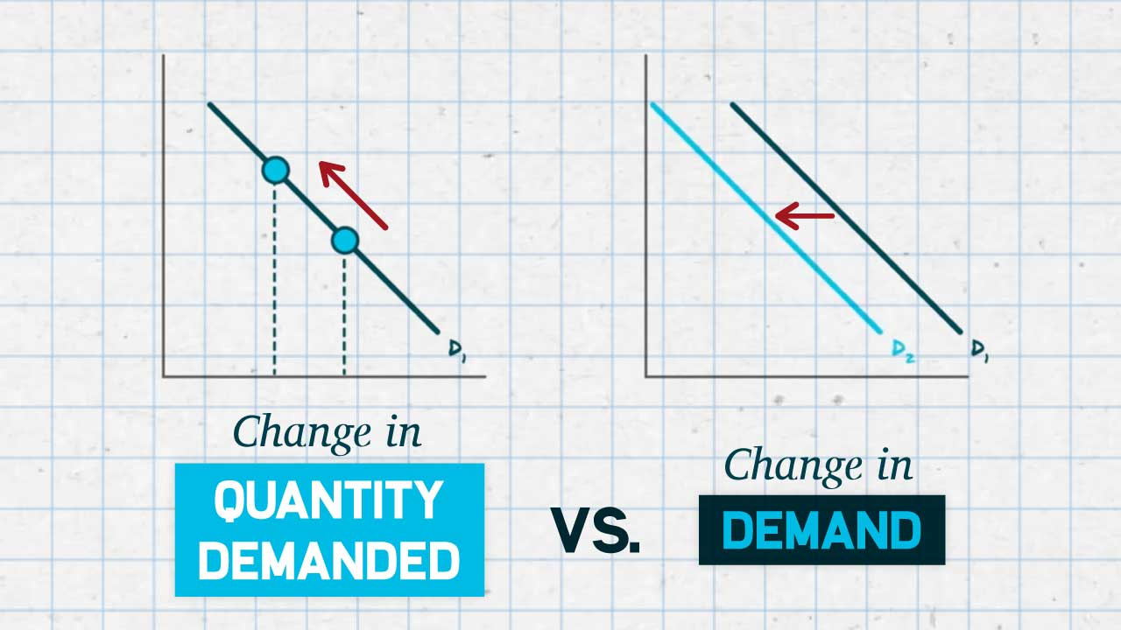

2. Finding areas and volumes: Integration enables us to calculate areas of irregular shapes and volumes of three-dimensional objects. By integrating a function that represents a curve or a surface, we can determine the area or volume enclosed by the curve or surface, respectively.
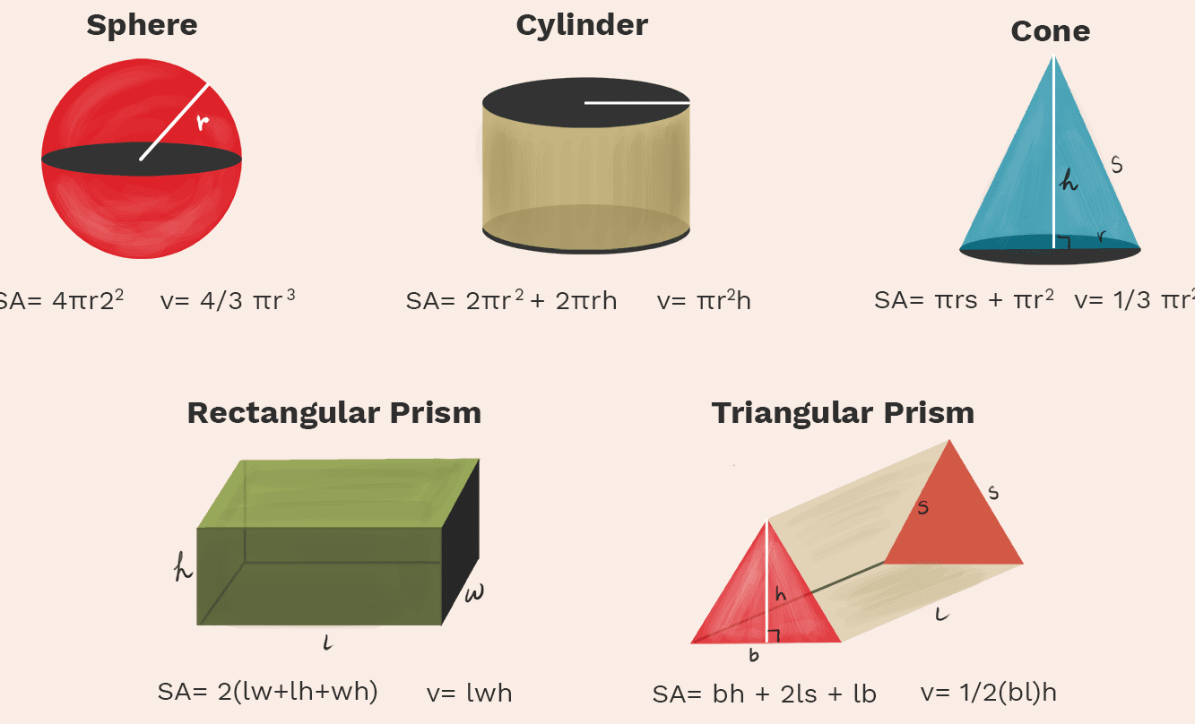

3. Probability and statistics: Integration is used extensively in probability theory and statistics. Probability density functions (PDFs) are continuous functions that describe the likelihood of a random variable taking a particular value. The area under the PDF curve represents the probability of an event occurring within a certain range, and integration is used to calculate these probabilities.
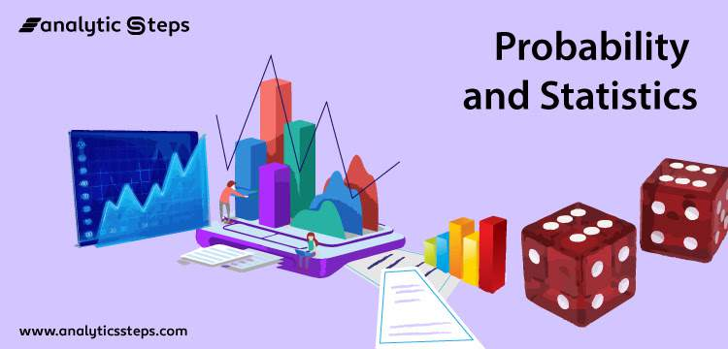

4. Optimization and optimization problems: Integration is utilized in optimization problems, where the goal is to find the maximum or minimum value of a function. By taking the derivative of the objective function and setting it to zero, we can often find critical points. Integration can then be used to determine whether these points correspond to maximum or minimum values.


5. Economic modelling: Integration is essential in economic modelling, particularly in the analysis of supply and demand curves, consumer surplus, producer surplus, and finding equilibrium points. These concepts rely on integration to calculate areas under curves, which represent economic quantities.
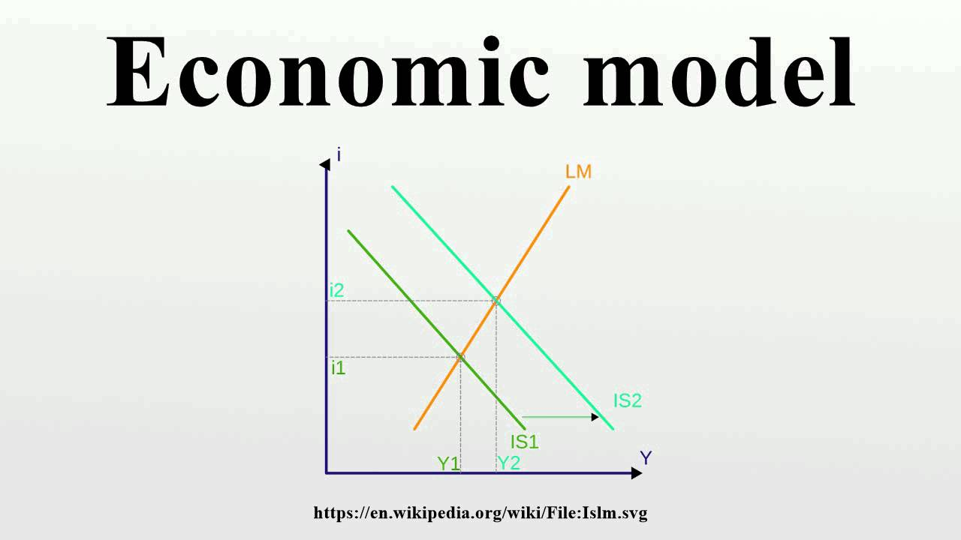

6. Signal processing: Integration is employed in signal processing to analyse and manipulate signals. Integrating a signal can reveal useful information such as the total energy or average value of the signal.


7. Solving differential equations: Many real-world problems are modelled using differential equations, which describe how a quantity changes over time. Integration is often employed to solve these equations and find the exact solution. The process of solving a differential equation involves integrating the equation to eliminate the derivative terms.
Overall, integration provides a powerful tool for mathematical modeling and problem-solving. It enables us to calculate quantities, determine areas and volumes, solve differential equations, analyze probabilities, optimize functions, model economic systems, and process signals. Its applications span a wide range of disciplines and are essential for understanding and solving complex real-world problems.

A. Physical Applications
- Use of integration in classical mechanics to determine position, velocity, and acceleration.
- Calculation of areas, volumes, and centers of mass.
- Integration in electromagnetism, fluid dynamics, and thermodynamics.

B. Economic and Financial Applications
- Calculation of total revenue, total cost, and profit functions.
- Estimation of consumer and producer surplus.
- Integration in financial modeling, option pricing, and risk assessment.

C. Biological Applications
- Analysis of growth rates, population dynamics, and epidemiological models.
- Determination of reaction rates in enzymatic kinetics.
- Integration in neuroscience and physiological modeling.

D. Engineering Applications
- Evaluation of electric circuits and control systems.
- Integration in structural analysis and design.
- Application of integration in signal processing and image analysis.

E. Data Analysis and Statistics
- Integration for probability density functions and cumulative distribution functions.
- Calculation of expected values, moments, and statistical inference.
- Numerical integration techniques for data integration and curve fitting.

F. Challenges and Future Directions
- Limitations and challenges in the application of integration.
- Advances in numerical integration methods.
- Integration in high-dimensional spaces and complex systems.
- Integration with machine learning and artificial intelligence.

Conclusion
- Recapitulation of the diverse applications of integration across various fields.
- Importance of integration in advancing scientific and engineering knowledge.
- Discussion of future possibilities and directions for integration research.

By examining the wide range of applications, this research paper aims to showcase the significance of integration in diverse fields. Understanding the various techniques and methods of integration empowers researchers, scientists, and engineers to solve complex problems, model dynamic systems accurately, and make informed decisions. As integration continues to evolve, incorporating advanced computational methods and interdisciplinary approaches, its applications will continue to expand, contributing to the development of innovative solutions and advancements in science and technology.

