RESEARCH ARTICLE

Miss. Sayali Hande
pallavighope@gmail.com
jagrutitete123@gmail.com

Formulation and standardization of herbal lotion
Dnyanvilas college of pharmacy dudulgaon, pune-411205

ABSTRACT
Herbal cosmetics are understood to mean herbal products, the products of which are used in beauty education among herbal product buyers and have created a demand for natural products and herbal extracts in cosmetics. Lotions are liquid preparations for external use without rubbing in. They are directly applied to the skin with several absorbent cloths consisting of soaked cotton wool or gauze. Soaked in it. Formulation of aloe vera lotion method. These formulations were evaluated using exceptional evaluation parameters like Uniformity, Appearance, Aftertaste, Acid Price, pH measurement, Irritancy Control, Viscosity, Accelerated stability testing, Subjective Properties, Spread ability Emulsion Type Test, Sensitivity Test, Washability Control Test, Statistical Analysis, In Vitro Permeation Test, Thermal Stability Test, Total Fat Mass Determination, Water Content Determination, Patch Test. The purpose of this review is to gather information about and evaluate various herbal formulations. The production of herbal lotions has been studied by many researchers, and this kind of information can be used by many researchers to develop new herbal cosmetic formulations using new herbs.
Keywords: Herbal Lotion, Herbal Cosmetics, Arrow Root Powder, Herbal skin Lotion Aloe Vera, Menthol.

Introduction:
Herbal lotion is a liquid preparation, applied externally to the skin to create or improve beauty. Lotions are used to cleanse the skin and remove oily secretions. (1)Herbal lotion increases blood circulation by, softens skin, extends to astringent, skin freshening, whitening and other healing properties. (14)Herbal lotions are generally applied without friction. Insoluble material should be broken down to because particles approaching the colloidal size will calm inflamed areas more effectively and are more effective when in contact with infected surfaces. A variety of ingredients may be added to a formulation to create a greater dispel or to accentuate the cooling, calming, drying or safeguard properties of a lotion. (15)Cosmetics developed to reduce wrinkles, treat acne and control sebum secretion. For different types of skin conditions, formulas such as skin protection, sun protection, anti-acne, anti-wrinkle and anti-aging are designed using a variety of materials. Current studies gathering detailed information on herbal plants used in herbal lotions discuss its benefits and actions in cosmetic formulation. (16)Ayurveda traditionally uses herbs and plants for various ailments.The function of the lotion is to resist the skin against different weather and environmental conditions and provide a soothing effect on the skin(29).

AloeVera:
Aloe vera stimulates formative cell to produce collagen and elastin fibers which make the skin more flexible and less wrinkled. It also works to bind the shed surface epidermal cells by sticking them together to soften the skin. Aloe Vera belongs to the Liliaceae family and is commonly used in cosmetics to make skin creams. It has a healing effect on the skin and has the ability to moisturize and soften the skin. The antibacterial and moisturizing properties of Aloevera protect the skin against bacterial breakdown and prevent it from becoming dry.The refreshing action of aloe leaves a feeling of freshness and limits the appearance of sunburn. This medication is used as a moisturizer to handle or prevent dry, uneven, scaly, itchy, and light skin irritation.
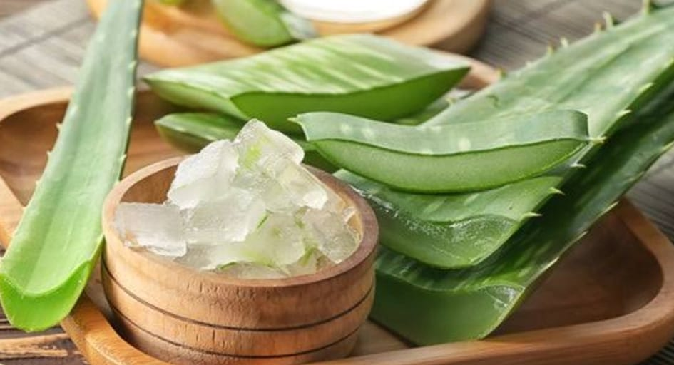
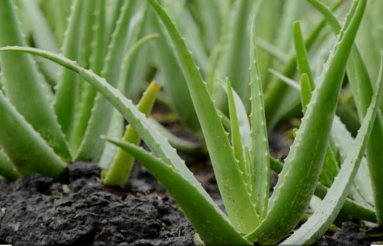

Uses of Aloe vera:
- Helps moisturize the skin.
- Stimulates wound healing.
- Anti-aging skin.
- Reduces infection and acne.
- Reduce facial defects
- Light blemishes on the face

Preparation of Lotions:
- Liquid preparations are liquid preparations for external use without causing friction.
- They are applied directly to the skin with the help of some absorbent material, such as cotton wool, gauze soaked in it.
- Lotion should not be applied to damaged skin, which may cause excessive irritation. The insoluble material must be divided very finely to prepare the lotion. Bentonite as a suspension agent is added to it.
- Applied for antiseptic, astringent, bactericidal effects, for example, Aloe Vera lotion.

Ideal properties of Herbal Lotion:
- They must have give cooling effect when applied
- They must be free from particles.
- They must have a softening effect.
- After use it should remove the oily secretion.
- They must be evenly distributed over the skin surface.
- Not expected to have toxic effects on the skin.
- They must be compatible with the pH of the skin.

Formulation of Herbal Lotion (Aloe vera):
Composition:
Sr No. | Ingredients | Quantity
1 | Beeswax | 5gm
2 | Cocoa butter | 5gm
3 | Almond Oil | 5ml
4 | Aloe vera gel (extract) | 2.5gm
5 | Peppermint oil | 12 to 14 drops
6 | Perfume | 3 to 5 drops

Procedure:
- Take the crush bees wax, add coconut oil and put in a water bath to melt all ingredients in the distillation pot.
- Using a blender, pour the above melted ingredients into it.
- Refrigerate for 15 minutes.
- Mix again and add aloevera gel.
- Mix again and add peppermint oil one last time.
- Blend until smooth. Fresh mix and store lotion in sealed container.
Evaluation of herbal lotion:
1- Physical appearance Determination-:
The physical form of the lotion is examined visually against a dark background. The average reading is recorded.
2-Uniformity-:
Consistency is a lotion whose formula has been tested for uniformity as well as for visual look and feel. After Touch the softness, smoothness and residue left after applying a fixed amount of lotion were tested. The ease of removal of applied lotion has been tested by rinsing the applied portion with tap water.
3-Sensitivetest-: One portion of lotion was applied to the arms of 6 volunteers and left for 20 minutes. After 20 minutes, any kind of irritation, if any, is noted.
4-Spread ability-:
The Two standard size glass slides (20 × 5cm) were selected. The word is on one of the slides. The other blade rests on top of the lotion so that the formula is sandwiched between the two blades in an area that occupies a distance of 7.5 cm, next to a 100 g weight, is spaced evenly to form a thin layer. Weight has been removed and excess lotion clinging to the blade has been removed. Both sliders are in one position fixed to the holder (45° angle) without any disturbance and in such a way that only the lower slider is held securely by opposite hooks of the clamps allowing the slider to slide. on sliding freely by the force of the weight relative to him. The 60g weight has been neatly attached to the top slide. The time required for the upper slider to travel a distance of 5 cm and separate from the lower slider under the influence of weight was recorded. The experiment was repeated 3 times and the mean of three of these dimensions was calculated and the results have been recorded.
The Spread ability can be calculated by using this formula:
S = M x L/T
Where,
S= Spreadability,
L= Length of glass slide,
M= Weight attached to top slide and
T= Time.

5-pH -:
The pH meter is measured with standard intermediary solutions. Weigh about 0.5 g of the solution and dissolve it in 50 ml of distilled water and measure its pH with a digital pH meter.
6-Viscosity-:
The viscosity of the composition was determined by a Brookfield or Ostwald viscometer at 100 rpm, using a rotary dial. 7 at 25°C.Determinations were performed in triplicate and the mean of three readings was recorded.
7-Washability test -:
Apply a generous amount of hand cream and let it run under running water for 10 minutes. The time when the lotion is completely removed has been noted.
8-Irritancy test:-
Mark an area (1 cm²) on the left dorsal side. The lotion is applied to the designated area and the time is noted. Irritation, erythema, and edema, if present, were checked periodically within 24 hours and reported.
Result and discussion:
Observation table:
Sr.no | Parameter | Obseravation
1 | Colour | White
2 | Odour | Pleasant
3 | Texture | Smooth
4 | State | Semi solid

Sr.no | Test | Obseravation
1 | Washability | Easily washable
2 | pH | 7.00
3 | Sensitivity | No: irritant effect

Conclusion:
I was examined approximately the as well much data of homegrown plant i.e Aloe Vera. It could be a particular plant, appear different sorts of exercises in therapeutic time.So it play an imperative part in pharmaceutical field. Aloe Vera and its system have been widely used as medicines since ancient times. Various studies have been conducted to prove that aloe vera does not cause any health problems. Hidden in juicy vents, the dynamic accessory controls the to make life and well-being extra special. As an aquatic plant, aloe vera is purifying and anti-inflammatory, has calming meanings such as cancer and diabetes, and is an area of ​​restorative.
Referances:
- Saudagar R. B.* 1 and Sisodiya M. H., Review on Herbal Cosmetics Review, World Journal of Pharmaceutical Research, band 7, Issue 7, 573-591.
- R. M. Mehta, Pharmaceutics-II, 4th Edition, (119-120) Vallabh Prakashan 2015.
- Harshita Verma *, Dr. Dharmesh Sisodiya; Formulation and Evaluation of Herbal Lotion of Aloe Vera (AloeBarbadensis) 2020 ScholarsAcademic Journal of Biosciences | Published by SAS Publishers, India
- Dr. Santram Lodhi; Dr. Mohanlal Kori, Practical Book of Herbal Drug Techn Edition of 2020 S. Vikas & Company-Medical Publishers P. No. 34-35
- Ms. Surpriya Shidhaye; Dr. Sweta Srivastava Koka,Handbook of Experimental-Herbal Drug Technology, S. Vikas & Company-Medical Publishers,Editio 2020, P. No. 16,18,19
- SNH Shah Et.al. Effect of Permeation Enhancers on the Release Behavior and Permeation Kinetics of Novel Tramadol Lotions Tropical Journal of Pharmaceutical Research February 2013; 12 (1): 27-32
- G. Hadisoebroto and N. M. Saptarini1, Formulation and Evaluation of Lotion and Cream of Nanosized Chitosan-Mangosteen (Garcinia mangostana L.) case extract Rasayan J. Chem., 13(2), 789-795(2020)
- Namita and Nimisha Development and Evaluation of Herbal Cosmeceutical for Skin Care Int J Pharm Bio Sci 2013Apr; 4(2): (P) 86 -92
- Medically Reviewed by Stephanie S. Gardner, MD on August 01, 2021
- ALOE VERA: A SHORT REVIEW Amar Surjushe, Resham Vasani, and D G Saple
- Tisserand R: The Art of Aromatherapy. 1987 C.W.Daniel & Co. Ltd.
- Bisset NG, Wichtl M, eds. Herbal Drugs and Phytopharmaceuticals. 2nd ed. Boca, Raton, Fla: CRC Press; 2001.
- Ratanshi, 2017; Sa & Das, 2008; Sabale, Modi & Sabale, 2013.
- By Rose Alexander ,Reviewed: November 15, 2017
- Nisha devi,Arvind Kumar,Mr.Ayush Garg,Abid Hussain,Rajesh Khathuriya,A review of herbal cosmetics,January 2018World Journal of Pharmaceutical
- Dr.Kuntal Das ,Nirali prakashan, A review of herbal lotion, first edition: February 2020.
- Dr.Ashok A. Hajare,Dr.Durgacharan A. Bhagvat,Nirali prakashan,first edition: June 2017.
- Prof .,Samuel Thavamani , Vincy Varghese ,Vinod , Dhanapal Venkatachalam, REVIEW ON HERBAL COSMETICS IN SKIN CARE , April 2019
- K.A. Kamalapurkar¹, S.V. Malage¹*, Y.R.Kothari, S.D. Paralkar,FORMULATION AND EVALUATION OF HERBAL LOTION COMPRISING OF CELOSIA ARGENTEA LINN.EXTRACT,Volume 8, Issue 4 .
- Benefits of Aloe Vera Plant, Aloe Vera Juice & Aloe Vera Products. Knowledge Base Script.2009; 1-7. Available from: www.knowledgepublisher.com. Das N,Chattopadhay RN. Commercial cultivation of Aloe Natural product radiance 2004; 3:85-87.
- Davis RH, Kabbani JM, Maro NP. Aloe Vera and wound healing. J Am Podiatric Med Assoc1987; 77:165-9
- Visuthikosol V, Chowchuen B, Sukwanarat Y,Sriurairatana S, Boonpucknavig V. Effect of Aloe Vera to healing of burn wound- a antiseptic and analysis study. J Med Assoc Thai 1995; 78:403-9.
- Miller MB, Koltai PJ. Treatment of preliminary frostbite with aloe Vera cream and pentoxifylline. Arch Otolaryngology Head Neck Surge 1995; 121:678-80.
- Heggers JP, Pelley RP, Robson MC. Beneficial effects of Aloe in wound healing. Phytotherapy Res 1993; 7:S48-52.
- Unani Pharmacopeia of India .Part-1 vol. 1. New Delhi: Department of Ayush; 2007 p.83-84.
- Yates A. (2002) Yates Garden Guide. Harper Collins Australia
- Random House Australia Botanica's Pocket Gardening Encyclopedia for Australian Gardeners Random House Publishers, Australia
- Gong M, Wang F, Chen Y (2002). "[Study on the application of ularmycorrhizas in growing seeding of Aloe Vera]". Zhong Yao CAI (in Chinese). 25 (1): 1–3. PMID12583231
- https://www.aloe-medicalgroup.com/en/aloevera/botany.html Nadkarni KM. Indian plants and Drugs. New Delhi;srishti book Distributors, 2004 p.28-29PMid:15129907.
- Newton LE (1979). "In the defense of the name of Aloe Vera”. The Succulent Cactus and Cactus Journal of Great Britain. 41:29–30

