Voice based E-Mail System for Blind Person

“Mauli Bhor”, “Abhijit Thorat”, “Avinash Bhor”, “Madhuri Kandhare” “Dept. of Comp. Engineering”, “Prof.Chaudhari.N.J.”

Abstract:

Due to its simplicity and accessibility, Internet is widely used in almost all the communication applications. Every human being is widely accessing the knowledge and information through internet. Out of these numerous applications, E-mail is the most widely used and reliable way to communicate with each other. The usage of e-mail is quite easy and lucid for regular users but when it comes to the user with visual defect, the system is yet very difficult to use. However, blind people face difficulties in accessing these text materials, also in using any service provided through internet. This paper thus aims to provide voice assistance for them. The contribution made by this research has enabled the Blind people to send and receive voice-based e-Mail messages in their native language with the help of a computer Keyword: - Voice based Email for blind person, visually impaired, Speech-to-text, text-to-speech, Speech recognition.

INTRODUCTION

This application is based on using speech-to-text and text-to speech converters, thus enabling everyone to control their mail accounts using their voice only and be able to read, send, and perform all the other useful tasks. The Text-to-Speech module gives audio output of the mail received, the sender, the subject and the body of the mail is read out by the system. Internet has made life of people so easy that people today have access to any information they want easily. Communication is one of the main fields highly changed by Internet. E-mails are the most dependable way of communication over Internet, for sending and receiving some important information. But there are also differently abled people in our society who are not gifted with what you have. There are some visually impaired people or blind people who can't see things and thus, can't see the computer screen or keyboard. Therefore, we came up with our project as voice based email system for blinds which will help a lot to visually impaired peoples and also illiterate peoples for sending their mails. This system aims at developing an
email system that will help even a visually impaired person to use the services for communication without previous training. The system is completely built on interactive voice response which will make it userfriendly and efficient to use. The entire project is based on voice interaction which means speech recognition.

EXISTING SYSTEM
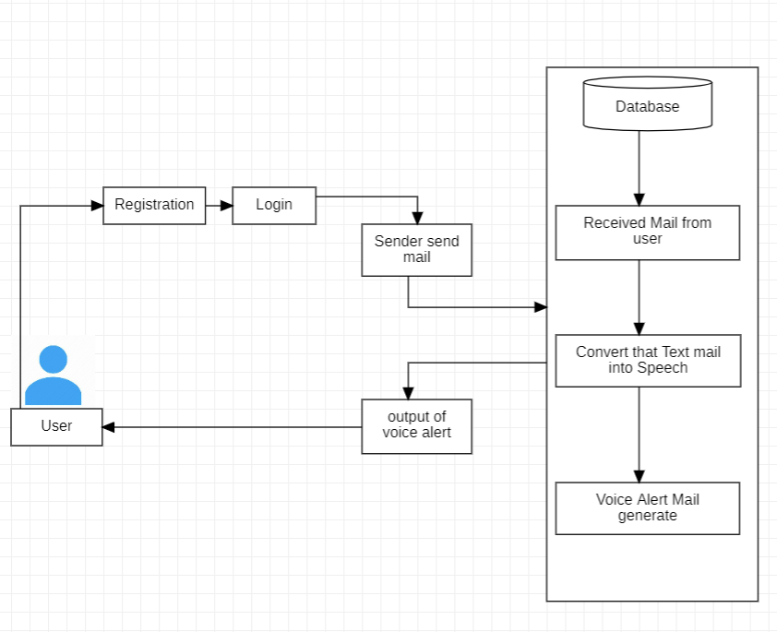

The Simple e-mail systems are available in which only voice recognition & text-to-speech systems are accessible. The most common mail services that we use in our day-to-day life cannot be used by visually challenged people. This is because they do not provide any facility so that the person in front can hear out the content of the screen.
In Existing E-mail systems are available in which only voice recognition & text-to-speech systems are accessible by remembering the keyboard shortcuts to access. The existing voice-based e-mail system has made use of IVR, Speech to text converter, Mouse click event and Screen reader. There will be

a small icon of mic on who’s clicking the user had to speak and his/her speech will be converted to text format, which the blind people would see and read also, as in references.

PROPOSED SYSTEM

In this system mainly three types of technologies are used namely:
- STT (Speech-to-text), here whatever we speak is converted to text.
- TTS (text-to-speech): Here the systems read text loudly, this method is opposite of STT.
- IVR (Interactive voice response): IVR is an advanced technology describes the interaction between the user and the system in the way of responding by using keyboard for the respective voice message. While filling up the necessary fields, speech would be recorded in database. Very frequently used words will be present i.e., when user would speak, it would get typed automatically.
After successful login the user would read the received mails present in inbox and also can send the mails.

LITERATURE SURVEY

A voice-based email architecture is proposed which will help blind people to access email. The existing system is not user friendly for blind people as it does not give any audio feedback to readout contents for them. The proposed system makes use of Speech Recognition, Interactive Voice Response and Mouse Click events. After login, users can perform normal operations of a mailing system. System options are: Compose, Inbox, Sent Mail. The user can switch between these using voice commands. The complete system is primarily based on speech to text commands. The Main activity Screen will be the First screen to be displayed on start of the app. This screen waits for the user to press the button so that the system will start accepting voice commands. And this is a full-sized button so they can press anywhere on the screen. Then using Voice commands users can send, read emails.
the system uses mainly three technologies:
- Speech to text
- Text to Speech.
- Interactive Voice Response.
In paper We have proposed an email system which can be accessed easily by blind people. The use of Speech to Text convertor, Text to speech convertor. The user needs to register to the website when they visit the site for the first time.

INTERACTIVE VOICE RESPONSE(IVR)

Interactive voice response (IVR) is an innovation that enables a PC to associate with people using voice and DTMF tones input through a keypad. In broadcast communications, IVR enables clients to connect with an organization's host framework by means of a phone keypad or by speech recognition, after which administrations can be asked about through the IVR exchange. IVR frameworks can react with pre- recorded or dynamically produced sound to additionally guide clients on the best way to continue. IVR frameworks sent in the network are measured to deal with large call volumes and furthermore utilized for outbound calling, as IVR frameworks are cannier than numerous prescient dialer frameworks

SPEECH RECOGNITION

Speech recognition (SR) is the ordered sub-field of computational linguistics (CL) that generate techniques and advancements to empower the acknowledgment and interpretation of communicated in language into text by PCs. It is also known as “automatic speech recognition “(ASR), “computer speech recognition ", or only “speech to text“ (STT). It consolidates information and study in the linguistics, software engineering, electrical engineering fields. Some SR frameworks require "training" where an individual speaker understands message or isolated vocabulary into the framework. The framework breaks down the individual's particular voice and utilize it to recognition the acknowledgment of that individual’s speech, for bringing about expanded exactness. Frameworks that do not use preparing are called as “speaker independent “frameworks. Frameworks that utilization preparing are named as “speaker dependent ". SR applications incorporate voice UIs, for example, voice dialing, call routing, household apparatus control, search (for example discover a web recording where specific words were verbally expressed), basic information entry (e.g. Visa number), readiness of organized reports for instance a radiology report, discourse to-content handling for instance word processors or

ALGORITHMS

messages, and airplane (ordinarily named Direct Voice Input). The term voice recognition or speaker recognizable proof alludes to identifying the speaker, instead of what they are saying. Perceiving the speaker can enhance the undertaking of deciphering discourse in frameworks that have been generated on a particular individual's voice or it tends to be used to confirm or check the personality of a speaker as a major aspect of a security procedure. From the innovation point of view, SR has a long history with a several waves of significant advancements. Most as of late, this field has profited by progresses in big data and deep learning (DL). The advances are proving not just by the flood of academic papers distributed in the field, however more critically by the overall worldwide industry appropriation of an assortment of DL strategies in planning and conveying SR frameworks.

DISADVANTAGES OF EXISTING SYSTEM
- The existing mail services do not provide easy access to the visually challenged people because they are in written format or any type of attached information and there is no read out option to hear the mail that is received to their mail addresses.
- User have to use mouse connected to the computer and should perform mouse click events to send and receive emails
- In existing system, they have chosen Web UI as the interface for system which is not easy for the impaired people to use.

ADVANTAGES OF PROPOSED SYSTEM

- More efficient.
- Requires less effort and time.
- This system makes the disabled people feel like a normal user.
- They can hear the recently received mails to the Inbox.
- User Friendly (The Blind Person Can Easily Use This Application)
- Easy Storage of data.
- It also helps handicapped and illiterate people.
- STT (Speech-to-text): Here whatever we speak is converted to text. Their will be a small icon of mic on whose clicking the user had to speak and his/her speech will be converted to text format, which the naked people would see and read also.
- TTS (Text-To-Speech): This, method is full opposite of STT. In this method, the text format of the emails is converted to synthesized speech.
- Voice Recognition Algorithm
- Security Purpose - MD5()
- String Data/ Email Filter - filter_var()
- IMAP (Internet Message Access Protocol) - Reading emails from the Gmail account using PHP will be an enriching task for web developers for its simplicity of code through IMAP (Internet Message Access Protocol).

USE CASE DIAGRAM
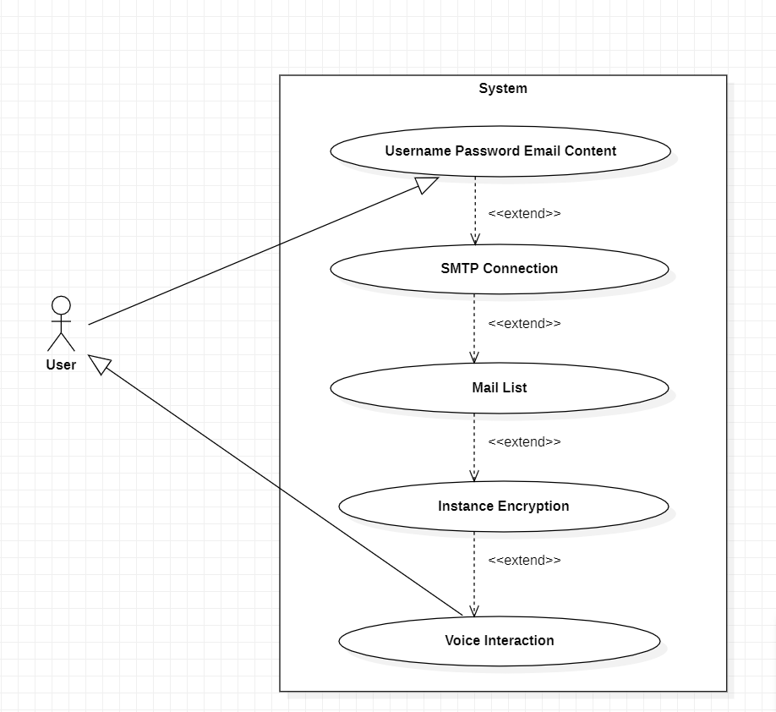

CONCLUSION

This e-mail system can be used by any user of any age group with ease of access. It has feature of speech to text as well as text to speech with speech reader which makes designed system to be handled by visually impaired person as well as blind person.This paper is the proposed Voice based Email system for visually impaired people, which is developed as an application which helps the blind and handicapped people to access mails easily and efficiently
In future, we attempt to make the system keyboard free and fully voice based. So, it's easy for the visually impaired people to access the services. The system developed now is working only on desktops. As use of mobile phones is emerging as a trend today, there is a scope to incorporate this facility as an application in mobile phones also.With the use of technically advanced smartphones, such systems and applications have a chance to be implemented as an App in smartphones. It provides a voice-based mailing service where the visually impaired person could read and send mail by their own without the help of others. It uses a speech recognition application which provides an efficient voice input method for mailing devices for blind. It is also useful for handicapped and illiterate people.

REFERENCES

[1]. Jagtap Nilesh, Pawan Alai, Chavhan Swapnil and Bendre
M.R. “Voice Based System in Desktop and Mobile Devices for Blind People”. In International Journal of Emerging Technology and Advanced Engineering (IJETAE), 2014 on Pages 404-407 (Volume 4, issue 2).
[2]. http://www.ijarcce.com/upload/2015/january/ijarcce5c.pdf
Challenges of Multidimensional Translation: Conference Proceedings SAMUEL THOM.
[6]. Speaker/Voice-Command Recognition in MATLAB http://matlabrecognition-code.co
[7]. Preeti Saini, Parneet Kaur “Automatic Speech Reorganization: A Review”, International journal of Engineering Trends and Technology Volume 4 Issue 2-2013.

[3]. M.R. Univar Banu P K, “Voice Based Search Engine and Web page Reader”. In International Journal of Computational Engineering Research (IJCER). Pages 1-5
[4]. Ender Tekin, James Coughlan – “A Mobile Phone Application Enabling Visually Impaired Users to Find and Read Product Barcodes”, July 2010, Page-290- 295.
[5]. Wagner S. (Halle). Intralinguas speech-to-text-conversion in real time Challenges and Opportunities. Muttra 2005 –

