A STUDY ON MARKETING ANALYSIS OF TOMMY HILFIGER WITH REFERENCE TOCOIMBATORE CITY

Ms. Kowsalya M
Student, III B.Com PA B,
Sri Krishna Adithya College of Arts and Science.

Mrs. Mythily R
Assistant Professor,
Sri Krishna Adithya College of Arts and Science.

CHAPTER -1

1.1. INTRODUCTION
Marketing analysis refers to the systematic strategy to reach the customer for products and services so that competitive advantage and benefits can be achieved. Market analysis is an assessment of a market within a specific industry. It examines all aspects that impact the relevant market, or a segment of it, and evaluates the size, value, and trends.
Tommy Hilfiger is one of the world’s leading designer lifestyle brands is internationally recognized for celebrating the essence of classic American cool style, featuring preppy with a twist designs. It was founded in 1985 and delivers premium styling, quality and value to consumers worldwide under the Tommy Hilfiger and Hilfiger Denim brands, with a breadth of collections including Hilfiger Collection, Tommy Hilfiger Tailored, men’s, women’s and kids’ Sportswear, denim, accessories, and footwear. In addition, the brand is licensed for a range of products, including fragrances, eyewear, watches and home furnishings. Founder Tommy Hilfiger remains the company’s Principal Designer and provides leadership and direction for the design process.
Tommy Hilfiger, which was acquired by PVH Corp. in 2010, is a global apparel and retail company with more than 17,000 associates worldwide. With the support of strong global consumer recognition, Tommy Hilfiger has built an extensive distribution network in over 90countries and more than 1,400 retail stores throughout North America, Europe, Latin America and the Asia Pacific region. Global retail sales of the Tommy Hilfiger brand were US $6.7 billion in 2014.
Tommy Hilfiger Corporation had taken a virtually unknown designer and declared him a dean of menswear on par with industry leaders Calvin Klein, Ralph Lauren, and Perry Ellis. Remarkably, consumers bought the idea and bought the clothing. A dozen years after the company’s brash inaugural ads, the clothing was selling more strongly than ever, not only in the United States but in Japan, Europe, and Central and South America.

1.2. STATEMENT OF PROBLEM
Although Tommy Hilfiger is a lifestyle family brand, women do not really have a strong connection with the brand. A lack of connection that normally draws the female customer in-store and the fact that in most cases women do not know that Women’s wear is sold as there is a stronger focus on the Men’s division (which is often placed in front of the store), result in a lower conversion rate for Women’s wear. The Tommy Hilfiger stores are currently more masculine than feminine. The company has already been working on responding to this problem by developing a new Sportswear concept and making it more feminine by using lighter colors, lighter fixtures, different materials, etc.

1.3. LIMITATIONS OF THE STUDY
- The study is a limited area within Coimbatore city.
- Duration of the project covers only 6 months.
- The study is purely based on both primary and secondary data
- The study is restricted to Tommy Hilfiger only.
- The sample size was limited to 132 respondents on a random basis.

1.4. SCOPE OF THE STUDY
This report aims to critically analyses the Tommy Hilfiger brand by researching into their current marketing communications. The report will include in-depth analysis into their current practice looking at strengths, weaknesses and possible opportunities for improvement.
There is something else that is customer expectation, perception, Preferences, buying behaviour and income level with respect to customer satisfaction. The survey also helps in indicating the specific areas of satisfaction or dissatisfaction in the market price.

1.5. OBJECTIVES OF THE STUDY
- To study brand Preference towards Tommy Hilfiger.
- To analyse the usage and satisfaction level of Tommy Hilfiger brand
- To analyse the awareness of Tommy Hilfiger in Coimbatore city.
- To investigate sales promotion techniques adopted by Tommy Hilfiger.
- To find the market analysis of Tommy Hilfiger.
- To study factors that affect Tommy for customer satisfaction.

1.6. RESEARCH METHODOLOGY
Research methodology is a way to solve the problem systematically by allotting procedures, step of plan. It explains the various steps that are generally adopted by research in studying the research problem.

1.6.1. Research Design
A research design is simple the framework or plan for the study. The design may be a specific presentation of the various steps in the process of research. For this was descriptive design used. Descriptive research includes survey and fact-finding enquiries of different kinds. The major purpose of descriptive research is descriptive of the state of affairs, as it exists at present. In this method the researcher has no control over the variables
.

1.6.2. Sample size
Sample size is a term used in market research for defining the number of subjects included in a sample size. The size of the sample is 132.
1.6.3. Area of study:
Area of study refers that which all categories of the research falls into. The sampling units are the customer who is making use of Tommy Hilfiger in Coimbatore.
1.6.4. Data Collection:
Data collection refers to process of gathering & measuring information on targeted variables. The data is collected through both primary data and secondary data.
Primary data:
Primary data is a data that is collected by a researcher from first-hand sources using survey. The primary data are those which are collected fresh and for the first time and thus happen to be original in character.
Secondary data:
Secondary data is a data gleaned both from published & unpublished research notes. The secondary data on the other hand in which have already been collected by someone else and passed through the statistical process. Both primary and secondary data was collected for this study. The primary data was collected through questionnaire. The structured questionnaire is used.

1.7. TOOLS AND TECHNIQUES USED FOR ANALYSIS
The analysis is done by using the following tools:
- Simple percentage Method
- Weighted Average Method
- Rank Analysis

1.8. CHAPTER SCHEME8
CHAPTER 1:
This chapter deals with introduction of the study, statement of problem, Objectives of study, research methodology and limitations of study.
CHAPTER 2:
This chapter reflects the review of literature of present study.
CHAPTER 3:
This third chapter deals with the history of the company, profile of the organization.
CHAPTER 4:
This fourth chapter deals with analysis and interpretation of data.
CHAPTER 5:
This fifth chapter deals with findings, suggestions and conclusion.
CHAPTER-2

2.1. REVIEW OF LITERATURE
Hui Yun Yen, Po Hsien Lin, Rungtai Lin, (2014) this study says that product with emotional design, which should be stressed in an emotional brand to trigger luxury brand emotion. The new product design can use this emotional design character to get recognition for the brand. Although this design has performance of high level, they also have a certain limitation. The result is to indicate that product design of an emotional brand involves the emotional characteristics of attractiveness, beauty, and creativity.
JianaDaikh[10](2015) the purpose of this research is to study the relationship between customer satisfaction and consumer loyalty and apply its relationship into all the market industries Including products and services, particularly in financial institutions. The discussion of the study Indicated that there is a significant positive relationship between customer loyalty and customer satisfaction however, it is important to fully understand that the loyalty which is the main goal of each industry is very hard to achieve and is not very easy to be reached by industries due to the customer satisfaction which is very hard to reach by itself, and the service quality as well.

Sheek Meeran, Ranjitham (2016) The objectives of this research are to ascertain the branded apparel most preferred by respondents and to examine customer’s perception towards retail garments showrooms. The study reveals that Raymond, Peter England, and John player remains the top branded apparels preferred by the respondents. It is clear that most of the shoppers on branded apparel were highly influenced by the factors such as durability, reference groups, wider choice of colour and design, attractiveness, price range and celebrity endorser. Most of the customers are expecting reduced price and wider choice of color and design. The manufacturers of branded apparel must focus on all these factors to formulate branding strategies effectively and to sustain their growth. Convenient shop hours and the offer & discounts are the two factors that contribute more to prefer a particular retail garment showroom. The retailers need to give more attention to these factors in order to attract and retain their customers.
Khan, A. A., jadoon, S., (2016) the aim of this study is to explore the effectiveness of advertisement on brand commitment with the moderating role of quality between brand awareness and commitment. While the role of brand awareness as a mediator will be explored with respect to the female apparel industry in Abbottabad. The study is quantitative in nature as 150 questionnaires were handout to females that belongs to the upper middle and the upper class. The empirical result indicates that how consumer’s present and future commitment is affected by brand awareness. This research work is done in female apparel industry in Abbottabad which can help others or marketers to make the most worthy strategy in this sector. The research page 8 is carried out with minimum resources and not many respondents which were not enough to observe the inclination of the whole population towards brands

Salehzadeh and Pool,(2016) ⁵this study examined the perceived value and brand attitude and the purchase intention of the consumers regarding the luxury products of global brand. This investigate the way perceived value and brand attitude affected the purchase intention of the consumers regarding luxury products of global brands. The perceived values made by the consumers were found to be the antecedents of the consumer’s purchase intention.
Y Bai, C Li, J Niu (2016) The development of network information technology and the acceleration of people’s pace of life have caused online shopping to become an indispensable part of the lives of many consumers. Chinese online clothing brands have rapidly grown in this context. First, this paper introduces the development situation of Chinese online clothing brands and proposes that customer-perceived value may affect brand competiveness. Second, this study designs questionnaires and conduct a survey of customer perceived value of online clothing brands based on the literature review and obtains the scale of customer-perceived value based on online shopping. Finally, strategies and measures that could be adopted to enhance the customer perceived value during the development process of online clothing brands are proposed.
Bikramjit Rishi, Preeti Tak, Ashish Pareek (2017) this study identifies four factors self-evaluation, peer-evaluation, self-improvement and self-enhancement. This factor could show to be highly useful to costly brands for making an effective marketing strategy. The result of the study is that customer includes in comparing themselves with others and in this process tend to show off their luxury fashion brands. The marketers can use social comparison and ostentation in their publicity campaigns.

D Ryding, M. Wang Fox, Y Xu (2017) This chapter provides insights into current environmental trends impacting on the global fashion industry. The rise of secondhand luxury fashion and in particular vintage is examined; this sector having witnessed Page 7 the largest growth in recent times. Aside from the natural resource issue, there has been an alarming rise in the negative impacts of increased cyclical effects of garment production on the environment. With an increase in pollution and scarcity of resources, it can be argued that fashion firms will need to better understand how to trigger behavioural shifts towards slower consumption and develop new sustainable business models. With secondhand retailing thriving as a business format, this chapter provides a conceptual review of the attitudinal and behavioral motivators towards sustainable consumption for an evolving and significant sector, set within the context of the circular economy.
Bahar Cana Eker Kan,2017) this study says the companies which offering luxury products only have primary objective of discovering and satisfying the consumer needs and to differentiate from other competitors by offering a best and better service to customers. The result has contribution to examine the existing hesitation to purchasing the luxury products also the price and quality of which is mostly come into concern of buying branded products.
Chaitanya Mahaprabhu Seth,2018)” this study shows that tommy Hilfiger had enlarge the objective purchaser statistic enabling the brand to be more open to the delicate esteem buyer. This has to some degree debilitated the brand’s extravagance picture and seemingly desensitized shoppers to brands hedonic advantages and may have brought about the loss of brand faithfulness. It was additionally revealed that current deals advancement strategies had no immediate effect in harming shopper’s interior reference cost or general value desires. This additionally added to the brand keeping up its clear, great picture all through.
MMH Shibly, Z Yasmim (2018) The information about apparel preferences by various social status people of Bangladesh is represented in this paper to get a clear scenario to understand customer demand in Bangladesh local market. The Apparel Industry reflects people’s lifestyles and shows their social and economic status. Therefore, different social status people of Bangladesh apparel preferences are essential to research because it is a vital sector of consumer behavior. The key objectives of the study are to assume apparel preferences in different status people of Bangladesh apparel market. Then a questionnaire was prepared to collect primary data from various social status people of Bangladesh Dhaka city areas, people’s Yearly income, Gender, Name, Occupation, Age, Product Name, Favorite Brand, Color, Cost, Design & Buying place of apparel. The collected data were then represented by using different quantitative tools.
Kip Becker, Jung Wan Lee, M. Nobre, (2018) The link between Costly product and the consumer’s psychological association provides in hierarchical order of cognitive characteristics at its base level, extrinsic characteristics on a secondary level, and intrinsic characteristics at an advance level. In conclusion, the paper provides a more holistic perspective in the understanding of the constructs of brand personality and consumer brand relationships. However, the research was conducted in Portugal and the United States so that there is always a potential criticism concerning the ability to generalize research results to a broader international
HV Ekanayake, K. Gunawardana (2018) The purpose of this research study is to analysis customer experience, customer involvement in developing an innovative product and its impact on performance of the organization. Researcher aims to investigate whether the apparel industry believes there is a need for great customer experience and involvement, and to find out perceptions of the professionals in the industry have towards developing an innovative product and what impact these factors can create to the performance of the organization.
AyselErcis and Celik, (2018) this study was to identify the effect of consumer’s perception regarding value on their purchase intention of luxury products and also the way in which the consumer knowledge moderated the relation of consumer’s perception of values with the purchase intention of luxury products. There was no moderation of consumer knowledge on the relation of social value with the purchase intention of luxury products.

KT Yim (2018) The purpose of this study was to analyze the relationship among self-image congruity, affect, brand attitude and purchase intention toward sports brands. In order to achieve the purpose of this study, totaling 329 students were recruited from several different university. Data were collected by using convenience sampling method. Research model and hypothesis testing were conducted by using SEM (structural equation modeling) through AMOS 18.0. The results were as follows; First, sports brand ideal self-image positively influenced on brand affect. Second, brand affect had significantly affect brand attitude and purchase intention. Third, brand attitude positively influenced purchase intention toward sports
A Rasool, R Tao, K Marjan (2019) Social media especially Twitter is providing a space for expression and opinions, where users discuss various events, services, and brands. Entrepreneurs are in continuous need of the feedback about their services to improve the quality and quantity. However, due to the bulk amount of data, it’s difficult to detect the consumer’s opinions. This article deliberates the problems about the Twitter data for the sentiment analysis. Furthermore, it implements the text mining and document-based sentiment on the preprocessed Twitter data through the machine learning techniques, Naïve Bayes and lexicon dictionary. Our case study is to find the public opinion about the top two apparel international brands and compare the positive and negative attitude of common users about each brand. We found that positive reviews of Adidas are more than the Nike while there is the slight difference in negative reviews.
Joanna Pietrzak, (2019) she says that the standardization of luxury goods market is are being rare, exclusive, unique is became challenged by financial advancement of many consumer for whom have unobtainable dream. It poses a challenge to luxury companies in existing marketing strategy. Mass prestige brand strategy is important and creative concept to encompass both high brand image and a broad access to branded products. This will not put an end to their marketing strategies only the modification for some luxury brands and not for all of them. There will always a demand for some brands no matters how small or high price. Mass prestige strategy are relevant for popular brands to enhance their market positions or new quality luxury products.
Nguyen le, (2020) his study says that the major significant role in luxury industry is played by brand management. As brand management who create a brand image successfully will pay attention to the current changes of luxury industry as well as their consumers and trends to seek a brand goals and to create a sustainable future for the industry. The emerging market for new market and growing younger generations the brand management will step into internet marketing to enhance their business revenue, profit and reputation as whole. To focus on specific market and industry the brand management needs to analyze the empirical background and theoretical background statistically
Shuvo Ghosh, (2020) the result of this study is that strategic business planning is a crucial factor for any Organization for developing business. As luxury brand group gradually entering the Indian market, they need to focus on several matters and aspects such as the country’s behavior and their market demand. Consumers thought regarding to the detailed information about their product and structure to their preference. They need to observe the Indian markets fashion culture to make their goods attract the consumers.
Anna Cabigiosu, (2020) this study says that the globalization of fashion industry, the definition of luxury goods remains in fashion brand market. The luxury goods are more the expected concept, which changes constantly in the time basis and on the perspective basis which is scrutinized. Luxury products which expand globally needs to research more about cross culture and consumers behavior and the needs of country with specific culture. Fashion firms needs to constantly communicate with customers needs. To make a luxury brand globalize they should manage have large supply change to face less shortage of goods.

JM Lavin (2020) Relations within the textile and apparel industry have varied considerably in recent years. New modes of relationship management and the emergence of new international actors have altered traditional concepts. A classification of the 28 articles has been made based on their context, their sources of results, the stakeholders that appear, and their results. The contributions are shown in each of the two areas mentioned and which is the most studied. Later on, an account is made of the main theoretical bodies mentioned in the articles, and finally, it is observed that while marketing and supply chain management, belonging to inter-organizational relations are widely mentioned, intra-organizational relations have less value, especially in the question of human resources.
Ozlem Kaya, (2021) he says that the luxury market which will gain more importance and globally make a dynamic change rapidly in upcoming years. It is predicted that cultural boundaries in luxury market may disappear and make a high consciousness about luxury product and will rebuild the luxury market with widespread use of internet, social media, and e-commerce. Consumer will shape the evaluation based on their preference of functional, experiential and depending on the situation.
R sharama,v Ahuja, s Alevi (2020) The proliferation of Ecommerce sector has rapidly increased the number of online shoppers and e-retailers, thereby raising a need to study an online consumer. Increasing number of online shoppers, spurt in mobile penetration, secure payment gateways and improved logistics infrastructure are the key factors affecting the domestic online market. This study aims at developing an instrument to map the three major constructs-Consumer Brand Perception (CBP), Consumer Buying Behaviour (CBB) and Consumer Brand Relationship (CBR) that impact the online consumer buying process. Many studies examined various factors affecting an online consumer in isolation, but an integrated approach of mapping CBP, CBB and CBR is what the authors found missing.

Hitesh Bhasian, (2022) he says that luxury brand marketing is one of the recent means to marketing. It helps a high-end business or company to gain more success. Apart from that it also helps them to more reach and more people who desire to have luxury products. People can easily get knowledge about the fashion brands through the digital platform site or other in other media. People can also connect to the brands and maintain their loyalty anywhere and at any point of time that will ultimately optimize the revenue of luxury brands.
Yajin Wang, (2022) this study says the systematic, integrative framework of contemporary luxury consumption. The desire of luxury is not only driven by benefits of wealth and high social status but also result from interest in luxury products and its nature. The luxury brand forms a framework to add new and specific conceptual insights into multiple lines of inquiry. This framework proposes a social influence that maybe employed through persuasion. The empirical contribution that do more justice for the nature of luxury consumption. Brand also needs to be aware that they can know longer control the aspects of their brand because of social influencers with competitor in marketplace. A firm needs to manage the brand images and impression that influencers intentionally or unintentionally have created.

2.2 RESEARCH GAP
There is a lack of research on the marketing strategies employed by Tommy Hilfiger in Coimbatore, including the effectiveness of its promotional initiatives and retail store placement in the city. Additionally, there is a need to explore how the brand positions itself in comparison to other fashion brands that are popular in Coimbatore.
Such research will provide valuable insights into the viability of Tommy Hilfiger’s marketing approach in Coimbatore and aid in the development of strategies to enhance its market share in the region.
CHAPTER-3
COMPANY PROFILE

3.1. HISTORY OF THE ORGANIZATION
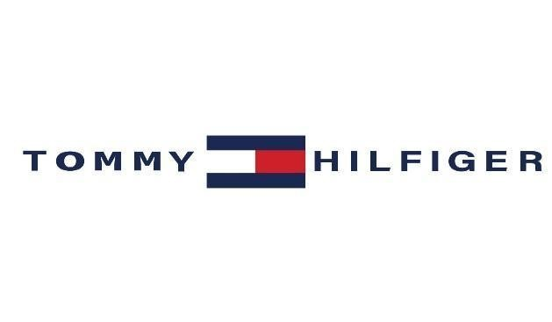
Tommy Hilfiger was born in 1952 and grew up in Elmira, New York. Tommy Hilfiger started as a fashion designer by driving to NYC, purchasing jeans, and selling them where there were not available in the rural area of Elmira, NY. Eventually he made enough money to open his own clothing stores throughout upstate New York. In time, he found himself considered one of the “4 Great American Designer for Men” from a very successful ad campaign Ralph Lauren, Calvin Klein, Perry Ellis, and Tommy Hilfiger.
His clothing was getting very popular and was surprisingly being worn by many different people of all ages and races. Tommy Hilfiger responded to the diversity of his customers by adding more variety to his clothing line. Tommy Hilfiger has succeeded in making clothing that many people enjoy wearing. His fragrances have been a huge success as well. The clothing line has expanded by including home products, eyewear, footwear, swimwear, jewelry and divisions such as Tommy Hilfiger Athletics. Tommy Hilfiger is a true American Designer.
Tommy Hilfiger’s clothing company, TOM Inc., has been amongst the leading exponents in this intensified process of mass customization over the last few years. indeed Hilfiger clothing can be seen as an extreme case of how the idea of mass designer fashion operates. Mass designer fashion is a specific formation within the industry; it is not equivalent to traditional haute couture nor is mass designer fashion equivalent to standard garment production. Mass designer fashion is that peculiar formation which occurs within this nexus of the globalizing economy and the concomitant expansion of the means of consumption.
Almost by definition it demands the capture of ever wider segments of the mass market at the same time as it needs to maintain familiar standards of product differentiation between brands, and offer frequent variation. Thus Hilfiger’s relative importance and visibility in this context is in part a result of an ongoing strategy which has put his company in a position to cover just about all segments of the clothing market, but which also marks the products as identifiable and unique, offering appreciably variable “looks” or themes from season and year to year.

3.2. TOMMY HILFIGER IN INDIA
Hilfiger was in India to unveil the first set of stores in New Delhi, Mumbai and Bangalore, and renew his ties with the country which date back to 1978. Tommy Hilfiger was brought to India through a joint venture between the Murjani group and the Lalbhai group, which owns the ‘Arvind’ brand. Called Arvind Murjani Brands Private Limited, the joint venture had entered into a licensing agreement for marketing and distribution of Tommy Hilfiger.
AMD introduced the Tommy Hilfiger men’s sportswear, men’s Jeanswear and juniors Jeanswear collections in freestanding specialty stores across country in spring 2004. Tommy Hilfiger Inc., through its subsidiaries, designs, sources and markets men’s and women’s sportswear, Jeanswear and children’s wear under the Tommy Hilfiger trademarks. Its products can be found in leading department and specialty stores throughout the United States, Canada, Europe, Mexico, Central and South America, Japan, Hong Kong, Australia, other countries in the Far East.

3.3. SYMBOL

If you by any coincidence are familiar with the International Code of Signals, then you might recognize the emblem used by Tommy Hilfiger (at least, its central part). The combination of the white and red fields stands for the letter “H” (“Hotel”) in the list of International maritime signal flags. Its direct meaning is “I have a pilot on board.”
Of course, when Tommy Hilfiger borrowed the flag, he was not interested in its direct meaning: he just opted for the “H” character because it was his initial. So, in this case, “H” standard for “Hilfiger”.

3.4. EMBLEM
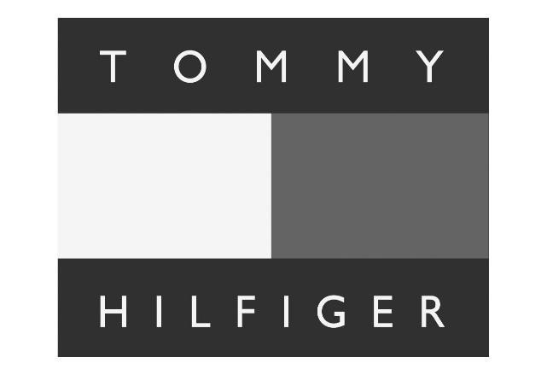
The emblem reflects the core values of the brand. From the very start, Tommy Hilfiger imagined his marque as nautical and preppy-inspired. Also, the choice of the color palette emphasizes the brand’s American spirit.

3.5. BRAND IDENTITY AND BRAND IMAGE
Brand identity is how a brand expects the consumers to perceive your product or brand.
Tommy Hilfiger’s main brand identity traits are following:
- Strong identified logo with blue, red and white three main colours
- Special packages with consistent visual of main colours
- A brand that can prove your unique taste
- A brand that can demonstrate your social status and wealth level
- Can provide the best after-sales service
Brand image is the perception of the product or brand by consumers. The brand image traits are proved by following points:
- A place where consumers can buy unique American Style apparels
- A brand whose products can show consumers’ social status
- A brand of which garments can give people a sense of youth
- Products are too expensive to afford

3.6. PROBLEMS ORGANISATION OF THE COMPANY
The foundations of the Indian textile trade with other countries began as early as the Second century BC. The silk fabric was a popular item of Indian export to Indonesia around the 13th century, where these were used as barter for spices. Towards the end of the 17th century, the British East India Company had begun exports of Indian silks and various other cotton fabrics to other countries. These include the famous fine Muslin cloth of Bengal, Bihar and Orissa. The trade in painted and printed cottons or chintz, flavored in the European Market at that time, was extensively participated between India, China, Java and Philippines, long before arrival of the Europeans.
Together with allied agriculture sector, it provides employment to over 82 million people by the end of the tenth plan period. The contribution of this industry to the gross export earnings is over 23 percent while it adds only 3 percent to the gross import bill of the country. It has been estimated that India has approximately 30000 readymade garment manufacturing units in the country. It is the only industry which is self-reliant, from raw material to the highest value-added products viz. garment/made-ups. Cotton accounts for more than 73 percent of the total fiber consumption in the textile sector. The Indian textile industry contributes substantially to India’s export earnings. The 1996 Indian textile exports approximately amounted to Rs.35000 crores of which apparel occupied over Rs.14000 crores. At present, the exports of textiles account for about 24.46 percent of total exports from India and are the largest net foreign exchange earner for the country as the import content in textile goods is very little as compared to other major export products.
The clothing sector is a labour-intensive, low wage industry and a dynamic, innovative sector, depending on which market segments one focuses upon. In the high-quality fashion market, the industry is characterized by modern technology, relatively well-paid workers and designers and a high degree of flexibility. The competitive advantage of firms in this market segment is related to the ability to produce designs that capture tastes and preferences-in addition to cost effectiveness. Another major market segment is mass production of lower quality and standard products such as T-shirts, uniforms, white underwear etc., and manufacturers for this market segment are largely found in developing countries, often in export processing zones and under outward processing agreements with major importers. They employees mainly female workers semi-skilled and unskilled and outsourcing to household production are quite common in the low end of the market. In the low to middle priced market, the role of the retailer has become increasingly prominent in the organization of the supply chain. The retail market has become more concentrated, leaving more market power to multinational retailers.
Globalization has put forth India’s business community in the international market. Various foreign trade policies and investment policies have been framed to facilitate foreign trade and increase the profitability of the Indian garment manufacturers. The advent of liberal trade policies in textile and garments sector have made it possible of usage of modern technologies and international methods manufacturing clothes. The sector of garments is one of the most successful and important in terms of foreign exchange generation and employment generating field. It provides employment to lakhs of people and is most sort out and booming industry of India.
It is essential that the textile engineering industry is assured of substantial and sustained demand from the textile industry to enable it to turnout sophisticated and latest generation machines. Frequent interactions between the users and the manufacturing industries should take place to understand and mitigate each other’s problems.

3.7. COMPETITOR’S INFORMATION
PROFILE OF COMPETITORS:
- Duke
- Benetton
- Levis
- Rebook

DUKE
Duke, reportedly rated by ORG-MARG as the top T-shirt maker in the country, prices its T-shirts in the Rs.199-699 range. It also makes trousers, shirts, jackets, sweaters and will begin making thermal underwear this year. T-shirts account for 60-65 percent of the company’s total revenues. Domestic sales account for 80 percent. Its overseas buyers include Gap, Wal-Mart and target.
Today, Duke embraces a complete vertically integration garment manufacturing plant, with knitting, dyeing, processing, finishing, mercerizing, compacting, embroidery and printing under one roof. Production facilities are located in India and Nepal.
Duke Fashion (India) Ltd pioneered the T-shirt culture, and gradually established several new trends in knitted garments and fabric research. In 1998, thermal wear was introduced for the first time in India, under the brand name of Neva. Two other group constituents, Venus garments
(India) limited and Deekay export are also there. The group also consists of Duke Fabrics and Glaze Garments. Duke is acknowledge today as the undisputed leader, with a turnover of Rs.
1250 million over 500000 garment units are produced every month by over 2000.

BENETTON
When Benetton was started in 1989 in India, all they founded themselves selling were jeans and t-shirts. With television serials like ‘Friends’ and ‘Ally McNeal’ market waves on the small screen, people began to feel that it is okay to be wearing trousers and jackets, evening clothes and party wear, Benetton now sells 1500 styles as compared to the 400 they started shop with. The 17 billion Italian fashion companies had entered India through a joint venture with DCM but now Benetton India is a wholly owned subsidiary after they broke up about a year

LEVIS
Levis is a future brand in the Indian context. Levis has excellent brand architecture in place, and it is performing well. The market for denim, especially at the premium end, is growing between 15 and 20 percent annually. The overall domestic Denim market in the top six metros is estimated at 12 million pieces annually. The mass-priced segment of Rs.300-500 accounts for six million pieces. The mid-priced market up to Rs. 1000 chips in with three million pieces, while the premium end of above Rs.1000 accounts for another three million, which include 0.4 million over the price point of Rs.1400.
The four sub-brands are pretty well straddled. We have 30 percent of the premium denim market in the country, and about 10 percent of the overall market across price segments.

REEBOK
Reebok is the brand for sportswear like shoes, t-shirts etc., while Rockport is for a premium range of footwear and apparel market by 3Rs rugged, refined and relaxed, explained Mr. Manish Dawar, country manager, Rockport. Entering India in 1995, reebok has captured a market share of 50 percent followed by Nike.. As a marketing tactic, the MNC promotes fitness through aerobics. The girls are trained for six months by an expert from the USA.

3.8. SWOT ANALYSIS OF ORGANIZATION
- Strength
- Weakness
- Opportunities
- Treat

STRENGTHS
The strengths of Tommy Hilfiger looks at the key aspects of its business which gives it competitive advantage in the market. Some important factors in a brand’s strengths include its financial position, experienced workforce, product uniqueness & intangible assets like brand value. Below are the Strengths in the SWOT Analysis of Tommy Hilfiger :

- Tommy Hilfiger has a strong recognition being a successful global brand offering premium clothing.
- The company has a very strong distribution network across the world
- Tommy Hilfiger has its presence in more than 100 countries and more than 1500 retail stores in North America, Europe, Central and South America and Asia Pacific.
- The brand offers cool, American style designs by reputed designer Tommy Hilfiger
- Associations and promotion from popular celebrities has helped the brand grow significantly over the years
- Advertising and brand visibility via TV ads, print media, online forums and digital marketing make the brand popular
- The brand has won several awards and accolades at global level

WEAKNESS
The industry suffers from certain inherent weakness which has been responsible for its apparent inability to capitalize on many of its advantage. These are as following:
- Decentralized structure of industry
- Old and outdated machinery
- Shortage of trained manpower
- Restricted fabric base
- Restricted export ranges
DECENTRALIZED STRUCTURE OF INDUSTRY:
The industry is highly decentralized. At the top of the exporting chain is the merchant exporter who canvasses for and finally executes the import orders. The production operations however are carried out by independent and individual fabricating units who are sometimes assisted by button-holing in its & other small processing units. Although this factor gives the industry some degree of operationally flexibility. It can cause hardships if the merchant exporter has not control or little control over the fabricators leading to delayed shipments and needless trade disputes.
OLD AND OUTDATED MACHINERY:
Compared to most of the other exporting nations of the world. The Indian garment sector is equipped with obsolete machinery in many cases with simple pedal operated machines with hardly any productivity. This problem is only now being addressed with a liberalized import policy.
SHORTAGE OF TRAINED MANPOWER:
Although labour in India is plentiful the garment sector has been experiencing a shortage of skilled labour force like expect cutters, machine operator, designers and so on in the different manufacturing centers. This also a problem of migrant labour force which have no stakes in the industry particularly in a place like Delhi which has often posed a problem to entrepreneurs.
RESTRICTED FABRIC BASE:
While acknowledging the fact that Indian has vast and variegated textile industry it has been recognized that the production of specialized & heavier varieties of fabrics like drills twills, gabardines corduroys velvets & denims etc. is generally of very poor quality of grossly inadequate for the requirements of the Indian garment sector. This has preclude the garment sector from producing heavier garments for winter wear or the finer varieties for sport wear and so on.
RESTRICTED EXPORT RANGES:
The limitations experienced by the Indian garment sector in regard to fabrics has its impact in the export sector also. Currently India’s apparel exports are more or less confined to light weight cotton garments made from the power loom sector mainly for summer wear. These items are also used as casual wear. There is huge international demand for standard garments like formal wear shirts & trousers besides children’s garments made out of polyester cotton blends besides clothing & industrials clothing in which India has currently little or no representation.
From analysis of India’s strengths & weakness in the garment industry it emerges that on the balance the strengths in the industry are more pronounces. Also many of the weakness mentioned are now being suitably addressed by the government of Indian. For instance the establishment of the institute of fashion technology by the ministry of textiles should overcome the problem of obtaining skilled technicians & designers for the industry. The industry on its part has also result in the induction of modern and update machines into this sector which will improve its productivity. The industry is also going in for marketing tie-ups with some of the reputed international brand leaders of specific varieties of garments like jeans & sportswear which augurs well for quality & variety of garment to be manufactured in the country in the future.

OPPORTUNITIES
With each product category opportunities exist because products in which Indian exports have minimal share have been showing a substantial growth rate. India needs to expend its potential in these markets. Indian also has to sustain its product categories where to demand for imports as are showing a declining trend. Opportunities also exist in product diversification into new products categories of formal knitwear which fashion forecasts predict as a booming industry all over the world.
Indian exporters should improve their manufacturing system quality speed and efficiency in order to effectively enter markets which will yield great value realization & more value added profits margins. India’s exports readymade garments mill it badly most of the would want to import trade sanction against the country for conducting their nuclear sanction have come at a time when India’s garments exports hence started picking of the period of stagnation which determined at for India’s garment export back.

THREAT
The threats for any business can be factors which can negatively impact its business. Some factors like increased competitor activity, changing government policies, alternate products or services etc. can be threats. The threats in the SWOT Analysis of Tommy Hilfiger are as mentioned:
- Intense competition from international brands can lead to loss of business revenue
- Economic slowdown & recession, which will cause reduction in demand for premium priced products can be a threat for Tommy Hilfiger brand
- Constantly changing fashion trends means inventory issues for a global brand
3.9. TOMMY HILFIGER MISSION, VISION & VALUES :
TOMMY HILFIGER MISSION STATEMENT
Our mission is to be one of the leading sustainable designer lifestyle brands through how we create our product, manage our operations and connect with our community and our Stakeholders.
TOMMY HILFIGER VISION STATEMENT
- It’s a Sustainable Evolution
TOMMY HILFIGER VALUES
- Individuality
- Partnership
- Passion
- Integrity
- Accountability

3.10. AWARDS & ACHIEVEMENTS
- In 1995, he received the title of ‘Menswear Designer of the Year’, which was conferred by the Council of Fashion Designers of America.
- In 1998, he received the ‘Designer of the Year ‘ award, which was conferred by the Parsons School of Design in New York City.
- In 2006, he received the Individual Achievement Award from the Hispanic Federation.
- In 2009, he received the UNESCO Support Award and the Marie Claire Lifetime Achievement Award.

3.11. PRODUCTS OF TOMMY HILFIGER
Tommy Hilfiger caters to a large audience in the market thus it needs to provide them with different products to keep them in the trend. Following are some of the products that Tommy Hilfiger provides:
- Apparel
- Accessories
- Fragrances
- Home wares

3.12. CHRONOLOGY: TOMMY HILFIGER
- 1952: Born.
- 1971: Opened People’s Place in Elmira, New York.
- 1981: Founded 20th Century Survival.
- 1982: Started to design women’s clothing.
- 1985: Hired by Mohan Murjani to oversee design of Coca–Cola clothing line.
- 1986: Launched Tommy Hilfiger clothing line, backed by Murjani.
- 1989: Formed Tommy Hilfiger, Inc. with Silas Chou.
- 1992: Tommy Hilfiger Corp. is made public.
- 1997: Opened Tommy Hilfiger store on Rodeo Drive.
- 1997: Published All American: A Style Book.
- 1999: Named in class–action law suit charging manufacturers of violating workers’ rights.
- 1999: Published Rock Style: How Fashion Moves to Music.
- 1999: Sponsored Metropolitan Museum of Art exhibition of rock music fashion.

3.13. COMPETITIVE ADVANTAGE


BRAND IMAGE
- Tommy Hilfiger is one of the leading designer brands that is doing extremely well in the market. It enjoys a unique position in the premium designer brand. The brand has a wide range of products that give the brand extremely high brand visibility.
- The ranges of products include eyewear, watches, fragrance home furnishings and women’s wear which is marketed extremely well. The brand’s global retail sale amounted to $7.4 billion in 2017.
- Tommy Hilfiger has good quality, stylish designer products that people want to be associated with.

INNOVATION
- The brand recently announced the highest tech collection called Tommy Jeans Explore that uses Bluetooth technology to track how often a consumer wears the product and also where the consumer wears the product.
- The brand seeks to find micro-community of brand ambassadors with this initiative and also offers rewards based upon each of the usages of the item. The main idea was to offer more from the brand to its loyal consumers. The app-based feature would also increase the points the customer gets when they would pass through certain locations.
- These technology-based initiatives have increased the brand loyalty of consumers.

GLOBAL MARKETING STRATEGY
- Tommy Hilfiger being one of the world’s leading designer brands engages customers through various marketing and advertising campaigns the marketing strategies are comprehensive 360° which focuses on digital marketing experiences and innovative experiences.
- In the year 2018, Tommy Hilfiger celebrated the designer’s love towards pop culture, fashion, music through different brand partnerships and celebrity collaboration driving the high number of sale and also engaging new customers and making it attractive for the millennial consumers.
- In 2017, the total expenditure on marketing was $180 million globally for marketing and communication initiatives.

3.14. CUSTOMER ANALYSIS IN THE MARKETING STRATEGY OF TOMMY HILFIGER
- The brand targets a wide demographic and targets and attracts younger customers. It has a children’s line and also clothes designed for older customers. According to Hilfiger, he wants to keep the brand younger and keep it cool.
- The recent collaboration with Gigi Hadid helped the brand get access to her 30 million fan base and it was seen that brand was able to generate double-digit sales growth after the collaboration. The brand finds an innovative way to engage and entertain the millennial consumers across the world, to become their choice of fashion

3.15. HILFIGER MARKETING STRATEGY & MARKETING MIX (4PS)
Tommy Hilfiger marketing strategy helps the brand/company to position itself competitively in the market and achieve its business goals & objectives.
Let us start the Tommy Hilfiger Marketing Strategy & Mix to understand its product, pricing, advertising & distribution strategies:
- Product Strategy
- Pricing Strategy
- Place and Distribution Strategy
- Promotional and Advertising Strategy

PRODUCT STRATEGY
- Tommy Hilfiger is a leading fashion label having a wide clothing range and strong global presence.
- They provide style, quality and value to the buyers and focus on the American classic designs by adding a youthful twist to them.
- Tommy Hilfiger also has products for kids’ section.
- Tommy Hilfiger Denims brand is targeted at a younger customer section of 18-30 years old, and has more edgy and casual designs.
- The brand has also committed itself to not use exotic animal skin for any of its products.
- As a part of its innovation, the brand has created a clothing line for a neutral gender in 2021.

PRICING STRATEGY
- Tommy Hilfiger is a high-end fashion brand and charges premium on its products, but as compared to its competitors like Ralph Lauren and Lacoste, its prices come in the lower segment.
- This has decreased its brand equity among the users since its high glory phase of the 90’s.
- The company follows a discount based pricing model in its marketing mix and offers sale on products in major off seasons.
- The Hilfiger collection is priced in the higher segment as it can charge premium based on its value, quality and New York fashion week runway designs.
- Similarly, the Tommy Hilfiger Tailored collection also charges premium based on value based pricing and customized fit.
- The price range for most of the clothes lies anywhere between $10 to $500.

PLACE AND DISTRIBUTION STRATEGY
- Tommy Hilfiger is global brand and therefore has a global presence through its huge chain of retail stores and online shopping website.
- Tommy Hilfiger caters to a wide variety of customers Its head office is in Amsterdam, Netherlands.
- The company has its own stores as well as a franchise based model for retail.
- It has flagship stores are in the major cities around the world- New York, London, Paris, Tokyo, Los Angeles and Dusseldorf.
- The store layouts reflect the classic cool American style and the upbeat Tommy Hilfiger designs.

PROMOTIONAL AND ADVERTISING STRATEGY
- Tommy Hilfiger follows an aggressive marketing strategy using different channels to reach out to its customers and thus has a very high brand visibility.
- Tommy Hilfiger uses magazine ads, newspaper ads and billboards for promotions.
- Its current brand ambassador is supermodel Gigi Hadid.
- It also uses point of sale promotions by making their store layout in line with the preppy fashion they offer.
- They also launched a virtual reality store experience in 2015 which was a big hit among the customers.
- The buyers could watch the 2015 Fall Hilfiger Collection in 360-degree 3D virtual reality from front row and shop the collection immediately.
- But this was available only in select flagship and franchise stores.
- For online promotions, it gives special offers on its website.

CHAPTER-4
ANALYSIS OF THE INTERPRETATION`OF DATA

STATISTICAL TOOL
- Simple Percentage Method
- Weighted Average Method
- Rank Analysis

4.1. SIMPLE PERCENTAGE
The percentage method is used for comparing certain feature. The collected data respondents in the form of table and graphs in order to give effective visualization of comparison made.
No of Respondents
SIMPLE PERCENTAGE METHOD = ________________________ X 100
Total no of Respondents

TABLE NO-4.1.1 SHOWING THE GENDER
OF THE RESPONDENTS

S.NO | GENDER | NO OF  RESPONDENTS | PERCENTAGE
1 | Male | 77 | 58
2 | Female | 55 | 42
 | Total | 102 | 100
Source: Primary data

INTERPRETATION
The above exhibit portrays that 58% of the respondents are male and the remaining 42% of them are female.
CHART NO.4.11 SHOWING THE GENDER OF
THE RESPONDENTS

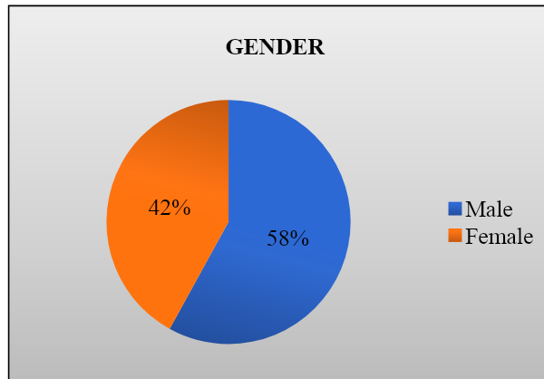

TABLE NO-4.1.2 SHOWING THE AGE OF THE RESPONDENTS

S.NO | AGE | NO OF  RESPONDENTS | PERCENTAGE
1` | Below 20 | 28 | 21
2 | 21-30 | 58 | 44
3 | 31-40 | 40 | 30
4 | Above 40 | 6 | 5
 | Total | 132 | 100
Source: Primary data

INTERPRETATION
The above exhibit says 21% of the respondents are below-20 age and 44% of the respondents are between 21-30 ages, 30% of the respondents are between 31-40 ages and the remaining 5% are above 40 age.
CHART NO.4.1.2 SHOWING THE AGE OF THE
RESPONDENTS

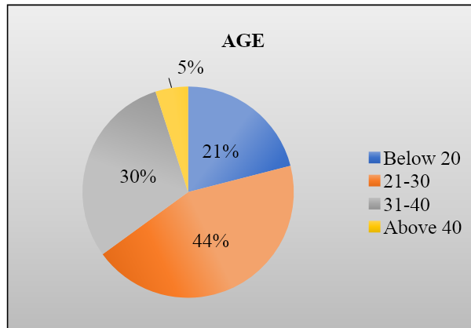
TABLE NO-4.1.3 SHOWING EXPENSES OF PURCHASING
OF THE RESPONDENTS

S.NO | EXPENSES OF  PURCHASING | NO OF  RESPONDENTS | PERCENTAGE
1 | Below 5000 | 33 | 25
2 | 5000-10000 | 42 | 32
3 | 10000-20000 | 45 | 34
4 | Above 20000 | 12 | 9
 | Total | 132 | 100
Source: Primary data

INTERPRETATION
The above exhibit shows 25% of the respondents expenses of purchasing is below-Rs5000, 32% of the respondents expenses of purchasing is Rs5000-10000, 34% of the respondents expenses of purchasing is Rs 10000-20000, 9% of the respondents expenses of purchasing is above-Rs20000.
CHART NO.4.1.3 SHOWING EXPENSES OF PURCHASING
OF THE RESPONDENTS
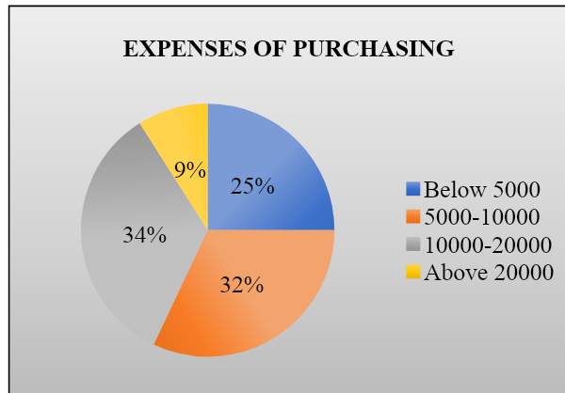
TABLE NO-4.1.4 SHOWING OCCUPATION OF THE RESPONDENTS

S.NO | OCCUPATION | NO OF  RESPONDENTS | PERCENTAGE
1 | Self employed | 36 | 27
2 | Salaried | 41 | 31
3 | Students | 51 | 39
4 | Others | 4 | 3
 | Total | 132 | 100
Source: Primary data

INTERPRETATION
The above exhibit shows 39% of the respondents occupation is students and 31% of the respondents are salaried and the 27% of the respondents occupation is self- employed and remaining 3% of the respondents are others.
CHART NO.4.1.4 SHOWING OCCUPATION OF
THE RESPONDENTS
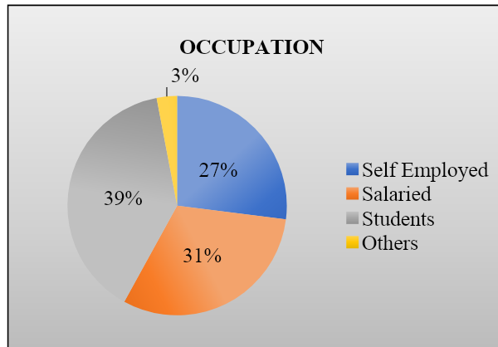
TABLE NO-4.1.5 SHOWING THE USING OF ALL THE
UPDATED PRODUCTS OF THE RESPONDENTS

S.NO | USING ALL UPDATED  PRODUCTS | NO OF  RESPONDENTS | PERCENTAGE
1 | Yes | 54 | 41
2 | No | 39 | 29
3 | Rarely | 39 | 30
 | Total | 132 | 100
Source: Primary data

INTERPRETATION
The above exhibit shows 41% of the respondents are using all the updated products of Tommy Hilfiger, 29% of the respondents are not using all the updated products of Tommy Hilfiger and remaining 30% of the respondents rarely using all the updated products of Tommy Hilfiger

CHART NO.4.1.5 SHOWING THE USING OF ALL
THE UPDATED PRODUCTS OF THE RESPONDENTS

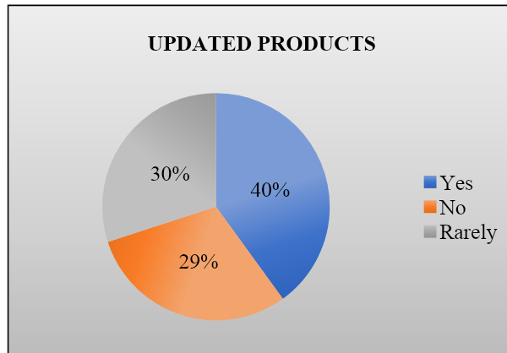
TABLE NO-4.1.6 SHOWING FAMOUS PRODUCTS
IN TOMMY HILFIGER OF THE RESPONDENTS
S.NO | FAMOUS IN  TOMMY  HILFIGER | NO OF  RESPONDENTS | PERCENTAGE
1 | Sports wear | 35 | 27
2 | Footwear | 49 | 37
3 | Men’s wear | 33 | 25
4 | Women’s wear | 15 | 11
 | Total | 132 | 100
Source: Primary data

INTERPRETATION
The above exhibit shows that 27% of the respondents are saying sportswear is famous in Tommy Hilfiger,37% of the respondents are saying footwear is famous, 25% of the respondents are saying men’s wear is famous, 11% of the respondents are saying women’s wear is famous in Tommy Hilfiger.
CHART NO.4.1.6 SHOWING FAMOUS PRODUCTS
IN TOMMY HILFIGER OF THE RESPONDENTS
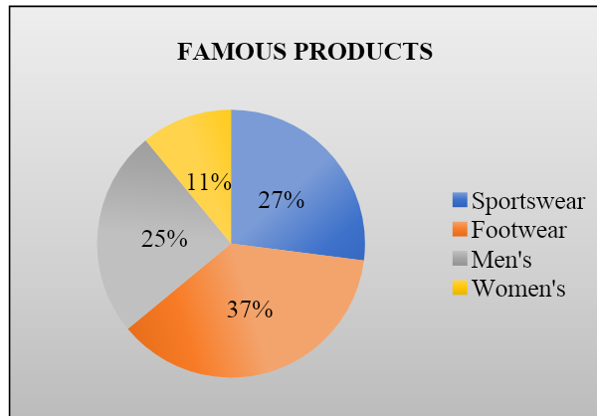
TABLE NO-4.1.7 SHOWING SATISFACTION ON PURCHASES
BASED ON PRICE AND OFFERS OF THE RESPONDENTS
S.NO | PURCHASES  BASED ON  PRICE AND  OFFER | NO OF  RESPONDENTS | PERCENTAGE
1 | Good quality | 61 | 46
2 | Eco-friendly | 59 | 45
3 | Economics | 12 | 9
 | Total | 132 | 100
Source: Primary data

INTERPRETATION
The above exhibit shows that 46% of the respondents purchase based on price and offer is good quality, 45% of the respondents purchase based on price and offer is eco-friendly and remaining 9% of the respondents purchase based on price and offer is economical.
TABLE NO.4.1.7 SHOWING SATISFACTION ON PURCHASES
BASED ON PRICE AND OFFERS OF THE RESPONDENTS

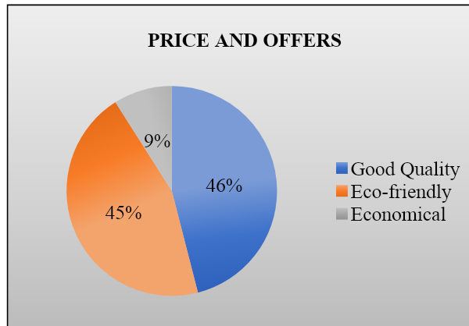
TABLE NO-4.1.8 SHOWING FAST MOVING
PRODUCTS IN SPORTS THE RESPONDENTS
S.NO | FAST MOVING  PRODUCTS IN  SPORTS | NO OF  RESPONDENTS | PERCENTAGE
1 | Gym items | 29 | 22
2 | Yoga pants | 51 | 39
3 | Running products | 31 | 24
4 | Smart watches | 21 | 15
 | Total | 132 | 100
Source: Primary data

INTERPRETATION
The above exhibit represent that 22% of the respondents choosing gym items as a fast moving product, 39% of the respondents choosing yoga pants as a fast moving products, 24% of the respondents choosing running pouches as a fast moving product and remaining 15% of the respondents choosing smart watches as a fast moving product in sports
CHART NO-4.1.8 SHOWING FAST MOVING
PRODUCTS IN SPORTS OF THE RESPONDENTS

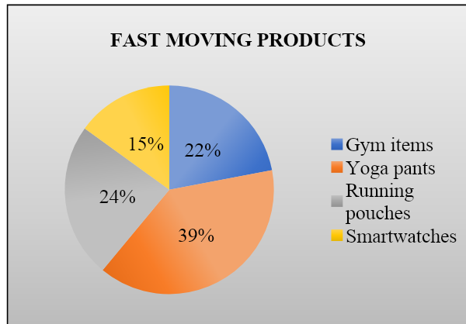
TABLE NO-4.1.9 SHOWING NON-VERBAL COMMUNICATION
SATISFIED THE CUSTOMER OF THE RESPONDENT

S.NO | SATISFIED THE  CUSTOMER | NO OF  RESPONDENTS | PERCENTAGE
1 | Satisfied | 48 | 36
2 | Happy | 53 | 40
3 | Neutral | 31 | 24
4 | Unsatisfied | _ | _
 | Total | 132 | 100
Source: Primary data

INTERPRETATION
The above exhibit represents that 36% of the respondents are satisfied on non-verbal communication, 40% of the respondents are happy on non-verbal communication, 25% of the respondents are neutral on non-verbal communication.
CHART NO-4.1.9 SHOWING NON-VERBAL COMMUNICATION
SATISFIED THE CUSTOMER OF THE RESPONDENTS

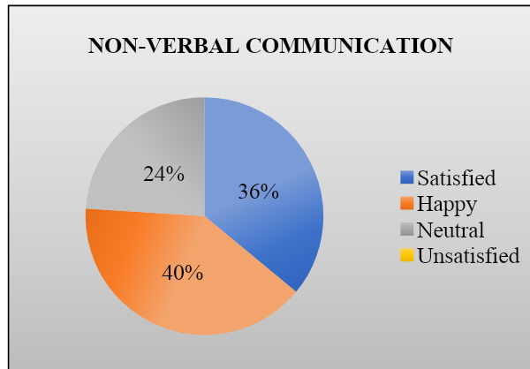
TABLE NO-4.1.10 SHOWING THE AVAILABLE OF
PRODUCTS IN TOMMY OF THE RESPONDENTS

S.NO | AVAILABLE OF  PRODUCTS | NO OF  RESPONDENTS | PERCENTAGE
1 | Watches | 34 | 26
2 | T -shirts | 57 | 43
3 | Jeans | 29 | 22
4 | Trolley bags | 12 | 9
 | Total | 132 | 100
Source: Primary data

INTERPRETATION
The above exhibit portrays that 26% of the respondents saying available of product is watches, 43% of the respondents saying available of product is T-shirts, 22% of the respondents saying available of product is jeans, 9% of the respondents saying available of product is trolley bags Tommy Hilfiger.
CHART NO-4.1.10 SHOWING THE AVAILABLE OF
PRODUCTS IN TOMMY OF THE RESPONDENTS

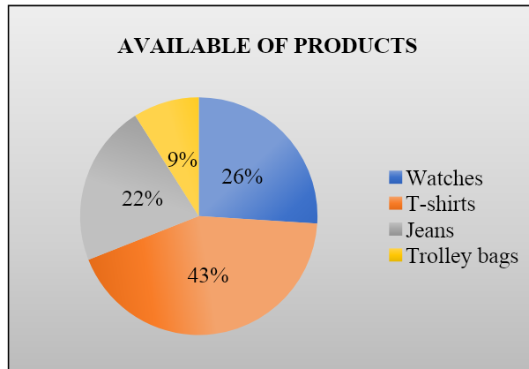
TABLE NO-4.1.11 SHOWING THE RESPONDENTS FOR TYPE
OF PRODUCT DO YOU PREFER IN TOMMY HILFIGER

S.NO | TYPE OF PRODUCT | NO OF  RESPONDENTS | PERCENTAGE
1 | Accessories | 20 | 15
2 | Clothes | 79 | 60
3 | Handbags shoes | 16 | 12
4 | Shoes | 17 | 13
 | Total | 132 | 100
Source: Primary data

INTERPRETATION
The above exhibit represent that 15% of the respondents are prefer accessories in Tommy Hilfiger, 60% of the respondents are prefer Clothes in Tommy Hilfiger, 12% of the respondents are prefer handbag in Tommy Hilfiger,13% of the respondent are prefer shoes in Tommy
Hilfiger.
CHART NO-4.1.11 SHOWING THE RESPONDENTS FOR TYPE
OF PRODUCT DO YOU PREFER IN TOMMY HILFIGER
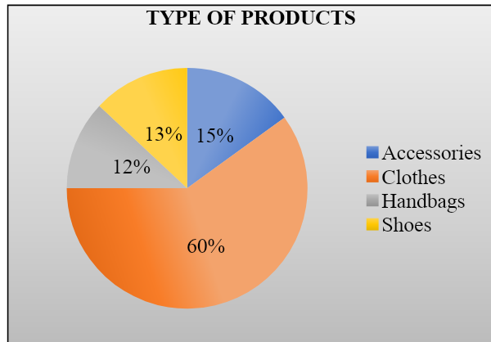
TABLE NO-4.1.12 SHOWING THE TYPE OF SOURCE
TRUST INITIALLY OF THE RESPONDENTS

S.NO | TYPE OF  SOURCE | NO OF  RESPONDENTS | PERCENTAGE
1 | Peers | 21 | 16
2 | Advertisement | 60 | 46
3 | Website | 36 | 27
4 | Family members | 15 | 11
 | Total | 132 | 100
Source: Primary data

INTERPRETATION
The above exhibit shows that 16% of the respondents are come to know about Tommy Hilfiger with the help of their peers, 46% of the respondents are come to know about Tommy Hilfiger with the help of the advertisement, 27% of the respondents of the respondents are come to know about Tommy Hilfiger with the help of the website and remaining 11% of the respondents are come to know about Tommy Hilfiger with the help of their family members.

CHART NO-4.1.12 SHOWING THE TYPE OF SOURCE
TRUST INITIALLY OF THE RESPONDENTS
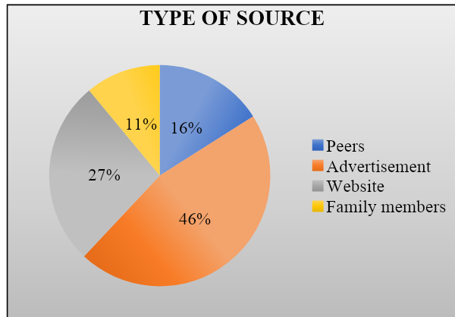
TABLE NO-4.1.13 SHOWING THE RESPONDENTS
SATISFIED WITH PRICE OF ACCESSORIES

S.NO | PRICE OF ACCESSORIES | NO OF  RESPONDENTS | PERCENTAGE
1 | High | 28 | 21
2 | Very high | 67 | 51
3 | Moderate | 36 | 27
4 | Low | 1 | 1
 | Total | 132 | 100
Source: Primary data

INTERPRETATION
The above exhibit represent that 21% of the respondents are satisfied with price of accessories is high, 51% of the respondents are satisfied with price of accessories is very high, 27% of the respondents are satisfied with price of accessories is moderate and remaining 1% of the respondents are not satisfied with price of accessories in Tommy Hilfiger.
CHART NO-4.1.13 SHOWING THE RESPONDENTS
SATISFIED WITH PRICE OF ACCESSORIES
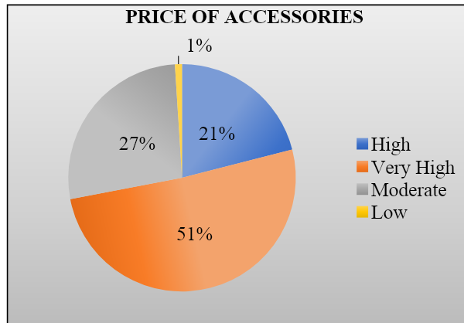

TABLE NO-4.1.14 SHOWING THE RESPONDENTS
PREFER TO PURCHASE ON TOMMY HILFIGER
S.NO | PREFER TO  PURCHASE | NO OF  RESPONDENTS | PERCENTAGE
1 | During offer season | 33 | 25
2 | During peak season | 48 | 36
3 | During fall in sale volume | 30 | 23
4 | During occasion | 21 | 16
 | Total | 132 | 100
Source: Primary data

INTERPRETATION
The above exhibit shows that 25% of the respondents are prefer to purchase during offer season, 36% of the respondents are prefer to purchase during peak season, 23% of the respondents are prefer to purchase during fall in sale volume and remaining 16% of the respondents are prefer to purchase during occasion in Tommy Hilfiger.
CHART NO-4.1.14 SHOWING THE RESPONDENTS
PREFER TO PURCHASE ON TOMMY HILFIGER

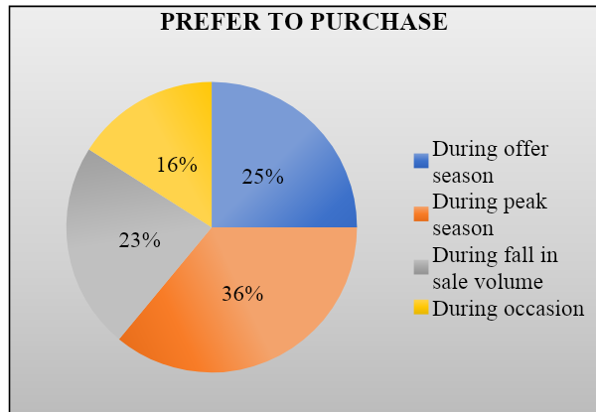
TABLE NO-4.1.15 SHOWING THE SALES PROMOTION
OF THE RESPONDENTS FOR MORE ATTRACTIVE

S.NO | MORE  ATTRACTIVE | NO OF  RESPONDENTS | PERCENTAGE
1 | Offers | 29 | 22
2 | Coupons | 62 | 47
3 | Discounts | 41 | 31
 | Total | 132 | 100
Source: Primary data

INTERPRETATION
The above exhibit represent that 22% of the respondents are used to push sales in offers, 47% of the respondents are used to push sales in discounts and remaining 31% of the respondents are used to push sales in coupons
CHART NO-4.1.15 SHOWING THE SALES PROMOTION
OF THE RESPONDENTS FOR MORE ATTRACTIVE
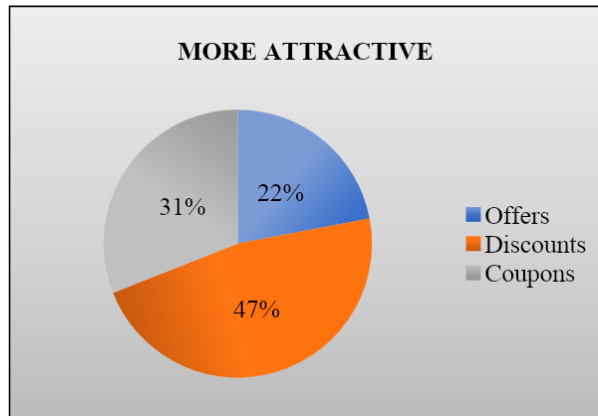

TABLE NO-4.1.16 SHOWING THE RESPONDENTS IF
BRAND IS NOT AVAILABLE IN NEARLY BY SHOP

S.NO | BRAND IS NOT  AVAILABLE | NO OF  RESPONDENTS | PERCENTAGE
1 | Wait for availability | 53 | 40
2 | Change the product | 46 | 35
3 | Change brand | 19 | 14
4 | Go to other store | 14 | 11
 | Total | 132 | 100
Source: Primary data

INTERPRETATION
The above exhibit shows that 40% of the respondents will wait for availability of the accessories, 35% of the respondents will change the product, 14% of the respondents will change the brand and remaining 11% of the respondents will go to other store.
CHART NO-4.1.16 SHOWING THE RESPONDENTS IF
BRAND IS NOT AVAILABLE IN NEARLY BY SHOP
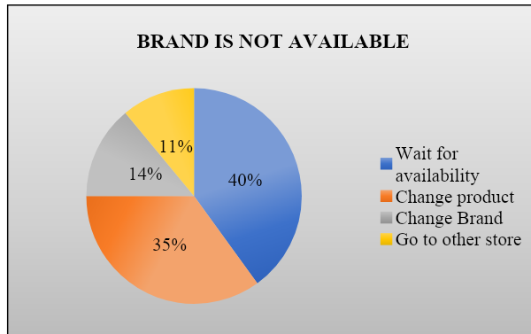

TABLE NO-4.1.17 SHOWING THE RESPONDENTS HOW SALES
PERSON REACT IF PURCHASE PROLONGS FOR LONGER TIME
S.NO | SALES PERSON  REACT | NO OF  RESPONDENTS | PERCENTAGE
1 | Pleasantly | 39 | 30
2 | Fair | 63 | 47
3 | Irritated | 25 | 19
4 | Impatiently | 5 | 4
 | Total | 132 | 100
Source: Primary data

INTERPRETATION
The above exhibit shows that 30% of the respondents will treat pleasantly if purchase prolongs for longer time, 47% of the respondents will treat fair if purchase prolongs for longer time, 19% of the respondents will treat irritated if purchase prolongs for longer time, 4% of the respondents will treat impatiently if purchase prolongs for longer time.
CHART NO-4.1.17 SHOWING THE RESPONDENTS HOW SALES
PERSONREACT IF PURCHASE PROLONGS FOR LONGER TIME

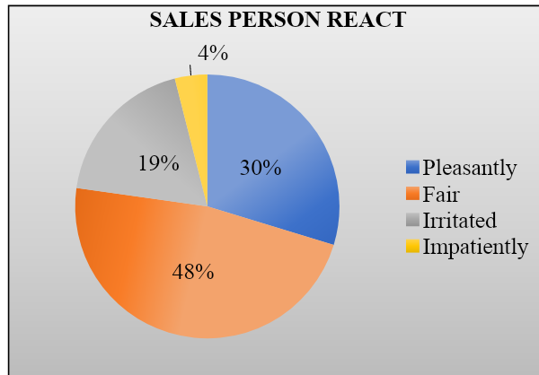
TABLE NO-4.1.18 SHOWING THE RESPONDENTS OF THE
SHOPPING EXPERIENCE AT TOMMY HILFIGER

S.NO | SHOPPING EXPERIENCE | NO OF  RESPONDENTS | PERCENTAGE
1 | Good | 35 | 27
2 | Excellent | 76 | 58
3 | Very poor | 6 | 4
4 | Average | 15 | 11
 | Total | 132 | 100
Source: Primary data

INTERPRETATION
The above exhibit shows that 27% of the respondents rated that shopping experience is good, 58% of the respondents rated that shopping experience is excellent, 4% of the respondents rated that shopping experience is very poor and the remaining 11% of the respondents rated that shopping experience is average in Tommy Hilfiger.
CHART NO-4.1.18 SHOWING THE RESPONDENTS OF THE
SHOPPING EXPERIENCE AT TOMMY HILFIGER
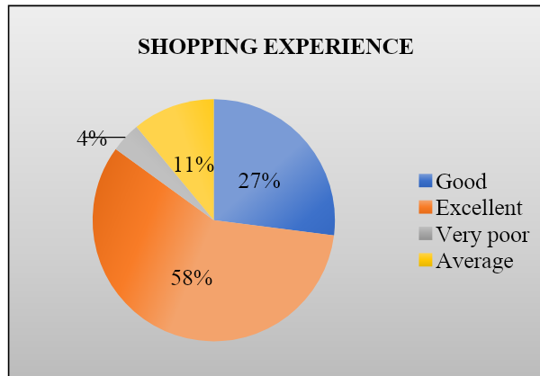
TABLE NO-4.1.19 SHOWING THE RESPONDENTS
DESCRIBING THE BRAND IN ONE WORD

S.NO | BRAND IN ONE WORD | NO OF  RESPONDENTS | PERCENTAGE
1 | Classic | 22 | 17
2 | Comfort | 52 | 39
3 | Unexpected twist | 29 | 22
4 | Attractive | 22 | 17
5 | Cool | 7 | 5
 | Total | 132 | 100
Source: Primary data

INTERPRETATION
The above exhibit represent that 17% of the respondents are saying Tommy brand is a classic, 39% of the respondents are saying Tommy brand is a comfort, 22% of the respondents are saying Tommy brand is a unexpected twist, 17% of the respondents are saying Tommy brand is a attractive one and remaining 5% of the respondents are saying Tommy brand is a cool.
CHART NO-4.1.19 SHOWING THE RESPONDENTS
DESCRIBING THE BRAND IN ONE WORD
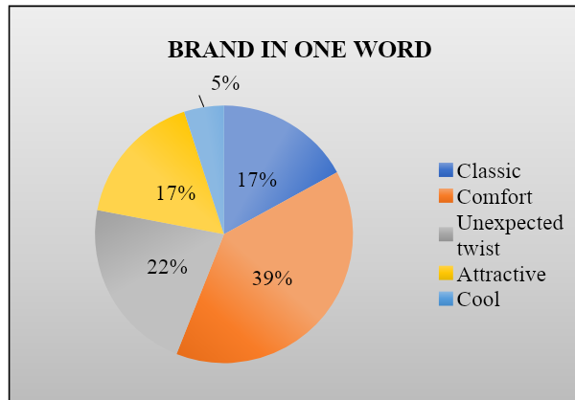
TABLE NO-4.1.20 SHOWING THE RESPONDENTS TO
PURCHASE THE PRODUCT AGAIN AND AGAIN

S.NO | PURCHASE THE  PRODUCT AGAIN  AND AGAIN | NO OF  RESPONDENTS | PERCENTAGE
1 | Brand name | 45 | 34
2 | Quality | 51 | 39
3 | Service | 25 | 19
4 | Pride | 11 | 8
 | Total | 132 | 100
Source: Primary data

INTERPRETATION
The above exhibit says that 34% of the respondents are purchase mostly by the brand name, 39% of the respondents are purchase mostly by the quality, 19% of the respondents are purchase mostly by the service and remaining 8% of the respondents are purchase mostly by the pride.
CHART NO-4.1.20 SHOWING THE RESPONDENTS TO
PURCHASE THE PRODUCT AGAIN AND AGAIN
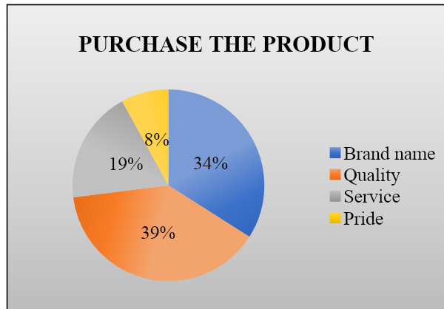
TABLE NO-4.1.21 SHOWING THE RESPONDENTS OF
THE CUSTOMER SERVICE IN TOMMY HILFIGER

S.NO | CUSTOMER SERVICE IN TOMMY | NO OF  RESPONDENTS | PERCENTAGE
1 | Good | 43 | 33
2 | Moderate | 32 | 24
3 | Fair | 57 | 43
4 | Moderate | _ | _
 | Total | 132 | 100
Source: Primary data

INTERPRETATION
The above exhibit shows that 33% of the respondents rated that customer service in tommy Hilfiger is good, 43% of the respondents rated that customer service in Tommy Hilfiger is fair and remaining 24% of the respondents rated that customer service in Tommy Hilfiger is moderate.
CHART NO-4.1.21 SHOWING THE RESPONDENTS OF THE
CUSTOMER SERVICE IN TOMMY HILFIGER
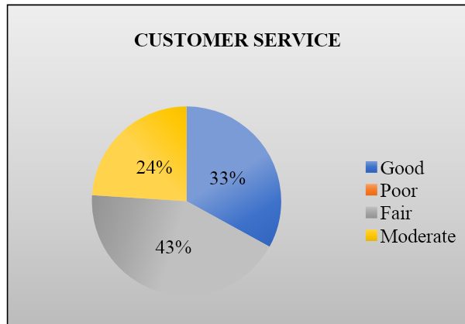

4.2. WEIGHTED AVERAGE METHOD
A weighted average is an average in which each observation in the data set is assigned or multiplied by a weight before summing to a single average value. In this process, each quantity to be averaged is assigned a weight that determines the relative importance of each quantity. Weightings are the equivalent of having that many like items with the same value involved in the average.
A weighted average score takes different scores, or grades, with assigned weights, or percentages. To calculate a weighted average with percentages, each category value must first be multiplied by its percentage. Then all of these new values must be added together.
Weighted Average Method=Sum of weight terms/Total no. of terms
TABLE NO -4.2.1 SHOWING THE RESPONDENTS OF THE
IMPORTANT FACTOR THAT WOULD SHOW A POSITIVE
APPROACH FROM CUSTOMER
IMPORTANT  FACTOR | SA | A | N | DA | SD  A | TOTAL | WEIGHTED  AVERAGE | RANK
Comfortness | 55 | 45 | 27 | 3 | 2 | 544 | 4.13 | 3
Good in quality | 68 | 51 | 9 | 3 | 1 | 578 | 4.37 | 1
Quantity | 52 | 55 | 13 | 9 | 3 | 540 | 4.09 | 4
Economical | 30 | 44 | 36 | 17 | 5 | 473 | 3.58 | 5
Brand | 65 | 48 | 12 | 7 | - | 567 | 4.29 | 2

INTERPRETATION
The above exhibit indicates the first weighted is given for Good in quality by the consumer and the last weighted is given for economical by the consumer

4.3. RANK ANALYSIS
A ranking is a relationship between a set of items such that, for any two items, the first is either ‘ranked higher than’, ‘ranked lower than’ or ‘ranked equal to’ the second. In mathematics, this is known as a weak order or total pre order of objects. It is not necessarily a total order of objects because two different objects can have the same ranking. The rankings themselves are totally ordered.
TABLE NO 4.3.1 SHOWING THE RANK ACCORDING TO THE
RESPONDENTS PREFERENCE TOWARDS TOMMY HILFIGER
PREFERENCE | NO OF RESPONDENTS | TOTAL | RANK
Quality | 98 | 31 | 5
Customer preference | 94 | 30 | 4
Odours colours and stylish | 88 | 28 | 3
Variety of products available | 73 | 23 | 2
Quantity | 60 | 20 | 1

INTERPRETATION
The above exhibit indicates respondents preference towards Tommy Hilfiger for quantity of products (ranked first) and followed by variety of products available (ranked second), Odour colors and stylish (ranked third), customer preference (ranked fourth) and quality of products (ranked fifth) given by the consumer.

CHAPTER -5
FINDINGS AND SUGGESTIONS

5.1. FINDINGS

5.1.1. SIMPLE PERCENTAGE METHOD
- Majority of 58% of the respondents are male.
- 44% of the respondents belong to the age group of 21-30 years old.
- 32% of the respondents expenses for purchasing Tommy products is Rs.5000-10000.
- 39% of the respondents are students using Tommy products
- 40% of the respondents using all the updated products of Tommy Hilfiger ❖ 37% of the respondents say footwear is famous in Tommy Hilfiger.
- 46% of the respondents are satisfied with purchasing good quality products.
- 39% of the respondents are choosing yoga pants are fast moving products in sports.
- 40% of the respondents are happy on non- verbal communication.
- 43% of the respondents are choosing T-shirts are available products in Tommy Hilfiger.
- Majority of 60% of the respondents prefer clothes in Tommy Hilfiger.
- 46% of the respondents came to know about Tommy Hilfiger in advertisement.
- Majority of 51% of the respondents were satisfied with the price of accessories in Tommy
Hilfiger.
- 36% of the respondents preferred to purchase on during peak season.
- 47% of the respondents are used to push sales in discounts.
- 40% of the respondents will wait for availability of the accessories.
- 47% of the respondents will treat it fair if purchase prolongs for a longer time.
- Majority of 58% of the respondents rated that shopping experience in Tommy Hilfiger is excellent.
- 39% of the respondents describing a brand in one word is comfort in Tommy Hilfiger.
- 39% of the respondents are purchasing mostly by quality.
- 43% of the respondents rated that customer service is fair in Tommy Hilfiger.

5.1.2. WEIGHTED AVERAGE METHOD
❖ The important factor that indicates the first weighted is given for Good in quality by the consumer and the last weighted is given for economical by the consumer

5.1.3. RANK ANALYSIS
❖ The respondents preference towards Tommy Hilfiger for quantity of products (ranked first) and followed by variety of products available (ranked second), Odour colors and stylish (ranked third), customer preference (ranked fourth) and quality of products (ranked fifth) given by the consumer.

5.2. SUGGESTION
- The most important suggestion that can be given is to provide Seasonal and Festival offers.
- Increase brand awareness through targeted advertising and social media campaigns
- Expand the product range to offer a wider variety of clothing and accessories
- Offer personalized styling and fitting services to enhance the shopping experience
- Collaborate with local influencers and celebrities to create buzz around the brand
- Host exclusive events and sales promotions to attract new customer
- Invest in visually appealing store designs and displays to create an immersive shopping experience.

5.3 CONCLUSION
Tommy Hilfiger is a global fashion brand, providing premium clothing and accessories to its customers. Through a market analysis of Coimbatore city, it was observed that there is a significant potential for the brand to expand and increase its customer base in the city.
However, the brand needs to consider the local preferences and customs and offer products that cater to the city’s unique taste. Additionally, it needs to focus on effective marketing strategies that resonate with the target audience and differentiate it from its competitors.
Overall, with the right approach and execution, Tommy Hilfiger can successfully capitalize on the potential of Coimbatore city and establish a strong market presence.

BIBLIOGRAPHY
- https://www.oxfordreference.com/display/10.1093/acref/9780192800978.001.0001/acr ef-9780192800978-e-382
- https://www.referenceforbusiness.com/history2/1/Tommy-Hilfiger-Corporation.html
- https://www.businessoffashion.com/community/people/tommy-hilfiger
- https://www.theguardian.com/fashion/2023/feb/20/tommy-hilfiger-interview-fashion
-brand-history
- https://issuu.com/ellienicholls97/docs/tommy_hilfiger_brand_book__1
- https://www.ajio.com/b/tommy-hilfiger?gclid=CjwKCAjw0N6hBhAUEiwAXab-TW
HLB38aAWCJu7j2jlrp5ZZcX_9PDPxTZgvwgo66_HhHpSh5ZpOaQRoCffcQAvD_
BwE
- https://www.crunchbase.com/organization/tommy-hilfiger
- https://www.highrevenuegate.com/nuxjk9bv2?key=9ca601a9f47c735df76d5ca46fa26 a66&submetric=18452496
- https://www.encyclopedia.com/people/literature-and-arts/fashion-biographies/tomm y-hilfiger
- https://www.citethisforme.com/topic-ideas/business-marketing/Tommy%20Hilfiger-
74534866
- https://www.thehut.com/blog/fashion/who-is-tommy-hilfiger/
- https://issuu.com/ellienicholls97/docs/tommy_hilfiger_brand_book__1
- https://www.farfetch.com/style-guide/how-to/what-is-tommy-hilfiger/
- https://www.pvh.com/brands/tommy-hilfiger
- https://apparelgroupglobal.com/en/tommy-hilfiger/
- https://pipecandy.com/companies/tommy-hilfiger-corporation
- https://www.standout.co.uk/blog/the-history-and-popularity-of-tommy-hilfiger/
- https://en.m.wikipedia.org/wiki/Tommy_Hilfiger_(company)
- https://www.arvindfashions.com/tommy-hilfiger/
- https://www.citethisforme.com/topic-ideas/other/Tommy%20Hilfiger%20Bibliograp hy-36422679

REFERENCE TO BOOKS
- John W Santrock, 2007, “A Topical Approach to Life Span Development” 3rd Edition,
Tata McGraw Hills, ISBN 0-07-061570-5
- Robert S Feldman, 2006, “Understanding Psychology” 6th Edition, Tata McGraw
Hills,ISBN 0-07-058698-5
3. Joeseph F Hair, Jr., Rolph E Anderson, Ronald L Tatham, William C Black, 2003,
“Multivariate Data Analysis”, 5th Edition, Pearson Education, ISBN 81-297-0021-2
4. C R Kothari, 2005, “Research Methodology, Methods and Techniques” 2nd Edition, New
Age International Publishers, ISBN 81-224-1522-9

ANNEXURE

- Name: ________________
- Gender
  - Female
b)Male
c) Others
- Age
  - below 20
  - 21-30
  - 31-40
d)Above 40
- Expenses of purchasing your Tommy products
  - below 5000
  - 5000-10000
  - 10000-20000
d)above 20000
- Occupation
  - Self employed
b)Salaried
c) Students
d)Others
- Are you using all the updated Products of Tommy Hilfiger
  - Yes
  - No
  - Rarely
- Tommy Hilfiger is famous for
  - Sportswear
  - footwear
  - men’s
  - Women’s
- Have you satisfied on purchasing of Tommy Hilfiger brand based on price and offers
  - Good quality
  - Eco-friendly
  - Economical
- Fast moving products in sports
  - Gym items
  - yoga pants
  - Running Pouches
  - Smartwatches
- The non verbal communication satisfied the customer in Tommy Hilfiger
  - Satisfied
  - Happy
  - Neutral
  - Unsatisfied
- Available of products in Tommy Hilfiger
  - Watches
  - T-shirts
  - Jeans
  - Trolley bags
- What type of product do you prefer in Tommy hilfiger
  - Accessories
b)Clothes
c) Handbags
d)Shoes
- What type of source do you trust initially In Tommy Hilfiger
  - Peers
  - Advertisement
  - Website
  - Family members
- Are you satisfied with the price of accessories in Tommy Hilfiger?
  - High
  - Very High
  - Moderate
  - Low
- When you will prefer to purchase on Tommy Hilfiger
  - During offer season
  - During peak season
  - During fall in sale volume
  - During Occasion
- Which type of sales promotion More attractive in Tommy Hilfiger
  - Offers
  - Coupons
  - Discounts
- What will you do when your Brand is not available in the nearly shoppers shop?
  - Wait for availability
b)Change product
c) Change Bran
d)Go to other store
- How does the salesperson react if the purchase prolongs for longer time
  - pleasantly
  - fair
  - Irritated
  - impatiently
- How was your shopping experience at Tommy Hilfiger
  - Good
b)Excellent
c) Very poor
d)Average
- ‘If you could describe the brand in one word what would it be
  - Classic
b)Comfort
c) unexpected twist
d)Attractive
- The factors which affect the customers to purchase the product again and again
  - Brand name
  - Quality
  - Service
  - pride
- How was the customer service in Tommy Hilfiger
  - Good
  - poor
  - Fair
  - Moderate
- Think ‘Smile’ is an Important factor that would show a positive approach to a customer.
  - Strongly agree
  - Agree
  - disagree
  - strongly disagree
- Rank according to your preference towards Tommy Hilfiger
  - Variety of product available
  - Customer prefer
  - Quality
  - Odour colours & stylish
  - Quantity

Hui Yun Yen, Po Hsien Lin, Rungtai Lin, 2014, Emotional product design and perceived brand emotion, Department of Advertising, Chinese Culture University, Taipei, Taiwan; Graduate school of creative industry design, National Taiwan University of Arts, Taipei, Taiwan; Received 4 Mar, 2014; Accepted 10 Apr, 2014; Published 10 May, 2014
Daikh, Jiana, "A Research Proposal: The Relationship between Customer Satisfaction and Consumer Loyalty" (2015). MBA Student Scholarship. 42.
S. Sheek Meeran, Ranjitham (2016) Impact of branding on Gen Y's choice of clothing. Journal of the South East Asia research centre for communications and Humanities.
Khan, A. A., Jadoon, S., & Tareen, N. A. K. (2016). Impact of advertising on brand awareness and commitment in female apparel industry. International Journal of Academic Research in Business and Social Sciences, 6(3), 79-94. ⁵ Salehzadeh and Pool,) October 2016 Journal of International Consumer Marketing
Bai, Y., Li, C., & Niu, J. (2016). Study on customer-perceived value of online clothing brands. American Journal of Industrial and Business Management, 6(08), 914.
Bikramjit Rishi, Preeti Tak, Ashish Pareek 2017, Social Comparison of Brands: Impact of Ostentation and Media Habits, February 2017
Ryding, D., Wang, M., Fox, C., & Xu, Y. (2017). A review of second-hand luxury and vintage clothing. In Sustainability in fashion (pp. 245-266). Palgrave Macmillan, Cham.
Bahar Cana Eker kan,2017 factors affecting customer satisfaction of luxury goods consumption: research on luxury eyewear consumption in Istanbul; yeditepe university; November, 2017.
Chaitanya Mahaprabhu Seth May 2018, " Sales Strategy of Tommy Hilfiger in India" Delhi School of Management, Delhi Technological University, Bawana Road, Delhi
Shibly, M. M. H., Yasmin, Z., Ahmed, M. S., & Swati, S. S. (2018). Understanding Apparel Preference of erent Social Status People of Bangladesh Apparel Market. Global Journal of Research. Diff
(Kip Becker, Jung Wan Lee, M. Nobre, 2018) The Concept of costly Brands and the Relationship between Consumer and Brands August 2018Journal of Asian Finance Economics and Business 5(3):51-63
Ekanayake, H. V., & Gunawardana, K. (2018). An Analysis of the Customer Experiences, Customer Involvement to Develop an Innovative Product and its impact on the Organization Performance in Apparel Industry. International Journal of Advanced RePerformance valuation: Customer Perceived Value Analysis. SCMS Journal of Indian Management.
AyselErcis and Bilal Celik (2018) Impact of value perceptions on luxury purchase intentions: moderating role of Consumer knowledge; Press Academia Procedia, V.7, p.52-56.
Yim, K. T. (2018). The Effect of Sports Brand Self-Image Congruity and Effect on Brand Attitude and Purchase Intension. Journal of the Korea Convergence Society.
Rasool, A., Tao, R., Marjan, K., & Naveed, T. (2019, March). Twitter Sentiment Analysis: A Case Study for Apparel Brands. In Journal of Physics: Conference Series, IOP Publishing.
Joanna Pietrzak,2019, Mass Prestige brands – the end of traditional luxury brand marketing? September 2019; University of Gdańsk
Nguyen Le, 2020 BRAND MANAGEMENT IN LUXURY MARKETING; Centria University of Applied Sciences; March 2020
Shuvo Ghosh,2020 A Visual report on Prada’s' Marketing & Branding strategies in Indian Market, June 2020; Report number: 1Affiliation: Birmingham City University
Anna Cabigiosu,2020, An Overview of the Luxury Fashion Industry; Department of Management, Ca’ Foscari University, Venice, Italy. Published on may 22,2020
Lavin, J. M. (2020). Type of Relationships and Their Management Towards Quality and Performance in the Textile and Apparel Industry: A Literature Review. In Management and Inter/Intra Organizational Relationships in the Textile and Apparel Industry.
Ozlem Kaya,2021 THE CHANGE OF THE PERCEPTION OF LUXURY BRAND; April 2021; Usak University.
Sharma, R., Ahuja, V., & Alevi, S. (2020). Developing a Research Instrument to Study the Impact of Consumer Brand Perception, Consumer Brand Relationship and Consumer Buying Behaviour on Online Apparel Shopping. In Digital and Social Media Marketing (pp. 67-81). Springer, Cham.
Hitesh Bhasian, 2022, Luxury Brand Marketing – Concept and Strategies, January 25, 2022; By Hitesh Bhasin; Tagged With: Branding.
Yajin Wang,2022, A conceptual framework of contemporary luxury consumption; China Europe International Business School, Shanghai, China. Volume 39, Issue 3, September 2022, Pages 788-803.

