PROJECT REPORT
on

Crime Prediction Using Machine Learning
SUBMITTED IN PARTIAL FULFILLMENT OF THE REQUIREMENT FOR THE AWARD OF THE DEGREE OF

BACHELOR OF TECHNOLOGY

(COMPUTER SCIENCE AND ENGINEERING)

SESSION-:(2022-23)
SUBMITTED BY

DEEPENDRA RAI (1900460100029)

DEEPAK SHARMA (1900460100028)

ABHISHEK GAUTAM (1903490100002)


Dr APJ Abdul Kalam Technical University, Uttar Pradesh LUCKNOW, INDIA

MAY 2022-2023

CERTIFICATE

This is to certify that project report entitled “CRIME PREDICTION USING MACHINE LEARNING” which is submitted by Deependra rai, Deepak sharma, Abhishek Gautam in partial fulfillment of the requirement for the award of degree B.Tech in department of Computer Science & Engineering of Maharana Pratap Engineering College affiliated to Dr. A.P.J. Abdul Kalam Technical University, Lucknow is a record of the candidates own work carried out by them under my/our supervision. The project embodies result of original work and studies carried out by the students themselves and the contents of the project do not form the basis for the award of any other degree to the candidate or to anybody else.

Signature: Signature:
Mr. Subhash Chandra Dr. Saurabh Singh
(H.O.D.)
CSE Department,
MPEC, Kanpur

ACKNOWLEDGEMENT

We take this opportunity to express our sincere gratitude and respect to MPEC, Kanpur for providing us a platform to pursue our studies and carry out our final year project. We have a great pleasure in expressing our deep sense of gratitude to Mr. Subhash Chandra constant encouragement. We would like to thank, Dr Saurabh singh Professor and Head, Department of Computer Science and Engineering, MPEC, Kanpur, who has been a constant support and encouragement throughout the course of this project.
I would like to express my deepest gratitude to my guide, Mr. Subhash Chandra his valuable guidance, consistent encouragement, timely help and providing me with an excellent atmosphere for doing research. All through the work, spite of his busy schedule, he has extended cheerful and cordial support to me for completing this research work.

TABLE OF CONTENTS :-
- Abstract
- Acknowledgement
- Table of contents
- Table of content
5. INTRODUCTION
5.1 Related Work
5.1.1 Research questions
5.1.2 Databases
5.1.3 Search strategy
5.1.4 Search strings
5.1.5 Selection criteria
5.1.6 Collecting and Filtering
6. Results
7. Discussion
8. SYSTEM ANALYSIS AND DESIGN
8.1 Initial Engine Design
8.2 Use Cases
9.DFD-0 LEVEL DIGRAM
10.DFD-1 LEVEL DIGRAM
11.ER-DIGRAM
12. PROBLEM FORMULATION
9.1 Dataset Formulation
13. Limitations
14. Future research outlooks
16.CONCLUSION AND FUTURE SCOPE
13.1 Conclusion
13.2 Future Scope
13.3 References

Abstract

Predicting crimes before they occur can save lives and losses of property. With the help of machine learning, many researchers have studied predicting crimes extensively. In this paper, we evaluate state-of-the-art crime prediction techniques that are available in the last decade, discuss possible challenges, and provide a discussion about the future work that could be conducted in the field of crime prediction. Although many works aim to predict crimes, the datasets they used and methods that are applied are numerous. Using a Systematic Literature Review (SLR) methodology, we aim to collect and synthesize the required knowledge regarding machine learning-based crime prediction and help both law enforcement authorities and scientists to mitigate and prevent future crime occurrences. We focus primarily on 68 selected machine learning papers that predict crime. We formulate eight research questions and observe that the majority of the papers used a supervised machine learning approach, assuming that there is prior labeled data, and however in some cases, there is no labeled data in real-world scenarios. We have also discussed the main challenges found while conducting some of the studies by the researchers. We consider that this research paves the way for further research to help governments and countries fight crime and decrease this for better safety and security.

Keywords Machine learning · Artificial Intelligence · Feature selection · Crime prediction · Neural networks · Crime

DECLARATION
We here by declare that this submission is our own work and that, to the best of my knowledge and believe, it content no material previously publish or written by another person nor-material which to a substantial extend has been expected for the aboard of any other institute of higher learning, except were due acknowledgement has been made in the text.

Signature

Deependra Kumar Rai (1900460100029)

Abhishek Gautam (1903490100002)

Deepak Sharma (1900460100028)

Introduction
A crime is a form of violence or illegal act done by a perpetrator against another person that can cause harm or property damage and is punishable by the law of the governing state of authority in which the crime was carried out. Law authorities apply crime-solving techniques to take preventive measures but in many cases, they cannot deliver effective results (Dakalbab et al. 2022). Over the years, crimes have continued to increase within countries. In another study, it is stated that the top three countries with the highest crimes
Venezuela, and Papua New Guinea (Materekeet al. 2021). As the population of a country increases, crime rates within that country increase (Walczak 2021), this also impacts the accurate prediction of crime (Pratibha et al. 2020). The safety and security of a country are a very important part of its growth and economic development, crime prediction will decrease economic loss and increase public safety in exchange (Toppi Reddy et al. 2018; Rumi et al. 2018). Governments are responsible for ensuring the safety of their citizens to control and maintain crime incidents, threats, and data being collected to better the lives of their citizens (Butt et al. 2020).
Data mining and ML are both versatile fields that involve the use of computers and mathematics where the programming is completed for the system to perform certain tasks, these are both important parts of crime prevention and detection (Bandekar and Vijayalakshmi 2020). Data mining can be considered as the process where discovers of new patterns from large data sets involving methods from statistics and AI, but also database management.
Different techniques have been developed for crime prediction and in recent years, more researchers are publishing
papers and finding interest in the topic, which can be seen in the upward trend of publications between 2021 and 2022 in Fig. 2. Crime is a growing pandemic that contributes to social and economic issues which in turn negatively affect the development of a country and its communities (Matereke et al. 2021). Both social and economic elements, a.k.a., features, contribute to a perpetrator committing a crime or a victim being the subject of a crime, these features can be used to predict the future occurrence of future crimes and help decrease crime rates across many communities (Hajela et al. 2020).
The availability of enormous volume of data being made available by certain governments has given motivation to researchers to further pursue research in the field of crime. Historical data has made it an interesting subject that sparked attention in research, many researchers have proposed several different models for predicting the future occurrence of crimes (Pratibha et al. 2020). In some areas law authorities have restrictions over their data and may not make this available to researchers in the area, causing further frustration and disappointment.
Governments and police have access to a large amount of data that could be used to help reduce the crime rate (Yuki et al. 2019). Crime pattern theory also suggests that offenders prefer not to venture into unknown territories or areas and that they would rather commit opportunistic and violent crimes by taking advantage of familiar areas they have previously encountered (Jalil et al. 2017). Crimes are also not distributed evenly and uniformly nor are they random in an area or city. A hotspot is defined as an area or region where crimes would commonly take place. Based on this knowledge, it is worth noting that mapping crime hotspots can help researchers understand the reasons behind frequent crimes in a specific area (Kadar and Pletikosa 2018; Kadar et al. 2019).
Machine learning (ML) is a subfield of Artificial Intelligence being used across many different fields today to predict the future occurrence of certain events as well as better decision making. ML can be understood as the study of computer algorithms that can automatically improve on their own through experience/learning and by the use of data. Deep Learning (DL) is a subset of machine learning that is inspired by how our brains function, this technique is an artificial neural network that includes many different layers and layer types (e.g., pooling layer, convolution layer, fully-connected layer, dropout layer) that attempt to replicate the behavior of our brains. There exist four types of learning types, which are supervised, semi-supervised, unsupervised, and reinforcement learning. AI comprises both computer and mathematics (i.e., statistics) aspects where the programming is performed for the system to perform a certain action, commonly associated with humans (He and Zheng 2021).
To develop a highly accurate crime prediction model, it is important to understand the nature of a crime (Elluri et al. 2019). The nature of a crime could include features relating to the crime such as the offender(s) age, gender, location, number of offenders, education status, income, the weapon used, victim(s) age, gender, location, economic status, education status, time, date, day of the week, year, month, to name a few.
In Fig. 1, we have identified the objectives for each of the articles in our paper, the articles have been categorized into 6 main objectives namely: Social media crime prediction, Novel crime prediction, Suspect or Offender prediction, Spatial–temporal crime hotspot prediction, Feature selection, and Crime patterns and mapping. We need to understand the objectives of the articles to draw accurate findings from our research, understand the direction, gaps, and challenges faced by other researchers in the study of crime prediction, and motivate the research taken.
Researchers have made numerous amounts of contributions to crime investigation and prediction. Unlike most industries; health care, transportation, agriculture, finance, retail, and customer services, crime prediction has a lack of comprehensive and systematic literature reviews, which can help to organize, and summarize existing literature, evidence, and challenges they encounter. This SLR study focuses on the prediction of future occurrences of crime using machine learning techniques between the years 2010 and 2022, to answer the identified research questions and provide further research on the gaps that have been recognized in the field. We seek to broaden the opportunity for further research on crime investigation and machine learning and our motivation for this work was not to only publish research on previous and current studies on crime prediction, but to:
- Demonstrate the need for the availability of crime data to researchers
- Help to decrease the crime rate in our communities by synthesizing the existing knowledge
- Identify the gaps in current findings
- Help to improve existing models
The purpose of this paper is to provide a better understanding of ML algorithms used in crime prediction and analysis. Contributions to crime prediction are ongoing. This SLR aims to cover literature between the Jan 2010 and August 2022 and is guided by the work (Catal 2012; Ligthart et al. 2021; Kitchenham and Charters 2007). These guidelines are used widely in literature for conducting SLR.
The rest of the paper is organized into the following sections: Sect. 2 presents the related work. Section 3 discusses the adopted research methodology followed
Novel Crime prediction model
Novel Crime
prediction model
%
53
Suspect/Offender
Prediction
%
4
Spao-Temporal
Crime Hotspot
Prediction
19
%
Feature selection
%
4
Crime prediction and
mapping
19
%
Social Media crimee
prediction
1
%
Spano-Temporal Crime Hotspot Prediction
Crime patterns and mapping
Fig. 1 Distribution of objectives
Suspect/Offender Prediction
Feature selection
Social Media crime prediction

throughout the paper. Section presents the results found in the SLR for the research questions we have identified. Section discusses our findings and results in detail and finally, in Sect. we present our conclusion and future work.

Related work
This study seeks to explore different machine learning algorithms and techniques used in crime prediction. Our findings are reported together with the challenges identified by the researchers to help gain a better understanding of the current state-of-the-art that is available to conduct further research and build better performing and more accurate models to fight crime.
A review (Falade et al. 2019) is conducted where they focused on crime prediction using data mining and further concluded that crime prediction using data mining is a hot research topic due to the impact of crime on the socio-economic development of a nation (Kounadi et al. 2020). They stated that the data being used could be statistical reports of crimes in an area or region. They also note that crime prediction research will positively benefit society in assisting law enforcement agencies and governments understand the multiple layers that contribute to the cause of a crime. This research may also aid governments in making better decision-making approaches for the security and safety of their citizens and provide a more proactive approach towards the improvement of communities and decrease in crime.
In 2020, a review (Butt et al. 2020) is published that discusses the approaches of Spnatio-temporal crime hotspot detection and prediction. The researchers state that the availability of large amounts of data that are being collected and made available to the public has made it more possible to conduct and pursue further research in the field of crime and crime investigation. The availability of historical data allows for the forecasting of future crimes, with it being a growing point of interest to develop significant machine learning models to assist in discovering different features that are related to crime prediction (Butt et al. 2020). It is also worth noting that the researchers proposed in their future work to explore the enhancement of clustering approaches for crime hotspot detection (DBSCAN), enhancement of time series analysis for crime forecasting (ARIMA), exploration of transfer learning in crime prediction, and the use of LSTM with exponential smoothing for crime prediction. The researchers concluded by stating, that for a novel spatial–temporal model, datasets should be produced to improve the proposed methods and that regions or countries should have datasets available or should collect data to help scientists in the development of better crime prediction methods to decrease crime and grow the country.
There is another a paper on spatial crime forecasting, spatial referring to space and time (Kounadi et al. 2020). The researchers investigated crime both in time and space in this paper. They followed the “PRISMA” (Liberati et al. 2009) reporting process in their review to report their findings and gain knowledge and analyze the state-of-the-art techniques and methods in current studies of crime prediction. Some of the limitations outlined by the researchers in the study included the terminology, which is not consistent and could be due to the different academic backgrounds of the stakeholders (e.g., criminology, data analyst, computer science, geoscience, and public policy) and those significant details of some experiments are partly or not at all reported.
Our last related work-study (Ippolito and Lozano 2020) focuses on tax crime prediction using machine learning. It was noted as a significant paper as this crime is known as a white-collar crime, most papers in the study focused on violent crimes. The researchers seek to better decision-making in fiscal audit plans relating to service taxes in the municipality of São Paulo. In the study, the researchers applied Neural Networks, Naïve Bayes, Decision trees, Ensemble learning, Random forests, and Logistic regression. The researchers also conducted manual face-to-face data collection of fiscal audits and plans from 2016 to 2019. The results obtained showed that Random Forest provides the highest accuracy of 66.2%. Machine learning can better assist governments in making better decisions and plans around tax audits. Tax crime prediction allows governments to prepare for these crimes before they are committed. They conclude by stating that machine learning helps make predictions on crimes against law systems, and predictions can guide better decision-making and planning of fiscal audits more assertively.
Governments and law enforcement agencies are the gatekeepers to crime datasets (historical and present) and ensure their maintenance thereof (Falade et al. 2019). Accurate predictions of future crimes can have a positive impact on society and the economy (Butt et al. 2020). It is seen from Ippolito et al. that a crime detection system can alert users and make them cautious of the crime they are about to commit and the likelihood of them being caught, the implementation of such a system in society could leverage the same impact on violent crime (Ippolito and Lozano 2020). Safer and more secure conditions lead to economic growth and sustainable development. The literature presents many different approaches to crime prediction using machine learning, compared to other review studies, to our knowledge this study includes recent papers and has different research questions applied. As such, the observations and suggestions are different than those of previous studies (Table 1).

Research methodology
Systematic literature reviews (SLRs) are and have been used in many different fields of academia from engineering to medicine to gather and summarize data on a certain research topic, we employed guidelines (Kitchenham et al. 2010) to follow a structured approach for our study. By using an SLR, we can also identify the challenges and possible solutions that can be employed. It defines the guidelines for the following three (3) main phases:
- Planning the review: Gathering related data and research work related to our research topic (i.e., the use of machine learning in crime prediction), defining research questions and systematic search protocols that include the selection of keyword strings to be used for related papers, and how this criterion will be applied to the papers. The planning phase also includes the following phases:
  - Identification of the need for a review
  - Commissioning a review
  - Specifying the research question(s)
  - Developing a review protocol
  - Evaluating the review protocol
- Conducting the review: Putting a classification schema in place, details on how the data and papers will be separated for analysis where features are grouped based on similar or common attributes. The papers are subject to inclusion and exclusion criteria. The papers that pass the criteria should meet the minimum quality assessment threshold, which is mostly selected as the mean value. Critical data from these papers are extracted and synthesized to present a general overview of the understanding of how machine learning can be used for crime prediction to identify possible gaps and opportunities in the selected field. The phases in the conducting phase include:
  - Identification of research
  - Selection of primary studies
  - Study quality assessment
  - Data extraction and monitoring
  - Data synthesis
- Reporting the review: The final step discusses and presents our findings, the research questions which were identified in step 1 are addressed and visually presented with graphs, figures, and tables if needed and may include:
  - Specifying dissemination mechanisms
  - Formatting the main report
  - Evaluating the report
3.1 Research questions
The research questions that are investigated are presented as follows:
- What are the objectives of the paper? To answer this question, we need to understand what the researcher aims to achieve. What is the desired output variable? (e.g., suspect detection, crime hotspot detection, etc.).
- What data source types have been used to collect data?
- What independent variables are (a.k.a., features) used in the publications?
- Which ML algorithm(s) performed best in the study?
- Which public datasets have been used?
- Which evaluation metrics have been applied?
- What are the top 5 ML categories?
- What challenges have the authors identified?
3.2 Databases
We used five top reliable and trustworthy scientific databases to find relevant papers for our study. We did not select Google Scholar because it indexes non-peer-reviewed papers and sometimes non-reputable journals as well. For searching the databases, we applied search strings, which are defined in Sect.
- ACM Digital Library (https://dl.acm.org/)
- IEEE Xplore (http://ieeexplore.ieee.org)
- Springer Link (https://link.springer.com/)
- Science Direct (http://www.Sciencedirect.com)
- Scopus (https://www.scopus.com/)
As shown in Table 4, IEEE Xplore provides the largest number of papers before and after the exclusion criteria, ACM Digital library being the lowest. Forward and backward snowballing was also applied in this SLR study to find more relevant papers. The papers that were collected using these methods were included in the study selection criteria and those that passed were added to the list of selected publications (Fig. 2).
  - Search strategy
We applied search parameters to the databases to collect the relevant papers for the study. An advanced search was applied to the selected databases, which included the following terms: “crime”, “crime prediction”, and “machine learning”. To help broaden our search string parameters, we read the abstract, introduction, and conclusion sections of the recent papers to find synonyms that could be included in the search string. Some of the identified words included “Neural Networks”, “Artificial Intelligence”, “Data mining” and/or “Crime patterns”. The search string that was used within each database is presented in the following subsection.
  - Search strings
We had to adjust the search string for each database to gather a more detailed search on our related papers for the SLR.
These search strings shown in Table 2 were applied to the databases in the title, abstract, and keywords fields. In Science Direct, we searched for “Crime Prediction” AND “Machine Learning” with Year between 2010 – 2022, this would ensure that we retrieved all the latest papers for the last 10 years. IEEE Xplore returned the largest amount of papers that we could use for our study, it is also one of the largest online scientific research databases, we applied “Crime Prediction” to all metadata, and “Crime Prediction” AND “Machine Learning” were applied to the document title. Finally, Springer Link was used and the search string applied with the title “Crime Prediction” AND “Machine learning” and a year range of 2010 and before 2023. Figure 3 shows the yearly trend of the selected papers.
  - Selection criteria
We define the selection criteria in the first phase of the guidelines to decrease any possibility of bias in the selection of the publications for the study. It is also employed to ensure that we process relevant studies, in our case, we would define these studies as those that can assist us in answering the research questions. We establish a criterion before we begin with the study to avoid and reduce the chance of a biased criterion (Kitchenhamet al. 2007). Papers should respond false to all the exclusion criteria and true to all the inclusion criteria.
The following criteria have been defined as the exclusion criteria:
- Only abstract is available
- The paper is not in English
- The publication is a review/survey paper

Table

1

Related review studies
Title
Description
Year
Reference
Survey on crime analysis and prediction using Data mining techniques
To perform a survey on supervised and unsupervised ML techniques for
criminal investigation
2017
David and Suruliandi (
2017
)
Survey of analysis of crime detection techniques using data mining and
machine learning
A survey paper on different data mining techniques used in crime investiga
-
tion
2018
Prabakaran and Mitra (
2018
)
A survey of research into artificial neural networks for crime prediction
The paper focuses only on the previous 8 years, to help identify the time and
place of the next crime occurrence
2019
Abbas et al. (
2019
)
Systematic literature review of crime prediction and data mining
Crime prediction and data mining techniques to aid in the prediction of
future occurrences of crime
2019
Falade et al. (
2019
)
Spatio-temporal Crime HotSpot detection and prediction: A systematic
Literature Review
Aims to provide core, bases for research on spatio-temporal crime hotspot
detection and prediction applications
2020
Butt et al. (
2020
)
A systematic review on spatial crime forecasting
The aim of the paper is to provide research and evaluate state-of-the-art
spatial crime forecasting, more focused on the design and technical aspects
2020
Kounadi et al. (
2020
)
Tax Crime Prediction with Machine Learning: A Case Study in the Munici
-
pality of São Paulo
To use ML to aid in decision-making in fiscal audit plans when referring to
service taxes in Sao Paulo
2020
Ippolito and Lozano (
2020
)
Predicting crime and other uses of neural networks in police decision mak
-
ing
Reviews and examines current research on the utilization of neural networks
for forecasting crime and other police decision-making
2021
Steven Walczak (
2021
)
Survey on crime analysis and prediction using data mining and ML tech
-
niques
Explores opportunities in analyzing large data repositories, analyzing
socioeconomic factors assigned with crime incidents, finding the outliers,
categorizing patterns, and designing effective models to predict crimes
using data mining and ML techniques
2021
Saravanan et al. (
2021
)
Comparative analysis of time series model and machine testing systems for
crime forecasting
Uses time series and machine testing systems for crime estimation, predict
-
ing the number of crimes
2021
Jha et al. (
2021
)
A survey on crime analysis and prediction
Analyzes historical data using deep learning, statistical models, and algo
-
rithms, and identifies different approaches used to predict and forecast
crime occurrences
2022
Thomas and Sobhana (
2022
)
Artificial intelligence and crime prediction: A systematic literature review
Evaluates models from different views; crime analysis type, crime studied
types, prediction technique, performance metrics and evaluations, strength
and weaknesses, limitation, and future works
2022
Dakalbab et al. (
2022
)

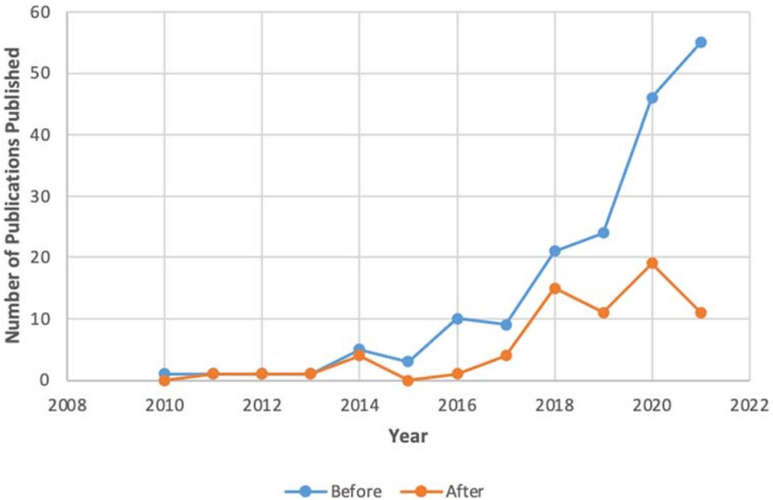
Fig. 2 Yearly trend of publications
- The publication is duplication and already retrieved from another database
- The paper does not explain in detail how Machine Learning was applied
3.6 Collecting and filtering

After collecting and finding various publications by applying the defined search strings to each database, we also used snowballing, the results obtained were then gathered in an excel spreadsheet to analyse and synthesize the data. All the papers that passed the selection criteria were subject to a quality assessment, which would enable us to narrow down the publications further, for high-quality papers to
Table 2 Databases and the search strings used for the study
be included as primary studies. It defines eight (8) quality assessment questions which we applied and then further scored a paper with 1 (yes/non-compliant), 0 (no/comply), and 0.5 (somewhat) against each question. If the score of the related paper is lower than 4.5 that paper was excluded, if that paper scored above 4.5, it was included. The quality assessment questions were defined as follows:
- Are the aims of the study clearly defined?
- Are the scope and experimental design of the study defined?
- Is the technology assessed or used clearly defined?
- Is the research process clearly defined?
Database | Search string
ACM Digital Library | 27 results for: [[Title: "crime"] OR [[Title: "crime prediction"] AND [Title: "machine learning"]]] AND [[Abstract: "crime prediction"] OR [Abstract: "machine learning"]] AND [Publication Date: (01/01/2010 TO 08/31/2022)]
IEEE Xplore | 116 for: ("All Metadata”: crime prediction) AND ("Document Title”: machine learning) AND ("Document Title”: crime) OR ("Document Title”: crime prediction)  Filters applied: 2010–2023
Springer Link | 25 Result(s): for ‘Crime prediction’ AND ‘Machine learning' within 2010–2022
Science Direct | 108 results for: Year: 2010–2022 Title: Crime OR Crime prediction AND Machine learning
Scopus | 77 document results: TITLE ( "CRIME" OR "CRIME PREDICTION" AND "MACHINE LEARNING") PUBYEAR > 2010 PUBYEAR < 2023 KEY ( "crime" AND "machine learning")

- Are all the study questions answered?
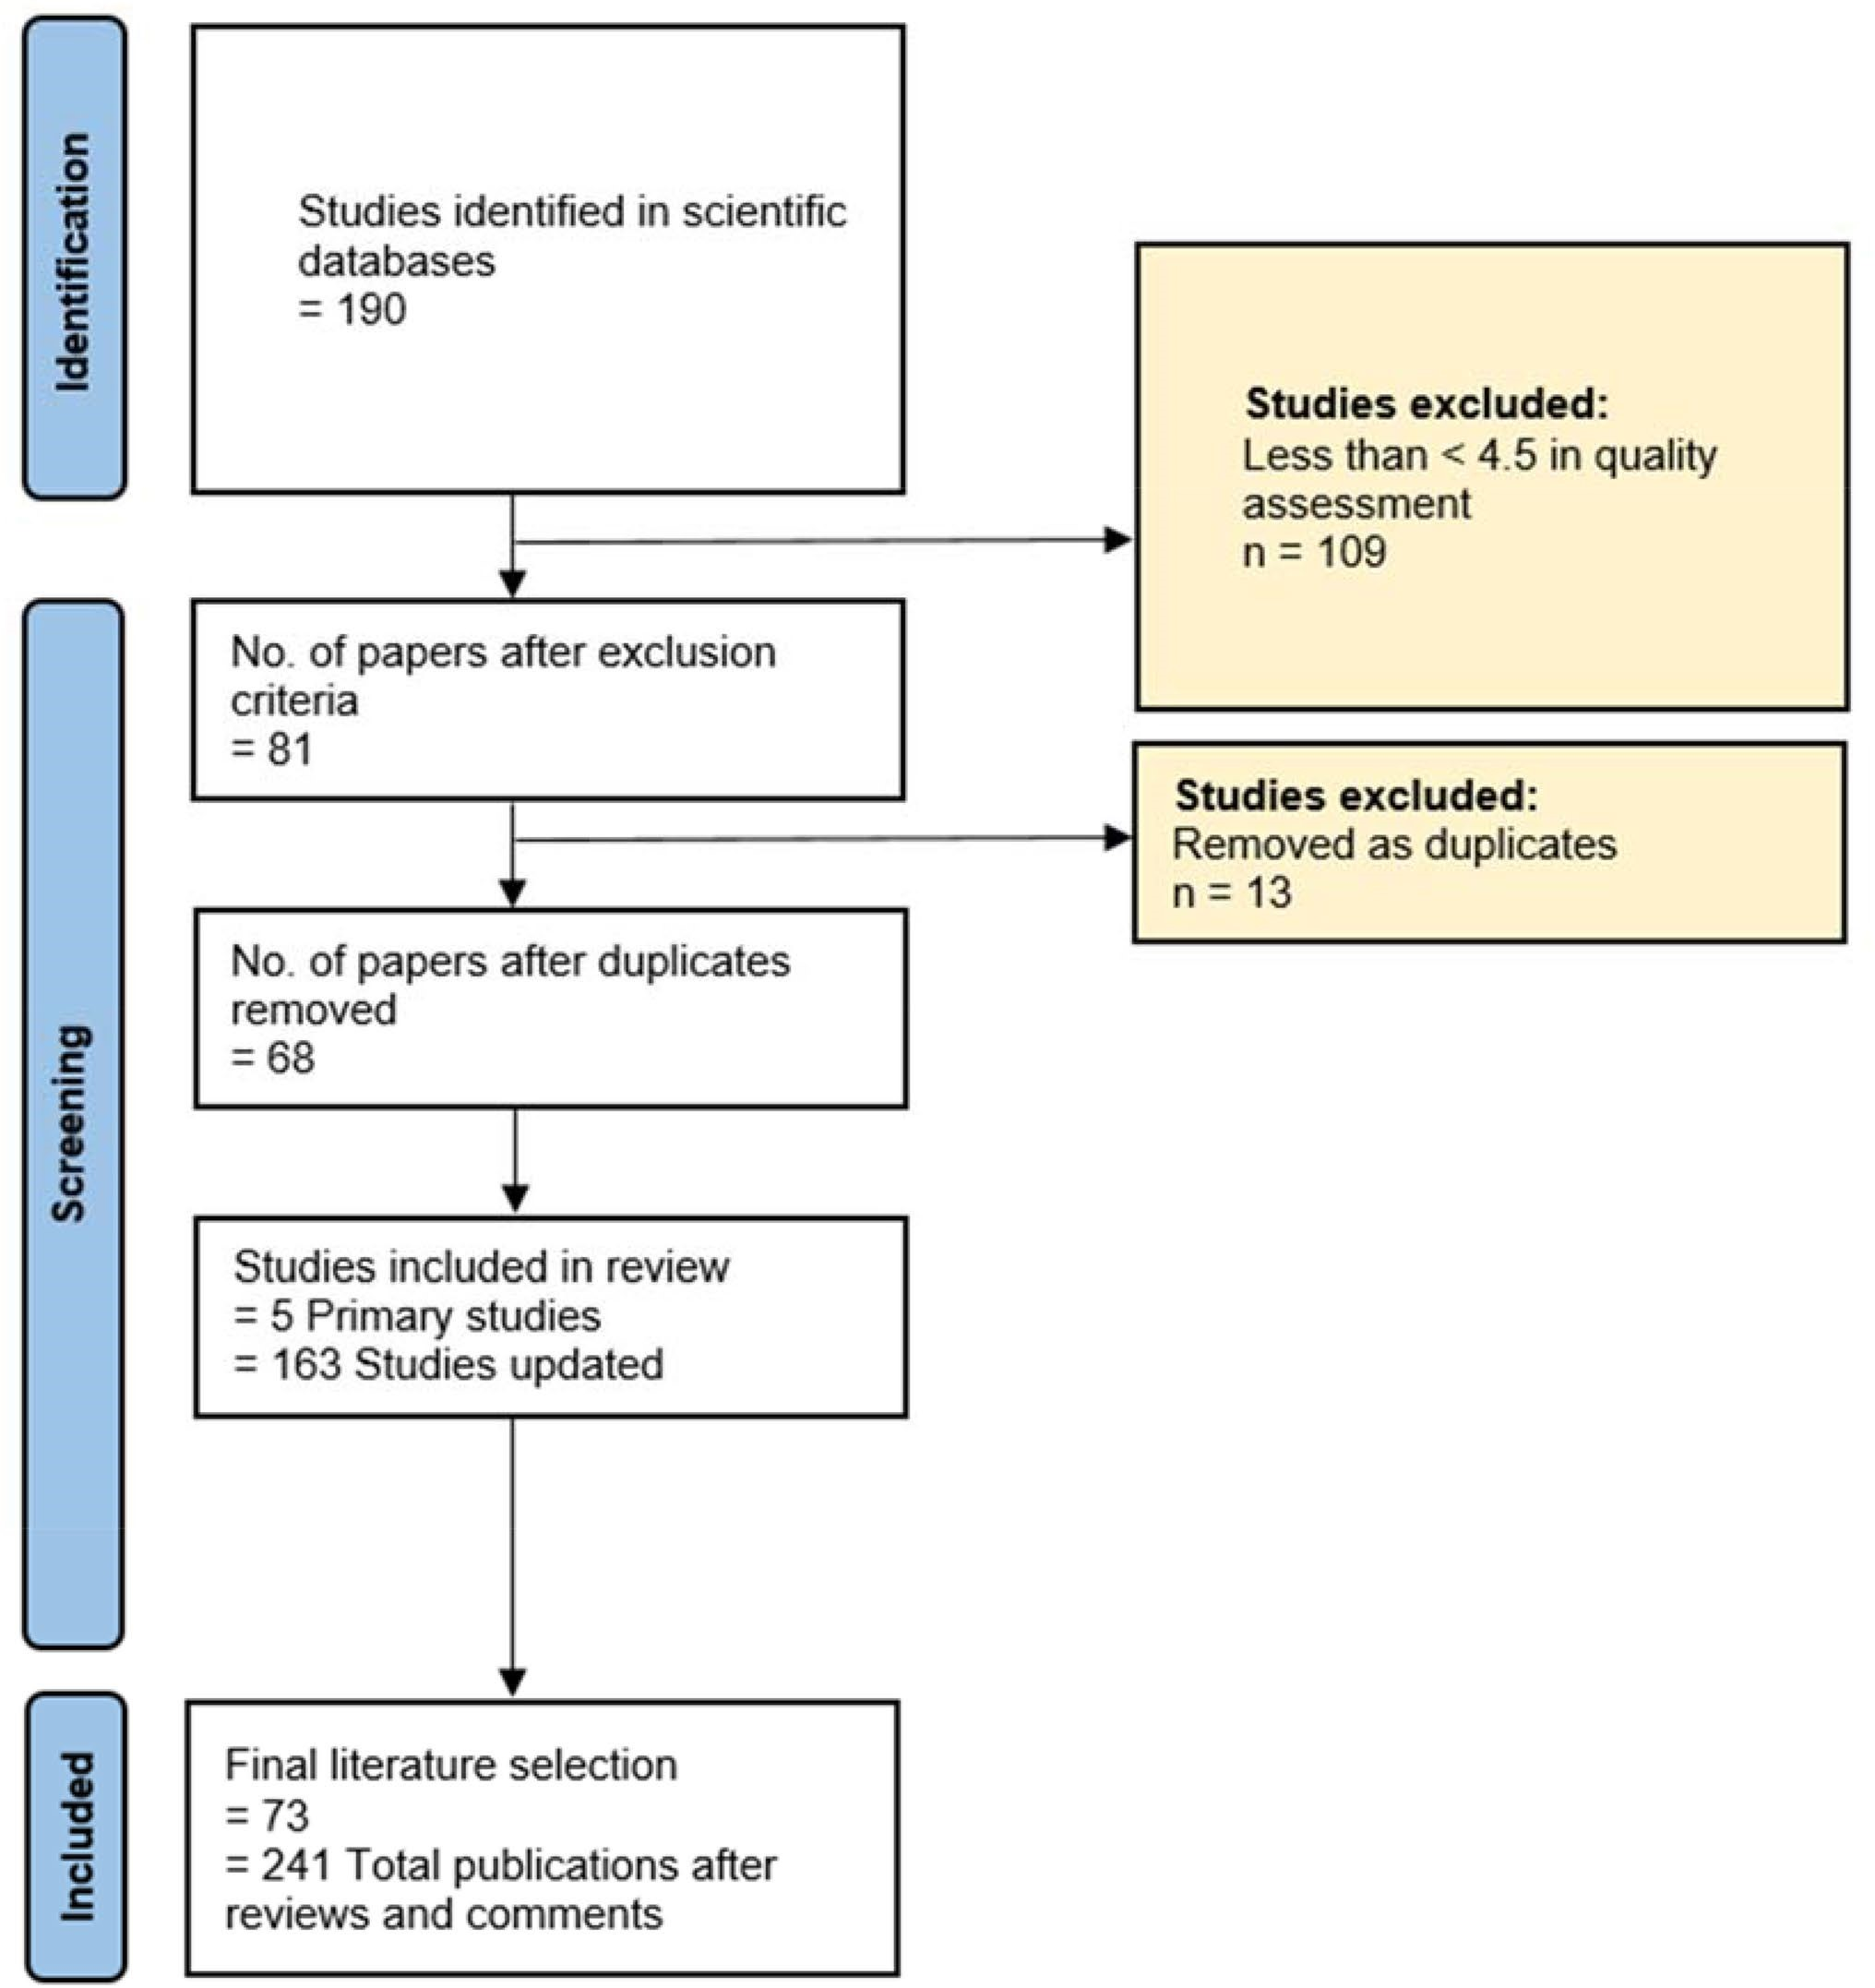
Fig. 3 Search methodology applied to identify relevant papers
- Are the challenges, limitations, and negative findings clearly defined?
- Are the main findings on the creditability, validity, and reliability stated?
- Does the conclusion relate to the aim of the purpose of the study?
3.7 Data extraction, synthesis, and reporting
To answer the research questions with the most reliable data, all publications needed to pass the quality assessment to ensure that only reliable and trustworthy publications had been included in this next phase. All the relevant data were collected from primary studies we read the articles in full to gather all the relevant data needed. We assigned each publication to a specific row and each answer was assigned to a different column in the extraction process. We found that with some of the research questions, some of the answers and features which returned were categorized into fewer groups to allow for better handling of the data. For research question 1 we identified the following categories: Novel crime prediction model, suspect/offender prediction, Spatiotemporal crime hotspot prediction, feature selection, crime patterns, and mapping, and social media crime prediction. In research question 2, we found that some answers were synonyms and we then combined them (e.g., meteorological and weather are both weather data features, social media, websites, and newspapers also are categorized into one column. In research question 3, we broke down the independent variables into crime parameters, data parameters, time parameters, offender parameters, victim parameters, and location parameters. The algorithms in research question 4 were categorized into decision-tree algorithms, regression algorithms, neural network algorithms, and others (e.g., Naive Bayes, and Support Vector Machines). Lastly, the final step in the SLR process is to report on our findings and answer all of the research questions.

Results
In this section, we present our findings using various visual aid graphs, and tables to illustrate all findings effectively. In total, 353 publications were found across all databases, after we applied the study selection criteria, and the quality assessment, 68 publications remained as relevant publications that we could then use throughout our study. Table 3 represents all the 68 primary studies found. Table 4 shows the number of publications retrieved after the exclusion criteria. The research questions that were identified are addressed in the following section in detail one after the other. In Fig. 3, we have applied the Prisma flow process, which is a technique used for reporting systematic reviews and meta-analyses (Kounadi et al. 2020).
4.1 Research Question 1—what are the objectives of the paper?
We first need to understand what the researchers are trying to achieve through the study. What is their desired output variable? What do they intend to predict? (e.g., suspect detection, developing a novel crime prediction model). We found that several different researchers would have different objectives and to manage this data efficiently, we would need to group our findings into more narrow / detailed categories. We then identified 6 categories in which the publication could be grouped as the researchers found a common objective within their target variable. To find these categories, we need to read all the publications. The objectives have been categorized into novel crime category prediction model included all papers that sought to find a crime prediction model to detect the future occurrence of crimes, the researcher did not focus on a single or common crime type as stated by (Yu et al. 2011) crime analysis is done by using historical data to predict the time and place where a crime could take place. Suspect / offender prediction used technology to predict the future occurrence of an offender committing a crime using location data based on the fact that offenders or crime committers do not venture into crimes in new locations and thus would repeat crimes in common areas. Only three papers focused on offender prediction. Spnatio-temporal crime hotspot is the study of crime using space and time, researchers focused on space (i.e., location parameters) and time (i.e., date parameters) to build models that could predict crime using space and time, the likely location of the potential crime (Zhang et al. 2020), hotspots and cold spots have an unbalance in data and that is because cold spots are much more prevalent than hotspots. Feature selection, knowing the right type of features and variables to use is a vital part of the machine learning process and could aid in the development of an accurate predictive model. The crime patterns and mapping category focused on understanding different crime types and how certain crimes occurred in various areas or locations to aid in the prediction of future crimes. Social media crime prediction uses Natural Language Processing (NLP) methods and textual data from social platforms, newspapers, etc. to aid in predicting crimes. Figure 3 shows the distribution of these objectives.
4.2 Research Question 2—what data source types have been used to collect data?
Due to the sensitivity of the data and the information held within the datasets, five authors did not report on the data source type that they used to collect the data resulting in five Not Applicable (NA) values. We further divided the rest of our findings into five categories: Actual crime records (datasets collected and maintained by governments and law enforcement agencies), traffic data (data from traffic segments or taxi flow data), location data (data from points of interest locations), visual data (data collected by using CCTV surveillance systems), text data (data from social media platforms, newspapers and other text data sources).
All categories are presented in Fig. 4.

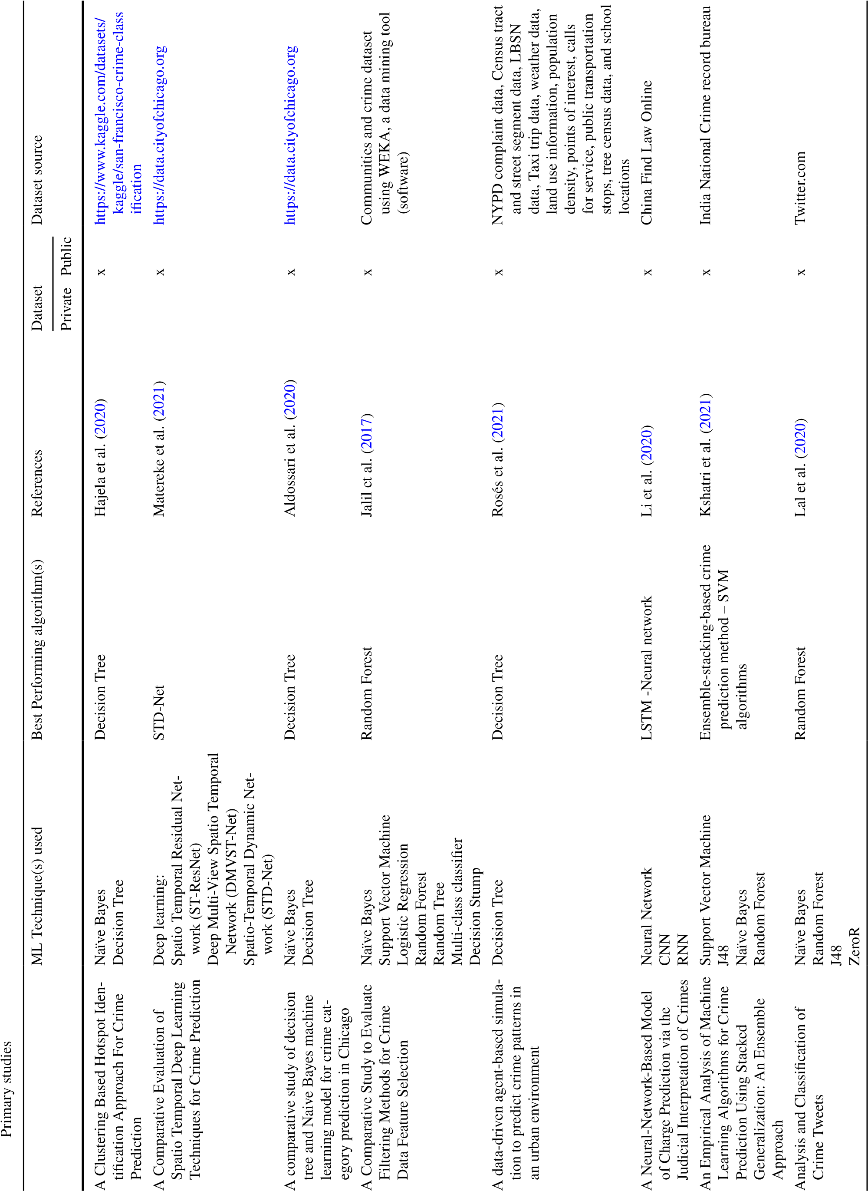
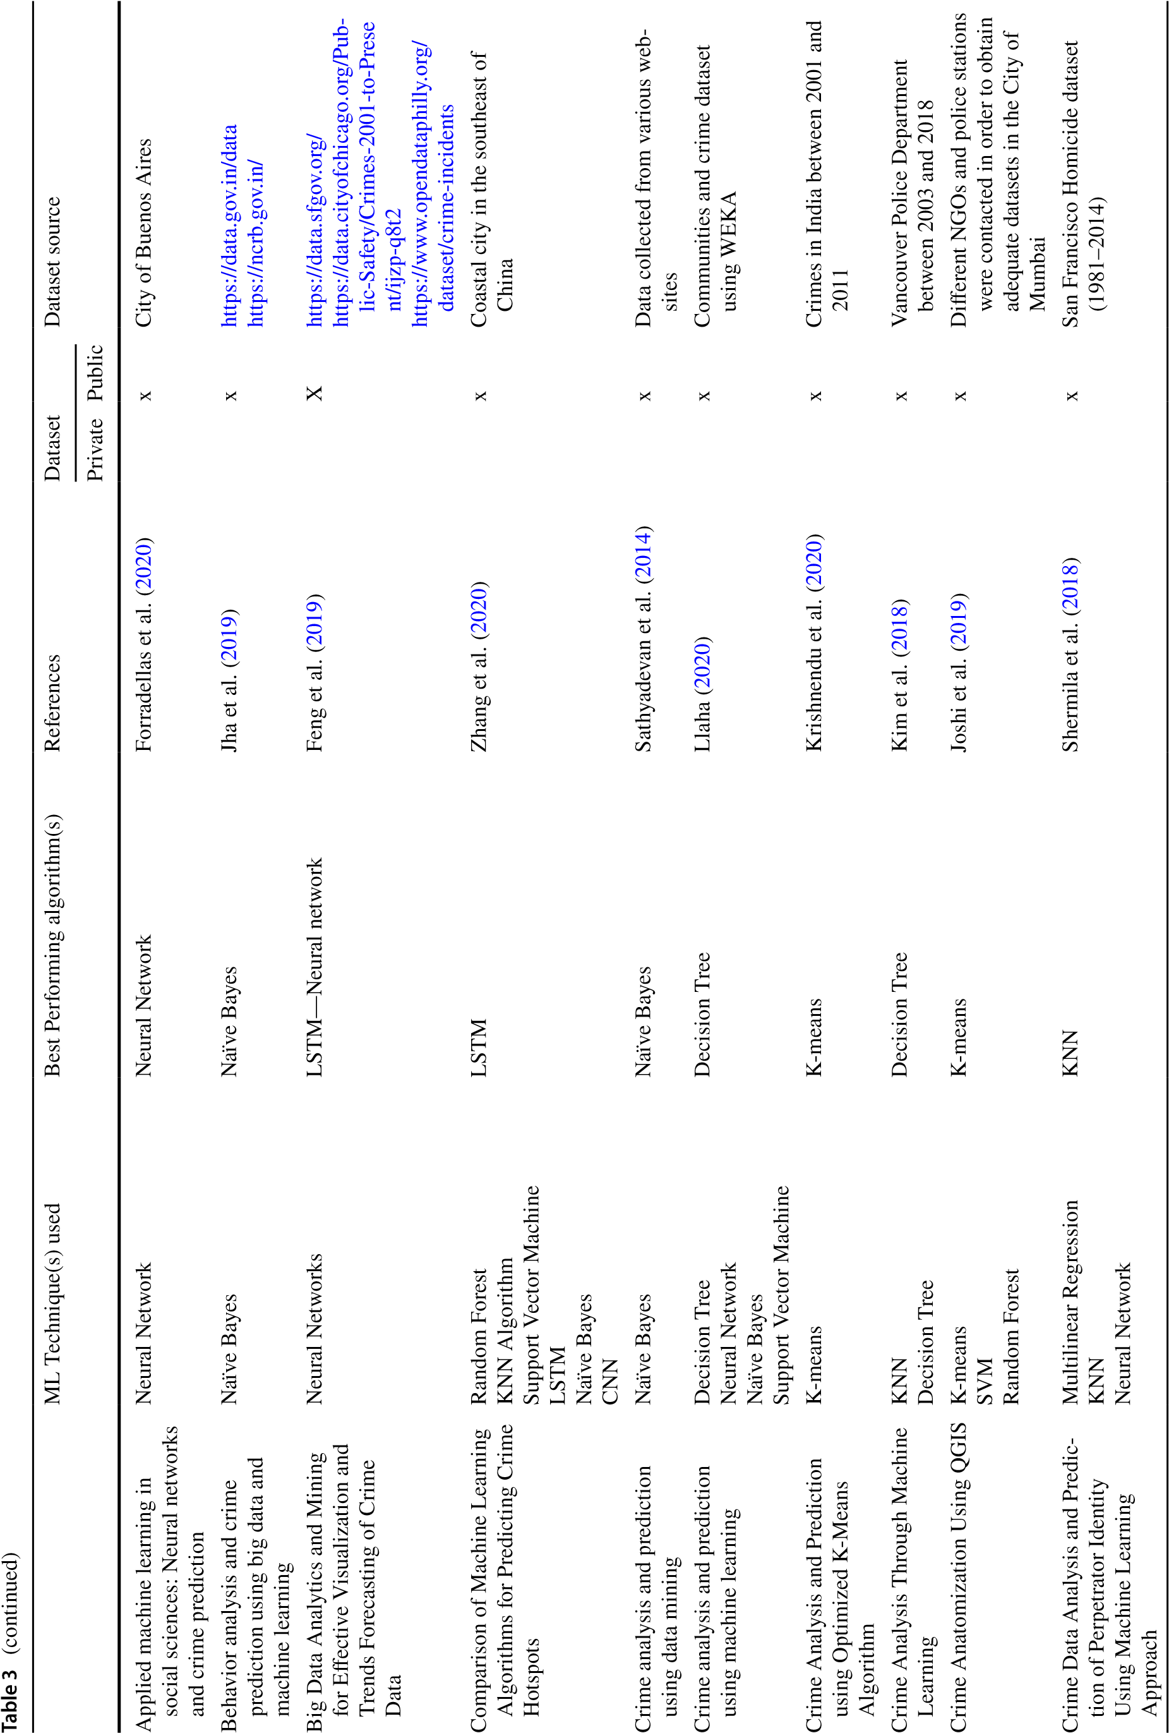
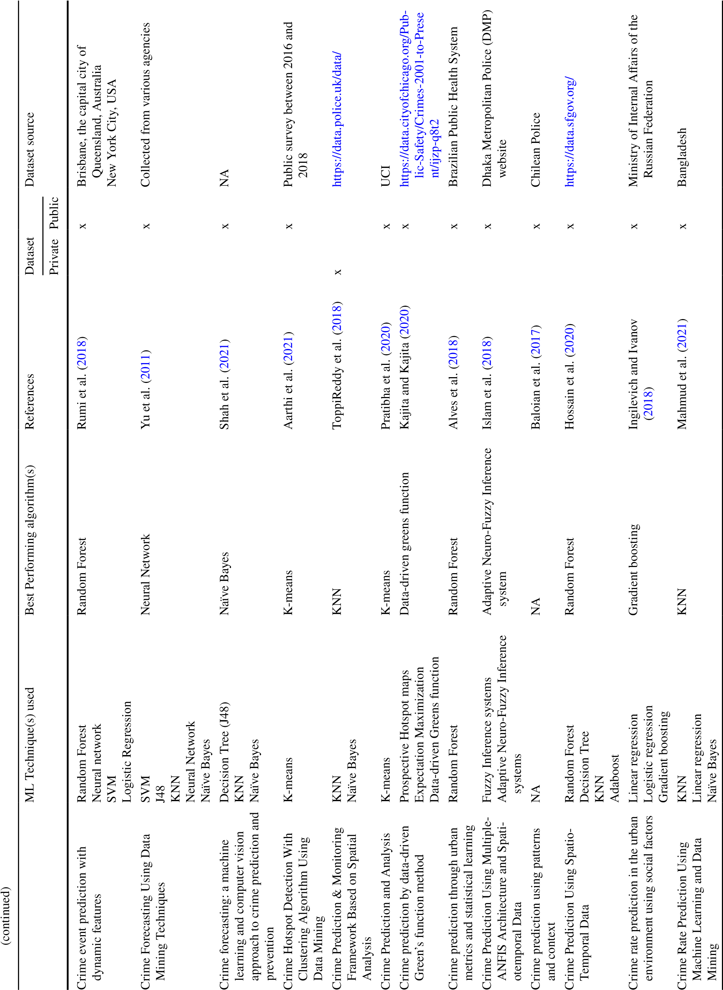
Table

3

continued
)
(
ML Technique(s) used
Best Performing algorithm(s)
References
Dataset
Dataset source
Private
Public
Crime risk analysis through big
data algorithm with urban
metrics
Statistical models
Ordinary Least Square
Linear regression
Random Forest
Artificial Neural Network
Least Absolute Shrinkage and
Selection Operator
Extra—Trees
Wang et al. (
2020
)
x
Chinese Ministry of Public Security
Crime Scene Prediction by Detect
-

Threatening Objects Using
Convolutional Neural Network
CNN
CNN
Nakib et al. (
2018
)
x
Pictures of knives, guns (short gun,
revolver and machine gun) and
blood
Crime Spatiotemporal Prediction
With Fused Objective Function
in Time Delay Neural Network
Artificial Neural Network
Time Delay Neural Network
Nonlinear Autoregressive with
Exogenous Input
Nonlinear Autoregressive with
Exogenous Input
Ghazvini et al. (
2020
)
x
Malaysian crime spatial dataset
Three benchmark time series
Crime Prediction Model using
Deep Neural Networks
Deep Neural Network
Deep Neural Network
Chun et al. (
2019
)
x
Historical booking data between
1997

Government
Criminal shortlisting and crime
forecasting based on modus
operandi
K-means
Hierarchical clustering with Aver
-
age linking
Hierarchical with mean linking
Munasinghe et al. (
2014
)
x
Sri Lanka Police
DeepCrime: Attentive Hierarchi
-
cal Recurrent Networks for
Crime Prediction
Deep Neural Network
Deep Neural Network
Huang et al. (
2018
)
x
New York City Police Department
Design and Analysis of Machine
Learning Algorithms for the
reduction of crime rates in India
Statistical Analysis
Bayesian Neural Network
Levenberg Algorithm
Scaled Algorithm
Statistical Analysis
Bandekar and Vijayalak
-
shmi (
2020
)
x
India National Crime record bureau
Developing Machine Learning-
Based Predictive Models for
Smart Policing
Deep learning
AutoMLP (Multilayer Perceptron)
Decision Tree
Logistic Regression
Random Forest
Neural Network
SVM
LSTM
Elluri et al. (
2019
)
x
New York City Police Department
Dynamics of crime activities in
the network of city community
areas
KNN
Decision Tree
Naïve Bayes
SVM
Decision Tree
Niu et al. (
2019
)
x
Citizen Law Enforcement Analysis
and Reporting (CLEAR) system—
City of Chicago – 2002 to 2017)
Census Data – 2000, 2008, 2013,
and 201
7
Examining the impact of cross-
domain learning on crime
prediction
Gradient boosting
TrAdaBoost
TrResampling
Gradient boosting
Bappee et al. (
2021
)
x
/
http:/

.
data

n
toro

l
topo

.
ice

.
on

/
ca
continued
(
)
ML Technique(s) used
Best Performing algorithm(s)
References
Dataset
Dataset source
Private
Public
Extracting crime information from
online newspaper articles
Conditional Random Field (CRF)
Conditional Random Field (CRF)
Arulanandam et al. (
2014
)
x
Otago Daily Times
New Zealand Herald
The improved method of clas
-
sification algorithms for crime
prediction
Naïve Bayes
Back Propagation
Naïve Baye
Babakura et al. (
2014
)
x
US census
1990
Law enforcement data from 1990
US LEMAS survey
FBI UCR
1995

Improving crime count forecasts
using Twitter and taxi data
Random Forest
Gradient Boosting
Feed-forward Artificial Neural
Network
Artificial Neural Network
Vomfell et al. (
2018
)
x
Twitter.com
Taxi Data in New York
US Census Bureau
Learning to Detect Patterns of
Crime
Series finder
Series finder
Wang et al. (
2013
)
x
Cambridge Police department –
House break ins
Machine learning-based analytical
approach for geographical analy
-
sis and prediction of Boston City
crime using a geospatial dataset
Decision Tree
Information gain
Gini impurity
Chi-square
Random Forest
Random Forest with PCA (Princi
-
pal Component Analysis)
Sharma et al. (
2021
)
x
Boston Kaggle crimes dataset
Mining large-scale human mobil
-
ity data for long-term crime
prediction
Random Forest
Extra Trees
Gradient Boosting
Extra Trees
Kadar et al. (
2019
)
x
New York City – Crime data,
Census data, Foursquare venues
data, Subway usage data, Taxi
usage data,
Mixed spatial–temporal character
-
istics based on Crime Hot Spots
Prediction
KNN
KNN
Zhang et al. (
2016
)
x
Crimes in Nanchang, China
Multi-UAV Allocation Framework
for Predictive Crime Deterrence
and Data Acquisition
Neural Network
Neural Network
Miyano et al. (
2020
)
x
Data from audio and visual sensors
in residential and commercial
areas
Optimization of criminal hotspots
based on underlying crime con
-
trolling factors using geospatial
discriminative pattern
Geospatial Discriminative Patterns
Geospatial Discriminative Pat
-
terns
Wang et al. (
2012

)
x
A north-eastern city in the United
States
Predicting Crime Using Time and
Location Data
Random Forest
Decision Tree
Extra Trees
Bagging
Adaboost
Bagging
Yuki et al. (
2019
)
x
Chicago crime dataset
Prediction Analysis of Crime in
India Using a Hybrid Clustering
Approach
Naïve Bayes
KNN
Naïve Bayes
Kiran and Kaishveen (
2018
)
x
NA
Table

3

(
continued
)
ML Technique(s) used
Best Performing algorithm(s)
References
Dataset
Dataset source
Private
Public
Prediction of Crime Hotspots
based on Spatial Factors of
Random Forest
Random Forest
Random Forest
Yao et al. (
2020
)
x
San Francisco Dataset
Prediction of Crime Occurrence
using Information Propagation
Model and Gaussian Process
Information Propagation
Information Propagation
Morimoto et al. (
2019
)
x
Kobe crime dataset
Boston crime dataset
Prediction of crime rate in urban
neighbourhoods based on
machine learning
GAN Neural Network
GAN Neural Network
He and Zheng (
2021
)
x
Philadelphia crime data from 2006
to 2018
Predictive Policing in the Context
of Residential Burglary: An
Empirical Illustration based on a
Pilot Project in Baden-Württem
-
berg, Germany
Near-repeat ratio
Near-repeat ratio
Gerstner (
2018
)
x
City of Karlsruhe
Public decision support for low
population density areas: An
imbalance-aware hyper-ensem
-
ble for Spatio-temporal crime
prediction
Logistic Regression
Bagging
Boosting
Logistic Regression
Bagging
Boosting
Kadar et al. (
2019
)
x
Burglary incidents in the Swiss
canton of Aargau between January
, 2014 to January 12,
2017
14
Risk Prediction of Theft Crimes
in Urban Communities: An
Integrated Model of LSTM and
ST-GCN
LSTM
Spatial–Temporal Graph Convolu
-
tional Network
LSTM
Spatial–Temporal Graph Convolu
-
tional Network
Han et al. (
2020
)
x
Chicago crime data
Smart Policing Technique with
Crime Type and Risk Score
Prediction Based on Machine
Learning for Early Awareness of
Risk Situation
DNN
CNN
SVM
Naïve Bayes
DNN
CNN
Baek et al. (
2021
)
x
Korean police security data from
KICS
Spatio-Temporal Crime Predic
-
tions by Leveraging Artificial
Intelligence for Citizen's Secu
-
rity in Smart Cities
Seasonal Auto-regressive
Integrated Moving Average
(
)
SARIMA
Hierarchical Density-Based Spa
-
tial Clustering of Applications
with Noise
Hierarchical Density-Based Spa
-
tial Clustering of Applications
with Noise
Butt et al. (
2021
)
x
New York City between 2008 and
2017
Spatio-Temporal Prediction of
Baltimore Crime Events Using
CLSTM Neural Networks
CNN

+

LSTM
CNN

+

LSTM
Esquivel et al. (
2020
)
x
City of Baltimore
StreetNet: preference learning
with a convolutional neural net
-
work on urban crime perception
CNN
CNN
Fu et al. (
2018
)
x
Street view image

(
continued
)
ML Technique(s) used
Best Performing algorithm(s)
References
Dataset
Dataset source
Private
Public
The use of predictive analysis in
spatiotemporal crime forecast
-
ing: Building and testing a
model in an urban context
Logistic Regression
Neural Network
Logistic regression

+

Neural
Network
Rummens et al. (
2017
)
x
Crime anticipation system
Towards a Crime Hotspot Detec
-
tion Framework for Patrol
Planning
Random Forest
Multi-Layer Perceptron
KNN
KNN
Araújo et al. (
2018
)
x
Natal, Brazil – Crime data, Exog
-
enous data sources
Unsupervised identification of
crime problems from police
free-text data
Latent Dirichlet Allocation
Latent Dirichlet Allocation
Birks et al. (
2020
)
x
Crime records in UK
Using CNN's RNNs and Machine
Learning Algorithms for Real-
time Crime Prediction
CNN
RNN
SVM
Logistic Regression
Decision Tree
Random Forest
Gradient Boosting
Gradient Boosting
Rajapakshe et al. (
2019
)
x
Sri lanka, videos clips
Using Machine Learning to Assist
Crime Prevention
Random Forest
Naïve Bayes
Deep Learning
Deep learning
Lin et al. (
2017
)
x
Predicting Crime and Other Uses
of Neural Networks
Neural Network
Neural Network
Walczak (
2021
)
x
—
City of Detroit
https:
/
/

.
a
dat

o
r
det

i
itm
.

/
gov

s
data

s
et
/

rm
s
-

crim
-
e

inc
i
d

en
t
s

Databases | Publications before exclusion criteria | Publications after exclusion criteria
ACM Digital Library (https://dl.acm.org/) | 27 | 6
IEEE Xplore (http://ieee xplore.ieee.org) | 116 | 29
Springer Link (https:// link.springer.com/) | 25 | 8
Science Direct (http:// www.Science direct. com) | 108 | 13
Scopus (https://www.scopus.com/) | 77 | 11
Total | 353 | 68
Table 4 Number of publications retrieved before and after exclusion criteria per database
Social Media/Websites/RSS/Newspaper etc.
Data source types
Land use Data, POI(s), Population Density
LBSN Data, School location data
Crime Survey/Government Senses
Traffic Violation data, Street segment data
Taxi Flow/Trip data
Image/Video/Survilience Data
Meteorological/Weather data
Actual Crime data (Law enforcement/Governments)

Count
Fig. 4 Data source types used

4.3 Research Question 3—what independent variables are (aka features) used in the publications?
A total of 44 independent variables were found, 5 of them were identified as common variables: Crime ID, date, crime type, latitude, and longitude. 23 of the publications did not clarify the independent variables they used to achieve their objectives. The remaining independent variables were then grouped into the following categories to better understand and easily separate them across the study: (1) Crime parameters that contain information regarding the crime that had occurred, (2) Date parameters that contain information regarding the date like the day of the week, week, year, month, etc., (3) Time parameters that contain information on the time the crime took place, (4) Offender parameters that contain information regarding the offender of the crime age, gender, address, income, etc., and (5) Victim parameters that represent information regarding the offender of the crime age, gender, address, income, etc. and (6) Location parameters that present information regarding the location of the crime. Table 5 shows the distribution of these categories. Based on this table, the most-used category is the location and the second most used one is related to the crime parameters category. The % of papers column represents the % of how many times the variables appeared in the papers, the % will be above 100% due to the fact the researchers use more than one variable in some studies. E.g Crime parameters appeared 75% of the time in the papers, however, had an overall appearance of 24% out of 100% (Fig. 5).
4.4 Research question 4—which ML algorithm(s) performed best in the study?
The study identified 14 different machine learning algorithms. Each publication stated the best algorithms they used and various evaluation metrics to conclude the best-performing algorithm. If a publication only applied one algorithm, that algorithm was then noted as the best-performing algorithm from the study. We grouped the best-performing algorithms

Table 5 Independent variables by category and their distribution
Category | Independent Variable | % Appearance of variable in papers | % out of 100
Crime parameters | Record ID, Crime category, description, police district, resolution | 75 | 24
Date parameters | Date, year, month, day of the week | 61 | 20
Time parameters | Time, the hour of the day | 18 | 6
Location parameters | Address, longitude, latitude, location description, home location of  offender, home location of the victim, state, weather conditions | 96 | 31
Offender parameters | Offender age, offender sex, offender income, education status, no. of  offenders, gang activity, family structure, weapon | 39 | 13
Victim parameters | Victim age, victim sex, victim race, the victim count | 20 | 6

Algorithm category | Algorithms | # of papers
Decision Tree-based | Random Forest, Decision Tree, Extra Trees, Gradient Boosting | 16
Regression algorithms | Support Vector Regression | 3
Artificial Neural Networks | Long Short Term Memory, Deep Neural Networks, Convolu-  tional Neural Networks, Recurrent Neural Networks | 24
Others | K-means, K-nearest neighbor, Naïve Bayes | 14

Table 6 Best performing algorithms by category
Crime parameters
%
24
Date parameters
%
20
Time parameters
%
6
Locaon parameters
31
%
Offender parameters
13
%
Victim parameters
6
%
Crime parameters
Date parameters
Time parameters
Location parameters
Offender parameters
Victim parameters
Fig. 5 Features by categories

Other
0
5
10
15
20
25
30
1
Count
Algorithm categories by colour
Artificial Neural Networks
Fig. 6 Algorithms grouped by categories
into decision tree-based algorithms, artificial neural networks, regression algorithms, and others. However, the most commonly used algorithms were Artificial Neural Networks, Random Forest, and KNN algorithms. Table 6 shows the algorithms by category and the number of times they appeared in papers (Fig. 6).
4.5 Research Question 5—which public datasets have been used?
The majority of the datasets used throughout the study were collected from actual crime records datasets collected and maintained by governments or law enforcement agencies that made their data available to the general public via their online platform where web scrapping can be performed or third-party platforms that have the datasets available for the public such as kaggle.com or UCI. The majority of the datasets being used today show that governments and law enforcement are taking an interest in the collection and maintenance of these datasets. Figure 7 shows the distribution of public and open datasets that have been used it also indicates that most of the studies preferred public datasets, which are very useful for repeatability, verifiability, and even refutability of the experiments., and we have also grouped the commonly used datasets with links in Table 7.
Regression algorithms
Decision Tree algorithms
Public
Dataset
80
%
Private Dataset
20
%
Public Dataset
Private Dataset
Fig. 7 Distribution of Public & Private datasets used
4.6 Research Question 6—which evaluation metrics have been applied?
14 different evaluation metrics were identified in the study that researchers applied to evaluate the model performance.
Some of the researchers used more than one evaluation metric, which resulted in a higher % value than 100%. In some of the papers, the researchers did not clearly state the evaluation method they had applied and in others, they did not state it at all, we found that 21 papers did not state their evaluation metrics in detail. In most cases, these papers were those where only one machine learning algorithm was applied in the study. The following evaluation metrics were used more than 5 times (Joshi 2016): Accuracy, Root Mean Square Error (RMSE), Mean Square Error (MSE), Mean Absolute Error (MAE), Precision, Recall, Area Under the ROC curve (AUC), F1 score, Hit rate, and R2 score and the rest of the metrics were applied 4 times or less (Fig. 8).
4.7 Research Question 7—what are the top 5 ML categories?
In research question 4, we identified the machine learning algorithms used in the study. We deduced this information further to understand the type of machine learning
Table 7 Used datasets in the study and their distribution
Dataset location | Public | Private | Description | Distribution of papers
Kaggle (kaggle.com), UCI, Open crime data portals |  |  | San Francisco https:// www. kaggle. com/c/ sf- crime  Chicago https:// www. chica go. gov/ city/ en/ dataset/ crime. html  NYPD https:// comps tat. nypdonline. org/  City of Detroit crime data https:// detro itmi. gov/ node/ 14916  Brazil Crime data https:// www. kaggle. com/ datasets/ inquisitiv ecrow/ crime- data- in- brazil
Official police department and law enforcement records  and sensitive data |  |  | UK police website https:// www. met.  police. uksd/ stats- and- data/ met/ crime- data- dashboard/,  Dhaka metropolitan https:// dmp. gov. bd/ crime- data/  Chilean police department  Saint Petersburg police crime data  Bangladesh police crime data Malaysian police crime data  Sri Lanka police crime data Cambridge police  Philadelphia police crime data  Amsterdam police crime data  China police crime data
 |  |  | Social media, newspaper articles
categories. As data is fed into the algorithms, the machines learn from this data and optimize their tasks to better their performance and intelligence over time. Several papers used multiple machine learning algorithms. The most applied was supervised machine learning, these tasks are those which contain labelled data for the algorithms to learn from. In semi-supervised learning, a mixture of both labelled and unlabelled data is fed into the algorithms, unsupervised algorithms learn from unlabelled data, and reinforcement algorithms are those, which are rewarded based on the desired behaviours/target outcome or punished for undesired outcomes. Reinforcement learning algorithms learn through a trial anderor basis (Fig. 9).
4.8 Research Question 8—what are the challenges / limitations and possible solutions?
Researchers need to pay careful attention to the challenges they face when implementing machine learning algorithms or when seeking to develop a robust crime prediction model due to the sensitivity of the outcome variable and data
2
9
7
5
11
8
10
8
6
1
6
3
2
1
1
Confidence Score
Root mean square error (RMSE)
Mean Square Error
Mean Absolute Error
Precision / Mean average precision
Recall
Area Under Curve (AUC) / Receiver Operating Characteristics (ROC) Curve
F1 / measure
Hit Rate
Jaccard Score
R2 score
Cross Validation
Log loss
Validation Accuracy & Validation Loss
Z score
Fig. 8 Distribution of evaluation metrics applied
contained. We picked up one primary and common challenge when conducting crime prediction, which is the accuracy and trustworthiness of the available data. Just above 50% of the papers failed to provide or detail the challenges they had faced, we then indicated these as “Challenge NA”. The same applied when looking at the possible solutions, we found that more than 50% also lacked to identify further solutions and we deduced this as "Solution NA". Several internal and external factors can contribute to the limitations of crime data and prediction. It is worth noting that one of the major challenges across the world is the reporting of crimes within communities. Underreporting is when people do not come forward with information on a crime or report a crime that has taken place to them due to fear of life and or any other threatening factors, and due to this, these statistics cannot be added or included to official crime statistics. In the work (Butt et al. 2020) it is stated that a survey by Malaysian and British police concluded that about 50% failed to report a crime. The challenges presented forward by the researchers have been narrowed down into 4 commonly faced challenges in machine learning: (1) Data collection, (2) data storage and security, (3) data pre-processing, and
(4) performance issues. We have not found any issue with visualization (Table 8).

Discussion
In this section, we present our discussion and feedback on each research question in Sect. 5.1, and we also discuss the potential threats to validity in Sect. 5.2.
5.1 General discussion
Firstly, we identified 350 + publications in total when conducting our general search into crime prediction publications. After we applied our exclusion criteria and quality assessment to our results, our total number of publications narrowed down to 68 primary studies. From our results, we have managed to identify different machine learning approaches, challenges, and possible solutions in current and past crime prediction trends. Crime prediction is a broad term that can be used by different fields of academia such as criminology and social development. We further discuss our responses to each research question in the following subsections.
5.2 Research Question 1—what are the objectives of the paper?
The results obtained from the data concluded that the objective of 68 of the publications was to produce a novel crime prediction model, it is also worth noting that the results would exceed the number of publications as some publications had more than one objective in their study (e.g., some included feature selection and a novel crime prediction model). We can conclude that an interesting point of interest would be to narrow down a crime prediction model to focus on common crimes in a specific area and develop a novel crime prediction model from this data.
5.3 Research Question 2—what data source types have been used to collect data?
To understand the approach and methodology of the researcher, the data source used was an important part of the study, also to learn the various types of data sources being used currently in crime prediction. We noted that there are several different data source types such as actual crime records, Twitter tweets, Facebook posts, census data, weather data, cellphone tower data, and point of interest data. As a result, we further narrowed down our results, most publications have made use of actual crime records in their

Supervised; 54; 59%
Unsupervised; 14;
15
%
Semi-supervised; 19;
21
%
Reinforcement; 4;
5
%
Supervised Unsupervised Semi-supervised Reinforcement

Fig. 9 Distribution of machine learning categories
studies. The use of actual crime data could improve crime prediction models, decrease crime rates within communities, and help researchers gain a better understanding of crime patterns (Yuki et al. 2019).
5.4 Research Question 3—what independent variables are (aka features) used in the publications?
Crime is affected by both social and economic factors (Matereke et al. 2021); features from both the offenders and victims can contribute to the occurrence of a crime. Many of the researchers proposed that crime is a time and space problem and looked into pursuing prediction models about Spantio-temporal crime prediction. As an indication of this, researchers used a lot of location data, it is also suspected that criminals or offenders repeat a crime in places they are ost familiar with (Bandekar and Vijayalakshmi 2020).
5.5 Research Question 4—which ML algorithm(s) performed best in the study?
Artificial Neural Networks came up as the most used machine learning algorithm for crime prediction. More complex models can be built around neural networks with ensemble algorithms combined, adding boosting parameters can help improve performance and accuracy in the models for real-time predictions.
5.6 Research Question 5—Which public datasets have been used?
80% of the publications retrieved are from public datasets, which are openly accessible to the public, we have also shown this information in Table 7. Most of the data and how it could be used to public advantage in the wrongful hands of others, they could not disclose who the data source owner was nor where the dataset was collected from.
Table

8

Challenges and Solutions proposed by researchers in primary studies
Category
Challenges
Proposed Solutions
References
Data Collection
Researchers can only predict crime records known to
the police
Victims should report more crimes
Kshatri et al. (
2021
)
Noisy data, Noisy Twitter data
Researchers achieved higher predictions when using the
CPLIC model (4% improvement), proposed text data
cleaning methods
Forradellas et al. (
2020
(
; Kajita and Kajita
)
2020
)
Data used was not for actual police crime record
Use of actual crime records for actual or novel models
Yuki et al. (
2019
)
; Kiran and Kaishveen
(
2018
)
Data imbalance
Data augmentation
Saravanan et al. (
2021
)
Data Storage and Security
Security and infrastructure costs of data
Researchers have not provided a solution to the con
-
stantly changing environments
Nakib et al. (
2018
; Han et al.
(
)
2020
)
Reliable and secure environments, large infrastructure
Hajela et al. (
2020
)
Data pre-procession
The sparsity of data
There is no viable solution to this challenge, Dynamic
information is very sparse, and a matrix factorization-
based approach can be considered
Huang et al. (
2018
)
(
; Wang et al.
2013
)
Performance issues
Low accuracy, computational issues with KNN, low
accuracy for Decision Tree and KNN algorithms,
negative values by linear regression
Use of neural networks for future works, Use of
manhattan distance instead of Euclidean distance,
Random Forest approach with Adaboost for better
accuracy, Improved results with Gradient boosting
Baek et al. (
2021
(
, Falade et al.
)
2019
)
; Ippolito
and Lozano (
2020
)
5.7 Research Question 6—which evaluation metrics have been applied?
It was difficult to gather some information and data from some of the publications due to the researchers not giving full or detailed information on their study, some 20 + did not disclose the type of evaluation metrics they used within the study, and only detailed their results and findings during the study process, and accuracy percentage was given in these sections in replacing. Accuracy, area under the ROC curve and precision came as the top three evaluation metrics identified in the study. Equation 1 represents how to calculate the precision parameter and also, shows how to calculate the recall metric. Area under the ROC curve (AUC) value can be understood as the ability to differentiate between classes by a classifier, and accuracy refers to the % out of 100 for

the prediction made.
True Positive
Precision = Actual Results
or
TruePositive
True Positive + False Positive (1)
True Positive
Recall =True Positive
Predicted results True Positive
or
True Positive + False Negative (2)
True Postive + True Negative
Accuracy = (3)
Total

The precision is the ratio of True Positive (TP) over True Positive (TP) + False Positive (FP). The recall is the ratio of True Positive (TP) over True Positive (TP) + False Negative (FP) (Rumi et al. 2018).
5.8 Research Question 7—what are the top 5 machine learning categories?
In this study, the authors used supervised machine learning as the common machine learning category (Sharma et al. 2021). This means that more research can be performed for the other categories, particularly semi-supervised learning, and unsupervised learning because sometimes the number of labeled data points is quite limited or does not exist, therefore, we need models that can be used in these cases.

5.9 Research Question 8—what are the challenges/ limitations and possible solutions?
We categorized our results into the following categories: Data collection, data pre-processing, data storage and security, and performance issues. It is worth noting that during our study we did not find any publication which had data visualization issues, this does not mean the challenge doesn’t exist within the domain however, it is something that could be investigated in the future. Data collection in this domain remains a general issue with data owners, governments, or law enforcement agencies not making this data available to the public, not properly maintaining this data, or not keeping such data in reliable and safe storage locations. As we can see from Fig. 2, the rise in interest in this domain as a research topic is primarily due to the increased availability of data by governments in some parts of the world.
5.10 Available commercial tools
At present, ML is being used by law enforcement and other government agencies to predict crime. These known predictive policing software are Crime anticipation system, Pre-Cobs, Pred-Pol, and Hunch-lab, these systems also allow for more efficient allocation of resources for law enforcement agencies and provide crime prevention strategies (Carvalho and Pedrosa 2021). I is also worth noting that these systems are fairly new and may come with limitations making the evaluation of its impact in crime rates more difficult.
5.11 Potential threats to validity
To ensure that quality research in software engineering is conducted, it is important to analyze threats to validity. Our current research has some limitations to other secondary studies (Dinter et al. 2021), and is discussed as follows. Regarding construct validity, we performed an automated search instead of manually reading titles in electronic journals, this means that we might have missed some relevant papers due to our automated search. Also, query phrasing is an important construct validity threat, and each electronic database has different options for executing the corresponding query. To minimize the potential risks, query design was discussed among authors before executing it in the databases. Another potential construct validity threat is related to the data extraction forms; we might have missed some useful data fields although we have updated these fields several times during our review process. Since we carefully specified the research questions, we reached our objectives adequately and we consider that there is no internal validity threat. Regarding the conclusion validity, we followed a well-defined SLR protocol, and the process was discussed among authors before performing this research. Conclusions were derived from the collected data and personal/subjective opinions were not included.
5.12 Limitations
Even though some of these methods may present many benefits, there are also limitations. Some of these limitations may be noted as technical limitations to ML models, which may come with some of these benefits in crime prediction:
- ML techniques do not produce accurate results or predictions immediately, because they need to learn from previous data.
- The relationship between urban metrics and population size is not linear (Alves et al. 2018)
- Data availability and a limited amount of resources
- System performance issues (technical)
- Data storage (technical)
- Data sparsity (pre-processing of data)
5.13 Future research outlooks
We identified the following research directions to pave the way for further research:
- The development of Explainable Artificial Intelligence (XAI) models / interpretable machine learning models
- The use of new deep learning models such as transformers to improve the performance of models
- The development of unsupervised learning-based crime prediction models
- The design and implementation of a benchmarking tool that can evaluate the performance of different machine learning models on public datasets
- The development of semi-supervised learning-based crime prediction models
- The development of new publicly available datasets for researchers
- The use of new features to build crime prediction models
- The analysis of cross-country crime prediction models to analyse the commonalities between models
- The development of opensource tools for crime prediction

Conclusion and future work
This SLR provided an overview of crime prediction analysis and the various machine learning algorithms used in the field. Based on the primary selected studies, we have found that crime is affected by many internal and external factors. In this study, we systematically reviewed the critical aspects of crime prediction by following the guidelines of the work (Kitchenham et al. 2007). Researchers have made numerous amounts of contributions to the study of crime investigation and prediction. Unlike most industries; health care, transportation, agriculture, finance, retail, and customer services crime prediction has a lack of comprehensive and systematic literature reviews that can help to organize, and summarize existing literature, evidence, and potential challenges they encounter. To our knowledge, this is the most up-to-date review on the use of machine learning in crime prediction between 2010 and 2022. The study showed that the researchers in the field are interested in crime prediction and there is a growing need for interest in the field. Secondly, we noted that most of the publications used crime data records from police stations/law enforcement agencies. These datasets contained a variety of variables that made up the data from crime type, crime case, victim, perpetrator, date, time, weather, and many more. This SLR concludes that crime prediction can help assist law enforcement, governments, and police department across the world to improve their communities and economy. A novel approach to crime prediction would be an optimal approach to solving crime prediction and for a safer economy.
In this SLR, the limitations are restricted to journal articles, and reviews between 2010 and 2022 related to ML and AI in crime prediction. A large number of irrelevant articles were omitted in the exclusion criteria phase of the search approach. This made it possible for us to only look at the papers that passed the criteria for the study. We believe that the quality of this study has been further improved and strengthened by the addition of more sources and articles.
Acknowledgements We thank Dr. Nosis Jenga for taking the time to assist in the proofreading of this manuscript. We also thank our universities for providing the infrastructure and scientific database access rights.
Funding Open Access funding provided by the Qatar National Library.
Data availability statement The paper has no associated data to declare.
Open Access This article is licensed under a Creative Commons Attribution 4.0 International License, which permits use, sharing, adaptation, distribution and reproduction in any medium or format, as long as you give appropriate credit to the original author(s) and the source, provide a link to the Creative Commons licence, and indicate if changes were made. The images or other third-party material in this article are included in the article's Creative Commons licence, unless indicated otherwise in a credit line to the material. If material is not included in the article's Creative Commons licence and your intended use is not permitted by statutory regulation or exceeds the permitted use, you will need to obtain permission directly from the copyright holder. To view a copy of this licence, visit http://c reative.com mons nses/b y/4 .0 /.

References
Aarthi S, Samyuktha M, Sahana M (2019) Crime hotspot detection with clustering algorithm using data mining. In: 2019 3rd International Conference on Trends in Electronics and Informatics (ICOEI), IEEE, pp 401–405
Abbas AJF (2019) A survey of research into artificial neural networks for crime prediction. Пepcпeктивы нayки, 33
Aldossari BS, Alqahtani F M, Alshahrani NS, Alhammam MM, Alzamanan RM, Aslam N (2020) A comparative study of decision tree and naive bayes machine learning model for crime category prediction in chicago. In: Proceedings of 2020 the 6th International Conference on Computing and Data Engineering, pp 34–38
Alves LG, Ribeiro HV, Rodrigues FA (2019) Crime prediction through urban metrics and statistical learning. Physica A 505:435–443
Araújo A, Cacho N, Bezerra L, Vieira C, Borges J (2019) Towards a crime hotspot detection framework for patrol planning. In: 2018 IEEE 20th International Conference on High-Performance Computing and Communications; IEEE 16th International Conference on Smart City; IEEE 4th International Conference on Data Science and Systems (HPCC/SmartCity/DSS), IEEE, pp 1256–1263
Arulanandam R, Savarimuthu BTR, Purvis MA (2020) Extracting crime information from online newspaper articles. Proc Sec Austral Web Conf 155:31–38
Babakura A, Sulaiman MN, Yusuf MA (2019) The improved method of classification algorithms for crime prediction. In: 2014 International Symposium on Biometrics and Security Technologies (ISBAST), IEEE, pp 250–255
Baek MS, Park W, Park J, Jang KH, Lee YT (2021) Smart Policing Technique with Crime Type and Risk Score Prediction Based on
Machine Learning for Early Awareness of Risk Situation. IEEE
Access 9:131906–131915
Baloian N, Bassaletti CE, Fernández M, Figueroa O, Fuentes P, Manasevich R, Vergara M (2019) Crime prediction using patterns and context. In: 2017 IEEE 21st international conference on computer supported cooperative work in design (CSCWD), IEEE, pp 2–9
Bandekar SR, Vijayalakshmi C (2020) Design and analysis of machine learning algorithms for the reduction of crime rates in India. Procedia Comput Sci 172:122–127
Bappee FK, Soares A, Petry LM, Matwin S (2021) Examining the impact of cross-domain learning on crime prediction. J Big Data 8(1):1–27
Birks D, Coleman A, Jackson D (2020) Unsupervised identification of crime problems from police free-text data. Crime Sci 9(1):1–19
Butt UM, Letchmunan S, Hassan FH, Ali M, Baqir A, Sherazi HHR (2020) Spatio-temporal crime HotSpot detection and prediction:
a systematic literature review. IEEE Access 8:166553–166574
Butt UM, Letchmunan S, Hassan FH, Ali M, Baqir A, Koh TW, Sherazi HHR (2021) Spatio-temporal crime predictions by leveraging artificial intelligence for citizens’ security in smart cities. IEEE Access 9:47516–47529
Carvalho A, Pedrosa I (2021) Data analysis in predicting crime: predictive policing. In: 2021 16th Iberian Conference on Information Systems and Technologies (CISTI), IEEE, pp 1–7
Catal C (2022) On the application of genetic algorithms for test case prioritization: a systematic literature review. In: Proceedings of the 2nd international workshop on evidential assessment of software technologies, pp 9–14
Chun SA, Avinash Paturu V, Yuan S, Pathak R, Atluri V, Adam NR (2019) Crime prediction model using deep neural networks. In:
Proceedings of the 20th Annual International Conference on Digital Government Research, pp 512–514
Dakalbab F, Abu Talib M, Elmutasim O, Bou Nassif A, Abbas S, Nasir Q (2022) Artificial intelligence & crime prediction: a systematic literature review. Soc Sci Humanit 6:100342
David H, Suruliandi A (2019) Survey on crime analysis and prediction using data mining techniques. ICTACT J Soft Comput
7(3):1459
Elluri L, Mandalapu V, Roy N (2019) Developing machine learningbased predictive models for smart policing. In: 2019 IEEE International Conference on Smart Computing (SMARTCOMP), IEEE, pp 198–204
Esquivel N, Nicolis O, Peralta B, Mateu J (2020) Spatio-temporal prediction of Baltimore crime events using CLSTM neural networks. IEEE Access 8:209101–209112
Falade A, Azeta A, Oni A, Odunayo I (2019) Systematic literature review of crime prediction and data mining. Rev Computer Eng Stud 6(3):56–63
Feng M, Zheng J, Ren J, Hussain A, Li X, Xi Y, Liu Q (2019) Big data analytics and mining for effective visualization and trends forecasting of crime data. IEEE Access 7:106111–106123
Forradellas RFR, Náñez Alonso SL, Jorge-Vazquez J, Rodriguez ML (2020) Applied machine learning in social sciences: neural networks and crime prediction. Social Sci 10(1):4
Fu K, Chen Z, Lu CT (2020) Streetnet: preference learning with a convolutional neural network on urban crime perception. In: Proceedings of the 26th ACM SIGSPATIAL International Conference on Advances in Geographic Information Systems, pp 269–278
Gerstner D (2019) Predictive policing in the context of residential burglary: an empirical illustration on the basis of a pilot project in Baden-Württemberg, Germany. Eur J Secur Res 3(2):115–138
Ghazvini A, Abdullah SNHS, Hasan MK, Kasim DZAB (2020) Crime spatiotemporal prediction with fused objective function in timedelay neural network. IEEE Access 8:115167–115183
Hajela G, Chawla M, Rasool A (2020) A clustering-based hotspot identification approach for crime prediction. Procedia Comput Sci 167:1462–1470
Han X, Hu X, Wu H, Shen B, Wu J (2020) Risk prediction of theft crimes in urban communities: an integrated model of lstm and st-gcn. IEEE Access 8:217222–217230
He J, Zheng H (2021) Prediction of crime rate in urban neighborhoods based on machine learning. Eng Appl Artif Intell 106:104460
Hossain S, Abtahee A, Kashem I, Hoque MM, Sarker IH (2020) Crime prediction using spatio-temporal data. International conference on computing science communication and security. Springer, Singapore, pp 277–289
Huang C, Zhang J, Zheng Y, Chawla NV (2018) DeepCrime: attentive hierarchical recurrent networks for crime prediction. In: Proceedings of the 27th ACM International Conference on Information and Knowledge Management, pp 1423–1432
Ingilevich V, Ivanov S (2018) Crime rate prediction in the urban environment using social factors. Procedia Comput Sci 136:472–478
Ippolito A, Lozano ACG (2020) Tax crime prediction with machine learning: a case study in the municipality of São Paulo. ICEIS 1:452–459
Islam M, Karim R, Roy K, Mahmood S, Hossain S, Rahman RM (2018) Crime prediction using multiple-anfis architecture and spatiotemporal data. In: 2018 International Conference on Intelligent Systems (IS), IEEE, pp 58–65
Jalil MMA, Mohd F, Noor NMM (2019) A comparative study to evaluate filtering methods for crime data feature selection. Procedia Comput Sci 116:113–120
Jha P, Jha R, Sharma A (2019) Behavior analysis and crime prediction using big data and machine learning. Int J Recent Technol Eng
8(1):1
Jha S, Yang E, Almagrabi AO, Bashir AK, Joshi GP (2021) Comparative analysis of time series model and machine testing systems for crime forecasting. Neural Comput Appl 33(17):10621–10636
Joshi R (2016) Accuracy, precision, recall & f1 score: interpretation of performance measures. Retrieved 1(2019):2022
Joshi N, Shaikh S, Tripathy A, Sen S, Janson J, Karnik S, Varghese B (2019) Crime anatomization using qgis. In: 2019 IEEE 5th International Conference for Convergence in Technology (I2CT), IEEE, pp 1–4
Kadar C, Pletikosa I (2018) Mining large-scale human mobility data for long-term crime prediction. EPJ Data Sci 7(1):1–27
Kadar C, Maculan R, Feuerriegel S (2019) Public decision support for low population density areas: An imbalance-aware hyperensemble for Spatio-temporal crime prediction. Decis Support Syst 119:107–117
Kajita M, Kajita S (2020) Crime prediction by data-driven Green’s function method. Int J Forecast 36(2):480–488
Kim S, Joshi P, Kalsi PS, Taheri P (2019) Crime analysis through machine learning. In: 2018 IEEE 9th Annual Information Technology, Electronics and Mobile Communication Conference (IEMCON), IEEE, pp 415–420
Kiran J, Kaishveen K (2019) Prediction analysis of crime in India using a hybrid clustering approach. In: 2018 2nd International Conference on I-SMAC (IoT in Social, Mobile, Analytics, and Cloud)(I-SMAC) I-SMAC (IoT in Social, Mobile, Analytics, and Cloud)(I-SMAC), 2018 2nd International Conference on IEEE, pp 520–523
Kitchenham B, Charters S (2020) Guidelines for performing systematic literature reviews in software engineering. Technical report EBSE
2007-001, Keele University and Durham University Joint Report
Kitchenham BA, Mendes E, Travassos GH (2020) Cross versus withincompany cost estimation studies: a systematic review. IEEE Trans
Softw Eng 33(5):316–329
Kitchenham BA, Brereton P, Turner M, Niazi MK, Linkman S, Pretorius R, Budgen D (2010) Refining the systematic literature review process—two participant-observer case studies. Empir Softw Eng 15(6):618–653
Kounadi O, Ristea A, Araujo A, Leitner M (2020) A systematic review on spatial crime forecasting. Crime Sci 9(1):1–22
Krishnendu SG, Lakshmi PP, Nitha L (2020) Crime analysis and prediction using optimized k-means algorithm. In: 2020 Fourth International Conference on Computing Methodologies and Communication (ICCMC), IEEE, pp 915–918
Kshatri SS, Singh D, Narain B, Bhatia S, Quasim MT, Sinha GR (2021) An empirical analysis of machine learning algorithms for crime prediction using stacked generalization: an ensemble approach. IEEE Access 9:67488–67500
Lal S, Tiwari L, Ranjan R, Verma A, Sardana N, Mourya R (2020)
Analysis and classification of crime tweets. Procedia Comput Sci
167:1911–1919
Li X, Kang X, Wang C, Dong L, Yao H, Li S (2020) A neural-networkbased model of charge prediction via the judicial interpretation of crimes. IEEE Access 8:101569–101579
Liberati A, Altman DG, Tetzlaff J, Mulrow C, Gøtzsche PC, Ioannidis JP, Moher D (2009) The PRISMA statement for reporting systematic reviews and meta-analyses of studies that evaluate health care interventions: explanation and elaboration. J Clin Epidemiol
62(10):e1–e34
Ligthart A, Catal C, Tekinerdogan B (2021) Systematic reviews in sentiment analysis: a tertiary study. Artif Intell Rev 54(7):4997–5053
Lin YL, Chen TY, Yu LC (2017) Using machine learning to assist crime prevention. In: 2017 6th IIAI international congress on advanced applied informatics (IIAI-AAI), IEEE, pp 1029–1030
Llaha O (2020) Crime analysis and prediction using machine learning. In: 2020 43rd International Convention on Information, Communication and Electronic Technology (MIPRO), IEEE, pp 496–501 Mahmud S, Nuha M, Sattar A (2021) Crime rate prediction using machine learning and data mining. Soft computing techniques and applications. Springer, Singapore, pp 59–69
Matereke T, Nyirenda C, Ghaziasgar M (2021) A comparative evaluation of spatio temporal deep learning techniques for crime prediction (No. 5648). EasyChair.
Miyano K, Shinkuma R, Shiode N, Shiode S, Sato T, Oki E (2020) Multi-UAV allocation framework for predictive crime deterrence and data acquisition. Internet of Things 11:100205
Morimoto S, Kawamukai H, Shin K (2019) Prediction of crime occurrence using information propagation model and gaussian process. In: 2019 14th Asia Joint Conference on Information Security (AsiaJCIS), IEEE, pp 80–87
Munasinghe AKDMP, Udeshini S, Perera H, Weerasinghe R (2014) Criminal shortlisting and crime forecasting based on modus operandi. At 2014 14th International Conference on Advances in ICT for Emerging Regions (ICTer)
Nakib M, Khan RT, Hasan MS, Uddin J (2018) Crime scene prediction by detecting threatening objects using a convolutional neural network. In: 2018 International Conference on Computer, Communication, Chemical, Material and Electronic Engineering (IC4ME2), IEEE, pp 1–4
Niu X, Elsisy A, Derzsy N, Szymanski BK (2019) Dynamics of crime activities in the network of city community areas. Appl Netw Sci 4(1):1–17
Prabakaran S, Mitra S (2018) Survey of analysis of crime detection techniques using data mining and machine learning. J Phys 1000(1):012046
Pratibha AG, Uprant SD, Chouhan L (2020) Crime prediction and analysis. Int Conf Data Eng Appl. https://d oi.org/1 0 .1109 /I DEA4
9133. 2020. 91707 31
Rajapakshe C, Balasooriya S, Dayarathna H, Ranaweera N, Walgampaya N, Pemadasa N (2019) Using CNN's RNNs and machine learning algorithms for real-time crime prediction. In: 2019 International Conference on Advancements in Computing (ICAC),
IEEE, pp 310–316
Rosés R, Kadar C, Malleson N (2021) A data-driven agent-based simulation to predict crime patterns in an urban environment. Comput Environ Urban Syst 89:101660
Rumi SK, Deng K, Salim FD (2018) Crime event prediction with dynamic features. EPJ Data Sci 7(1):43
Rummens A, Hardyns W, Pauwels L (2017) The use of predictive analysis in spatiotemporal crime forecasting: Building and testing a model in an urban context. Appl Geogr 86:255–261
Saravanan P, Selvaprabu J, Arun Raj L, Khan AA, Sathick KJ (2021) Survey on crime analysis and prediction using data mining and machine learning techniques. Advances in smart grid technology. Springer, Singapore, pp 435–448
Sathyadevan S, Devan MS, Gangadharan SS (2014) Crime analysis and prediction using data mining. In: 2014 First International Conference on Networks & Soft Computing (ICNSC2014), IEEE, pp
406–412
Shah N, Bhagat N, Shah M (2021) Crime forecasting: a machine learning and computer vision approach to crime prediction and prevention. Vis Comput Indu Biomed Art 4(1):1–14
Sharma HK, Choudhury T, Kandwal A (2021) Machine learning-based analytical approach for geographical analysis and prediction of Boston City crime using geospatial dataset. GeoJournal. https://
doi. org/ 10. 1007/ s10708- 021- 10485-4
Shermila AM, Bellarmine AB, Santiago N (2018) Crime data analysis and prediction of perpetrator identity using machine learning approach. In: 2018 2nd International Conference on Trends in
Electronics and Informatics (ICOEI), IEEE, pp 107–114
Thomas A, Sobhana NV (2022) A survey on crime analysis and prediction. Maters Today 58:310–315
ToppiReddy HKR, Saini B, Mahajan G (2018) Crime prediction and monitoring framework based on spatial analysis. Procedia Comput
Sci 132:696–705
Van Dinter R, Tekinerdogan B, Catal C (2021) Automation of systematic literature reviews: a systematic literature review. Inf Softw Technol 136:106589
Vomfell L, Härdle WK, Lessmann S (2018) Improving crime count forecasts using Twitter and taxi data. Decis Support Syst
113:73–85
Walczak S (2021) Predicting Crime and Other Uses of Neural Networks in Police Decision Making. Front Psychol 12:587943
Wang D, Ding W, Stepinski T, Salazar J, Lo H, Morabito M (2012) Optimization of criminal hotspots based on underlying crime controlling factors using geospatial discriminative patterns. International conference on industrial engineering and other applications of applied intelligent systems. Springer, Berlin, pp 553–562
Wang T, Rudin C, Wagner D, Sevieri R (2013) Learning to detect patterns of crime. Joint European conference on machine learning and knowledge discovery in databases. Springer, Berlin, pp 515–530
Wang J, Hu J, Shen S, Zhuang J, Ni S (2020) Crime risk analysis through big data algorithm with urban metrics. Physica A
545:123627
Yao S, Wei M, Yan L, Wang C, Dong X, Liu F, Xiong Y (2020) Prediction of crime hotspots based on spatial factors of random forest. In: 2020 15th International Conference on Computer Science and Education (ICCSE), IEEE, pp 811–815
Yu CH, Ward MW, Morabito M, Ding W (2011) Crime forecasting using data mining techniques. In: 2011 IEEE 11th International
Conference on Data Mining Workshops, IEEE, pp 779–786
Yuki JQ, Sakib MMQ, Zamal Z, Habibullah KM, Das AK (2019) Predicting crime using time and location data. In: Proceedings of the 2019 7th International Conference on Computer and Communications Management, pp 124–128
Zhang X, Liu L, Xiao L, Ji J (2020) Comparison of machine learning algorithms for predicting crime hotspots. IEEE Access 8:181302–181310
Zhang Q, Yuan P, Zhou Q, Yang Z (2016) Mixed spatial-temporal characteristics based on crime hot spots prediction. In: 2016 IEEE 20th International Conference on Computer Supported Cooperative Work in Design (CSCWD), IEEE, pp 97–101

