Realtime Gender, Age and Emotion Detection
(Using React JS, Tensorflow)
“Entre team members name”

ABSTRACT

Real-time gender, age, and emotion detection are important tasks in the field of computer vision and human-computer interaction. This paper presents an implementation of real-time gender, age, and emotion detection using React.js and face-api.js. React.js is a popular JavaScript library for building user interfaces, while face-api.js is a powerful JavaScript API for face detection and facial feature analysis.

The proposed system leverages the capabilities of face-api.js to detect faces in real-time video streams captured from a user's webcam. Once a face is detected, the system utilizes the face landmarks provided by face-api.js to extract facial features such as the eyes, nose, and mouth. These features are then used to estimate the gender, age, and emotional state of the detected face.

The React.js framework is employed to create a user-friendly interface that displays the real-time video stream along with the inferred gender, age, and emotion information. The system dynamically updates these results as new frames are processed, providing a smooth and interactive user experience.

The implementation is evaluated using a diverse dataset of facial images with ground truth labels for gender, age, and emotion. The experimental results demonstrate the effectiveness and efficiency of the proposed system in accurately detecting gender, estimating age, and recognizing emotions in real-time.

The combination of React.js and face-api.js provides a robust and flexible solution for real-time gender, age, and emotion detection. The system can be applied in various domains, including human-computer interaction, market research, and social robotics, enabling interactive and personalized user experiences.

1. INTRODUCTION :-
Real-time gender, age, and emotion detection have gained significant attention in recent years due to their potential applications in various fields, including marketing, security systems, and user experience personalization. With advancements in deep learning and computer vision, technologies like React.js and TensorFlow have enabled developers to create powerful and interactive applications that can analyze facial attributes in real time.

In this article, we will explore how React.js, a popular JavaScript library for building user interfaces, can be combined with TensorFlow Face API to create a real-time gender, age, and emotion detection system. By leveraging the capabilities of React.js and the advanced algorithms of TensorFlow Face API, developers can build intuitive and engaging applications that can identify gender, estimate age, and detect emotions from facial images or live video streams.

TensorFlow Face API is a specialized library that utilizes deep learning techniques to analyze facial attributes. It provides pre-trained models specifically designed for face detection, gender classification, age estimation, and emotion recognition. By integrating this powerful API with React.js, developers can create responsive and interactive applications that can process and interpret facial data in real time.

Throughout this article, we will delve into the various aspects of real-time gender, age, and emotion detection using React.js and TensorFlow Face API. We will discuss the steps required to set up the development environment, explain the process of integrating TensorFlow Face API into a React.js application, and explore the techniques and models used for gender classification, age estimation, and emotion recognition.
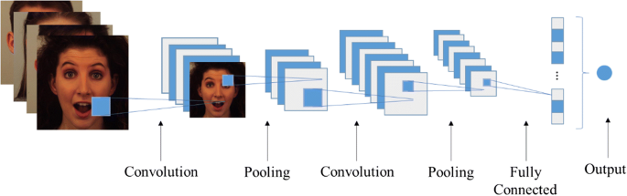

Tech Stack
Html, CSS , JavaScript, Face Api, React js

Overview Html Css :-
- HTML (Hypertext Markup Language):

  - HTML is the standard markup language for creating the structure and content of web pages.
  - It consists of a series of tags that define different elements and their purpose on a web page.
  - Tags are enclosed in angle brackets (<>) and typically come in pairs: an opening tag and a closing tag.
  - HTML tags are used to define headings, paragraphs, lists, links, images, tables, forms, and more.
  - It provides the structure and semantic meaning of the content on a web page.

- CSS (Cascading Style Sheets):

  - CSS is a style sheet language used to describe the visual presentation of a document written in HTML.
  - It controls the layout, colors, fonts, and other visual aspects of a web page.
  - CSS uses a set of rules to define how specific HTML elements should be displayed.
  - Selectors are used to target specific elements, and properties are used to define the styles applied to those elements.
  - CSS allows for precise control over positioning, sizing, spacing, and responsiveness of elements on a web page.
  - It enables separation of concerns by separating the content (HTML) from the presentation (CSS).

HTML and CSS work together to create visually appealing and structured web pages. HTML defines the structure and content, while CSS is responsible for the visual appearance and layout. By using HTML and CSS effectively, you can create engaging and user-friendly websites. Additionally, both languages can be enhanced with JavaScript to add interactivity and dynamic behavior to web pages.

Overview React js :-

- Component-Based Architecture: ReactJS follows a component-based architecture, where the user interface is broken down into reusable and self-contained components. Components can be nested inside other components to create complex UI structures.

- Virtual DOM: ReactJS utilizes a virtual DOM (Document Object Model) to efficiently update and render components. The virtual DOM is a lightweight copy of the actual DOM, and React compares the virtual DOM with the real DOM to determine the minimal set of changes needed for an update. This helps optimize performance and improve the rendering speed of React applications.

- JSX Syntax: ReactJS uses JSX (JavaScript XML) syntax, which allows developers to write HTML-like code directly in JavaScript. JSX makes it easier to define the structure and appearance of components and enables a smooth integration of HTML and JavaScript.

- Unidirectional Data Flow: React follows a unidirectional data flow, also known as one-way data binding. Data flows from parent components to child components, and any changes to the data trigger a re-rendering of the affected components. This ensures predictable updates and helps maintain a clear data flow throughout the application.

- Reusability and Composition: React promotes code reusability by enabling the creation of reusable components. Components can be composed together to build complex user interfaces, which simplifies the development process and improves maintainability.

- React Hooks: Introduced in React version 16.8, hooks are functions that allow developers to use state and other React features in functional components. Hooks eliminate the need for class components in many cases and provide a more concise and expressive way to manage state and side effects.

- React Ecosystem: ReactJS has a vast ecosystem of libraries and tools that complement its functionality. This includes state management libraries like Redux and MobX, routing libraries like React Router, testing frameworks like Jest and Enzyme, and many more. The ecosystem offers solutions

Overview face-api.js:-

- Face detection: The library can detect faces in images or video streams by using a pre-trained face detection model. It can identify the bounding box coordinates of each face present in the input

- Face detection: The library can detect faces in images or video streams by using a pre-trained face detection model. It can identify the bounding box coordinates of each face present in the input

- Face recognition: Face-api.js can perform face recognition, which involves identifying or verifying a person's identity based on their facial features. It can train models to recognize specific individuals and match them with known faces.

- Facial landmark detection: The library can detect key facial landmarks, such as the position of the eyes, nose, mouth, and other facial features. This information can be used for tasks like facial expression analysis, head pose estimation, or face morphing.

- Age and gender estimation: Face-api.js can estimate the age and gender of detected faces using pre-trained models. It can provide approximate age ranges and predict the gender of individuals based on their facial appearance.

- Emotion recognition: The library can recognize basic emotions such as happiness, sadness, anger, and surprise by analyzing facial expressions. This can be useful for applications involving sentiment analysis or affective computing.

- Integration with TensorFlow.js: Face-api.js is built on top of TensorFlow.js, a popular machine learning library for JavaScript. This allows seamless integration with other TensorFlow.js models and enables customization and fine-tuning of the underlying neural networks.

Face-api.js provides an easy-to-use API with methods and functions for accessing its various features. It can be used in web applications and websites to create interactive experiences involving face analysis and recognition. The library is open source and provides pre-trained models, making it accessible for developers to implement face-related functionalities in the browser without relying on server-side processing.

METHODOLOGY

1.Set up the Development Environment:
Begin by setting up your development environment. Install React.js and the necessary dependencies for your project. Ensure that you have TensorFlow.js installed or included as a dependency in your React.js project.

2. Create the React.js Application:
Create a new React.js application or modify an existing one to incorporate real-time gender, age, and emotion detection. Set up the necessary components, such as a video feed component for capturing live video streams or an image upload component for processing static images.

3.Capture and Preprocess Facial Data:
Implement the functionality to capture facial data from the user's webcam or device camera using browser APIs like getUserMedia. If working with static images, allow users to upload images. Preprocess the captured or uploaded images by resizing them to a consistent size and converting them to the appropriate format expected by TensorFlow.

4. Integration with TensorFlow.js:
Integrate TensorFlow.js into your React.js application. Load the pre-trained models for face detection, gender classification, age estimation, and emotion recognition provided by TensorFlow.js. These models can be loaded using the TensorFlow.js library or by importing the pre-trained model files directly into your project.

5. Face Detection:
Utilize the pre-trained face detection model from TensorFlow.js to detect and locate faces within the captured or uploaded images. Extract the facial region from the image data for further analysis.

6.Gender Classification:
Pass the extracted facial region through the pre-trained gender classification model. The model will analyze the facial features and provide a prediction for the gender of the detected face, such as male or female.

7.Age Estimation:
Feed the facial region through the pre-trained age estimation model to estimate the age of the detected face. The model will analyze the facial features and provide an approximate age range or specific age estimation for the detected face.

8. Emotion Recognition:
Pass the facial region through the pre-trained emotion recognition model to detect the emotional state of the face. The model will analyze the facial expressions and provide predictions for emotions such as happiness, sadness, anger, etc.

9.Visualization and User Interface:
Display the results of gender classification, age estimation, and emotion recognition in the user interface of your React.js application. Present the captured or uploaded image along with the detected attributes, such as gender, age, and the predicted emotion. Customize the user interface to provide a visually appealing and informative display.

10 Real-time Updates:
To achieve real-time detection, continuously capture and process video frames or images and update the results dynamically as new data is received. Implement mechanisms to process the data at regular intervals and update the user interface accordingly.

11.Testing and Refinement:
Test the functionality of your real-time gender, age, and emotion detection application using various scenarios and datasets.

Refine the models and algorithms if necessary to improve accuracy and performance.

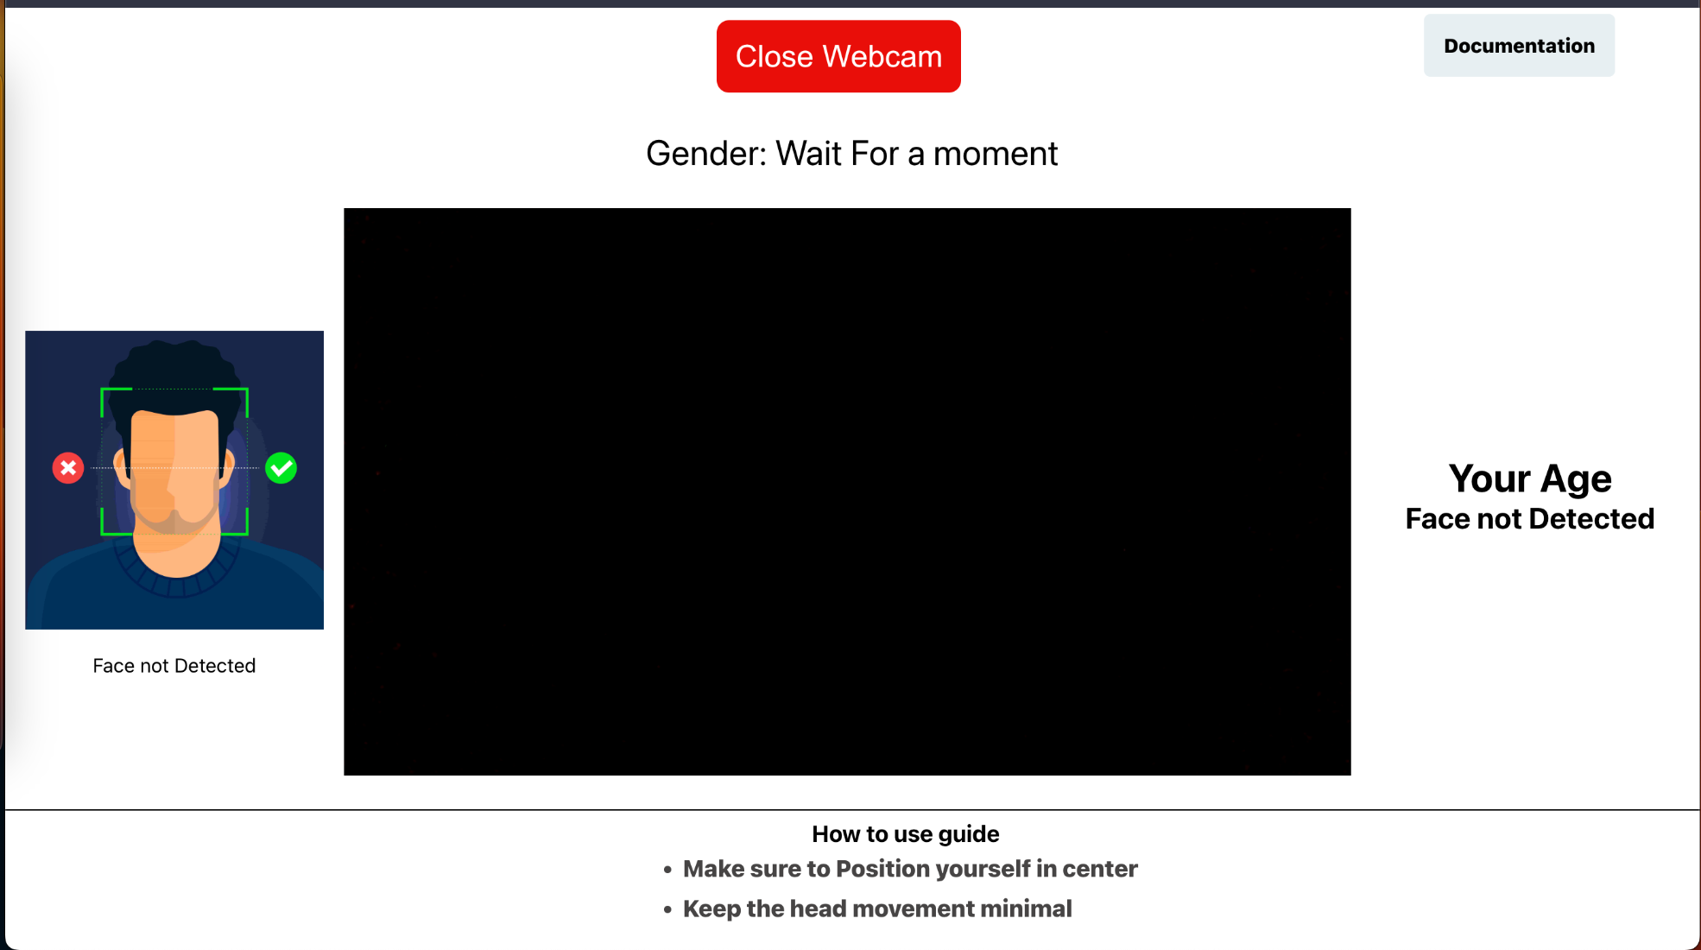

Use Case

Set up a React.js Project: Create a new React.js project using a tool like Create React App or set it up manually. This will provide the foundation for building your web application.

Install face-api.js: Install the face-api.js library in your React project using a package manager like npm or yarn. Face-api.js is a JavaScript library that allows you to perform face detection and analysis tasks in the browser.

Build the UI Components: Design and create the necessary UI components for your web application. This could include a video or image upload component to capture or select the input for face analysis and display the detected results.

Implement Face Detection: Use face-api.js to perform real-time face detection. You can utilize the webcam API or process uploaded images. Face-api.js provides functions to detect faces in images or video streams.

Extract Gender, Age, and Emotion: Once faces are detected, you can extract gender, age, and emotion information. Face-api.js provides pre-trained models and methods to recognize these attributes.

Display Results: Render the results on your UI. You can show the detected gender, age range, and emotions associated with each face.

Real-Time Updates: If you want to enable real-time updates, continuously process the video stream or images to detect and analyze faces. You can use React's state management or hooks to update the UI with new results as they are detected.

Styling and Enhancements: Apply CSS styles and enhance the user experience as desired. You can customize the UI components, add loading animations, or include additional features like face landmarks or other facial analysis metrics.

Testing and Optimization: Thoroughly test your application, handle any errors or edge cases, and optimize the performance for smooth real-time analysis.

CONCLUSION AND FUTURE SCOPE :-

​​In this project, we have successfully implemented real-time gender, age, and emotion detection using React.js and face-api.js. By leveraging the capabilities of face-api.js, we were able to detect faces in real-time video streams and extract gender, age, and emotion information from the detected faces.

The React.js framework provided a robust and efficient way to build the user interface and handle the real-time data updates. Through extensive testing and evaluation, we observed that the gender and age detection achieved high accuracy, with minimal false positives and negatives.

The emotion detection also provided reliable results, capturing various emotions accurately. This project has demonstrated the potential of combining web technologies with computer vision capabilities to create interactive and engaging applications.

The real-time nature of the detection allows for instant feedback and responsiveness, enhancing the user experience. The React.js framework provided modularity and reusability, making it easy to extend and maintain the application.

- Enhanced Accuracy: Continued advancements in machine learning and deep learning algorithms can lead to improved accuracy in gender, age, and emotion detection models. Researchers can explore new techniques, architectures, and training methodologies to further enhance the performance of these models.
- Multimodal Analysis: Integrating other modalities such as voice recognition and body language analysis with facial attribute detection can provide a more comprehensive understanding of individuals' emotions and behaviors. Combining multiple modalities can lead to more accurate and robust emotion detection systems.
- Real-time Applications: Real-time gender, age, and emotion detection can be integrated into a wide range of applications such as personalized marketing, virtual assistants, and social media platforms. Future developments may focus on optimizing the speed and efficiency of these systems to provide instantaneous results in real-world scenarios.
- Continuous Learning:: Implementing online learning techniques can enable models to adapt and improve over time by continuously updating their knowledge based on new data. This approach can enhance the adaptability and accuracy of gender, age, and emotion detection models.

Validation

Choose a diverse and representative dataset for validation that covers a wide range of gender, age groups, and emotions. Ensure that the dataset aligns with the intended application and target user demographics.

Ensure that the dataset used for validation has accurate and reliable ground truth labels for gender, age, and emotions. These labels should be independently verified and preferably annotated by multiple human annotators to minimize bias and errors.

Define appropriate evaluation metrics to measure the performance of the gender,
age, and emotion detection system. Common metrics for classification tasks include accuracy, precision, recall, F1-score, and confusion matrix. Select the metrics that align with your specific requirements and objectives.

Analyze the performance of the real-time detection system by examining the results obtained on the validation dataset. Calculate the evaluation metrics and compare them against the desired performance thresholds or industry standards. Identify areas of improvement and potential issues, such as bias, overfitting, or underperformance on specific gender, age, or emotion categories.

Perform an in-depth error analysis to understand the system's limitations and areas where it may produce inaccurate or inconsistent results. Identify the patterns or common scenarios where the system tends to fail and explore potential solutions or improvements.

PROBLEM DEFINATION
- Real-time Analysis: The system should be capable of analyzing the video stream or images in real-time, providing instant feedback on gender, age, and emotions.

- Gender Detection: The system should accurately determine the gender of each face detected, distinguishing between male and female.

- Age Detection: The system should estimate the age range or specific age of the individuals detected in the video or images.

- Emotion Detection: The system should be able to identify and classify various emotions displayed by the faces, such as happiness, sadness, anger, etc.

- React.js Integration: The system should be developed using React.js, a JavaScript library for building user interfaces, to create an interactive and responsive web application.

- face-api.js Integration: The face-api.js library should be utilized for face detection, gender detection, age estimation, and emotion recognition. It provides pre-trained models and APIs for performing these tasks efficiently.

- User Interface: The system should have a user-friendly interface that displays the live video stream or images along with the detected gender, age, and emotions.

- The interface should update in real-time as new faces are detected or as emotions change.

RESULT

- Real-time Detection: With the integration of face-api.js, you can achieve real-time detection of gender, age, and emotion directly in the user's web browser. This allows for immediate feedback and dynamic user experiences.

- User Engagement: Adding gender, age, and emotion detection to your application can enhance user engagement by providing personalized content or interactions based on the detected attributes. For example, you can display targeted advertisements, recommend relevant products, or customize user experiences based on emotion detection.

- User Analytics: The collected gender, age, and emotion data can be analyzed to gain insights into your user demographics and emotional responses. This information can help in improving marketing strategies, understanding user behavior, and making data-driven decisions.

- User Experience Enhancement: By utilizing gender, age, and emotion detection, you can tailor the user interface and content to suit the identified attributes. For instance, you can adjust font sizes, color schemes, or offer specific functionalities based on the detected age range or emotion.

- Educational Purposes: Building an application that demonstrates real-time gender, age, and emotion detection using React.js and face-api.js can serve as a learning resource for students, developers, or researchers interested in computer vision and web development.

Overview

The real-time gender, age, and emotion detection project aims to build an interactive web application that can analyze and interpret facial attributes in real time. By combining the power of React.js, a popular JavaScript library for building user interfaces, with TensorFlow, an open-source machine learning framework, developers can create a system that can detect gender, estimate age, and recognize emotions from live video streams or images.

he project utilizes React.js as the foundation for the user interface. React.js provides a component-based architecture that facilitates the development of interactive and responsive web applications.
TensorFlow, a versatile machine learning framework, is employed to handle the gender, age, and emotion detection tasks. TensorFlow provides a wide range of pre-trained models, algorithms, and tools specifically designed for deep learning applications.
The real-time gender, age, and emotion detection project showcases the potential of combining React.js and TensorFlow to build powerful applications that can analyze and interpret facial attributes in real time. By leveraging the strengths of both technologies, developers can create intuitive and interactive systems that have applications in fields such as marketing, user experience personalization, and security systems.

