Smart Hire
Rahat Sayyed¹, Hrushikesh Ambike², Akash Malekar³, Faizan Shaikh⁴, Sonali Murumkar⁵
¹²³⁴Student, Dept. of Computer Engineering, Keystone School of Engineering, Pune, India
⁵Professor, Dept. of Computer Engineering, Keystone School of Engineering, Pune, India

Abstract—This research paper proposes the automation of pre-screening rounds in recruitment processes to reduce time and resource consumption for companies. The proposed system uses AI assessment algorithms to filter candidates based on hard and soft skills required for a specific job. Two algorithms are presented in this paper: the personality insights algorithm for assessing OCEAN skills and the answer relevancy algorithm for assessing the significance of candidate answers. To simulate the recruitment process, a website was implemented with the developed algorithms. The objective of this paper is to automate the hiring process by applying machine learning techniques for personality prediction. The system aims to utilize video and tone analysis to assess the confidence and other traits of candidates. The system is designed to enable automatic sending of emails to selected or rejected candidates with just one-click. The proposed system also aims to facilitate faster recruitment in larger numbers. It generates concise insights and provides a summary of the candidate's profile. This application is designed to be user-friendly and convenient for HR/Recruiting teams. Overall, this system aims to streamline and optimize the hiring process for companies while reducing time and resources spent on recruitment. Additionally, a chatbot was implemented for the website, replicating the functionality of ChatGPT. A Resume builder was also developed, which offers multiple templates to choose from, easing the task of creating resumes. The proposed system has the potential to significantly reduce the time and cost associated with recruitment processes.
Keywords—TF-IDF, NLP, BERT, OCEAN personality traits, openAI.

Introduction
The recruitment process is a critical element of any organization's success, and hiring the right candidates is essential for achieving business objectives. However, traditional recruitment processes are often time-consuming, resource-intensive, and can lead to biases and inaccuracies in candidate selection. According to a report by Glassdoor, the average time to fill a job vacancy in the United States is 23.8 days, and the average cost per hire is $4,129. These figures highlight the need for more efficient and cost-effective recruitment processes that can deliver accurate candidate selection in a shorter time frame.
In today's competitive business world, recruitment is a critical process for any organization. The recruitment process requires significant investments in terms of time and resources. Companies often struggle with hiring the right candidates, and interviews can be time-consuming and exhausting. In recent years, there has been a growing interest in the use of artificial intelligence (AI) and machine learning (ML) to streamline and optimize the recruitment process.
AI-powered systems can filter candidates based on their skills, personality traits, and other relevant factors, reducing the time and effort required for pre-screening rounds. Moreover, AI-powered systems can help eliminate bias in the recruitment process, leading to more accurate candidate selection. As such, the use of AI and ML in recruitment processes has become increasingly popular across industries.
This research paper proposes a novel approach to automate the pre-screening rounds in the recruitment process. The proposed system utilizes AI assessment algorithms to filter candidates based on the hard and soft skills required for a specific job. This system also predicts the personality of candidates using ML and checks their confidence and other traits using facial emotion recognition and tone analysis. The proposed system further facilitates faster recruitment in larger numbers, generates concise insights, and provides a summary of the candidate's profile.
Additionally, this system implements a chatbot replicating the functionality of ChatGPT and a Resume builder that offers multiple templates to choose from, easing the task of creating resumes. The proposed system has the potential to significantly reduce the time and cost associated with recruitment processes while increasing the accuracy of candidate selection.
Overall, this research paper aims to revolutionize the recruitment process by introducing a more efficient, automated, and AI-driven approach. This paper presents the proposed system's design, implementation, and evaluation, demonstrating its effectiveness and usefulness for HR/Recruiting teams in organizations.

Hard and Soft Skills
Soft skills, often known as interpersonal skills, enable employees to make the most of their hard skills. Skills like dispute resolution, emotional intelligence, time management, and functioning well under pressure are essential in the job. Candidates can use soft skill interview questions to demonstrate personality attributes that can be utilized in the workplace. Soft-skilled employees become terrific team players and efficient bosses. They are skilled at forming bonds and are easy to get along with. Employers should focus on the seven important soft skills: communication skills, emotional intelligence, team player, growth mindset, time management, creativity, and leadership. [7]
Hard skills, also known as subjective skills, are quantifiable abilities or skill sets that may be taught. These abilities are typically obtained through classroom learning, reading, or on-the-job training and are frequently stated in a cover letter and CV to help employers discover them.

Existing System Survey

Myways.ai [8]: It is a recruitment portal for internships. Employers may advertise internships, review individuals who have applied for the internship, and hire them. This is an old way of recruiting in which just the internship information is published, and the rest of the interview process has to be performed manually by recruiters for every candidate. We recognized the need for automation in this process from this website.

Autogram [9]: On this portal, recruiters can create general job posts, and candidates can apply for them by answering questions in a video interview. The recruiters then manually assess the interviews and add a comment for their team about candidate evaluation. Further, the evaluators collaboratively take a decision to hire/reject the candidate

Adaface [10]: This platform uses a chatbot-based UI for screening. Only coding and aptitude questions are asked and reviewed automatically based on answers preset during the question configuration step. Additionally, a library feature is provided where the sample questions and packages are available for direct conduction of general job profiles.n
By surveying all these products, we extracted some distinct and innovative features from each product that would help us develop a definite solution for automating the recruitment process. There was a need of a Video Interview based assessment method over the manual interview process, a sample question library for multiple job profiles, collaborative feedback on the assessment by team members, and simple cloud-based solutions that can be easily deployed and used from anywhere in the world.

Literature Survey
The use of chatbots has become increasingly popular in recent years, with many organizations using them to provide customer service, automate tasks, and engage with users. One of the most advanced chatbot models available today is the GPT-3 (Generative Pre-trained Transformer 3) model developed by Open AI. The GPT-3 model has been trained on a massive amount of data and can generate human-like responses to a wide range of prompts [1]. One of the ways that GPT-3 is being used is to develop chatbots that can provide more advanced conversational experiences for users. The DaVinci API from Open AI is one such tool that enables developers to create chatbots that can understand and respond to user queries in a natural and human-like manner [2]. Overall, the literature suggests that the integration of chatbots using advanced models like GPT-3 can provide a more efficient and engaging conversational experience for users. The use of chatbots is expected to continue to grow across industries, and the development of more advanced chatbot models is likely to have a significant impact on various domains.
Bidirectional Encoder Representations from Transformers (BERT) is a pre-trained deep learning model that has gained significant attention in the natural language processing (NLP) community. Since its release in 2018, BERT has achieved state-of-the-art performance in a wide range of NLP tasks, including sentiment analysis, question answering, and text classification. Recent research has shown that BERT's performance can be further improved through fine-tuning on task-specific data. For example, in a study by Devlin et al. (2018), BERT was fine-tuned on the Stanford Question Answering Dataset (SQuAD) and achieved an F1 score of 93.2%, surpassing the previous state-of-the-art score of 91.6% [3].
A Naïve Approach for Monolingual Question Answering. [4] The paper employs a method that involves categorizing questions into types such as Factoid, Definitive, Reason, Procedure, or Purpose. The keywords from the question are then used to search a pre-indexed database of questions and answers using Lucene Indexer. The retrieved passages are ranked based on the frequency of matching keywords, and the most suitable passage is selected to check answer similarity. The paper also utilizes an advanced algorithm that utilizes natural language processing (NLP) techniques to score answers[5]. The system employs an algorithm that relies on natural language processing to search for answers to user queries within a knowledge base, typically consisting of resources such as Microsoft Satori, Wikipedia, or Freebase. The algorithm incorporates a scoring mechanism that enables it to calculate the average score for sentences extracted from the answers retrieved from the knowledge base, thereby enhancing its efficiency.
Automatic resume generation has been researched for years, with NLP and deep learning techniques like VAEs and sequence-to-sequence models. Researchers aim to generate resumes based on user input. Wang et al. (2020) proposed a system that used VAEs to create multiple resume templates, while Nallapati et al. (2017) used a sequence-to-sequence model to generate high-quality resumes. Karthik et al. (2014) used a template-based approach for resume generation. it also generates multiple resume templates for users to choose from, allowing for better customization [6].

Working
It involves the development of a website that leverages algorithms to simulate the entire recruitment process. The screening rounds feature a question bank where the recruiter can create queries to evaluate the hard and soft skills of candidates. During the recording process, candidates must answer these questions within a specified time frame. Following this, we apply our assessment algorithms to recorded video interviews. Our personality test algorithm evaluates the soft skills of candidates, while the answer relevancy algorithm assesses their hard skills. The algorithms generate overall scores for each skill, aiding the recruiter in selecting the best-suited candidate for the job.

Architecture
We have named our system as Smart Hire and there are 2
major modules in our system:
1. Recruiter Module
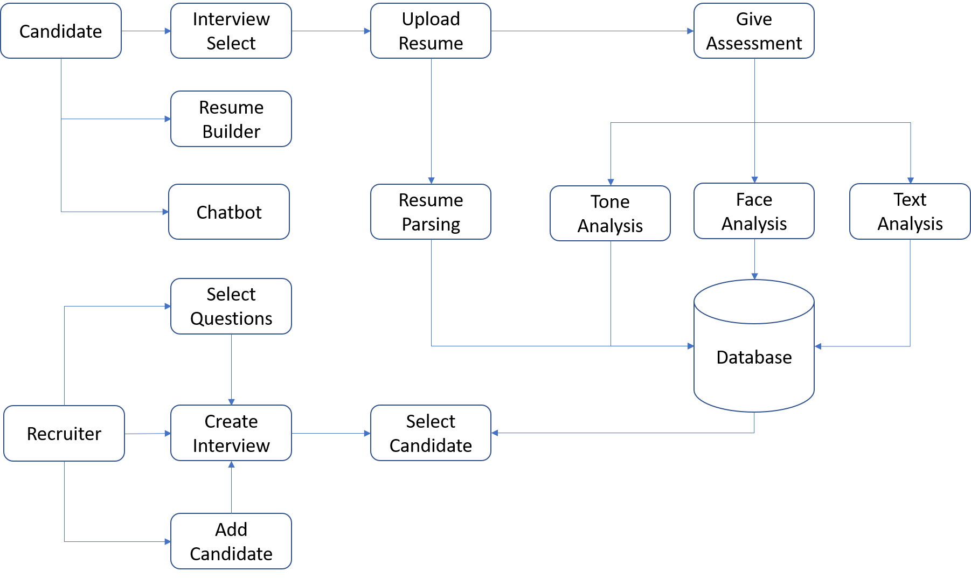
2. Candidate Module

Recruiter Module-
The Recruiter Module offers various functionalities to the recruiter persona, allowing them to simulate the entire recruitment process on our system. The recruiter can create a job opening post and a set of questions for the interview. Based on the submissions of the candidates and their scores generated by our assessment algorithms, the recruiter can filter out the candidates for the job post. The module provides an intuitive interface with interactive visualizations and statistical analysis of candidate data. The functionality of using a chatbot for solving queries can also be used by the recruiter.

Candidate Module-
In this, there is also a Candidate Module, as illustrated, which allows candidates to create their profile or resume and apply for job openings that match their skills and qualifications. Candidates are required to answer video interviews for the job profile they applied for, which are processed by our system, and scores are displayed to the recruiter. Additionally, candidates can utilize our chatbot feature to resolve any queries they may have, and our Resume Builder functionality to generate a resume from multiple templates.

Algorithms
Our proposed system includes two AI-based assessment algorithms for scoring candidate skills. The first algorithm is the Answer Relevancy Algorithm, which evaluates the candidate's hard skills based on a scale of 5 points. The second algorithm is the Personality Insights Algorithm, which scores the candidate's soft skills on a scale of 5 based on OCEAN values. These algorithms are integrated into our system to provide the recruiter with an overall score for each candidate based on their skills, making it easier to filter the most suitable candidates for the job.

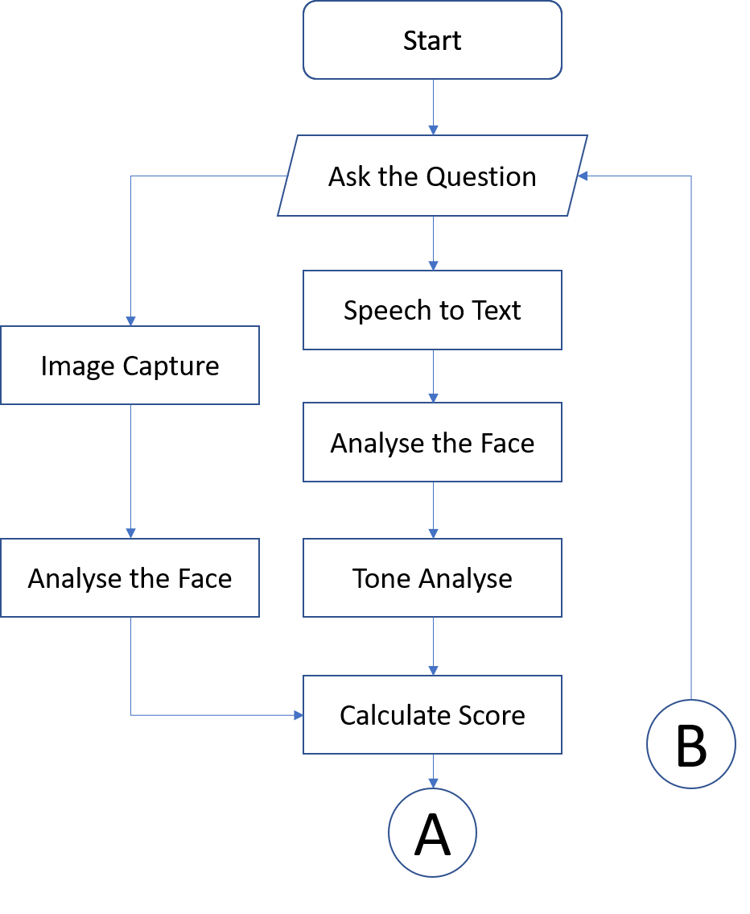
Answer Relevancy Algorithm
The proposed algorithm in our system aims to assess the hard skill questions provided by the recruiter. The video-interview responses for these questions are passed as an input to the algorithm, where initial pre-processing is conducted, such as converting the video to audio and then audio to text.
The question is then passed to the Search API, and based on the various answers fetched, the algorithm extracts the keywords from those answers and creates a bag of stemmed words. This bag of words is utilized for relevancy matching on the answered video text.
To improve the accuracy of the algorithm, additional weights for keywords will be added in the future. Figure 2 demonstrates the data preparation process, which includes the following steps:

- Search Question: The algorithm searches the question on Google using the Google search query. The URLs of the first page results are extracted and stored in an array.
- Summarizer: Each URL in the array is passed to the summarizer to generate a summary of the information contained in the webpage.
- Tokenization: The text in the summary is tokenized into individual words.
- Stemming: The algorithm applies stemming to the tokens to reduce them to their base form.
- Stop Word Removal: Stop words are removed from the stemmed tokens.
- Bag of Words: The remaining tokens are combined to create a bag of words, which will be used for relevancy matching on the answered video text.

Summarizing from URL:
- Parse each URL using HTMLParser to retrieve data.
- Tokenize the retrieved sentences, stem the tokens, and remove stop words.
- Summarize the resulting data and store it in a collection of relevant answers.
Video to Text Conversion:
- Read the video clip using VideoFileClip function from the moviePy library.
- Extract the audio from the clip and save it in a wav file format.
- Use the speech recognition library provided by Google to convert the audio file to textual format.
Preprocessing and Scoring:
- Preprocess the candidate's answer by stemming, tokenizing, and removing stop words.
- Compare the preprocessed candidate's answer with the collection of relevant answers generated in step 1 to generate a score.
- Pass the collection of relevant answers and the candidate's answer in the textual format as input to the scoring algorithm in part 2.
The second part of our answer relevancy algorithm involves scoring and is represented by flowchart Figure 5. This process involves pre-processing of documents in the relevant answer collection, followed by calculating document frequency (DF) and term frequency-inverse document frequency (TF-IDF).
Processing of relevant answers: The pre-processing steps include converting all documents to a uniform case, removing punctuation, apostrophes and stop words, converting numbers to words, and stemming words. After pre-processing, punctuation, stop words, and stemming are performed again to ensure no new instances of these items have been introduced. The result of this process is a tokenized preprocessed word document, and a collection of such documents for relevant answers.
- convert_lower_case()
- remove_punctuation
- remove_apostrophe
- remove_stop_words()
- convert_numbers()
- stemming()

Calculating DF: To calculate DF, all words in all documents are iterated through, and the document IDs for each word are stored in a dictionary, with the word serving as the key and a set of documents as the value. The set eliminates duplicates, even if the addition of the document occurs multiple times.

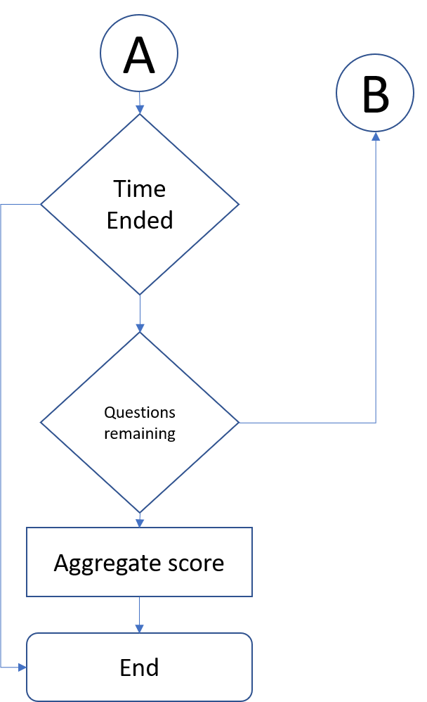
Calculating TF-IDF: TF-IDF, a statistic intended to reflect the importance of a word to a document in a collection, is then calculated. This statistic is calculated by multiplying the term frequency (TF) of a word in a document by the inverse document frequency (IDF) of the word across all documents in the collection.
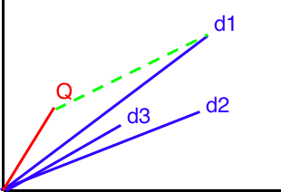
Cosine similarity is a commonly used technique to measure the similarity between two vectors of TF-IDF (term frequency-inverse document frequency) tokens. It is applied to the collection of preprocessed documents and the candidate's answer in the form of a vector. The documents are represented as vectors and plotted from the center of origin, and cosine similarity is used to calculate the angle between the candidate's answer vector and the document vectors. Cosine similarity is particularly useful in cases where the query length is small but closely related to the document because it is less sensitive to the length of the documents and focuses more on the relative importance of each word in the documents. This method helps to determine the relevance of the candidate's answer to the given question.

- Vectorization: To compute cosine similarity, all the documents are converted into a vectorized format using their TF-IDF values, which are stored in a NumPy array format.
- Pre-processing of relevant answers: Before vectorizing the candidate's answer, it must be pre-processed to match the format of the collection of documents.
- Generate a vector for the candidate’s answers: A vector for the candidate's answer is generated using the vectorization method to measure the angle between the vector of the answer and the vectors of the documents.
- The cosine similarity is calculated for all the documents with the query using the formula np.dot(a, b)/(norm(a)*norm(b)), which measures the cosine of the angle between the vectors projected in a multi-dimensional space.
- The cosine of the angle between the vectors is stored in an array, and two documents are considered similar if the angle between them is less.
- The document ID with the highest cosine value is retrieved, and the score is generated by normalizing the cosine value on a scale of 5.
The final average score of all the hard skill questions answered by the candidate is then displayed to the recruiter on a scale of 5.

Personality Insights Algorithm
The algorithm in our system maps the soft skill question assigned by the recruiter to assess the candidate for the job via video interview.
The answered video of the candidate for the soft skill-specific question is used as input to the algorithm.
Pre-processing is performed on the input video, including converting it to audio and then to text.
The resulting text is then passed to IBM Watson API to obtain a JSON response of OCEAN values in percentage.
Figure 5 illustrates the flowchart of the implementation of the algorithm.
The candidate's video answers for the soft skill question are pre-processed using BERT (Bidirectional Encoder Representations from Transformers) to convert the video to text format. The BERT model then generates contextualized word embeddings for each word in the text. These embeddings are fed into the BERT-based model for fine-grained sentiment analysis to obtain OCEAN values. Each value is between 0-100, which are later normalized to a scale of 5
O: Openness, C: Conscientiousness, E: Extroversion, A:
Agreeableness, N: Neuroticism
Algorithm for Personality Insights:
- Read the video clip using VideoFileClip function from the moviepy library to extract the audio and save it in a WAV format file.
- Use the speech recognition library provided by Google to convert the audio file into text and save it in a JSON format file.
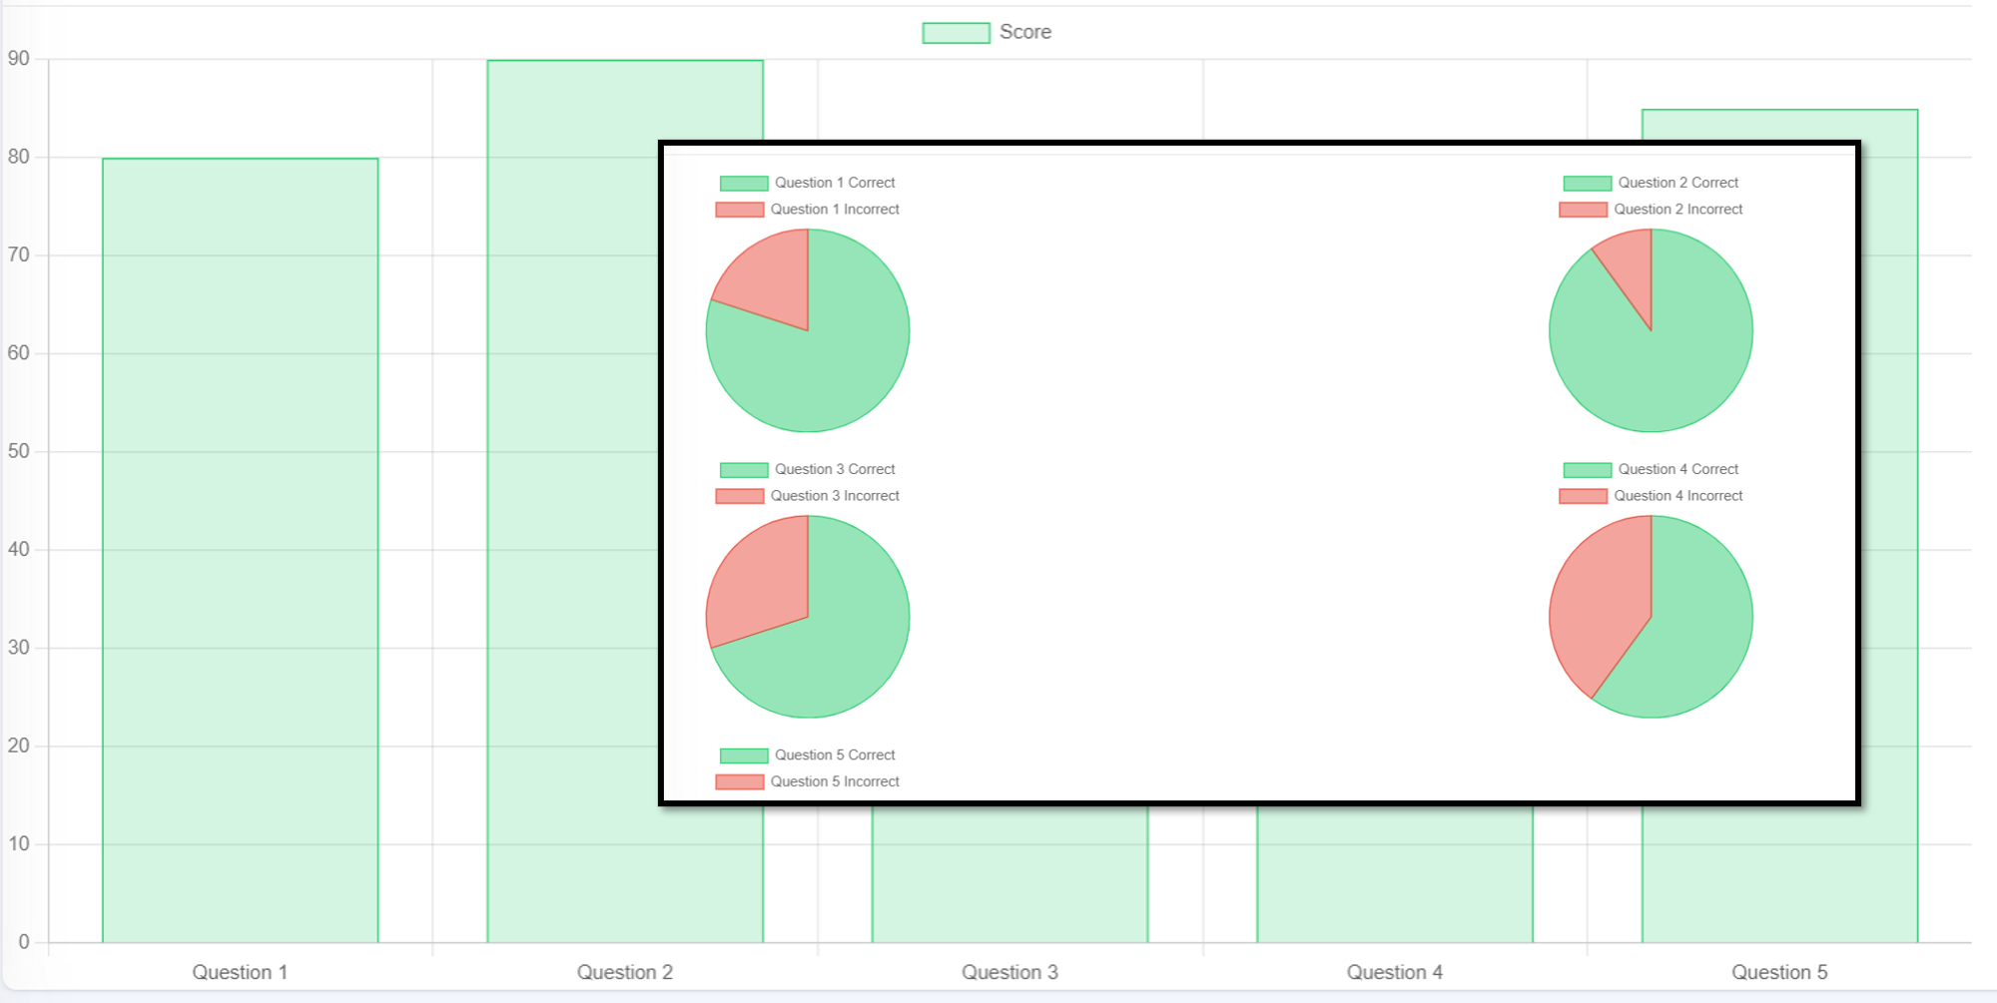
- Preprocess the text by removing stop words, punctuations, and other irrelevant characters using BERT tokenizer.
- Pass the preprocessed text to the BERT model for generating the OCEAN values of personality traits.
- BERT model returns the OCEAN values in JSON format.
- Extract each value from the JSON file and calculate the percentage.
- Normalize the scores on a scale of 5 and display the final scores to the recruiter.

RESULT
The study involved the practical implementation of the proposed system for assessing job candidates for five different job profiles. Specifically, the job profiles considered were Software Developer, Accountant, Business Consultant, Teaching Professional, and Event Manager, with each profile having at least ten candidates tested. Due to limited resources, manual assessments with experts in the respective fields were used as a benchmark to compare the algorithm-generated results.
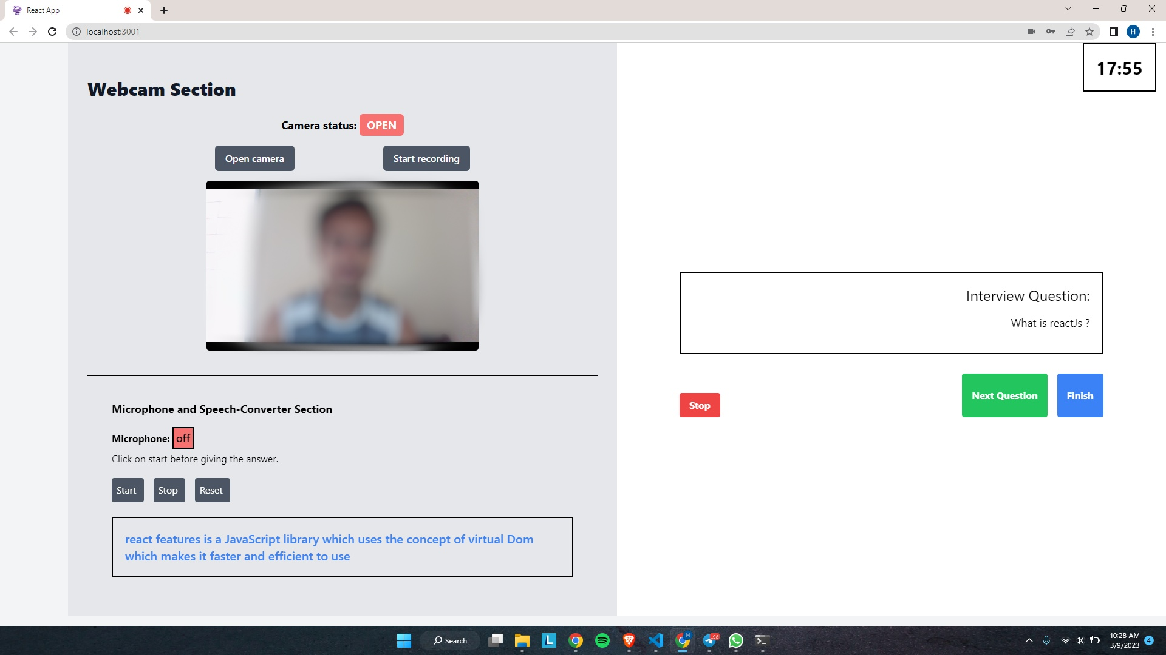
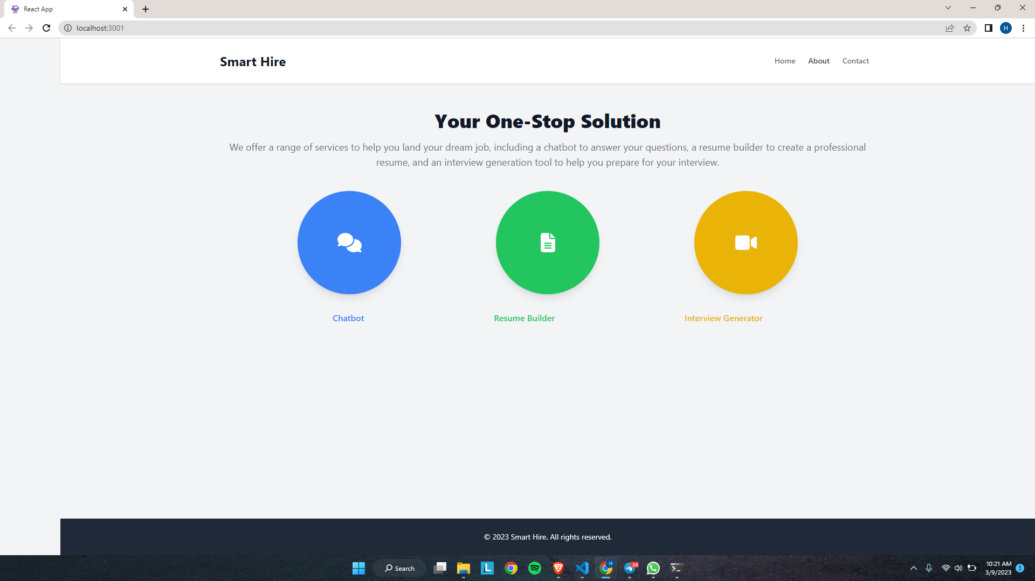
The results of the study showed an accuracy of 79% in finding the best-fit candidates using the proposed algorithms, which was considered a decent accuracy for algorithms running on an open dataset. However, the researchers acknowledged the need for testing the system on a larger scale with broader job profiles and thousands of candidates to obtain more accurate efficiency of the algorithm.
The display screen for the performance results shown to the recruiter for their posted jobs was presented in Figure 7, which included a list of candidates who gave the interview with filters and sorts for the recruiter to select the best fit for the role or subsequent rounds.

CONCLUSION
The presented paper is a significant contribution to the human resource industry, particularly the recruitment process. By automating the time-consuming aspects of the recruitment process, such as assessing candidate qualifications and soft skills, our system allows recruiters to save a considerable amount of time and effort. The solution features a website and algorithms that provide an AI-based analysis of each candidate's application for the job, making it easier for recruiters to find the best-fit candidates for the job.
The Personality Insights Algorithm, which provides BIG 5 personality values for soft skill-based questions, and the Answer Relevancy Algorithm, which scores candidate responses to subject knowledge-based questions, enable recruiters to evaluate each candidate's abilities more effectively. Our solution reduces manpower requirements and the time duration of the recruitment process while providing a more efficient method for assessing candidates' qualifications.
Overall, this paper provides an innovative solution to optimize the recruitment process, enhancing efficiency, accuracy, and objectivity. This approach could transform recruitment by making it less time-consuming and more effective, making it easier for candidates and recruiters alike. Further testing with a broader range of job profiles and a more extensive dataset is required to improve the algorithm's accuracy and efficiency.

FUTURE SCOPE
Since this research paper states the unique idea and a huge time & cost saver for all people involved in the job recruitment process, this system has a large future scope. The system can be made more robust and secured. Collaborations can be done with a few companies to test its real-world performance and introduce it as a complete weapon for the recruitment process. Currently, the system has algorithms for processing the hard skill and soft skill questions. But later, we can even include the processing of logical and analytical questions, which will cover a broader aspect of the interview questions.
This system is made to help the recruiter majorly, but we can also make it a tool for educational purposes. The students (before entering the recruitment phase) can give mock interviews on the system and can assess themselves based on the score for their answers, and the candidate can then practice the points or skills which he/she is lacking and give the interview again and try to become perfect at it. This will give them confidence for the real interviews. Colleges can use this educational tool to train their students.
Face Recognition feature can be added to recognize and match the candidate’s photo submitted in the resume, and the person giving the video interview is the same. This will not permit candidates to cheat the system and recruiter both. Thus, a couple of future works are mentioned above, but the HR industry is enormous, and there can be tons of improvisation made for this product.

Acknowledgment
We feel profound pleasure in bringing out this project report for which we must go through various papers to make it reality. This project work reflects contributions of many people with whom we had long discussions, and without which would not have been possible. We take this opportunity to express our heartiest gratitude to respected Prof. Sonali Murumkar (Department of Computer) for providing us with true guidance to complete project.
We would also like to express our gratitude to HOD and all computer department staff member for encouraging us and providing us all with the required facilities to complete this project.
We express our gratitude and appreciation and thanks to all those who knowingly and unknowingly have assisted us & encouraged us for project.

References
- OpenAI, research organization focused on developing artificial intelligence technologies “Blog ChatGPT”: https://openai.com/blog/chatgpt
- Juniper Research Market research firm that provides analysis on emerging technologies, including chatbots and their impact on industries:
https://www.juniperresearch.com/
- Devlin, J., Chang, M. W., Lee, K., & Toutanova, K. (2018). BERT: Pre-training of deep bidirectional transformers for language understanding. arXiv preprint arXiv:1810.04805.
https://arxiv.org/abs/1810.04805
- NLP Algorithm Based Question and Answering System, December 2014, https://uksim.info/cimsim2015/CD/data/8083a075.pdf
- "Applying Multinomial Naive Bayes to NLP Problems: A Practical Explanation," https://medium.com/syncedreview/applying-multinomial-naive-bayes-to-nlp-problems-a-practical-explanation-4f5271768ebf
- Karthik, P., Mathur, A., & Yagnik, J. (2014). Resume generator. International Journal of Advanced Research in Computer Science and Software Engineering, 4(11), 285-288. https://www.semanticscholar.org/paper/Resume-Generator-Karthik-Mathur/e506a8d25a7c4f37dd33e998e360c8da9da94a39
- The balance careers, “Hard Skills vs. Soft Skills: What's the Difference?”, accessed 26 December 2021, https://www.thebalancecareers.com/hard-skills-vs-softskills-2063780
- MyWays, accessed 03 November 2022, myways.ai
- Autogram, accessed 03 November 2022, myautogram.com
- Reculta, accessed 5 May 2019, reculta.com

Rahat Sayyed¹
Keystone School of Engineering
Savitribai Phule Pune University
Pune, India
sayyedrahat721@gmail.com
Akash Malekar³
Keystone School of Engineering
Savitribai Phule Pune University
Pune, India
malekarakash70@gmail.com
Hrushikesh Ambike²
Keystone School of Engineering
Savitribai Phule Pune University
Pune, India
hrushikesh.ambike@gmail.com

Faizan Shaikh⁴
Keystone School of Engineering
Savitribai Phule Pune University
Pune, India
faizanvit8@gmail.com
Prof. Sonali Murumkar⁵
Keystone School of Engineering
Savitribai Phule Pune University
Pune, India
sonali.murumkar@kaystonesoe.in

