REVIEW OF 3D PRINTING IN AUTOMOTIVE APPLICATION
¹Deepak J, ²Sreedhar Krishna M S, ³Ankit Waghmare, ⁴Akashay V, ⁵Santhu Kumar
¹Department of Mechanical Engineering, Jain University, India.
²Department of Mechanical Engineering, Jain University, India.
³Department of Mechanical Engineering, Jain University, India.
⁴Department of Automobile Engineering, Jain University, India.
⁵Department of Automobile Engineering, Jain University, India.

ABSTRACT: This is a paper on 3D printing, sometimes referred as an additive manufacturing technique, which has become a prominent topic in today’s modern world, notably in vehicle industry. This is one of the most commonly employed strategies in the current context, mostly to reduce materials and energy consumption, hence boosting innovation. This paper discusses what we mean by this phrase and why it is so beneficial and notorious in the automotive industry. Three-dimensional (3D) printing is a unique production process that has proven to be extremely efficient and dependable, as well as faster and less expensive than some existing production technologies. It is primarily used in the industry to create prototype parts, but its repeatability, precision, use of various materials, and range of Accessible printing technologies have made it appropriate for automotive sector. This review paper will make us to understand the methods used in automotive sector and its application in automotive sector.
Keywords: 3D printing, automotive, industry, vehicles, additive manufacturing, rapid prototyping

- INTRODUCTION
Three-dimensional (3D) printing, also known as "additive manufacturing" or "rapid prototyping," is a 1980s production technology for creating three-dimensional objects (also known as "prints"). The term "additive manufacturing" arose from the main principle of the technology, which is to add material layer by layer to achieve the desired shapes of the object. Rapid prototyping is another term for additive manufacturing (RP).RP was used by industries to create prototypes before final commercialization, but it was soon used to generate the final product, so the name was changed to additive manufacturing. The change in terminology was suggested by ASTM. The AM works by constantly adding layers of material of small but finite thickness until the desired product dimensions are obtained. Each AM process begins with the creation of a geometric model in modelling software, which is then converted to the STL file format. The CAD model is sliced in this step. The STL file is now transferred to the AM Machine and manipulated for proper position and size. 3D printing is a novel technology that has been used in a variety of industries, including manufacturing. The layer thickness, printing speed, and print orientation are entered into the machine via software. Printing size is mostly automated. AM machine made use of previously fed data. Post processing is an important aspect of AM. It is completed after the printing is completed. It entails removing support features. Surface finishing and painting are also completed during this stage. Heat treatment is also used to achieve a perfect body shape and reduce porosity in the product. It is important to note that there are various AM machines that are directly compatible with the modelling software, so slicing with STL format is ignored. Maintenance is the primary concern for the proper operation of AM machines. Because 3D printers are expensive and fragile, they must be carefully monitored. They must be checked and cleaned on a regular basis. As a result, they must be kept away from the filthy and noisy environment.
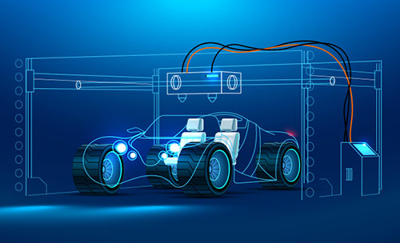
Fig. 1 3D printing

LITERATURE REVIEW
By 2022, the 3D printing market in the automotive industry is expected to reach $2391 million. The rise in popularity of 3D printing technology has been attributed to the cost-saving benefits that the technology provides to automobile manufacturers in the production of high-quality vehicles.
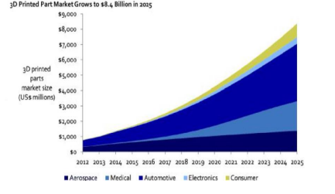
Fig. 2.1.1 Graph showing the growth in 3D technology from 2012 and the forecasted growth rate in 2025

Major car manufacturers such as Rolls Royce, BMW, and Bentley are already using 3D printing technology to create strong and durable automotive parts. Due to the high demand for vehicles in most parts of the world, the automotive industry has been characterized by intense competition over the last decade.
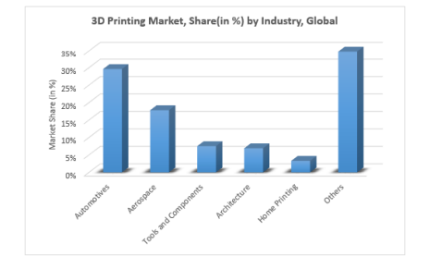
Fig. 2.1.2 3D printing Market share by Industry

Each new car begins as a prototype before going into production, first in miniature and then as a full-scale model. Instead of producing each piece independently, 3D metal printing enables engineers to generate a fully functional prototype immediately from their digital design, eliminating the need for additional fabrication stages in the middle. 3D metal printing is useful for more than just producing automotive prototypes. It can also be utilized to make rapid prototypes of tools and replacement parts that would take days or weeks to make otherwise. 3D metal printing could quickly prototype and print a replacement before sending it to the primary manufacturer, saving time and money and lessening the impact of the recall on the company and its reputation. On the best of days, classic vehicle collectors often find it difficult to obtain the parts they require to keep their automotive relic working. Some firms, such as Porsche, have turned to 3D printing to produce spare parts for rare and limited-run automobiles or any vehicle that owners or shops may have difficulty obtaining. Traditionally, if the warehouse runs out of any of the 52,000 individual parts that comprise the Porsche classic catalogue, specific tooling is required to create more of them. Not so with 3D printing. This method is less expensive than revamping a factory to produce a single part. These printers can be used by manufacturers to generate latticed items out of aluminum alloys. These components are as durable and safe as solid aluminum counterparts, yet they are up to 80% lighter. This 3D printing application's ultimate goal is to lower the weight of various vehicle components by 40 to 80%. This not only reduces weight, but also waste and the overall cost of production, making purchasing a new car or truck much more affordable for the average driver. Lighter vehicles also consume less fuel, improving fuel economy and lowering the amount of CO2 and monoxide emitted by the exhaust system.

- MARKET SURVEY

The automobile 3D printing market is divided into component, application, propulsion, and geographical segments. It is divided into three components: technology, materials, and services. Material extrusion, powder bed fusion, vat photopolymerization, material jetting, direct energy deposition, and binder jetting are the technology segments. Polymers, metals, and other materials are subdivided into the material segment. The market is divided into several applications, including prototyping, tooling, jigs and fixtures, end-use parts, and others. The propulsion category is separated into two categories: ICE vehicles and electric cars. The paper examines North America, Europe, Asia-Pacific, and Latin America. 3D Systems Corporation, Autodesk, Inc., Desktop Metal, Inc., EOS Gmbh, General Electric Company, Hoganas AB, Materialise, and others are among the main firms mentioned in the automotive 3D printing market study. The global automotive 3D printing market was valued $1,664.0 million in 2020, and is projected to reach $13,022.4 million in 2030, registering a CAGR of 23.7%. The research was conducted through a survey of automobile part manufacturers at Ford Motors, Toyota, Kia, Volkswagen, Bugatti, Mercedes, and Honda Motor. The seven companies were chosen because they currently use 3D printing technology in the manufacturing of automobiles.
Element of the 3D printers researched. | Fo rd | To yot a | kia | Volkswagen | BUGATTI | MERCEDES | HONDA
Improve the manufacturing cost per unit. | 96% | 98% | 98% | 97% | 96% | 99% | 99%
Allow the creation of geometric complex parts. | 99% | 99% | 99% | 99% | 99% | 99% | 99%
Saves on cost of manufacturing. | 95% | 96% | 99% | 97% | 96% | 98% | 99%
Facilitates customization of automobile parts. | 99% | 98% | 94% | 97% | 99% | 98% | 96%
Promoted the profitability and revenue generation of the automobile manufacturing companies. | 99% | 99% | 99% | 99% | 99% | 99% | 99%
Total/Average | 97.6% | 98% | 97.8% | 97.8% | 97.8% | 98.6% | 97.5%
Table 3.1 Survey of automobile part manufacturers with 3D printing.

The percentages represent the responses of the seven respondents from the seven automobile manufacturing companies. The responses obtained indicated that the research participants recognized the value of 3D printing technology in optimizing the automobile manufacturing process. The results demonstrated that using a 3D printer reduces the cost per unit of every vehicle produced by an automobile manufacturing company. As a result, the price per unit of all cars manufactured using 3D technology is reduced. Furthermore, using 3D printing technology reduces the cost of manufacturing for automobile assembly companies. Finally, the technology boosts the net revenue and profitability of the market's automobile manufacturing companies.

4. APPLICATION OF 3D PRINTING IN AUTOMOTIVE
There are various examples of the automotive industry using AM technology for historic car restoration or spare part production, ranging from specialized shops to car makers. An intriguing use of the combined use of 3D scanning and 3D printing to recreate outdated pieces like window winders and rollers or door knobs is the restoration of Elvis Presley's renowned BMW 507. The Pinin farina Jaguar XK120 is a great example of an analogue restoration where AM was used to recreate the damaged bumpers and lights. Both vehicles were displayed at the Pebble Beach Concours d'Elegance in California. Cases from other manufacturers, including Volkswagen, Bentley, Bugatti, and numerous more, abound.
A general framework has been depicted based on the analysis of the components' reproduction or repair. AM reconstruction of automotive components includes several areas of a vehicle, which are generally divided into four major categories:

- Interior: the dashboard, consoles, air vents, mirror, control levers, handles, switches, trims, etc.
- Bodywork: the body panels, fenders, bumpers, mirrors, headlights/indicators, grilles, handles, trims, etc.
- Structural parts: the suspensions, wheels, subframe components, brackets, etc.
- Powertrain: the gearbox, engine, differential, carburettors, pumps, etc.
In terms of automotive spare parts, the existing applications can be divided into two categories:
4.1 Direct AM Processes Polymer Spare Parts: -
AM processes such as ME (FDM/FFF), VP (SLA/DLP), and PBF are commonly used in the reproduction of polymer door handles, air vents, and interior switches. (SLS/MJF). Most of the time, acrylonitrile butadiene styrene (ABS) or acrylonitrile styrene acrylate (ASA) are used, but depending on the application, several industrial polymers and post-processing phases are considered. According to Paulic et al, RE and AM integration are well suited to the production of small components, providing the entire process in this case a set of polyamides car volume buttons was reproduced using SLS PBF. Many interesting applications with multiple components and varying production requirements can be found. Indeed, several companies focus on classic-car spare-part reproduction; for example, Tyr3D, a small company specializing in covering the entire process, focuses primarily on plastic components and employs a diverse range of 3D-printing materials. Gryp 3D is a French company that specializes in the reproduction of spare parts for vintage vehicles, such as the hood-release handle of the Ferrari 328.
In terms of car manufacturers, Porsche Classic used 3D printing to create spare parts for its classic models. The company made plastic parts and relied on SLS PBF to replicate several components, such as the crank arm and the filler-cap seal. High quality and accuracy of size and fit were ensured for all of these parts by performing tests to meet the specifications with respect to the original components, this included the selection of the appropriate polymeric materials for resistance to oils and fuels. Porsche, Mercedes-Benz has begun to manufacture replacement parts for several classic models using 3D printing, SLS PBF was used to replicate polymeric parts, such as the sliding sunroof rollers for the W 110, W 111, W 112, and W 123 model series, which are made of strong polyamide 12. In addition, the sparkplug holder from the toolkit of the 300 SL Coupé and Roadster was printed in PA12. The component in this case was customized, including a magnet to ensure compatibility with all spark plug types and terminal nuts. Nissan launched a Heritage Parts program to digitize the inventory and enable vintage car maintenance support. As a result, several Nissan Motorsports (NISMO) parts have been reproduced, including the reconstruction of the R32 Nissan Skyline GT-R's plastic harness protector, which was digitized and printed in MJF PBF using HP's High-Reusability PA 11 powder. There are numerous examples of single-component reproduction. Among these is the reproduction of the Ferrari Dino seat belt cover, provided by the company Bluepoint’s. 3D printing is an ideal candidate for producing parts cheaply and without the need for a mould, starting from 3D models that can be easily stored for future jobs.
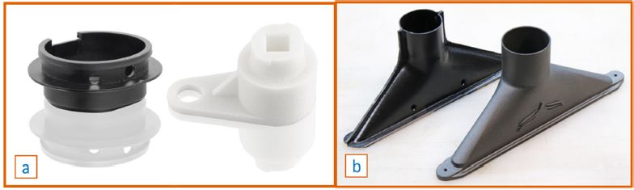
Fig 4.1 Polymer spare-part reconstruction based on direct AM processes: (a) Porsche 964 crank arm and Porsche 959 filler-cap seal (b) Jaguar E-Type heating air ducts
4.2 Direct AM Processes Metal Spare Parts: -
Metal end-use parts are created using Direct Metal AM (MAM) processes. The most common are laser-based PBFs, which are followed by thermal (e.g., annealing or Hot Isostatic Pressing (HIP)) and finishing (e.g., sandblasting or machining) post-processing to achieve the desired material and precision properties. Furthermore, it has been discovered that SL, the first metal process, as well as ME, MJ, and BJ can be combined with specific post-processing (e.g., the debinding and sintering of "green parts") to produce final parts. Finally, DED can be used for large-part fabrication (e.g., Wire Arc Additive Manufacturing (WAAM)) or component repair or reinforcement. High thermal gradients during material melting and solidification characterise MAM processes (e.g., PBF and DED), which can potentially cause many flaws. As a result, research continues to focus on overcoming issues and improving process reliability by reducing part and microstructure defects. There are numerous examples of structural and interior parts, and there is no shortage of powertrain applications.
Porsche Classic used to reproduce rare metal spare parts, such as the cases of the Porsche 959 clutch release lever (of which only 292 vehicles were ever produced) and the bracket for the 356B and 356C. The components were made of tool steel and processed using SLM PBF. Mercedes Classic provided an interior part case: the mirror base of the 300 SL Coupe. The component was made from aluminium alloy that was processed using SLM PBF and then finished with high-quality chrome plating.
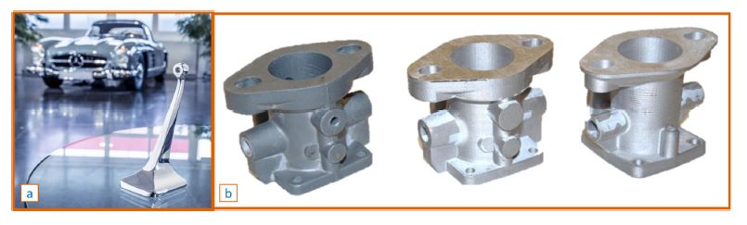
Fig 4.2 Metal spare-part reconstruction based on direct AM processes: (a) Mercedes 300 SL Coupè mirror base (b) Steyr 220 carburettor body (left), 3D printed original design (centre), 3D-printed DfAM design (right)
Many examples also involve engines and transmissions. Montero et al. describe a diesel engine valve cover reconstruction process based on RE and AM. Cooper et al. describe the RE, modelling, construction, and testing of lightweight valves. Mercedes also produced uncommon spare parts for Unimog models, such as thermostat covers for truck engines.
Jay Leno's Garage in collaboration with Stratasys, the component was created using Inconel 718 (a nickel-based superalloy) and processed using DMLS PBF. Tecron restored the carburetor of a 1930s Steyr 220 Roadster in another engine application. They performed RE on the parts using 3D scanning and produced them in 17-4 PH stainless steel using Markforged's Metal Fused-Filament Fabrication ME process. Interestingly, they also demonstrated how applying DfAM guidelines can reduce manufacturing time and costs by 30%.
The well-known motorsport company Sauber is currently involved in the historic-vehicle sector, replicating classic car components. A powertrain case is the gearbox housing from a 1950s Ferrari 350 America Barchetta. They used 3D scanning to perform RE on the housing, and they built the component in aluminum alloy using Additive Industries' laser-based PBF process. Finally, if components can be repaired rather than reproduced, such as engine crankshafts, oil pumps, cylinder heads, DED or Cold Spray AM processes can be used. Furthermore, because repairing engine blocks via AM can cost 40% less than purchasing a new engine with spare parts priced at 40% of the original cost, economic benefits are possible.
4.3 Indirect AM Processes of Metal-casting: -
Metal-casting technologies use additive manufacturing to develop tooling, and two approaches can be distinguished: direct tooling and indirect tooling. The first category includes 3D-printed sand moulds and casting cores. The second group includes the creation of 3D-printed master models (patterns) to form the sand mould in sand casting, sacrificial patterns for the fabrication of ceramic disposable moulds for investment (lost-wax) casting, or—indirectly—silicone or rubber moulds for the creation of wax patterns.
The direct tooling group, which is part of the rapid tooling processes, primarily focuses on sand-casting processes for the production of sand-cast moulds and cores using commercially available techniques, such as Direct Laser Sand Sintering (DLSS) and 3D Sand Printing. DLSS, like SLS and DMLM, uses a low-power laser to directly sinter silica sand without the use of a binder. It has a relatively low deposition rate (2500 cm3/h) and requires no tools to produce the mould, giving the engineer design freedom. Because of the low relative speed and high machine price, it can only be viable for high-value, highly complex, small, one-off castings.
A multi-jet print head is used in a deposition head to deposit micro-droplets of foundry-grade resin binder into a fine, thin layer of permeable casting sand premixed with an activator. It is a cold process that only requires off-machine de-powdering after production. The components manufactured are extremely accurate, and the machines produce at a high rate. Many automotive manufacturers require large moulds, which the 3D SP can produce. Casting is performed in the same way as in the traditional process, with the exception that the mould is produced differently, taking advantage of the advantages of AM.
In terms of antique vehicles, an early example of RC application was the creation of the engine block of the last-surviving 1914 Delage Type-S this was made feasible owing to a grant from the National Science Foundation.3D scanning of the cracked block, 3D modelling of the engine mould, and 3D printing of the mould using a Voxeljet VX1000 printer comprise the digital workflow. Finally, the metal was put into the 3D-printed moulds, which were used to replicate the whole engine block (Figure A3a). Another example from the realm of automotive repair is the recreation of a damaged 1912 one-cylinder car engine [122]. The 3D-scanned model needed contraction allowance, machining allowance, gating system, risers, chills, vents, and a hoisting system, as well as partitions in the moulds and cores. An ExOne S-Max 3D sand printer was used to create the mould parts. The cores and moulds were coated in the traditional way. Figure 6a depicts the cores, mould, and finished casting.
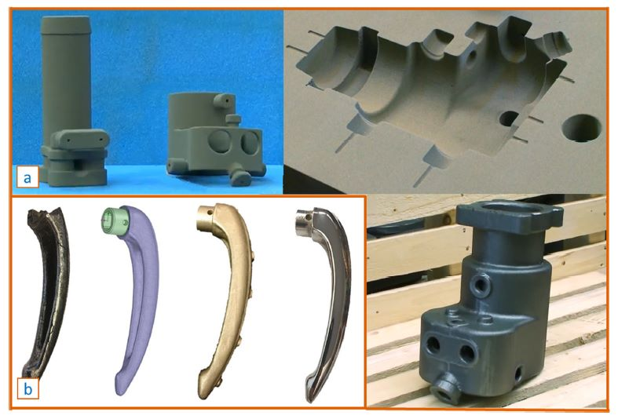
Fig 4.3 Polymer spare-part reconstruction based on indirect AM processes: (a) Sand mould and cores for casting a 1912 one-cylinder car engine. (b) Investment cast door handle
The indirect tooling group, also known as rapid casting (RC), creates patterns for producing moulds utilizing 3D-printing techniques like FDM, SLA, SLS, or any other 3D-printing technology. We identify indirect tooling applications in sand casting and investment casting, according to Chhabra.
Patterns, cores, and gating systems for indirect tooling applications in sand casting are created using AM methods in a reasonably short amount of time, proving to be cost-effective and time-efficient. By ignoring internal cavities and designing core prints, AM aids in the fabrication of patterns with additional cores. Pereira et al, documented the benefits realized with the application of FDM patterns in sand molding, beginning with the initial application utilizing Laminated Object Manufacturing (LOM) for manufacturing paper master patterns, and are open to alternative AM techniques (SLA, PolyJet, and SLS).
Investment (lost-wax) casting (IC), which uses a wax or polymer pattern as a sacrificial pattern to manufacture solid metal pieces, is another form of indirect tooling application. These sacrificial designs are used to make a ceramic mould by coating patterns with refractory ceramic coatings, which are subsequently removed using heat. Chhabra divides IC processes into two categories: direct wax patterns (created using the SLS, FDM, SLA, and DOD procedures) and direct non-wax patterns (made using thermoplastic polymers such as ABS and PLA, from which the name "lost-PLA casting" originates).
Gray and Depcik, as well as Chhabra, reported the use of rapid-casting (RC) techniques for the production of internal combustion engine components, such as crankcases, cylinder blocks, air-intake manifolds, exhaust manifolds, and gearboxes, by printing master models using PolyJet, SLA, or FDM processes.
In the case of antique vehicles, a 3D-scanned door handle from a 1959 Lancia Aurelia B24S was reverse-engineered before wax models were 3D-printed (SLA) to cast an exact replica in solid brass, which was then chrome-plated. A 1937 Voisin C30 fan, for example, was reverse-engineered, raw-cast in aluminum, and then machined to provide mounting holes. Finally, a 1955 Mercedes Gullwing 300 SL door and trunk key was 3D-scanned, the 3D model was cleaned up, and a wax pattern of the key was 3D-printed to be utilized in an investment-casting process. The key was made of solid brass, which was then post-processed and slotted.
4.4 Composite Spare Parts Direct AM Processes: -
Additive Manufacturing of fibre/polymer composites marks a watershed moment in AM technology. The improved mechanical properties provided by the incorporation of reinforced materials into plastic materials have broadened the application field, increasing the potential of AM. Several AM processes based on fiber-reinforced polymers, including ME (FDM/FFF), PBF (SLS), VP (SLA), and SL (LOM), have been developed. In terms of direct AM, the most common polymer composite automotive applications are exterior panels and trims, interiors and seating, but also electrical sensors, suspension, and engine components. Furthermore, there is a growing interest in car restoration, part reproduction, redesign, and customisation.
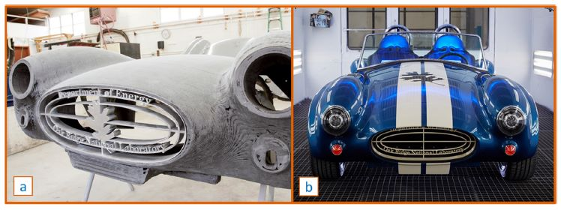
Fig 4.4 Composite spare-part reconstruction based on direct AM processes: the Shelby Cobra’s (a) rough and (b) finished bodywork Composite spare-part reconstruction based on direct AM processes: the Shelby Cobra’s (a) rough and (b) finished bodywork

4.5 Composite Spare Parts Indirect AM Processes: -
The creation of moulds and cores is a major component of indirect AM procedures for fibre-reinforced components. AM of big moulds and dies is often used to manufacture tooling for low-volume productions or one-of-a-kind prototypes. Over time, AM technology has advanced to cover the primary types of composite moulding (prepreg and wet moulding), lowering tooling costs and increasing productivity. Among these, BAAM has been used with promising results, and there have been recent improvements in metal additives for composite compression moulding. Furthermore, additive manufacturing of sacrificial equipment, such as cores and mandrels, in conjunction with filament winding, prepreg, and wet layup, can be utilised to automate the production of ducts, pipes, manifolds, tanks, or tubular/hollow structures.

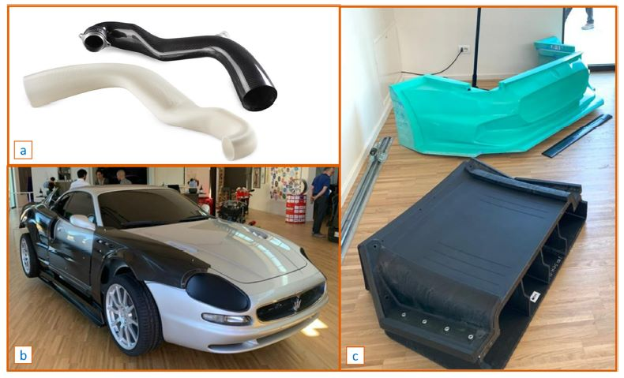
Fig. 4.5 Composite spare-part reconstruction based on indirect AM processes: (a) the FDM sacrificial core and the carbon fibre inlet ducts (b) body components and (c) related tooling
To allow removal of the material used to form cores must be made soluble or breakable, but it must also be compatible with the temperature and pressure necessary by composites operations. Traditional methods employ eutectic salts, soluble ceramics, and flexible urethanes, which necessitate the use of metal moulds or the direct application of clamshells. FDM cores consisting of soluble SR100/ST-130 or break-away ULTEM® Support that can withstand autoclave processing (up to 110-130 °C and 2-5 bars) offer numerous benefits, including the elimination of bonding and seams and enhanced internal and external surface finishes As proven by the case of carbon fibre inlet ducts (Figure 8a) for the Porsche 997 Turbo given by Champion Motorsport in partnership with Stratasys, the pieces manufactured in one layup operation also enable for reduced manufacturing time and cost (up to 85%).

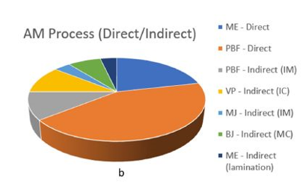
Fig. 4.6 Spare-part reconstruction cases according to vehicle areas

5. CONCLUSION
Three-dimensional printing is quickly evolving and has the potential to become one of the industry's primary production methods. For fast and effective production, more than five distinct additive manufacturing techniques are used in the car industry alone. To be more specific, all of the technologies mentioned can be utilised for automotive prototypes, polymeric tooling, and components when non-metallic materials are employed, however DMLS and LMD are only suited for metallic parts and prototypes. Most methods can produce polymer and metal moulds, depending on the material, but binder jetting is especially effective for sand moulds. Moulds for large carbon fibre parts and entire chassis sections may be readily and cheaply produced with FDM. By using 3D printing in automotive is a cost effective and quick production of parts for automotive companies.

REFERENCES
[1] Sreehitha, V. (2017). Impact of 3D Printing in Automobile Industries. International Journal of Mechanical And Production Engineering , 5 (2), 91-94. Retrieved from http://www.iraj.in/journal/journal_file/journal_pdf/2-347-149260399391-94.pd
[2] jiménez, M., Romero, L., Domínguez, I. A., Espinosa, M. d., & Domínguez, M. (2019). Additive Manufacturing Technologies: An Overview about 3D Printing Methods and Future Prospects. Hindawi, 1-30. doi: 10.1155/2019/9656938
[3] Manghnani, R. (2015). An Exploratory Study: The impact of Additive Manufacturing on the Automobile Industry. International Journal of Current Engineering and Technology, 5 (5), 3407-3410. Retrieved from http://inpressco.com/wp-content/uploads/2015/10/Paper563407-3410.pdf
[4] Ichidai, Y. (2019). Current Status of 3D Printer Use among Automotive Suppliers: Can 3D Printed-parts Replace Cast Parts? IFEAMA SPSCP, 69-82. Retrieved from http://ifeama.org/ifeamaspscp/selected%20papers/13th%20in%20Ulaanbaatar/13th%2006%20%20Y_Ichida_final.pdf
[5] Beiderbeck, D., Deradjat, D., & Minshall, T. (2018). The Impact of Additive Manufacturing Technologies on Industrial Spare Parts Strategies. Centre for Technology Management working paper series, 1-57. Retrieved from https://pdfs.semanticscholar.org/fde3/38bf35690594dc9a4f2822853bab87fb45dc.pdf
[6] Mpofu, T. P., Mawere, C., & Mukosera, M. (2012). The Impact and Application of 3D Printing. International Journal of Science and Research (IJSR), 3 (358), 2319-7064.
[7] Reeves, P., & Mendis, D. (2015). The Current Status and Impact of 3D Printing Within the Industrial Sector: An Analysis of Six Case Studies. Centre for Intellectual Property Policy & Management, 2015 (41), 1-15. Retrieved from https://assets.publishing.service.gov.uk/government/uploads/system/uploads/attachment_data/file/549046/Study-2.pdf
[8] Sharma, A., & Garg, H. (2016). Utility and challenges of 3 D Printing. IOSR Journal of Mechanical and Civil Engineering (IOSR-JMCE), 49-53.
[9] Sarvankar, S. G., & Yewale, S. N. (2019). Additive Manufacturing in Automotive Industry. Internationl Journal of Research in Aeronautical and Mechanical Engineering, 7 (4), 1-10
[10] Maxmize Market Research. (2019). Global 3D Printing Automotive Market and Forecast (2016-2024) by Technology, Input Materials and by Geography. Retrieved from Maxmize Market Research PVT. LTD.:

