Implementation of Dr Ambedkar scheme for Social Integrations through Inter Caste Marriage Around Manaparai

Author:
V.R.SreeHari,
131801084,
4th YEAR,BA,LL.B(Hon’s),
Saveetha School of Law,
Saveetha University, Saveetha Institute of Medical and Technical Science (SIMATS),
Chennai-77,

Co-author:
Dr.D.Vezhaventhan,
Assistant Professor,
The Head,Department of Humanities and Social Science
Saveetha school of law,
Saveetha Institute of Medical and Technical Science (SIMATS),
Chennai-77,

Abstract:
Inter Caste Marriage is a way to break the Caste System Barrier in Society.And inter caste marriage can break because the marriage is traditional customs where Indians respect that more where if caste was not seen in that then that will be helpful to break the caste barrier and To know how far the objective of the scheme where inter caste Marriage can break untouchability. Simple Random sampling has been used and Response Collected is 200 and The Result was there is no Good Responses for the Inter Caste Marriage. Schemes like This don't help society and there should be more awareness given to people and that Should be as powerful as the caste system is the Powerful in the Society. And make people think that the caste system doesn’t prevail and it doesn’t help humans in any way.

Keywords:Inten-caste, Marriage, Caste, Shedule caste, Discrimination.

Implementation of Dr Ambedkar scheme for Social Integrations through Inter Caste Marriage Around Manaparai

Introduction:
The society nowadays have discrimination with regard to caste, religion, race, sex, place of birth and gender. The society so far is deep rooted in major discrimination of caste and religion. Only a few luminaries found some ways to eradicate the caste in the society. One such way is inter-caste marriage which can eradicate the caste discrimination to some extent. In India, caste discrimination is so high and the marriage is also important social custom for them. So the thought was that if inter-caste marriage could happen, then it would be the best means to remove caste system barriers. And to make that so effective the Government had brought out many schemes for inter-caste marriages. The Dr. Ambedkar Scheme for Social Integration through Inter-caste Marriage is one of those schemes for inter-caste marriage and its main objective is to appreciate the bold step of inter-caste marriage. And this scheme can put forth social integration in the society and to promote inter-caste marriage the government provides the incentives and financial support to the married couples. And the incentives of the scheme is Rs:5,00,000/- and the 50% of the amount Rs:2,50,000/- is given in the form of DD in the name of married couples and the balance incentive amount will be released after the 5 years of the marriage. The factor which affect the inter-caste marriage is low literacy level where it is in the rural area and small towns and if though they are educated and in urban areas they are not appreciating towards the inter-caste marriage because of their status and they may be discriminated if they are married to the schedule class people.And according to India we follow that the selection bride or groom by the parents where they doesn’t need the bride or groom from the lower caste.And if we take any survey or statistics we see only the major response is that everyone oppose the Inter-caste marriage because of their traditional customs. In the Society of India we now could see the culture of inter caste marriage in the cities but where as in the rural area of India we have very long way to go for it.Major Factor that affects us is if we marry or if we accept the marriage from a lower caste then what will be words and thoughts from the family, friends and society. And the current change is the union government has altered the income limit and the eligibility criteria as annual income Rs:5,00,000/- has been lifted. And compared to other states and countries it was observed that they were running schemes similar to this without an income limit. So, keeping that in mind the union government removes the income criteria to promote social integration. In Odisha the government offers them Rs:1,00,000/- as incentives for the inter-caste marriage couples irrespective of their income ceiling and between 2010 to 2016 they have given incentives to around 4100 couples. Rajasthan is the first state to introduce the incentives for inter-caste marriage through Dr. Savita Ben Ambedkar Inter-Caste Marriage Scheme. Whereas we have many schemes we can’t change the mindset of Indians which is for years that is they are having orthodox mindset of marrying within their caste or community. If they have the dare to violate the traditional customs of marriage within caste they may be facing the consequences of boycott from society and family and death.
Objectives:
To know how the public is aware Of Dr. Ambedkar scheme for Social through Inter-caste Marriage. To know public Tendency Towards Intercaste Marriage. To know is the scheme Appreciate the public for Inter caste Marriage.
Review of Literature:
Divya (2007) The parental Involvement in the Spouse choice was strong in urban areas. Strong Financial parents were also involved in mate Choice. Women College Educated, Labour work suggested Reduction in parent Control. (Kannan), suited 149 Inter-caste Married couples in Bombay found steadily Increase in Inter caste Marriage Recently at age of Marriage chose her Partner. Shankar (1970) Matrimonial ads, shows, Selection of Families has Caste Barrier. Friends & Family play all means to stop but it was Increased 700 in 1965 to 5800 in 1969. Bhraminas was the top hierarchy opposed to this. Chintamani (1973), Rural areas of Andhra 963 people are favouring only within caste marriage only 29 were not particular about marriage within Caste both top and low shows try to improve social status. Reddy et al(1984), Scheduled caste have high tendency to Inter-caste Marriage urban Residence, education, employment in morden occupation and middle class economic have tended arritubites and affects Inter Caste Marriage. Take place at an advanced age and Rather young age. Kapadia (1966),India the 513 universities quarters was Interviewed 51%. Cheer their child to marry outside their Caste. Prasad (1957), shows this study In India 4750 marriages Including Dalits in 2008 & 2009 while the number was slightly lower 4205 in 2007 to 2008 and 3945 in 2006 to 2007. Andhra Pradesh and Maharashtra conducted around 1000 inter-caste marriages in 3 years. Saroja (1999), only 1/3 against the department Culture postgraduate students only Moderately favouring Inter caste Marriage. ,(Despande)To understand Evil of Inter caste Psychological viewpoint marriage samples of 75 inter caste Married in Maharashtra were surveyed. Not only Friends & Relatives, couples themself consider such marriages problematic. Kannan.C.T(1963), 200 Inter-caste Married people Randomly in Maharashtra were collected and the result was respondents look after year by year the inter-caste Marriage was Increased among the upper - Middle class people. Ross Aileen(1961), Findings were 2/3 of men respondents were in favour of Inter-Caste Marriage. They favour because the caste system, Destroys the Love Marriage. Ramu.G.N (1977), he conducted the Research in the K.G.F, there Intercaste Marriage was highly opposed and Author found that they have six Important Reasons to Restrain no such Inter Caste Marriage in K.G.F. (Chakraborti), values and attitudes of the students in calcutta Examine in changing hindu society. 200 Students 100 male and 100 Female they were less favourable towards the Inter Caste Marriage. Rajana C.H (1984), Focus on the Socio-Economic Background of Inter caste Marriage Survey conducted in Andhra Pradesh the people who inter Caste Married are in Morden occupation have high Education qualification. Yadav. DR (1979) Result shows increase in Amount of Librazations In Selection of Marriage partners half Repotents Caste Rules, Marriage half say caste doesn't previl. Banerjee AR (1978), Data Found Intercaste Marriage higher in the Vaidhya people and 12%. Were Intercaste Marriage. Industrialization , urbanisation have Effect in breaking caste. Chintamani (1972), The author has Rural Response of 965 and 936 were only within caste Marriage. Parents Including having a Marriageable age son / daughter were not favour In Intercaste Marriage Expect 29. Prasad (1957), Bihar the Author found many in Inter Caste and studied Related with 5 Major Caster higher class opposite of Intercaste Marriage. And urban & rural middle Class favour Inter caste Marriage. Krishna Work Sammy (1996), It was conducted in the university to the students Rural, small town stutes think strongly of caste feeling like Village Prevalence evil-customs dowry, serious Problem. (Saroja and Surendra),In this study noted just a decrease in Inter Caste Marriage in Large.Cities but Plural areas are not aware of Inter Caste Marriage.
Methodology:
The research method followed here is empirical research. The sample size is 200 and the samples were selected through simple random sampling technique. The research problem was identified through the review of literature. Descriptive research design was adopted for the study. The sample frame taken by the researcher in Trichy District place called Manapparai.Data collection included both primary and secondary resources. Primary data was collected through questionnaires. Secondary sources included published information from journals, reports and newsletters. The analysis was done by using the SPSS 21 version. The independent variable is Age, gender, Occupation, Educational Qualification. The dependent variable is Data was analysed using graphical representation through bar charts. Comparisons were done across the demographic variables using these bar charts and the mean value of the ratings received.

Data Analysis:
Figure:1
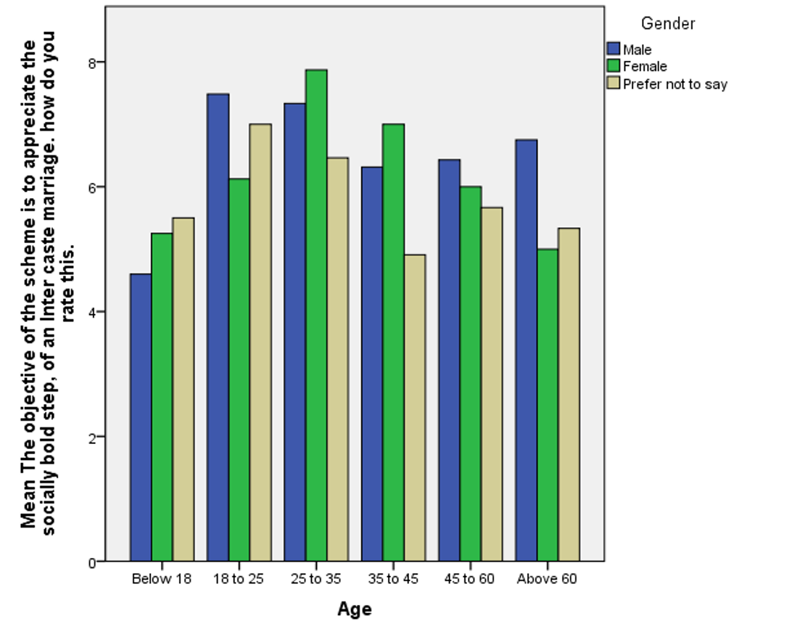Legend:Fig 1 Shows the distribution of Age and Gender with relation to The objective of the scheme is to appreciate the socially bold step of an Inter caste marriage. How do you rate this.

Figure:2

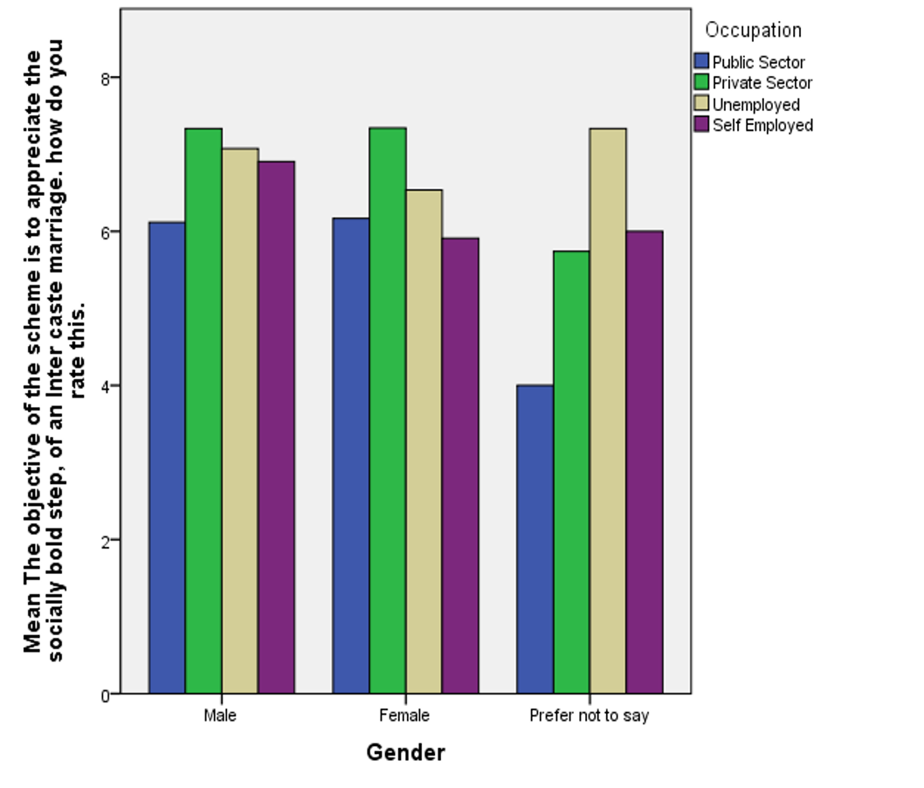
Legend:Fig 2 Shows the distribution of Gender and occupation with relation to The objective of the scheme is to appreciate the socially bold step, of an Inter caste marriage. how do you rate this.

Figure:3
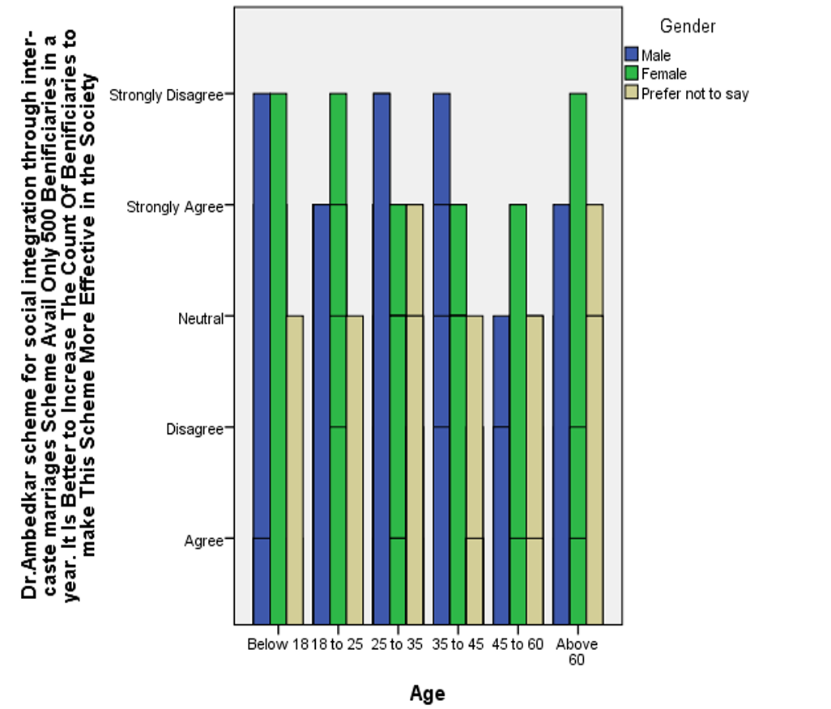
Legend:Fig 3 Shows the distribution of Age and Gender with relation to The Dr.Ambedkar scheme for social integration through inter-caste marriages Scheme Avail Only 500 Beneficiaries in a year. It Is Better to Increase The Count Of Beneficiaries to make This Scheme More Effective in the Society.

Figure:4
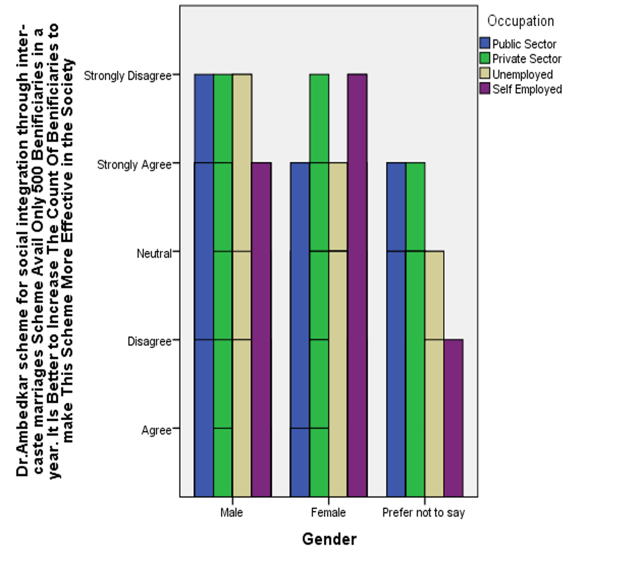
Legend:Fig 4 Shows the distribution of Gender and occupation with relation to TheDr.Ambedkar scheme for social integration through inter-caste marriages Scheme Avail Only 500 Beneficiaries in a year. It Is Better to Increase The Count Of Beneficiaries to make This Scheme More Effective in the Society.

Figure:5
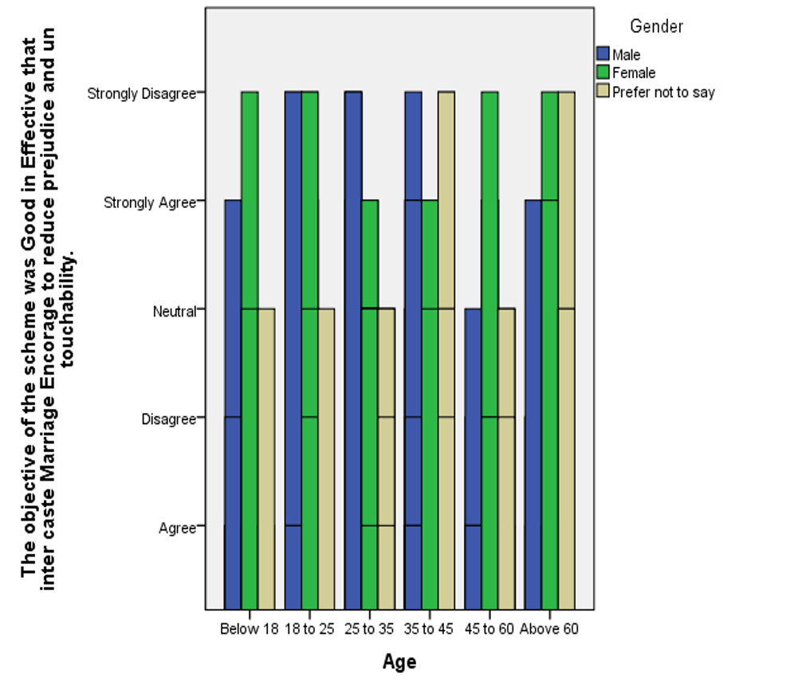
Legend:Fig 5 Shows the distribution of Age and Gender with relation to The objective of the scheme was Good in Effective that inter caste Marriage Encorage to reduce prejudice and untouchability.

Figure:6
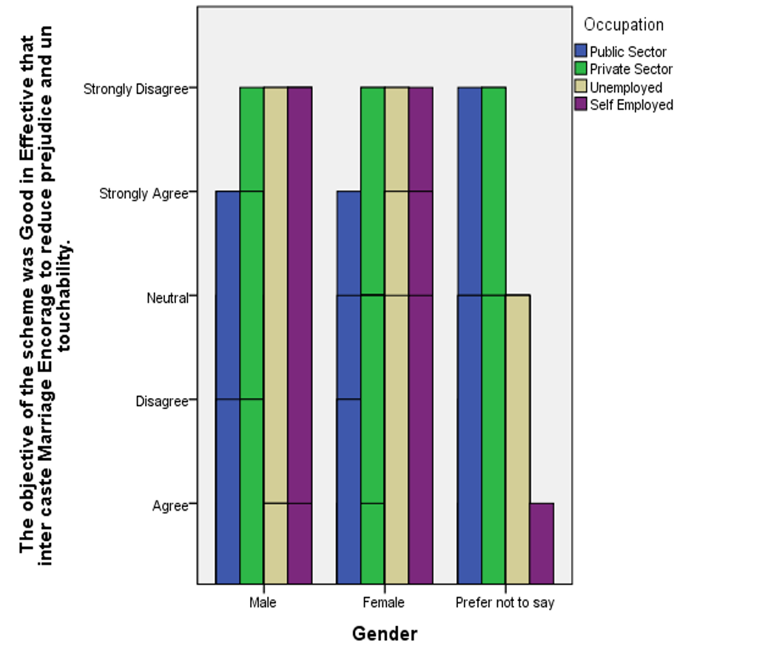
Legend:Fig 6 Shows the distribution of A Gender and occupation with relation to The objective of the scheme was Good in Effective that inter caste Marriage Encorage to reduce prejudice and untouchability.

Figure:7
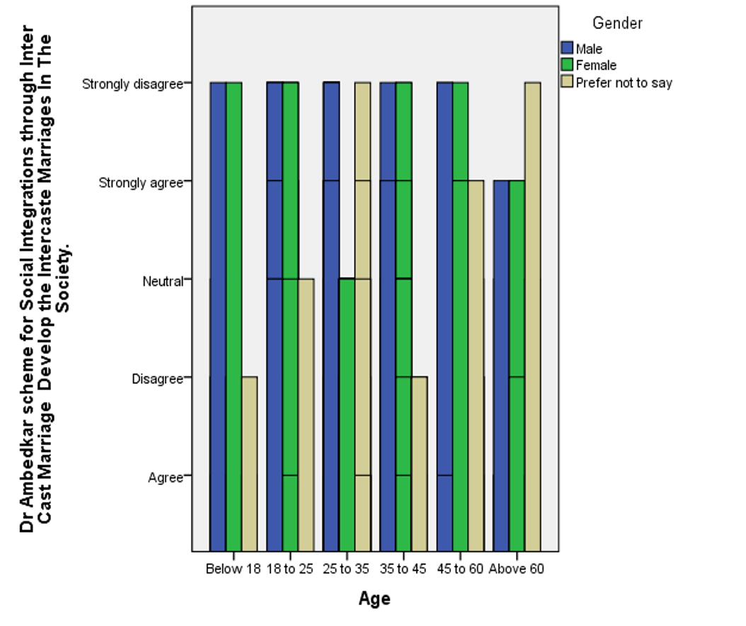
Legend:Fig 7 Shows the distribution of Age and Gender with relation to Dr Ambedkar scheme for Social Integrations through Inter Cast Marriage Develop the Intercaste Marriages In The Society.

Figure:8
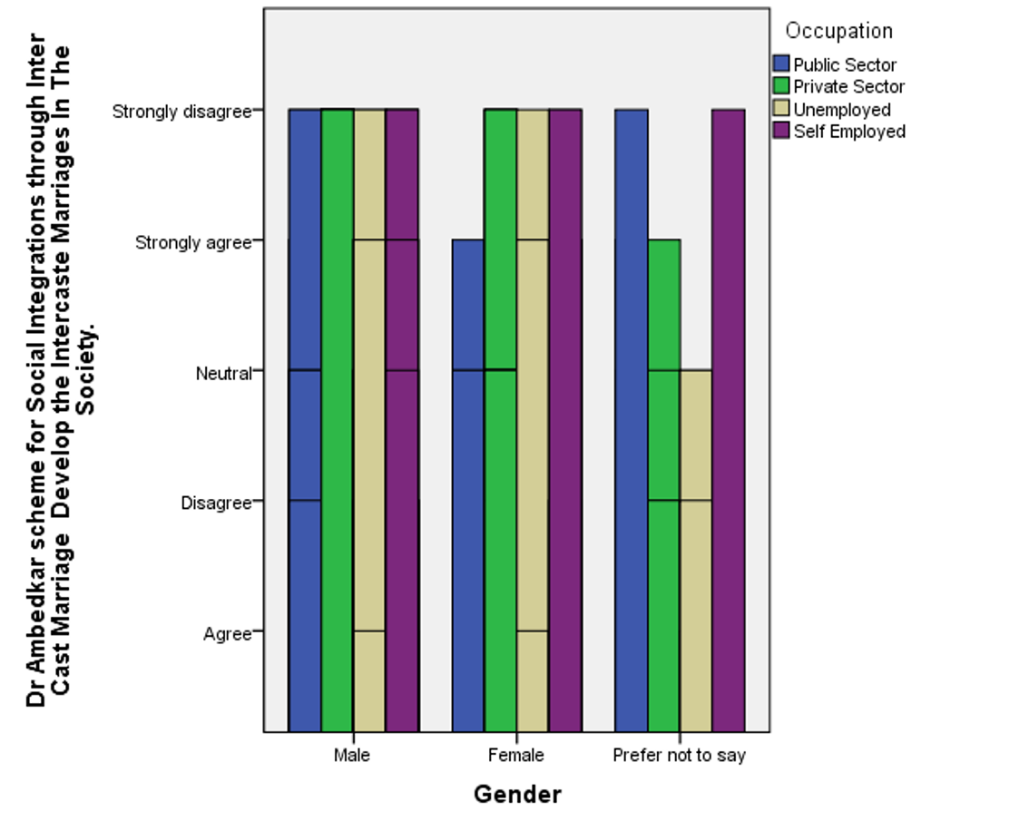
Legend:Fig 8 Shows the distribution of Gender and Occupation with relation to Dr Ambedkar scheme for Social Integrations through Inter Cast Marriage Develop the Inter Caste Marriage in the Society

Results:
Fig1:Respondents from all the age groups and all grander Rate above 4 and Maximum to 8 and the age of 25-35 the age for Group Marriage Respondents have given high Rating for this. They think they are Appreciated for Inter-Caste Marriage.Fig 2:Respondents from all Gender Rate above 6 Expect prefer not to say that public sector Respondents alone Rated below 4. And irrespective of their occupation all given above 6.Fig 3: All ratios are the same Respondents disagree strongly and strongly agree and neutral with this statement that Dr.Ambedkar scheme for social integration through inter-caste marriages Scheme Avail Only 500 Beneficiaries in a year. It Is Better to Increase The Count Of Beneficiaries to Make This Scheme More Effective in the Society.Fig 4: Respondents give in the same ration of strongly agree and strongly disagree and majorly male agree and major women don’t agree that strongly The statement Dr.Ambedkar scheme for social integration through inter-caste marriages Scheme Avail Only 500 Beneficiaries in a year. It Is Better to Increase The Count Of Beneficiaries to Make This Scheme More Effective in the Society.Fig 5: The Respondents irrespective of Gender and age strongly disagree this and only male in above 60 and below 18 and female in 25-35 and 35-45 agrees strongly and prefer not to say mostly given neutral groups that The objective of the scheme was Good in Effective that inter caste Marriage Encourage to reduce prejudice and untouchability. Fig 6:All Respondents in the age and gender of Female Prefer not to say Irrespective of occupation they disagree Strongly Expect Male and female of public sector was Agreed strongly.Fig 7:The Major Response. The Respondents is Strongly disagree. and only very few was Strongly agreed.Male and Female in all age groups except above 60 strongly disagree.And females in age group of 25-35 were given neutral.Fig 8:The Respondent highly Given that they strongly Disagree. And only females in the public sector and prefer not to say in the private sector Respond Strongly agree this.
Discussion:
Fig1: If we see this bar Graph the age group of 25-35 was given high rating were that age group peoples are age group for the marriage and it was happy that they are accepting inter caste marriage and this scheme encourages them to do inter caste marriage.And all other response were also high where they are encouraged to do intercaste marriage. Fig 2: Here the public sector is low while comparing the private sector where the private sector employees irrespective of their gender says this scheme appreciates inter caste marriage and this shows that many surveys also say people in Morden jobs are in support of intercaste marriage system. Whereas the public sector employees are concerned about it. Fig 3: where from here we are been brought to be the confusion where they accept and rated high before as mentioned in above figures and from here they different mindset that this figure shows that neutral,strongly agree and strongly disagree are in same ratio where they say this scheme can appreciate and encourage people to do inter caste marriage but this can’t be so effective by increasing its beneficiaries. Fig 4: In this Result also we get same ratio for the strongly agree and strongly disagree where the people doesn’t have the correct mindset to answer that and this sample frame is developing town and many rural areas were been surrounded so they doesn’t have the correct idea that if the beneficiaries of the scheme is increased wheaten the scheme can be more effective. Fig 5: This shows and people respondent that they strongly disagree because the untouchability can’t be abolish by inter caste marriage and they say if the inter caste marriage is been done they are very volitent to the couples like killing or boycott them from family only because of the reason caste and then how can be it abolished.Fig 6: And here to same that they strongly disagree is the result where they think inter caste marriage can’t reduce the untouchability where the peoples in the area gives that if the intercaste marriage is happened there boycotted from the society and family then how come the untouchability can be reduced. Fig 7: This shows that they strongly disagree where this scheme can’t increase the inter caste marriage in the society where the male and female in the age of marriage also strongly disagree this because introducing this scheme to the people of developing town and the rural areas we can’t convince the parents who takes major decision in the marriage. Fig 8: This also shows the result of strongly disagreeing where they say Same in rural areas and developing towns. The parents follow their traditional customs and only Marry within caste where we can’t introduce this scheme and change them.
Limitation:
The major limitation of the study is the sample frame. The majority of respondents were collected in a particular location through a random sampling method. So the surveys didn't help in interactive collection of responses. There were audiences who had very contradictory opinions towards their work and with the government development schemes . Few Respondents were not aware about the usage of online sources. So a larger audience was not reached. The restrictive area of sample size is also another drawback.The physical factors are the most impactful and a major drawback to the research. The researcher had to face time restraints on college campuses. Survey question options may lead to clear data because certain answer options may be interpreted differently by the respondents.
Conclusion:
Inter-caste marriage was brought to eradicate the caste barrier in the society though this was not much effective in the public and if we see to any research survey and statistics there is no good result for the inter caste marriage though government brings many new schemes and etc.The inter-caste marriage was a good inactive for breaking caste barrier.But According to our survey it reveals that Dr.Ambedkar Scheme for social integration through inter caste marriage this scheme appreciate the bold step to socially by intercaste marriage for this we get high ratings but whereas we don’t get good response for the objective of the act that is it doesn’t reduce the untouchability and this don’t make anyone to do intercaste marriage in the society.And It is that everywhere we see the survey they are not ready to do inter caste marriage and if though they have done inter caste marriage they were not happy with that married life the society discriminate them and they have Some Problems relating that. The survey has been taken at the developing town and where it is surrounded by many rural villages where the people doesn’t have correct ideas where they say this scheme appreciate and encourage to do inter caste marriage but they are not ready to do intercaste marriage and they say they can’t introduce this schemes to their parents and can’t convince them for the inter caste marriage And this paper suggests that there should be more awareness for the people to do inter-caste marriage and that all Schemes only have very few changes in the society and the impact of this all indicators and schemes were not up to the level we’re high. This caste system has been rooted in society.

Plagiarism Report:
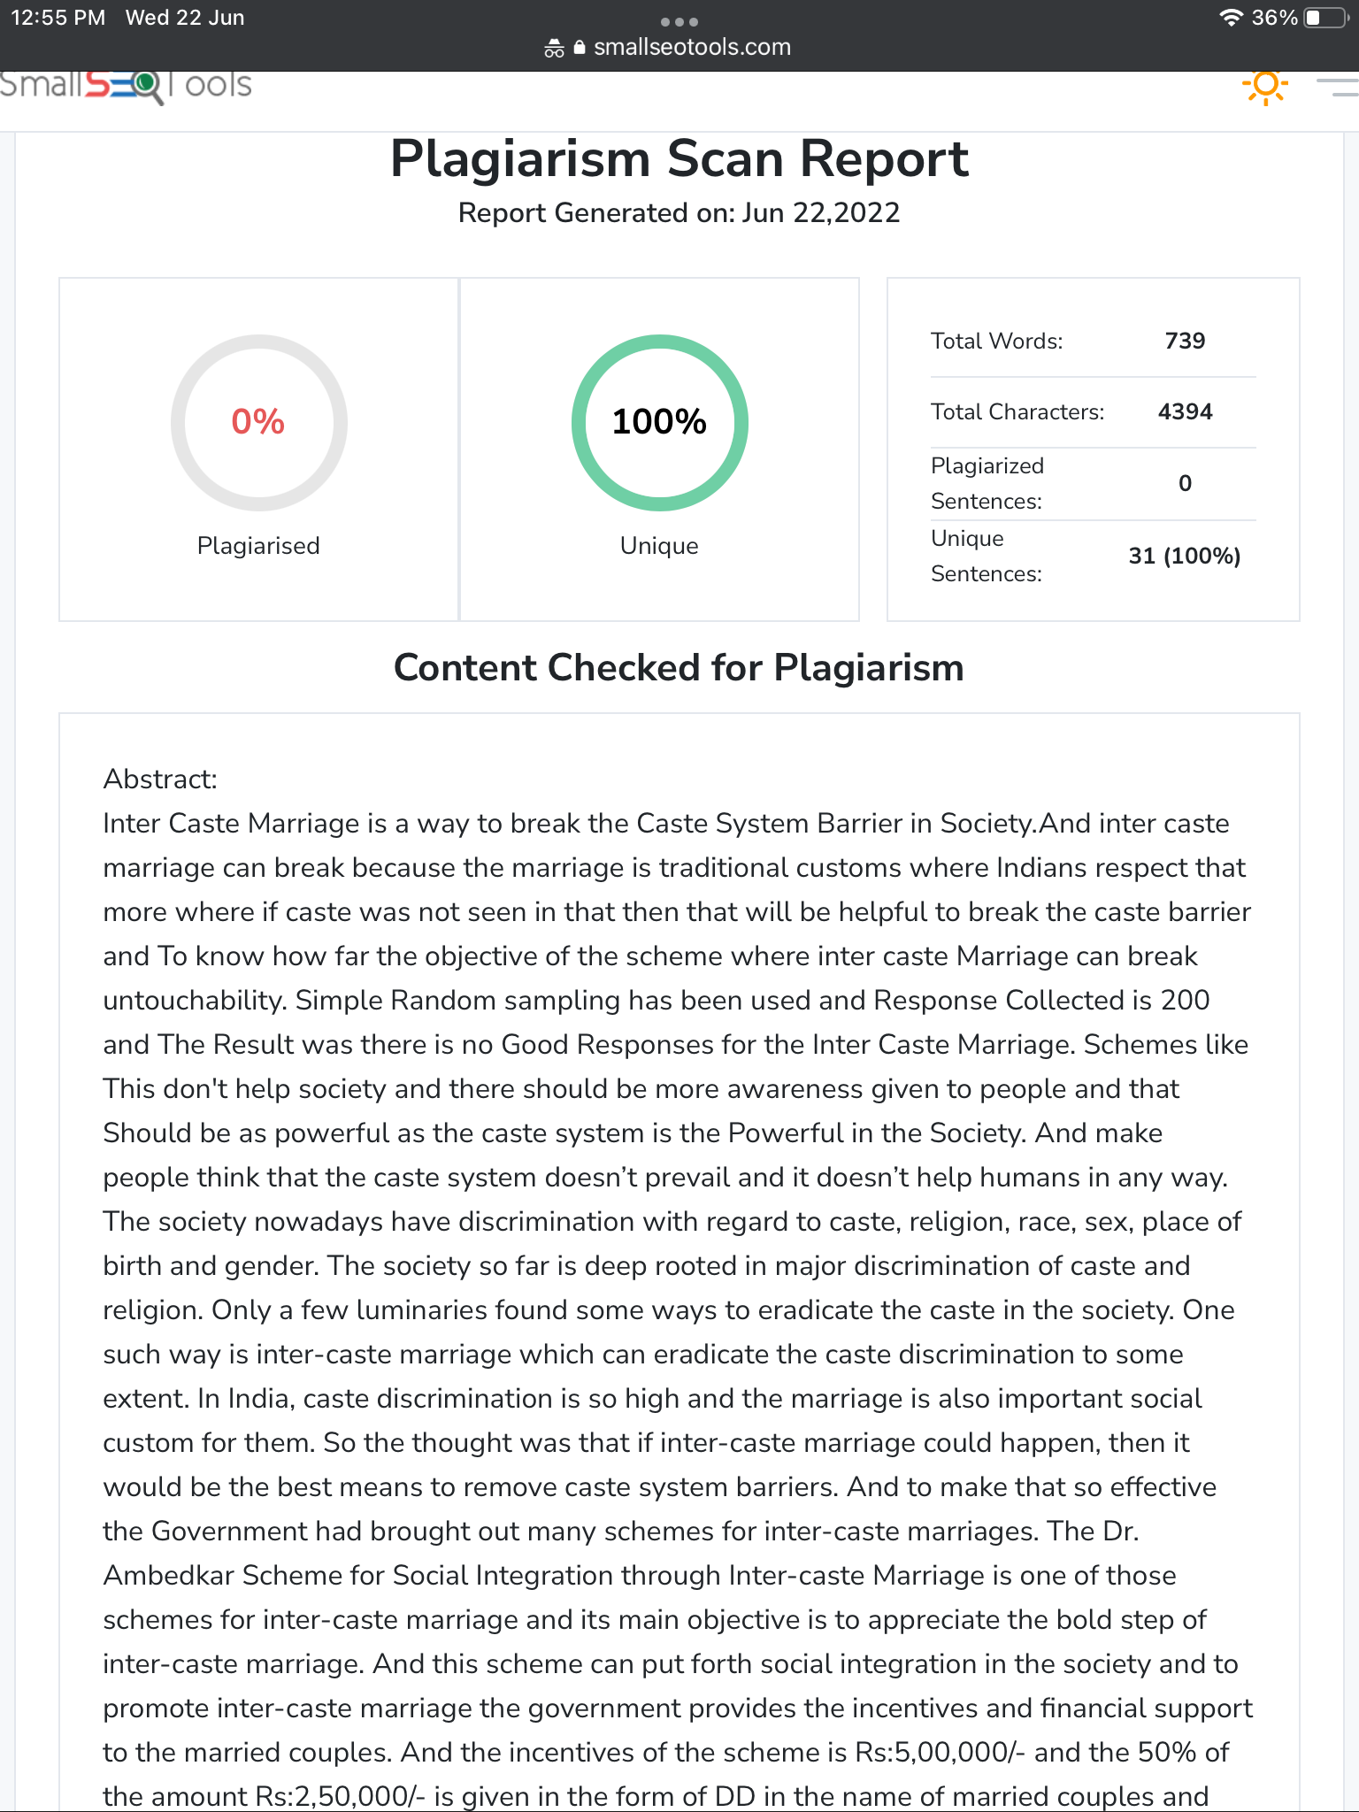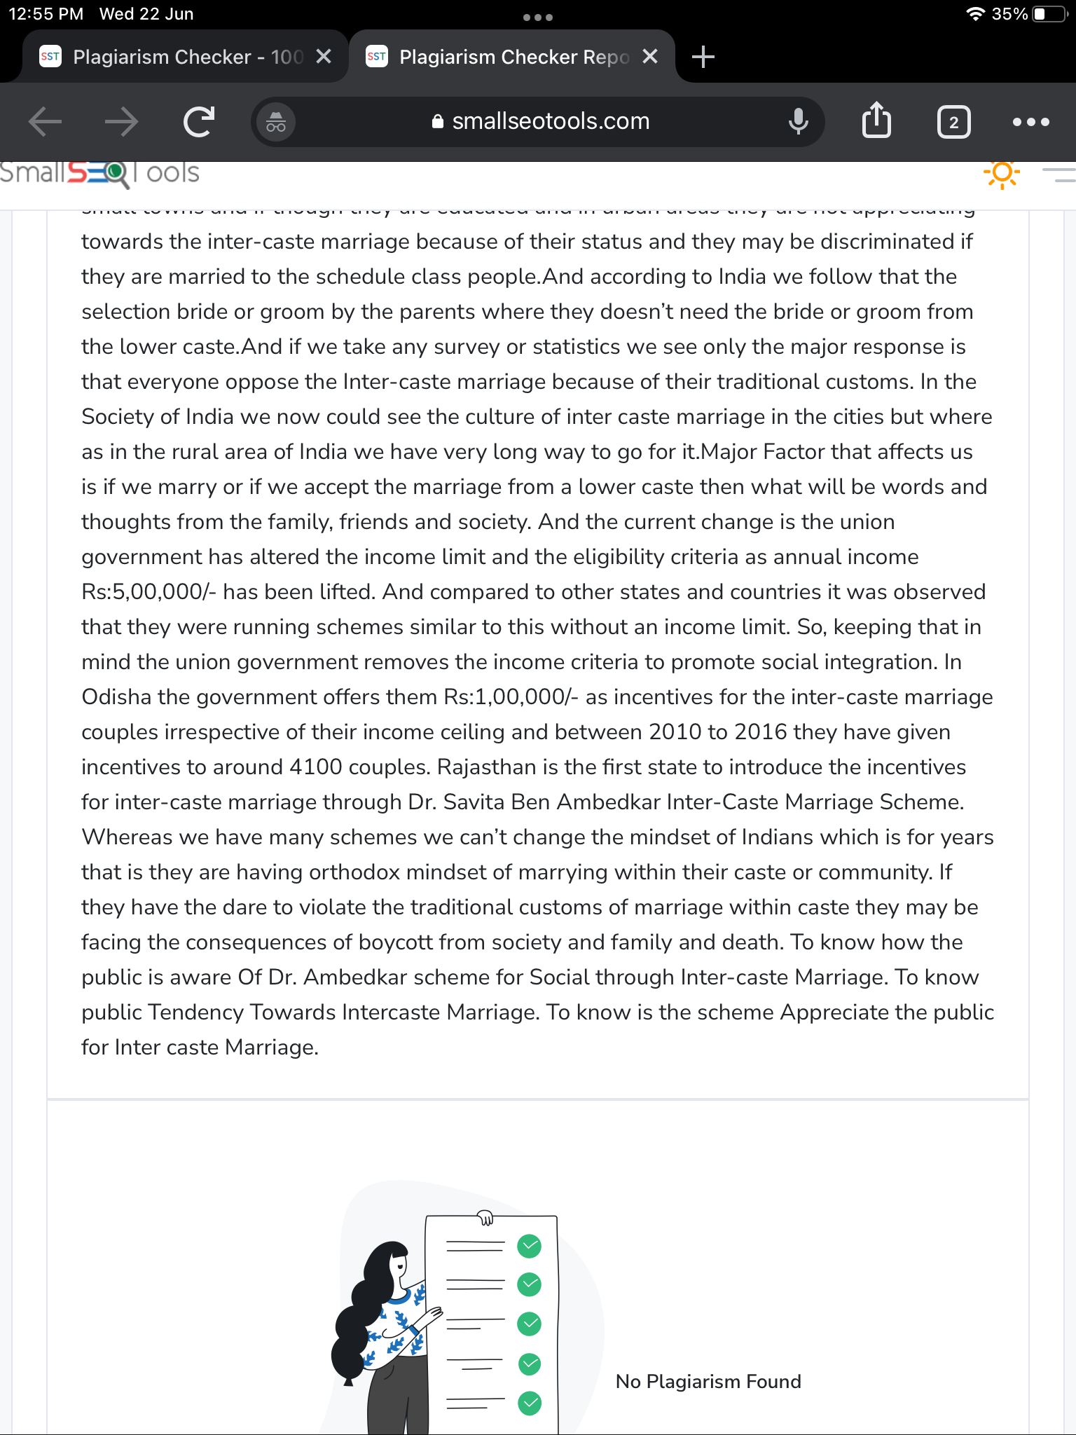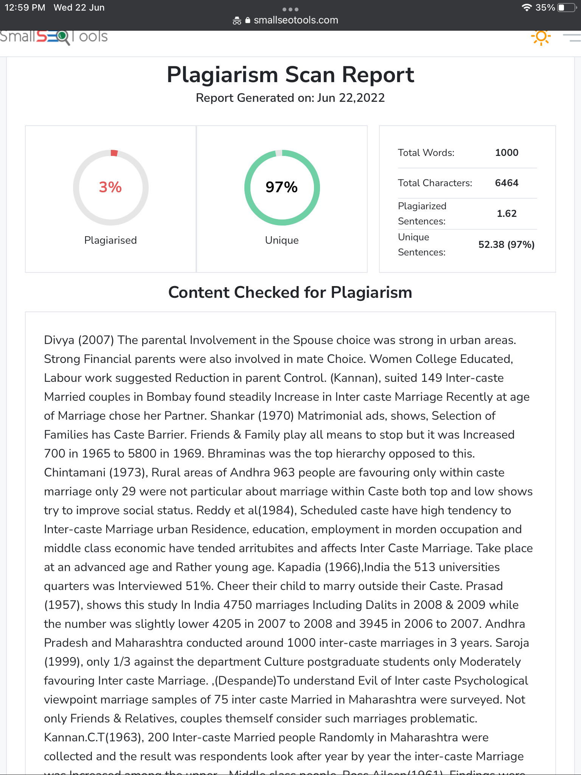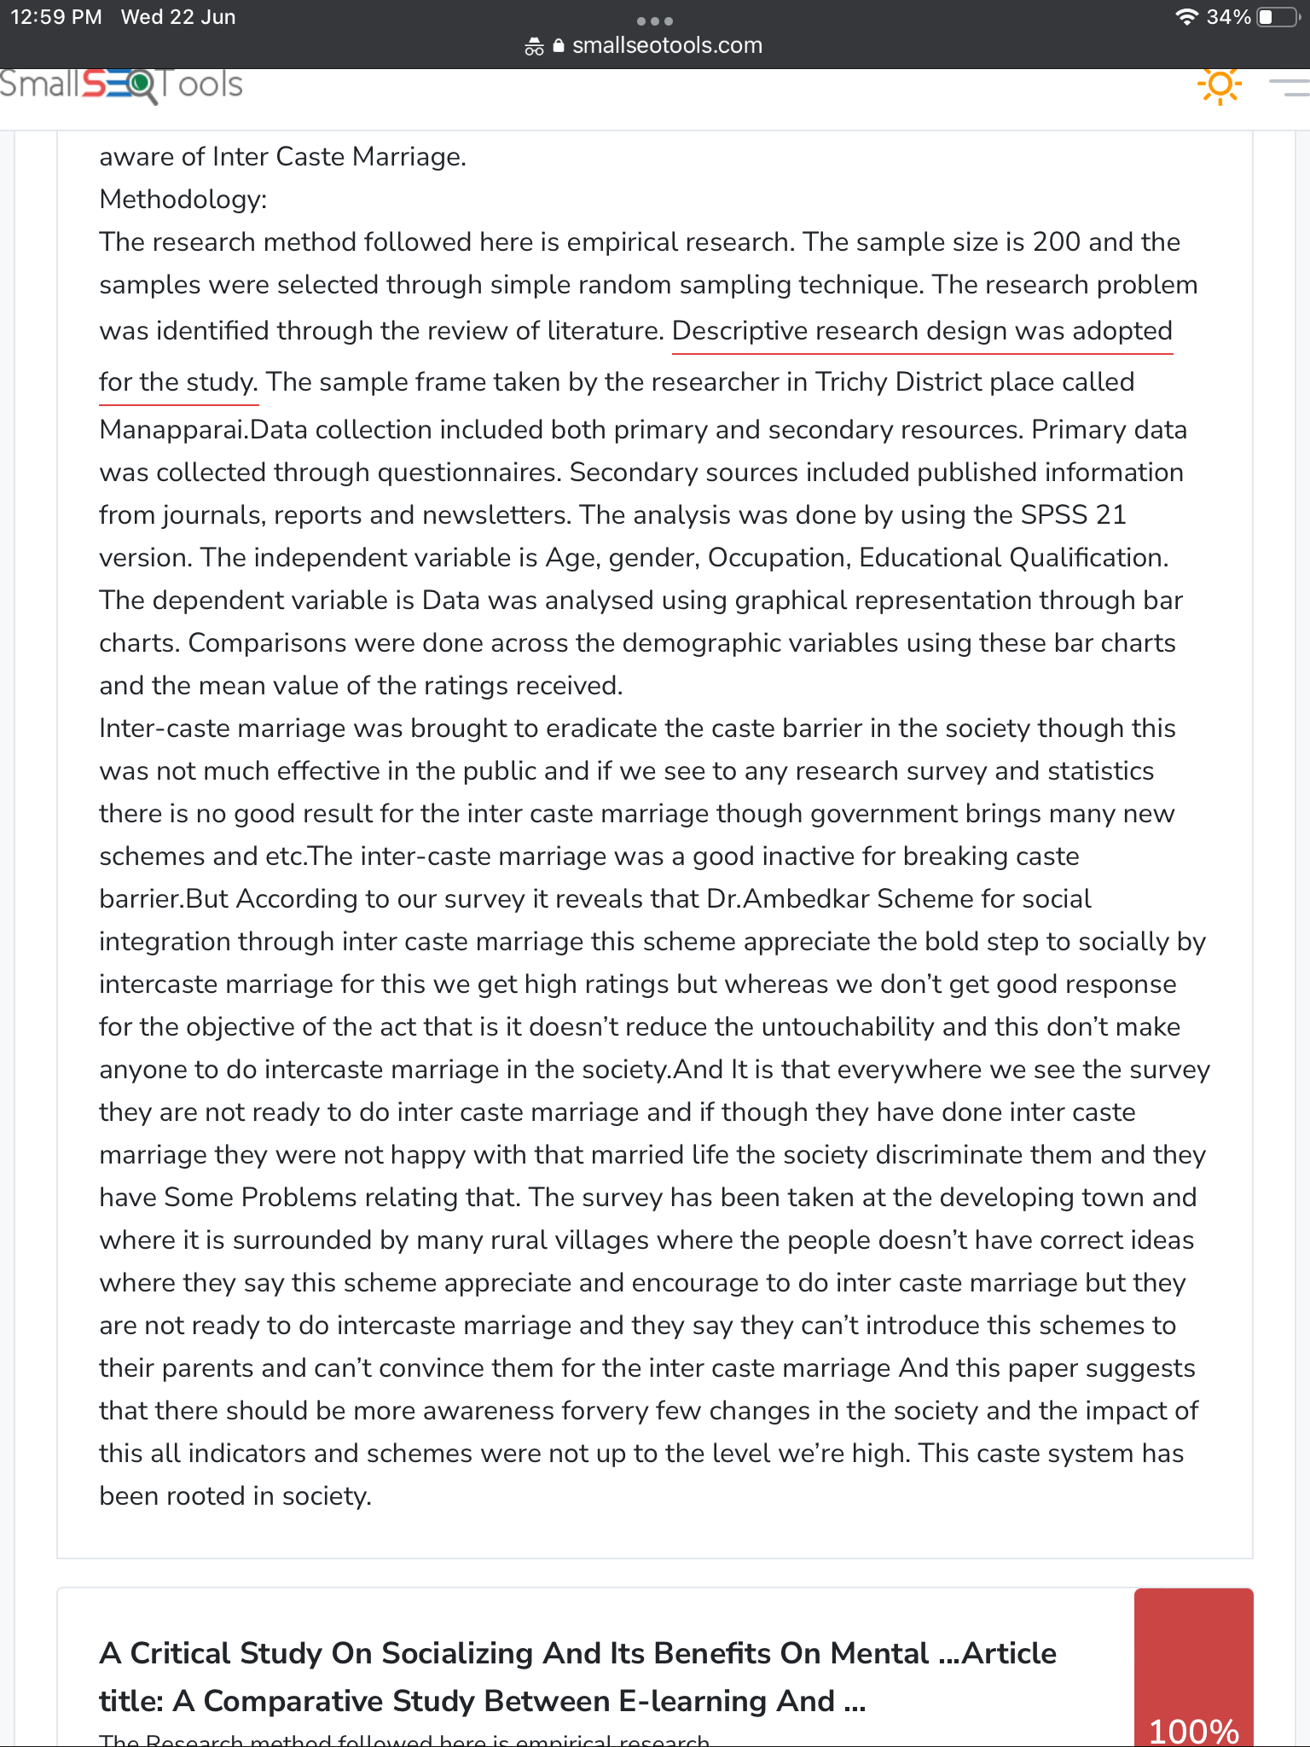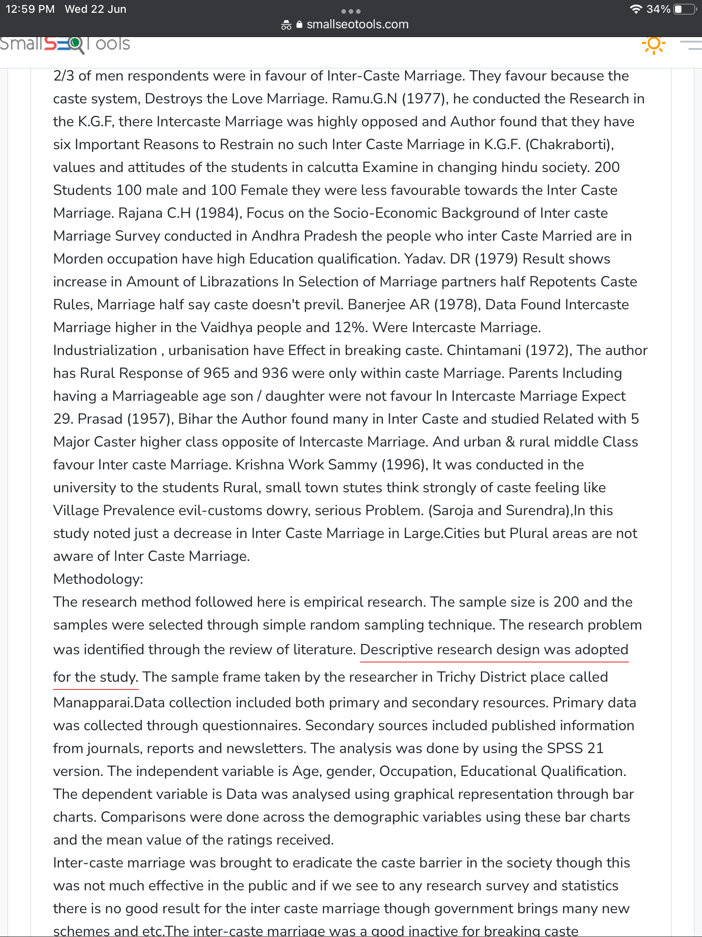

References:
Allendorf, Keera, and Roshan K. Pandian. “The Decline of Arranged Marriage? Marital Change and Continuity in India.” Population and Development Review, vol. 42, no. 3, Sept. 2016, pp. 435–64.
Anant, Santokh S. “Change in Intercaste Attitudes in North India between 1968 and 1972.” The Journal of Social Psychology, vol. 95, no. 2, 1975, pp. 275–76, https://doi.org/10.1080/00224545.1975.9918716.
Anant, Santokh Singh. “The Changing Intercaste Attitudes in North India: A Follow-up after Four Years.” European Journal of Social Psychology, vol. 5, no. 1, 1975, pp. 49–59, https://doi.org/10.1002/ejsp.2420050104.
Chakraborti, Haripada. Hindu Intercaste Marriage in India: Ancient and Modern. 1999.
Das, M. S. “A Cross-National Study of the Effect of Intercaste Marriage on Fertility in India and the United States.” International Journal of Sociology of the Family, vol. 8, July 1978, pp. 145–57.
Despande, C. G. On Intercaste Marriage Can Empirical Research Works. 1972.
Grover, Shalini. Marriage, Love, Caste and Kinship Support: Lived Experiences of the Urban Poor in India. Routledge, 2017.
Kannan, Chirayil Thumbayil. Intercaste and Inter-Community Marriages in India. 1963.
Khubalkar, Deepti. “Role of Interreligious and Intercaste Marriages in Achievement of the Constitutional Goal of Unity and Integrity in India.” Proceedings of the 2nd International Conference on Fundamental Rights, I-COFFEES 2019, 5-6 August 2019, Bandar Lampung, Lampung, Indonesia, 2021, https://doi.org/10.4108/eai.5-8-2019.2308556.
Kolenda, Pauline. “Why They Do Not Plow: The Domestic versus the Intercaste Mode of Production in Rural India.” Reviews in Anthropology, vol. 11, no. 4, 1984, pp. 314–20, https://doi.org/10.1080/00988157.1984.9977701.
Mandal, Saptarshi. “Ambedkar’s Illegal Marriage: Hindu Nation, Hindu Modernity and the Legalization of Intercaste Marriage in India.” Indian Law Review, 2021, pp. 1–23, https://doi.org/10.1080/24730580.2021.1964873.
Manor, James. “The Making, Ambiguity and Sustainability of Intercaste Accommodations in Rural India.” South Asia: Journal of South Asian Studies, vol. 42, no. 2, 2019, pp. 406–22, https://doi.org/10.1080/00856401.2019.1583789.
Saroja, K., and H. S. Surendra. “A Study of Postgraduate Students’ Endogamous Preference in Mate Selection.” Indian Journal of Behaviour, vol. 15, no. 1, Jan. 1991, pp. 1–13.
Singh, Sabita. “Interpretation of Marriage Rituals in Medieval Rajasthan.” The Politics of Marriage in Medieval India, 2019, pp. 85–157, https://doi.org/10.1093/oso/9780199491452.003.0003.
---. “Socio-Political and Economic Aspects of Marriage.” The Politics of Marriage in Medieval India, 2019, pp. 48–84, https://doi.org/10.1093/oso/9780199491452.003.0002.
“Some Historiographical Challenges in Approaching Child Marriage in India.” Love, Labour and Law: Early and Child Marriage in India, 2021, pp. 1–28, https://doi.org/10.4135/9789354792915.n2.
Tambe, Ashwini. “Population Control and Marriage Age in India, 1960–1978.” Defining Girlhood in India, 2019, pp. 101–20, https://doi.org/10.5622/illinois/9780252042720.003.0006.
Taruk, Elim Wilsen. “INTERCASTE MARRIAGE IN THE CONTEXT OF TORAJA: Towards Contextual Theology Of Intercaste Marriage In Toraja.” QUAERENS: Journal of Theology and Christianity Studies, vol. 3, no. 2, 2022, pp. 155–71, https://doi.org/10.46362/quaerens.v3i2.76.
Vanita, Ruth. “Marriage in India.” Courtship, Marriage and Marriage Breakdown, 2019, pp. 191–206, https://doi.org/10.4324/9780367824228-13.

