CATTLE DISEASE DIAGNOSIS USING DEEP LEARNING
Drethi Shetty, Megha, Prajna S Puthran, Rakshitha
A J Institute of Engineering and Technology, Mangalore

MR. Rakesh M R
(Project Guide)
Assistant Professor, Department of Information Science and Engineering,
A J Institute of Engineering and Technology, Mangalore
Email: rakesh@ajiet.edu.in

Abstract-- Dairy cow productivity to produce milk decreases due to increase in diseases. In usual conditions, dairy cows can produce 12 to 15 litres of milk every day, while dairy cows that are affected by the disease are only able to produce milk 5 to 10 litres every day. The difficulty of early analysis and managing of cows is to monitor the condition of cows that are not carried out at any time and minimum knowledge of Breeders about the illness. Handling the dairy farm is not a simple thing since farmer should manage cattle’s health, food and should produce quality milk for attention of market. At current situation, dairy farmer in rural area needs to go a long distance to buy food for cattle and it is difficult to contact doctor in case of emergency. The precision and the selectivity of the conventional clinical assessment of cattle diseases leave much to be convenient. On the other side, the rural early analysis of diseases with the support of advanced technological systems can improve noticeably the precision and scheduling of disease analysis.
I. INTRODUCTION
Cows’ health in dairy sector is one of the factors that affect productivity. Cows that are affected by a disease cannot produce milk desirably. For instance, the mastitis range in cattle increases from 14.6 percent to 19 percent per day. If the mastitis case is not controlled thoroughly, the loss is evaluated at Rp. 8.5 billion for each year. Looking after the health of cattle is an important job for breeders. If cattle are affected by a disease, it will definitely harm the Breeders themselves. To handle the health of cattle, they are well handled, Breeders need to
accomplish good handling management. One of such is the process of inspecting conditions in cattle and monitoring of dairy cows that are attacked by disease. But conforming to, at current situation, handling management, mainly in managing and inspecting diseases, is one of the problems faced by cattle.

There are so much factors by which it is difficult to identify the disease and to provide treatment in earlier stage, one is that it is not possible to check the cattle health at any time. For example, the former checks the condition of the cattle 3 times, in the morning, afternoon and night. This is because the process of checking is done normally using human power, so it is difficult to check every day. Checking of the cattle health normally is not efficient in case if they have many cows and if they depend on it for their livestock.
II. PROBLEM STATEMENT
Practical and theoretical studies were conducted in working cattle facilities in order to identify infectious, parasitic, and nervous diseases in cows. The introduction of technological innovations for intensive cattle growing and the breeding of high-yielding cows is tightly connected with an increase in diseases incidence. Now a days in our villages and all cattle are suffering from diseases (lumpy skin) and it spreads faster. Which leads to a panic among the formers. And also, animal husbandry department had issued an advisory to the former to not to bring out cattle effected by the viral diseases to the veterinary hospital. Possibly, a constant non-invasive observing of cattle conditions based in different techniques can become significant tool for observing cattle’s emotional state on stockyard and in dairy productivity. Such monitoring can also allow the early analysis of diseases and inspection will be made faster than with the aid of convenient methods of clinical evaluation. In our proposed system, we design a framework to provide a best solution and timely treatment of cattle diseases by identifying the cattle disease through their symptom and cattle image and helps the cattle owner to take precautionary to avoid these diseases.
III. OBJECTIVE
The main objectives of proposed systems are,
- To develop a system that process cow images and classifies them into normal or diseased using CNN.
- To design a system that identifies the disease based on symptoms using machine learning.
- To apply the concept of machine learning in dairy industry and to help farmers to detect cow diseases well in advance.
- To design a system with well-defined user interfaces for the end users.
IV. OUTCOMES
- Proposed system should provide disease information based on cattle symptoms to dairy owner.
- Proposed system should classify cattle either as Normal or Diseased based on cattle image.
- System should contain well defined user interfaces.
- System will provide precautions for the respective disease and give suggestion to veterinary hospital.
V. LITERATURE SURVEY
Thi Thi Zin et. ed [1] in “Dairy Cow Body Conditions Scoring System Based on Image Geometric Properties” proposed a dimensional imaging approach for an mechanized dairy cow body conditions scoring system. Uniquely, some significant land marks or structural points are to be take out from the top view image of a cow and their dimensional properties such as angles, length and area are look into evaluate body condition scores. In doing so, the proposed method will employ techniques of multinomial regression, multiple regression, Markov Chain classification.

Thi Thi Zin, Saw Zay Maung Maung, Pyke Tin et. ed [2] in “Feature Detection and Classification of Cow for Predicting Calving Time” reports the test of cow motion pattens by using 360 cameras in order to identify various views of cow condition. Firstly, Principle Component Analysis (PCA) is applied to break the rotation variant problem in various view of cow body and then the features are extracted for cow movement classification such as Standing, Lying, and Changing States (Standing to- Lying and Lying-to Standing). During the period of cow movement, the increasing and decreasing styles of shape from cow body are used to classify movement of cows.

Faruq1, Iwan Syarif et. ed [3] in “Health Monitoring and Early Diseases Detection on Dairy Cow Based on Internet of Things and Intelligent System” develop a dairy cow health management system, from health monitoring until the detection and operating of cows that have been affected by the disease. Monitoring systems and detection systems are combined into one application utilizing Internet of Things and Intelligent System technology. Where the monitoring system measures the temperature and heart rate of cows using sensor, then it gives results of health condition of the cows whether it is normal or abnormal.

Lijing Niu et. ed [4] in “Cattle Disease Auxiliary Diagnosis and Treatment System Based on Data Analysis and Mining” collected a large number of source cattle electronic medical record data and to realize the intelligent diagnosis system for cattle disease by using the data analysis and mining technology. Firstly, the text pre-processing technology is used to delete the repetition on the cattle electronic medical record data, remove the stop words, word segmentation etc. the data is classified into a training set and a test set. Then the classifier developed using a support vector machine (SVM) which classify the selected symptom words.

Qinping Yao, Takashi Masuda et.ed [5] in “Development of Noncontact Body Temperature Monitoring and Prediction System for Livestock Cattle” proposed system ensures the cattle disease detection at an early stage and it identifies the health status of cattle, then we gathered the environment temperature, humidity, lightness, and infrared pictures of cattle in natural environment as input parameters to construct an artificial intelligence characterization module for observing deep body temperature in a contactless manner. By measuring deep body temperature at the horn, eyeball, and nose of cattle, the most effective way of recognizing this temperature was found to be at the horn.

Francisco G´omez et. ed [6] in “Identification of Super Spreaders of Foot-and-Mouth Disease in the cattle transportation network: The 2018 outbreak case in Cesar (Colombia)” this will explain the recognition of the super-spreaders for FMD is considered in the cattle transportation network. The super spreaders are nodes that can increase their impact on the complete network. These nodes were easily recognized by aggregating number of axis measures list on each node. By using this approach, a ranking of nodes with high sensitivity for the scattering of FMD is build.

Kamil Aykutalp Gündüz et. ed [7] in “Identification of Acidosis Disease in Cattle Using IoT” developed an IoT based system which will help to detect the acidosis disease in cattle and it helps to observe the control of data by recording nutrition parameters and behaviours. In a laboratory environment a circuit is designed for data group where conditions of rumen part are given, and the pH and temperature values are obtained wirelessly through the circuit.
Bruno A. da Silva et. ed [8] in “Ontological model for classification of diseases in bovines and buffaloes” presents an onto logical model for dividing common diseases with generality in herds of cattle and buffaloes.
The technique adopted is based on a literature review. The data take out from the works reviewed were assigned in the proposed model. The ontological model developed is consisting of six main classes, being: Anatomy, Amazon Biome, Diseases, Breeds, Breeding System, and Production Type; The relationships between diseases and its class(es) are also designed in the model.

Gourab Sen Gupta, Aaron Dalbeth et. ed [9] in “An Automatic Lameness Detection System for Dairy Cattle” describes the design of the measurement platform which detects disability The walk-over-platform (WoP) has four independent platform segments, with each of them consisting of four shear beam load cells and electronic hardware for processing. The load cell signals are processed to measure the three basic kinematic variables associated with disability: energy, position and time. Based on these variables, a broad range typical step specifications such as stride length, abduction, posture time, etc. were calculated.

Mikel Gjergji1, Vanessa de Moraes Weber et. ed [10] in “Deep Learning Techniques for Beef Cattle Body Weight Prediction” it makes use of different deep learning models performance in the regression task of identifying cattle weight. While moving from 3-D space to 2-D images leeds to a loss of information in object shape, so weight prediction become more difficult. A model that produces good results in this type of problem could be applied more to similar problem spaces. We make use of convolutional neural networks, abstractly to similar problem spaces. We analysed convolutional neural networks, Recurrent Attention Models RNN/CNN networks and Recurrent Attention Models with Convolutional Neural Networks, show that convolutional neural networks achieve the highest performance.
VI. REQUIREMENT SPECIFICATION
Functional Reqirements
Present system has following components: Owner Component: Owner will operate the system using an Android Application. Farmer has following components:
• Registration: This module is used to register a new farmer to system. Farmer need to give their basic data such as name, contact number, emailId, address, username and password.
• Login: The farmer used this module to login to the system.
• Disease Module: This component provides different disease information with remedies.
• Upload Image Module: This module is used to upload cattle image to find whether it has any disease or not.
• Presentation Module: This module is used to present list of symptoms under different categories.
- Result Module: This module is used to display predicted result to owner. Admin Component: Admin will use web interface to get access to the system. He has following components.
• Login: The Admin used this module to login to the system.
• Handle disease Component: This module is used to handle different disease module.
• Manage Farmer: This module is used to manage farmers.
• Model Creation: This module is used to create a machine learning model to determine the cattle disease
• Feature Extraction: This module is used to extract image features from specified image dataset.
• Prediction Module: This module is used to predict the cattle disease based on either symptoms or cattle image.

Hardware Requirements
- Processor : 1 GHZ or higher CPU
- Hard disk : 500 MB available internal storage
- Memory : 6GB of RAM is
minimally recommended
- Display : 2.8 inches or larger
- Android Smartphone

Software Requirements
- Operating System : Windows 7 or above/ Linux
- Web Server : Django
- Programming Languages : Python, CSS, Java,
XML, Javascript.
- Web browsers : Google chrome
- Database : MYSQL
- IDE : Android Studio 4.0,
Visual studio code
VII. SYSTEM DESIGN
System includes modules for pre-processing, feature extraction and model creation and training. System needs cattle image dataset to classify uploaded cattle image to determine whether it is healthy or diseased. System needs symptom dataset to predict cattle’s disease from cattle symptoms. System uses Convolution Neural Network to build and train image model and uses Random Forest model to classify symptoms.

Architectural Design
The two arising techniques that have recently attracted many researchers are Machine learning algorithms and Deep learning algorithms. Deep learning techniques has also achieved huge success in computer vision. These techniques provide a uniform feature extraction-classification framework to users and free them from difficult handcrafted feature extraction.
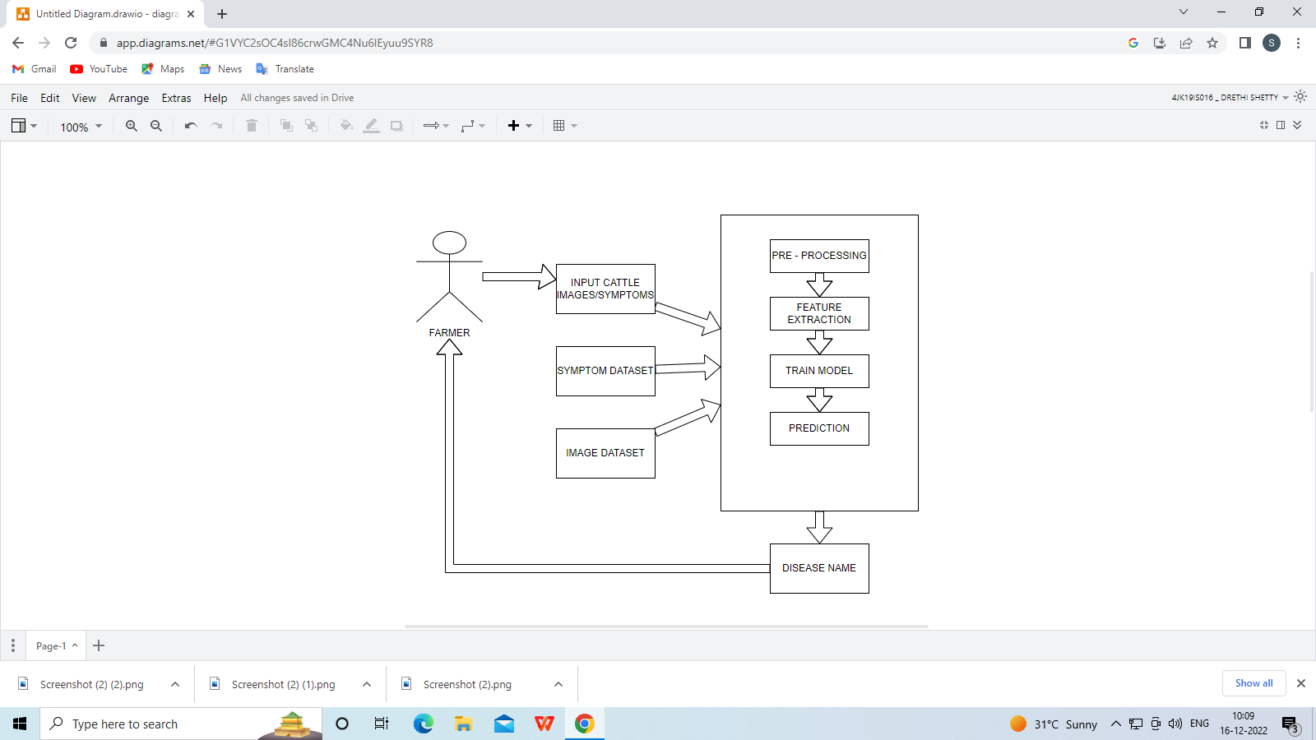
Deep learning techniques also provides the chance to increase the precision of the early detection of diseases. Proposed system uses the deep learning techniques, such as - convolutional neural network and recurrent neural network are utilized to propose a model to detect cattle health status from images and to obtain high precision. System also detects diseases from symptoms using Random Forest algorithm.
Above diagram shows the system architecture of proposed system. System includes modules for pre-processing, feature extraction and model creation and training. System needs cattle image dataset to classify uploaded cattle image to determine whether it is healthy or diseased. System needs symptom dataset to predict cattle’s disease from cattle symptoms. System uses Convolution Neural Network to build and train image model and uses Random Forest model to classify symptoms.
Use Case Illustration
A use case illustration is a graphical portrayal of a user's possible interactions with a system. A use case sketch shows various use cases and various types of users the system has and will often be accompanied by other types of sketches as well.
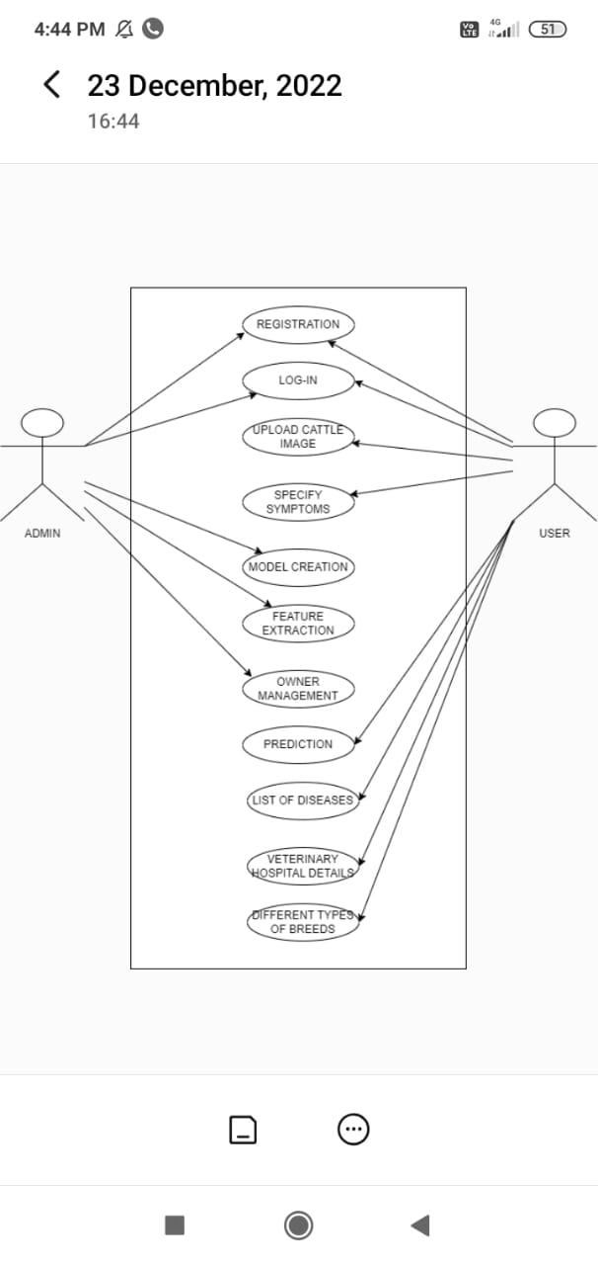
The use cases are shown as either circles or ellipses. The actors are often represented as stick figures. A use case diagram is used to portray the dynamic behaviour of a system.
It encloses the system's functionality by including use cases, actors, and their relationships. It models the tasks, services, and functions required by a system/subsystem of an application. It represents the high-level functionality of a system and also tells how the user handles a system. The main motive of a use case diagram is to represent the dynamic aspect of a system. It collects the system's requirement, which includes both internal as well as external influences. It invokes persons, use cases, and several things that invoke the actors and elements accountable for the implementation of use case sketches. It portrays how an entity from the external environment can interact with a part of the system.
Use-case sketches describes the high-level functions and scope of a system. These pictures also identify the interactions between the system and its admin. The use cases and admin in use-case sketches describe what the system does and how the admin use it but not how the system perform internally.

Block Illustration
Here once the registration is done the user will get the of their username and password. By using this information, the user can then login. Once the user logged in there will be four tabs are available.
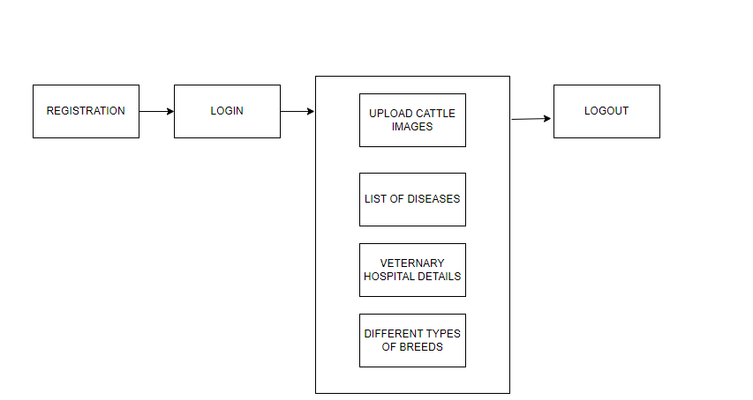
Among them first tab is used to upload the images of the cattle’s. Second one consists of list of disease and its precaution. In the third tab details of the nearby veterinary hospitals and doctors are available. Finally, by clicking on fourth tab user will get the different variety of breeds of cattle’s.
User Interface Designs
Registration Unit
Below figure shows the registration unit used to register a new farmer to the system while registering they need to provide their basic data such as name, contact number, username, email address and password. . During registration, farmers are required to provide basic personal data such as their name, contact number, username, email address, and password. This information is necessary for creating a unique account for each farmer, which allows them to access various features and functionalities within the web application. By registering farmers can create a personalized profile, upload information about their products, and interact with other users within the system. The registration page is a crucial component of the web application, as it enables farmers to join the platform and participate in its services.

Login Unit
Below figure shows the login Unit used by the farmer to login to the system by using username and the password.

the Login Page is presented, which is used by farmers to access the system by entering their username and password. This page provides a secure and reliable way for users to log in to the system, ensuring the privacy and confidentiality of their personal information. By requiring users to enter a unique username and password, the Login Page can prevent unauthorized access and protect the system from potential security threats
Home Page
Below figure shows the home page, after logging to the system there will be four tabs are available. Following tabs are Upload image, Disease, Nearby hospital, Doctor, Breeds and Symptoms.
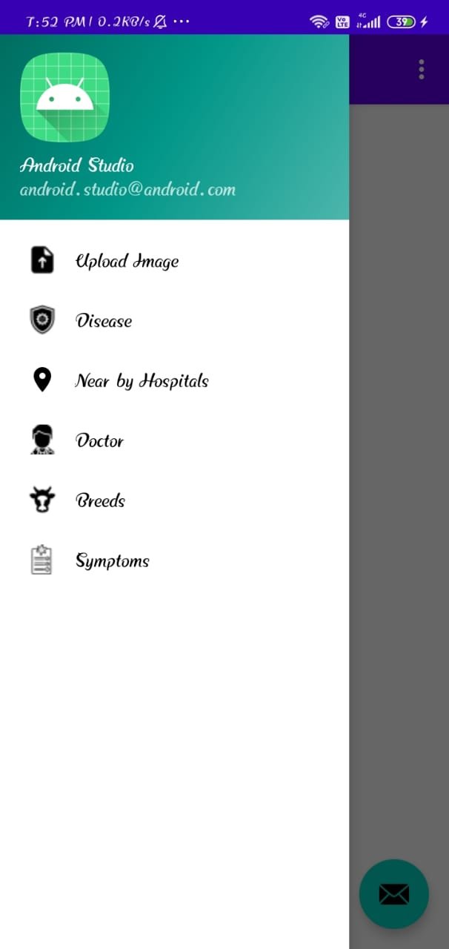
Cattle Image Test
Below figure displays the "Upload Image" page, which is used by users to upload an image for analysis or prediction. The page generally consists of a form that allows users to select an image from their computer or mobile device. The form may include options for specifying the image quality, resolution, or file type. These options help in ensuring that the uploaded image is of high quality and meets the system's requirements for processing and analysis. Once the user selects the desired image and specifies any relevant options, they can upload the image to the system by clicking on the "submit" button. The system then processes the uploaded image using its machine learning model to detect any possible diseases or abnormalities in the cattle. After processing the image, the system may provide the user with information about the detected disease or abnormality, its severity, and any recommended treatments or actions. The user can also view the results of the analysis on the system's dashboard or through any other relevant interface.
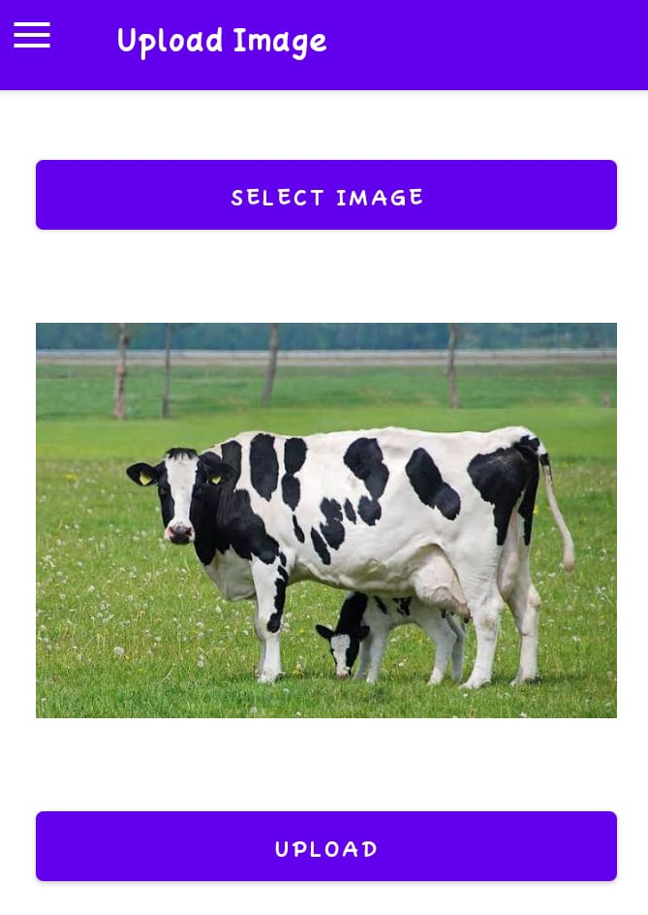
Prediction
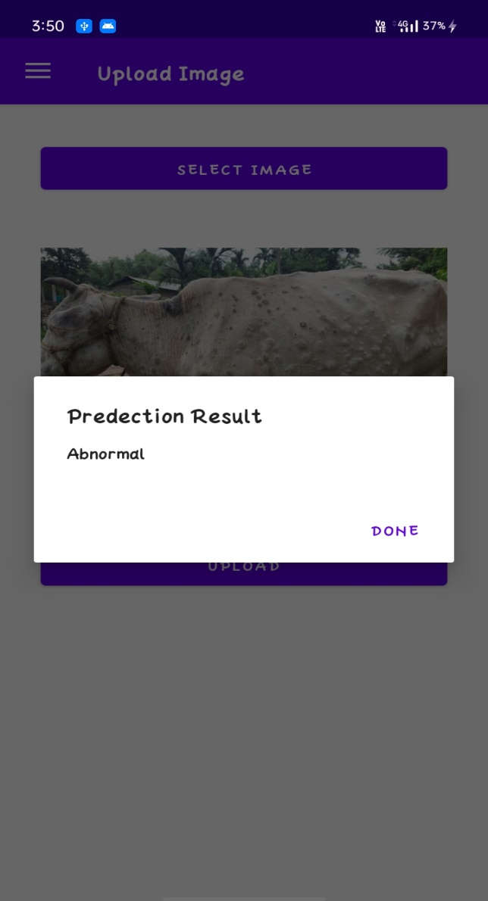
This snapshot shows the result of the uploaded cattle image, that is whether the cattle is normal or abnormal.
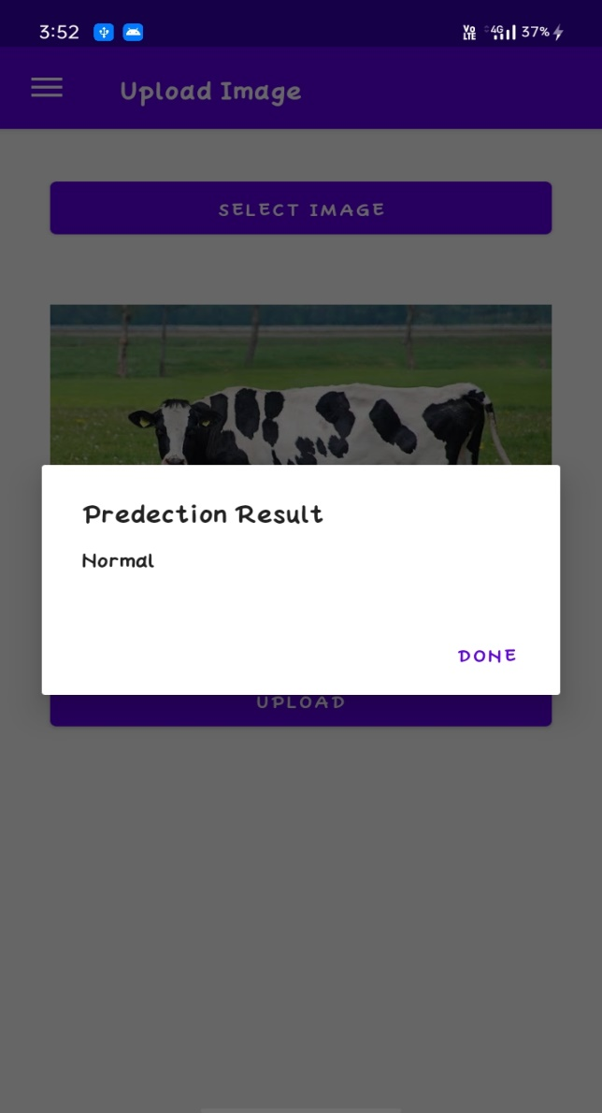
The page displays the predicted output of the uploaded image and determines whether the cattle is normal or abnormal based on the system's analysis. The result page may also include additional information, such as the confidence level of the prediction or suggestions for further action based on the result. The purpose of this page is to provide users with a clear and easy-to-understand summary of the system's analysis of the uploaded image.
Feedback Page

VIII. CONCLUSIONS
- We have decided to develop an Android system to help dairy owner to detect their cattle diseases in earlier stage. System includes modules for pre-processing, feature extraction and model creation and training.
- System needs cattle image dataset to classify uploaded cattle image to determine whether it is healthy or diseased. System needs symptom dataset to predict cattle’s disease from cattle symptoms.
- System uses Convolution Neural Network to build and train image model and uses Random Forest model to classify symptoms.
IX. REFERENCES
[1] Yi Lu; Yuhan Ke in “Research on Business Ethics of Dairy Industry under the Background of Science and Technology Update” Published in: 2020 International Conference on Modern Education and Information Management (ICMEIM).
[2] Cheng-Jung Yang; Yi-Hong Lin; Shao-Yu Peng in “Develop a video monitoring system for dairy estrus detection at night” Published in: 2017 International Conference on Applied System Innovation (ICASI).
[3] Ronak Chudasama; Sagar Dobariya; Komal Patel; Hezal Lopes in “DAPS: Dairy analysis and prediction system using technical indicators” Published in: 2017 Third International Conference on Sensing, Signal Processing and Security (ICSSS).
[4] Thi Thi Zin; Pyke Tin; Ikuo Kobayashi in “Dairy Cow Body Conditions Scoring System Based on Image Geometric Properties” Published in: 2019 IEEE 1st Global Conference on Life Sciences and Technologies (LifeTech).
[5] A. Susanty; A. Bakhtiar; H. Suliantoro; Christoper Manalu in “The effect of collaborative communication, power dependency, and price satisfaction on trust and loyalty of individual farmers to dairy cooperative case study dairy supply chain in Boyolali” Published in: 2016 IEEE International Conference on Industrial Engineering and Engineering Management (IEEM).
[6] Faruq; Iwan Syarif; Ahmad Syauqi Ahsan; M. Udin Harun Al Rasyid; Yogi Putra Pratama in “Health Monitoring and Early Diseases Detection on Dairy Cow Based on Internet of Things and Intelligent System” Published in:2019 International Symposium (IES).
[7] C. Nusai; W. Chankeaw; B. Sangkaew in “Dairy Cow-Vet; “a Mobile Expert System for Disease Diagnosis of Dairy Cow” Published in: 2015 IEEE/SICE International Symposium on System Integration (SII) December 11-13, 2015. Meijo University, Nagoya, Japan.
[8] Lijing Niu; Chenhao Yang, Yongxing Du; Ling Qin; BoaShan Li in “Cattle Disease Auxiliary Diagnosis and Treatment System Based on Data Analysis and Mining” Published in: 2020 Fifth International Conference on Computer and Communication System.
[9] Sai Ma; Qinping Yao; Takashi Masuda; Shogo Higaki; Koji Yoshioka; Soho Arai; Seiichi Takamatsu in “Development and Prediction System for Livestock Cattle”Published in: IEEE Sensors Journal, VOL. 21,NO.7,APRIL 1,2021

[10] Thi Thi Zin; Pyke Tin; Ikuo Kobayashi in” Dairy Cow Body Conditions ScoringSystem Based on Image Geometric Properties” Published in: Japan 2019 IEEE 1st Global Conference on Life Sciences and Technologies (LifeTech 2019).

