VIRTUAL TOP-TRY-ON USING DEEP LEARNING
Dr.P.D.R.Vijayakumar,M.E.,Ph.D., P.Gokila,M.E., B.Durgadevi, S.Srikanth, CB.Veerakumar, S.Yogapriya.
Dr.P.D.R.Vijayakumar HOD-CSE & INFO INSTITUTE OF ENGINEERING, COIMBATORE
P.Gokila AP- CSE & INFO INSTITUTE OF ENGINEERING, COIMBATORE
B.DurgaDevi BE CSE & INFO INSTITUTE OF ENGINEERING, COIMBATORE
S.Srikanth BE CSE & INFO INSTITUTE OF ENGINEERING, COIMBATORE
CB.Veerakumar BE CSE & INFO INSTITUTE OF ENGINEERING, COIMBATORE
S.Yogapriya BE CSE & INFO INSTITUTE OF ENGINEERING, COIMBATORE

---------------------------------------------------------------------***---------------------------------------------------------------------
Abstract - The evaluation mainly focuses on dealing with virtual try-on. With the rapid development of image classification, there is a profound growth of garment purchases through the internet. We can fit or suggest the appropriate top to corresponding input frontal women image by using classification algorithm fit evaluation of virtual women top try-on is vital in the clothing industry. Image dataset (Frontal women and top images) is implemented as input. We propose a Convolutional Neural Network model to evaluate perfect outfit. The inputs of the proposed model are digital clothing pressures of different Frontal women and top images, while the output is the predicted result of Frontal women and top fit or unfit. Virtual Try-On new VR technologies have been developed, which form the basis for a realistic, three dimensional, simulation and visualization of individualized garments put on by virtual counterparts of real customers. To provide this cloning and dressing of people in VR, a complete process chain is being build up starting with the touch- less 3-dimensional scanning of the human body up to a photo-realistic 3-dimensional presentation of the virtual customer dressed in the chosen pieces of clothing. The emerging platform for interactive selection and configuration of virtual garments, the "virtual shop", will be accessible in real fashion boutiques as well as over the internet, thereby supplementing the conventional distribution channels.

Key Words: VITON, Deep learning, Python, Image classification, Neural networks, CNN

1.INTRODUCTION

To improve the quality of the generated on-garment textures and logotypes, we design a novel geometric matching module that conditions the pose-matching procedure on body segmentations only, and therefore, minimizes the dependence on multiple (potentially error prone) pre-processing steps. Additionally, we formulate learning objectives for the module’s training procedure that penalize the appearance of the aligned clothing solely within the body area (while ignoring other body parts) to ensure that challenging pose configuration and self-occlusions do not adversely affect performance.

2. Body of Paper
Image-based virtual try-on solutions that do not require specialized hard ware and dedicated imaging equipment, but are applicable with standard intensity images. This allows for the design of virtual fitting rooms that let consumers try-on clothes without visiting stores, and also benefits retailers by reducing product returns and shipping costs. Existing solutions to image-based virtual try-on are dominated by two-stage approaches that typically include:
(i) a geometric matching stage that aligns the target clothing to the pose of the person in the input image, and estimates an approximate position and shape of the target garment in the final try-on result
(ii) an image synthesis stage that uses dedicated generative models, together with various refinement strategies to synthesize the final try-on image based on the aligned clothing and different auxiliary sources of information, e.g., pose key points, parsed body-parts, or clothing annotations among others. To further improve on this overall framework, various enhancements have also been proposed, including:
- Refinements of the data fed to the geometric matching stage.
- Integration of clothing segmentations into the synthesis procedure.
- The use of knowledge distillation schemes to minimize the impact of parser-related errors.

2.1. PROPOSED SYSTEM

To overcome the existing problems we proposed a new stylized virtual try on clothes, we used the u-net is convolutional network architecture for fast and precise segmentation of images ,which can not only retain the authenticity of clothing texture and pattern, but also obtain the undifferentiated stylized try on. We propose a new image-based virtual Tryon network, which greatly improves the try-on quality in semantic alignment, character retention and layout adaptation. We for the first time take the semantic layout into consideration to generate the photo-realistic Tryon results. A novel adaptive content generation and preservation scheme is proposed. A novel second-order difference constraint makes the training process of warping module more stable, and improves the ability of our method to handle complex textures on clothes. Experiments demonstrate that the proposed method can generate photorealistic images that outperform the state-of-the-art methods both qualitatively and quantitatively. Incorporate clothing-agnostic person portrayal in order to eliminate the reliance on the attire donned by the reference human figure in the first instance. The existing system produces inaccurate output with taking long duration to process the user input.

2.2 HIGH LEVEL DESIGN

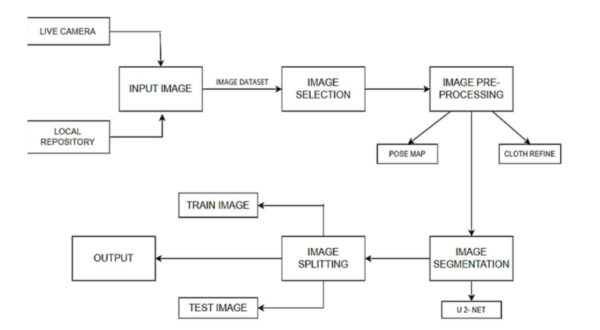
Fig -1: High level Diagram

We can select the image from local storage or through live cameras and Image dataset (Frontal women and top images) is implemented as input. The input dataset is taken from dataset repository. The dataset is in the format .jpg. Image selection: In this step, we can choose the input image as top and frontal women image. Pre-processing the collected input images are subjected to pre-processing. Here, pose map and cloth refinement is done in order get the desired cloth image. In Image Segmentation we can segment the pre-processed image using u 2-net architecture (The u-net is convolutional network architecture for fast and precise segmentation of images. Up to now it has outperformed the prior best method. Image segmentation is a computer vision task that segments an image into multiple areas by assigning a label to every pixel of the image. It provides much more information about an image than object detection, which draws a bounding box around the detected object, or image classification, which assigns a label to the object.).After this step, the pre-processed data’s are split into train set and test set for decision Train image is used for evaluate the model. Test image is used for predict the model. In this step, we used to segmentation with U-Net. Final step is output, we can fit or suggest the appropriate top to corresponding input frontal women image.

2.3 REQUIREMENT ANALYSIS

1. Tensor Flow: Tensor Flow is an open-source machine learning library that is widely used for deep learning applications. It provides a wide range of tools for building and training neural networks, and is commonly used for tasks such as image recognition and natural language processing.
2. PyTorch: PyTorch is another open-source deep learning library that is widely used in virtual try-on systems. It is known for its dynamic computational graph, for scaling rotating which allows for more flexible model design and training.
3. OpenCV: OpenCV (Open Source Computer Vision Library) is a popular open-source computer vision library that is commonly used in deep learning for tasks such as image and video processing, object detection, and facial recognition. OpenCV provides a wide range of tools and algorithms for image and video processing, including tools for filtering, thresholding, edge detection, and feature detection. These tools can be used to preprocess images and extract useful features for use in deep learning models.
4. Pillow: The Pillow library contains all the basic image processing functionality. You can do image resizing, rotation and transformation. Pillow module allows you to pull some statistics data out of image using histogram method, which later can be used for statistical analysis and automatic contrast enhancement.
5. TensorBoard-X: TensorBoard-X is a library that provides visualization tools for deep learning tasks in PyTorch. It is based on the original TensorBoard library from TensorFlow and allows you to monitor the training and evaluation process of your PyTorch models. With TensorBoardX, you can visualize a variety of metrics such as loss, accuracy, and learning rate during training, as well as visualize the model's structure and the distribution of weights and biases. You can also visualize the gradients and activations of different layers of the model, which can help with debugging and fine-tuning.
6. NINJA: which stands for "Network In Network with Squeeze and Excitation blocks and Self Attention" is a deep learning architecture that was proposed by authors of the paper "NINJA: Nonlinear independent feature Analysis for Joint Diagonalization" in 2021.
7. NumPy: is a fundamental library in Python that is commonly used in deep learning for numerical operations and data manipulation. NumPy provides an array data structure that is similar to the native Python list, but with several key advantages, including faster execution speed and built-in functions for mathematical operations.

2.4 PROJECT OUTPUT

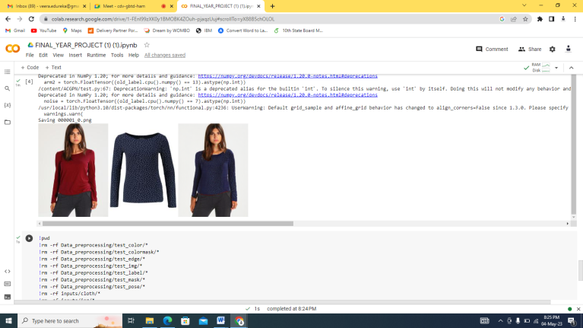

Fig-2: Output Image

3. CONCLUSIONS

Virtual try-on using deep learning has great potential to revolutionize the way people shop for clothes online. With advancements in computer vision and deep learning techniques, virtual try-on systems can provide a realistic and personalized experience for customers, increasing their confidence in purchasing clothes online. In conclusion, virtual try-on systems using deep learning have shown promising results in accurately and efficiently mapping virtual clothes onto a person's body. Future work in this area could include improving the realism and accuracy of the virtual try-on system by incorporating more advanced techniques, such as generative adversarial networks and 3D modeling. Additionally, there is room for improvement in the integration of virtual try-on systems into e-commerce platforms, making the experience more seamless and accessible to customers. One area of future work for virtual try-on using deep learning is improving the diversity of body types and skin tones represented in the virtual models. Many current systems are trained on a limited dataset of body types and skin tones, which can lead to inaccuracies and biases in the virtual try-on experience. By incorporating a more diverse range of models and data, virtual try-on systems can better serve a wider range of customers.

ACKNOWLEDGEMENT

- We wish to express our gratitude to Dr.N.KOTTISWARAN,M.E.,Ph.D., Principal, Info Institute of Engineering, Coimbatore, who always helped us whenever we approached him during the course of our project.

- We would also like to express gratitude to Dr.P.D.R.VIJAYAKUMAR,M.E.,Ph.D., Professor, Head of the Department, Department of Computer Science and Engineering, for his constant encouragement, valuable guidance and constructive criticism in making this project a successful one.

- We pay our respects and kindly thank our project coordinator Mrs .P.GOKILA, M.E., Department of Computer Science and Engineering, for her valuable guidance and timely suggestion in bringing out this project.

REFERENCES

[1] Image Segmentation Using Deep Learning: A Survey Shervin Minaee, Member, IEEE, Yuri Boykov, Member, IEEE, Fatih Porikli, Fellow, IEEE, Antonio Plaza, Fellow, IEEE, Nasser Kehtarnavaz, Fellow, IEEE, and Demetri Terzopoulos, Fellow, IEEE
[2] An Efficient Style Virtual Try on Network for Clothing Business Industry Shanchen Pang, Senior Member, IEEE, Xixi Tao, Student Member, IEEE, Neal N. Xiong, Senior Member, IEEE, Yukun Dong, Senior Member, IEEE
[3] A Survey and Taxonomy of Models Applied in 2D Human Pose Estimation Tewodros Legesse Munea , Yalew Zelalem Jembre , Halefom Tekle Weldegebriel , Longbiao Chen , Chenxi Huang , And Chenhui Yang.
[4] VITON: An Image-based Virtual Try-on Network Xintong Han, Zuxuan Wu, Zhe Wu, Ruichi Yu, Larry S. Davis University of Maryland, College Park.
[5] Evaluation of clothing fit I Dabolina , L Silina1 and P Apse-Apsitis Riga Technical University, Faculty of Material Science and Applied Chemistry, Institute of Design Technologies, Kipsalas street 6-220, Riga, LV-1048, Latvia.

