Title: Impact of Augmented Reality and Virtual Reality: A Literature Review
Ms. Shikha Katyal
Department of Management, IITM Janak Puri New Delhi-110058
Abstract:
Augmented Reality (AR) and Virtual Reality (VR) have emerged as transformative technologies with wide-ranging applications across various domains. This paper presents a comprehensive review and comparative analysis of AR and VR, exploring their individual characteristics, underlying technologies, and current research trends. Furthermore, this paper investigates the potential synergies and integration possibilities between AR and VR, emphasizing the benefits and challenges associated with combining these immersive technologies. The objective is to provide researchers and practitioners with a holistic understanding of AR and VR, enabling them to leverage these technologies effectively in their respective fields.
This academic paper aims to provide a thorough understanding of augmented reality (AR) and virtual reality (VR) individually, their comparative analysis, and potential integration possibilities. It discusses the underlying technologies, applications, challenges, and limitations of AR and VR, along with exploring case studies in different domains. The paper concludes with key findings, implications for research and practice, and recommendations for future exploration in the field of AR and VR.

Keywords: VR, AR, integration, learning, limitation, impact

1. INTRODUCTION
The integration of AR and VR can revolutionize training and simulation environments. AR can overlay virtual information and instructions onto real-world scenarios, providing users with real-time guidance and feedback. VR, on the other hand, can create fully immersive simulated environments for training purposes. By combining the two, users can benefit from realistic simulations enriched with contextual information, enhancing learning and skill acquisition. AR and VR integration can enable remote collaboration and telepresence experiences. AR can be used to overlay virtual objects and information onto real-world video streams, facilitating remote assistance and guidance. VR can provide a shared virtual environment where geographically dispersed users can collaborate and interact with each other as if they were physically present, enhancing communication and teamwork.

In recent years, AR and VR technology has advanced quickly and gained popularity across a variety of industries, including education and training. AR and VR offers a highly interactive and immersive environment that enables students to interact with the subject matter in a way that is not possible with conventional teaching techniques. As a result, there is an increasing amount of interest in using AR and VR for teaching and learning.
This paper's goal is to review the research on the use of augmented reality (AR) virtual reality (VR) for learning and training and to showcase the essential elements that make it effective.
These AR and VR-related issues will be the focus of this study:

A. How do AR and VR-related learning and training outcomes fare?
B. What are the drawbacks and difficulties of using VR for training and education?

2. LITERATURE REVIEW

Augmented Reality (AR) and Virtual Reality (VR) have shown promising effectiveness in enhancing learning experiences for students and improving training outcomes for employees.
The integration of AR and VR can revolutionize architectural and design processes. AR can overlay virtual models and design elements onto physical spaces, allowing architects and designers to visualize and evaluate their creations in real-world contexts. VR can provide immersive walkthroughs of virtual environments, enabling clients and stakeholders to experience designs before they are built, leading to better-informed decision-making and enhanced design iterations. The integration of AR and VR can create compelling and immersive gaming experiences. AR can be used to overlay virtual objects and characters onto the real-world environment, blending fantasy with reality. VR can transport users into fully immersive virtual worlds, providing a heightened sense of presence and interactivity. By integrating the two, users can experience hybrid gaming experiences that combine the physical world with virtual elements, enhancing gameplay and immersion. Moreover, AR and VR integration can have significant implications for medical and healthcare fields. AR can provide surgeons with real-time visualizations and guidance during complex procedures, overlaying vital information onto the patient's body. VR can create immersive environments for pain distraction, rehabilitation, and exposure therapy. The integration of AR and VR can enhance medical training, remote consultations, and patient education by combining virtual information with real-world contexts.

AR and VR technologies provide interactive and immersive learning experiences, capturing students' attention and increasing their engagement. This engagement can lead to improved knowledge retention and understanding of complex concepts. AR and VR enable students to visualize abstract concepts, explore virtual environments, and interact with virtual objects, making learning more experiential and practical. This hands-on approach enhances comprehension and promotes active learning. AR and VR can offer personalized learning experiences by adapting content to individual student needs. Virtual simulations and scenarios can be tailored to different skill levels, enabling students to learn at their own pace and address specific learning gaps. Collaboration and Social Interaction: AR and VR can facilitate collaborative learning by allowing students to interact and collaborate with peers in shared virtual environments, even if they are geographically separated. This promotes teamwork, communication, and problem-solving skills.
AR and VR provide realistic and immersive training environments for employees, allowing them to practice skills and procedures in a safe and controlled setting. This can be particularly beneficial in high-risk industries or complex job roles where hands-on experience is crucial. AR and VR-based training can reduce costs associated with traditional training methods, such as physical equipment, travel, or dedicated training facilities. Moreover, employees can access training modules remotely, eliminating the need for on-site training sessions and minimizing downtime. AR and VR simulations enable employees to repeatedly practice tasks, improving muscle memory and skill development. The interactive nature of these technologies promotes active engagement, leading to better retention of information and procedural knowledge.
AR and VR can simulate real-world scenarios and complex situations, allowing employees to develop critical thinking, decision-making, and problem-solving skills. By presenting employees with challenging and dynamic environments, AR and VR training can enhance their ability to make informed decisions under pressure.AR and VR technologies facilitate remote collaboration among employees by creating shared virtual workspaces. This enables geographically dispersed teams to collaborate, brainstorm ideas, and work on projects together, fostering effective communication and teamwork.

Other than the student and employee training there are different industries where AR and VR have proved its effectiveness.AR and VR have transformed the gaming industry by overlaying virtual objects onto the real world, creating immersive and interactive experiences. Games like Pokémon Go have demonstrated the widespread adoption and popularity of AR gaming. Additionally, AR has been used in entertainment applications such as virtual concerts and interactive storytelling. AR and VR has revolutionized the retail experience by enabling customers to virtually try on clothes, accessories, or makeup before making a purchase. It enhances the online shopping experience by providing a more realistic representation of products and helps reduce returns, increasing customer satisfaction.AR and VR has tremendous potential in the field of education and training. It allows for interactive and experiential learning by overlaying digital content onto the real world. AR can be used to visualize complex concepts, simulate real-world scenarios, and provide interactive guides and instructions.AR and VR is transforming healthcare by providing innovative solutions for medical training, surgery planning, and patient care. Surgeons can use AR to visualize and plan surgeries, overlaying diagnostic images directly onto a patient's body. It also aids in medical education by offering virtual training modules and realistic simulations.AR and VR is improving efficiency and productivity in manufacturing and maintenance processes. It can provide real-time instructions and guidance to workers, overlaying relevant information onto their field of view. This reduces errors, speeds up training, and simplifies complex tasks.
AR has become an essential tool in architecture and design by allowing architects and designers to visualize and present their ideas more effectively. Clients can experience virtual walkthroughs of buildings or see how furniture and decor would look in their space before making decisions.
AR enhances the tourism industry by providing interactive and informative experiences to visitors. It can offer virtual tour guides, historical information, and interactive maps to enhance the exploration of landmarks and attractions.

3. METHODOLOGY
The terms “Augmented Reality” "Virtual Reality" AND "learning" OR "training" were used in a systematic review of the literature. A number of academic databases, including Web of Science, Scopus, and many others, were searched. The research had to have been published in English, been published between 2010 and 2021, have been focused on the use of AR and VR for learning and training, and have presented empirical data on the results of learning and training.
Statistics on virtual reality training:
Figure 1: Training completion with VR
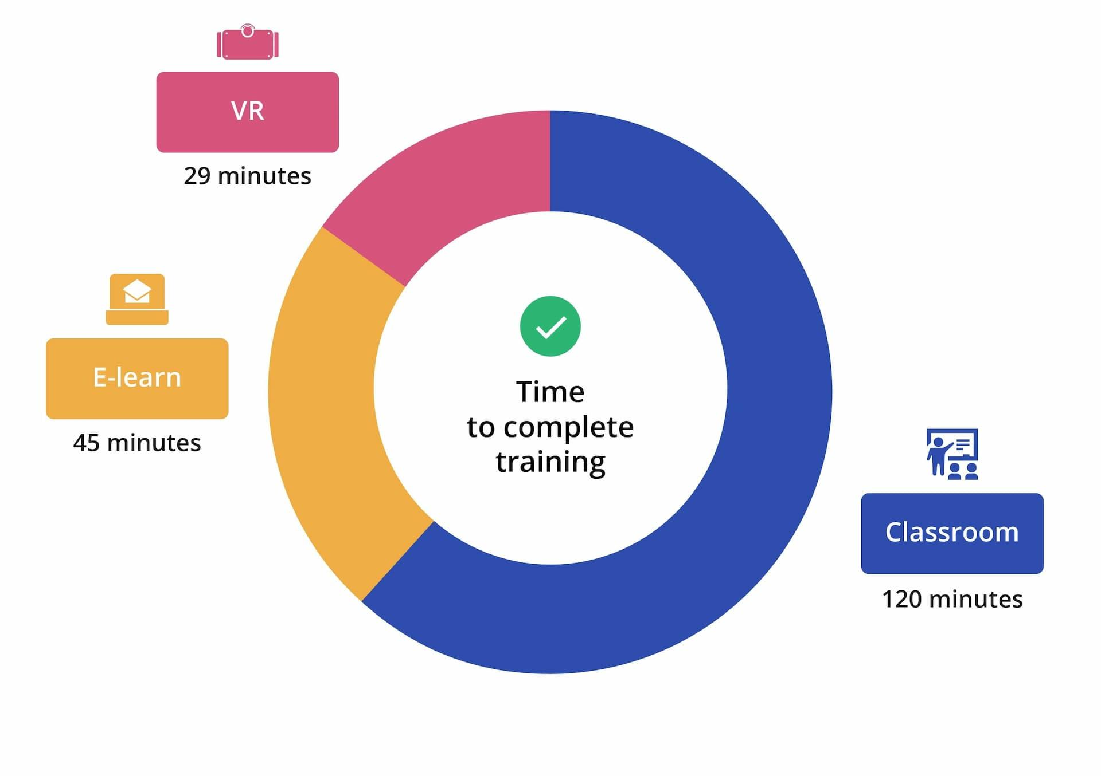

Figure 2: Increasing consumption of AR
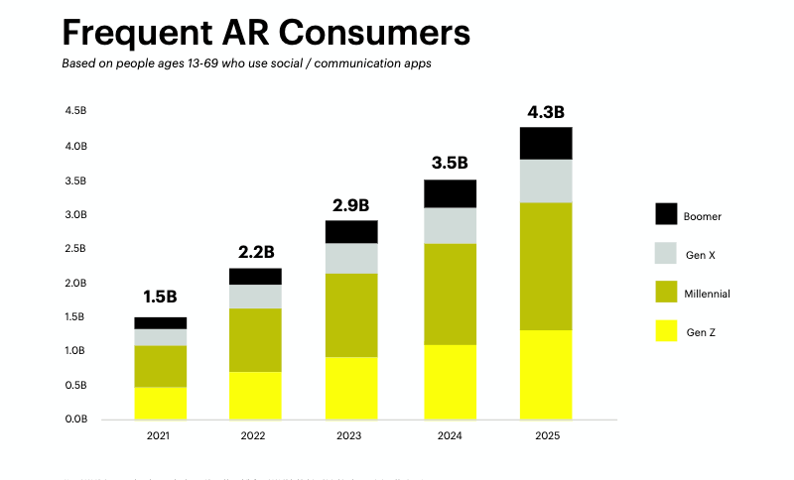

Figure 3: Potential of AR and VR
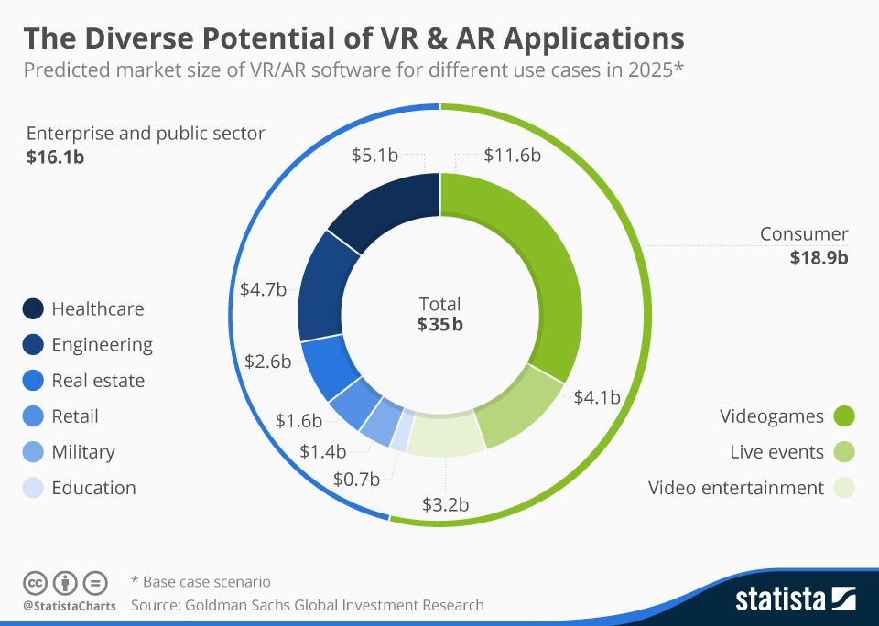

Figure 4: Projected growth of AR and VR
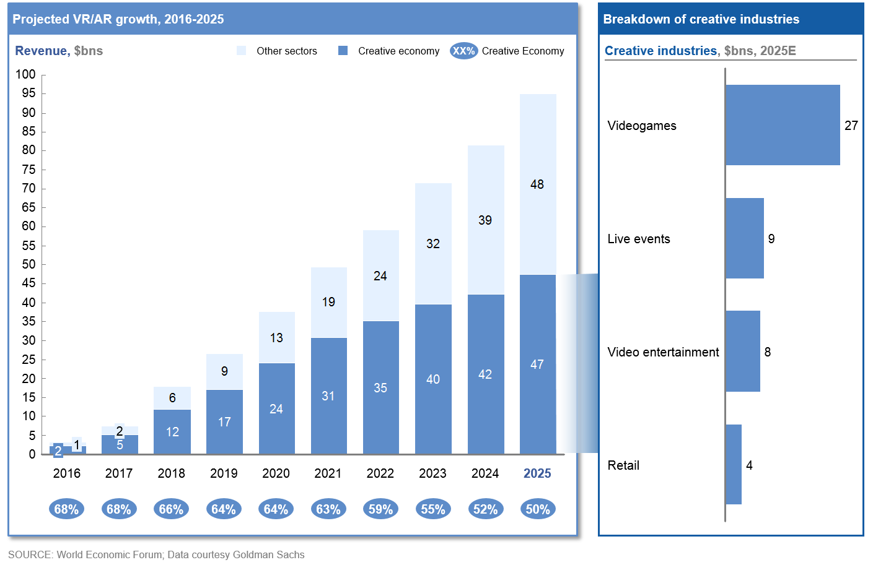

Limitations and difficulties of AR and VR when used for training and education:
While Augmented Reality (AR) and Virtual Reality (VR) offer transformative and immersive experiences, they also come with certain limitations that need to be considered. Here are some limitations of AR and VR:
Hardware Requirements: Both AR and VR technologies often require specialized hardware devices, such as headsets, sensors, cameras, or tracking systems. These devices can be costly, bulky, and require additional setup or maintenance. The hardware limitations can restrict widespread adoption and accessibility, particularly for individuals or organizations with limited resources.
User Experience and Discomfort: Extended use of AR and VR systems can lead to user discomfort and fatigue. Common issues include motion sickness, eye strain, and nausea, especially in VR experiences where the virtual environment does not align with the user's physical movements. This limitation hinders long-duration usage and may impact user acceptance and adoption.
Limited Field of View: Current AR and VR devices often have a limited field of view, restricting the extent to which users can perceive virtual or augmented content. This limitation can hinder immersion and prevent users from fully experiencing the virtual environment or interacting with virtual objects in their periphery.
Interaction and Input Methods: Interaction in AR and VR environments is still evolving and faces challenges. While controllers, gestures, or voice commands are common input methods, they may not always provide intuitive or precise interactions. The lack of tactile feedback can also limit the realism and haptic interactions in virtual environments.
Real-World Integration Challenges: AR faces challenges in accurately mapping virtual content onto real-world environments. The precise alignment of virtual objects with the physical world can be challenging due to variations in lighting conditions, object recognition, or tracking accuracy. Similarly, VR experiences may not be aware of real-world obstacles, potentially leading to collisions or safety concerns.
Limited Content Availability: The availability of high-quality AR and VR content is still relatively limited compared to traditional media. Creating realistic and compelling virtual environments or augmented overlays requires substantial resources, expertise, and time. This limitation can restrict the range and diversity of AR and VR experiences available to users.
Social and Ethical Considerations: AR and VR technologies raise important social and ethical considerations. For example, privacy concerns arise when AR devices capture and process personal data or when VR experiences collect user behavioral data. Additionally, the potential for escapism or addiction to immersive virtual experiences highlights the importance of responsible usage and balance in integrating AR and VR into daily life.
Cost and Affordability: The cost of AR and VR hardware, software development, and content creation can be significant barriers to adoption, especially for individuals or organizations with limited budgets. The expense associated with purchasing, maintaining, and upgrading AR and VR systems may limit their accessibility and widespread use.

RESULTS
The integration possibilities demonstrate the potential of combining AR and VR technologies to create more immersive, interactive, and context-aware experiences in various domains. As the technologies continue to evolve, we can expect further innovations and applications that leverage the strengths of both AR and VR.
While AR and VR technologies have demonstrated their effectiveness, it is important to note that their successful integration into educational and professional settings relies on appropriate design, content development, and pedagogical strategies. Additionally, ongoing research and evaluation are essential to assess their long-term impact, identify best practices, and address any challenges that may arise during implementation.
As the technology advances and more research and development are conducted, efforts are being made to address these limitations. Over time, it is expected that advancements in hardware, software, and content creation will help overcome many of these challenges, making AR and VR more accessible, comfortable, and intuitive for a broader range of users.
To conclude,AR and VR has had a transformative impact across various industries, enhancing user experiences, improving productivity, and unlocking new possibilities for innovation. As technology continues to advance, we can expect even greater integration of AR into our daily lives.

ACKNOWLEDGEMENT

I am appreciative of the editing assistance, late-night feedback sessions, and emotional support I received from my students and cohort members, especially my office mates. Also deserving of praise are the university's librarians, research assistants, and study participants who had an influence and motivated me.

REFERENCES

1. P. Milgram, H. Takemura, A. Utsumi and F. Kishino, "Augmented reality: A class of displays on the reality-virtuality continuum", Telemanipulator and telepresence technologies, pp. 282-293, 1995.
2. Google cardboard", 2014, [online] Available: https://ar.google.com/.

3. R.T. Azuma: SIGGRAPH '95 Course Notes: A Survey of Augmented Reality. Los Angeles, Association for Computing Machinery, 1995.
4. W.-S. Lee, J.-H. Kim and J.-H. Cho, "A driving simulator as a virtual reality tool", Robotics and Automation 1998. Proceedings. 1998 IEEE International Conference on, vol. 1, pp. 71-76, 1998.
5. D. Grajewski, F. Górski, P. Zawadzki and A. Hamrol, "Application of virtual reality techniques in design of ergonomic manufacturing workplaces", Proc. Int. Conf. Virtual Augmented Reality Educ., vol. 25, pp. 289-301, 2013.
6. D. Gorecky, M. Khamis and K. Mura, "Introduction and establishment of virtual training in the factory of the future", Int. J. Comput. Integr. Manuf., vol. 30, no. 1, pp. 182-190, 2017.
7. R. J. Seidel and P. R. Chatelier, Virtual Reality Training’s Future?, New York, NY, USA:Plenum Press, 1997.

