Covering Letter
Jie He, MD
Editor in chief
Journal of the National Cancer Center
Respected Jie He, MD

We wish to submit this manuscript “Through Naturopathy reduce the breast cancer risk factor’’ by my name Maha Andleeb to be considered for the publication as an original review article.
Breast cancer spread all the world and not proper treatment yet. In this review article reduce the risk factor of breast cancer through naturopathy.
We declare that manuscript is original has not been published before, not being considered for publishing elsewhere. I know that non conflicts of interest association with the publication and no significant financial support of the week that could influenced its outcomes.
I co- responding author conform that manuscript has been read and approved for the submission by all name Authors. Hopefully you will considered this manuscript for publishing in Journal of National Cancer Center.

Sincerely,
Maha Andleeb
Department of biotechnology
Email: mahandleeb046@gmail.com

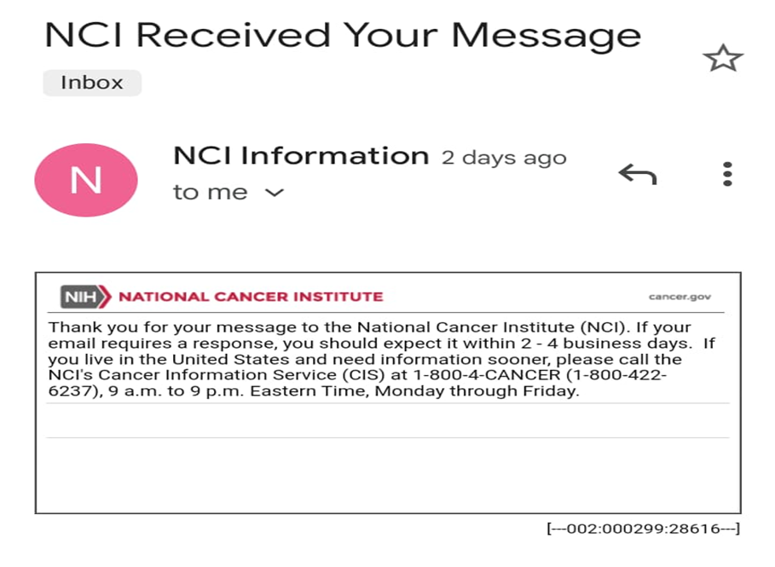

Through naturopathy reduce the Breast Cancer risk factor

Maha Andleeb¹, Pervez Anwar²
Department of Biotechnology, University of Sialkot, 1-km main Daska road Sialkot, 51310
Department of Biochemistry and Molecular Biology, University of Sialkot, 1-km main Daska road Sialkot, 51310
Email: mahaandleeb046@gmail.com
Abstract
Breast cancer is the most commonly diagnosed cancer worldwide and it’s ratio less has been rising over the past decades. [1]According to survey 2.3millions patients of breast cancer are diagnosed every year, it is a highly effective ratio worldwide, and it is 5th leading cause of death, in which females lost their lives due to breast cancer. About .5million females lost their lives due to breast cancer disease. [2]Most dreadful fact which is now the alarm of danger that females from every age are affected by this disease. So many studies and researches have been conducted to find out the particular reasons or causes behind this but no one could conclude any specific reason. There can be a different reason like genetic, (inherited changes) radiation exposure, obesity, infertility, hormone receptors and drinking alcohol etc. Secondly, number of studies that analyzed the connection between stress and risk of breast cancer. These analytical studies express their views that different reasons are traced to grow the breast cancer in different region depends upon their daily routine, life style, diet, genetic transmission, and other medical treatment used for cancer like (radiation) can create risk for cancer. Although, breast cancer is very common now a days and spreading rapidly but it does not mean that it is non treatable disease. Substantial support for breast cancer awareness and research has helped in diagnosis and treatment of breast cancer.
Keywords
Breast cancer, worldwide, inherited changes, high risk, medical treatment

Introduction
Breast cancer is the type of cancer which is formed in the cells of breast. After lungs and skin cancer, breast cancer is commonly found cancer in women. Breast cancer can cure in both male and female but it is for more common in females. [3] It is estimated that 2.3millions females were diagnosed breast cancer in 2020, which is accounting for approximately 24.5% of all cancer cases worldwide. This rate was 58.5 per 100000 population. Barbados has the highest rate of breast cancer, followed by Fiji. The life risk of breast cancer is 11% of Asian women, as compared to the other races in Asian women the ratio is slightly lower. [4] Japan and South Korea reported the highest rate of breast cancer for Eastern Asia. India 1 in 22 and Pakistan has 1 in 9 which is almost so highest rate of breast cancer. On the other hand, it is estimated that Europe has 13.3% of accounts of cancer cases in all 27 European countries. In USA about 264000 cases of breast cancer are diagnosed every year. Rhode Island, New Hampshire have highest breast cancer incidence rates. [5] A survey was conducted globally by who in 2020, who reported that 16% or 1 in 16 death occurs in women. Many types of cancer are diagnosed in the world but experts could not find the exact causes and sure reasons why this is occurring and spreading so rapidly. Moreover, researcher have identified, after so long studied and experiments that some are common and certain risk factors for breast cancer and their precaution to control, Ductal carcinoma, inflammatory breast invasive ductal carcinoma, Poget’s gets disease of breast, Lobular carcinoma, Hormone receptors are some common types of breast cancer, Age factor is also considered the main cause of breast cancer, mostly breast cancer are diagnosed after the age of 50. As for as the age is concerned the most common in women over age of 50 who have been through the menopause. It is estimated that about 8 out of 10 cases of breast cancer occur in women over 50. The role of stress in breast cancer incidence is also considered a main factor. Studies conducted to find the relationship between stress and breast cancer have produced more results. Bio psychological studies puts forward the hypothesis that different distinctive environmental context of stress on stressor and co-occurrence of stress may reflect different exposes on group. As a result, these reflection of exposure contribute significantly to health disparities which have been observed in certain groups. [6] Although it is not possible to measure the exact stress value but it has continuous interplay between individuals. The environmental stress pressure in the both internal and external, this condition of threats is the very fact of its existence put a question on integrity of organism. Focus point of any review is that a specific area of breast cancer depends upon the hormonal receptors and its contribution in developing the breast cancer and its therapy through naturopathy. [7] Estrogen (ER) and progesterone (PR) receptors play vital roles in women sexual development and their reproductive functions. Studies proved that about 70% of all types of breast cancer in women are due to receptors which are attached to estrogen and progesterone, they stimulate a cancer to grow. These cancer are called hormone receptors negative or hormone receptors positive. These receptors are actually protein in or on cell that can attach or mix with the substance of blood. Breast cancer cells can have one or both or more of these receptors. Keeping control of the hormones estrogen and progesterone from attaching to their receptors would help to keep the cancer from growing and spreading. Cancer is curable now a days but breasts cancer almost curable if found diagnosed earlier. My object through these lines is to provide awareness to those who are conscious about their health and wellness by naturopathy or yogic exercise. Some of the researcher are off the view that yoga is not any treatment for cancer but studies has proved its importance to reduce the stress and control the hormone receptors to reduce the risk factor of developing cancer in female breasts.

Breast cancer rates

Rank | Country | Number | ASR/100,000
 | World | 2,261,419 | 47.8
1 | Belgium | 11,734 | 113.2
2 | The Natherlands | 15,725 | 100.9
3 | Luxembourg | 497 | 99.8
4 | France | 58,083 | 99.1
5 | France new Caledonia | 185 | 99.0
6  7 | Denmark  Australia | 5,083  19,617 | 98.4  96.0
8 | New Zealand | 3,660 | 93.0
9 | Finland | 5,228 | 92.4
10 | US | 253,465 | 90.3

Breast cancer Deaths

Rank | Country | Number | ASR/100,000
1 | World | 684,996 | 13.6
2 | Barbados | 111 | 42.2
3 | Fiji | 184 | 41.0
4 | Jamaica | 637 | 34.1
5 | Bahamas | 80 | 31.0
6 | Papua New Guinea | 847 | 27.7
7 | Somalia | 1,189 | 27.2
8 | Mali | 1,425 | 26.6
9 | Dominican Republic | 1,577 | 26.4
10 | Syria | 1,946 | 26.2
11 | Samoa | 21 | 25.6

Hormone receptors and breast cancer
What are hormone receptors and how they are connected with breast cancer, Hormone receptors are basically present in or on cancer cell, nothing to do with hormone receptors level in the body. The explanation of receptors and how they help to grow the cancer cell is easily understandable. Every women whether she has function ovary or not, has some kind of estrogen, which bind with receptors and help to grow cancer cell. Progesterone receptors are very similar, they also set on or inside the cell and bind yourself with receptors to stimulate the cancer cell. An other explanation of source of estrogen and progesterone and their relation to develop the breast cancer is that, estrogen is made by the body and in younger people ovary is the primary source of estrogen but it also made by fat or even ovary stop functioning. Progesterone is also made by body but main source of progesterone production is estrogen. Estrogen is more essential element because it need it to develop breast tissues, the ability to produce children, for hormones and bones. To understand, cell receptors are actually proteins, which is located on the surface of cell or inside the cell. It is called the eyes and ear of the cell. Whenever, if any particular substance or ligand found they would detect it and bind to it. If we have ER (+) PR (+) it shows that cell have any receptors, when it turn into negative (-) it shows it does not have any receptors. The importance of having or not having receptors play significant role to detect and diagnosed the disease because breast cancer would depend on increase of estrogen exposure. The unopposed increase of estrogen would result to breast cancer.

Estrogen

Estrogen Receptor(ER)

Nucleus

ER + Breast Cancer cell

Progesterone looked endocrine pathway in breast cancer

Estrogen Progesterone Prolactin

Formation of terminal ends buds Ductal elongation Side branching Alveologenesis Lactogenic differ.
v

Prepuberty Puberty Adult Virgin Pregnancy

Naturopathy is a holistic approach to wellness
The common principles of naturopathy are healthy diet, clean fresh water, sunlight, exercise and the stress management. Meditation and exercise are the best rising tool to reduce the risk factor cancer. After many years of research and investing thousand millions of dollars in searching to cure the cancer, many of researcher of this field have admitted that the best way of fighting with cancer is probably by strengthen our body immune system. Yoga therapy, meditation, exercise are also good tool to cure cancer, as well as the stress management. Many famous companies of pharma like Nouarits and kite pharma are using these process to strengthen the body immune system of patient’s under the supervision of Prof Zolig Aschar, from Waitzman institute in Israel. Now a days it is focused that most of the disease are based on stress in which cancer is one. Through meditation and exercise of different styles, the reduction of risk factor of cancer and its wellness is observed. Most countries have professional association for naturopathy. These association have a set of standards of practices and codes of ethics that naturopathic tool which must abide by. This inclination of world toward naturopathy is evident that this is reliable, cheap, safe and harmless step for wellness against cancer.

Conclusion
A core of element of naturopathic medicine is recognizing. The individuality of each patient. The treatment plans will fit each patient’s unique life style and environmental conduction. According to the Canadian association of naturopathic doctors. Naturopathic medicine is a distinctive primary health care system that blends modern scientific knowledge with traditional and natural forms of medicine. It is based on the healing power of nature and it supports and stimulates the body’s ability to heal itself. [8] However, most naturopathic oncology provide use naturopathic principles and treatment to provide supportive therapy services. They focus on using natural non-toxic technique to support the self-healing process. Naturopathic doctor (Nos10) trained in integration cancer care are qualified to play an important role in the lives of patients. Over 80% of people with cancer are choosing to use natural medicine along with their conventional treatments. [9] A collaboration study, organized by Bastyr University and Fred Hutchension cancer treatment center examined, whether naturopathic care given adjuntively to conventional cancer treatment improves disease free survival in breast cancer patient. They concluded that patients who choose naturopathic oncology had worse disease-free survival than comparable cohort of patients who received usual conventional cancer care without consulting naturopath. Some randomized studies of specific intervention, as well as other observational studies suggest that integrative therapies have great potential to improve cancer patient’s quality of life, disease outcome and survival.

References
- Arnold M, Morgan E, Current and future burdon of Breast cancer, published online on 2,Sep 2022
- Cancer fact and figure 2020 and 2023, The ACS website. The international agency for research on cancer website.
- Lisa Schlim, VOA News.com on Feb,4, 2023
- Jodi Hamler, Web MD on March 17, 2022.
- SUNG H, Ferlay J, Jemal A, et global cancer static 2020, www.Ncbi. NLM. Nih.gov
- Palm Stephen, American cancer society: impact of attitudes and feelings on cancer.
- Inserm, EHESP, isert (insititue de Research on Sante, Environment et travail) Rennes university, France.
- https://www.wcrf.org/cancer-trends/breast-cancer-statistics/
- By optimum cancer care August 23rd, 2021.
- By Kathic Magre Natural medicine Feb, 05, 2018 General

Covering Letter
Jie He, MD
Editor in chief
Journal of the National Cancer Center
Respected Jie He, MD

We wish to submit this manuscript “Through Naturopathy reduce the breast cancer risk factor’’ by my name Maha Andleeb to be considered for the publication as an original review article.
Breast cancer spread all the world and not proper treatment yet. In this review article reduce the risk factor of breast cancer through naturopathy.
We declare that manuscript is original has not been published before, not being considered for publishing elsewhere. I know that non conflicts of interest association with the publication and no significant financial support of the week that could influenced its outcomes.
I co- responding author conform that manuscript has been read and approved for the submission by all name Authors. Hopefully you will considered this manuscript for publishing in Journal of National Cancer Center.

Sincerely,
Maha Andleeb
Department of biotechnology
Email: mahandleeb046@gmail.com

