TO DESIGN AND IMPLEMENT APB INTERFACE

Dr. V. G. Raut¹, Hitanshu Vibhute², Gauri Deshmukh³, Gauri Kale⁴
(Electronics and Telecommunication Department, Sinhgad College of Engineering/Savitribai Phule Pune University, India)

ABSTRACT: The AMBA (advanced microcontroller bus architecture) family includes the APB (Advanced peripheral bus) protocol. The AMBA specification offers a model for communication and interaction. Planning high performance embedded microcontroller processors or systems requires an on-chip communication standard, which is defined by the Advanced Microcontroller Bus Design (AMBA) specification. It is a non-pipelined and synchronous protocol. In this paper we have designed the APB protocol for power optimization in low bandwidth peripheral devices. The master side of the protocol is implemented using Xilinx ISE14.7, EDA Playground. The APB protocol has two independent data buses one for read data and one for write data. The buses are 32 bits wide. It is used to connect the Timer, Keypad, and other peripheral devices to the bus design, and it has low bandwidth requirements, low costs .We synthesized the APB interface on the FPGA Virtex-6 and the device is XC6VLX75TL.The signal performance was observed using waveform and the device utilization summary generated indicated the low power consumption of the design .The design utilized Verilog programming which considerably improves a test bench component's capacity to be reused by creating tasks for multiple test cases.
Keywords– AMBA, APB, SoC, Design, Power consumption, Verilog.

INTRODUCTION

System-on-a-chip (SoC) designs employ the Advanced Microcontroller Bus Architecture (AMBA) as the on-chip bus. Since its creation, AMBA has expanded significantly beyond microcontrollers and is now extensively employed on a variety of ASIC and SoC elements, including applications processors found in contemporary portable mobile devices. The Advanced Microcontroller Bus Architecture (AMBA) family of protocols includes the Advanced Peripheral Bus (APB). APB 2.0, which was released with AMBA 4, is the most recent version. It is a low-cost interface that is designed to use the least amount of power and have a simple interface. It is a non-Pipelined protocol, in contrast to AHB, and is used to link peripherals with limited bandwidth.

APB interface design and implementation are the tasks involving six test cases, including single and multiple write transactions with and without the wait, multiple write transactions with and without wait states, and multiple read transactions, are being designed here. with and without wait states, and multiple read and write transactions with and without the wait. The design is programmed using Verilog HDL and tested using a Verilog test bench. And finally, the APB design is verified using the Quest Asim tool.

It offers high performance, non-pipelined operations, and high bandwidth operation. It also supports multiple bus masters, burst transfers, and split transactions and offers excellent latency and low power consumption. Performance is improved at high-frequency operation. And static time analysis is simplified by the use of a single clock edge. APB has easy integration with cycle-based simulators and also provides Latched address and control. It is suitable for many peripherals.

LITERATURE REVIEW

[1] Kiran Rawat et al. [2015] The study's chosen Advanced Microcontroller Bus Architecture (AMBA), also known as AMBA APB (Advanced Peripheral Bus), has the lowest transmission capacity and power efficiency. An APB Extension with Reset Controller configuration written in the Verilog language has been used to do this. Reset controller displays a reset flag RES and Power-on Reset (PO Reset), which can be used in instances when glitches can be kept at a strategic distance and the circulation of Meta stable characteristics can be dispensed with. The power report shows how the various power segments influence how the APB connect architecture uses power. As a result, extension under PO Reset conditions only uses 9.52% of On-Chip Add-Up to Control, 29.12% of Chain of Command Control, and 28.89% of Dynamic Supply Control, which is less than Scaffold under no PO Reset situations. Scaffold can therefore make effective use of intensity when it is planned under Power on Reset circumstances. The method adopted for this is the Verilog dialect, which is used to design test benches and models of finite state machines. Modalism Rendition 10.3 is used to show and replicate APB Extension and Reset Controller. Combination and power reports use form 13.4 of the Xilinx-ISE outline suite.
[2] Sandeep Jagre et. al. [2017] There are numerous methods to lower power consumption parameters. In essence, system on chip design involves mounting several components of a computer or other electronic system on a single chip or integrated circuit (IC). Advanced microcontroller bus architecture, a key component of SoC, is commonly employed on chip buses. The beginning of the sophisticated microcontroller bus architecture was first introduced by ARM; as a result, ARM Ltd. registered it. Modern portable mobile devices such (Smartphones, hard drives) utilize a range of application specific integrated circuits (ASIC) and application processors from a system on chip, making them one of the applications of AMBA buses. Also, the current microcontroller bus architecture provides a platform for the technology industry's independent designers and organizes numerous auxiliary devices like UART, Keypads, and PIO in SOC style.
[3] Ashutosh Gupta et al. [2016] The focus of this work is on the physical implementation of the advanced peripheral bus bridge module, advanced system bus, and advanced microcontroller bus architecture. The advanced microcontroller bus architecture is used to represent high performance embedded microcontrollers as a system on chip. This article details the physical implementation of the advanced peripheral bus bridge module, advanced system bus, and advanced microcontroller bus architecture. A three-bit ripple counter has also been used to lessen the clock skew. ModelSim 10.3 is used to simulate and model the system, and test benches are made specifically for this purpose. The Xilinx-ISE design suite is utilized to extract synthesis and design utilization reports. Synthesis and Encounter RTL Compiler. A digital system is used to implement the physical design. In this research, it has been demonstrated that an efficient system clock design results in speedier operation and improved resource use.
[4] Abhishek Deshwal [2020] The Advanced Microcontroller Bus Architecture (AHB), an open System on Chip bus protocol for high-performance buses on low-power devices, is studied, successfully designed, and simulated in this study. Moreover, AHB with and without clock gating is illustrated, with AHB using more power due to its clock net behaviour. It is found that replacing a simple clock with clock gating lowers power consumption. In the current work, we have simulated the AMBA AHB and demonstrated the software; in the future, when it is implemented on the FPGA platform, it might be demonstrated that this yields more precise and accurate results.
[5] Varsha Vishwarkama [2012] "In this research, we found that parallel data transfer on the advance microcontroller bus, AHB, is faster than serial data transfer. Also, we can analyze data transfers using a master and slap up to 16 numbers. On the data of each master, read and write operations are carried out simultaneously. During our investigation, we discovered that the clock period time is 8.66 nanoseconds, the delay period time is 4.33 nanoseconds, and the frequency rises to 115.401MHz. Here, to improve system performance, AMBA and AHB support data transfer by reducing the time and raising the bus frequency. In this study article, we successfully tried to identify the software solution for the issue of memory compliance in the microcontroller using high-capacity memory management with the AMBA, AHB. The described approach can be used on any PC that has an FPGA card, Xilinx, and Modelsim EDA tools installed. This solution supports the external memory bandwidth required by the CPU, on-chip memory, and other direct memory access devices. This solution allows for an external memory capacity of up to 2GB.

IMPLEMENTATION METHODS AND TOOLS USED

Introduction - System-on-a-chip (SoC) designs employ the Advanced Microcontroller Bus Architecture (AMBA) as the on-chip bus. Since its creation, AMBA has expanded significantly beyond microcontrollers and is now extensively employed on a variety of ASIC and SoC elements, including applications processors found in contemporary portable mobile devices. Advanced Microcontroller Bus Architecture (AMBA) family protocols include Advanced Peripheral Bus (APB). APB's most recent version, v2.0, was released alongside AMBA 4. It is a low-cost interface that is designed to use the least amount of power and have a simple interface. It is a non-Pipelined protocol, in contrast to AHB, and is used to link peripherals with limited bandwidth.
  - Implementation Method: We implemented APB Interface using Verilog HDL.We designed it using FSM and verified the design using Verilog Testbench. We were able to stimulate and verify using Testbench. We iterated with different logics in order to optimize area overhead while maintaining the functionalities and removing unintended latches.

  - Tools Utilized:

Software Requirement : XilinxISE14.7, EDA Playground
Language Used : Verilog, System Verilog

Technical Specification:

FPGA BOARD: Virtex- 6 XC6VLX75TL
- Lower-power 0.9V core voltage option (-1L speed
- grade only)
- Lower-power 0.9V core voltage option (-1L speed
- grade only)
- Process technology 40nm
- Number of Logic cells :74496
- Number of I/O pins :240
- RAM size: 702kB

Virtex 6 Specifications: Lower-power 0.9V core voltage option (-1L speed
grade only

SYSTEM BLOCK DIAGRAM
Figure 1 given below represents the system configuration of the protocol with AHB or ASB protocol.
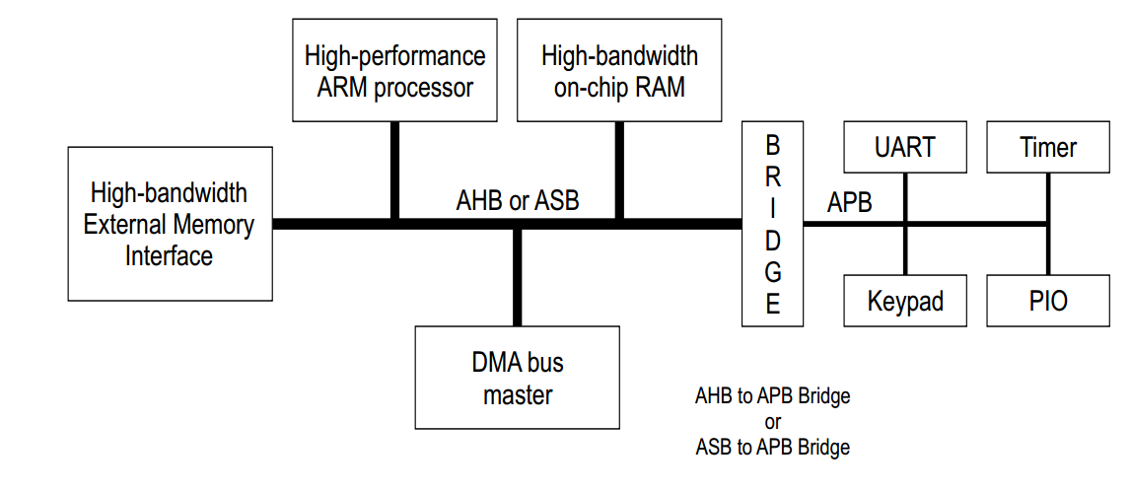
Fig :1 System Block Diagram
The above diagram depicts a block diagram of a System. The system's core is a high-performance ARM CPU. The High-bandwidth Memory Interface, DMA bus master, and other extra parts are linked to the Core via the System bus, which in this case is the AHB. By employing a peripheral bus, in this case the APB bus, the other low bandwidth peripherals like UART, Timer, Keypad, and PIO are connected to the System bus through the Bridge. In this case, the Bridge serves as the Core Master's matching AHB Slave. Additionally, it serves as the APB Master for any other low-bandwidth external peripherals. The APB transfers are not typically produced by any component. The sole part of a system that serves as the APB master is the AHB to APB Bridge.

BLOCK DIAGRAM
Figure 2 demonstrates the block diagram of the protocol along with signal description.
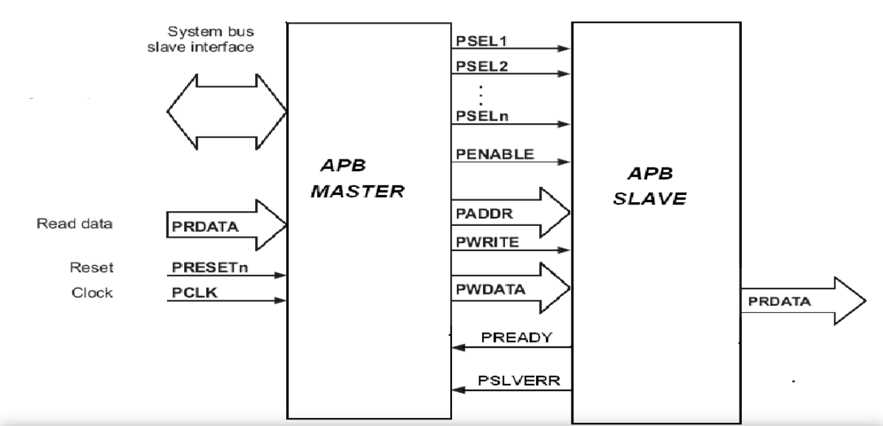
Fig. 2 Signal requirement of APB Master-Slave
Signal Description –
- PCLK – Generally System clock is directly connected to this
- PRESETn – Active Low Asynchronous Reset
- PADDR [31:0] – Address bus from Master to Slave, can be up 32 to bit wide
- PWDATA [31:0] – Write data bus from Master to Slave, can be up to 32-bit wide
- PRDATA [31:0] – Read data us from Slave to Master, can be up to 32-bit wide
- PSELx – Slave select signal, there will be one PSEL signal for each slave connected to master If the master is connected to 'n' slaves, then PSELn is the the most signals that can possibly be present at one time. similar to PSELn, PSEL1, and PSEL2. (E.g.: PSEL1, PSEL2, PSELn)
- PENABLE – Denotes the second and succeeding transfer cycles. The ACCESS step of the transfer begins when PENABLE is asserted.
- PWRITE – Indicates Write when HIGH, Read when LOW
- PREADY – It is used by the slave to include wait states in the transfer. i.e., For example, if the slave is not yet prepared to finish the transaction, it will de-assert the PREADY and ask the master to wait.
- PSLVERR – Indicates the Success or failure of the transfer. HIGH indicates failure and LOW indicates success

State Diagram
Figure 3 depicts the operating stages of the protocol.
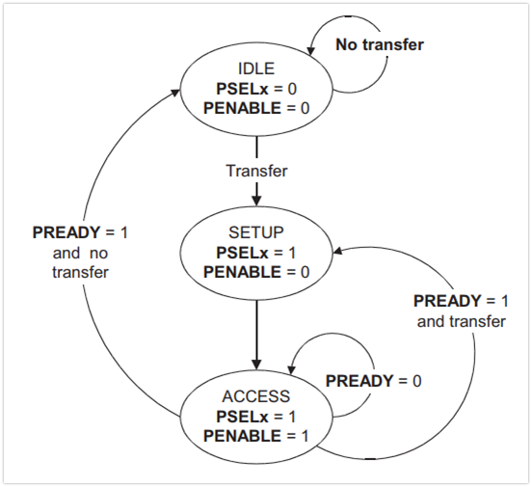

Fig:3 State Diagram
IDLE: This is the default state of APB.
SETUP: When transfer is required, PSELx is asserted then the bus moves in setup state, bus always transitions to the ACCESS state on the following rising edge of the clock and only lasts one clock cycle in the SETUP stage. As a result, during the setup cycle itself, the slave must be able to sample the address and control information.
ACCESS: PENABLE is asserted to enter into the ACCESS state. During the ACCESS state, the PADDR, PWRITE, PSELx, and PWDATA signals must stay steady.

RESULT
We synthesized the APB protocol on the FPGA board Virtex-6. The signal performance was observed using waveform and the device utilization summary generated indicated the low power consumption of the design. The design utilized Verilog programming which considerably improves a test bench component's capacity to be reused by creating tasks for multiple test cases.

- DEVICE UTLIZATION SUMMARY
Figure 4 provides us insight into the device utilization.
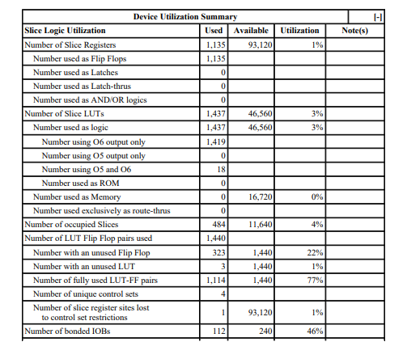
Fig:4 Device Utilization
The summary report provides us the total percentage of resources utilized by the design of APB interface. In this project additional external signals have been utilized for stimulation and verification purpose. It is an interface where signals would be coming from AMBA protocol bridge or the CPU.

- TIMING ANALYSIS
Maximum Frequency: The maximum clock frequency at which a digital circuit can operate is called its f MAX. 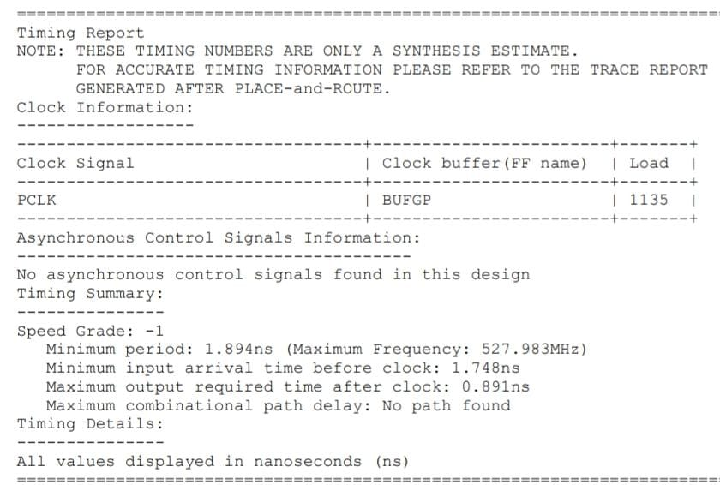
Fig:5 Timing Analysis
The f MAX is the maximum rate at which the outputs of registers are updated. As it can be observed in Fig 5, the maximum frequency is of 527.983MHz this is the maximum value the design can reach.

- POWER CONSUMPTION ANALYSIS
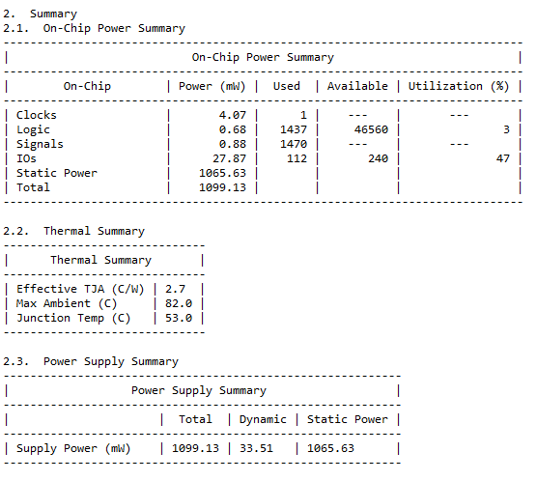
Figure 6 depicts the power consumption by the design
Fig 6. Power Analysis
As Fig 6 shows that dynamic power consumption is very low at 33.51 mW this provides us power optimization for the design.

- WAVEFORM
Fig 7 and Fig 8 shown below are the attachments that explain the waveforms obtained in the process.
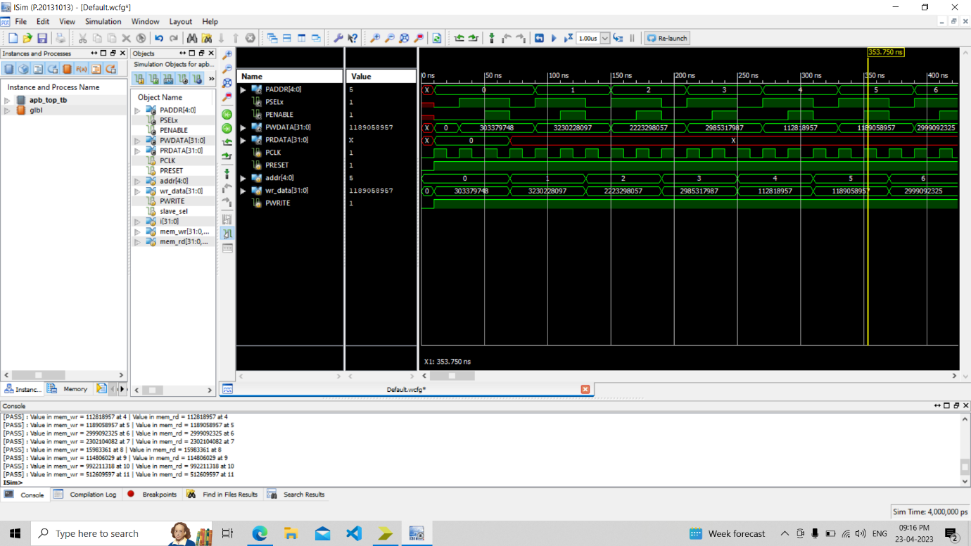 Fig 7. Waveform 1
PWRITE indicates an APB write access when HIGH and an APB read access when LOW.
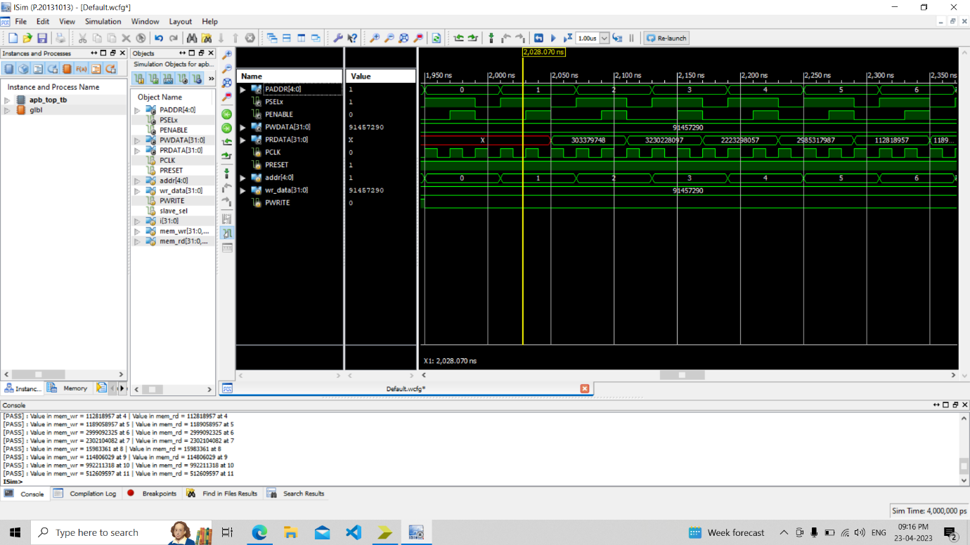
Fig: 8 Waveform 2
When a read transaction is required, the signals PSEL, PWRITE, and PADDR will assert high (1) and low (0) on the T1 clock edge, respectively (setup phase). The read transaction has begun as of this setup phase. And at the upcoming clock positive edge T3, PENABLE and PREADY both went high (1), indicating that one read transaction in APB interface has been successfully completed.

- CONCLUSION
APB interface is implemented without latches while providing optimized power even at high frequencies. The clock frequency of 50 MHz is considered for the Proposed APB Interface design simulation. In later stages of design development, we were able to optimize the area of the design by 4.5 %. Dynamic power consumption was reduced by 2 to 3% while providing low power consumption.

References
[1] Kiran Rawat et al. (2015). “RTL Implementation for AMBA ASB APB Protocol at System on Chip Level” 2nd International Conference on Signal Processing and Integrated Networks (SPIN,) pp. 927-930.
[2] Sandeep Jagre (2017). “Design and Implementation of AMBA APB Bridge with Low Power Consumption” IJSTE - International Journal of Science Technology & Engineering | Volume 4 | Issue 2 | August 2017.
[3] Ashutosh Gupta et al. (2016). “Physical Design Implementation of 32-bit AMBA ASB APB module with improved performance” International Conference on Electrical, Electronics, and Optimization Techniques (ICEEOT), pp. 3121-3124.
[4] Abhishek Deshwal et al. (2020). “Power Optimization in High Performance Advanced Micro-Controller Bus Architecture in AHB” EasyChair preprints, May 19, 2020
[5] Varsha Vishwarkama (2012) “Implementation of AMBA AHB protocol for Wide Narrow BUS-SLAVE combination using VHDL” International Journal of Computational Engineering Research. ISSN2250– 3005.

