EXPERIMENTATION AND PERFORMANCE ANALYSIS OF CATTLE FEED MAKING MACHINE
Vikrant D. Dhopte *1, Onkar N. Kapse*2, Ankit M. Kalse*3, Likesh M. Maski*4, Namrata D. Nimje*5, Siddhesh V. Ghodmare*6,
*1 Assistant Professor, Dept of Mechanical Engg, K.D.K College of Engineering, Nagpur,
Maharashtra, India.
*2,3,4,5,6Student, Dept Of Mechanical Engg, K.D.K College Of Engineering, Nagpur,
Maharashtra, India.

ABSTRACT
The feed Mixture machine was designed fabricated and tested The machine is handling 50 kg of feed and proper mixed in live with the use of proper material selection. The high power motor properly mixes all the materials in the mixture within a few minutes. For safely and easily operation, machine was designed to carry @50kg of ingredients at once. The bulk densities and angles of repose were measured in laboratory. Maximum bulk density was used to calculate the mixing time . The feed Mixture machine was designed fabricated and tested The machine is handling 50 kg of feed and proper mixed in live with the use of proper material selection. The high power motor properly mixes all the materials in the mixture within a few minutes . The machine was tested by the use of feed components like 10 kg of rice powder, wheat Powder 20 kg, Maize bran 10 kg, sunflower/cotton cake 2kg, sunflower oil 1/2 lit, Boan meal 2kg, lime & Salt 1/2 kg and water 1lit for proper moisture .The frame stand designed was able to support total force of 620 N.

INTRODUCTION
In cattle farm man power is a very critical asset. Without appropriate manpower work cannot happen. And feed making for all the cattle is a huge task and requires more time to mix it properly all the ingredients, premix and moisture contain.
In this machine the machine takes place 2 tasks at single operating cycle. The chopper system is the more advantageous for cattle farms . These come in the outer side of the mixture machine where you will find 2 operations in a single machine. One is used for mixing and the other one is for chopping grass. The chopper plays a role in cutting grass in fine pieces. The blades are very sharp and rotate with machine RPM. The materials for the construction of the machine were obtained locally so as to be cheap. This should serve as a guide in material selection. Also the materials were chosen on the basis of their availability, suitability, economy, viability in service among other considerations. Design of mixer is done by the use of crio software. This machine manly use for the small as will as large farms, and also it use for large scale industries such as food industry, chemical mixture industry.

EXPERIMENTAL SETUP
The feed mixture making process required more power, it takes1/2 hr to mix 10 kg of feed (1tub) and for large cattle farms where 100 to 200 kg feed required it takes 4 to 5 hrs daily and more than 2 labours are appointed. So we reduce the man power by the use of this machine. The machine takes 5 min for 50 kg feed for proper mixed. Overall cost for manpower is up to the 200000, and also the work cannot properly operates and the feed mixture was not yet properly mixes all the ingredients within. So feed mixture machine is the only way that the all ingredients as will as all premixes are properly mix, distributed in feed. It's takes some electricity to perform well mixing. The overall cost of machine is the 1/4th of the Cost of labours and it's a onetime investment after that the cost decreases only the maintenance cost is required which is very less .

EXPERIMENTAL SET-UP

Sr. No. | Feed in Kg | Power Consumption KW | Time(Min)
 | In Manually
1 | 50 Kg Of Feed | - | 30Min
 | By Machine
2 | 20 Kg of Feed | 1/2KW | 2Min
3 | 50 Kg of Dry Feed | 1KW | 3Min
4 | 50 Kg Moisture Contained Feed | 2KW | 5Min

CALCULATIONS
The length of shaft is 60cm
Maximum allowable shear stress of mild steel = 42 Mpa
Shear modulus of mild steel material -79.3 x10 N/m²,
When the shaft is subjected to a twisting moment (or torque) only, then the diameter of the shaft may be obtained by using the torsion equation. T/J = t/r

Where,
T- Twisting moment (or torque) acting upon the shaft,
J- Polar moment of inertia of the shaft about the axis of rotation,
1 Torsional shear stress, and rd/2 Distance from neutral axis to the outer most fiber, where d is the diameter of the shaft.
The equations for computing equivalent twisting moment (Te) and that of a mixer shaft diameter (d) are given by Khurmi and Gupta (2005)
Volume of hopper.
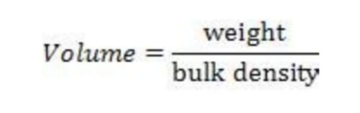
Design of mixing chamber.
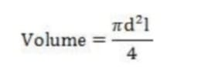
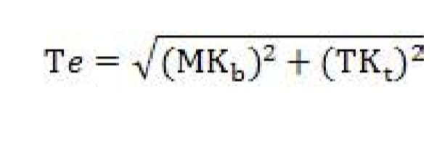
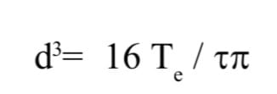
Where.
Te =equivalent twisting moment, Nm;
M = maximum bending moment, Nm
T = torsional moment, Nm;;
Kb= fatigue factor due to bending, 2.0;
Kt= fatigue factor due to torsion, 1.5;
t = maximum allowable shear stress, N/mm
d = diameter of mixer shaft, m

CAD MODEL
The model of feed mixture machine and the chopper cutter is drown by the use of Crio-software. Purpose to design this machine for calculating appropriate dimensions and calculation. So the mixture can perform given below.
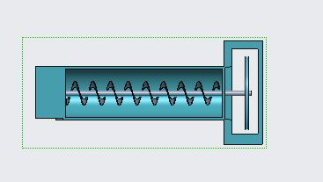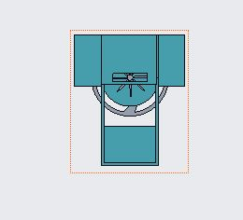
Top view Side view
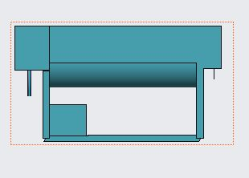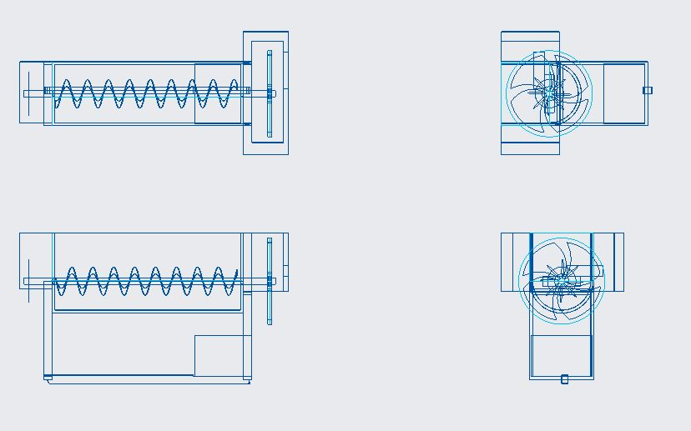

REFERENCES
[1] ASAE Standards, (ASAE S380 DEC1975 R2006). Test Procedure to Measure Mixing Ability of Portable Farm Batch Mixers, pp. 261 – 262.
[2] ASME, 1995. Design of Transmission Shaft. American Society of Mechanical Engineering, New York, USA.
[3] CSA, 1996. Livestock resource and production statistics in Ethiopia. Central Statistics Authority (CSA). In proc. fourth conference of the Ethiopian Society of Animal production. (ESAP) 18-19 April 1996. Addis Ababa, Ethiopia, pp: 11-29
[4] Hall, H., M. S. Holowenk and G. L. Herman, 1988. Theory and Problems of Machine Design, Shaum Outline Series, Mac Graw-Hill Book Company, New York.

