ANALYSIS OF PROCESS OF GEAR MANUFACTURING THROUGH FDM
Rajat Ray¹, Dr.Maneesh C Srivastava², Dr. Kheelraj Pandey³
¹ MTech Scholar, Automobile Engineering, Amity University Lucknow Campus-226028
² Assistant Professor, ASET, Amity University Lucknow Campus-226028
³Assistant Professor, ASET, Amity University Lucknow Campus-226028

ABSTRACT

There is a lot of competition in the car business. OEMs and Suppliers are always trying to come up with better ways to do things that will increase production, efficiency, and innovation while reducing costs and waste. Fused Deposition Modelling, a type of Additive Manufacturing, is becoming one of the most important tools that automakers use. Fused Deposition Modelling, or FDM technology as it is more commonly known, has become popular in the automotive business because it can use engineering-grade thermoplastics. Traditionally, additive manufacturing has been used for concept modelling and prototyping, but the materials you can print with FDM open up many more uses, which the car industry is really starting to take advantage of. Users who have access to high-strength materials like Nylon, Polycarbonate, and Ultem have been able to make a lot of important automotive uses possible. Putting these materials through professional-grade printers has been a key way to improve workflow and test sample parts' functionality. The car industry uses FDM for things like printing jigs, fixtures, and check gauges, designing and testing how things work, and making parts for the aftermarket. With FDM technology, Additive Manufacturing is changing not only how goods are designed and tested, but also how they are made. In the present study a model of spur gear was developed by fusion 360 software and fuse deposition technology. The specimen performed under surface roughness test by Mitutoyo and bending compression test by three-point bending test by universal testing machine. The observed results were observed by the factorial 8 and Minitab. All the samples are made three independent factors i.e., layer thickness, nozzle temperature and infill density.

Keywords: Spur gear, Fusion 360 software, Mitutoyo surface roughness tester, Iron-PLA.

- INTRODUCTION

Industries expect cost efficiency, better life of the commodity, greater quality and product durability in today's dynamic environment. Customized models are being increasingly sought after in various areas, automobiles with complicated geometry, including the aviation, and nuance features. It has proven to be an effective solution for factories to manufacture complicated components with reducing the human effort at a faster speed while eliminating largely the need for tools and Design for Manufacturing (DFM). Fuse deposition modeling (FDM) has been selected among many AM technologies available in the current situation, due to its particular characteristics such as the ability to layer by layer compiling complex structures beginning with a Fusion 360 software/computer-aided design (CAD) file and the ability to use various materials in production. The ground breaking technology was made a desirable way for manufacture through different industries [1] by effectiveness and viability to monitor the process remotely to manufacture personalized consumer products. Despite the vast variety of advantages provided by FDM, this mechanism has a considerable number of hurdles. With 2 geometric stability, component consistency and product efficiency, FDM technology needs to be enhanced. A comprehensive knowledge of processes and their characteristics is vital to resolving these limitations [2].
Mechanical strength of AM manufactured components is considered to be a
significant element in assessing the efficiency of the production [3], as the mechanical characteristics are considered as the most relevant indicators. While FDM has evolved from prototyping to production of components for direct use in applications, FDM- produced components have poor mechanical properties [4]. The quality of the FDM part based on process parameters, like orientation, feed rate, fill density, raster angle, temperature printing, infill pattern and layer thickness, for example [5-7]. The wide variety of FDM technology parameters makes the procedure complicated [8]. The influence of process parameters on the mechanical characteristics of the components is therefore extremely important to understand [9]. In this analysis the relationship between process parameters and component output will be understood.

Understanding these relationships can help to find the optimum combination of process parameters for components with the desired intensity (among those used for this study).
The results of FDM parameters often vary from material to material, meaning that for another material the optimum combination of parameters obtained cannot be equal [10]. Until now, research has concentrated more on traditional materials such as ABS [11], PLA [12] and ULTEM 9085[13] in this direction. This requires that parameters be examined in the impact of newly emerging CF-PLA (Carbon-Fiber-Poly lactic Acid), iron-PLA and Wood-PLA materials. The comparatively recent materials CF-PLA, iron-PLA and Wood-PLA are a PLA composite (Poly lactic acid). This thesis would investigate the impacts of FDM process parameters on the mechanical properties of Iron-PLA.
In addition, fused deposition modeling (FDM) technology in the field of additive manufacturing in particular, overall offers a great deal of potential. The need to include them in the manufacture of goods with low costs is rising significantly as new materials arise. FDM is one of the most common and rapidly growing three- dimensional printing technologies, offering a comparatively inexpensive method of production.
The aim of this study is to study the impact on component quality (Iron-PLA material) by means of an FDM imprinted part, such as layer thickness, infill density & nozzle temperature. The mechanical properties as surface roughness and bending fatigue strength of components are measured in component efficiency. The aim of this analysis is to describe the mechanical properties of each parameter including the surface roughness and bending strength of the components. This report has the following overall objectives:
- To study the impact on efficiency of Iron-PLA sections of FDM process parameters.
- Experimental effects and mathematical calculation using Lewis’s equation analysis using statistical approaches. The relationship between parameters of the FDM process and the mechanical properties is investigated and determined.
- Finding the optimal mix of process parameters to achieve better component performing materials.

Process Parameters
Mechanical Properties
AM Techniques

Bending Strength
FDM Process
Surface Roughness

Figure 1. Proposed framework illustrations

Infill Density
Nozzle
Temperature
Layer Thickness

1.1 Fused Deposition Modeling (FDM)
The FDM procedure was used in this analysis but the Annex offered a description of all other additive production processes. Scott Crump's 1988 Fused Deposition Modeling (FDM) is a quick prototype method that focuses on surface chemical, thermal energies and layer production technologies [13]. The desired component is initially modeled on CAD in FDM and is transformed in an STL (stereo- lithography) file to search for defects such as missing facets and spangling edges [14]. Thermoplastic filaments are layer by layer extruded by a tip of the bucket from an extrusion head that goes through X-Y direction' during the process of construction and heated to the melting point.
The extruder head consists of two extrusion screws, one for the extruder and the other one for the extractor [15]. The head, operated by an engine, places thin material beads on the platform surface, forming the first layer which quickly solidifies because of the low platform temperature [16]. In order to facilitate cooling of the material, the base plate is kept at a lower temperature.
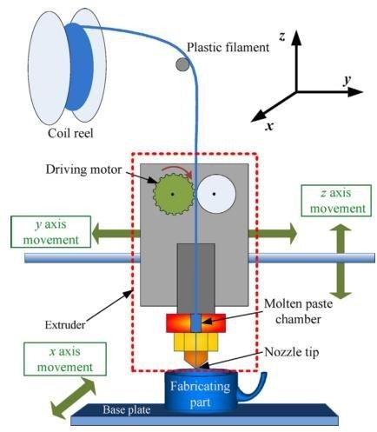
Figure 2. Fused deposition modeling process schematic diagram (FDM) [17]

The platform then decreases by a certain distance, i.e., to position the second layer on the nozzle. The extruded material is held at 0,5°C above the temperature of

melting so that it consolidates itself into 0,1s and becomes cool to neighboring previous layers [15]. This method continues until the component is constructed according to the measurements in the specification entry [18]. In addition to the part, construction reinforcements are designed to protect the part's weakest parts and suspension mechanisms. Figure 2 [17] contains a graphical diagram of the FDM method.
Compared to most other additive production systems, the FDM process has many advantages: lower initial costs in the system procurement process, ease of use and reduced chance of material degradation and user-friendly process protection. Other benefits include ease of material transition, minimum material wastage and quick removal of supplies [19]. The main subject of this research is the use of the FDM system for producing the parts.
Any of the disadvantages are limited spatial accuracy, small work piece reliability and increased building time. Depending on procedural criteria used for construction of parts, the nature and costs of the FDM portion. Precision and surface ruggedness depend primarily on the parameters of the process [20]. This means that a proper choice of parameters, including intensity, is very important.
The advantages and drawbacks of each AM process are specific, some of which depend on the quality of the component made. [21] The comparison of different AM processes as seen in Table 1 was provided with a description.

Table 1 Comparison of different AM procedures [21].

 | Stereo Lithograp hy | Selective Laser sintering | Laminated object manufactur  ing | Fused deposition modelling | 3d Printing
Materials | Photopoly mers (acrylic and epoxy  resigns) | Metals, sand, thermoplas tics (PA12,  PC, PS) | Foils (paper, polymers, metals, ceramics) | Thermoplas tics (ABS, PC, ABS-  PC blend,  PPSU) | Thermoplast ics, cement, cast-sand
Part  Size(mm) | 600*600*5  00 | 700*380*5  50 | 550*800*50  0 | 600*500*6  00 | 508*610*40  6

Accuracy | <0.05mm | 0.05-  0.1mm | 0.15mm | 0.1mm | 0.1/600*540  dpi
Curing time | No cooling off or curing time up to 30  min | Depending on geometry and bulk | Depending on geometry | No cooling off or curing time up | No cooling off or curing time up
Commerci ally available  since | 1987 | 1991 | 1990 | 1991 | 1998
Costs (T) | From 130 | From 150 | From 150 | From 50 | From 25
Relative sample  costs | medium | Medium- high | Low- medium | Low- medium | Low

- MATERIALS & METHOD

FDM has major advantages as an RP technique, such as easy layer-by-layer production of complicated component structures, costly tools removal and high flexibility [24, 22]. FDM has many benefits in delivering components in lower time and expense in comparison to conventional production methods [25]. The biggest problems for this technology, however, are the consistency of the manufactured component and the restricted supply of processing materials that hinder the use of it in different fields [23]. The relationship between material qualities and process factors that constitute an important issue therefore needs to be investigated. The efficiency of any FDM variable is obvious from the literature, not only based on the mechanism, but also on the material. In this chapter, the materials and methods used to analyze the FDM component under investigation are defined. It provides the specifics of the method of production of the components and different tests submitted by the samples. Dimensional precision, surface roughness, mechanical strength and wear characteristics are regarded in compliance with industrial standards as measuring component efficiency. Both measurements are conducted at temperature 23±2 °C (132 °F), and relative humidity at 50% in accordance with ISO R291:1977. This section of the paper also contains the methods relating to the nature and testing of the factorial L8 technique and the study of variation (ANOVA).
Metal-based filament is a combination of iron dust, cork and other derivatives made of powdered iron, characteristic of PLA's basic content. The filament is usually composed of about 20% iron particles. The inclusion of these particles gives the aesthetics of real metal to the printed 3D elements. This filament is purchase from AMOLEN 3D Premium.

Table 2 Property of Iron-PLA filament.

Properties | Details
Material | Iron-PLA
Diameter | 1.75 mm
Filament Length | 330m
Accuracy | +/-0.03mm
Manufacturer | AMOLEN 3D
Extrusion Temperature | 200-220 ° C
Bed Temperature | 0-50 ° C
Printing Speed | 30-60mm/s
Origin country | USA

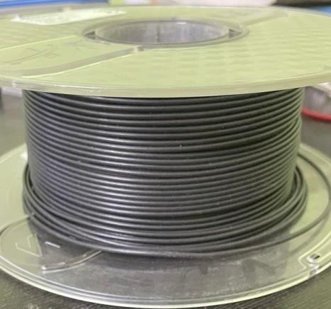
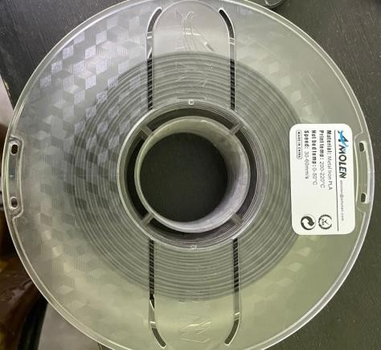
Figure 3. Iron-PLA spool (AMOLEN)

For manufacture of Iron-PLA specimens, FDM is most common & fast-growing 3D printing process used in this research. Experimental specimens have been made using the FDM Creality Ender 3D printer. The Creality Ender 3D series FDM printer image is presented in Figure 4. The computer is capable to use a vast variety of materials including PLA, ABS, extreme plastics such as PI, TPI, PBI, high-temperature, & plastic engineering. A list of the technical specifications of the machine is provided below.
Table 3 Specifications of the FDM machine

Modelling  Technology | FDM (Fused Deposition Modeling)
Printing Size | 220*220*250mm
Max Traveling  Speed | 180mm/s
Filament | 1.75mm (ABS, PLA, TPU, WOOD, FLEXIBLE, Carbon  fiber, Iron-PLA etc.)
Layer Thickness | 0.1-0.4mm
Nozzle diameter | 0.4mm
Precision | ±0.1mm
File Format | STL, OBJ, G-Code
Max Nozzle  Temperature | 260℃
Max Hotbed  Temperature | 110℃

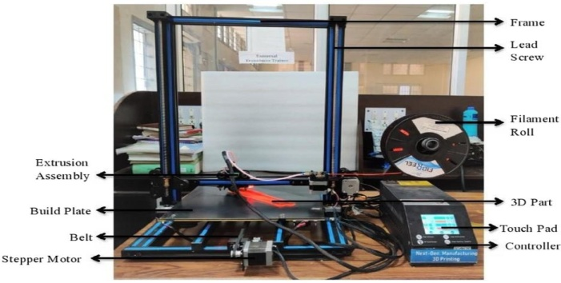

Figure 4. Creality Ender 3D Printer

The 3D models of the component specimen were created by means of a software modeling system of the Solid Works model. The STL file moved the slicing programme, so that we can set the experimental schedule. The consumer can now pick the infill density, layer thickness, speed of printing, and pattern of infill, if desired. The programme will slice the model and produce the necessary tool path information once the parameters are set as needed. The printer then uses the knowledge to transfer the nozzle then print the element. The spur gear with 20-degree phase angle involute gear was made by Fusion 360 software. Figure 5 (a) shows the designing of spur gear via fusion 360 software and (b) shows the printing of model with the help of FDM machine.
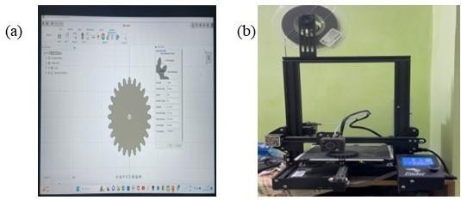

Figure 5. (a) Design Spur gear on Fusion 360 software (b) Printing specimen on FDM machine

2.1 Selection of Process Parameters
(a) Layer height/Layer Thickness
Future scope Work The layer height is known as the layer thickness. You may also mean the height of the deposited filament plate. The schematic layer height diagram in an FDM setting is shown in Figure 6.
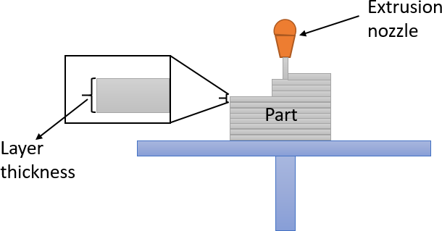

Figure 6. Layer thickness
Layer thickness was the most divisive as an FDM parameter with regard to the results obtained in many experiments. The results of an analysis in terms of the influence of the layer thickness dispute the results of a related study directly. For example the smallest layer thickness has always been part of the strongest value parameter set while
shows that the tensile strength of an FDM part decreases first & then increases with increasing layer thickness. In another study, when the importance of layer thickness was poor, tensile strength was greatest. On the other hand, layer thickness found was less important for the strength of the tensile. A look in the literature review also reveals that layer height affects mechanical properties significantly. Given the conflicting findings in the studies and its important impact on the mechanical properties, there is still an unclear influence of layer thickness on material consistency. This process parameter therefore needs to be investigated to consider its effect on the mechanical properties of Iron-PLA. The layer spreads in this sample are 0.2mm & 0.4mm. The layer thickness values for each machine are generally fixed and set on the basis of the print resolution. Different experiments employed various levels of machine-based layer thickness values. The increasing layer thickness amounts chosen in this analysis help to gather an understanding of how the thickness values of the Iron-PLA sections increase or decrease their mechanical ability.

(b) Infill Density
The distance from the interior filling lines and thus the percentage of solidity inside the part as seen in figure 7 are determined by this parameter. The percentages of this parameter will greatly influence the mechanical characteristics of the components, but the quantity of this percentage is essential for increasing/decreasing the overall use and costs of the material. Assess the impact of the ABS produced parts by a design of experiments (DOE) approach, inter-layer cooling time (ILCT), nozzle diameter, filling density, raster angle, and spacious layer on ultimate strength tensile strength, yield strength and elastic module. The result seen is the parameters that most affect ABS' mechanical properties, namely, the nozzle diameter and fill density. The authors in are investigating the properties of ±45 tones for nylon filling configuration and the effect of nylon infill on the strength properties. It should be observed that a considerable improvement in strength happens after raising the volume fraction of the infill structure by over 60 percent. The final strength of the generated samples is determined not only by the volume of the specimen, but also by contact with the parallel tracks. The manufacturing method has shown that the nearby tracks of the same sheet do not strike each other when setting a potential volume fraction of a filling in the 20-40% range. The parallel path interaction contributes to continuous layer formation, increasing the sensitivity of the whole sample up to 60 percent (this correlate to the actual value of 54 %). Another study aimed at studying the effect on the tensile and impact strength of specimen of poly-lactic acid (PLA) printed with open- source 3D printer by means of varying infill densities. The findings show that the density of the specimens with different infill’s is greater than with the same filling density of the specimens. The several specimens of infill density weigh lighter than the single infill density to conserve the raw substance. The test results for impacts show that the strength of impact is directly proportional to the density of infill. Thus, the effect intensity of the printed specimens is decreased by varying the infill density. Since the highest filler percentages do not produce optimal outcomes of the properties, this parameter was motivated to discover individual specifications and likely its association with other techniques. This was not accomplished. The creality ender 3D printer used in this study has two infill density percentage are including 40% and 100%.

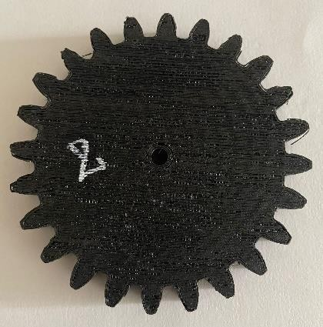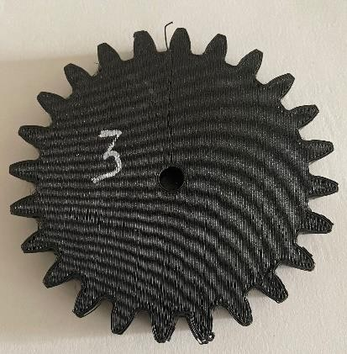

Figure 7. Spur gear sample made on two different infill density

(c) Nozzle Temperature
The creality ender 3D printer having maximum nozzle temperature of 260 ⁰C and for iron PLA suitable melting point is 230 ⁰C. In present study two nozzle temperature were in used for fabrication of specimen are 230 ⁰C and 260 ⁰C.

Surface Roughness Test
The surface roughness of eight spur gear samples is checked by Mitutoyo Digi Matic Mini-Processor DP-1VR. The result was recorded by taking average of five experiment perform on each sample. Figure 8 shows the device which was used for measuring the surface roughness of eight samples of spur gear made with the help of fuse deposition technology.
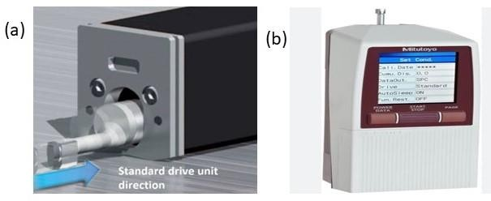
Fig 8. Mitutoyo Surface Roughness Testing Device

Bending Compression Load Test
Finding out a material's mechanical properties gives you important knowledge about its structure and how it will work in a technical application. Compression tests tell you about a thing's compressive strength, and bent flexural tests tell you about its bending strength. Bending strength is the power of a material to resist deformation under load. It is the highest stress that a material experiences at the moment it breaks. There are two kinds of tests for bending. There are three-point and four-point bending tests. In a three-point bending test, the area of constant stress is quite small and is mostly under the Centre loading point. In a four-point bending test, the area of constant stress is between the loading points on the inner span, which is usually half the length of the outer span.
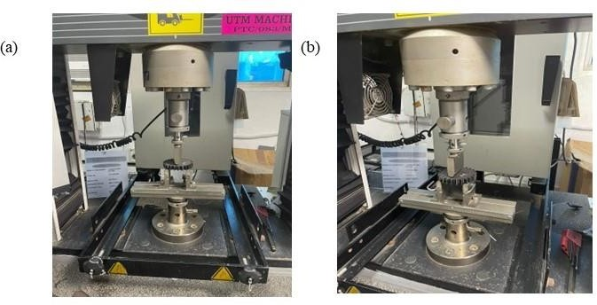

Fig. 9 Three- point Bending Compression test

Bending compression test were performed on eight fabricated sample done by three- point load system on UTM machine. Figure 9 shows the test of bending on eight fabricated specimens.

- ANALYSIS OF EXPERIMENTAL DATA

The main objective of factorial design is to plan and conduct objective in a controlled way to establish a hypothesis which can be tested. In the factorial design approach, there are factors which is also called as independent variables which needs to be controlled. The dependent variable is the objective which changes with respect to the independent variables. In the present study three independent variables i.e., X1=Infill Density (%), X2=Nozzle Temperature (oC), X3=Layer Thickness (mm) are chosen as the process parameters which decides the output responses, Surface roughness of fabricated spur gear (SR) and bending compressive load (BCL). A set of eight experiments based on factorial design were carried out in accordance with the design methodology with the help of statistical software Minitab.17. The independent factors and their level have been indicated in table 4.
Table 4 Independent factors and their level

S. No | Factors | Levels
S. No | Factors | Minimum | Maximum
S. No | Factors | -1 | 1
1 | Infill Density (X1) | 40% | 100%
2 | Nozzle  Temperature (X2) | 230 0C | 260 0C
3 | Layer Thickness  (X3) | 0.4 mm | 0.2 mm

The surface roughness model of fabricated spur gear obtained by using the experimental data highlighted in table 5 is given below:

𝑆𝑅 (µ𝑚) = −16.63 + 0.2693𝑋1 + 0.1066𝑋2 − 7.328𝑋3 − 0.00189𝑋1𝑋2 −
0.05139𝑋1𝑋3 + 0.03056𝑋2𝑋3 + 0.000278𝑋1𝑋2𝑋3 (i)

The bending compressive model for the specimen of metal PLA for the experimental data highlighted in table 4.1 is given as

𝐵𝐶𝐿(𝑁) = −3510 + 105.0𝑋1 + 16.64𝑋2 + 14111𝑋3 − 0.3823𝑋1𝑋2 − 423.0𝑋1𝑋3 − 64.72𝑋2𝑋3 + 1.697𝑋1𝑋2𝑋3 ……………………………………. (ii)

- RESULT & DISCUSSION

The table 5 Resembles the measured value of surface roughness for each trial of experiment which was recorded with the help of Mitutoyo Digi Matic Mini-Processor DP-1VR with traverse length of 2mm, equivalent length of 0.08 mm and probe speed of 0.4 to 0.5m/s. Also, the bending compressive load for each executed experimental trial was measured using Universal Testing Machine.

Table 5. Mean value of surface roughness and bending compressive load at each experimental trial

No. of sample | Infill Density (%) | Nozzle Temperature (⁰C) | Layer Thickness (mm) | Surface Roughness (micro-  meter) | Bending Compressive Load (N)
1. | 40 | 230 | 0.4 | 7.79 | 165.51
2. | 100 | 260 | 0.2 | 7.63 | 1193.80
3. | 40 | 260 | 0.4 | 10.06 | 243.96
4. | 40 | 260 | 0.2 | 9.77 | 640.94
5. | 100 | 230 | 0.2 | 7.65 | 1211.51
6. | 100 | 260 | 0.4 | 8.17 | 1016.04
7. | 100 | 230 | 0.4 | 7.84 | 403.64
8. | 40 | 230 | 0.2 | 7.75 | 581.55

4.1 Effect of process parameters on surface roughness
The main effect plot of the process parameter for surface roughness response is shown in fig. 10 (a) which examines the effect of independent process variables i.e., nozzle temperature, layer thickness and infill density on the dependent variables surface roughness of fabricated spur gear made from iron PLA using fuse deposition modelling additive manufacturing process.
It can be seen from fig.10 (a) that when the infill density of iron PLA increases the surface roughness of fabricated spur decreases. The reason could be that at low infill density voids may be developed during fabrication which may lead to undistributed crystal structure in the fabricated specimen. Due to the developed voids in the specimen at low infill density bubbles were seen to escape during fabrication which signifies that high infill density is required to lower the surface roughness of fabricated specimen.
It can be seen from fig. 10 (a) that when the nozzle temperature increases the surface roughness is also increases. As the melting temperature of iron PLA is limited 230 ⁰C and the temperature above it would cause the material staggered crystal structure when deposited layer by layer.
It can be seen from fig. 10 (a) that when the layer thickness increases the surface roughness also increases therefore lower value of layer thickness is preferred to obtain good surface quality of fabricated specimen. The reason could be that at high layer thickness the air gap developed during fabrication creates large voids between layers which leads to roughening of the surface. On the other hand, the lower of layer thickness reduces the voids between layers and hence good surface finish is obtained.

4.2 Effect of process parameters on Bending Compressive Load
The main effect plot of the process parameter for bending compressive load shown in fig. 10 (b) which examines the effect of independent process variables i.e., infill density, nozzle temperature and layer thickness on the dependent variables bending compressive load of fabricated spur gear made from iron PLA using fuse deposition modelling additive manufacturing process.
It can be observed from fig.10 (b) that when the infill density increases of iron PLA increases the bending compressive load on fabricated spur gear. The reason

could be that at high infill density no voids are developed during fabrication and formation of undistributed crystal structure less in the fabricated specimen due to which strength of specimen increases.
It can be seen from fig. 10 (b) that when the nozzle temperature increases the bending strength is also increases. At high temperature the melting of material will proper takes place due to which after deposition the solidification of the melted material will increase the strength of the fabrication specimen.
It can be seen from fig. 10 (b) that when the layer thickness increases the bending strength also decreases therefore lower value of layer thickness is preferred to obtain bending strength of fabricated specimen. The reason could be that at higher value of layer thickness the crystal structure of the fabricated material staggered in nature due to which the strength is found to decrease.

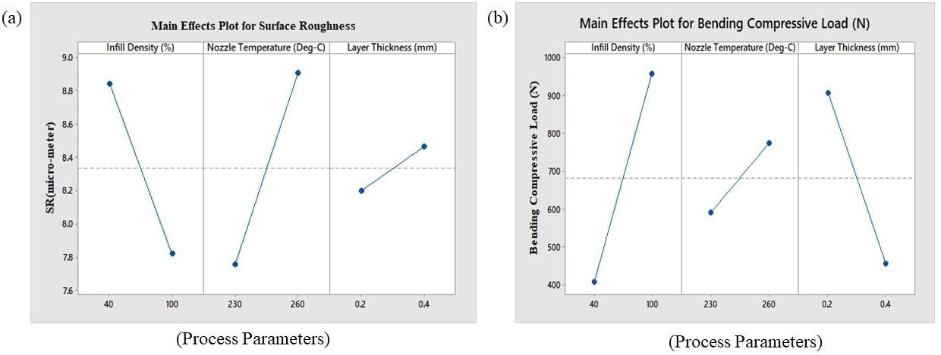
Figure 10. Main effect plot for (a) Surface Roughness (b) Bending Compressive load

4.3 Interaction effect of process parameters on Surface roughness
The interaction between infill density and nozzle temperature with surface roughness has been highlighted in fig. 11 (a). At lower infill density i.e., X₁= 40% the increase in nozzle temperature consequently increases the surface roughness of fabricated specimen. The reason could be that the increase in nozzle temperature resulted in formation of staggered crystal structure due to which the surface roughness was found

to increase. The same phenomenon resulted at higher infill density for the aforesaid reason.
The interaction between infill density and layer thickness with surface roughness has been shown in fig. 11 (b). The combination of low value of layer thickness i.e., X₃= 0.2 mm and higher value of infill density i.e., X₁= 100% resulted in obtaining good surface finish of fabricated specimen. On the other hand, at lower infill density i.e., X₁= 40% with the increase in layer thickness the surface roughness was found to increase because higher value of layer thickness resulted in formation of air gap developed during fabrication created enlarge voids due to which surface roughness was found to increases.
The interaction between nozzle temperature and layer thickness with surface roughness has been shown in fig. 11 (c). At the lower value of nozzle temperature X₂= 230 ⁰C with higher value of layer thickness surface roughness is found to increases. On the other hand, lower value of layer thickness X₃= 0.2mm with higher value of nozzle temperature surface roughness is also increases. This condition occurs due to the staggered crystal structure formation during melting of iron PLA at higher temperature.

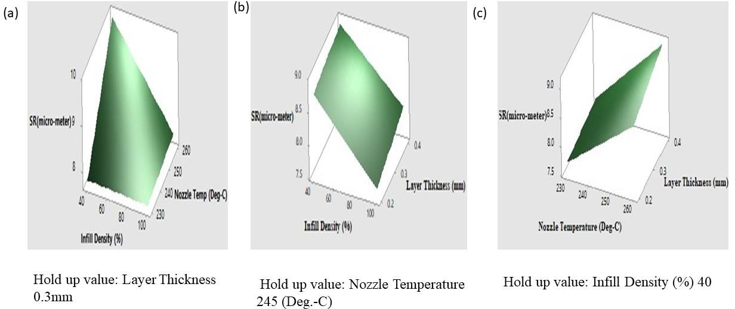

Figure 11. Surface plot for surface roughness

4.4 Interaction effect of process parameters on Bending Compressive Load
The interaction between infill density and nozzle temperature with bending compressive load has shown in fig. 12 (a). At lower nozzle temperature i.e., X₂= 230 0C the increase in infill density consequently increases the bending strength of fabricated specimen. The reason could be that the increase in infill density formed compact crystal structure and reduces the voids formation during fabrication.
The interaction between infill density and layer thickness with bending compressive load has been shown in fig.12 (b). At least value of layer thickness i.e., X₃= 0.2mm the increase in infill density increases the bending compressive load of the fabricated specimen. The reason could be that the increase in infill density reduces the voids in the fabricated specimen as the result of which a closed compact crystal structure is obatined which leads to the incremental value of bending compressive load. On the other hand at higher layer thickness X₃= 0.4mm the same trend is obsereved but the bending compressive load is on the lower side.
The interaction between nozzle temperature and layer thickness with bending compressive load has shown in fig.12 (c). At minimum nozzle temperature, X₂= 230 ⁰C with the increase in layer thickness the bending compressive strength of the specimen decreases. The reason could be that at increased value of layer thickness crystal structure were staggered in nature after solidification so result in decrease value of bending strength was obtained.

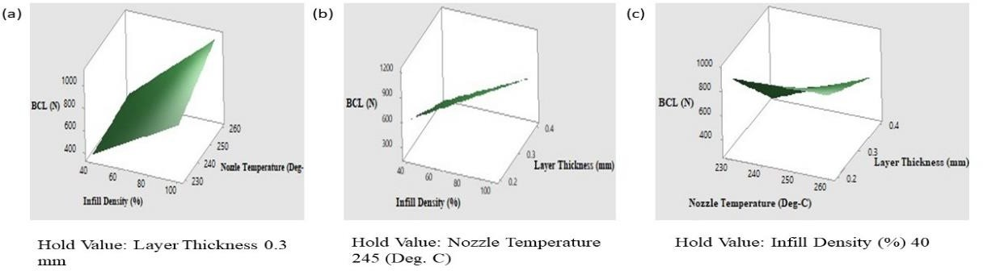

Figure 12. Surface plot for Bending Compressive Load (N)

- CONCLUSIONS

In the present work the eight sample of spur gear was made by using fuse deposition technology additive manufacturing. The iron PLA were used as material in the experiment after that surface roughness and bending strength test was performed on the samples. The following conclusions are drawn from the experimental observations.
    - For better surface roughness higher infill density is required because at lower infill density staggered crystal structure were form after solidification. Also voids formation occurs during fabrication due to which bubbles were generated.
    - Layer thickness value have to be kept at low for good quality of surface because at higher value of layer thickness air gap seems to be generated between two consecutive layers which leads to roughening the surface.
    - As the used material iron PLA its printing temperature is suggested to be 230 oC. When the nozzle temperature increases the surface roughness also increases so the preferred printing temperature provides better surface roughness.
    - At the higher nozzle temperature better, bending strength were observed because the material melts properly and after solidification gives better bending strength.
    - For better bending strength the lower value of layer thickness is to be used because when layer thickness layer is lower it stick with other layer without any gap or voids formation.
    - Bending strength is higher at high value of high layer thickness because possibilities of staggered crystal structure were found less.

Observation was done by taking three independent variables i.e., infill density, nozzle temperature and layer thickness with two dependent variables surface roughness and bending strength. The result of good surface finish found at higher infill density, lower layer thickness and lower nozzle temperature.

- REFERENCES

      - Palermo E. Fused Deposition Modelling: Most Common 3D Printing Method. September 19th, 2013. (Accessed on 23rd October 2018). https://www.livescience.com/39810-fused-deposition-modeling.html
      - Sood A.K., (2011). “Study on parametric optimization of used deposition modelling (FDM) process”. (Doctoral dissertation).
      - Deng, X., Zeng, Z., Peng, B., Yan, S., & Ke, W. (2018). “Mechanical Properties Optimization of Poly-Ether-Ether-Ketone via Fused Deposition Modeling”. Materials (Basel, Switzerland), 11(2), 216
      - Rajpurohit, S. R., & Dave, H. K. (2018). “Effect of process parameters on tensile strength of FDM printed PLA part”. Rapid Prototyping Journal, 24(8), 1317-1324.
      - Masood S.H., Mau K. and Song W.Q. (2010), “Tensile properties of processed FDM polycarbonate material”. In Materials Science Forum (Vol. 654, pp. 2556- 2559). Trans Tech Publications.
      - Smith W.C and Dean R.W. (2013). “Structural characteristics of Fused Deposition Modeling polycarbonate material”. Polymer testing, 32(8), 1306- 1312.
      - Bagsik A., Schöppner V. and Klemp E. (2010). “FDM part quality manufactured with ULTEM 9085”. Proceedings of the 14th international scientific conference on polymeric materials, Halle (Saale), Germany. 15–17 September 2010; pp. 307–315.
      - Casavola C., Cazzato A., Moramarco V. and Pappalettere C. (2016). “Orthotropic mechanical properties of Fused Deposition Modelling parts described by classical laminate theory”. Mater. Des. 90 (2016), pp. 453 -458.
      - Vaezi S. (2011). “Mechanical properties of Fused Deposition Modeling parts manufactured with ULTEM 9085”. In Proceedings of 69th Annual Technical Conference of the Society of Plastics Engineers (ANTEC'11) (Vol. 2, pp. 1294- 1298).

      - Gebisa, A. W., & Lemu, H. G. (2018). “Investigating Effects of Fused- Deposition Modeling (FDM) Processing Parameters on Flexural Properties of ULTEM 9085 using Designed Experiment”. Materials, 11(4), 500.
      - Ismail D. and Ertan R. (2014). “Experimental investigation of FDM process for improvement of mechanical properties and production cost”. Rapid Prototyping Journal, 20(3), 228-235.
      - Chacón J. M., Caminero M.A., García-Plaza E. and Núñez P.J. (2017). “Additive manufacturing of PL structures using Fused Deposition Modelling: Effect of process parameters on mechanical properties and their optimal selection”. Mater. Des. 2017, 124, 143–157.
      - Christiyan K. J, Chandrasekhar U. and K. Venkateswarlu. (2016). “A study on the influence of process parameters on the mechanical properties of 3D printed ABS composite”. In IOPConference Series: Materials Science and Engineering (Vol. 114, No. 1, p. 012109). IOP Publishing.
      - Tak A., Ingavale P., Khopatkar C., Bhure S., Barve V. and Rajurkar A. (2015). “Effect of 3D printing parameters on dimensional accuracy and shrinkage on printed parts”.
      - Pham, D., & Dimov, S. S. (2012). “Rapid manufacturing: the technologies and applications of rapid prototyping and rapid tooling.” Springer Science & Business Media.

      - Shofner M. L., Lozano K., Rodriguez-Macias F.J. and Barrera E.V. (2003). “Nanofiber-reinforced polymers prepared by fused deposition modeling”. Journal of applied polymer science, 89(11), 3081-3090.
      - Khan Adil. (2016). “Design and characterizing of an innovative acoustic resonator”.
      - Russel G.A, Wu B.M., Borland S.W., Cima L.G., Sachs E. M. and Cima M.J. (1997). “Mechanical properties of dense polyaltic acid structures fabricated by three-dimensional printing”. Journal of Biomaterials Science, Polymer Edition, 8(1), 63-75.
      - Chua C.K., Leong K.F. and Lim C.S. (2010). “Rapid prototyping: principles and applications”. (With companion CD-ROM). World Scientific Publishing Company.
      - Sood A. K., Ohdar, R. K., and Mahapatra, S. S. (2012). “Experimental investigation and empirical modelling of FDM process for compressive strength improvement”. Journal of Advanced Research, 3(1), 81-90.
      - Wendel B., Rietzel D., Kühnlein F., Feulner R., Hülder G., and Schmachtenberg
E. (2008). “Additive processing of polymers”. Macromolecular materials and engineering, 293(10), 799-809.
      - Bernard A. and Fischer A. (2002). “New trends in rapid product development”. CIRP Annals Manufacturing Technology, Volume 51, Issue 2, pp. 635-652.

      - Kim G.D. and Oh Y.T. (2008). “A benchmark study on rapid prototyping processes and machines: Quantitative comparisons of mechanical properties, accuracy, roughness, speed, and material cost”. Proceedings of the Institution of Mechanical Engineers, Part B: Journal of Engineering Manufacture, 222(2), 201-215.
      - Mueller B. (2012). “Additive manufacturing technologies: rapid prototyping to direct digital manufacturing”. Assembly Automation, 32(2).
      - Too M.H., Leong K.F., Chua C.K., Du Z.H., Yang S.F., Cheah C. M., and Ho
S. L. (2002). “Investigation of 3D non-random porous structures by Fused Deposition Modeling”. The International Journal of Advanced Manufacturing Technology, 19(3), 217-223.

