Automation Testing using Appium Tool
Preeti Pandey(Assistant Professor CSE Department, Delhi Technical Campus, Greater Noida), Nishchey Bhutani, Richa Thakur, Shubham Kr. Jha
Abstract
Software engineering must include testing as it plays a crucial role in many applications in the product-based industries. Businesses are investing an increasing amount of time and money in manual testing nowadays to make sure the application is thoroughly tested for the best user experience and optimum performance by the application. To ensure that daily updates are accurately represented, testing is done. This paper discusses automated testing for hybrid and web mobile applications.
Keywords: UI testing, Appium, automated testing, scripting approaches, mobile applications, iOS, and Android
1. Introduction
Application evaluation during usage is sometimes a part of software testing (P. Ammann & J. Offutt, 2008). The two main methods of software testing are manual testing and automated testing. In automated testing, we employ software that is distinct from the system being tested to manage the test execution. To confirm that the system is operating properly, the output produced in this case is compared to a specified output.
Software testing is a costly procedure to accomplish since it covers much of the software development life cycle. Our issue now is to figure out how to scale back these efforts without sacrificing the overall standard of the system that is being created.
The most notable and practical answer to this problem is to automate repetitive task testing.

2. Manual Testing vs Automated Testing
Software testing involves two primary methods: manual testing and automated testing. These methods can be differentiated in the following ways: When it comes to manual testing, writing complex tests may not uncover hidden faults or identify missing information, unlike automated testing, which allows for the creation of sophisticated tests. Manual testing can become tedious, slow, and time-consuming. In contrast, automation offers a solution to the increasing number of mobile applications by executing repetitive actions through scripts, reducing the risk of errors.
Additionally, automation enables testing a wider range of options to minimize potential errors. Manual testing is well-suited for detecting new and unexpected issues, while script-based software testing helps prevent new faults in tested and functional modules. Automated testing can efficiently handle a large number of test cases, whereas manual testing relies on the tester's expertise to focus on system components with a higher probability of error. These two approaches complement each other.
3. UI Automation Testing
Mobile technology has advanced quickly over time, changing company procedures and IT systems in the process. In order to demonstrate the impact of UI automation testing on the field of automation testing, a research of the subject is conducted in this paper. A solution that could test mobile applications across different platforms is also necessary. Android and iOS are the two mobile operating systems that are now most popular. Android and iOS are the two mobile operating systems that are now most popular. Using the Appium automation tool, the iOS and Android apps' functionalities may be effectively tested.
3.1 Types of Data Centric Applications
The three types of data-centric applications that can exist are native apps, mobile web apps, and hybrid apps (Swati Hajela, 2012). Appium supports all three of these application kinds, making it possible to test contemporary applications, which are often used online today.
1. Native apps are those that are downloaded and run directly from a mobile device. Access to a device ID is necessary in order to test such applications on specific mobile devices. Native apps should be tested across a variety of devices to determine their usability and usefulness.
2. Mobile Web Apps: These applications don't need to be downloaded. They must undergo testing on various mobile browsers.
3. Hybrid Apps: These apps combine native apps and mobile web, fusing the native app's icon and interface with the mobile web's simplicity and rich information.
3.2 Cardinality
The creation of scripts for an event that will be tested is the fundamental concept behind Appium. The scripts (i) have the option of being hard coded, (ii) include a control structure, and (iii) be able to choose between having a control framework and being data-driven [4]. Therefore, UI testing can be automated using scripting techniques. As a result, this approach allows for numerous input test cases while maintaining the same script. Consider the cardinality between the number of test cases and the required script, as shown in Figure 1. The number of test cases that need to be validated is equal to the number of times a test script that was recorded for a certain event can be run.
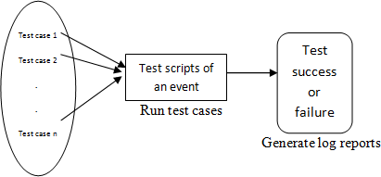
Fig.1 Scenarios for testing

3.3 Architecture of Appium

The Selenium WebDrivers, the industry standard for browser automation, are where Appium got its start. Developers utilize Selenium WebDrivers to programme in any language of their choice. Scripts are run by Appium using the Selenium WebDrivers.
The architecture of the Android and iOS platforms is covered in this section. while the framework for Android apps is shown in fig.2
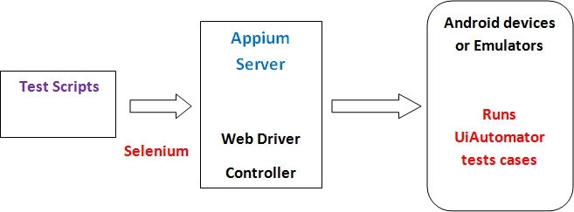
Fig.2 The Appium framework for Android apps
There are four main parts to Appium's architecture; scripts for Web Drivers:
a. Selenium WebDriver
The test case scripts are created using libraries and APIs. These scripts are comparable for a certain event of a related application on both Android and iOS.
b. Appium Server:
The Web Driver sessions are managed and created by the HTTP server known as Appium Server. It initiates the execution of a test case that launches a server.
c. Instruments or UiAutomator:
d. For iOS apps, the Instruments Command Server, and for Android apps, the device-based UiAutomator, the Appium server listens to proxies for commands.
e. Real devices or simulators and emulators:
When testing an app, a simulator is a duplicate of a genuine iOS device. An emulator functions similarly for Android. Without understanding the intricacy of the application code, Appium performs the test scripts significantly faster on a real device, making it the perfect framework wanted.
3.4 Working of Appium
Python, Perl, Java, Ruby, and C# are just a few of the programming languages that may be used to create the scripts and implement the needed features. Here, an eclipse IDE is used to write both the scripts and capabilities on the Windows platform. An illustration of desirable talents is shown in Figure 4. The Android app being tested on the emulator has the following capabilities. Only the necessary features, such as changing the platform's name to iOS and the device's name to iPhone, must be changed for an iOS app.
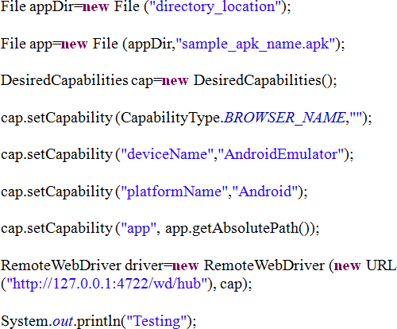

Fig.3 Desired Features for Testing Android Apps

The Appium Inspector automatically detects the elements, such as the element name, type, Xpath, and class, when evaluating the GUI of the apps. The element is located using Xpath based on the route that it was browsed to. The ability to record this script and utilise it immediately when executing the test case is provided by Appium. There will be a different script for that exact path in every recording of an event. They developed the Junit test scenarios shown in Fig. 4. Appium Inspector captures a screen shot of the application. In response to the command you click or press on the screen, Record will write the script. The following screen may be captured with a touch or click command.
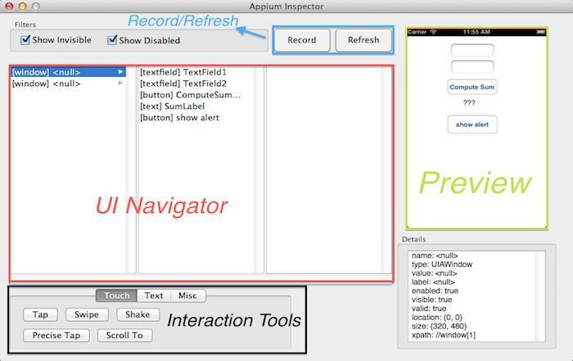
Fig.4 Appium Tool Inspector
In this manner, a script is generated with hardcoded values for a specific scenario. This initial script can then be transformed into a data-driven script by linking it to an external data file and incorporating a control structure in a program to execute the test cases.
Reusability, a vital component of automated testing, may be ensured with Appium. Using the same set of scripts, a given test case might be run against hundreds of different variables. Manually testing with 100 different numbers would take hours of labour, but appium makes it possible to complete the task fast and automatically.
Locating an element within a user interface (UI) screenshot
By Xpath: An abstract representation of an element's route is called an Xpath. The login and password items in Fig. 5 can be found by choosing them from a hierarchy of screen components. Fig. 7 displays the script that demonstrates how to utilise Xpath. The Xpath used for inputting a username is,
android.view.View[1]/android.widget.ListView[1]/android.view.View[1]. Similar to this, only the android.view.View[2] changes in the Xpath when a password is entered.
By ID: The appium inspector may distinguish a specific UI element by its ID. When building the script, this id is used to find the element.
By Name: The element's name may help you identify it. The Login button in Fig. 6 may be identified by that name. Giving the Appium Server a command

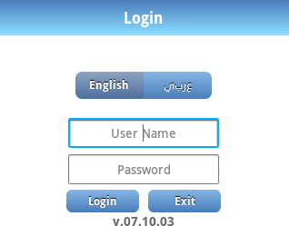
Fig.5 Login screen of an Android app

Appium offers various events that can be tested, leveraging the capabilities of Selenium Web Drivers. By utilizing Selenium Web Driver, commands are recognized and transmitted to the Appium Server in the form of JSON via HTTP requests. Appium, being a UI functional testing framework, supports events like click, text entry, tap, and scroll. For elements, the click event is utilized. When the click() event is triggered, it instructs Appium to interact with the client device and execute the command. The execution process generates a log report, which is then sent back to the Appium Server. Subsequently, Appium becomes ready to process new commands.
Users may tap anywhere on the screen with a tap event, just like they can with a click event. button within a textbox just before typing any characters, or use the UI to navigate to a certain screen. sendKeys event The code delivers a string of text called keys that must be input into the textbox on the client device.

This procedure is comparable to someone entering text into a textbox. In Fig. 5, the empty username textbox receives the key "username" by calling Elements.sendKeys("username").
The ability to scroll up or down the screen is supplied via a scroll event.
There are certain restrictions with regard to event support as well. For example, Appium does not enable the testing of pinching events.

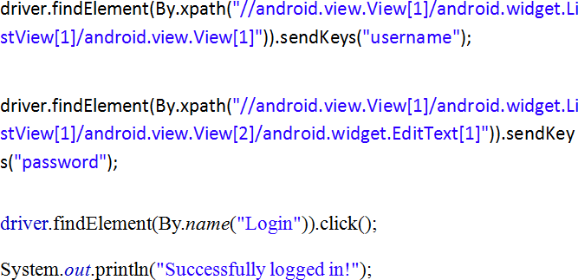
Fig.6 Recorded script for the Login screen

Conclusions
Mobile application UI automation testing may be a laborious procedure when carried out manually for industrial applications.
Using an automation tool to reuse the scripts after they have been recorded greatly simplifies this operation. Appium, an open source tool, supports both Android and iOS as platforms building mobile applications. The fact that Appium runs on both Windows and Mac OS makes the job of a tester easier. Appium makes it possible to test programmes without even having to know their source code or recompile them. Platform independence, support for hybrid and online apps, and language support for Ruby, Python, and C# set Appium apart from other automation solutions.

References
[1] Burnetein(2003), Practical Software Testing: process oriented approach, Springer Professional Computing.
[2] P. Ammann and J. Offutt (2008), Introduction to Software Testing, New York: Cambridge University Press.
[3] K. Karhu, T. Repo and K. Smolander(2009), Empirical Observations on Software Testing Automation, International Conference on Software Testing Verification and Validation.
[4] Milad Hanna, Mostafa Sami, Nahla El- Haggar(2014), A Review Of Scripting Techniques Used in Automated Software Testing, International Journal of Advanced Computer Science and Applications, Vol. 5, No. 1.
[5] Swati Hajela(2012), Automation Testing in Mobile Applications, International Software TestingConference.http://appium.io/slate/en/master/?ruby#http://appium.io/slate/en/v1.0.0/#example
[6] Boni García,Micael Gallego,Francisco Gortázar,Mario Munoz:A Survey of the Selenium Ecosystem; Electronics 2020, 9, 1067.Journals Electronics Volume 9 Issue 7 10.3390/electronics9071067.
[7] Nishi Srivastava, Ujjwal Kumar,Dr. Pawan Singh:Software and Performance Testing Tools; year 2021, Volume 10.54060,jieee,002.01.001.
[8] Monika Sharma and RigzinAngmo, Mobile based Automation Testing and Tools, of Computer Science (IJCSIT), Vol. 5(1),2014, ISSN:0975-9646, pp. 908-912.

